 | 10th International Conference on Short and Medium Span Bridges  Quebec City, Quebec, Canada,  July 31 – August 3, 2018 | 

EFFECTS OF ACCELERATED DETERIORATION DUE TO CHANGING CLIMATE ON THE STRUCTURAL DEFORMATIONS OF FRAME BRIDGES Mohammed, Amina^{1, 3} and Almansour, Husham²
¹ National Research Council Canada, Canada
² National Research Council Canada, Canada
³ Amina.Mohammed@nrc-cnrc.gc.ca
Abstract: Global changes in temperature, precipitation and wind patterns threaten the integrity of reinforced concrete highway bridges. The expected continuation or acceleration of climate change can induce additional stresses that increase the risk of failure of critical bridge components. In addition, it is expected that climate change will lead to an increased rate of chloride ingress into concrete, as well as an increase in the rate of corrosion of reinforcing steel, which in turn will lead to reduced strength, stiffness and shortened service life of critical bridge components. In this context, this study investigated the effects of accelerated corrosion damage on dynamic deformation a 46.0 m frame concrete bridge. The frame bridge is modelled as a rigid frame using a two-dimensional nonlinear finite element model. The truck is modelled as a multi-degree of freedom dynamic system integrated with the bridge model. Corrosion-induced damage is introduced through the reduction of the reinforcing steel area, complete loss of bond in the affected zones and spalling of concrete cover. From the case study, it is found that the corrosion of the frame bridge elements results in a marginal increase of the bridge super/substructure dynamic deflection under truck movement. The finite element model was able to capture the local dynamic excitation and oscillations results from the high variation of the stiffness and mass of the bridge superstructure. The results highlights that the assessment of the dynamic behavior of an over designed concrete frame bridge superstructure due to corrosion-induced damage could not clearly reflect any critical deterioration state of the bridge elements.
- INTRODUCTION
Climate change is one of the biggest challenges facing the earth, with its global changes in temperature, precipitation and wind patterns, and increased frequency and severity of extreme weather events, such as heat waves, storms and floods. These changes threaten the integrity, safety and serviceability of transportation infrastructure.
Bridge structures are designed based on historical weather records, where the climatic patterns reflect the local climate in which the bridge is located. It has been always observed that the bridge performance is highly affected by the weather (Nemry and Demirel 2012). In the design stage, assumptions about the range of temperatures, precipitation level, and wind speed are incorporated from historical climate data. Thus, bridges could be greatly impacted by the climate changes, mainly through increase of average temperatures, increases in different types of climate extremes such as hot/cold days, intense precipitation events and development of flash floods, and raising sea levels coupled with storm surges and hurricanes. The on-going effects of the climate changes are expected to have an impact on reinforced concrete (RC), prestressed concrete (PC) and steel structures such as bridges through increasing rates of deterioration and the impact of extreme whether events (Wang et al. 2010). Elements of aging bridge infrastructure are subjected to service loads, and they are usually affected by progressing environmental loads actions that results in reduction in their structural capacity. If an over loading situation is expected over the lifetime (for example an ultimate load), then the collapse of the element is more probable. Saetta et al. 1999 indicated that strength and ductility of aging RC structures are very important aspects of the structural behaviour at ultimate load as they are highly related to their durability. The long term structural performance of RC bridge elements, their instantaneous load-bearing capacity, and their mode of failure are all dependent on the degradation of both the concrete and reinforcing steel. In this context, aged bridges in regions affected by aggressive environment such as cold regions with high precipitation, high industrialized areas, or sea environment, are widely affected by chloride-induced corrosion of the reinforcements. Exposure of structural elements to such extreme environmental conditions could initiate, accelerate, and propagate reinforcement corrosion. Hence, the structural performance and stability of these damaged bridges could severely deteriorate.
Frame bridges have immense strength, high redundancy and rigidity that provide additional safety to the bridge structure. However, the structural continuity of the frame bridge would increase its sensitivity to vibrations when severe corrosion damage is induced in its elements. On the other hand, corrosion aggressive environment would results in an accelerated localized corrosion damage, which is hard to be observed and would lead to a sudden collapse.

Frame bridge type was well developed by mid 1920s century as a cost-effective and attractive alternative to the conventional arch bridge, which required massive abutments and significant excavation/grading to accommodate its relatively high profile. The strength of a concrete rigid frame bridge originated from the rigid connection of the vertical abutment walls with the horizontal deck slab, resulting in a shallow mid-span section. This bridge type has a unique ability to redistribute loads throughout the structure until it reached a balance, if any one element of the bridge is overstressed. Its immense strength and rigidity provides an additional safety to the structural system. The result is a bridge that provides greater structural strength and redundancy than reinforced concrete slab-on-girder bridges. By the 1930s and 1940s, these structures became more popular for river crossings and grade separations. Short and medium span rigid frame concrete bridges are still widely used today for rail/roadway grade separations in urban areas with constrained right-of-way’s or with minimal vertical and/or horizontal clearances.
Among the many effects of the climate changes, the increase of the average ambient temperature and the increase of the frequency and length of hot periods in addition to the increase of the freezing thaw cycles are predictable. As a result, significant increase in the magnitude and the rate-of-corrosion damage of RC bridge elements are expected. Then severe damage could occur way before it would be captured by a regular two-year bridge inspection. Based on such hypothesis, this paper investigates whether large RC damage in critical zones of aging Frame Bridge can be captured by the change in the deformations pattern and their maximums. The emphasis is on considering the high frequency and temperature extremes resulted from climate change and their effects that would accelerate the reinforcement corrosion damage of frame concrete bridges. In this study, the frame bridge is modelled as rigid frame using a two-dimensional nonlinear finite element model. The truck is modelled as a multi-degree of freedom dynamic system integrated with the bridge model. Corrosion-induced damage is introduced through the reduction of the reinforcing steel area and spalling loss of concrete cover.
- MODELING THE BRIDGE STRUCTURE, TRAFFIC AND CORROSION LOADS
The procedure of the numerical model proposed by Mohammed 2014 is used here. The model includes two time-dependent cycles presenting each process: an external cycle that represents the corrosion process, and an internal cycle performs time-history analysis of the bridge under traffic load.
  - Bridge Model
A typical rigid frame bridge consists of a superstructure part connected to the substructure part with rigid joints forming a continuous structural system. This continuity between the superstructure and the substructure integrates the bridge super/substructure stiffness and effective mass to form a continuous vibration wave over the whole structure when the structure is dynamically excited. The frame bridge is divided into three major beam-column parts; the horizontal part represents the superstructure, and two vertical or inclined parts represent the substructures. In order to include the effect of deterioration of steel reinforcement, each of the bridge parts was considered as a composite section. The bridge structure was modeled using beam-column finite element with two nodes and three degrees of freedom per node, and the three parts of the structure are assembled as a two dimensional structural system . The self-weight of each element is modeled as a uniform gravity load. The damping matrix of the bridge is assumed linearly proportional to its mass and stiffness matrices.
  - Vehicle Model
The vehicle is modelled as a dynamic system with five axles multiple degrees of freedom, representing the CHBDC design truck (CHBDC 2014/ CAN/CSA-S6-14). The dynamic properties of the five axles in this study is based on the average truck properties in North America which is most popular in use. The vehicle has eight independent degrees of freedom. The mass, damping and stiffness matrices of the vehicle are adopted from Harris et al. 2007. It is assumed that the five axles of the vehicle remain in contact with the surface of the bridge superstructure at all times. Only vertical vibration is considered. The governing equations of the moving dynamic system and the bridge are adopted from Lin and Trethewey 1990. The vehicle dynamic system is integrated with the bridge system, and then the equations of the vehicle–bridge system are solved by the step-by-step integration method.
  - Corrosion Model
Rodríguez et al. 1996 examined the effects of steel corrosion on the RC elements behaviour by considering the concrete section reduction, and concrete cover cracking and spalling by assuming that one or more concrete covers had delaminated. In this study, a similar concept has been used to simulate effects of the corrosion on the stages of damage considered in this investigation are (i) the reduction of the reinforcement cross-sectional area and ductility (which is modeled by reducing the bar and its ductility); (ii) loss of concrete cover (it is modeled by removing one or more of concrete cover) which may also result in increased eccentricity of applied load; and (iii) the local bond loss of tensile steel reinforcement.
- CASE STUDY
A rigid frame concrete bridge with inclined legs built in the early 1960s is modeled as a dynamic system subjected to moving load in the following case study. The bridge consists of a single RC rigid frame bridge with central span of 28.8 m and two “overhanged” side spans of 13.71 m each. The support connections are pinned at the inclined concrete piers connection to the foundation and are rollers at the ends of the “overhanged” side spans of the superstructure. The cross-section of the bridge superstructure part includes (south to north): (i) 6.096 m concrete sidewalk, 7.296 m traffic lane; (ii) 3.04 m parkway; and (iii) 6.096 m concrete sidewalk. The section of the rigid frame structure shows variable thickness of the three parts; the superstructure and two inclined piers. Figure 1 shows the longitudinal section of the structure. This frame bridge has been designed in the early sixties where the compressive strength, fc, of the concrete is 20 MPa, and the design truck load is AASHO H20-516-44; however, in this study, the design truck load of CHBDC CL625 (CHBDC 2014/ CAN/CSA-S6-14) is used. Since the dynamic model is two dimensional (in the vertical plane of the bridge) and the variation through the bridge width perpendicular to the traffic direction (parallel the top surface of the bridge deck) is ignored, the stiffness, mass, and damping values are calculated per traffic lane. It should be pointed out that as the design characteristics of this bridge is out of the scope of this study, the focus of this paper is only on the vibration pattern and amplitudes.
Figure 1: A rigid frame concrete bridge with inclined legs
  - Convergence Study
In order to ensure the originality and accuracy of the results obtained from the DFEM of this concrete rigid frame bridge under traffic load, two convergence studies have been conducted. For both convergence studies, the truck speed is equal to 100 km/h. In the first convergence, the number of element is assumed to be fixed (NE= 80), and the number of integration joints, NI, varies from 5 to 80. Figure 2-a shows the dynamic deflection under third axle of the truck along the bridge span for different NI. It is found that after NI = 30, the change in the deflection becomes negligible. In the second convergence study, the number of integration points is constant (NI= 50), and the number of elements is varied from 20 to 100. As shown in Figure 2-b, the results becomes stable after NE =40 and the change in the dynamic deflection due to the increase in the number of elements becomes negligible. Also, it should be pointed out that the minimum length of the element segment should be greater that the axle width tire which is equal to 0.25 as specified in CHBDC 2014/ CAN/CSA-S6-14.
It is observed that the developed dynamic finite element model (Mohammed 2014) is sensitive to the number of elements of the bridge superstructure and the number of integration points. In any specified application, it is required to perform convergence studies for both parameters, the number of elements and the number of integration points. In this case study, it is observed that further increase of the number of elements and/or the number of integration points to a reasonably high number would not result in round-off error, which reflects the high numerical stability of the model.
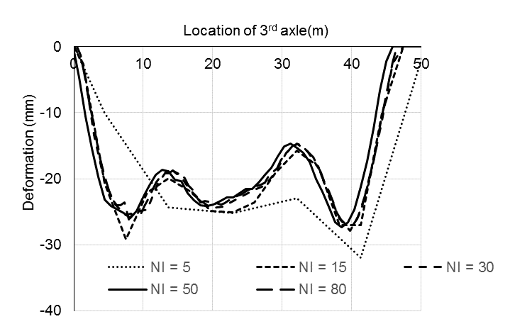 | 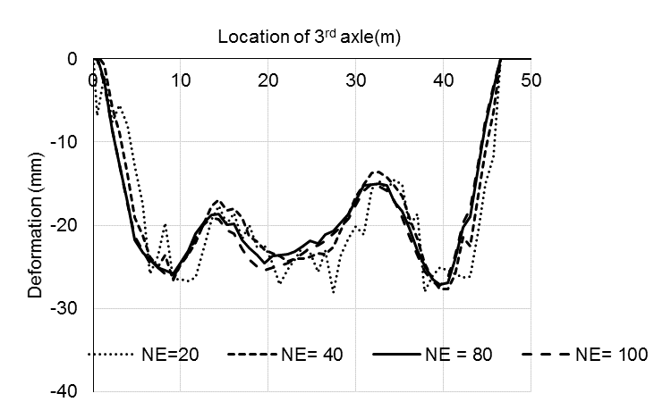
Figure 2-a: Convergence study for number of elements NE=80 and truck speed =100km/h for different number of integration points(NI) | Figure 2-b: Convergence study for number of integration points NI=50 and truck speed =100km/h for different number of elements(NE)

  - Dynamic Deflections of the Bridge Components
Integrating the results of the dynamic deformations for the vertical displacement under the truck axles (Figure 3), and the lateral and axial displacements at the top and mid-height of the two inclined piers (Figures 4-a and 4-b respectively) give a view of the oscillation pattern of the frame bridge system. When the truck is crossing the bridge at the maximum allowable speed of 100 km/h, the results show: (i) the two roller in the top supports allow the frame to sway horizontally; (ii) while the vertical displacement is growing downward with the movement of the truck, the left pier moves to the right side and slightly downward, the right pier moves oppositely to the left and slightly upward; (iii) the very high stiffness of the joint linking the inclined piers to the horizontal “superstructure” part reduces the vertical displacement significantly when the axles are passing over these connections. On the other hand, Figure 3 shows that sudden peak vibration amplitude is upward when the rear axles (fourth and fifth) entered the bridge, which can be explained by (i) high mass over the truck rear axles, (ii) the possible local dynamic excitation of the two-depth part of the superstructure at the two overhanged that results in high local oscillation, and (iii) high rigidity and continuity of the bridge. In Figure 4-a, 4-b the dynamic axial and lateral deformations of the two piers are opposite to each other, reflecting the frame mode of vibration related to its stiffness and mass distribution. Furthermore, Figure 4-b shows that the lateral (horizontal) deformation of the inclined piers is maximum at the connections of the horizontal-inclined piers, and reduced slightly downward reaching zero at the piers supports (the pins).
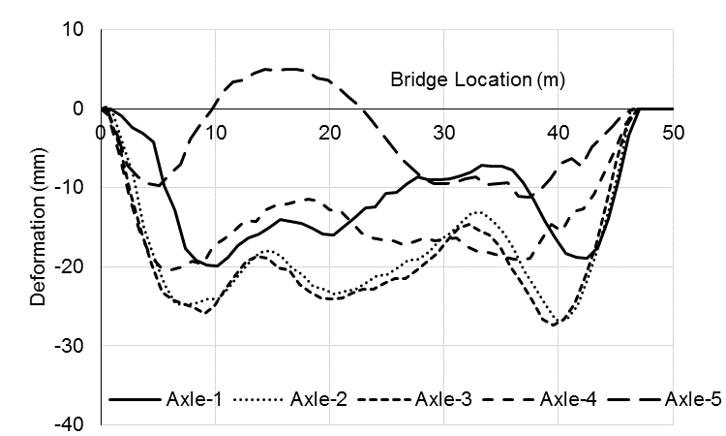
Figure 3: Dynamic deflection of the bridge superstructure under axles of a truck speed 100km/h.

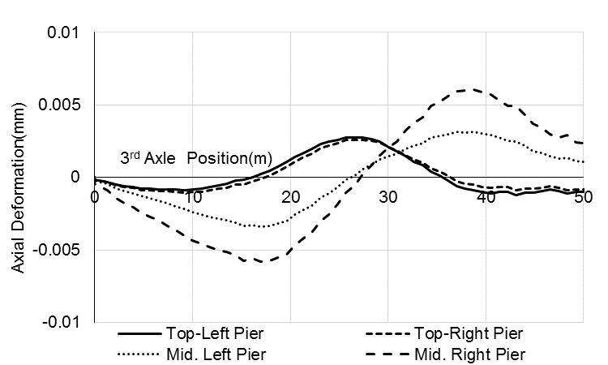 | 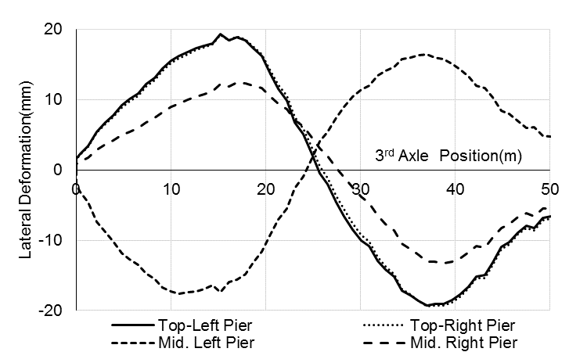
Figure 4-a: Axial deformations of the bridge piers under 3rd axle of a truck speed 100km/h. | Figure 4-b: Lateral deformations of the bridge piers under 3rd axle of a truck speed 100km/h.

  - Performance of the Aged Bridge Components
In this case study, it is assumed that the bridge has reached very high levels of corrosion damage where the damage is simulated by assuming a steel mass loss of 30 % which is equivalent to 10 years of corrosion with a corrosion density of 1μA/cm², and by assuming that the concrete cover of the substructure has spilled out where the bond of the rebars is completely lost. Figures 5, 6-a, and 6-b show that the deformation patterns have not changed. A very small increases in the dynamic deformations of different frame bridge elements are observed as the steel area is reduced and the spalling of the concrete cover is completely occurred on the internal sides of the bridge piers only (highly exposed to splash of the melted snow). Figures 5 and 6 show that when all the three parts of the bridge are affected from inside the frame, the vertical deflection at the mid span of the superstructure has been affected the most, yet the overdesign of the bridge dramatically prevented the high increase of the deformations. It should be mentioned that the pattern of the dynamic deflections as plotted over the bridge length looks similar to the pseudo-static deflections because it presented the peck deflection under the specified axle.

Since the ratio of the steel area and ratio of the concrete cover to the cross sectional areas of the bridge elements are small, then their losses are marginally affecting the elements stiffness and hence marginally affecting the deformations. In this case study, it is clear that the change of the dynamic deformations of the bridge super/substructure due to the assumed reinforcement corrosion level and the concrete cover spalling are not enough to be a sensitive parameter to reflect the structural performance of the bridge. This can be explained by the over-design of the bridge where all its elements are massive.
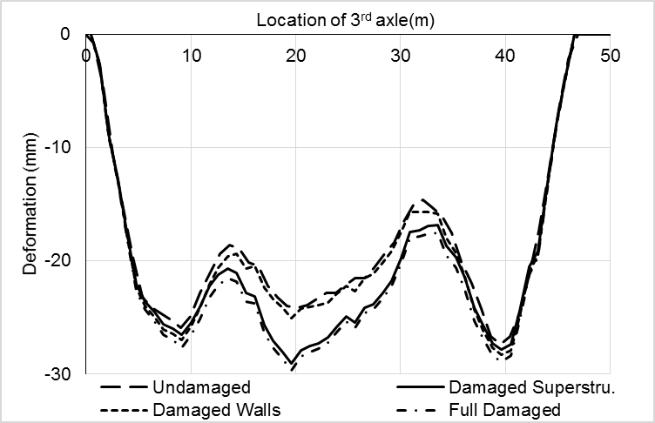
Figure 5: Comparison of superstructure deflections under 3rd axle for different cases of damaged

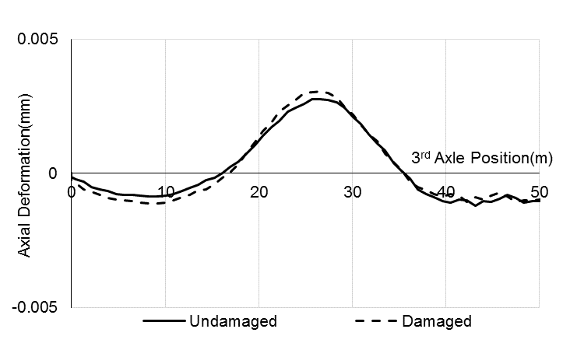 | 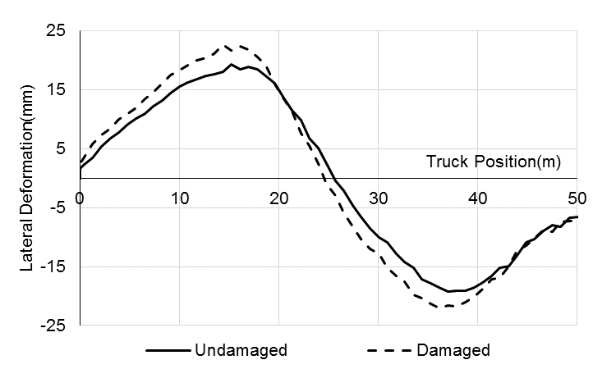
Figure 6-a: Axial deformations of the top-left bridge pier due to corrosion-induced damaged | Figure 6-b: Lateral deformations of the top-left bridge pier due to corrosion-induced damaged

- EVALUATION OF THE INSTANTANEOUS SERVICEABILITY AND THE RESIDUAL CAPACITY OF THE BRIDGE ELEMENTS
Exposure of frame bridge structural elements to high fluctuation of the climate parameters such as high variation of temperature, significant increase in snow/ice precipitation, and high frequency of freezing-thaw cycles would highly accelerate the corrosion damage of the bridge elements. This may require a reliable simulation of the governing deterioration mechanisms and accurate simulation of the residual capacity of the damaged structures. In the previous case study, the bridge is assumed to be exposed to a severe level of corrosion damage, where the concrete cover of the super/substructure has spalled out in addition to loosing 30% of steel mass. This assumption is introduced to explore whether such a damage level can lead to a safety critical situation and whether the super/substructure capacity load reduction due to reinforcement corrosion can be captured by observing the changes of the bridge dynamic response (mainly the dynamic deformations). Such a correlation between the dynamic deformations and the level and location of the corrosion damage would lead to the development of an effective sensing technique. Prediction of any critical safety and stability state from the characteristic changes of the bridge dynamic behaviour under traffic would enable expedited decisions in favor of cost effective bridge asset management. On the other hand, although the displacement due to traffic on damaged bridge is directly related to the serviceability of the bridge, it could also indicate the deterioration in the ultimate capacity of the bridge superstructure (bridge safety under extreme traffic load).
With more recent frame bridge designs, slender columns and superstructure are used. Such bridges could be more dynamically sensitive to corrosion where significant change in the dynamic vibration pattern and amplitude are expected. The staged deterioration of the stiffness and the material strength, loss of stirrups, loss of bond, variable mass and stiffness, local buckling of the longitudinal rebars, could result in staged changes of the dynamic behavior of the bridge, which indicate a significant drop in the loading capacity of different bridge elements.
- SUMMARY
Global changes in temperature, precipitation and wind patterns threaten the integrity of reinforced concrete highway bridges. The expected continuation or acceleration of climate changes can induce additional stresses that increase the risk of failure of critical bridge components. In addition, it is expected that the climate change will lead to an increase rate of chloride ingress into concrete, as well as an increase in the rate of corrosion of reinforcing steel, which in turn will lead to the reduction in bridge stiffness and shortened the service life of critical bridge components. In this context, this study investigated the effects of accelerated corrosion damage on the dynamic deformations of 46.0 m reinforced concrete frame bridge under the movement of CHBDC design truck. The frame bridge is modelled as a rigid frame using a two-dimensional nonlinear finite element model. CHBDC design truck is modelled as a multi-degree of freedom dynamic system integrated with the bridge system. Corrosion-induced damage is introduced through the reduction of the reinforcing steel area, complete loss of bond in the affected zones and spalling of concrete cover. From the case study, it is found that the corrosion of the frame bridge elements results in a marginal increase of the bridge super/substructure dynamic deflections. The results highlights that the assessment of the dynamic behavior of over designed concrete frame bridge due to corrosion-induced large damage could not clearly reflect any critical deterioration state of the bridge elements. It is important to investigate more slender frame bridges with longer spans to establish the relation between the dynamic performance (specifically the dynamic deformations) and deterioration of the bridge structural capacity when accelerated large level of corrosion damage is occurred. As part of on-going research project, the authors are investigating the effects of the temperature change and the increase of the number of freezing thaw cycles on the dynamic performance of different types of bridges and their load capacities.

References
CSA. 2014. Canadian Highway Bridge Design Code, S6-14. Canadian Standard Association, Toronto, Canada.
Harris, K.; O'Brien, J.; González, A. 2007. Reduction of bridge dynamic amplification through adjustment of vehicle suspension damping. J Sound Vib. 302(3):471-485.
Lin YH, Trethewey MW. 1990. Finite element analysis of elastic beams subjected to moving dynamic loads. Journal Sound Vibration. 136(2):323-42.
Mohammed, A.2014.Semi-quantitative assessment framework for corrosion damaged slab-on-girder bridge columns using simplified finite element analysis. PhD. Thesis, Dep. Of Civil Engineering, University of Ottawa, Ottawa, Canada.
Nemry. F., Demirel. H. 2012. Impacts of climate change on transport: A focus on road and rail transport infrastructure: European commission, Joint research center (JRC), Institute for prospective technological studies(IPTS); PP93.
Rodríguez, J., Ortega, L. M. and Casal, J., 1996. Load bearing capacity of concrete columns with corroded reinforcement. Corrosion of reinforcement in concrete construction, Royal Society of Chemestry: 220-230.
Saetta, Anne., Scotta, Roberto ., and Vitaliani, Renato.1999. Coupled environmental-mechnical damge model of rc structure. J. Eng. Mech. 125(8); 930-940.
Wang, X., Nguyen. M.,Stewart, M.2010. Analysis of climate change impacts on the deterioration of concrete infrastructure- Synthesis Report; CSIRO, Canberra. ISBN978 0 643 103641.

