|  |  |  |
| --- | --- | --- |
|  | **10th International Conference on Short and Medium Span Bridges**  **Quebec City, Quebec, Canada,**  **July 31 – August 3, 2018** |  |

**DEVELOPMENT OF DESIGN CHARTS FOR TRANSVERSE VERTICAL SHEAR IN SHEAR-CONNECTED CONCRETE BOX BEAM BRIDGES**

Pourmand, Hanieh1,3, and Sennah, Khaled2

1 Ryerson University, Canada

2 Ryerson University, Canada

3 [hpourmand@ryerson.ca](mailto:hpourmand@ryerson.ca)

**Abstract:** Prefabricated bridge systems and connection technology have been utilized to accelerate bridge construction to limit traffic disruption. One of these prefabricated bridge systems is adjacent precast deck-free concrete box beams. Adjacent precast box beams are placed side by side with 15 mm gaps, whereas the precast top flanges of adjacent box beams are connected with longitudinal shear keys, or flexural-shear joints, which help in truck load distribution among beams. Since, the concrete-filled joints provide transverse shear rigidity, the load transverse from one beam to another takes place, mainly through transverse shear, Vy, across the shear key. Clause 5.7.4 of the 2014 Canadian Highway Bridge Design Code specifies an equation to determine Vy. The drawback of this equation is that it was based on an eccentric lane loaded with a truck irrespective of the number of design lanes. Additionally, the flexural-torsional parameter, β, in the charts associated with this equation ranges from 0.2 to 2.0, which are applicable only to one- and two-lane bridges, while this value increase to 6 when the number of design lanes increases to 5. Thus, this study focused on investigating the values of Vy considering (i) number of design lanes ranging from 1 to 6; (ii) multi-lane loading conditions; (iii) different bridge spans and widths; and (iv) the value β ranging from 0.2 to 6. The analysis of the studied bridges was conducted using the Orthotropic Plate Theory. The data generated from this analysis was employed to develop charts for the transverse vertical shear force at the shear keys in the studied bridge configurations with extended range of applicability more than those specified in the 2014 CHBDC.

# INTRODUCTION

Adjacent prestressed concrete adjacent box girder bridges which is most common types of box girder bridges are extensively used in accelerated bridge construction (ABC). ABC decreases the construction time and cost significantly in comparison to conventional methods of bridge construction. Canadian Highway Bridge Design Code, CHBDC, (CSA 2014) specifies a simplified method of analysis to the following types of bridges:

1. Reinforced / post-tensioned solid slab
2. Post-tensioned circular / trapezoidal voided deck
3. Slab-on-girders, including concrete slab-on-girder, steel grid deck on girder and wood

deck on girder

1. Shear connected beams
2. Truss and arch
3. Rigid frame and integral abutment types
4. Bridges incorporating wood beams
5. Box girder including single cell, multi cell, and multi-spine

Precast prestressed concrete adjacent box beam bridges is widely used in bridge construction for its high torsional stiffness. The other benefits of employing the adjacent box girder bridges include lighter weight of the beams relative to some other bridge systems, given the hollow portion inside box beams that can be easily used for utilities lines and storm drains, enhance the bridge appearance owing to the slim superstructure and flat soffit (Hanna 2008). Generally, adjacent box beams connected to each other by partial or full depth shear keys included mild or prestressed transverse reinforcement (Lopez de Murphy et al. 2010). Figure1 demonstrates various cross sections of box beam bridges. Figure 1(a) shows a bridge cross-section comprising of precast adjacent box beams with continuity of transverse flexural rigidity across the cross-section, covered with an integral concrete deck. Figure 1(b) shows bridge cross-section of adjacent box beams without continuity of transverse flexural rigidity across the cross-section. In this case, the deck slab is made of integral concrete with shear joints between the top flanges of the adjacent boxes. Figure 1(c) shows a bridge cross-section with the deck constructed integrally with the top flange of the box beams, with top flanges connected using shear-flexural joint (continuity of reinforcement between the top flanges of the adjacent boxes). Figure 1(d) shows the bridge cross-section built with precast adjacent box beams with vertical shear key between boxes and with transverse post-tensioning and concrete overlay. Figure 1(e) shows bridge cross-section identical to that in Figure 1(d) but with deck slab integral with the precast box beam.

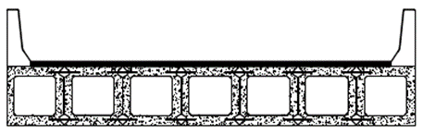 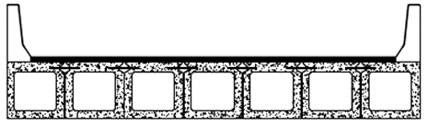

(a) Beams with continuity of transverse flexural (b) Beams with shear keys between top flanges

rigidity across the cross-section

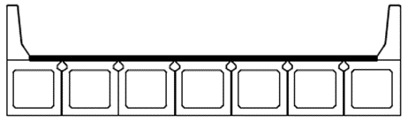 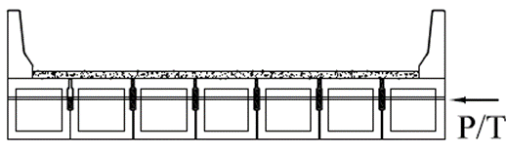

(c) Beams connected with shear-flexure joints (d) Beams connected using shear keys and transverse

between top flanges posttensioning and concrete overlay

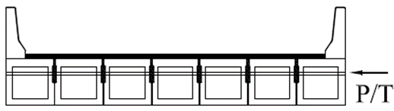

(e) Beams, with integral deck slab, connected with

shear keys and transverse posttensioning

Figure 1: Cross-sections of adjacent box beams

Shear keys plays a key role in transferring the live load from one beam to another (Bakht et al. 1983). As a result, failure of shear keys can create uneven load distribution between girders, and it causes some girders to support more loads than their design capacity. Also, cracking in shear keys results in corrosion of reinforcement inside the beam by letting the chloride-laden water inside the box girders. In addition to projecting reinforcement into the shear key, three crucial factors have significant effects on performance of shear keys, namely: geometry, location, and depth of grouting materials. Figure 2 shows various shear key configurations, including (1) partial-depth conventional grout with posttensioning (PT), (2) full-depth conventional grout with PT, (3) top flange shear joint filled with non-shrink grout or ultra-high performance concrete (UHPC), (4) top and bottom flange joints with full-depth UHPC as filling materials, and (5) top flange flexural-shear joint filled with non-shrink grout or UHPC.

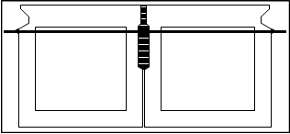 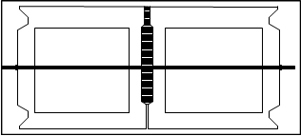

(a) Partial-depth conventional grout with PT (b) Full-depth conventional grout with PT

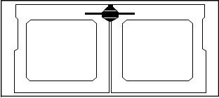 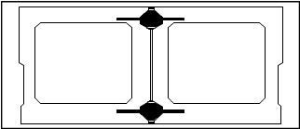

(c) Top flange shear joint with UHPC (d) Top and bottom flange joints with full-depth UHPC

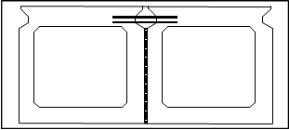

(e) Top flange flexural-shear joint filled with conventional grout

Figure 2: Various joint details between adjacent box beams

Lopez de Murphy et al. (2010) showed that employing a full-depth shear key with conventional grout as illustrated in Figure 2(b) can be a solution to shear key cracking problem given the fact that the partial shear key employed in bridge cross-section as shown in Figure 1(a). Also, the transverse posttensioning (PT) force in Figures 2(a) and 2(b), if well distributed along the connection, could enhance shear key strength. Nevertheless, PT cannot prevent tensile stresses between box girders. As a result, connection deterioration occurs. The function of the adjacent box-beam bridges with closure strip filled with UHPC can improve the tensile capacity on shear joints and increase joint durability compared to the conventional non-shrink grout. The lap-spliced steel reinforcement which used within UHPC connection design can make the joint behave as continuously reinforced; thus, it can result in larger local shear and tensile strengths, and reduced crack width (Yuan and Graybeal 2016). As elaborated earlier, a perfect shear key shall be able to transfer the transverse shear (Vy) from one box girder to another, so determining Vy values to design shear keys is a very important task for designers. In the past, the design of shear keys occurred through empirical methods, however Bakht et al (1983) provided a simplified method to calculate Vy based on the Orthotropic Plate Theory. Their study led to the simplified method specified in CHBDC of 2014 to determine the transverse shear intensity, Vy, is built on the study by Bakht et al, 1983 as well.

This paper presents a summary of previous work to determine the transverse shear force between shear-connected beams, followed by the description of the sensitivity and parametric studies considered by the authors to developed new Vy charts with greater scope and applicability than those specified in CHBDC.

# AVAILABLE LITERATURE ON THE CALCULATION OF TRANVERSE SHEAR IN BOX BEAMS

Bakht et al. (1983) conducted structural analysis of shear-connected beams to develop charts to determine maximum transverse shear (Vy) for four various bridge widths, namely: 7.5, 10, 12.5 and 15 m and flexural-torsion parameter, β, ranging from 0.2 to 2. The bridges were analysed using the Orthotropic Plate Theory, employing PLATO program which was developed based on this theory by (Bakht et al., 2003). This program was written in FORTRAN90 and has the capability to install on WINDOWS operating systems. The behaviour of orthotropic plate that the PLATO built on, is defined by an expression proposed by Cusens and Pama (1975) as follows:

[1] $D_{x }\frac{∂^{4}w}{∂x^{4}}+2H\frac{∂^{4}w}{∂x^{2}∂y^{2}}+D_{y} \frac{∂^{4}w}{∂y^{4}}=p\left(x,y\right)$

Where Dx = longitudinal bending stiffness, Dy = transverse bending stiffness, 2H = total torsional rigidity of the bridge, w = beam deflection, and p(x,y) = applied loading.

The exact solution of this forth order partial differential equation relies on the relative torsional and flexural rigidities. Equation [1] can be utilized to each individual patch loads as well as uniformly distributed load over the whole area of bridge deck slab (Bakht and Mufti 2015).The analysis conducted by Bakht et al. (1983) resulted in developed charts to calculate Vy for shear-connected beams based on three changeable factors, namely: flexural-torsion parameter (β), span length (L), and bridge width (B). The assumption which was taken in this study is that the transverse flexural rigidity (Dy) in multibeam bridges is zero. Instead, the structural response of these types of bridges depends on a factor β which is defined as follows, considering 2b as the bridge width:

[2] $β=π\left[\frac{2b}{L}\right]{\left[\frac{D_{x}}{D_{y}}\right]}^{0.5}$

The above-mentioned charts were first developed based on the Ontario truck (OHBDC vehicle) with total weight of 700 kN and weight of axle no. 4 as 200 kN. Bakht et al. (1983) concluded that the maximum Vy intensity was created close to the single 200 kN axle for bridge spans equal to or smaller than 25 m. Also, for spans over 25 m, the 280 kN tandem governed (i.e. axles 2 and 3).

CHBDC of 2000, 2006 and 2014 adopted the charts developed by Bakht et al. (1983) after converting their values to the CL-W truck of 625 kN gross weight, as depicted in Figure 3, to determine Vy in shear-connected beam bridges, considering the following equation:

[3] $V_{y}=kW$

Where k = a constant obtained from charts shown on Figure 1, and W = the maximum axle load of the CL-625 Truck (175 kN).

As per CHBDC, the dynamic load allowance for a single axle load, as specified in Clause 3.8.4.5, must be applied to Vy obtained from equation [3]. The value of β in Figure 3 shall be calculated as follows:

[4] $β=π\left[\frac{B}{L}\right]{\left[\frac{D_{x}}{D_{xy}}\right]}^{0.5}$

[5] $D_{x}= \frac{EI}{P_{x}}$

[6] $D_{xy}=G \frac{4A_{0}}{P_{x}Σ\frac{d_{s}}{t}}$

Where B = width of the bridge, L = bridge span length, Dxy = torsion rigidity, EI = flexural stiffness, Px is the spacing between boxes, center-to-centre, G = shear modulus, Ao = area enclosed by the centrelines of walls forming the box section, ds = length of box wall and t = thickness of box wall.

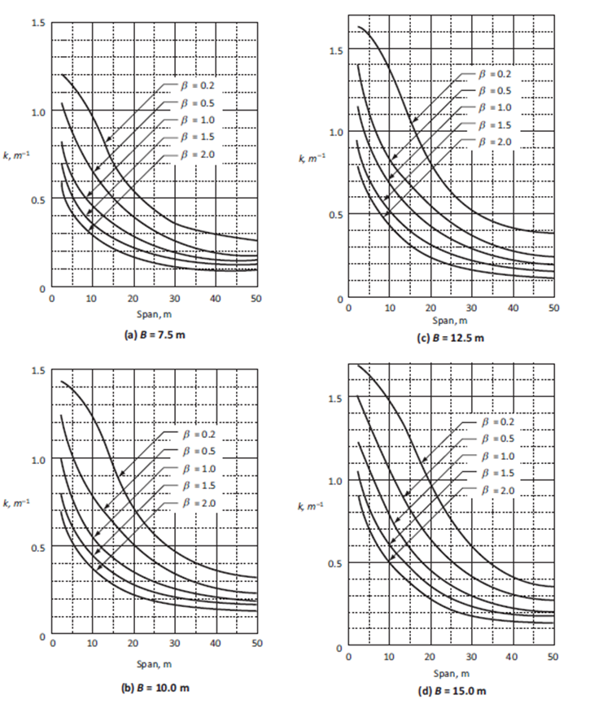

Figure 3: Values of k for calculating transverse vertical shear in shear-connected beam subjected

to CL-625 truck loading (CSA 2014)

# SIGNIFICANE OF RESEARCH

The review of previous work revealed that CHBDC charts to determine maximum transverse shear (Vy) in shear-connected beams are limited to 2, 3 and 4 design lanes for bridge widths of 7.5, 10, 12.5 and 15 m. In the current study, 1, 5 and 6 lanes were added for bridge widths of 5.75, 16.5, 20 and 23.5 m. Also, CHBDC Vy charts considers the flexural-torsion parameter, β, ranging from 0.2 to 2. However, recent research on adjacent box beam bridges revealed that β values reach 8 with increase of number of design lanes to 6 (Jajjawi 2016). As such, the current study included β values ranging from 0.2 to 8. The study by Bakht et al. (1983) considers only one eccentrically-loaded lane to obtain the greatest Vy value. However, in a sensitivity study conducted in the current study, it was found that single-lane loading provides the maximum Vy for one-, two- and three-lane bridge cross-section, while two adjacent lanes loaded with CL-W trucks produce the maximum Vy for four-, five-, and six-lane bridge cross-section. Finally, results not presented here by the authors of this paper proved that the original charts by Bakht et al. included the dynamic load allowance and that multiplying Vy obtained from CHBDC charts by DLA is not required.

# **ANALYSIS OF ADJACANT BOX BEAMS TO DETERMINE TRANSVERSE SHEAR**

An extensive sensitivity and parametric study were conducted over 2400 multibeam bridges with various parameters ranging from one lane to six lane bridges with the span of 3 to 50 m. The bridges analysed using the Orthotropic Plate Theory and employing PLATO program which was developed based on this theory by Bakht et al. (2002). In this study, the axel load of the CL-W truck considered as patch loads with the area of 600 mm x 250 mm which applied in PLATO over the deck. Although Bakht et al. (1983) considered transverse flexural rigidity equal to zero (Dy = 0) in developing CHBDC charts for shear-connected beam, designers may suspect that these charts may not be applicable to adjacent box beams with flexural-shear connection between top flanges of box beams. As such, a sensitivity study was conducted to examine the change in Dy/Dx ratio on Vy values for a four-lane bridge of 20 m span and 16.5 m width. This Dy/Dx ratio changed from 0 to 0.2 as depicted in Figure 4. It should be noted that Dy is to be calculated at the flexural-shear joint between boxes. Figure 4 shows that Dy has almost no effect on the maximum value of Vy in adjacent box beams. As such, the authors conducted the parametric study considering Dy = 0.

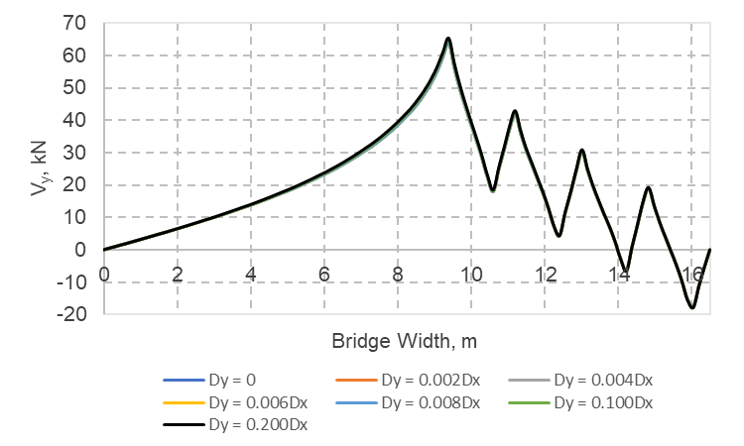

Figure 4: Transverse distribution of Vy

Furthermore, a study is conducted on dominant loading cases in transverse and longitudinal direction. As a transverse direction is considered, Figure 5 shows the loading case which produced the maximum Vy in transverse direction based on the sensitivity analysis conducted in this study. As it can be observed, for one, two, and three lane bridges, one lane loaded created maximum Vy, while the two-lane loaded scenario is prominent for four, five, and six lane bridges.

It is interesting to note that the study in longitudinal direction also revealed that axle 4 of CL-W truck for the bridge span up to 13 m produced maximum transverse shear, while for bridges with the span ranging between 16 m to 20 m, axles 1, 2, and 3 generated the largest transverse shear force at the joints between boxes. Moreover, for the span over 20 m, all five axles of CL-W truck produced the maximum Vy. In addition, the changes in Vy values were studied when using CL-625 truck and CL-625-ONT truck. Figure 6 depicted the difference between Vy intensity due to CL-625 and CL-625-ONT trucks for four-lane bridges of spans varying from 10 m to 30 m and a width of 16.5 m. Results showed that axles 2 and 3 of the truck produced the greatest Vy for spans ranging from 15 to 25 m and that Vy for CL-625-ONT truck was greater than that produced by CL-625 truck. As such, it was decided to use CL-625-ONT truck to conduct the parametric study with the understanding that the produced charts can cooperatively be used for bridges designed using CL-625 truck in span range between 15 and 25 m.

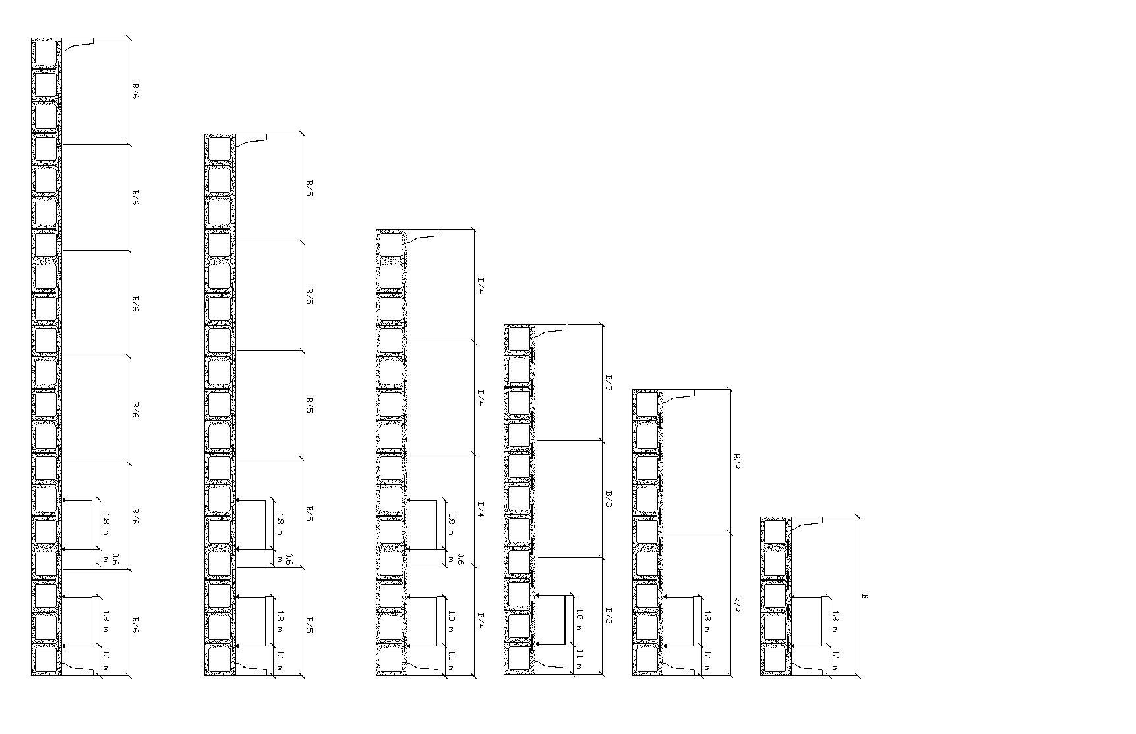

1. One-lane bridge cross-section

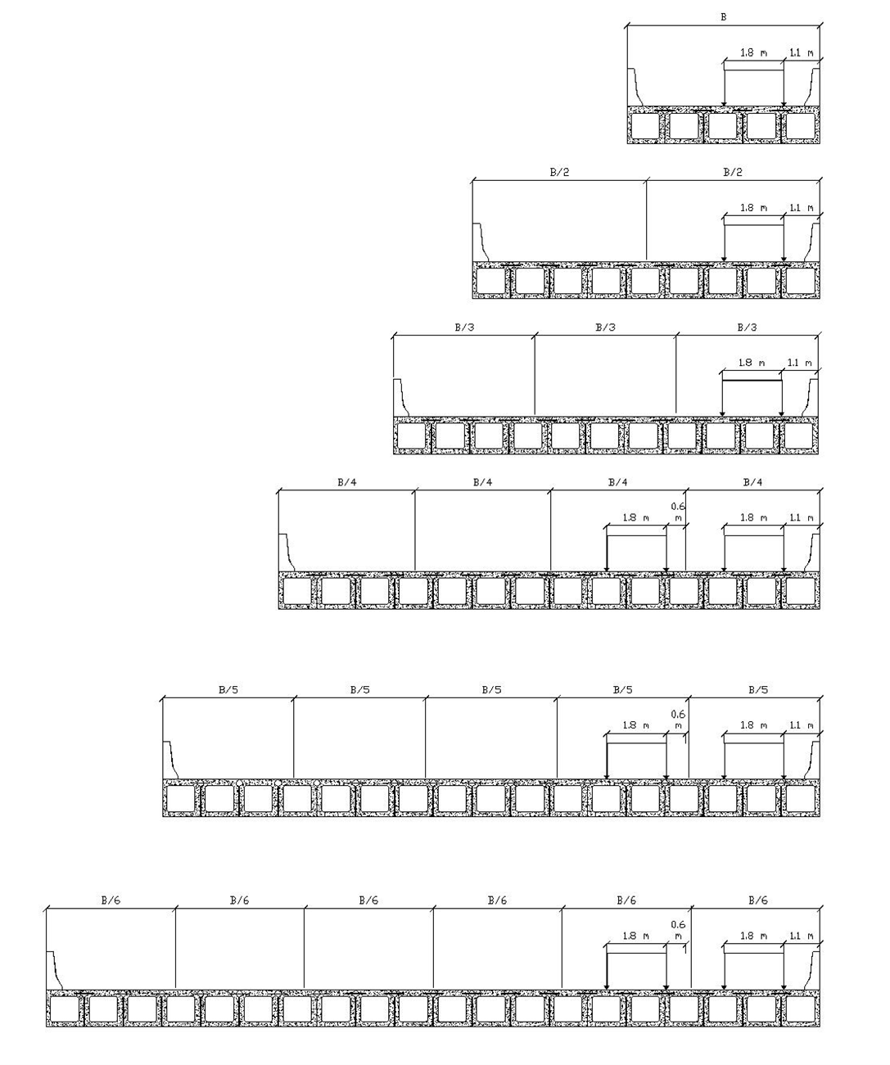

1. Two-lane bridge cross-section



1. Three-lane bridge cross-section



1. Four-lane bridge cross-section

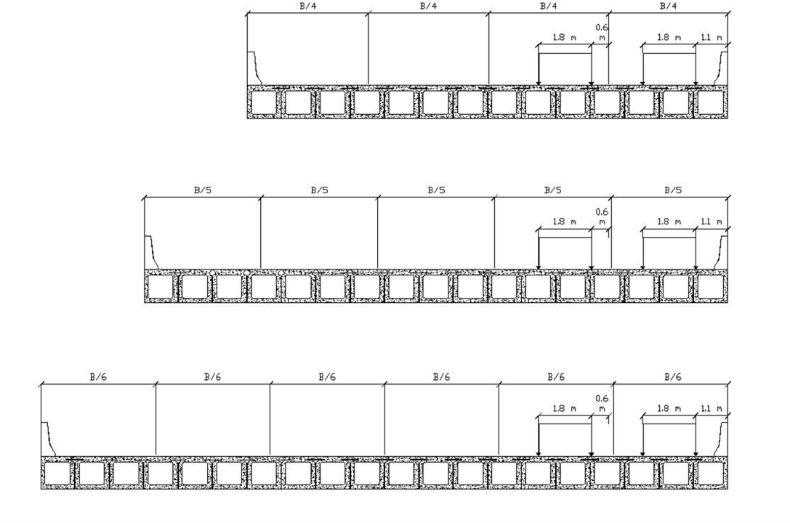

1. Five-lane bridge cross-section



1. Six-lane bridge cross-section

Figure 5: Dominant loading cases in transverse direction for one-lane to six-lane multibeams bridges

Figure 6: Comparison between CL-625 and CL-625-ONT in producing maximum Vy values

# NEW DEVELOPED GRAPHS TO PROPOSE TO CHBDC

Based on the parametric study on almost 2370 runs by PLATO software on one-lane to six-lane bridges with the span lengths ranging from 3 m to 50 m and β values ranging from 0.2 to 8, six charts, shown in Figure 7, were produced to calculate maximum transverse shear (Vy) for shear-connected concrete beam bridges subjected to CL-625 or CL-625-ONT trucks. It should be noted that the maximum intensity of transverse vertical shear in kN/m determined using these new charts include the dynamic load allowance. These charts were proposed to CHBDC to replace charts in Figure 5.6 of CHBDC 2014. Linear interpolation for this intensity shall be used for widths falling between the widths specified in this chart. Live load factor as specific in Clause 3.5.1 of CHBDC 2014 shall be applied to Vy values obtained from these charts for ultimate limit state design of the joints between precast box beams. The value of β in these charts shall be calculated as follows:

[7] $β= π(\frac{B}{L})\sqrt{\frac{{EI}_{L}}{{GJ}_{L}}}$

where EIL and GJL are obtained for one girder.

For CL-W trucks with W greater than 625 kN, the values of Vy obtained from the new chart shall be multiplied by the factor W/625. It should be noted that this proposed method for calculating transverse shear intensity is more straightforward than previous simplified method provided by CHBDC 2014. Since, it does note require to apply any formula, and the Vy intensity can be determined directly from the charts.

|  |  |
| --- | --- |
|  |  |
| (a) B = 5.75 m | (b) B = 10 m |
|  |  |
| (c) B = 13.0 m | (d) B = 16.5 m |
|  |  |
| (e) B = 20.0 m | (f) B = 23.5 m |

Figure 7: Transverse vertical shear in shear-connected beam bridges

# CONCLUSIONS

This paper presents the results from a practical-design-oriented parametric study to develop more reliable charts for the calculation of vertical transverse shear between adjacent box beams with either shear joints or shear-flexural joints between top flanges of connected box beams. The developed charts increase the scope of applicability of the existing charts in CHBDC of 2014 to one-, five- and six-lane bridges. Also, it increase the upper limit of the flexural-torsion parameter, β, from 2 to 8 to cover wide range of bridge geometry. Moreover, the developed charts are more reliable than those specified in CHBDC of 2014 since they included different truck loading conditions in design lanes.

# Acknowledgements

The authors acknowledge the Natural Science and Engineering Research Council of Canada (NSERC) for supporting this research. The authors would like to thank Technical Subcommittee of *Chapter 5: Structural Analysis* and Technical Committee of the Canadian Highway Bridge Code (CAN/CSA-S6-19) for including the six developed charts in Figure 7 of this paper in the 2019 CHBDC Edition.

# References

Bakht, B., and Mufti, A. 2015. *Bridges: Analysis, Design, Structural Health Monitoring, and Rehabilitation*. Springer, Switzerland.

Bakht B., Jaeger, L. G., and Cheung, M. S. 1983. Transverse Shear in Multibeam Bridges. *Journal of Structural Engineering*, **109**(4): 936–949.

Bakht, B., Mufti, A., and Desai, Y. 2003. PLATO User Manual - Analysis of Orthotropic Plates. Technical Report, University of Manitoba, Manitoba, Canada.

CSA. 2014a. *Canadian Highway Bridge Design Code*, CAN/CSA S6-14. Canadian Standard Association, Toronto, Ontario, Canada.

Cusens, A. R., and Pama, R. P. 1975. Bridge Deck Analysis. John Wiley and Sons Inc. London, England.

Hanna, K. E. 2008. Behavior of adjacent precast prestressed concrete box girder bridges. *ETD Collection for University of Nebraska - Lincoln*, 1–166.

Jajjawi, M. 2016. Simplified Method of Analysis for Adjacent Precast "Deck Free" Concrete Box Beams used in Accelerated Bridge Construction. M.A.SC. Thesis, Civil Engineering Department, Ryerson University, Toronto, Ontario, Canada.

Lopez de Murphy, M., Kim, J., Sang, Z., and Xiao, C. 2010. Determining More Effective Approaches for Grouting Shear Keys of Adjacent Box Beams.

Yuan, J. and Graybeal, B. 2016. Full-Scale Testing of Shear Key Details for Precast Concrete Box-Beam Bridges. *Journal of Bridge Engineering*, **21**(9), 04016043.