|  |  |  |
| --- | --- | --- |
|  | **10th International Conference on Short and Medium Span Bridges**  **Quebec City, Quebec, Canada,**  **July 31 – August 3, 2018** |  |

**INVESTIGATION OF VEHICLE IMPACT LOAD TRANSFER FOR TRAFFIC BARRIER CONSTRUCTED INTEGRALLY WITH CONCRETE RETAINING WALL**

Pourmand, Hanieh1,3, and Sennah, Khaled2

1 Ryerson University, Canada

2 Ryerson University, Canada

3 [hpourmand@ryerson.ca](mailto:hpourmand@ryerson.ca)

**Abstract:** Vehicular traffic exists on the high (fill) side of the concrete retaining wall supporting soil embankment outside the bridge structure. For traffic on the high side, a conventional traffic barrier might be placed on the top of the wall with rigid joint between them. The applied vehicle impact loads on the barrier wall are available in the Canadian Highway Bridge Design Code. However, the applied factored moment and shear force to design the joint between the traffic barrier and the top of the retaining wall are as yet unavailable. This paper presents the results from elastic finite element analysis (FEA) modelling of the barrier wall and supporting concrete retaining wall system when subjected to vehicle impact. The Tl-5 barrier was considered in this study. The height of the retaining wall under the barrier wall was taken as 1.8 to 7.2 m with 1.8 m increments, while the length of the barrier and the supporting wall in the direction of traffic was taken as 9 to 27 m, with increments of 3 m. The length of the barrier and the retaining wall represents the spacing between vertical expansion joints. FEA results included the applied factored moment and shear force at the barrier-retaining wall junction as well as at the fixed base of the wall. The practice of considering the dispersion angle of a line loading to be transferred to concrete element at 45-degree angle was examined. Conclusions for the analysis of forces at the barrier-retaining wall junction as well as at the retaining wall base were drawn.

# INTRODUCTION

Canadian Highway Bridge Code, CHBDC, (CSA 2014) specifies different types of traffic barriers based on their test levels (TL), namely: TL-1, TL-2, TL-4 and TL-5. Sennah and Khederzadeh (2014) developed cost-effective TL-5 barrier wall reinforce with GFRP bars for use in bridge superstructure. However, outside the bridge, this barrier is constructed integrally with the retaining wall. CHBDC specifies that a traffic barrier anchorage to the bridge deck slab shall be pass the crash testing of the traffic the traffic barrier without any noticeable damage to the anchorage and deck slab. In a case of unavailability of crash test results. CHBDC proposed to design the anchorage and deck for largest bending, shear, and punching load that can be transmitted to them by barrier wall. It also has been specified by CHBDC that transverse, longitudinal, and vertical loads of 210, 70, and 90 kN respectively which applied to the barrier along longitudinal dimension. The transverse load shall be applied over a barrier length of 2400 mm for TL-5 barriers (Rostami et al. 2017). As it is clear the maximum moment and shear force at the barrier-deck junction produced due to transverse loading. As a result, both longitudinal and vertical load can be ignored in the design of barrier wall reinforcement and anchorage between the deck slab and barrier wall. As per CHBDC, the factor of 1.7 shall be applied to the live load; therefor, the equivalent point load which applied to the TL-5 barrier wall over 2400 mm length is 375 kN. Washington State Department of transportation (WSDoT 2015) also provided guidance for reinforced concrete retaining walls and traffic barrier details. In this manual, the method of applying of lateral loads and collision loads elaborated. Figures 1 and 2 demonstrate the lateral soil distribution with horizontal and a sloping backfill respectively. The slope angle β shall be determined based on Figure 3.11.5.8.1-3 in AASHTO-LRFD Bridge Design Specifications (AASHTO 2017). The angle δ is calculated in accordance with Coulomb wedge theory.

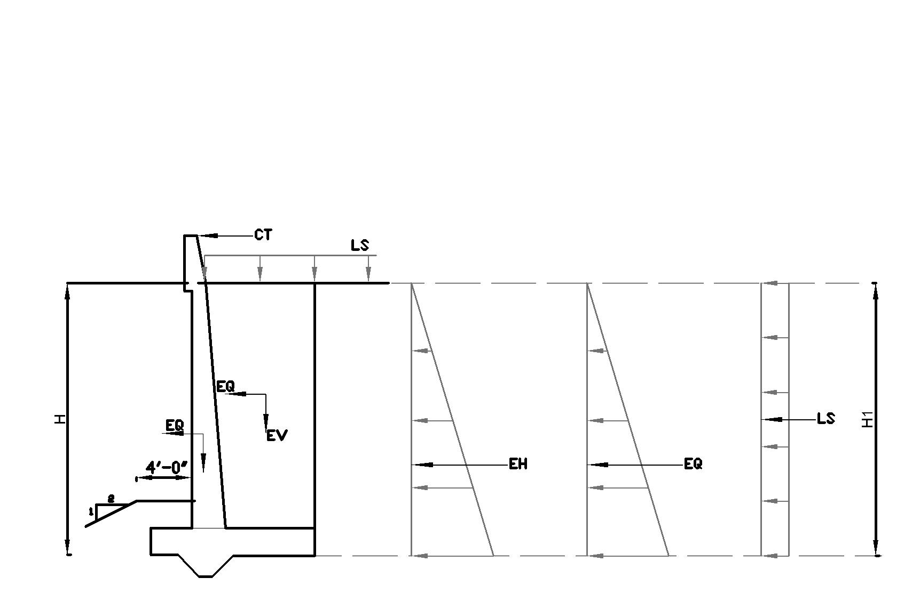

Figure 1: Lateral load distribution for a retaining wall with a flat backfill

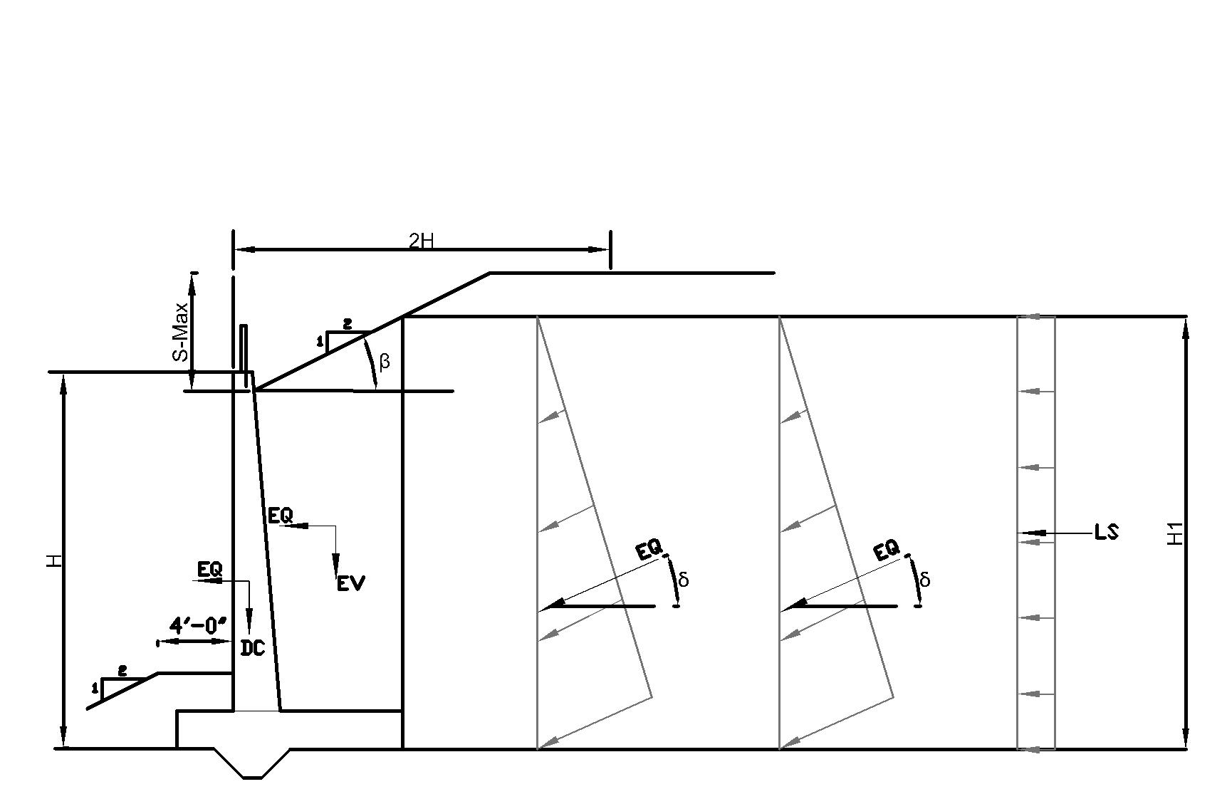

Figure 2: Lateral load distribution for a retaining wall with a sloping backfill

Moreover, WSDoT specified that for the walls integrated with traffic barrier, the vehicular collision load must be considered for the design. Also, to limit any failure due to collision impact to the barrier section, the top of the wall stem shall be designed as per AASHTO-LRFD article A13.4. Figure 3 and 4 present vehicle impact loads due to the collision on the barrier wall at midway of expansion joint length and near the expansion joint respectively. The force Ft is distributed along length (Lt) at the top of the traffic barrier and downward to the top of the footing at a 45-degree angle. The value of Ft and Lt can be found through table A13.2-1 from AASHTO-LRFD. In addition, in can be referred to drawings prepared by State of California for retaining wall details with a attached concrete barrier wall *(“California retaining wall type 7b details no 1” n.d*.).

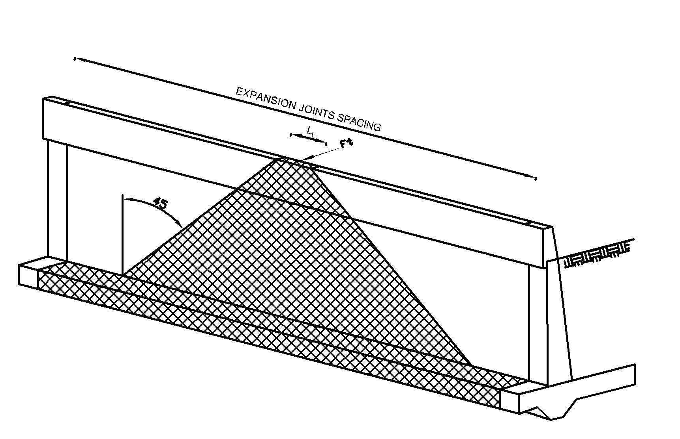

Figure 3: Vehicle impact dispersal at middle of expansion joints length (Lw)

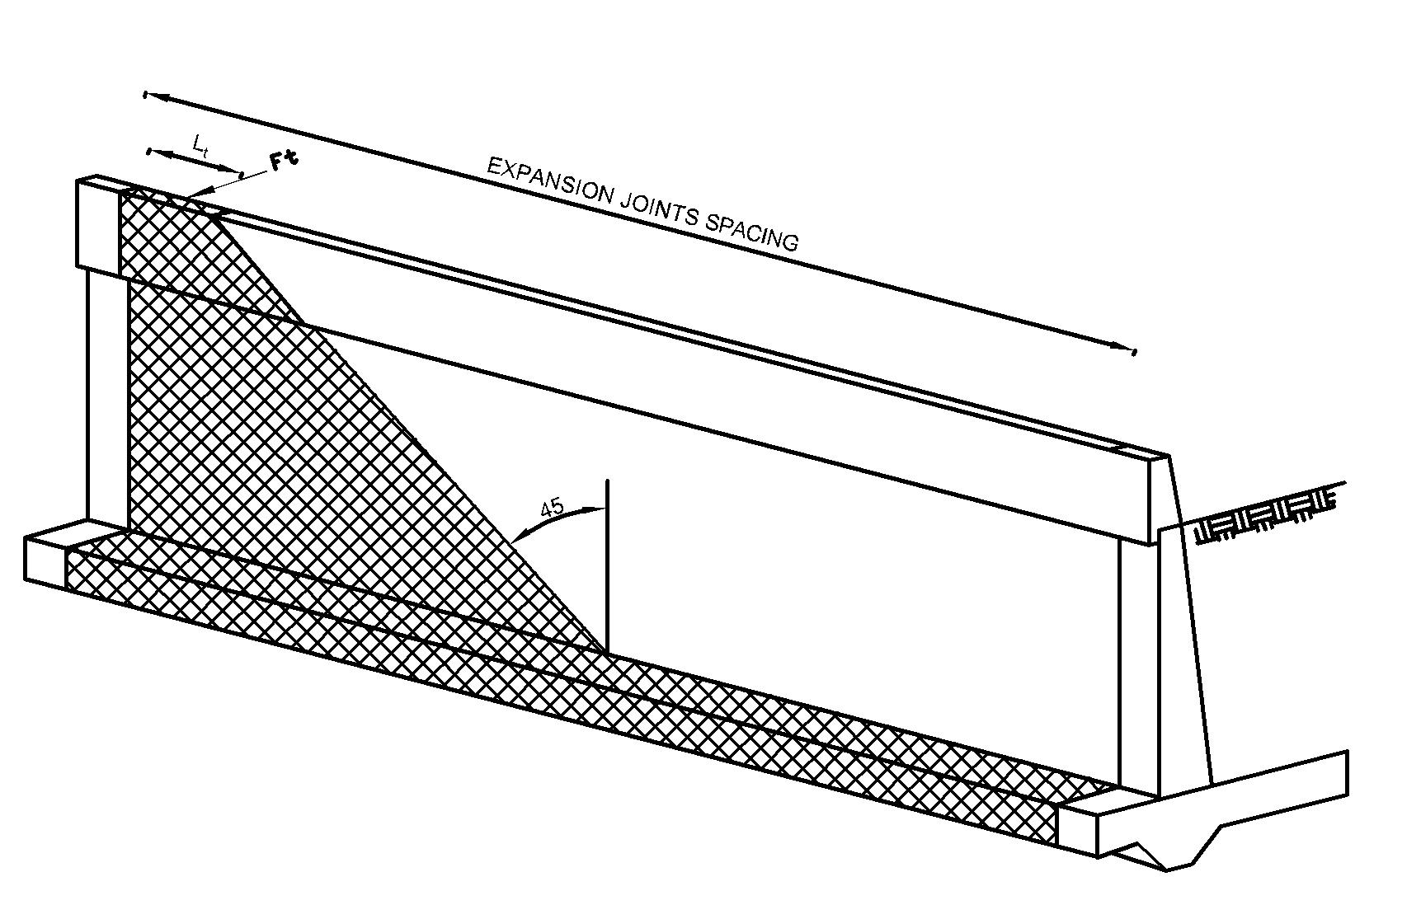

Figure 4: Vehicle impact dispersal near location of expansion joints

# PROPOSED TL-5 BARRIER-RETAINING WALL DETAILS

The roadside barrier system must be designed to contain and safely redirect a vehicle during an impact event. The applied vehicle impact loads on the barrier wall are available in the Canadian Highway Bridge Design Code. However, the applied factored moment and shear force to design the joint between the traffic barrier and the top of the retaining wall are as yet unavailable. Figure 5 shows the TL-5 barrier resting over the concrete retaining wall, with proposed rigid joint between them. Figures 6 presents the proposed joint details between TL-5 barrier walls with reinforced concrete wall. In this design, the retaining wall thickness was considered equal to the barrier wall thickness of 435 mm for TL-5 barriers. Due to limited width of the base of the barrier compared to the crash-tested barrier as well as the barriers tested under static loading to-collapse, the diagonal GFRP bars have slope of 78º for TL-5 barrier. This dictates a clear concrete cover of 115 to this bar at the barrier-deck junction. The embedment length of 300 mm for barriers vertical reinforcement into the top of the reinforced concrete retaining wall is proposed with the assumption of providing full capacity of the GFRP given the bond strength of bar with concrete as given by the barrier manufactures. It should be noted that the diagonal GFRP bars at the traffic side of the barrier wall, close to the lower tapered portion of the barrier wall, has headed end as supplied by the GFRP manufacturer. To allow for better bond and transfer of bending moments between the barrier wall base and the top of the retaining wall, the vertical reinforcement in the retaining wall from the top traffic side is proposed to bend at 90º angle and end with 180º hook close to the other vertical side of the retaining wall as depicted in Figs. 4(b) for TL-5 barriers unless the bridge owner provide other means of bending moment continuity at barrier-retaining wall joint.

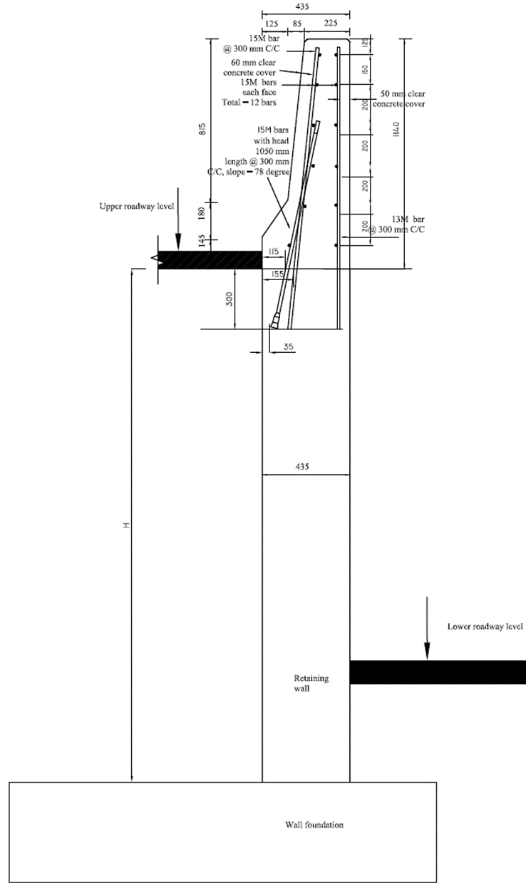

Figure 5: Cross-section of the TL-5 barrier wall constructed integrally over the concrete retaining wall

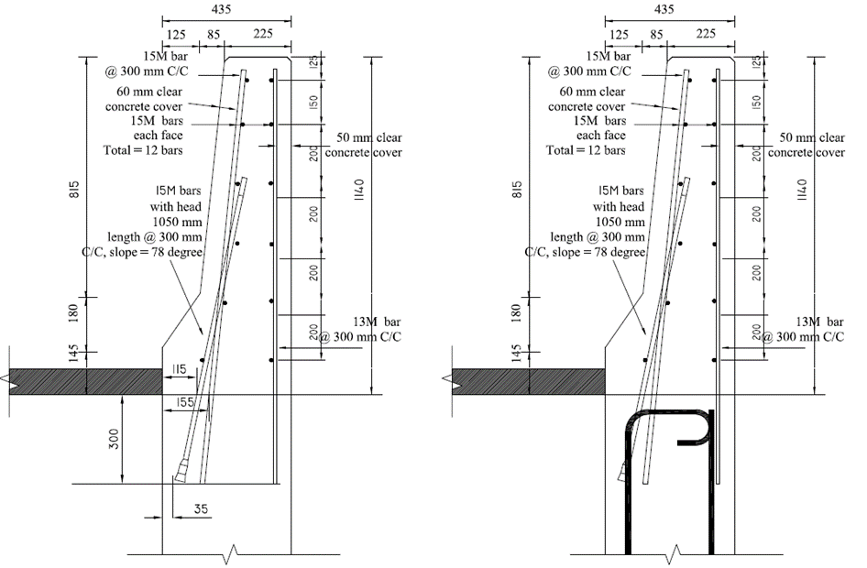

1. Without showing wall reinforcement b) with vertical wall reinforcement

Figure 6: Proposed TL-5 barrier details at the barrier-deck junction

# ANALYSIS OF THE BARRIER-RETAINING WALL SYSTEM

This paper presents the results from elastic finite element analysis (FEA) modelling, using SAP2000 software, of the barrier wall and supporting concrete retaining wall system when subjected to vehicle impact. Two, barrier types were considered in this study, namely, TL-4 and TL-5 barriers. The height of the retaining wall under the barrier wall (shown as H in Figure 5) was taken as 1.8 to 7.2 m with 1.8 m increments, while the length of the barrier and the supporting wall in the direction of traffic (shown as Lw in Figure 5) was taken as 9 to 27 m, with increments of 3 m. The length of the barrier and the retaining wall represents the spacing between vertical expansion joint shown in Figure 7.

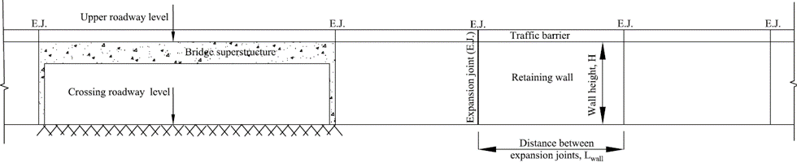

Figure 7: Elevation of the bridge superstructure with adjacent retaining wall holding soil embankment

Figures 8(a) and 8(b) shows an elevation of TL-5 barrier wall mounted over a retaining wall and factored transverse loading of 357 kN at a height of 990 mm from the barrier-retaining wall joint and distributed over 2400 mm length at interior and exterior locations, respectively. The exterior location herein can be at the end of the barrier wall or at the interior expansion joints between barrier-retaining wall segments as depicts in Figure 7.

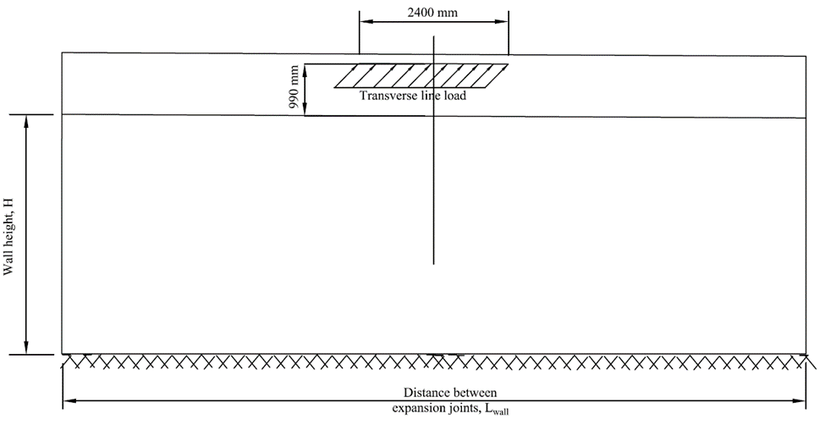

1. Loading at interior location

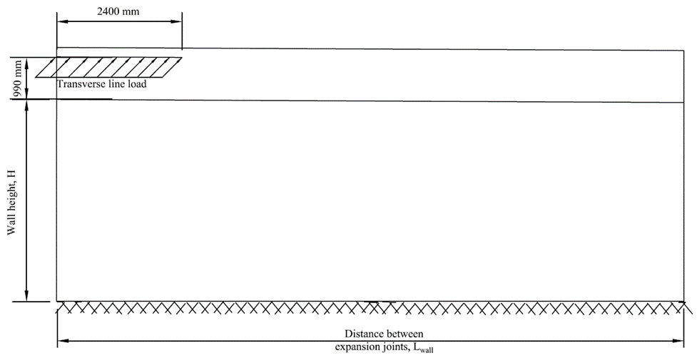

1. Loading at exterior location

Figure 8: Elevation of the retaining wall showing the applied load transverse to the TL-5 barrier wall

Figures 9, 10 and 11 shows elevations of the FEA modelling of different barrier-retaining wall segments for Tl-5 barrier-wall system. The results from the FEA modelling are in the form of the applied factored moment and shear at the barrier-retaining wall joint as well as at the base of the retaining wall (fixed base with concrete foundation). Tables 1 through 4 summaries these values for retaining wall heights, H = 1.8, 3.6, 5.4 and 7.2 m along with length of barrier-retaining wall segments, Lw = 9, 12, 15, 18, 21, 24 and 27 m.

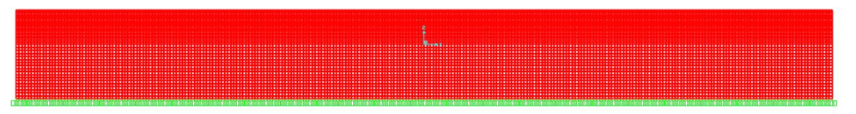

Figure 9: View of the FEA modelling of barrier-gravity wall system (H = 1.8 m and Lwall = 27 m)

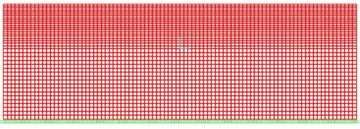 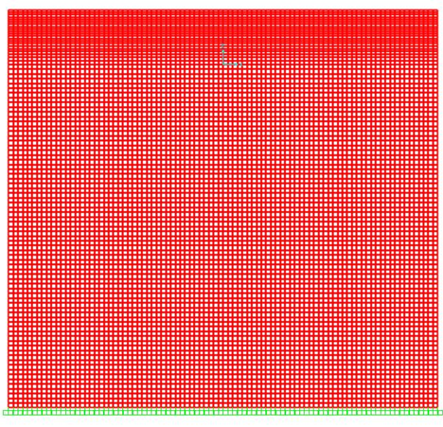

Figure 10: View of the FEA modelling of barrier- Figure 11: View of the FEA modelling of barrier-

gravity wall system (H = 1.8 m and Lwall = 9 m) gravity wall system (H = 7.2 m and Lwall = 9 m)

## Applied Factored Moment at the TL-5 Barrier-retaining Wall Joint Due to Interior Transverse Vehicle Impact Loading

Results in Table 1 for TL-5 barrier loaded at interior load location show that the factored applied moment decreases with increase in distance between expansion joint, Lw. Also, it can be observed that this moment is the greatest with retaining wall height of 1.8 m compared to those for greater height H. As such, it can be concluded that the greatest factored applied moment at the barrier-retaining wall joint is 77.36 kN.m/m. A GFRP-reinforced concrete section of 1000 mm width and 435 mm thickness was analyzed per CHBDC as well as the procedure for section analysis provided by ISIS Manual No. 3 (ISIS 2007). A concrete compressive strength of 30 MPa was considered in this analysis. The tensile strength, modulus of elasticity and strain at failure of the GFRP bar were taken as 1097 MPa, 53.2 GPa and 1.89%, respectively. The bar cross-sectional area was taken 199 mm2 with exterior bar diameter of 16.9 mm. The analysis at interior location led to compression-control failure considering the full tensile capacity of the bar. The moment capacity was obtained as 198 kN.m/m which is far greater that the applied factored moment of 77.36 kN.m/m. Although the vertical embedment length of the tension GFRP bars into the top of the wall is 300 mm, this analysis was repeated based on the capacity of the head alone obtained from previous concrete block tests (i.e. average pullout capacity of 155.4 kN). The corresponding tensile strength and ultimate strain of the bar were 778 MPa and 1.46%, respectively. This led to tension-control failure with flexural capacity of 145 kN.m/m which is still far greater that the applied factored moment of 77.36 kN.m/m at the barrier-retaining wall joint.

## **Applied Factored Moment at the TL-5 Barrier-retaining Wall Joint Due to Exterior Transverse**

## **Vehicle Impact** Loading

Results in Table 2 for TL-5 barrier loaded at exterior load location show that the factored applied moment is constant for retaining wall height of 1.8 m with increase in distance between expansion joint, Lw. However, with increase in retaining wall height to 7.2 m, this applied moment slightly decreases with increase in barrier length. Also, it can be observed that this moment decreases with increase in retaining wall height from 1.8 m to 7.2 m. As such, it can be concluded that the greatest factored applied moment at the barrier-retaining wall joint is 111.44 kN.m/m. A GFRP-reinforced concrete section of 1000 mm width and 435 mm thickness was analyzed per CHBDC as well as the procedure for section analysis provided by ISIA Manual No. 3 (2007). A concrete compressive strength of 30 MPa was considered in this analysis. The tensile strength, modulus of elasticity and strain at failure of the GFRP bar were taken as 1097 MPa, 53.2 GPa and 1.89%, respectively. The bar cross-sectional area was taken 199 mm2 with exterior bar diameter of 16.9 mm. The analysis at exterior location led to compression-control failure considering the full tensile capacity of the bar. The moment capacity was obtained as 239.84 kN.m/m which is far greater that the applied factored moment of 111.44 kN.m.

Table 1: Factored applied moment and shear force at barrier-retaining wall junction as well as at the base of the retaining wall for TL-5 barrier transversally loaded at interior location

|  |  |  |  |  |  |  |  |  |  |
| --- | --- | --- | --- | --- | --- | --- | --- | --- | --- |
| Retaining wall height, H | Location of force and moment calculations | Applied moment and shear force | Distance between expansion joints in walls, Lw | | | | | | |
| 9 m | 12 m | 15 m | 18 m | 21 m | 24 m | 27 m |
| 1.80 | At barrier base | M (kN.m) | -77.36 | -76.17 | -75.96 | -75.93 | -75.93 | -75.93 | -75.93 |
| V (kN) | -53.56 | -51.67 | -51.35 | -51.30 | -51.30 | -51.30 | -51.30 |
| At wall fixed end | M (kN.m) | -185.92 | -182.04 | -181.50 | -181.44 | -181.43 | -181.43 | -181.43 |
| V (kN) | -102.18 | -102.43 | -102.59 | -102.62 | -102.63 | -102.63 | -102.63 |
| 3.60 | At barrier base | M (kN.m) | -72.57 | -69.34 | -68.01 | -67.46 | -67.24 | -67.16 | -67.13 |
| V (kN) | -44.36 | -39.00 | -36.81 | -35.91 | -35.55 | -35.41 | -35.36 |
| At wall fixed end | M (kN.m) | -227.10 | -199.10 | -188.85 | -185.22 | -184.00 | -183.59 | -183.47 |
| V (kN) | -72.65 | -67.89 | -67.01 | -67.01 | -67.11 | -67.17 | -67.19 |
| 5.40 | At barrier base | M (kN.m) | -72.26 | -68.20 | -66.23 | -65.19 | -64.62 | -64.31 | -64.14 |
| V (kN) | -43.62 | -36.88 | -33.59 | -31.87 | -30.93 | -30.41 | -30.13 |
| At wall fixed end | M (kN.m) | -288.14 | -234.12 | -207.91 | -194.82 | -188.34 | -185.18 | -183.68 |
| V (kN) | -63.71 | -54.16 | -50.55 | -49.28 | -48.92 | -48.87 | -48.92 |
| 7.20 | At barrier base | M (kN.m) | -72.53 | -68.15 | -65.84 | -64.51 | -63.72 | -63.27 | -63.00 |
| V (kN) | -43.98 | -36.70 | -32.86 | -30.65 | -29.33 | -28.50 | -27.98 |
| At wall fixed end | M (kN.m) | -357.29 | -279.52 | -238.05 | -214.37 | -200.50 | -192.35 | -187.59 |
| V (kN) | -61.52 | -48.67 | -43.01 | -40.32 | -39.07 | -38.53 | -38.33 |

## Distribution of Vehicular Collision Load Occurring Adjacent to Expansion Joint

In this part, a comparison between the results from FEA and corresponding results calculated by WSDoT method conducted. Figure 12 shows the moment values from FEA and WSDoT method at the base of barrier wall, when the collision loads applied at the middle of wall length.

Table 2: Factored applied moment and shear force at barrier-retaining wall junction as well as at the base of the retaining wall for TL-5 barrier transversally loaded at exterior location

|  |  |  |  |  |  |  |  |  |  |
| --- | --- | --- | --- | --- | --- | --- | --- | --- | --- |
| Retaining wall height, H | Location of force and moment calculations | Applied moment and shear force | Distance between expansion joints in walls, Lw | | | | | | |
| 9 m | 12 m | 15 m | 18 m | 21 m | 24 m | 27 m |
| 1.80 | At barrier base | M (kN.m) | -111.44 | -111.44 | -111.44 | -111.44 | -111.44 | -111.44 | -111.44 |
| V (kN) | -86.69 | -86.69 | -86.69 | -86.69 | -86.69 | -86.69 | -86.69 |
| At wall fixed end | M (kN.m) | -307.70 | -307.70 | -307.70 | -307.70 | -307.70 | -307.70 | -307.70 |
| V (kN) | -250.96 | -250.96 | -250.96 | -250.96 | -250.96 | -250.96 | -250.96 |
| 3.60 | At barrier base | M (kN.m) | -95.63 | -94.95 | -94.86 | -94.85 | -94.85 | -94.85 | -94.85 |
| V (kN) | -54.59 | -53.32 | -53.15 | -53.13 | -53.13 | -53.13 | -53.13 |
| At wall fixed end | M (kN.m) | -377.36 | -375.44 | -375.28 | -375.26 | -375.26 | -375.26 | -375.26 |
| V (kN) | -268.77 | -269.99 | -270.21 | -270.24 | -270.24 | -270.24 | -270.24 |
| 5.40 | At barrier base | M (kN.m) | -89.69 | -87.79 | -87.25 | -87.10 | -87.06 | -87.06 | -87.05 |
| V (kN) | -42.55 | -38.89 | -37.81 | -37.52 | -37.45 | -37.44 | -37.43 |
| At wall fixed end | M (kN.m) | -427.21 | -415.67 | -413.64 | -413.31 | -413.26 | -413.25 | -413.25 |
| V (kN) | -269.48 | -272.05 | -273.67 | -274.20 | -274.34 | -274.37 | -274.38 |
| 7.20 | At barrier base | M (kN.m) | -87.14 | -84.43 | -83.35 | -82.92 | -82.76 | -82.70 | -82.68 |
| V (kN) | -37.31 | -31.97 | -29.80 | -28.93 | -28.61 | -28.49 | -28.45 |
| At wall fixed end | M (kN.m) | -475.55 | -446.76 | -439.07 | -437.17 | -436.74 | -436.64 | -436.62 |
| V (kN) | -264.80 | -264.92 | -267.80 | -269.60 | -270.38 | -270.68 | -270.78 |

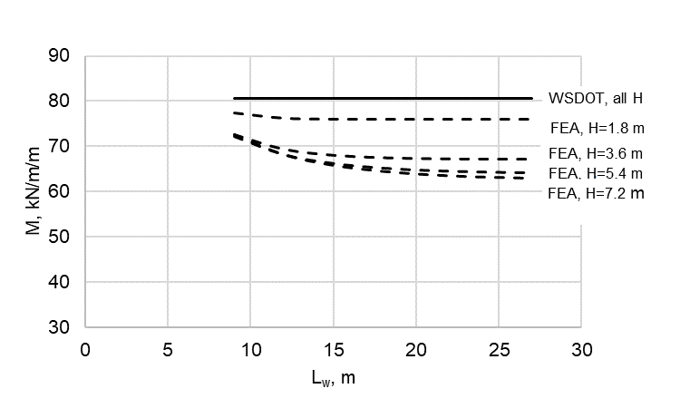

Figure 12: Moment intensity at barrier base by WSDoT and FEA methods, internal application of impact load

The moment magnitude determined by WSDoT method, calculated based on 45-degree dispersion angle for both barrier base and wall fixed end. As it observed, the percentage difference in moment magnitude at base of the barrier stood well below 22%. However, as it can be seen from Figure 13, this percentage change is much larger at retaining wall fixed end. The values obtained from FEA were greater by 49% to 129% from corresponding valued from WSDoT method for the retaining walls with the height of 1.8 m to 7.2 m respectively.

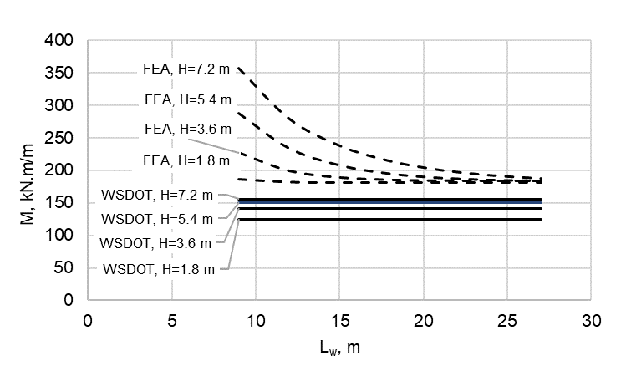

Figure 13: Moment intensity for internal application of impact load at retaining wall fixed end by WSDoT and FEA methods

# CONCLUSIONS

This paper presents the results from elastic finite element analysis (FEA) modelling of the TL-5 barrier wall and supporting concrete retaining wall system when subjected to transverse vehicle impact. The height of the retaining wall under the barrier wall was taken as 1.8 to 7.2 m with 1.8 m increments, while the length of the barrier and the supporting wall in the direction of traffic was taken as 9 to 27 m, with increments of 3 m. The length of the barrier and the retaining wall represents the spacing between vertical expansion joints. FEA results included the applied factored moment and shear force at the barrier-retaining wall junction as well as at the fixed base of the wall. The practice of considering the dispersion angle of a line loading to be transferred to concrete element at 45-degree angle was examined. It can be concluded from this study that calculated moment by the 45-degree dispersion angle approach at the base of barrier wall due to vehicular impact load is conservative. Nevertheless, the 45-degree dispersion angle approach for determining the bending moment at the retaining wall fixed end due to transverse vehicle impact loading at the barrier level gives a much smaller values in comparison with the values obtained from finite element analysis.

# References

AASHTO. 2017. AASHTO LRFD Bridge Design Specifications, 8th Edition. American Association of State Highway and Transportation Officials, Washington D.C., USA.

California retaining wall type 7b details no 1.(n.d.). <http://bookfreenow.com/download/california-retaining-

wall-type-7b-details-no-1/> (Jul. 15, 2018).

CSA. 2014. *Canadian Highway Bridge Design Code*. CAN/CSA-S6-14. Canadian Standard Association,

Toronto, Ontario, Canada.

ISIS. 2007. *Reinforcing Concrete Structures with Fibre Reinforced Polymers*. Design manual No. 3,

Intelligent sensing for innovative structures (ISIS) Canada Research Network, Winnipeg, MB, Canada.

Rostami, M., Sennah, K., and Afefy, H. 2017. Ultimate Capacity of Barrier-deck Anchorage in MTQ TL-5

Barrier Reinforced with Headed-end, High-modulus, Sand-coated GFRP Bars. *Canadian Journal of Civil Engineering*, **45**: 263–278.

Sennah, K., and Khederzadeh, H. 2014. “Development of Cost-effective PL-3 Concrete Bridge Barrier

Reinforced with Sand-coated Glass Fibre Reinforced Polymer (GFRP) Bars: Vehicle Crash Test.” *Canadian Journal of Civil Engineering*, **41**(4): 357–367.

WSDoT.2015. Standard Plan Reinforced Concrete Retaining Wall, *Washington State Department of*

*Transportation Bridge Structure Office*, pp. 1-7.