 | 10th International Conference on Short and Medium Span Bridges  Quebec City, Quebec, Canada,  July 31 – August 3, 2018 | 

TIRE-DERIVED AGGREGATE CONCRETE FOR BRIDGE APPLICATIONS
Jafarian Abyaneh, Mostafa^{1,4}, Sadeghian, Pedram² and El Naggar, Hany³
¹ Dalhousie University, Canada
² Dalhousie University, Canada
³ Dalhousie University, Canada
⁴ mjafarianabyaneh@dal.ca
Abstract: It is estimated that each person discards one car tire per year leading to many wasted car tires all over the world. Stockpiles of scrap tires can result in environmental, and aesthetic issues as well as public health problems. As a result, there is an increasing demand for applications of scrap tires in different types of constructions such as tire-derived aggregates (TDA). In this study, 12 concrete specimens with the dimensions of 150×300 mm were prepared. They include three plain concrete specimens as well as nine concrete specimens with 5%, 10%, and 15% of coarse aggregate replaced with TDA by volume. The specimens were tested under uniaxial compression up to failure. Effect of TDA percentage on mechanical properties of concrete was evaluated. It was observed that increasing the content of TDA from zero to 15% of coarse aggregates by volume decreased the compressive strength and elastic modulus of concrete 26 and 22%, respectively. This is a research in progress and more results on higher content of TDA will be provided at the time of the conference.

INTRODUCTION
Solid waste disposal is a major environmental issue to cities around the world. This environmental issue has become a real concern since 1990s resulting in more than 242 million scrap tires, approximately one tire per person, generated each year in the United States (Epps and Mason 1994, Khatib and Bayomy 1999). As a result, a significant disposal problem has been emerged by steady stream of scrap tires, and approximately three billion waste tires accumulated in stockpiles and uncontrolled tire dumps, and the millions of tires scattered in forests, grasslands, deserts, and empty lots (Thomas et al. 2015). These stockpiles are hazardous not only due to potential environmental threat but also because of fire hazard problem and they provide breeding grounds for rats, mice, and mosquitoes. Over the years, disposal of waste tires has become one of the serious problems for the environment because of rapid depletion of available sites for waste disposal, disposing of waste tires in landfills might not be feasible in the future (Zheng et al. 2008).
Ordinary cement-based concrete is a brittle material in general with high rigidity and relatively poor damping properties. It is desirable for concrete to have high toughness and good impact resistance in some applications such as traffic barriers and foundation pads. Although regular concrete is the most commonly used construction material, there is an increasing demand for a different type of aggregate that provides better toughness and impact properties. In order to fulfill these requirements, tire-derived aggregates (TDAs) can be added to the concrete mixture to increase the deformability and ductility of concrete (Topçu and Avcular 1997, Toutanji 1996, Siringi 2012, Shu and Huang 2014). Rubberized concrete can be utilized in various types of applications including: i) where vibration damping is required, such as railway stations and foundation pads for machinery; ii) where resistance to explosion or impact is required, such as railway buffers and road traffic barriers; and iii) where high strength requirement is not crucial, such as trench filling, pipe bedding, artificial reef construction, pile heads, and paving slabs (Zheng et al. 2008). Ismail and Hassan (2016) suggested utilisation of the recycled tire rubber modiﬁed bitumens (RTR-MBs) in road pavement industry as sustainable alternative to the binders currently used in road pavements.
In 2009, due to longitudinal joint raveling and minor rutting, preservation paving work was conducted using asphalt rubber binder on the eastbound lanes from mileposts 30.9 to 42.7 of interstate 78 (I-78) in Somerset County, New Jersey (Walker 2018). Furthermore, the rubber granules and powder are also to be found as concrete flooring for playgrounds, as athletic tracks, as shock absorbing mats for schools and stables, as paving blocks or tiles for patios and swimming pool surrounds as well as roofing materials (ETRMA 2018). A case study conducted by Dynemech (2018) on concrete foundation of Zeiss Coordinate Measuring Machines (CMM) as a vibrating machine showed that isolated foundation lowers the centre of gravity of the machine foundation system and adds to the stability of the machine.
Laboratory tests have indicated that adding waste tire rubbers to concrete mixture design increases impact resistance, toughness, and plastic deformation of concrete leading to a significant potential for the concrete to be used in retaining structures, sound/crash barriers and pavements. Although almost all the previous studies have observed a considerable decrease in concrete strength, there are several advantages of using TDA in concrete such as: lightweight, low lateral pressures on surrounding soil in foundations, good thermal insulator, high permeability, and vibration absorption (Siringi 2012).
Many studies have been conducted on replacing fine aggregates with small-size rubber aggregates derived from scrap tiers. Xue and Shinozuka (2013) studied the seismic and compressive behavior of rubberized concrete with different ratios of crumb rubber to evaluate the structural dynamic performance and compressive strength. Güneyisi (2010) investigated the effect of replacing fine aggregates with untreated crumb rubber as well as fly ash in the application of self-compacting concretes experimentally. Ling (2011) evaluated the influence of rubber content as the replacement for fine aggregates (FA) on the compressive strength of concrete blocks. Making small-size rubber aggregates consume significant amount of energy. Thus, this study aims at replacing coarse aggregates with large-size TDAs. It targets large-volume concrete components of bridges such as abutments and foundations where compressive strength of concrete is not as important as shallow components such as girders and decks. Use of TDA in strength sensitive components needs further studies.
Despite many researches regarding the application of TDAs for the replacement of fine aggregates (FA) in concrete, there is an increasing demand to investigate their effect on the mechanical properties of rubberized concrete comprehensively. In this research, 12 specimens were made by using various rubber ratios including 5%, 10% and 15% as a partial substitution for coarse aggregates (CA) and tested under uniaxial compression. The compressive strength and stress–strain curves of TDA concrete were studied and an optimum rubber content is proposed for future studies. Concrete made of coarse aggregates partially replaced with TDAs is referred as “TDA concrete” here after.

EXPERIMENTAL STUDY

Test Matrix
A total of 12 concrete cylinder (150 mm x 300 mm) with four different ratios of TDA were used including 0 (plain concrete), 5%, 10% and 15% by volume of coarse aggregates (CA). To ensure the accuracy of experiment, three specimens from each TDA ratio was made. The test matrix has been provided in Table 1. In order to name the specimens, an identification (ID) code like “TDA-X” was used where X indicates the volumetric percentage of CA replaced by TDA. For example, “TDA-10” means that the concrete specimen has 10 percent TDA with respect to the volume of CA. The amount of coarse aggregates (CA), fine aggregates (FA), water and cement used in the concrete mix design was 958, 559, 221 and 657 kg/m³, respectively.

Material Properties
The cement used in this research was general-use (also known as type-GU) cement, which is suitable for most of ordinary applications involved with concrete. The fine and coarse aggregates were acquired from batching plant in saturated surface-dry (SSD) condition. Shredded TDA were obtained from recycling facilities in Canada and washed by water to ensure that there is no dust or soil in the rubbers. After drying, the rubber chips were cut by the scissors to make them smaller as gravel (Figure 1). As a result, the gravel-type TDA were prepared with the size range of 12.7-25.4 mm.
This research is a pilot project to show the company that provided TDA the possibility of using TDA in concrete in the aforementioned range. The bulk density of coarse and fine aggregates as well as TDA were obtained based on ASTM C29 (2009) which provides standard test method for obtaining bulk density of aggregates. First, three samples from each aggregate including FA, CA, and TDA were poured into 100 mm × 200 mm plastic molds in three layers and each layer was compacted with 25 strokes of tamping rod evenly distributed over the corresponding surface. Consequently, the bulk density of CA, FA, and TDA was measured to be 1601 1744 and 516 kg/m³, respectively.

Table 1: Test matrix
Specimen ID | TDA content (%) | Number of specimens
TDA-0 | 0 | 3
TDA-5 | 5 | 3
TDA-10 | 10 | 3
TDA-15 | 15 | 3
Total | - | 12

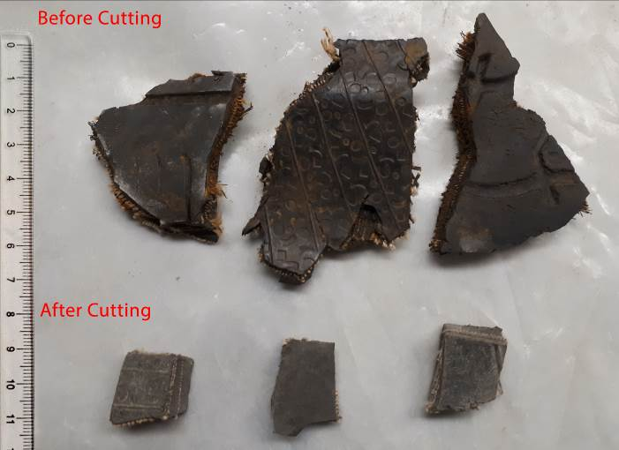
Figure 1: Illustration of TDAs before and after cutting (dimension in cm)

Sieve tests were conducted on various types of aggregates used in this research including FA, CA and TDA. First, the FA were poured into sieves within the range of 0.075 – 4.75 mm, whereas 0.6 – 16 mm sieve sizes were used for the CA and TDA. Second, the sieves vibrator was utilized to shake the materials for 6 minutes and allow them to cross the sieve. As a result, the gradation curves of FA, CA and TDA were derived based on the percentage of passing aggregates as shown in Figure 2. As can be seen the aggregates are in the range suggested by ASTM C33 (2013).

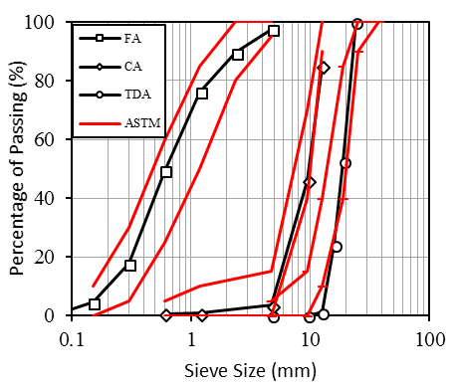
Figure 2: Gradation curves of fine aggregates (FA), coarse aggregates (CA), and tire-derived aggregates (TDA)

Specimen Preparation
For the preparation of fiber reinforced concrete, the following procedure was followed: (i) mixing the dried aggregates for about one minute; (ii) adding the cement to the mixture and continue mixing for another one minute as shown in Figure 3(a); and (iii) adding the water and superplasticizer to the mixture and allow them to get mixed for five minutes. Afterwards, the slump of specimens was measured based on ASTM C143 (2015) to ensure the workability of the mixture and finding the required amount of superplasticizer. The targeted slump of 100 mm was achieved for all the specimens by adding different amount of superplasticizer. After that, the fresh concrete was poured in the cylindrical plastic molds with diameter and height of 150 mm and 300 mm, respectively as depicted in Figure 3(b).
In order to ensure that there was no excessive air in the fresh mixture, the concrete was poured in three layers and each layer was vibrated for 15 seconds. Then, the specimens were held in the curing room for 21 days. Afterwards, the specimens were extracted from the molds and held in the room temperature for seven days to be tested in 28 days as shown in Figure 3 (c). To have a horizontal and flat loading surface, top and bottom of cylindrical specimens were covered by a capping compound represented in Figure 4 (d). The weight, density and reduction in density as well as their standard deviation (SD) are illustrated in Table 2.

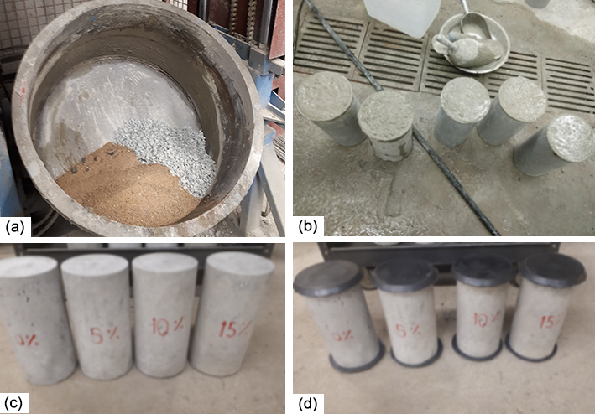
Figure 3: Preparation of concrete specimens: (a) mixing the concrete materials; (b) fresh concrete poured in the cylindrical molds; (c) concrete specimens after curing; (d) capped specimens

Test Setup and Instrumentation
In this study, the uniaxial compression test was conducted by using a 2 MN universal testing machine using a displacement control approach with a rate of 0.6 mm/min as shown in Figure 4. The loading was applied with a rate of 0.6 mm/min on the top and bottom steel plates, which transfer the pressure to the capping of specimens. In order to capture the axial and lateral displacements, four linear potentiometers (LPs) displacement gauges were used along with two steel rings on the concrete specimens. The displacements and corresponding loading were measured using a data acquisition system (DAS) reading the data from LPs at 0.1 sec. time steps. The total value of horizontal LPs was considered for lateral strain. The average of vertical LPs (i.e. LP #3 and #4), with a gauge length of 150 mm, were used to find the axial strain. Furthermore, two horizontal LPs (i.e. LP #1 and #2) were aligned with the center of concrete columns to measure the middle lateral displacement of specimens.

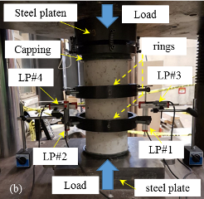

Figure 4: Test set-up: (a) Schematic test set-up and (b) test set-up

RESULTS AND DISCUSSION

Density
To determine the effect of using lightweight TDA as a partial replacement of CA on the overall weight, the density of concrete specimens with different TDA ratios was measured as shown in Table 2. The densities of TDA-5, TDA-10 and TDA-15 were decreased by 0.94, 1.97 and 3.33 %, respectively, with respect to the control specimens (TDA-0). Therefore, replacing CA with TDA in a concrete specimen would result in a light-weight specimen. Considering the large amount of concrete required in Civil Engineering projects, it might be more economical to use scrap tires and TDA.

Table 2: Density of concrete specimens containing TDAs
Specimen ID | Density
Specimen ID | Average (kg/m³) | Standard deviation (kg/m³) | Reduction (%)
TDA-0 | 2518.72 | 15.49 | 0.00
TDA-5 | 2495.04 | 13.70 | 0.94
TDA-10 | 2469.22 | 23.50 | 1.97
TDA-15 | 2434.94 | 14.60 | 3.33

Failure Modes
The failure mode of concrete specimens with different amount of TDA is illustrated in Figure 5. As can be seen in the figure the specimens failed at shear failure. However, the failure of specimens with TDA was less brittle and accompanied by more dilation meaning that it can provide a warning threshold for failure in their construction applications. Furthermore, the concrete specimens with TDA showed less cracks after failure as opposed to plain concrete that was split into two separate pieces.

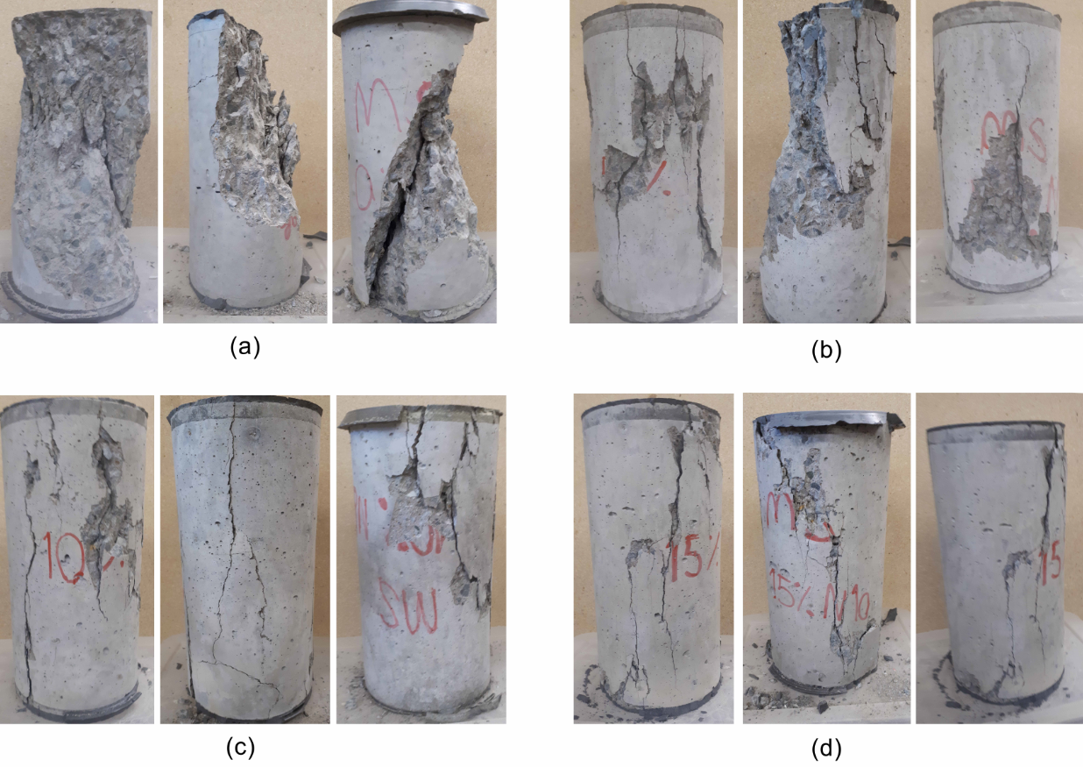
Figure 5: Concrete specimens after failure: (a) TDA-0; (b) TDA-5; (c) TDA-10; (d) TDA-15.

Compressive Strength
Figure 7 shows the strength of concrete specimens, which is important to understand the effect of TDA on the peak of stress-strain graph. As can be seen, the strength of concrete decreases with a larger rate by increasing TDA content from 5 to 15% of CA. Therefore, application of concrete with TDA content more than 5% should be limited to the cases in which the strength of concrete is not of a great importance. Overall, the average compressive strength of concrete specimens was decreased by adding more TDA. Despite this reduction in strength, the failure of specimens with more TDA content was less brittle in compression to plain concrete.

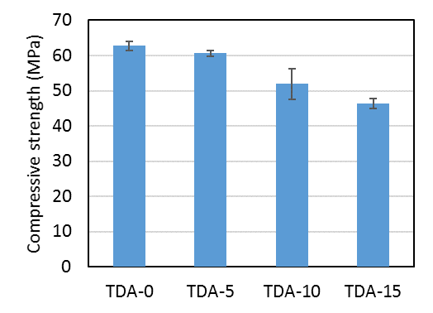
Figure 6: Compressive strength for concrete specimens with different amount of TDA

Elastic Modulus
The elastic modulus of concrete specimens was calculated by finding the initial slope corresponding to trend line of stress-strain curve up to 45 percent of compressive strength (f’c), and the results for different amount of TDA is shown in the Figure 6. As illustrated in the figure, adding 5% TDA to the TDA-5 specimens has a significant effect on decreasing the modulus of elasticity of specimens. As a result, the rate of TDA effect on concrete specimens was not consistent in the range of 0-15% of TDA. Overall, by adding more TDA, the average elastic modulus decreased.

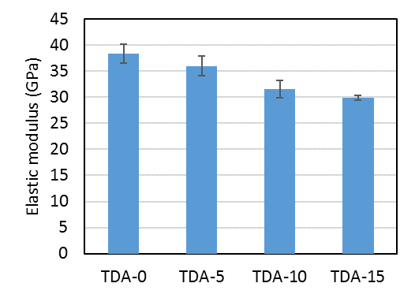
Figure 7: Elastic modulus for concrete specimens with different amount of TDA

Stress-Strain Behavior
The axial and lateral stress-strain curves of concrete specimens are depicted in Figure 8. By comparing the mechanical behavior of concrete specimens, it can be concluded that the post-peak behavior of concrete with CA being replaced partially by TDA has a more ductile behavior rather than brittle failure that is a characteristic of concrete specimens.

CONCLUSIONS
In this research, 12 concrete specimens with the dimensions of 150×300 mm were prepared, in which 0%, 5%, 10%, and 15% of coarse aggregate was replaced with TDA by volume. The specimens were tested under uniaxial compression until failure. Effect of adding TDA to the mixture on mechanical properties of concrete was evaluated. The weight of concrete specimens decreased by replacing CA with TDA in a concrete specimen; however, its strength decreases which requires to assure that use of TDA is limited to some applications in which the concrete strength can be ignored or justified by other structural elements. Moreover, it was observed that the failure of concrete specimens with TDA was less brittle than plain concrete providing a danger zone to prevent catastrophic failure. Moreover, the compressive strength and elastic modulus of concrete decreased at higher levels of TDA content such as 10 and 15% of CA. Concrete with CA being replaced partially by TDA had a more ductile post-peak behavior with respect to plain concrete. It was observed that increasing the content of TDA from zero to 15% of coarse aggregates by volume decreased the compressive strength and elastic modulus of concrete 26 and 22%, respectively. This is a research in progress and higher content of TDA will be considered for possible application in large volume of concrete in bridge abutments.

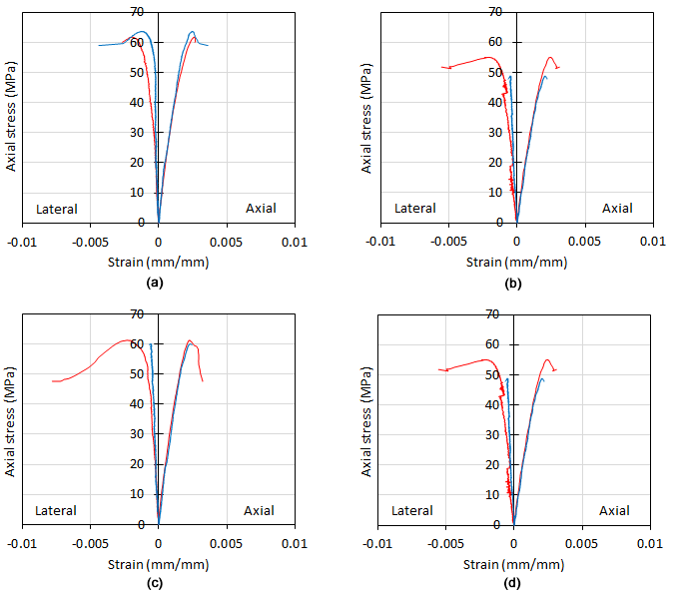
Figure 8: The stress-strain curve for concrete specimens: (a) TDA-0; (b) TDA-5; (c) TDA-10; (d) TDA-15

Acknowledgments
Authors would like to thank Blair Nickerson, Jesse Keane, and Koosha Khorramian for their assistance in the lab. The authors would also like to acknowledge and thank NSERC and Dalhousie University for their financial support.

References
ASTM C33 / C33M-13. 2013. Standard Specification for Concrete Aggregates. ASTM International, West Conshohocken, PA. https://doi.org/10.1520/C0033_C0033M-13.
Dynemech Systems. “Foundation Isolation.” Dynemech Vibration Technology. http://vibrationmountsindia.com/Foundation_Isolation.html (accessed May 17, 2018).
Epps, J A, and L S Mason. 1994. Uses of Recycled Rubber Tires in Highways: A Synthesis of Highway Practice. Final Report. National Cooperative Highway Research Program, Washington, DC (United States).
ETRMA. “Tire Recycling.” European Tire & Rubber Manufacturers’ Association. http://www.etrma.org/tyres/ELTs/material-recovery.
Güneyisi, Erhan. 2010. Fresh Properties of Self-Compacting Rubberized Concrete Incorporated with Fly Ash. Materials and Structures 43 (8). Springer: 1037–1048.
Ismail, Mohamed K, and Assem A A Hassan. 2016. Performance of Full-Scale Self-Consolidating Rubberized Concrete Beams in Flexure. ACI Materials Journal 113 (2). American Concrete Institute: 207.
Khatib, Zaher K, and Fouad M Bayomy. 1999. Rubberized Portland Cement Concrete. Journal of Materials in Civil Engineering 11 (3). American Society of Civil Engineers: 206–213.
Ling, Tung-Chai. 2011. Prediction of Density and Compressive Strength for Rubberized Concrete Blocks. Construction and Building Materials 25 (11). Elsevier: 4303–6.
Shu, Xiang, and Baoshan Huang. 2014. Recycling of Waste Tire Rubber in Asphalt and Portland Cement Concrete: An Overview. Construction and Building Materials 67. Elsevier: 217–224.
Siringi, Gideon Momanyi. 2012. Properties Of Concrete With Tire Derived Aggregate And Crumb Rubber As A Ligthweight Substitute For Mineral Aggregates In The Concrete Mix. Materials Science & Engineering.
Thomas, Blessen Skariah, Ramesh Chandra Gupta, Priyansha Mehra, and Sanjeev Kumar. 2015. Performance of High Strength Rubberized Concrete in Aggressive Environment. Construction and Building Materials 83. Elsevier: 320–326.
Topçu, ILKER BEKIR, and N Avcular. 1997. Collision Behaviours of Rubberized Concrete. Cement and Concrete Research 27 (12). Elsevier: 1893–1898.
Toutanji, Houssam A. 1996. The Use of Rubber Tire Particles in Concrete to Replace Mineral Aggregates. Cement and Concrete Composites 18 (2). Elsevier: 135–139.
Walker, Dwight. “Understanding how tires are used in asphalt.” Asphalt the Magazine of the Asphalt Institute. http://asphaltmagazine.com/understanding-how-tires-are-used-in-asphalt (accessed May 17, 2018).
Xue, James, and Masanobu Shinozuka. 2013. Rubberized Concrete: A Green Structural Material with Enhanced Energy-Dissipation Capability. Construction and Building Materials 42. Elsevier: 196–204.
Zheng, L, X Sharon Huo, and Y Yuan. 2008. Strength, Modulus of Elasticity, and Brittleness Index of Rubberized Concrete. Journal of Materials in Civil Engineering 20 (11). American Society of Civil Engineers: 692–699.

