 | 10th International Conference on Short and Medium Span Bridges  Quebec City, Quebec, Canada,  July 31 – August 3, 2018 | 

PROPOSED CYCLE COUNTING METHOD TO ESTIMATE FATIGUE DAMAGE IN INTEGRAL BRIDGE STEEL H-PILES
Dicleli, Murat¹, Karalar, Memduh²
¹ Middle East Technical University, Department of Engineering Sciences, TURKEY
² Bulent Ecevıt Universıty, Department of Cıvıl Engineering, TURKEY
¹ mdicleli@metu.edu.tr
Abstract: Several cycle counting methods exist in the literature for the study of fatigue damage generated in structures. Level Crossing, Peak, Simple range and Rainflow counting methods are those using the stress and deformation range to count the number of cycles. Close examination of the existing field measurement data for integral bridges revealed that the measured cyclic strains in steel H-piles consists of large amplitude, primary small amplitude and secondary small amplitude cycles. However, the above mentioned cycle counting methods do not take into consideration the primary and secondary small amplitude strain cycles. Because of the fact that these small strain cycles are part of the low-cycle fatigue effects on steel H piles, a new cycle counting method is developed. The developed cycle counting method is then used to estimate the number of large amplitude strain cycles per year due to seasonal temperature changes and the number and relative amplitude (relative to the amplitude of large amplitude strain cycles) of primary small amplitude strain cycles and secondary small amplitude strain cycles per year due to daily or weekly temperature changes. Then, using the available experimental data, an equation is developed to estimate the fatigue life of integral bridge steel H-piles as a function of the number and amplitude of large, primary small and secondary small amplitude strain cycles. It is observed that small amplitude thermal-induced strain cycles have only a negligible effect on the fatigue life of steel H-piles at the abutments of integral bridges. This is also verified experimentally.

1 INTRODUCTION
A change in temperature causes a material to change its length. This property of materials is accountable for expansion and contraction of the integral bridge superstructures. Each daily variation in temperature completes a cycle of expansion and contraction and the cycles repeat over time. The maximum expansion occurs during summer days while the maximum contraction forms during winter nights. The extreme lateral displacements of integral bridges are controlled by these extreme temperature changes. Therefore, low-cycle fatigue may occur in piles of long integral bridges due to lateral cyclic displacements induced by temperature variations. Several research studies have been conducted on thermal induced strains and low cycle fatigue effects in the steel H piles of integral bridges (Arsoy et al. 2004, Dicleli &Albahisi 2003, French et al. 2004, Hällmark 2006). However, none of these research studies provide simple yet effective method to determine the number and amplitude of cyclic thermal strains in integral bridge piles. In this research, the field measurements obtained for integral bridges are used to determine the amplitude and the number of temperature induced cycles on steel H-piles in integral bridges. Using the obtained measurements, the amplitude of large strain cycles and the number and relative amplitude, β (β=small strain cycle amplitude/large strain cycles amplitude due to seasonal temperature changes) of small strain cycles per year due to daily or weekly temperature changes are determined. Additionally, the number of secondary small cycles between the maximum and minimum cycle above and/or under the large strain cycles is counted. Using the available data on the number and amplitude of temperature induced displacement or strain cycles, a new cycle counting method is developed to determine the number and amplitude of primary and secondary small displacement/strain cycles. Then, an equation is obtained to determine a displacement/strain cycle amplitude representative of the number of small amplitude cycles existing in a typical temperature induced displacement/strain history in steel H-piles of integral bridges. Further, experimental tests of HP220x57 pile specimen are conducted to investigate the effect of small amplitude strain cycles combined with large amplitude strain cycles on the low cycle fatigue performance of the steel H-piles. Then, the results of the experimental studies on full size steel H-pile specimens are verified with the analytical results.

2 THERMAL EFFECTS ON INTEGRAL BRIDGE PILES
The thermal-induced longitudinal movement of the integral bridge deck results in one dominant cyclic lateral displacement of steel H-piles at the abutments each year due to seasonal temperature changes and numerous smaller cyclic lateral displacements due to daily and/or weakly temperature fluctuations. This is confirmed by the research studies of England & Tsang 2001, French et al (2004), Abendroth et al (2005) and Breña et al (2007) and by the strain vs. time records of instrumented steel H-piles for integral bridges. Field studies performed by Girton et al (1991), on the Boone bridge and the Maple bridge in Iowa, USA showed that both bridges exhibited one large strain cycle per year due to seasonal temperature changes and about 52 small strain cycles per year due to weekly temperature fluctuations. Another field test performed by French et al (2004) on a reinforced-concrete integral bridge in Minnesota, USA demonstrated one large strain cycle per year due to seasonal temperature changes and about 120 small strain cycles per year due to daily/weekly temperature fluctuations. According to another research study performed by Abendroth et al (2007), Tama county bridge in Iowa, USA, exhibited one large strain cycle per year due to seasonal temperature changes and about 81 small strain cycles per year due to daily/weekly temperature fluctuations. Moreover, the field test records demonstrate that the strain amplitude of the small cycles in the piles supporting the abutments fall within 20% to 40% range of the strain amplitude from the large cycles. Similar findings were reported by Lawyer et al (2000) and Dicleli et al (2003). The net difference between the seasonal and construction temperatures may be disparate in the summer and winter times based on the climatic conditions of the area where the bridge is located. Therefore, the amplitudes of the positive (ε_{ap}) and negative (ε_{an}) strain cycles corresponding to the summer and winter time may not be equal as observed from Fig.1-a. However, as the range of strain amplitudes rather than the strain amplitude itself defines the extent of fatigue damage in steel H-piles, the positive and negative strain amplitudes are assumed to be equal (Dicleli et al. 2003).
In this research, it is observed that the small cycles can be divided into two types as primary and secondary. The primary cycle is defined as a cycle that crosses the backbone of the large amplitude cycle and the secondary cycle is a smaller amplitude cycle that does not cross the backbone of the large amplitude cycle as observed from Fig.1-b. In the earlier research studies conducted by Dicleli & Albahisi 2003 and French et al (2004) to study the low cycle fatigue effects on steel H piles due to temperature induced strain cycles, the numbers of primary small and large amplitude strain cycles throughout the service life of the bridge were taken into account. However, the secondary small strain cycles above and/or under the backbone of the large amplitude cycle were not considered in these earlier research studies. From Fig.2 (a) and (b), it can be noticed that the secondary small strain cycles cause the steel H-pile to behave in a mixture of plastic and elastic cyclic behaviour. For this reason, the secondary small amplitude strain cycles are conservatively assumed to result in low cycle fatigue. Consequently, the secondary small amplitude cycles should also be considered in studying the low cycle fatigue effects in steel H-piles. Because of the fact that secondary small strain cycles may contribute to low-cycle fatigue effects in steel H piles and the effect of secondary small strain cycles was not regarded in the earlier researches, a new cycle counting method is developed.
- (b)
Figure 1. (a) General experimental versus time for bridges, (b) primary and secondary strain cycles
Strain
Time (months)
JAN
JUL
JAN

0
Large
Strain Cycle
A
B
C
D

(a) (b)
Figure.2. (a) Loading and unloading due to secondary small cyclic strain versus time, (b) Stress and strain relationship corresponding to the same loading versus time points

3 DEVELOPED CYCLE COUNTING METHOD FOR THERMAL EFFECTS IN INTEGRAL BRIDGES
Cycle counting methods have been developed for the study of fatigue damage generated in structures. Level Crossing counting (ASTM 2005), Peak counting (ASTM 2005), Simple range counting (ASTM 2005) and Rainflow counting (ASTM 2005) methods are those using the stress and deformation range to count the number of cycles. Although various methods may still be in use, Rainflow counting is the most favorable one among all. However, the primary and secondary small strain cycles mentioned earlier are not counted in these methods. Because of the fact that these small strain cycles are part of the low-cycle fatigue effects on steel H piles and these methods are not considering the effect of these small strain cycles, a new cycle counting method is developed. Stages of the new cycle counting method can be explained as follows; First, the cyclic displacements/strain data obtained from field measurements are used in a nonlinear minimum least square curve fitting technique to formulate a sixth degree polynomial curve representing the large amplitude cycles, due to seasonal temperature variations. The main reason for using a sixth degree polynomial function is to simulate the shape of the large amplitude cycle as accurately as possible. The solid line plotted in Fig.3 shows the large amplitude cycle obtained through such a process. The amplitude of the large displacement/strain cycle is determined as the average of the absolute maximum and minimum amplitudes obtained from the sixth degree polynomial function. The number of large amplitude cycles per year is equal to one.
To determine the amplitude and the number of primary small amplitude cycles, first, the corresponding amplitude of the large cycle (polynomial curve) is subtracted from each recorded data point to obtain the relative amplitude of the small amplitude cycles with respect to the large amplitude cycle. The maximum positive and absolute negative relative amplitudes before the relative amplitude changes sign, determines the positive and negative amplitudes of a specific primary small cycle as observed from Fig. 3 and Table 1. In the figure the points designated by ‘*’ indicates the amplitudes of the primary cycles. The rest of the points (other than those indicated by‘*’) are taken as the secondary small amplitude cycles. The average of the absolute values of the positive and negative relative amplitudes obtained through the process described above determines the amplitude of a constant amplitude primary small cycle that can be used for studying the performance of steel H piles under cyclic thermal effects. The number (n_{s1}) of these primary small cycles is calculated as the number of positive and negative amplitudes determined through the process described above divided by two. The amplitude of these primary small amplitude cycles relative to that of the large amplitude cycles is defined as;

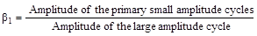
[1]
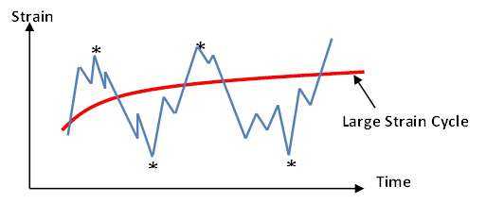

Figure 3. The maximum positive and negative amplitudes of primary small cycles
To determine the amplitude and the number of secondary small amplitude cycles, first, the set of data points above or below the polynomial curve are used in a linear minimum least square curve fitting technique to formulate a linear function representing the mean of the secondary small amplitude cycles as shown in Fig.4. Next, the linear function obtained in the previous step is subtracted from each recorded data point to obtain the relative amplitude of the secondary small amplitude cycles with respect to the linear function representing the mean values. The maximum positive and absolute negative relative amplitudes before the relative amplitude changes sign with respect to the linear mean function, determines the positive and negative amplitudes of a specific secondary small cycle as observed from Table 2. In the table the points designated by ‘+’ indicate the amplitudes of the secondary small cycles. The average of the absolute values of the positive and negative relative amplitudes obtained through the process described above determines the amplitude of a constant amplitude secondary small cycle that can be used for studying the performance of steel H piles under cyclic thermal effects.
The number (n_{s2}) of these secondary small cycles is calculated as the number of positive and negative amplitudes determined through the process described above divided by two. The amplitude of these secondary small amplitude cycles relative to that of the large amplitude cycles is defined as;

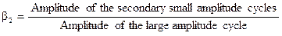
[2]

Table 1. Determination of the maximum positive and negative amplitudes of primary small amplitude cycles from Mn/DOT Bridge #55555
Time (month) | Strain  (µԑ) | Six Degree Polynomial | Difference
2,001 | 426,738 | 395,357 | 31,3814
2,029 | 397,83 | 393,439 | 4,3910
2,043 | 402,396 | 392,498 | 9,8982
2,084 | 410,016 | 389,703 | 20,3133
2,097 | 457,188 | 388,825 | 68,3628^{(*)}
2,125 | 391,758 | 386,902 | 4,8559
2,139 | 381,108 | 385,964 | -4,8564^{(*)}
2,165 | 516,546 | 384,282 | 132,2639
2,164 | 528,72 | 384,295 | 144,4246
2,178 | 542,418 | 383,391 | 159,0274
2,205 | 553,074 | 381,574 | 171,5003
2,232 | 612,42 | 379,818 | 232,6022
2,259 | 656,58 | 378,056 | 278,5238^{(*)}
2,274 | 585,042 | 377,073 | 207,9686
2,343 | 569,838 | 372,582 | 197,2563
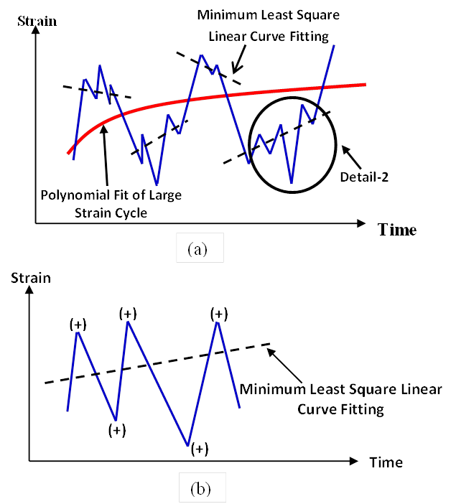

Figure 4. (a) The positive and negative small strain amplitudes obtained from minimum least square curve fitting, (b) Detail-2

Table 2. Determination of positive and negative amplitudes of secondary small amplitude
Time (month) | Strain  (µԑ) | Six Degree Polynomial | Difference
0,046 | 395,988 | 611,496 | 215,508
0,072 | 467,514 | 606,273 | 138,759
0,086 | 482,730 | 603,638 | 120,908
0,127 | 472,086 | 595,734 | 123,648
0,127 | 469,044 | 595,724 | 126,680
0,141 | 461,436 | 593,136 | 131,700
0,155 | 420,354 | 590,477 | 170,123
0,170 | 396,006 | 587,898 | 191,892
0,197 | 415,794 | 583,027 | 167,233

3.1 Application of the Developed Cycle Counting Method
In this section using the β₁ and β₂ values obtained from field measurements of integral bridges available in the literature and the cycle counting method developed above, the effect of primary small amplitude cycles and secondary small amplitude cycles on the fatigue performance of steel H piles is studied. For this purpose the fatigue damage equation developed by Dicleli & Albahisi 2003 is used;

[3]

Where, ε_{a} is total strain amplitude producing low cycle fatigue failure, n_{S} and n_{L} are the number of small and large amplitude strain cycles due to temperature variations through the service life of integral bridge. Additionally, M is equal to 0.0795 and m is equal to -0.448. β is the ratio of the small strain cycles to large strain cycles. β can also be calculated as:

[4]
The β value calculated above can be used in Equation (3). Based on the procedure developed by Dicleli & Albahisi 2003, a new equation is also developed to estimate maximum large amplitude strain a pile can sustain as a function of n_{S1}, n_{S2}, β₁ and β₂. The equation is presented below,

[5]

The above equation is used for the numerical investigation of the effect of primary and secondary small amplitude thermal induced flexural strain cycles on the low cycle fatigue life of steel H-piles at the abutments of integral bridges.
3.2 Numerical Investigation of the Relative Effect of the Small and Large Amplitude Strain Cycles using the Newly Developed Equations and Cycle Counting Method
In this section, the effect of primary and secondary small amplitude flexural strain cycles on the low cycle fatigue performance of steel H-piles at the abutments of various integral bridges available in the literature is investigated. For this purpose, first the number and amplitude of large as well as primary and secondary small amplitude flexural strain cycles in the steel H-piles of various integral bridges are obtained by using the field measurement data recorded by Girton et al.1991, French et al. 2004, Abendroth et al. 2007, and the cycle counting method developed as part of this research study. The amplitude, ԑ_{aL} of the large amplitude pile strain cycles as well as the numbers (n_{s1} and n_{s2}) and the amplitudes of the primary and secondary small amplitude pile strain cycles relative to that of the large amplitude pile strain cycles (β₁ and β₂) are tabulated in Table 3. Then the data given in Table 3 are substituted in Eq.(5) to calculate the number of large amplitude pile strain cycles, n_{L}, required for the low cycle fatigue failure of the piles by (i) considering only the effect of large amplitude strain cycle (the effect of primary and secondary small amplitude strain cycles are not considered).(ii) considering the effect of only the primary small amplitude strain cycle together with that of the large amplitude strain cycle, (iii) considering the effect both primary and secondary small amplitude strain cycles together with that of the large amplitude strain cycle. It is observed from the table that the effect of primary and secondary small amplitude flexural strain cycles on the low cycle fatigue life of steel H piles is negligible. On the average, the primary small amplitude strain cycles is observed to reduce the estimated fatigue life of steel H piles by 1.1% whereas the primary and secondary small amplitude strain cycles together are observed to reduce the estimated fatigue life of steel H piles by 1.4 %. This is also verified experimentally in the next section.
Table 3. The values of ԑ_{aL}, β₁, β₂, n_{s1}, n_{s2} for different integral bridges.
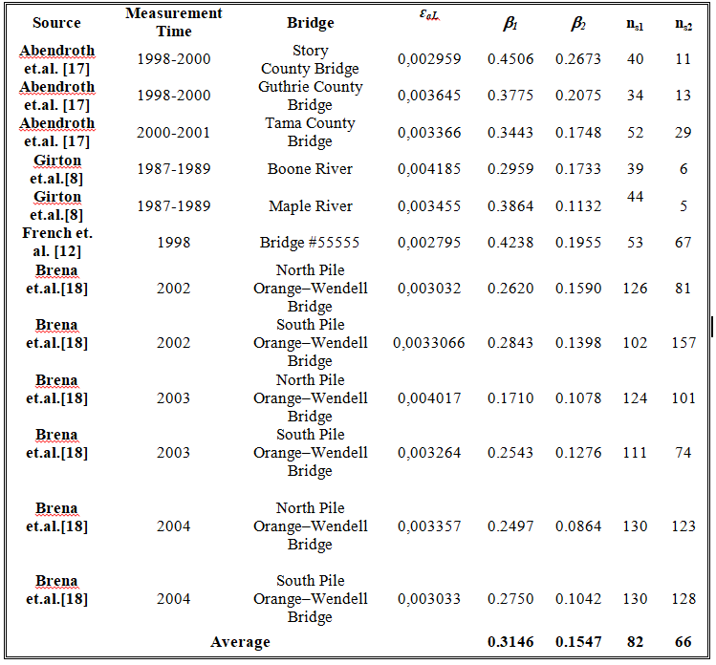

4 EXPERIMENTAL VERIFICATION OF THE EFFECT OF SMALL AMPLITUDE CYCLES ON THE LOW CYCLE FATIGUE LIFE OF STEEL H-PILES
4.1 Proposed test set up
A cantilever steel H-pile is tested to simulate cyclic behaviour of steel H-piles (HP220x57) under thermal effects in integral bridges. Thus, the equivalent system has upside down geometry of the pile/pile cap system under an integral bridge as shown in Figure 5. The cantilever length chosen approximately corresponds to the length of the pile effective in resisting the movement. For this purpose, a total of 128 static pushover analyses of the bridges are conducted to determine the length of the steel H-piles’ that is used in the experimental part of this research. Based on the pushover analyses results, the average equivalent pile length that is used in the experimental part of this research is determined as 1.35 m. However HP220x57 piles are cut in 1.90 m length where the 0.4 m part is encased in a steel base fixture to provide fixity and the load is applied at approximately 0.15 m from the top of the pile (the centreline of the load is at 0.15 m from the pile top).
4.2 Instrumentation
Three types of measuring devices are used to instrument the steel H-piles. These are, (1) electrical resistant strain gauges for measuring strains on the steel H–piles. (2) Load cell for measuring the lateral load level, (3) LVDT (displacement transducer) for measuring the lateral displacement. Test setup configuration is shown in Figure 6 with HP steel section vertically erected and instrumented with twelve strain gauge and three displacement transducer (LVDT). Strain measurements are required to correlate fatigue life of HP steel section with the intensity of strains. Therefore, strain measurement is performed at the critical section where fatigue failure occurs. Displacements, strains and load levels are measured using Data-logger (TDG Ai8b) during the loading on specimens. Furthermore, in the test set up, a computer controlled hydraulic actuator capable of applying ±500 KN of load and a stroke of ± 125 mm is used to impose lateral cyclic load.
4.3 Experimental Test
In this study, two sets (each set consists of three piles) of steel HP220x57 pile specimens (Specimen #1 and Specimen #2) are tested to investigate the effect of primary small amplitude strain cycles on the low cycle fatigue life of steel H piles at the abutments of integral bridges. Specimen #1 is tested to simulate cyclic behavior of steel H-piles under thermal effects in integral bridges by considering only the effect of large amplitude strain cycles. In the case of Specimen #2, the effect of the primary small amplitude cycles is also included in the experimental simulation.
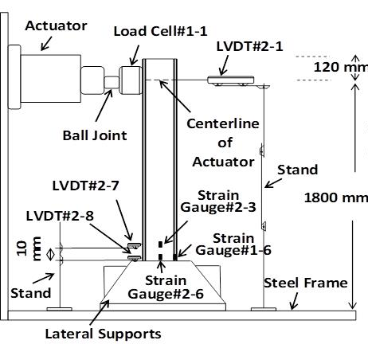

Figure 5. (a)Location of the strain gauge and LVDT and strain gauge arrangement

For this purpose, constant amplitude reversed cyclic displacements are applied to the top of the cantilever HP220x57 piles using a servo-controlled hydraulic actuator operated in displacement control where a sinusoidal cyclic displacement waveform signal with a frequency of 0.5 Hz is employed for displacement control at room temperature. The experimental parameters in this research study do not include the pile orientation related to the horizontal loading direction and vertical loading. Thus, no axial load is applied on the pile specimen due to the limitations of the test setup and lateral load is applied only in the strong axis direction. Detailed discussion of the experimental tests and test results are given in the following subsections.
4.3.1 Low cycle fatigue test results of specimen #1
The low cycle fatigue tests of Specimen #1 are conducted by applying only large amplitude strain cycles to the specimens. The amount of cyclic displacement at the top of the piles is controlled such that a flexural strain equal to five times the yield strain, the flexural strain of ε_{a}=5ε_{y} used in the tests is associated with jointless bridge lengths of 220-480 m, is developed in the outermost fibers of the flanges. This required the application of a cyclic lateral displacement of ±64 mm at the pile top. Fig.6 shows a typical HP220x57 pile specimen under cyclic lateral displacement. During the experimental testing of the piles under constant amplitude cyclic displacements/strains, the fatigue-induced cracks firstly developed in the intersection of the flanges and the web. The cracks then expanded towards the tips of the flanges under further cycling. Finally the specimens fractured due to low cycle fatigue when the number of cycles reached 200 (the average number of cycles to failure of three specimens; 204, 197, 200). The front and side views of the fracture pattern in one of the pile specimens are shown in Fig. 7. The fracture occurred right above the 400 mm-high steel base fixture.

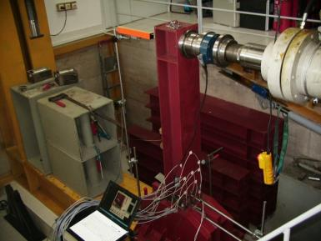
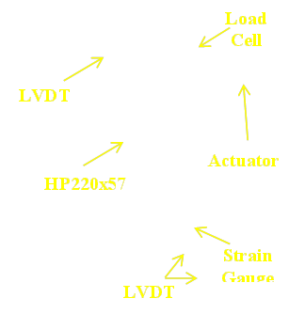

Figure 6. Specimen #1 under cyclic lateral load normal to its strong axis
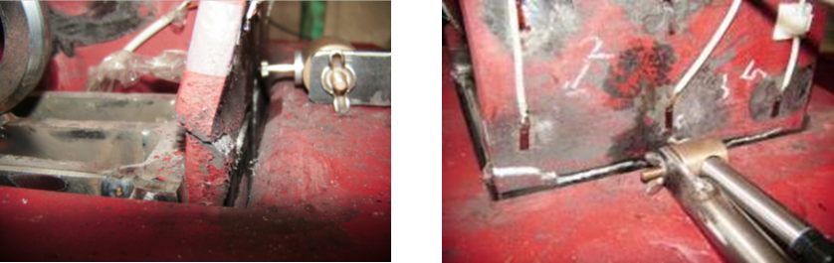

Figure 7. Front and side views of fatigue induced steel pile fracture right above the steel base fixture

4.3.2 Low cycle fatigue test results of specimen #2
In this phase of the research study, in addition to large amplitude strain cycles, primary small amplitude strain cycles are also applied to the pile specimens made of a HP220x57 section (identical to that of Specimen #1) to explore the effect of primary small amplitude strain cycles on the low cycle fatigue life of steel H piles at the abutments of integral bridges. To achieve the same large amplitude flexural strain level as in the case of Specimen #1 (five times the yield strain (ε_{a}=5ε_{y})), the piles are subjected to a displacement of 64 mm at the top. In the tests, as in the case of the Tama County Bridge (Dicleli and Albhaisi 2004 and Abendroth and Greimann 2007), the number of primary small amplitude strain cycles is assumed to be approximately 51 per large amplitude strain cycle (per year) and the ratio of the primary small and large strain amplitudes is taken as 0.3 (the cyclic small amplitude displacements applied at the pile top are taken as 64 x 0.3 ≈ 19 mm). For this purpose, the large amplitude cyclic lateral displacement is divided into 17 points as shown in Fig.9. At each large amplitude displacement point, three cycles of primary small amplitude strains are applied so that the total number of primary small amplitude cycles becomes 17 x 3 = 51 cycles per large amplitude cycle. Similar to the tests results of Specimen 1, during the experimental testing of the pile, the fatigue-induced cracks firstly developed in the intersection of the flanges and the web. The cracks then expanded towards the tips of the flanges under further cycling. Finally the specimens fractured due to low cycle fatigue when the average number of large amplitude cycles reached 193 (the average number of cycles to failure of three specimens; 194, 195, 190). The step-by-step spread of fatigue induced cracks are displayed in Fig.8.Comparing the test results of Specimen #1 with that of Specimen #2, it is observed that the number of large amplitude strain cycles to failure reduced from 200 to 193 when the effect of primary small amplitude strains are included in the tests. The low cycle fatigue life of the tested steel H-pile dropped about 3.5%. This is in reasonably good agreement with the numerical simulation of the effect of primary small amplitude strain cycles where on the average the reduction in low cycle fatigue life of the piles was calculated to range between 1.1 % and 1.4 %. Thus, it may be concluded that the effect of small amplitude strain cycles on the low cycle fatigue life of steel H piles is generally negligible.

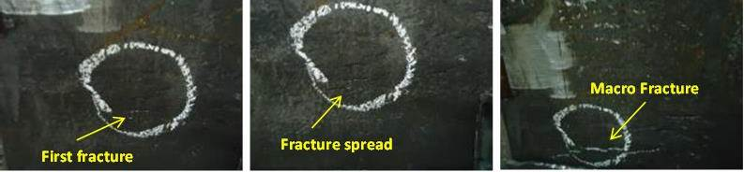
Figure 8. Step-by-step spread of fracture throughout the pile

Conclusions
In this study, a new cycle counting method is developed to determine the number and amplitude of large as well as primary and secondary small amplitude strain cycles in the steel H piles at the abutments of integral bridges. The newly developed cycle counting method is then employed to determine the amplitude of large amplitude strain cycles and the number and relative amplitudes of primary (β₁) and secondary (β₂) small amplitude strain cycles with respect to that of the large amplitude strain cycles. The calculated number of large as well as primary and secondary small amplitude strain cycles and their amplitudes are employed to study the low cycle fatigue performance of steel H piles in several existing integral bridges with field test results. On the average, the reduction in fatigue life due to the effect of primary and secondary small amplitude strain cycles is observed to range between 1.1 % and 1.4 %. This indicates that the effect of primary and secondary small amplitude strain cycles on the low cycle fatigue life of steel H piles at the abutments of integral bridges is negligible. The observations from this numerical study are also verified experimentally. The first and second sets of specimens failed on the average at 200 and 193 large amplitude strain cycles respectively. This verifies the results of the numerical study and confirms that the effect of small amplitude strain cycles on the low cycle fatigue life of steel H piles at the abutments of integral bridges is negligible. The large amplitude strain cycles due to seasonal temperature fluctuations are far more important for the low cycle fatigue life estimation of steel H piles at the abutments of integral bridges. Thus, in the estimation of the low cycle fatigue life of steel H-piles at the abutments of integral bridges, the effects of the small amplitude strain cycles may be ignored.

References
Arsoy, S., Duncan, J.M. and Barker, R.M. 2004. Behavior of a semi-integral bridge abutment under static and temperature-induced cyclic loading, Journal of Bridge Engineering, 9(2).
Abendroth, R.E., Greimann, L.F. 2005. Field Testing of Integral Abutments, Iowa DOT Project HR-399, Iowa Department of Transportation, Iowa.
ASTM E 1049-85. 2005. Standard practices for cycle counting in fatigue analysis. ASTM International.
Dicleli, M. and Albhaisi, S.M. 2003. Effect of cyclic thermal loading on the perfor-mance of steel H-piles in integral bridges with stub-abutments. Journal of Constructional Steel Research; 60(2):161-182.
England, G.L. and Tsang, N.C.M. 2001. Towards the design of soil loading for integral bridges experimental evaluation. Department of Civil and Environmental Engineering, Imperial College,London.
French, C., Huang, J. and Shield, C. 2004. Behavior of concrete integral abutment bridges. Final Report
Girton, D.D., Hawkinson, T.R. and Greinmann, L.F. 1991. Validation of design recommendations for integral-abutment piles. Journal of Structural Engineering, 117(7).
Hӓllmark, R. 2006. Low Cycle Fatigue of Steel Piles in Integral Abutment Bridges. Master Thesis, Lulea University of Technology.

