 | 10th International Conference on Short and Medium Span Bridges  Quebec City, Quebec, Canada,  July 31 – August 3, 2018 | 

Evaluation of the Elastic-Plastic Buckling of Variable Inertia Steel Compression Members
Mailhot, Guy^{1,2}
¹ Infrastructure Canada/The Jacques Cartier and Champlain Bridges Inc., Canada
² guy.mailhot@canada.ca
Abstract: This paper reviews the underlying principles of the CHBDC S6-14 design code equation governing the ultimate strength of a steel compression member. It presents a detailed general numerical method of analysis which accurately accounts for initial imperfections, residual stresses and the elastic-plastic response of a compression member and which is able to accurately reproduce the results of the code equation for conventional steel columns having constant inertia. The general method of analysis is later applied to a series of columns having variable inertia along their length. Based on the results of the general method, design guidelines are proposed to evaluate the elastic buckling, effective lengths as well as the elastic-plastic buckling of variable inertia columns including step-columns, centrally stiffened and tapered columns. The effects of variation in inertia, initial imperfections and residual stresses on such columns in both the elastic and elastic-plastic domain are also discussed.
- Introduction
Whereas scientific literature and engineering analytical techniques exist for the elastic buckling of compression members with variable inertia, limited information and/or design guidelines are available to assist the practising engineer in the evaluation of the ultimate strength of such a member. Furthermore, although the current equation in the Canadian Highway Bridge Design Code, CAN/CSA S6-14 (CSA 2014) is quite accurate and easy to use in the case of a standard column, it is not apparent how the equation can be applied to more unusual columns such as those with variable inertia. The problem is further compounded by the fact that the rationale and underlying principles which govern the design code equation may not be fully understood by the practicing engineer, making its adaptation to more complex problems using first principles difficult if not impossible.

In this context, this paper first exposes the basic principles governing the calculation of the ultimate strength of a steel compression member which has constant inertia (herein identified as Case I), and secondly, proposes a general method of computation for the evaluation of the elastic buckling load and the ultimate elastic-plastic compressive strength of a member with variable inertia which incorporates these basic principles. The general method of analysis is applied to the evaluation of a series of variable inertia columns including a step-column with an abrupt change in inertia (Case II), a centrally stiffened column with a central portion of greater inertia (Case III) and lastly, a tapered column (Case IV) with gradually increasing inertia from one end of the column to the other.
- ELASTIC iNSTABILITY UNDER COMPRESSION FOR STANDARD COLUMN
For a perfect member, devoid of geometrical imperfections and residual stresses, the critical load at which instability will occur in the elastic domain is given by the well-known Euler buckling load (Eqn. 1 below) where E is the elastic modulus, I is the moment of inertia and L is the column’s unsupported length
[1] $P_{\text{cr}}=\frac{π^{2}\text{EI}}{L^{2}}$
To facilitate the understanding of buckling phenomena, Shanley (Shanley 1946) devised a particularly simple model consisting of a column comprising at its mid-length a spring of rigidity k₁ linked to its supports by infinitely rigid extensions
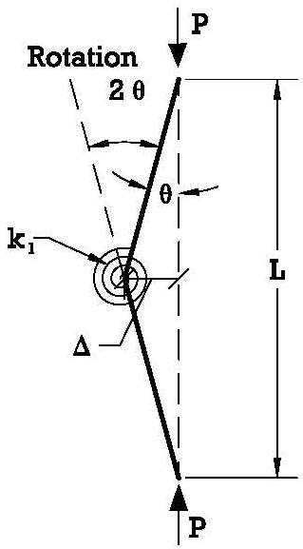
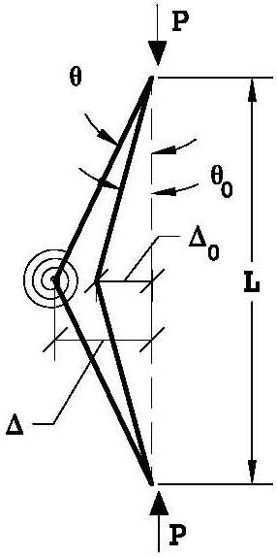
L/10,000
L/500
Rotation
P
P

k₁
L
L

P
P
Figure 2: Plot of total deviation as function of initial deviation
Figure 1: a) Simplified spring model (left) b) With initial deviation (right)
Referring to Figure 1a, the practicing engineer can easily derive the governing equations of equilibrium relating the axial load P and the deviation Δ to the spring rigidity k₁ and the rotation of the extensions through an angle θ as follows:

$PΔ=k_{1}2θ$where $θ=Δ/0\text{.}5L$ such that $PΔ=k_{1}2Δ/0\text{.}5L=4k_{1}Δ/L$ or if Δ ≠ 0, the critical load:

[2] $P=P_{\text{cr}}=4{k_{1}}/L$

Using this same model, but considering an initial deviation Δ_{O} as shown in Figure 1b, it is also possible to demonstrate that
$PΔ=M_{\text{spring}}=2k_{1}(θ−θ_{o})=2k_{1}(\frac{2Δ}{L}−\frac{2Δ_{o}}{L})−$such that $PΔ=\frac{4k_{1}}{L}(Δ−Δ_{o})=P_{\text{cr}}(Δ−Δ_{o})$ and thus:
[3] $Δ=\frac{Δ_{o}P_{\text{cr}}}{(P_{\text{cr}}\text{ -P})}=\frac{Δ_{o}}{(1{\text{-P/P}}_{\text{cr}})−}$

Equation 3 highlights the fact that in the system described above, the critical buckling load (in the elastic domain) is independent of the initial deviation ∆_{o.} This can be more easily visualised in Figure 2, which plots the load vs total lateral deviation of a spring model for various values of initial deviation ∆_{o} corresponding to L/10,000, L/2,000, L/1,000 and L/500 where the spring constant is selected to produce the same critical load as that for the W310 x 107 column described below when the unsupported lengths L are the same.
- ELASTIC iNSTABILITY UNDER COMPRESSION FOR VARIABLE INERTIA COLUMNs
Solutions for elastic instability of two types of variable inertia columns are treated below namely a step- column shown in Fig. 3 below and a centrally stiffened column (refer to Fig. 4).
$$y_{2}=A_{2}\text{sin}\left(\frac{{πx}_{2}}{k_{2}l_{2}}\right)$$
$$y_{1}=A_{1}\text{sin}\left(\frac{{πx}_{1}}{k_{1}l_{1}}\right)$$
$$l_{1}$$
$$l_{2}$$
I₁
I₂
_{A}
_{PA}
y₁
x₁
x₂
y₂₂
Figure 3: Buckled shape for a step-column
$$k_{2}l_{2}$$
$$k_{1}l_{1}$$
_{PA}
  - Step-Column (Case II)
b_{f}
0.75b_{f}
1.25b_{f}
0.75b_{f}
1.25b_{f}
0.75b_{f}
0.5b_{f}
1.5b_{f}
0.5L
0.5L
CASE I
CASE II
CASE III
CASE IV
P
P
P
P
Figure 3 above shows a step-column where the right-hand or lower portion of the column has a length l₂ and an inertia I₂ and the left-hand or upper portion has a length l₁ and an inertia I_{1.} The buckled shape of the left-hand section 1 takes the form a sine wave having a half wave length of k₁l₁ (segment shown in Fig. 3) whereas the right-hand section 2 takes the form of a sine wave having a half wave length of k₂l₂ (also shown in Fig. 3). Accordingly, the deflected shapes of each curve are defined as follows:

$y_{1}=A_{1}\text{sin}\left(\frac{{πx}_{1}}{k_{1}l_{1}}\right)$and$y_{2}=A_{2}\text{sin}\left(\frac{{πx}_{2}}{k_{2}l_{2}}\right)$. Furthermore, because point A is common to both curves along the true deviated shape of the column (between the two origins where the loads are applied), the deflection and the slope of the two curves must be equal at this point such that:
P
P
P
P
Figure 4: Standard column (Case 1) and three
types of variable inertia columns (Case 2, 3 & 4)
at$x_{1}=l_{1}$;$θ_{1}=\frac{{\text{dy}}_{1}}{{\text{dx}}_{1}}=A_{1}\text{cos}\left(\frac{{πx}_{1}}{k_{1}l_{1}}\right)\frac{π}{k_{1}l_{1}}$ and similarly at$x_{2}=lalignl{\begin{aligned}2\end{aligned}}_{}$;$θ_{2}=\frac{{\text{dy}}_{2}}{{\text{dx}}_{2}}=A_{2}\text{cos}\left(\frac{{πx}_{2}}{k_{2}l_{2}}\right)\frac{π}{k_{2}l_{2}}$. The magnitude of the two slopes are equal and due to the coordinate system used, $θ_{1}=−θ_{2}$such that:
[4a]$A_{1}\text{cos}\left(\frac{π⋅l_{1}}{k_{1}l_{1}}\right)\frac{π}{k_{1}l_{1}}$= -$A_{2}\text{cos}\left(\frac{π⋅l_{2}}{k_{2}l_{2}}\right)\frac{π}{k_{2}l_{2}}$such that $A_{2}=−A_{1}\frac{\text{cos}\left(\frac{π⋅l_{1}}{k_{1}l_{1}}\right)\frac{π}{k_{1}l_{1}}}{\text{cos}\left(\frac{π⋅l_{2}}{k_{2}l_{2}}\right)\frac{π}{k_{2}l_{2}}}$
From the deflected shapes assumed above and considering $y_{1}=y_{2}$ at $x_{1}=l_{1}$and $x_{2}=l_{2}$, gives:
[4b] $A_{1}\text{sin}\left(\frac{π⋅l_{1}}{k_{1}l_{1}}\right)=A_{2}\text{sin}\left(\frac{π⋅l_{2}}{k_{2}l_{2}}\right)$ . Replacing A₂ determined above into 4b gives:
$A_{1}\text{sin}\left(\frac{π⋅l_{1}}{k_{1}l_{1}}\right)=−A_{1}\frac{\text{cos}\left(\frac{π⋅l_{1}}{k_{1}l_{1}}\right)\frac{π}{k_{1}l_{1}}}{\text{cos}\left(\frac{π⋅l_{2}}{k_{2}l_{2}}\right)\frac{π}{k_{2}l_{2}}}\text{sin}\left(\frac{π⋅l_{2}}{k_{2}l_{2}}\right)$ or$\frac{\text{sin}\left(\frac{π⋅l_{1}}{k_{1}l_{1}}\right)}{\text{cos}\left(\frac{π⋅l_{1}}{k_{1}l_{1}}\right)}=−\frac{\text{sin}\left(\frac{π⋅l_{2}}{k_{2}l_{2}}\right)}{\text{cos}\left(\frac{π⋅l_{2}}{k_{2}l_{2}}\right)}\frac{k_{2}l_{2}}{k_{1}l_{1}}$. Simplifying gives
[4c]$\text{tan}\left(\frac{π⋅l_{1}}{k_{1}l_{1}}\right)=−\frac{k_{2}l_{2}}{k_{1}l_{1}}\text{tan}\left(\frac{π⋅l_{2}}{k_{2}l_{2}}\right)$. This latter equation relates the effective lengths $k_{1}l_{1}$ and $k_{2}l_{2}$.

Critical buckling loads for each section are related as follows:

[4d] $P_{\text{cr}}=\frac{π^{2}{\text{EI}}_{1}}{{\left(k_{1}l_{1}\right)}^{2}}=\frac{π^{2}{\text{EI}}_{2}}{{\left(k_{2}l_{2}\right)}^{2}}$ which gives:

[5]$k_{1}=k_{2}\frac{l_{2}}{l_{1}}\sqrt{\frac{I_{1}}{I_{2}}}$. Finally, replacing Eqn. 5 into Eqn. 4c gives the following transcendental equation:

[6] $\text{tan}\left(\frac{π⋅l_{1}\sqrt{I_{2}}}{l_{2}k_{2}\sqrt{I_{1}}}\right)$= $−\text{tan}\left(\frac{π}{k_{2}}\right)\frac{\sqrt{I_{2}}}{\sqrt{I_{1}}}$. Solving for k₂ , k₁ is found from Eqn. 5 and P_{cr} from Eqn. 4d.
Using a similar approach as the one described above but applied to the more complicated case where and intermediate load $P_{\text{conc}}=P_{2}−P_{1}$is applied at the change of section producing a load in the lower section of magnitude $P_{2}$ versus a reduced load intensity in the upper section of magnitude $P_{1}$, McGuire (McGuire 1968), derives the following equation:

[7] $\frac{π}{k_{1}l_{1}}\text{tan}\left(\frac{π}{k_{2}}\right)+\frac{π}{k_{2}l_{2}}\left(\frac{P_{1}}{P_{2}}\right)\text{tan}\left(\frac{π}{k_{1}}\right)=\frac{(P_{2}−P_{1})^{2}}{P_{2}(P_{1}l_{2}+P_{2}l_{1})}\text{tan}\left(\frac{π}{k_{1}}\right)\text{tan}\left(\frac{π}{k_{2}}\right)$
  - Centrally Stiffened Column (Case III)
Figure 4 above (Case III) illustrates a centrally stiffened pinned-end column where the central region consists of a heavier section having an inertia $I_{2}$ and length $l_{2}$ and where the two end regions each have length $l_{1}$and lighter inertia$I_{1}$. Using an approach very similar to the one described above with similar notation, McGuire (1968) derives the following transcendental equation:

[8] $\text{tan}\left(\frac{π}{k_{1}}\right)\text{tan}\left(\frac{π}{k_{2}}\right)=\frac{k_{2}l_{2}}{k_{1}l_{1}}$.
Again, it is to be noted that variables $k_{1}$and $k_{2}$are related by the fact that $P_{\text{cr}}=\frac{π^{2}{\text{EI}}_{1}}{(k_{1}l_{1})^{2}}=\frac{π^{2}{\text{EI}}_{2}}{(k_{2}l_{2})^{2}}$or if expressed in terms of the overall unsupported length of the column L rather than the segment length as$P_{\text{cr}}=\frac{π^{2}{\text{EI}}_{1}}{(k_{\text{eff}1}L)^{2}}=\frac{π^{2}{\text{EI}}_{2}}{(k_{\text{eff}2}L)^{2}}$. Using this latter expression, for the case of centrally stiffened column, when using the smaller inertia I₁, k_{eff 1} will be less than 1.0 and when using the larger inertia I₂, k_{eff 2} will be greater than 1.0. The same holds true for the step-column described above provided that no intermediate load is applied (i.e. $P_{2}−P_{1}=0$).
  - Tapered Pinned-Pinned Column (Case IV) and General Method
For a tapered column as illustrated in Fig. 4 (Case IV) where the inertia or the flange width of the column gradually increases from one end of the column to the other, the simplified approaches described above do not apply because the buckled configuration does not consist of a sine wave. Accordingly, closed form solutions are not available to compute the critical buckling load or effective length. In such a case, it becomes necessary to resort to a numerical method to estimate the critical elastic buckling load or the elastic-plastic buckling load. One such general method that can be used is described in section 4 below.
- Numerical Method for elastic or ELASTO-PLASTIC Buckling
The numerical method described in this section allows both the elastic buckling load and the elastic-plastic buckling strength of any pinned-pinned column having any form of variation in inertia to be computed, including the step-column, the centrally stiffened column as well as the tapered column discussed above. The method is developed and described for the more general case of the elastic-plastic buckling of a true column where the steel material is considered to have an elastic-plastic (bi-linear) stress-strain curve and the column is affected by both residual stresses and initial imperfection. For the classical case of pure elastic buckling, the more general method is easily adapted to suit by ignoring the material’s elastic limit, ignoring residual stresses and by considering a very small initial imperfection. In fact, the magnitude of the initial imperfections should not affect the elastic buckling load for the reasons described in section 2 (it will however affect inelastic buckling). For the classical case of pure elastic buckling, the accuracy of the proposed method is demonstrated by comparing the results of the numerical method to the solutions obtained for the standard column (Case I, Eqn. 1 with k =1), the step-column (Case II, with k computed from Equation 6) and the centrally stiffened column (Case III, with k computed from Equation 8).
  - Sectional Analysis
To account for both potential plastification of the section and residual stresses, it is helpful to first consider the behaviour of a steel section subjected to an axial load P and a moment M. These two load effects give rise to a curvature φ and a strain ε₁ at the lower fibre, a strain ε₂ at the upper fibre and ε_{c} at the central axis. The basic relationship between strain, curvature and position h_{x} of a fibre is identified in Fig. 5.
σ_{y}qh
ε₂
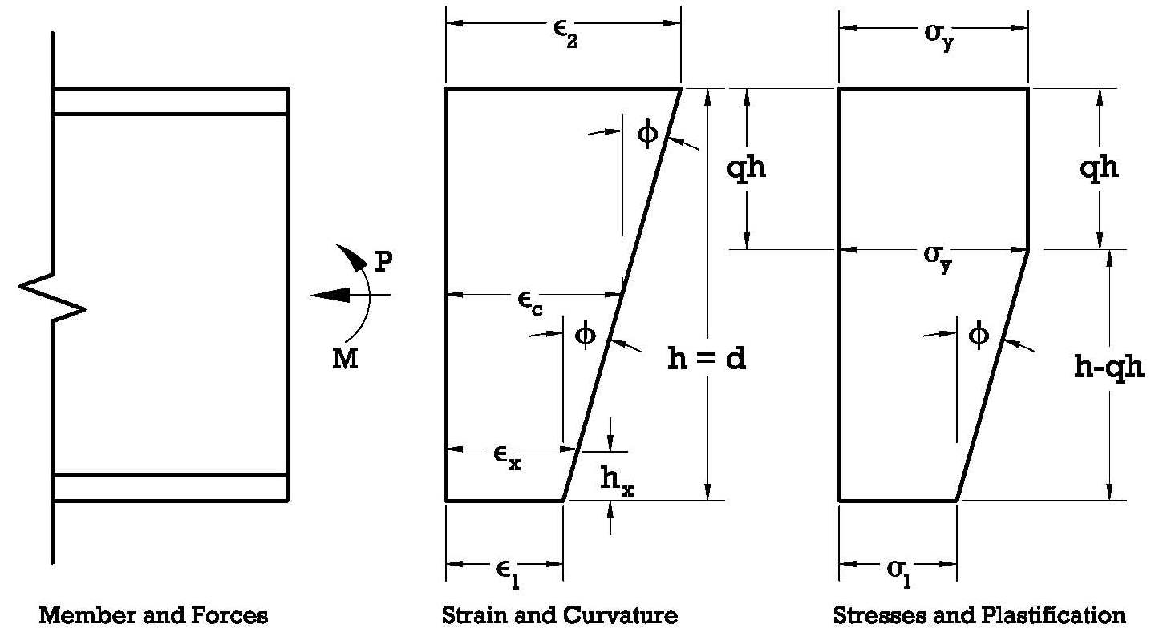

qh
qh
σ_{y}qh
Pε₂
ε_{c}
h = d
h - qh
MPε₂
ε_{x}

ε₁
σ₁h
Member & Forces Strain & Curvature Stresses & Plastification Plastification

Figure 5: Strain, curvature and plastification of a section subjected to loads P and M

The fundamental premise is that a plane section will remain plane under all loading conditions. This basic premise enables the establishment of relationships between φ, ε₁, ε₂, ε_{c}, and ε_{x} (the strain at any position h_{x} measured from the bottom fibre) and the depth d (or h) of the section as follows:
[9a] $φ=\frac{\left(ε_{2}−ε_{1}\right)}{d}$ ; [9b] $ε_{c}=\frac{\left(ε_{2}+ε_{1}\right)}{2}$ and [9c]$ε_{x}=ε_{1}+φ⋅h_{x}$

An equation relating moment M to axial load P (or C) is provided in Equation 10 (Beaulieu et al. 2006) for weak axis M vs P interaction. Results generated by the author for a W 310 x 107 section based on the plane section remains plane sectional analysis described above as well as the numerical integration process described in section 4.2 below (ignoring residual stresses) are plotted in Figure 6 and are compared to Eqn. 10 as well as published experimental results.

[10] $M_{\text{ucy}}=1\text{.}\text{19}M_{\text{py}}\left[1−{\left(\frac{C}{C_{y}}\right)}^{2}\right]≤M_{\text{py}}$
Over the full range of M and P values considered, Figure 6 shows good correlation between the experimental results and the numerical integration process and analysis described in this paper. In Equation 10, C, C_{y}, M_{py} and M_{ucy} designate the applied axial load, the axial yield load of the section, the plastic moment of the section and the ultimate weak-axis strength of the section respectively. The equation applies to the weak axis bending strength of a section when subjected to an axial load C.

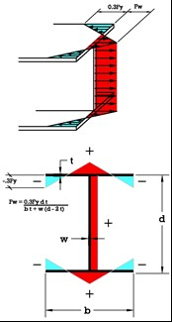
0.3F_{y}
d
b
w
t
0.3F_{y} F_{w}

Figure 6: M vs P plot for weak axis
bending of W 310 x 107 member

T₁₆
T₁
B₁
B₁₆
W₁
W₁₆
y
x

Figure 7: Discretisation of the section

Figure 8: Residual stress pattern (adapted from McGuire 1968)
  - Discretisation and Computation of Strains and Stresses
The numerical process begins by discretising the section in a manner similar to the one shown in Figure 7, whereby the member is subdivided into several smaller elements which are assigned corresponding geometrical and material properties as well as residual and imposed strain values. Numerical integration over the section enables the computation of P and M values. Each element is assigned properties of area, neglecting the inherent inertia I_{xx} and I_{yy} for each element about its own axes, due to the large number of elements used. Residual strains ε_{res} and imposed strains ε_{imp} and the corresponding stresses are computed. The imposed strains and stresses in the material can be calculated as:

[11] $ε_{\text{impix}}=ε_{1\text{imp}}+h_{x}φ_{\text{imp}}$
Where ε_{impx} is the imposed strain in component i at height h_{x}, ε_{1imp} is the imposed strain at the bottom of the section and ϕ_{imp} is the imposed curvature. The stress in the material, a function of the total strain $ε_{\text{impix}}+ε_{\text{resix}}$at the corresponding location is given by:

[12] $σ=E⋅\left(ε_{\text{impix}}+ε_{\text{resix}}\right)≤F_{y}$ where$F_{y}$is the yield stress of the material.
  - Residual Stresses
The distribution and magnitude of residual stresses, which depend on the particular method of fabrication used have an important influence on the strength of a column, particularly for intermediate length columns. The influence of residual stresses is illustrated with the help of Figure 8. In the case of a hot-rolled W shape, extremities of the section which cool faster following the rolling process tend to develop residual compressive stresses whereas those portions which cool more slowly tend to develop tensile stresses. Since the member is in equilibrium with no external forces, the overall sum of the stresses must equal zero. The characteristic distribution of residual stresses for a W shape is generally parabolic. However, the majority of analytical studies relating to the strength of columns in compression have been carried out on the basis of an assumed linear distribution of residual stresses (McGuire 1968, Beaulieu et al. 2006) as identified in Fig. 8 while considering a peak residual stress of 0.3Fy at the flange tips. This latter residual stress distribution was retained for the modelling used in the present study. Furthermore, by setting the peak residual stress to 0.3Fy in the flange tips and considering a uniform stress F_{w} in the web, it can be demonstrated that:
[13] $F_{w}=\frac{0\text{.}3F_{y}\text{bt}}{\text{bt}+w(d−2t)}$
  - Deformed Shape Along the Length of the Member
Referring to Figure 9 and assuming an initial deviation ∆_{o} which is maximum at mid-length and which is assumed to follow a sinusoidal shape, at each position along the member there will exist a constant force P giving rise to a variable moment M. For example, for a column divided into 10 segments, at position 3, a force P producing a moment M₃ = P∆₃ and at mid-length, a moment M₅ = P∆₅. Consequently, for each position along the member, given the initial deviation at mid-length and an assumed profile, the task is to determine if values of ϕ_{imp} and ε_{imp} (strain at the bottom or mid-depth) exist such that the external axial load and moment at each corresponding position can be balanced by internal forces obtained by integrating the associated stresses for each segment i, such that:

[14a] $\sum{A_{i}σ_{i}}=P$and
= M
[14b] $\sum{A_{i}σ_{i}}y_{i}=P$

y
ω
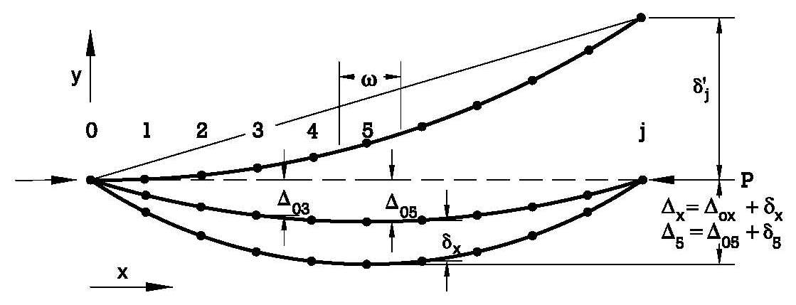

xy

Figure 9: Modelling along the length of the member

The spring model discussed previously was used to demonstrate that when in the elastic domain, the total deviation at mid-length can be computed as ∆_{F} = ∆_{o} / (1-P/P_{cr}). However, in the case where certain sections along the member are solicited within the elastic-plastic domain and others in the elastic domain under the influence of residual stresses and axial load P and moment M (PΔ), a method is required to determine the total deviation at all positions 1 to j illustrated in Figure 9. The modelling technique described below was proposed by Newmark, further expanded by McGuire (McGuire 1968) and used in the anlysis of reinforced columns (Mailhot 2010).

The method requires the subdivision of the member along its length into a number of j finite segments of length ω (ω = L/j). In this system, each angle change is concentrated at a node, an approach somewhat analogous to the simplified spring model described earlier. At each node 0 to j, it is possible to compute or estimate values for ϕ_{x}, M_{x} and ∆_{x} as follows:
- $M_{x}=P⋅Δ_{x}$and $φ_{x}=(P⋅Δ_{x})/{\text{EI}}$if in the elastic domain, otherwise determined by an iterative trial and error process by finding $ε_{x}$and $φ_{x}$ to match imposed values of P and M.
- $α_{x}=$the concentrated angle change $=φ_{x}ω$.
- $θ^{'},δ_{x}^{'}=$ the uncorrected slope and uncorrected displacement at a given node.
- $δ_{x}^{''}$ a correction to be applied to the computed displacement at position x.
- $δ_{x}=$the corrected displacement at position x.
- $Δ_{x}=$the true total deviation of a node ($δ_{x}+Δ_{\text{ox}}$) at position x.
To begin the process, an initial value of Δ_{x} must be assumed. For a column having an assumed initial deviation of Δ_{o} at mid-length (taken as L/1,000 for all the members analyzed below), it is appropriate to consider a sinusoidal shape, such that:

[15] $Δ_{x}=\frac{1}{\left(1−P/{P_{\text{cr}}}\right)}Δ_{o}\text{sin}\left(\frac{x}{L}π\right)$

It can be shown that the uncorrected deflection is given by:

[16a] $δ_{x}^{'}=δ_{x−1}^{'}+(α_{O}+α_{1}+\text{.}\text{.}\text{.}\text{.}α_{x−1})ω$
[16b] $δ_{x}^{''}=(x/j)⋅δ_{j}^{'}$.

and since the boundary conditions dictate that the node at the extreme right must be located at the same level as the node at the extreme left, the true (corrected) deflection at any position can be obtained by subtracting a correction value determined by Eqn. 16b from the uncorrected deflection computed at each position by Eq. 16a.
Figure 10: Case I results for W310 x 107 standard column
- Results AND DISCUSSION
Table 1: Case I results for various sections for standard pinned-pinned column with constant inertia
  - Cases I, II and III
The results obtained via the numerical modelling described above for column cases I, II, and III are presented and compared to the results obtained using effective lengths computed from Equations 6 and 8 in combination with the basic equation of CAN/CSA S6-14 applicable to a prismatic member composed of a single grade of steel which is given by:
[17] $C_{r}=φ{\text{AF}}_{y}(1+λ^{2n})^{{−1}/n}$ where n=1.34 or 2.24 (in certain cases, n = 1) and$λ=\frac{\text{kL}}{r}\sqrt{\frac{F_{y}}{π^{2}E}}$.
Firstly, the modelling technique described above was applied to the evaluation of the weak axis column buckling strength of a rolled W 310 x 107 section made of steel having yield stress of 228 MPa (33 ksi) for ten different column lengths having L/L_{r} values ranging between 0.2 and 2.0, where L_{r} represents a reference column length of 7.238 m, selected such that the parameter λ equals 1.0 for this particular column length. The model results are presented in Figure 10 and are compared against the ultimate strength predicted by CAN/CSA S6-14 equation with “n” equal to 1.34 and Ф equal to 1.0 (i.e. nominal strength). The results agree very well with the code equation for the W sections investigated over the full range of λ values considered as shown. The mean absolute error over the range of λ values is 2.2%. Furthermore, Table 1 provides the computed results for a variety of other W shapes, evaluated for weak axis buckling with Fy =228 MPa and unsupported lengths producing λ values of 1.0, where again good agreement is achieved (1% avg. error).
Table 2: Elastic buckling load computed by model for Case I, II and III columns compared to theoretical value for various sections

The same basic numerical modelling technique described above was used to calculate the elastic buckling strength of the standard column (Case I) and the variable inertia columns (Cases II, III, and IV) with the following minor adjustments:
- Initial imperfection (initial deviation) was set to a very small value (L/10,000)
- Yield strength of the material was set to a very high value to ensure that only elastic conditions would exist
- An abrupt change of section produces a discontinuity in the curvature of the column at the point of change. In this situation (Case II and Case III), the strains and curvatures are computed both to the immediate left and right of the section change and the average curvature is used to compute column deviation and buckling load.

The results are presented in Table 2, where again very good agreement is achieved between the theoretical elastic buckling values computed using Equation 1 (Case I), the effective length determined using Eqn. 6 (Case II) and the effective length determined using Eqn. 8 (Case III).
Table 3: Ultimate strength computed for cases II and III compared to code equation using computed effective lengths

Table 3 presents results for the ultimate strength of the section for case II and III using the effective lengths computed for the lighter section (I₁) and the heavier section (I₂). Whereas the effective lengths considered for each section produce the same elastic buckling load, it can be seen that the ultimate strength of the column is governed by the lighter section in each case even though it has a much shorter effective length (k_{eff}). It is to be noted that all numerical modelling results presented in the above for cases I, II and III and for case IV below are produced using a discretization of the section using 21 elements and with 21 nodes (0 to 20) in the longitudinal direction.

  - Case IV
Results stemming from the application of the numerical approach described above to case IV shown in Fig. 4 for the reference W 310 x 107 section (properties at mid-length) modified to have gradually varying inertia are presented and discussed below. The member is shaped such that the properties of the section at mid-length (0.5L) is equal to those of the reference section (i.e. b_{f} /b_{f ref} = 1.0) and the flange widths at the left-hand end (0.0L) and the righ-hand end (1.0L) are 0.5 and 1.5 times the mid-length flange width values respectfully. For such a section, the elastic buckling load was calculated to be 2,222 kN compared to 3,057 kN for a compression member having a constant inertia and properties equal to that of the W310 x 107 section throughout with with L = 7.238 m. The ultimate strength for this variable inertia column was computed by the numerical method to be 1,374 kN as indicated in Table 4. Knowing the elastic buckling strength of the column in question, for each section along its length an effective buckling length k_{eff} at each section can be computed such that P_{cr} = π²EI_{at section}/(k_{eff} L)². Furthermore, for each value of k_{eff} and the properties of the section at the same location, it is possible to compute an ultimate strength of the section according to the S6-14 Code Equation (Eqn. 17). The results of such a computation is shown in Table 4 and compared to the ultimate load computed from the numerical model.
Table 4: Ultimate strength computed for case IV W310 x 107 column

Table 5: Ultimate strength for various case IV columns compared to code equation using effective lengths

This table shows that a conservative estimate of the column strength (column no 1 in Table 4) can be made using the overall minimum value computed (in this case 1,210 kN at 0.0L) which produces a 13.6 % error. However, knowing the total deviation of the column at each position for the numerically computed ultimate load (1,374 kN in column no 2), it is possible to compute a corresponding moment and thus elastic stress value as shown in coulmn no 3. The results suggest that first yielding would occur at position 0.15L and using the section properties at this location with the corresponding effective length produces a more accurate under-estimate of the strength with a 3.6% error only. In reality, some inelastic behaviour would have occurred at a lower load level than those suggested in Table 3 due to residual stresses.

Based on the above, a simplified process to estimate the ultimate strength of a column of gradually varying inertia is proposed as follows:

Step 1. Compute the critcal elastic buckling load (P_{cr}) of the column using an appropriate method (the method described above can be used).
Step 2. Based on the critical elastic buckling load computed in Step 1, compute a value for k_{eff} at each position.
Step 3. Use the k_{eff} values computed in Step 2 to produce an estimate of P_{ultimate} at each position and retain the smallest value found as an estimate of the column strength.
Step 4. Use Equation 15 to compute an initial geometrical imperfection in the alignment of the column considering a mid-length value for ∆_{o} = L/1,000.
Step 5. With the smallest value of P_{ultimate} computed from the preceding Step 3, perform a conventional geometrical non-linear P-∆ analysis using the elastic properties of the section at each position. Determine the moment at each location resulting from the axial load and corresponding moment due to its initial deviation (from Step 4) and amplified value due to P-∆ effects.
Step 6. Use the axial load and moments computed in Step 5 to evaluate the resulting elastic stress and to estimate the location of first yielding.
Step 7. Use the properties of the section at the estimated location of first yielding to compute the governing k_{eff} value for the column as a whole and resulting ultimate axial strength of the column using Eqn. 17.

The simplified step-by-step process described above was applied to a variety of reference sections discussed earlier and are presented in Table 5 where very good agreement is found with errors ranging between -3.6% to + 1.7% for the seven sections analyzed.
- CONCLUSION
As demonstrated in this paper, it is possible to develop a numerical model in order to reproduce with very good agreement, the ultimate strength predictions obtained using the basic equation of CAN/CSA S6-14 for standard columns having constant moment of inertia. With some minor adjustments, the model can be adapted to predict the elastic instability of columns with variable moment of inertia and for the cases of a step-column and a centrally stiffened column, the computed results agree very well to those obtained using an effective length computed theoretically by solving specific transcendental equations.

For the step-column or the centrally stiffened column, the ultimate strength of the columns in these cases can be estimated with good accuracy if the corresponding effective lengths computed by elastic theory are combined with the S6-14 code equation provided that the lowest resulting strength value computed along the column length is used. On the other hand, the results also demonstrate that while the elastic buckling load computed from either segment (i.e. lighter section with a smaller effective length or the heavier section with a greater effective length) produce the same elastic buckling, significant differences exist when computing the ultimate strength of the corresponding segments.

For the case of a column with gradually varying inertia, the numerical method described above can be used to compute both elastic buckling and elastic-plastic buckling of this type of member. Knowing the elastic buckling capacity of the column in question, a step by step approach is proposed which can be used to determine the ultimate strength of the same member by combining the CAN/CSA S6-14 code equation with an effective length determined from the properties of the section where first yielding is expected to occur. First yielding can be estimated using an elastic analysis of the member which accounts for the initial imperfections in rectitude of the member and second order P-∆ effects.

The analysis in this study was performed using a steel having a relatively low yield stress since it was expected that such a material would be the most sensitive to alignment imperfections and inelastic behaviour and also because of the historical development of column curve equations using lower grade steels. Although lower grade steel were used in this study, the approach is applicable to higher yield material including high performance steels. In fact, limited analysis performed in the course of this study suggests that the column curve equation proposed in S6-14 may be somewhat conservative for higher strength steels. Finally, it is of interest to note that the four variable columns shapes selected represent the same overall material weight for a given section type. As could be expected, Case III represents the most efficient use of material of the four cases investigated. This type of arrangement could be advantageous for the reinforcement of existing bridge truss members where the ability to extend the reinforcement into the truss node connection could prove problematic in some cases.
- References
CSA 2014. Canadian Highway Bridge Design Code, CAN/CSA S6-14. Canadian Standard Association, Toronto, Canada.

Beaulieu, D., Picard, A., Tremblay, R., Grondin, G., and Massicotte, B. 2008. Calcul des Charpentes d’Acier. Volume I, 2nd ed., Canadian Institute of Steel Construction, Markham, Ontario, Canada.

Galambos, T. V. 1988. Guide to Stability Design of Metal Structures. 4th Edition. John Wiley & Sons Inc., New York, NY, USA.

Mailhot, G. 2010. Evaluation of the Ultimate Strength of a Hybrid Steel Bridge Compression Member Reinforced Under Load. 8th International Conference on Short and Medium Span Bridges, Niagara Falls, Ontario, Canada, 054: 1-12.

McGuire, W. 1968. Steel Structures. Prentice-Hall Inc., Englewood Cliffs, NJ, USA.

Shanley, F. R. 1946. The Column Paradox. Journal of the Aeronautical Sciences, 13(12): 678-678.

