 | 10th International Conference on Short and Medium Span Bridges  Quebec City, Quebec, Canada,  July 31 – August 3, 2018 | 

Constructing the Burgoyne Bridge – Unique Staging for a Unique Bridge
Archibald, Brent^{1,2}, Salib, Sameh¹ and Guiot, Nelson¹
¹ Parsons Inc, Canada
² Brent.Archibald@parsons.com
Abstract: This paper describes how a unique staging was utilized for the construction of a signature bridge for the Burgoyne Bridge replacement project located in St. Catharines, Ontario. The project involves the replacement of an existing 100-year-old high level truss bridge spanning over Twelve Mile Creek and the Highway 406 with a new twin deck steel box girder viaduct structure with a 125m main arch span. The central arch is flanked by the two decks which are continuous over 7 spans from end to end of the 333m long structure. The project requirement for maintaining traffic during construction, while replacing the existing structure on an alignment within the footprint of the existing bridge, resulted in a unique and innovative approach to the overall bridge design and construction staging. In a situation where twin structures could have been adopted, the design presupposed the incorporation of both bridge decks into a single structure within the arch span during the last stage of construction. Bridge construction utilized temporary supports for both the bridge erection as well as carrying live loads during the staged construction and incorporated both girder launching and heavy lifting erection methods. Both design and construction respected the continued use of the original structure during construction, requiring extensive monitoring, while concurrently addressing difficult site conditions related to slope stability and constructing deep foundations adjacent to the timber piled footings of the existing bridge. The culmination of the construction involved a sophisticated sequencing to install the arch tie and stay cables and perform the final load transfer of the bridge decks into the completed arch system. This innovative and unique approach to design and construction staging has proven to be an integral approach to meeting the project objectives.
- Introduction
For the past 100 years the Burgoyne Bridge in the City of St. Catharines has served as a key link in the transportation system of the City and of the Region of Niagara. The previous bridge, opened for service in 1915, was designed as a multiple-span steel truss superstructure supported by steel truss towers, together with steel girder approach spans, having a total length of 350m. The bridge, which carried Regional Road 81 (St. Paul Street West) over the valley, including Twelve Mile Creek and Highway 406, was judged to be reaching the end of its useful life and thus required replacement by a new crossing. The Region of Niagara required a landmark bridge to replace the existing bridge, with the goal of enhancing the environment and meeting the City of St. Catharines requirements for improved access for pedestrians and cyclists into and out of the downtown core, as well as incorporating urban design features into the crossing.

- Project Conception
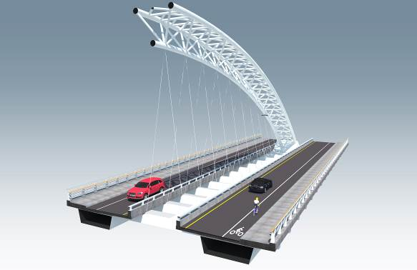
During the environmental assessment and preliminary design phases, numerous structure types and alignments were considered and evaluated. Parsons identified a key goal of having the structure visible from downtown St. Catharines in addition to its visibility by motorists both on and below the bridge. Maintaining the existing bridge alignment was both critical to achieving this goal as well as reducing the property acquisition required and thus the overall project cost. To achieve the high visibility requirement for the bridge, the it was determined that the main structural system of the bridge needed to rise above the deck, in turn leading to the development of a signature tied arch span. The design of the bridge is grounded in the history of the previous bridge and other historical crossings of the same valley in St. Catharines, expressed through the stays and the tri-chord trussed arch of the new bridge (tri-chord trussed arch bridges have been incorporated into several landmark type structures such as the Vimy Ridge Memorial Bridge in Ottawa, Canada (Ajrab et al. 2017); the Emidio Vivieri Bridge in Albenga, Italy (Romano 2001); and the Lusitania Bridge in Mérida, Spain (Frampton et al. 1996). The design intention was such that the environment be enhanced and that a singular bridge, respectful of history, be created in an attractive natural urban valley. The signature arch span also allowed for the elimination of a pier between Twelve Mile Creek and Highway 406, which in the case of the previous bridge configuration, was limiting the potential for widening or re-alignment of the Highway 406.

Figure : Concept of Main Arch Span

Both conventional twin tied arch structures and a single tied arch structure utilizing the main girders as the tie were explored; however, both options would have numerous challenges considering the bridge was to remain on the same alignment while maintaining traffic. Accordingly, an innovative approach to developing a tied arch structure which could be constructed both while maintaining traffic and adjacent to the existing bridge was developed and ultimately implemented at the site.
- Structure Description
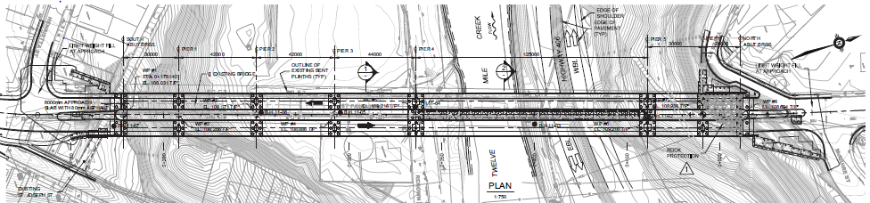
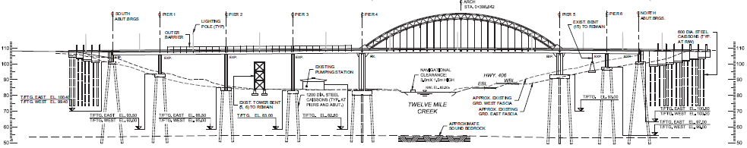
The bridge can be described as a central single steel tied arch carrying ‘flying’ twin composite steel box girders within the largest span (125m) via hangers supporting transverse floor beams which in turn are connected to the box girders. The girders are continuous over the seven spans with longitudinal fixity only provided at one of the arch pier supports. The tall concrete piers are supported on deep caisson foundations socketed into bedrock approximately 25m below the valley floor. The tri-chord arch rises more than 50m above the valley and consists of three 762mm diameter curved steel tubes braced together to form an arched truss; with a single tube for the bottom chord and double tubes for the top chord. The arch chords are fixed to anchor blocks at the top of the arch piers utilizing double corrosion protected post-tensioned anchors. The tie which completes the arch system is also anchored to the top of the arch piers, 25m above the valley, and comprises an innovative post-tensioned tie system to produce an optimum design under the projects unique construction conditions. The horizontal tie consists of a post-tensioned stay system utilizing 6 stays (tendons) with 62-13mm strands and the arch hangers consist of stays with 12-13mm strands.

Figure : Plan and Elevation View of New Structure

To the authors’ knowledge, the Burgoyne Bridge is the first arch bridge in Canada to utilize an external post-tensioning stay system as its permanent tie similar to the Lupu Bridge in Shanghai, China (Ellis 2007 and Lin et al. 2004). The tie system provides a level of redundancy unparalleled compared to a structural steel tie; however, since there is no other connection between the pier and tie themselves, the tie could not be fully stressed to balance the dead and live load thrust without overstressing the arch and piers. While the arch tie could be stressed to provide reaction to the arch dead load thrusts; with the ties low axial stiffness, the result is a structure which has a unique and complex structural behaviour under live load, relying on the piers foundation soil-structure interaction, in conjunction with the stiffness of the piers and the arch structure. Accordingly, the twin deck structure utilizes its longitudinal flexural stiffness under live load, closely balancing the stiffness and strength required during the temporary viaduct support condition during construction. The twin decks also provide additional lateral support to the arch though the transversely inclined hangers.
To reduce the torsional stresses in the girders by inducing compensating loads and deformations into the floor beams, in opposition to the hanger induced loads, a post-tensioned stay(tendon) system, consisting of 2 – 7-13mm strands, was detailed within each floor beam and anchored to the exterior portion of each girder. The stays (tendon) are located near the top of the floor beam situated above the main arch tie with the anchorage protected within decorative floor beam extensions on the girder exteriors.
The crossing design also included extensive works to improve the upper slope stability of the Twelve Mile Creek valley. Two systems were utilized, with both lightweight expanded polystyrene and cellular concrete detailed in the embankments at the bridge approaches to improve the slope stability safety factor as well as enabling the overall bridge length to be reduced compared to the existing bridge. During construction, the expanded polystyrene was replaced with cellular concrete at the south embankment in order to suit the contractor’s girder launching operation

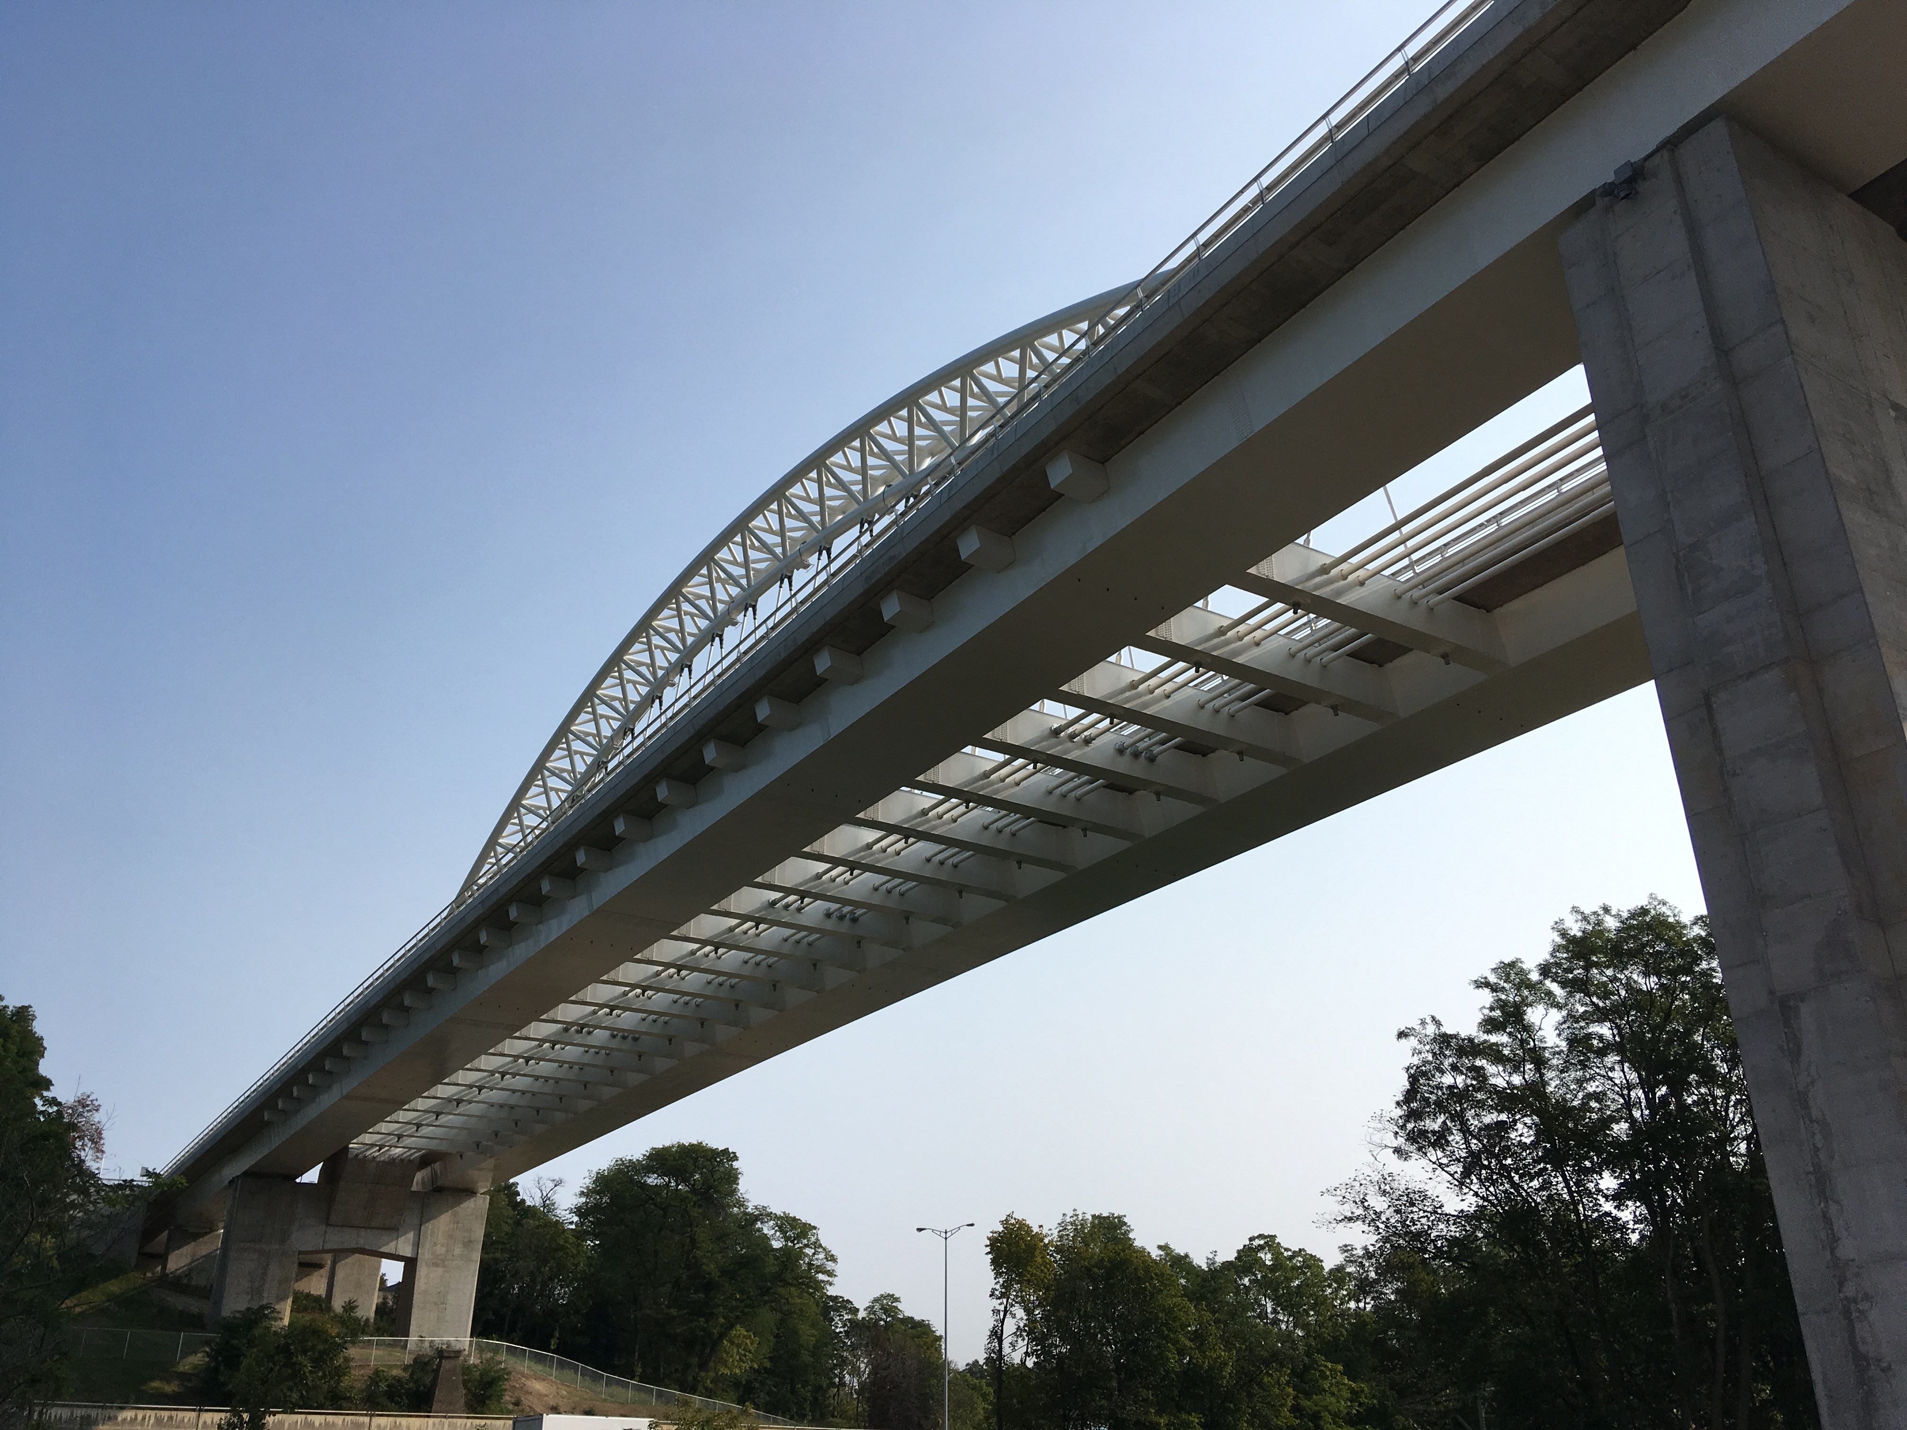
- Construction Staging

Figure : Underside of Arch Span Showing Floor Beam and Arch Tie System.
In order to maintain the existing alignment of St. Paul Street West, which is carried by the Burgoyne Bridge, the new structure needed to be superimposed on the footprint of the existing bridge. With the new bridge having a width of twice the existing bridge and two separate decks, a three stage-approach was adopted for the construction of the twin girder superstructures and the main arch. While this would work quite well for the viaduct spans of the bridge, this was contrary to conventional construction sequences for the main arch span, rendering the deck for the 125m arch span unsupported without the presence of the arch. Accordingly, the first construction stage involved completing the east half of the entire bridge immediately adjacent to the old bridge (partial removal of the existing sidewalk was required due to the proximity of the new bridge to the existing) while utilizing three temporary supports within the arch span. Once completed, the east bridge viaduct was capable of carrying two lanes of traffic to allow for the demolition of the existing bridge. The second stage involved construction of the west bridge viaduct in its entirety, supported on the same temporary supports shared with the east bridge viaduct through the arch span. Once both east and west bridges were completed, the third and final stage of construction consisted of erecting the central arch, installing the floor beams and transverse post-tensioning between the two completed viaduct structures, and installing the hangers and main arch tie. This final stage included the transfer of the loads from the temporary supports to the arch in a systematic manner discussed in further detail below.
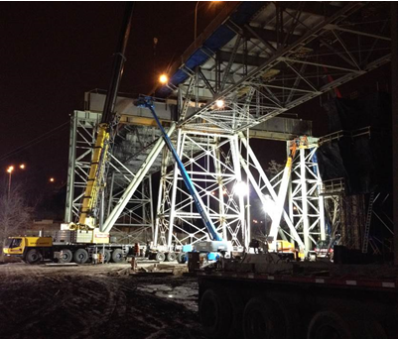
One of the unique aspects of the bridge construction staging was that the east bridge viaduct portion of the crossing within the arch span was required to carry both the structure itself as well as two lanes of live traffic. This required the temporary supports to be designed for both structure dead load as well as live loads during construction, in addition to also supporting the arch during erection. Three temporary supports were positioned symmetrically within the arch span based on the indexing for the hangers and threaded though the existing truss structure. The permanent bridge design necessarily considered this temporary viaduct configuration in addition to the final arch configuration and also included consideration of a design envelope based on a range of temporary support stiffnesses and behaviour in the development of the final design. A detailed review of temporary support configurations was performed during the detailed design phase, with temporary support design advanced to a level sufficient to demonstrate the bridge erection and determine the performance requirements required for the contract documents.

Figure : Installation of Temporary Support Through Existing Truss
The three lines of temporary supports were environed to be constructed in numerous stages in order to avoid interference with the existing structure. Ultimately, the three lines of temporary supports were utilized by the contractor during construction with some innovative improvements made to reduce the number of construction sequences for the temporary support construction. The contractor developed a chevron braced temporary support allowing for all the foundations of the temporary supports to be constructed in a single stage while meeting the requirements for construction adjacent to the existing bridge.
- Girder Erection
Girder erection by means of launching was considered during the design stage and details and provisions were incorporated into the design to readily accommodate this method, such as maintaining a consistent datum for the underside of the girder, and detailing bottom flange splices to avoid interference with roller support equipment. The contractor developed a unique process for transferring the girder segments from transport vehicles directly onto launching frames with minimum use of cranes. The girders were launched from the south abutment toward the north and were advanced using a hydraulic jack and cable pulley system anchored to the south abutment and the back of each girder segment. A ”skyhook” nosing assembly was utilized on the leading end of the girder which allowed the end of the girders to be raised by means of jacking the nosing assembly off each pier just prior to the girder reaching each pier. This resulted in a reduction of the cantilever load and the elimination of the inclined loading compared to using a tapered launching nose. In order to address the cantilever deflection, the girders were launched higher than their final elevation and systematically lowered onto the piers after the girder launch was completed.

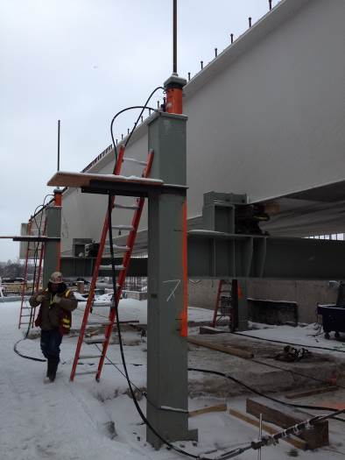
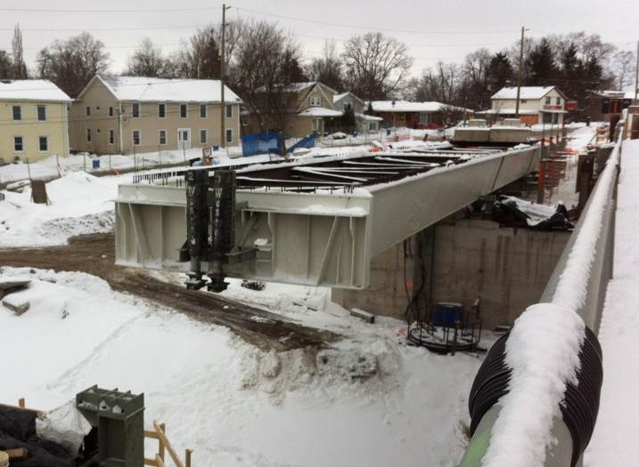
In order to reduce the work required over Twelve Mile Creek and the Highway 406, these portions of the bridge were launched with formwork in place. Ballast blocks placed on the girders were also utilized within the launching frame area at critical stages of the launch to balance the cantilevered portion of the girder and ensure the tip deflection remained within the limitations of the “skyhook” nosing. Having independent girder lines allowed the East and West girders to be launched in two separate stages; utilizing the same equipment for each launch.
(a) (b)

Figure 5: Girder Launching (a) East Girder Adjacent to Existing Bridge (b) Launching Frames
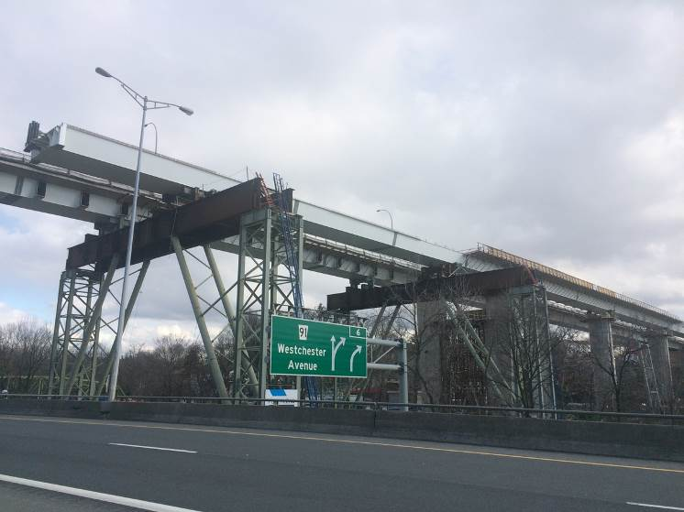
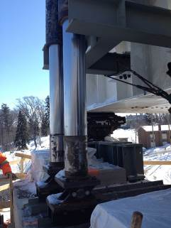
(a) (b)
Figure 6: (a) West Girder Launching Over Highway 406 (b) Jacking “skyhook” nosing
- Arch Erection
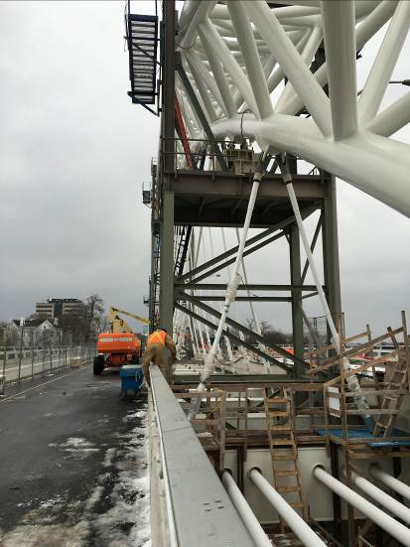
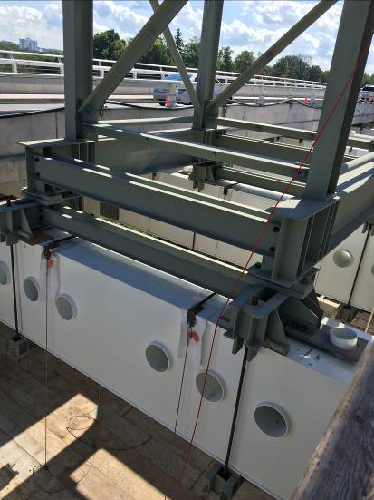
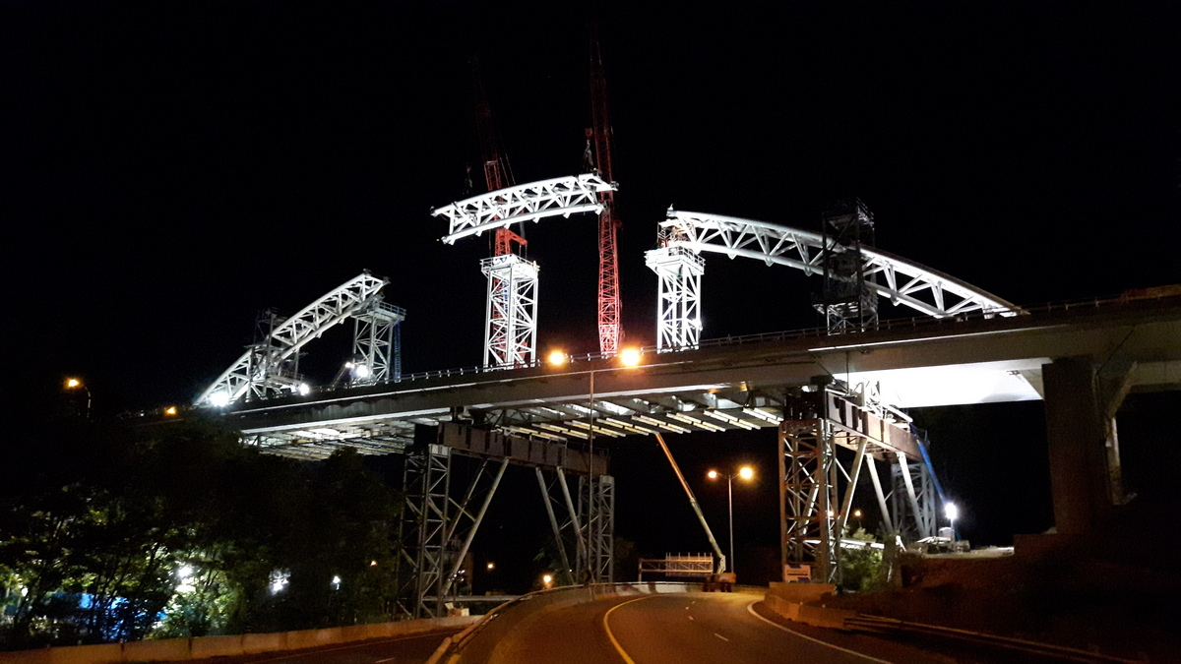
The three temporary supports, which carried the bridge as a viaduct, were also utilized in supporting the arch segments during the arch erection stage by extending the supports upward above the bridge deck within the gap between the two decks. The contractor also utilized two additional temporary supports, supported off the permanent floor beams allow the arch to be fabricated in six segments of similar length. The erection of the arch consisted of transporting each of the arch sections onto the East bridge deck which were lifted onto the temporary tower supports using two crawler cranes positioned on the West deck. Once the arch segments were erected, the arch chords for the segments were welded together using full penetration welds. Trial assembly and mock up welding assemblies were conducted to validate the welding and associated testing non-destructive testing process during construction.
(a) (b)

Figure 8: (a) Intermediate Arch Support (b) Arch Temporary Support

Figure 7: Erection the Arch Segments Using Tower Cranes on Bridge Deck
Having a central arch and utilizing an arch tie system independent from the twin deck structure allowed construction to be staged while allowing traffic to be maintained during construction, as the arch and the temporary works did not interfere with the vehicular envelope. Minimal structural steel modifications were required to accommodate the contractor’s temporary supports and erection methods which were readily implemented during the girder fabrication stage.
- Conversion from Temporary Viaduct to Final Arch Span
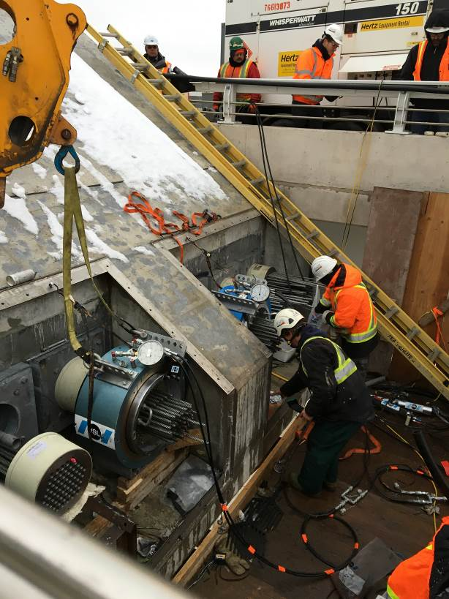
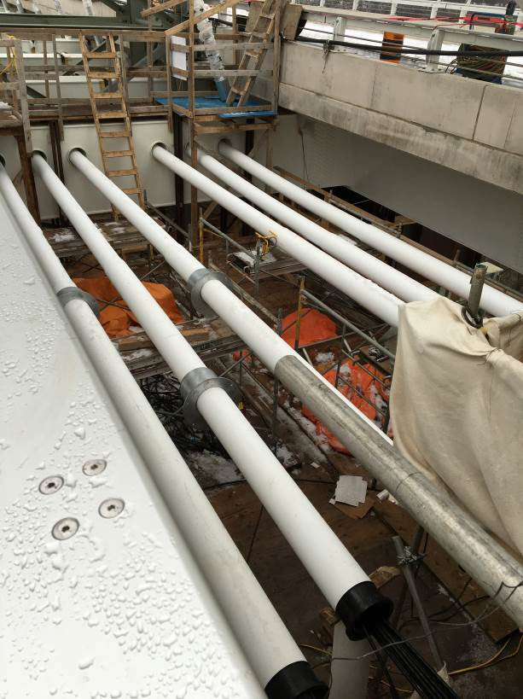
The process of transferring load from the temporary supports into the arch structure was understood to be a very critical and unique aspect of the project. Typical construction for an arch bridge would involve the arch, hangers and tie being installed at the same time as the structural steel girders, with the deck placed afterwards.

(a) (b)

Figure 9: (a) Jacking the Arch Tie (b) Tie Installation
However, erecting the arch at the end of the construction sequence, as in the case of the new Burgoyne Bridge, meant that the two concrete bridge decks and parapets would already be in place during the viaduct configuration and thus adding significant stiffness to the girder structure. A series of interacting construction stages was developed during the design phase, and refined thereafter by the contractor’s erection engineer, in order to install the arch tie and the stay cables. The load transfer consisted of three main activities; initial nominal hanger stressing; initial tie stressing; and lowering the girders at the temporary supports within the arch span simultaneously and systematically. The sequence and magnitude of the girder lowering would induce the final tie and hanger loads; while utilizing the actual girder/deck stiffness to distribute the loads into the hangers, and ultimately release from the temporary supports completely in the final sequence. The initial arch tie stressing was performed by simultaneously stressing the arch tendons in pairs to minimize the lateral eccentricity on the pier. Pairs of hangers were also simultaneously stressed at each floor beam to ensure the lateral loads were always balanced. Such sophisticated construction sequencing was unique to this bridge construction and essential in maintaining the bridge straining actions and deformations within acceptable limits.
- Analyzing the Structure and its Behaviour
Sophisticated structural analysis methods were utilized to model the structure. Various types of analysis were conducted through the developed model in order to have a more complete understanding of the bridge behaviour and to achieve an optimum design under construction, serviceability and ultimate loading conditions, as well as localized structural modeling to capture the stress flow in connections to verify their strength and fatigue capacity. The analysis also considered the soil-structure interaction between the arch, piers and foundations due to the integral connection of the arch and tie with the piers as well as non-linear characteristics of the proposed construction staging. The modeling incorporated a wide range of model element types based on material and geometry of the modeled bridge component as well as the expected behavior and the desired output results.
Analytic modeling and wind tunnel testing of the bridge was carried out to gain a comprehensive understanding of the wind effects under the complex bridge geometry and the irregular surrounding terrain. Among the objectives fulfilled by the testing was the undertaking of a buffeting analysis to obtain equivalent static design wind loads (with a total of 29 different loading cases), determining aerodynamic characteristics/stability of the twin deck structure and assessing the bridge vibration sensitivity under various scenarios of pedestrian activities. Wind tunnel tests were conducted by a sub-consultant, Rowan Williams Davies & Irwin Inc. in Guelph, Ontario, and the twin bridge deck configuration proved to be advantageous from a wind stability perspective. In order to ensure pedestrian comfort and to meet a requirement which would allow pedestrian events to take place across the structure, a total of 52 different scenarios, modeling crowds walking and running on the bridge, were established and targeted each of the modes of vibration identified as potentially sensitive to this type of excitation.
- Existing Structure Monitoring
The original bridge foundations consisted of short timber pile supported foundations in the valley adjacent to Twelve Mile Creek and spread footings for the remainder of the structure piers and abutments. The foundations for the new bridge comprised deep caisson foundations which needed to be installed while respecting and minimizing disturbance to the existing bridge foundations. In addition, difficult subsurface conditions, including artesian water levels within the soils immediately above the bedrock, loose soils within the valley adjacent to the river and corrosive groundwater conditions provided challenges during construction.
As a result, a monitoring system was developed which included inclinometers, tiltmeters, precision surveying, and settlement rods to provide a redundant system in order to monitor the existing bridge and embankment slopes. Daily readings were taken and results from the devices were analyzed to understand the normal bridge behaviour and construction impacts. Review and alert levels were also developed, and construction activities modified as required to remain within acceptable limits.
- Conclusion

The Burgoyne Bridge is an example of innovative engineering applied both during design and construction to address difficult site conditions and constraints without compromising the key goals for the structure. The unique construction staging, and temporary support conditions were integral to the design of the bridge and proved to be a successful approach for the replacement of the Burgoyne Bridge
The resulting aesthetics of the bridge and landscaping both enhance the bridge surroundings and create a destination for the public. Signature bridges have successfully proven to provide renewal to areas in need of such benefit, and with the Burgoyne Bridges’ proximity to downtown St. Catharines, it provides the City with state of the art bridge engineering and aesthetics that promises to become synonymous with the City itself.
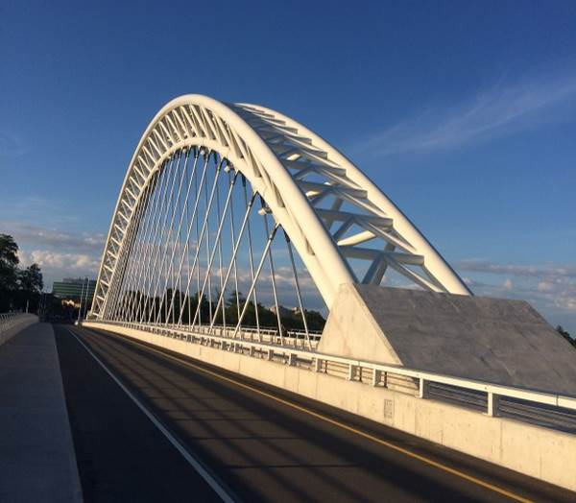

Figure 15: Completed Bridge looking towards Downtown St. Catharines
Acknowledgements

The authors acknowledge the Regional Municipality of Niagara for the opportunity to deliver this signature bridge. Also, they extend their thanks to the City of St. Catharines, the Ministry of Transportation-Ontario (MTO) and the entire project team.

References
Ajrab, J.J., Montminy, S. Delph, M., and Anderson, W.V. 2017: Vimy Memorial Bridge”, International Bridge Conference, Pittsburgh, PA, USA
Ellis, L. J. H. 2007. Critical Analysis of the Lupu Bridge in Shanghai. Dept. Civil & Architectural Engineering, University of Bath.
Frampton, K., Webster, A.C., Tischhauser, A., 1996: Calatrava Bridges. Birkhäuser, Basel (Switzerland), pp. 78-89.
Lin, Y., Zhang, Z., Biao, and Zhou, L. 2004: Lupu Arch Bridge, Shanghai. Structural Engineering International, 14: 24-26.
Romano, Luca. 2001: Structural Analysis and Construction of an Arch Bridge in Albenga, Italy, Structural Engineering International, 11: 47-52.

