 | 10th International Conference on Short and Medium Span Bridges  Quebec City, Quebec, Canada,  July 31 – August 3, 2018 | 

EXTENDING THE LIFE OF THE ALEXANDRA BRIDGE
Habel, Katrin^{1,3}, Dowling, Jason¹, Harvey, David¹, and Szto, Bill²
¹ Associated Engineering, Vancouver, BC, Canada
² British Columbia Ministry of Transportation and Infrastructure, Coquitlam, BC, Canada
³ habelk@ae.ca
Abstract: The iconic 481 m long Alexandra Bridge, built in the early 1960’s, crosses the Fraser River via a 257 m riveted steel arch main span and multiple steel girder approach spans with concrete decks. The bridge is located on Trans-Canada Highway 1, one of the most important transportation routes in Canada. A detailed condition and renewal options assessment in 2009 concluded that the bridge needed major deck rehabilitation and a seismic retrofit. Subsequent rehabilitation design work addressed structural safety, structure deterioration and functionality concerns by incorporating a partial-depth reinforced concrete deck overlay addressed concrete deterioration and facilitated widening the roadway deck to 12.2 m with new barriers designed to current standards. The main components of the seismic retrofit included re-articulation of the approach spans with installation of link decks across the breather joints near the arch crown and the installation of elastomeric bearings. In the approach spans, the deck was selectively made composite with the girder top flanges using shear studs to increase capacity, and the approach girders were strengthened for shear and moment at select locations. Other work included deck joint replacements, concrete substructure repairs, and drainage modifications to improve structural durability. Several of the rehabilitation items fulfilled multiple functions, demonstrating a thoughtful rehabilitation that extends the usable life of the existing structure long into the future at an affordable cost.
- Introduction
The iconic 481 m long Alexandra Bridge (Figure 1) is located on Trans-Canada Highway 1, one of the most important transportation routes in Canada. The structure, built in the early 1960’s, crosses the Fraser River via a 257 m riveted steel arch main span and multiple steel girder approach spans. The bridge also crosses a Canadian Pacific Railway (CPR) track under the west approach spans and a Canadian National Railway (CNR) track under the east approach spans. The two-lane concrete deck was non-composite with the steel structure below. Abutments and piers are made of reinforced concrete. The arch foundations were placed on soils, not rock, as had been erroneously reported from the original borings at the site. This resulted in the decision to incorporate vertical and horizontal preloading of the arch foundations to minimize settlements in the arch span (Golder and Sanderson, 1961).
The structure can be subdivided into of four distinct systems, progressing form the west to east abutments (Figure 2):
- System 1: The spans between the West Abutment and Pier 1 support the bridge over the CPR track, which is at a skewed alignment to the bridge. The section comprises exterior girders and four stringer lines with full height floor beams and a concrete deck. The two intermediate supports (Columns 1 and 2) carry the exterior girders on either side of the rail track and are staggered in 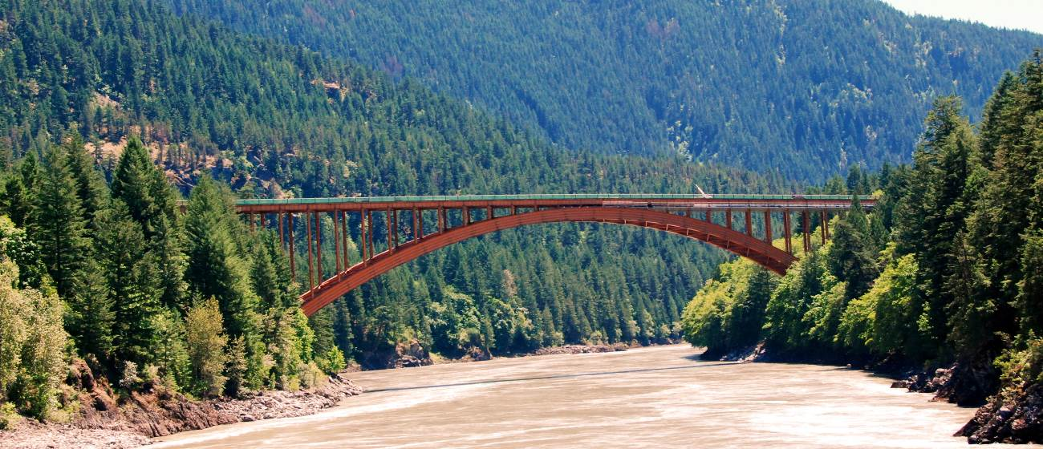their alignment. The irregularity of the spans requires two counterweights, one at the west abutment, and the other at the diagonally opposite corner at Pier 1 to counteract uplift at these locations.
Figure 1: View of the Arch Span of the Alexandra Bridge

- System 2: The three spans between Pier 1 and Pier 4 utilise four continuous girder lines and a concrete deck with diaphragms and intermediate bracing.
- System 3: The main span, between Piers 4 and 5, consists of a pinned arch and spandrel columns. Full-depth floor beams and wind girders frame into the spandrel columns. The deck is supported by four stringer lines framing into the floor beams.
- System 4: The three spans between Pier 5 and the East Abutment utilise four continuous girder lines and a concrete deck with diaphragms and intermediate bracing, similar to System 2.
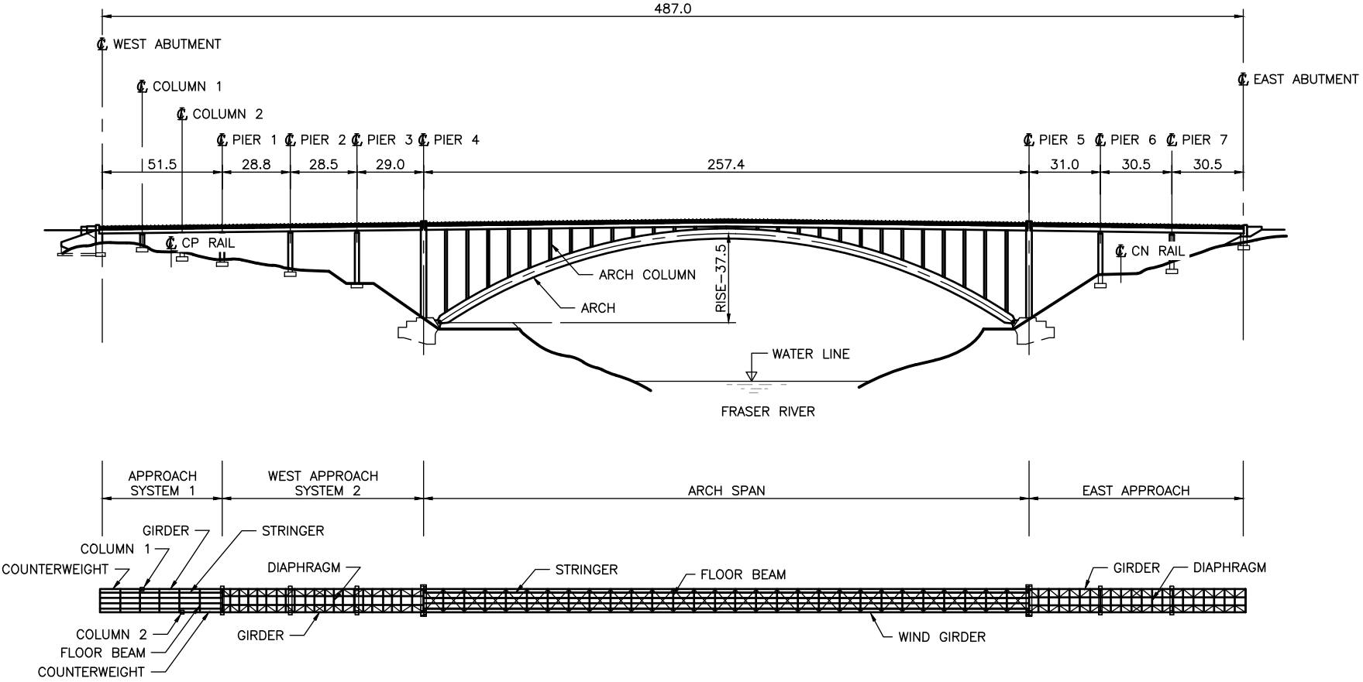
Figure 1: Plan and Elevation Views of the Alexandra Bridge
The existing bridge had plated joints at the abutments and Pier 1, and finger plate joints at the ends of the main span at Piers 4 and 5. Near the centre of the arch, four breather joints were built into the concrete deck.
The bridge owner, the British Columbia Ministry of Transportation and Infrastructure (Ministry), retained Associated Engineering to carry out a detailed condition and renewal options assessment in 2009 which concluded that the bridge was in need of rehabilitation and did not meet current seismic standards. It was deemed unlikely that lanes would be added to the two-lane Trans-Canada Highway 1 in the near-to-medium future, since the four-lane Coquihalla Highway 5 carries the majority of traffic between Vancouver and Eastern Canada, and that a replacement of the Alexandra Bridge would not be cost-effective. Thus, the preferred option was to carry out a major rehabilitation and a seismic retrofit of the existing structure.
This paper describes the rehabilitation and seismic retrofit work of the structure and discusses how several work items fulfilled multiple functions and how thoughtful rehabilitation and retrofit schemes can take advantage of synergies to extend the usable life of existing structures long into the future at an affordable cost.
The scope of the construction project focused on deck rehabilitation and seismic retrofit. The original design was carried out to the 2006 Canadian Highway Bridge Design Code (CHBDC) in 2013 and was updated to meet the 2014 CHBDC requirements in 2016, with construction in 2017 and 2018. The main scope of the work consisted of the following tasks:
- Concrete deck rehabilitation and widening
- Expansion joint replacements and installation of link decks
- Isolated steel girder strengthening work
- Creation of jacking locations and replacement of steel bearings with elastomeric reinforced bearings
- Abutment modifications and approach works
- Deck drainage reconfiguration
- Partial painting
- Concrete substructure repairs and
- Miscellaneous work
- Constraints
The rehabilitation work needed to be carried out under the following constraints:
- Construction staging: The structure had to remain open to at least single-lane alternating traffic during construction. Thus, the deck rehabilitation had to be carried out in a minimum of two stages. During the design phase, there were several discussions regarding whether a lane could be closed over the entire bridge length, or if lane closures were allowed over only a portion of the bridge at a time. During construction, lane closures extended over the entire bridge, simplifying contractor logistics and increasing worker safety. Further, the contractor was required to reopen the structure fully for two-lane traffic over the winter. In addition, the arch span deck work had to be carried out symmetrically to the arch crown to avoid excessive unbalanced loading on the arch span.
- Railways: The structure crosses two busy railway tracks, requiring coordination of the contractor with both CPR and CNR. While there was significant clearance to the CNR track under the east approach spans, the clearance to the substructure and the steel structure to the CPR track under the west approach spans was marginal (Figure 3), and did not allow for any scaffolding below the existing steel girder bottom flange.
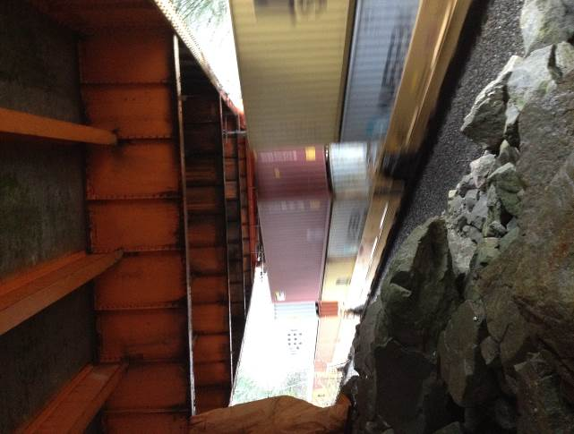
- Access: The work required construction access to the deck and steel deck system over the entire length of the structure as well as to the concrete substructure. Staging areas were limited to a pull-out at the west end of the bridge and access below the west approach spans, further complicating the construction work.
Figure 3: Container Train under West Approach Spans
- Analyses
The rehabilitation and retrofit design required a seismic assessment as well as a load evaluation to determine the most favourable retrofit scheme and possibilities of a deck widening.
  - Load Evaluation
The load evaluation was carried out using the evaluation section of the CHBDC. The design vehicle was the Ministry’s live load BCL-625, which is similar to the CL-625 load in the CHBDC. The initial load evaluation showed that some widening of the deck was possible with only isolated steel strengthening with only two lanes of traffic on the deck, even though the deck is wide enough for three lanes of traffic in accordance with the CHBDC.
The global buckling of the arch rib was preliminarily evaluated using linear methods. However, it was found that a geometrically non-linear buckling analysis was required to confirm that the arch ribs had adequate global stability when considering only two lanes of live load and a 50 mm future overlay allowance.
  - Seismic Evaluation
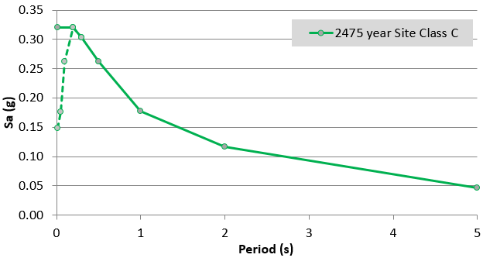
The Trans-Canada Highway 1 is a major connection between the Lower Mainland (Vancouver) and the interior of British Columbia and Eastern Canada, but not the only route. Thus, the bridge was determined to be on a “major route”, requiring collapse prevention for the 2475 year return period design earthquake in accordance with the 2014 CHBDC and the Ministry’s Bridge Standards and Procedures Manual, Supplement to CHBDC S6-14 (B.C. MoTI 2016).
Figure 4: 2475-Year Response Spectrum

The seismic demand was obtained from Natural Resources Canada (NRCan 2016); the 2475 year return period hazard spectral acceleration, corresponding to a 2% probability of exceedance in 50 years, is shown in Figure 4. The values shown in Figure 4 are for a structure with 5% of critical damping and founded on Site Class C soils (that is, very dense soil and soft rock with shear wave average velocity, standard penetration resistance and undrained shear strength as defined in the 2014 CHBDC). Note that the seismic hazard at the site is moderate compared to that in the metropolitan areas of Victoria and Vancouver, largely due to the greater distance between the site and the subduction and intraplate sources. The current hazard is also reduced from that of the 2006 Geological Survey of Canada models.
Having considered the moderate seismic hazard at the site, the existing configuration of the structure and an initial seismic assessment, it was decided to use reinforced elastomeric bearings as primary seismic retrofit elements and replace the deck joint at Pier 1 and the breather joints in the arch span with link decks. The performance of the retrofit scheme was assessed using Finite Element (FE) analyses of the bridge. Response Spectrum Analysis (RSA) techniques were used to identify force and displacement demands placed on the structure in a global 3D FE model. The first four mode shapes contributing most heavily to the response of the structure the seismic excitation have periods of 1.14s, 1.56s, 1.85s and 1.94s, corresponding to the arch longitudinal and transverse responses, the longitudinal response of the west approach and the longitudinal response of the east approach, respectively (shown in Figure 5). These are relatively long period values, typical for a structure of these proportions.

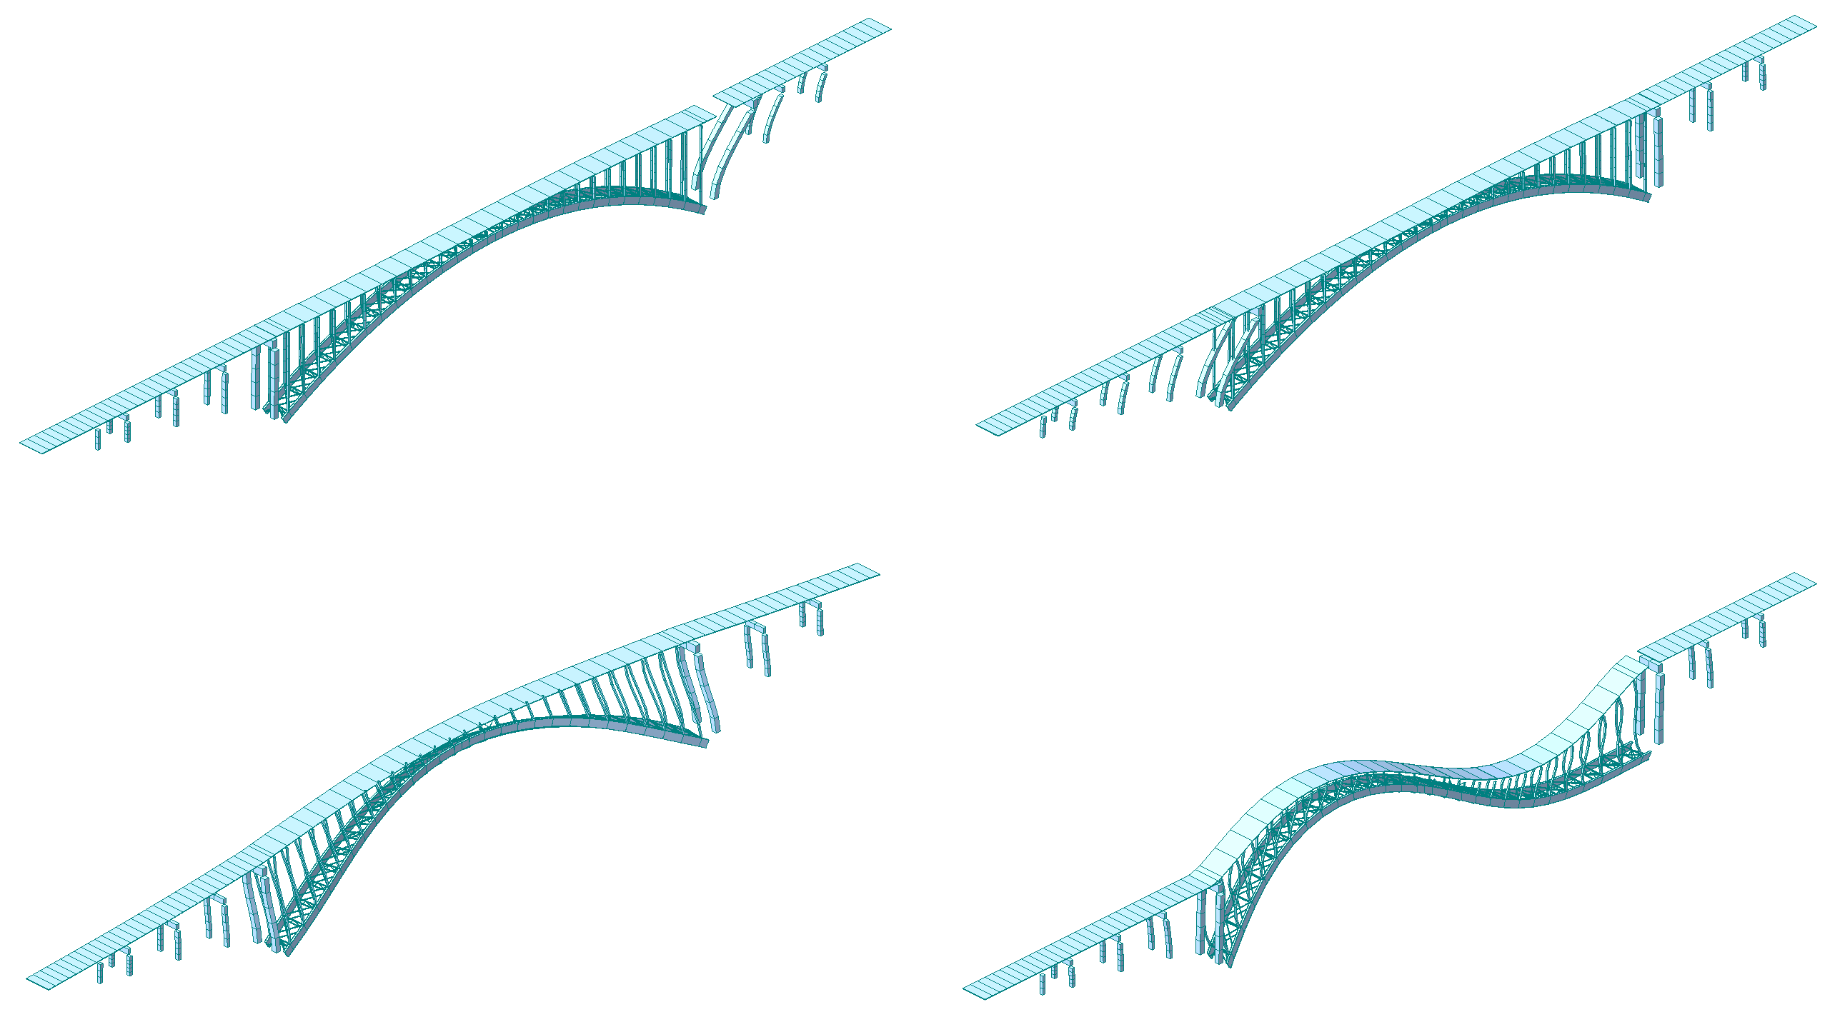
Arch longitudinal mode
1.14s
West approach mode
1.85s
East approach mode
1.94s
Arch transverse mode
1.56s

Figure 2: First Four Mode Shapes of the Alexandra Bridge
The spectral acceleration values at period values corresponding to these mode shapes are all 0.17g or less. The calculated demands were compared with elastic deformation and component capacities. These analyses were also used to select the desired stiffnesses of the bearings, and ensure the maximum displacements at the joints could be accommodated by the joint components. Non-linear moment-curvature and pushover analyses were performed on individual concrete pier column elements in the structure to obtain accurate element level results.
The bridge was initially assessed at multiple return period seismic demand levels, but the response of the structure to the highest demand considered, the 2475 year level, was within acceptable limits. Accordingly, lower seismic demands were not considered further. The steel structure was found to remain elastic and the strains in the reinforced concrete elements were within acceptable limits considering the 2475 year hazard level demands. The criteria for assessing the concrete behaviour were taken from Priestley et al. (2007). First yield is defined as the point where the outermost tension reinforcement reaches its yield strain (taken as 0.2%). The highest strain values obtained from the analyses were for the Pier 2 columns, where the strain in the steel and concrete were 0.13% and 0.14%, respectively, resulting from a drift of 0.5% in the longitudinal direction (i.e. the concrete will remain elastic). The moderate seismic demand and the force reductions obtained by using the elastomeric bearings allowed the deformations in the concrete substructure to remain within acceptable limits. As a result, no further retrofit was required in the concrete substructure which was lightly reinforced and poorly detailed by today’s standards, although typical for the period in which the bridge was constructed.
- Rehabilitation and Retrofit Work Features
  - Reinforced concrete deck overlay
A major component of the rehabilitation work consisted of a reinforced concrete deck overlay with deck widening, and new, current standard parapets and railings. By eliminating the sidewalks, sub-standard railings, and including portions of new deck cantilevered beyond the outside girders with a reinforced concrete deck overlay, the existing narrow shoulders could be widened, and standard concrete parapets with steel bicycle railings, conforming to Test Level 4 as specified in the 2014 CHBDC, could be included improving the safety for the bridge users. The existing deck concrete was removed to below the existing reinforcing steel to inhibit future corrosion. A nominally 150 mm thick reinforced concrete overlay was constructed using stainless steel for the top layer of deck reinforcing and in the parapets with sufficient reinforcing to control crack formation and adequately anchor the parapets (Figure 6). The reinforcement in the overlay facilitated widening of the deck with new edge cantilevers, and was designed to accommodate a construction joint near the centreline of the roadway to accommodate two-stage construction. The deck cantilevers not only allow widening the roadway cross section, but importantly, will provide additional shelter for the exterior girders in the future.
In order to support the proposed deck rehabilitation, the previously lightly loaded exterior girders in the approach spans were made composite with the new deck by installing shear studs along their top flanges. Acting compositely, the capacity of the existing girders was sufficient in all but a few locations where additional strengthening was required (see Section 4.3 for a description of the superstructure modifications). The girders, floor beams and stringers of the arch span did not require any strengthening to accommodate the deck rehabilitation. However, local repairs were required in many locations to address section loss resulting from corrosion. The deck rehabilitation work increased both structural durability and user safety.

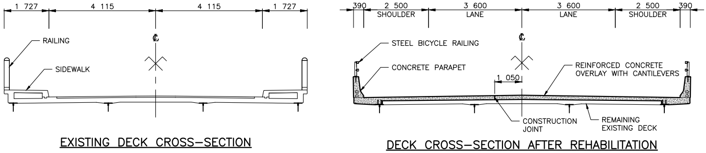
Figure 3: Bridge Deck Section Before and After Rehabilitation
  - Re-articulation of the superstructure
A clear and robust understanding of the load paths, and in particular, the seismic load paths was fundamental to determining the optimum articulation for an efficient and effective retrofit. A review of the record drawings and a close-proximity site inspection indicated that changing the existing structure articulation would optimise the seismic retrofit requirements. To re-articulate the structure, the existing steel pin and rocker bearings were replaced with vulcanised elastomeric bearings, and the four breather joints near the arch crown and at Pier 1 were replaced with link decks.
By removing the breather joints near the centre of the main arch span, and installing link decks, a much stiffer transverse seismic load path was created, and the demands in the vulnerable short columns near the crown of the arch were reduced to acceptable levels. The link decks eliminated joints at the source of preferential leakage paths from the deck to the structure below, thus significantly improving durability. Where the breather joints in the arch span `were replaced by link decks, the bearings supporting the wind girders were replaced with shallow (24 mm high) elastomeric bearings designed to accommodate the live load rotations at these locations. The link deck at Pier 1 was installed to improve the robustness of the seismic load path and enhance durability. Note that the bearing replacements were also required to accommodate the modified steel girder displacements resulting from the installation of the link decks.
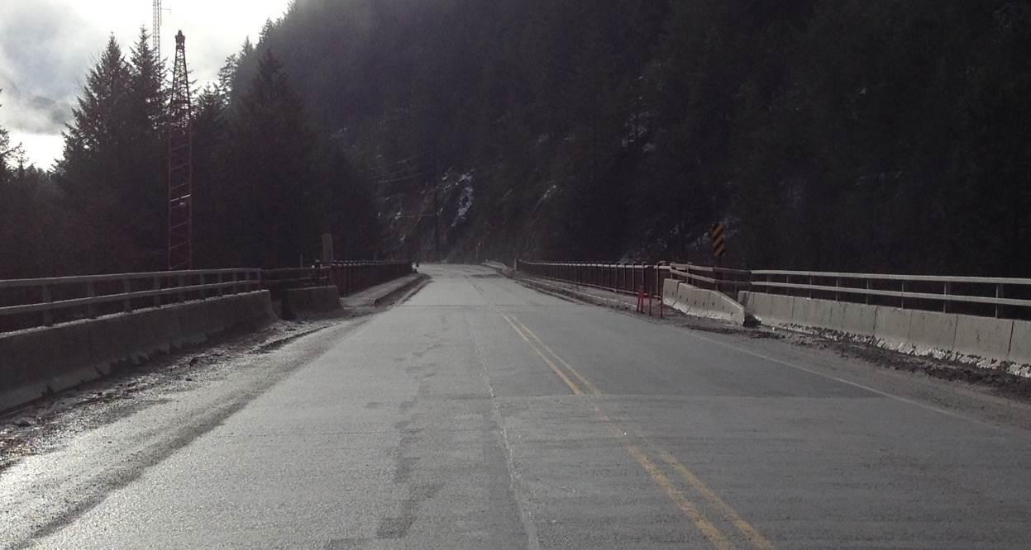Figure 4: Completed Deck Rehabilitation with Parapets and Barriers over the Arch Span (Foreground) and the Existing Deck of the West Approach Spans (Background)
Rehabilitated 12.20 m clear width with parapet and railing
Original 8.23 m clear width
West Abutment
The elastomeric bearings have the effect of partially isolating the superstructure, and hence reduce the seismic demands on the superstructure elements. Standard elastomeric bearings were designed to resist all vertical and horizontal loads. The bearing design was sufficiently robust that variations of up to 25% in the stiffness of the actual bearings when compared to the design would not require redesign during construction. To assure that the bearings would be adequate, a portion of all bearings installed were tested to serviceability load levels, and a further one of each specific type of bearing was tested to ultimate load levels, followed by a complete destructive test.
Figure 8 shows a portion of the retrofit at the top of Pier 4 – the new elastomeric bearings and a new jacking location for a west approach span. The taller bearings at the end of the arch span are required to accommodate the larger seismic and thermal displacements of the arch span (Figure 8).
The bearing replacement design required installation of jacking locations at all replacement locations. At most supports, jacking stiffeners were added to the steel girders, located above jacks placed on the concrete substructure. In order to replace the bearings at Pier 1, the end diaphragm of System 1 was replaced with sturdy jacking beams. At Columns 1 and 2 in System 1, permanent concrete corbels were installed, which will facilitate future girder jacking and bearing replacement.
The lightly reinforced concrete piers and columns were strengthened with dowels through the columns and pier caps to accommodate horizontal bearing forces and splitting forces due to bearing loads in a more robust manner (see example in Figure 8).

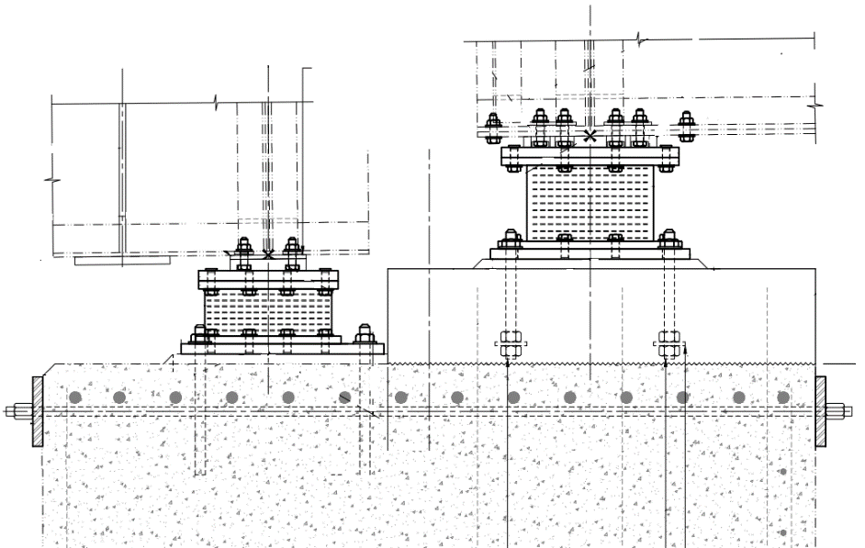
West approach spans
(System 2)
Arch span (System 3)
Jacking Location
149 mm high reinforced elastomeric bearing
239 mm high reinforced elastomeric bearing
Strengthening dowels through pier cap

Figure 5: Section at the Top of Pier 4.
  - Superstructure modifications
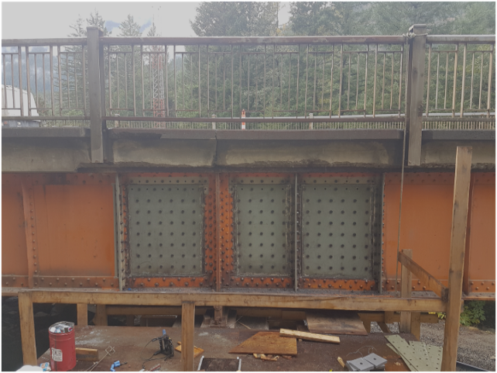
The load evaluation results highlighted superstructure locations in the approach spans where the demand after the deck widening exceeded the member capacity. The flexural capacity in some exterior girder locations in the irregular west approach spans (Systems 1, 2 and 4) was inadequate to carry the widened deck, and this deficiency was addressed by making all exterior girder composite with the reinforced concrete deck overlay. Nelson shear studs were welded to the top of the upper flange to mobilize composite behaviour with the concrete deck. This solution was very convenient, and by making only the exterior girders composite facilitated the deck rehabilitation work by allowing the concrete deck between the exterior girders (or wind girders) to remain in place and act as formwork for the reinforced concrete deck overlay throughout construction.
Figure 9: Shear Panel Strengthening
Similar custom retrofit solutions were developed to address insufficient capacity at positive moment, shear, and combined moment/shear locations in the irregular west approach spans (System 1): Positive moment strengthening was performed by adding cover plates to the bottom flange; shear strengthening was achieved by proving additional stiffeners; combined moment/shear strengthening utilised panelised web overlay plates carefully detailed and bolted into place (Figure 9).
The deck rehabilitation required additional stability considerations for the irregular west approach spans (System 1). The additional cantilevered dead deck and live load loads resulted in greater uplift forces at the West Abutment and Pier 1 bearings which exceeded the capacity of the original bridge counterweights. Accordingly, the counterweight was enlarged at the West Abutment. At Pier 1, uplift was avoided, since the new link deck tied System 1 to System 2, and the combined downwards forces at Pier 1 exceeded the uplift force created by System 1 only.
  - Other features
Other features of the rehabilitation work either flowed from the deck widening, resulted from existing deterioration, or were required to improve structural durability.

The abutment backwalls and wing walls required modification to accommodate the widened roadway. Wing walls and backwalls were trimmed, and new approach slabs with parapets cantilevered over the existing wing walls. The approach slabs are supported by soil only. A flexible layer was used to separate the underside of the approach slabs from the top of the wing walls to avoid a load increase which may have required wing wall strengthening. Corbels were installed at the approach slab ends to accommodate the historic salmon sculptures installed at the four bridge approach corners (Figure 10). In addition, a concrete wall was added in the northwest corner of the bridge to protect the bearings and bearing seat from debris and rock fall.
Figure 10 Salmon Sculpture at Bridge Approach
As part of the structural re-articulation described in Section 4.2, the deck joints at the arch ends (Piers 4 and 5) and the abutments were retained. The existing deck joints needed to be replaced or modified because the top of deck was approximately 90 mm higher than the existing deck. Replacement was selected, which provided the opportunity to replace the existing joints with robust new joints, while addressing joint leakage and other durability concerns at the same time. The expected joint movements at the arch ends required the use of finger joints; while the displacements at the abutments were readily accommodated by economical and reliable strip seal joints.
The open finger joints also serve as the primary drain outlets for the reconfigured deck drainage system. Accordingly, we designed robust plumbing systems beneath the expansion joints to convey deck run-off to the base of the piers. In addition, deck drains were installed near the East Abutment and Pier 1 to accommodate changes in roadway cross section, where the crowned bridge deck became superelevated to accommodate the roadway approach curves. Reconfiguration of the deck drainage system eliminated a multitude of drainage pipes and leakages over the entire length of the structure, which will minimize future structural deterioration and maintenance requirements beneath the deck.
The contract also included partial recoating of the steel floor system in order to address the most urgent zones of deterioration. Concrete repairs were carried out in the substructure to repair local delamination.
- Discussion
The rehabilitation and retrofit work items for the Alexandra Bridge were designed to maximize overall benefits by taking advantage of synergies to cost-effectively rehabilitate the iconic structure. For example, the installation of link decks not only created a robust seismic load path, but increased durability by eliminating several deck joints. The deck cantilevers and parapets not only improved roadway safety, but significantly enhanced the protection of the steel structure from salt spray, moisture, and solar radiation. The seismic upgrading in this moderate seismic zone was achieved efficiently by replacing the existing vulnerable and deteriorated steel bearings with laminated elastomeric bearings and the installation of the link decks. This approach avoided any potentially costly retrofitting of the lightly reinforced and poorly seismically detailed substructure.
The rehabilitation work needed to accommodate several constraints, notably with respect to traffic operations during construction, active railway lines below the approach spans, and limited space for access and laydown areas. The rehabilitation work was designed to accommodate two-stage construction of the overlay to allow for single lane alternating traffic at all times. The contract had envisaged completion of one side of the deck overlay in two successive construction seasons; however, in the end, the contractor chose to carry out the deck rehabilitation of the entire arch span in 2017 and the approach spans in 2018. This allowed the bridge to be opened for two-lane traffic for the winter, as required by the contract, and simplified tie-in details with minimal temporary work between the rehabilitated deck and remaining portions of the existing structure.
Ongoing discussions between the owner and consulting engineers were maintained throughout the design development to assure that optimum value could be achieved by the rehabilitation. The discussions focused on scope of the rehabilitation work as well as design decisions. For example, the number of traffic lanes was deliberately limited to two, even though the rehabilitated deck is wide enough to accommodate three lanes of traffic. However, catering for three traffic lanes would have required a significant amount of additional strengthening. Based on the current amount of traffic and expected future traffic patterns, this provision was considered to be an unnecessary part of the current rehabilitation work.
The current rehabilitation and retrofit project is a large step towards preserving the Alexandra Bridge for generations to come. The work will significantly reduce the need for future maintenance and slow deterioration in the existing structure. However, detailed inspection of the arch span and full recoating of the steel structure was excluded from the scope of the project, and future work will be required to recoat the steelwork and address corrosion in the arch span.
- Conclusions
The Alexandra Bridge is one of the key structures on Trans-Canada Highway 1 in the Fraser Canyon in British Columbia. A major deck rehabilitation and seismic retrofit were part of an efficient rehabilitation scheme, that maximized synergies between several rehabilitation work items. Construction is currently underway with an expected completion at the end of 2018. The work will significantly improve user safety and structure durability. While there are still some portions of the structure to be rehabilitated, this project was a big first step in the renewal of the Alexandra Bridge which will minimize future interventions and maintenance.

Acknowledgements
Associated Engineering would like to thank the staff of the British Columbia Ministry of Transportation and Infrastructure for their efforts in making this project a success and for their contribution to this paper.

References
Priestley, M.J.N., Calvi, G.M., and Kowalsky, M.J. 2007. Displacement-Based Seismic Design of Structures. IUSS Press, Pavia, Italy.
B.C. MoTI. 2016. B.C. Ministry of Transportation and Infrastructure Bridge Standards and Procedures Manual, Supplement to CHBDC S6-14. BC MoTI, Victoria, B.C., Canada.
Canadian Standards Association. 2014. CAN/CSA-S6-14 - Canadian Highway Bridge Design Code. Canadian Standards Association, Rexdale, Ontario, Canada.
Golder, H.Q. and A.B. Sanderson, A.B. 1961. Bridge Foundation Preload. Engineering Digest, June 1962, 34-37.
Natural Resources Canada (NRCan 2016). 2015 Seismic Hazard Calculator <http://www.earthquakescanada.nrcan.gc.ca/hazard-alea/interpolat/index_2015-en.php>. Accessed June 14th, 2016.

