 | 10th International Conference on Short and Medium Span Bridges  Quebec City, Quebec, Canada,  July 31 – August 3, 2018 | 

WESTHAM ISLAND BRIDGE REHABILITATION – A CASE STUDY
Ian Walters¹ and Leggett, Casey^{1,2}
¹ Mott MacDonald, Canada
² casey.leggett@mottmac.com

Abstract: One of Metro Vancouver’s oldest, most interesting and historic structures, the Westham Island Bridge is the single gateway onto Westham Island in Delta, BC, which is home to key agricultural developments, a sports club, and popular local tourist attractions. Now entering its 107th year, the Westham Island Bridge needs a comprehensive structural assessment and rehabilitation study that will consider extending the structure’s life for another 20 to 25 years such that it can continue to provide safe and reliable access to the island. Mott MacDonald has been retained by the Owner to undertake this asset preservation work in three phases comprising a comprehensive structural assessment and preparation of a rehabilitation plan, detailed design of the rehabilitation works, and construction support. This paper describes the recent work undertaken in Phase 1 to formulate a cost-effective rehabilitation strategy for the bridge.
1 INTRODUCTION
1.1 Project Background
Due to its age, the Westham Island Bridge has required near continuous monitoring and interventions to address ongoing deterioration. In recent years, the rate of deterioration of various elements has increased, resulting in more frequent repairs and interventions. In 2016, Mott MacDonald was retained by the Owner, South Coast British Columbia Transportation Authority (TransLink) to undertake Phase 1 of the Westham Island Bridge Rehabilitation Project, comprising a comprehensive structural Condition Assessment, a Live Load Evaluation and preparation of a Rehabilitation Plan for the Bridge. The work on this phase was completed by mid-2017 and is the subject matter of this paper.
The ongoing project includes additional phases currently underway for detailed design, procurement, and construction support services, with the aim of overall project completion at the end of 2018. Overall, the project will help the Owner to manage the existing bridge more efficiently until its anticipated replacement by reducing the need for frequent monitoring and interventions over its remaining service life.
1.2 Description of the Bridge
Westham Island Bridge, known as 0053 Canoe Pass in BC Ministry of Transportation and Infrastructure (Ministry) documentation, was constructed between 1909 and 1912. Most, if not all, of the structure’s components have been replaced during its life to date. Except for alternating single lane traffic on the trusses and opening span, the bridge carries two lanes of traffic across Canoe Pass in the Fraser River Estuary from Delta on the mainland to Westham Island (Figure 1).
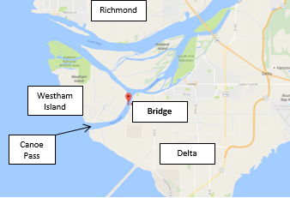
Figure 1: Location Plan
The posted vertical clearance is 4.38 m which requires traffic to be travelling within the centre 3 m of available road width through the single lane, through-truss spans. The minimum horizontal clearance is 4.37 m; however, the vertical clearance at the road edge is further restricted to approximately 2.8 m by portal frame diagonal bracing at each end of the trusses.
The 325 m long, 34-span bridge is comprised of trestle-style approaches, constructed largely of timber elements with several spans supported by steel stringers. The approaches provide access to a 38 m timber Howe Truss, a 50 m steel Callender-Hamilton Truss, and a two-span, 44 m movable steel Howe truss – the Swing Span, which cross the main channel of the river (Figures 2 and 3).
According to available records, the West Approach and Howe Truss were replaced or reconstructed in 1950, the Swing Span in 1957, the Callender-Hamilton Truss in 1971 and the East Approach in 1987. Significant repairs and upgrades were subsequently undertaken on the bridge in the early 2000’s coinciding with an increase in the posted limit from 20 to 50 tonnes Gross Vehicle Weight (GVW). The next significant repair contract will take place in 2018 as part of this project.
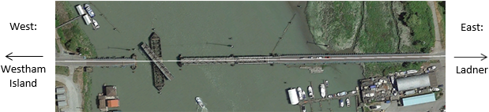
Figure 2: Aerial View
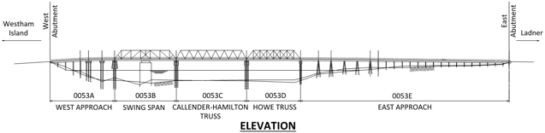
Figure 3: Bridge Geometry
2 Condition Assessment
The detailed, on site Condition Assessment of the bridge was completed over 4 days between September 6th and September 14th, 2016.
2.1 Scope of Work
The assessment comprised above and below water visual inspections of the bridge including coring (i.e. resistance drilling) a representative number of timber components to identify evidence and location of fungal decay, residual thickness measurements of steel components exhibiting corrosion related deterioration, mechanical and electrical inspections of the slew bearing components for the swing span, spot dimension checks on primary structural components, and preparation of a factual summary report presenting the results of the assessment.
2.2 Inspection Challenges
Some of the challenges experienced while conducting the assessment included very poor underwater visibility mostly requiring a hands-on feel technique, tidal variations preventing close-up inspection of some lower pier components, and lack of close-up access to the underside of in-span deck elements located over water and away from the piers. The assessment recommended that these locations, together with inaccessible parts of the timber Howe Truss tension rods hidden within the truss chords, should be inspected as part of the next construction contract.
2.3 Assessment Results
The main observed deteriorations were related to the age of the bridge and its components which are generally beyond or approaching their anticipated original design service life, as shown in Figure 4 and Figure 5. Common deteriorations included internal fungal decay in timber elements and varying degrees of corrosion and perforations in steel components.
Of note, the nature of the bridge system and porosity of the timber deck has led to below deck steel elements suffering significant corrosion related section loss from exposure to runoff water with high concentrations of de-icing salts. The worst examples of this type of deterioration were found in the significantly perforated end floor beams of the Callender-Hamilton Truss, leading to a separate recommendation to urgently repair or replace these components in 2016, Figure 6 and Figure 7, and closely inspect the remaining floor beams and stringers during the next major intervention. The end floor beams of the truss were replaced in 2017.

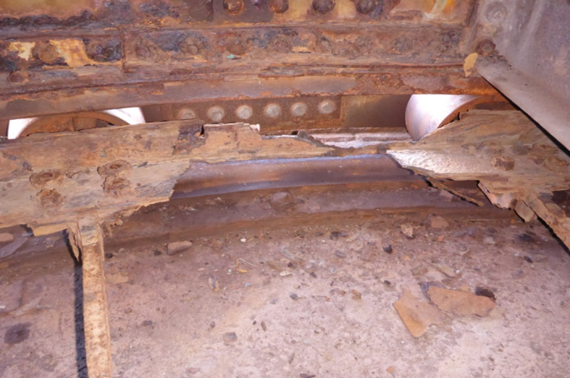
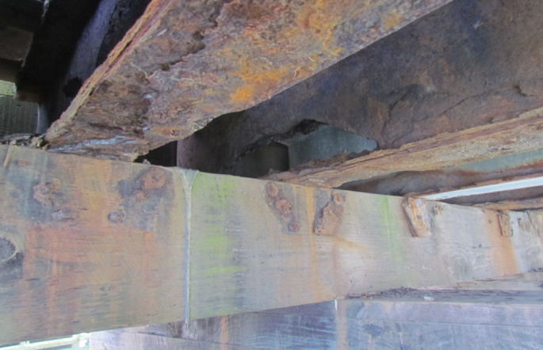
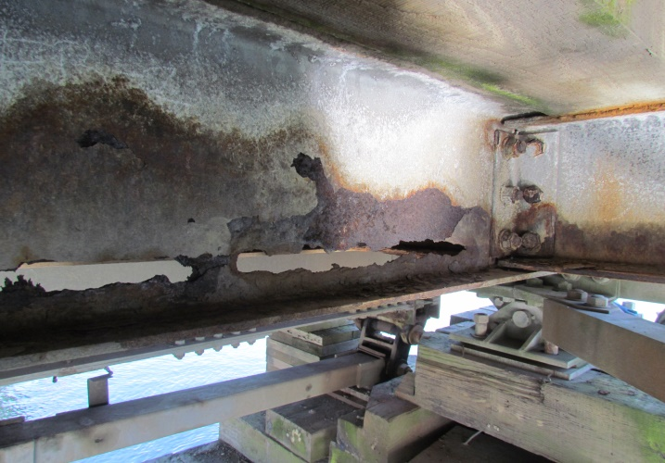
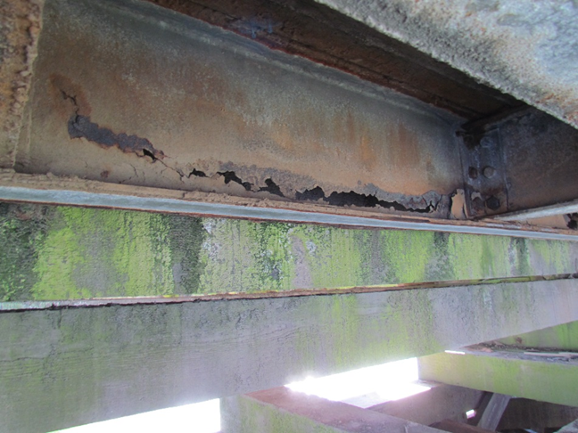
Figure 4: Swing Span slew bearing deterioration Figure 5: Corroded older West Approach stringers
Figure 6: Pier 5 end floor beam perforations Figure 7: Pier 6 end floor beam perforations
From the results of the Condition Assessment, the deteriorations and/or deficiencies – collectively termed “Needs”, were separated between those of a maintenance and rehabilitation type. All rehabilitation needs were assigned an Urgent, Short-term or Long-term priority based on safety and estimated repair cost criteria for further consideration during development of the Rehabilitation Plan. An estimate of the remaining service life of the bridges’ major structural components was also prepared to help prioritize the rehabilitation options. Since the service life of a component depends on many variables including changes in materials, environmental and exposure conditions over time, and implementation of regular and effective maintenance programs over the life of a structure, it is often common for elements to perform satisfactorily well beyond their typical estimated service life and this was observed in many components of the bridge.
The Condition Assessment found that except for the Callender-Hamilton floor beams, the remaining spans and components of the bridge were generally considered to be in a serviceable condition, and provided recommendations for monitoring and repairs to be scheduled through the Rehabilitation Plan.
3 Live Load Evaluation
3.1 Scope of Work
A detailed Live Load Evaluation of the bridge was completed considering the degree of deterioration found in some components during the Condition Assessment. Additionally, to determine and estimate the existing and future loading conditions of the bridge, a functional review including a canvas survey of bridge users and a visual traffic survey was conducted.
Evaluation of the various bridge elements was undertaken in accordance with Section 14 of the Canadian Highway Bridge Design Code (CSA 2014) using the Evaluation Level 1 CL1-625 Truck and Lane Loading model. Live Load Capacity Factors (LLCFs) for each of the governing structural components were calculated. The LLCF indicates the available residual capacity of a component to carry the design live load in excess of the dead load. Therefore, a LLCF greater than 1.0 indicates that the element has sufficient capacity for the design live load and a LLCF of 0.81 at Evaluation Level 1 is equivalent to a posting limit of 50 tonnes.
3.2 Evaluation Results
The Live Load Evaluation generally confirmed the appropriateness of the current 50-tonne posting limit on the Bridge. Most of the element capacities were found to exceed this loading demand without necessitating additional strengthening. A handful of elements were shown to have slightly less capacity than required for the current posting limit; however, all were deemed sufficient when considering relatively conservative simplifications made in the analysis combined with observations of satisfactory performance from the field. Many of the elements were also found to have sufficient reserve capacity to support the standard design vehicle (63.7 Tonnes). Table 1 identifies those elements that would require strengthening to accommodate the standard design vehicle and remove the 50-tonne posting limit.
Table 1: Elements Deficient for CL1-625 standard design vehicle
Element | Governing  LLCF | Force  Effect | Posting  (tonne) | Potential Upgrade / Comment
West Approach Ties (P1 to P3) | 0.55 | Moment | 34 * | Add stingers
West Approach Timber Stringers | 0.79 | Moment | 49 | Add stringers
West Approach Steel Stringers | 0.89 | Moment | 56 | Add stringers
Swing Span Timber Stringers | 0.80 | Moment | 50 | Add stingers
Swing Span U2-U3 | 0.80 | Compression | 50 | Strengthen
Callender-Hamilton U4-U5 | 0.95 | Compression | 60 | Refine analysis / strengthen
Callender-Hamilton L2-U3 | 0.95 | Compression | 60 | Refine analysis / strengthen
Howe Truss Timber Stringers | 0.90 | Shear | 56 | Add stringers
East Approach Planks | 0.85 | Moment | 52 | Refine analysis
Piles – Geotechnical Capacity | < 1.0 | Geotechnical | Unknown | Investigation / refine analysis
* Ignoring the support of highly corroded older stringers
The functional review indicated that the number of vehicles crossing the bridge has doubled since the last known survey was conducted in 2002 but the percentage of truck traffic has reduced and the number of trucks crossing the bridge is comparable to the previous survey. Given the findings of the live load evaluation and the survey of regular bridge users, the Live Load Evaluation recommended maintaining the current posting load limit of 50 tonnes on the Westham Island Bridge and not implementing improvements to eliminate the posting limit.
4 Rehabilitation Plan
4.1 Scope of Work
A Rehabilitation Plan was prepared for the bridge comprising an outline of Rehabilitation Treatment options and unit costs at a component level, identification of possible Rehabilitation Options detailing the type and timing of Treatments to be applied to each component when treating the bridge as a whole, evaluation of the Rehabilitation Options including life cycle costs, and recommendation of a preferred plan for adoption as the Westham Island Bridge Rehabilitation Plan.
Although not part of the assignment scope, the Rehabilitation Plan acknowledged the existing functional constraints that would not be addressed with Rehabilitation Options that extend the current bridge type and configuration indefinitely. These include the load limit posting, substandard horizontal and vertical clearances, non-redundant nature of the truss spans, uncertainties in reliably assessing condition of timber members, single lane alternating conditions, traffic disruption and costs due to swing span operations, non-standard accommodation of pedestrians and cyclists, and safety risks. These are noteworthy given that no alternative road access onto or off Westham Island is available.
4.2 Rehabilitation Treatments
Rehabilitation Treatments describing specific repairs or rehabilitation methods for each component’s identified needs were investigated. Where more than one repair or rehabilitation type was possible, a variety of Treatments was presented allowing for evaluation of different alternatives to address the same issue. The benefits and concerns for each Treatment were evaluated; infeasible and significantly high-cost options were then discounted, and the Treatments were refined and combined to create Rehabilitation Options which consisted of a series of interventions occurring over time to coincide with the service life of one or more of the Treatments.
Of note, the unique nature of the existing timber Howe Truss presented reason for caution (Figure 8). Despite the truss being found in serviceable condition, discussions with the Ministry indicated a preference for phased replacement of their remaining older in-service timber Howe trusses, mainly due to the difficulty in effectively detecting all internal deterioration within the treated timber components, combined with the lack of redundancy in trusses which results in a risk of collapse due to failure of a single member. The Ministry had recent experience (circa 2009) with a similar Howe truss in BC where an unexpected compression failure of a timber diagonal member resulted in the need for immediate bridge closure and emergency repairs. The truss did not collapse; however, the risk was present and immediate traffic closure due to the maintenance contractor’s presence in the area was fortunate. Extensive repairs were completed allowing the bridge to remain in service prior to construction of a replacement, planned for around 2019.
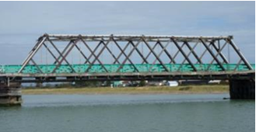
Figure 8: Westham Timber Howe Truss
The experience was particularly concerning as the bridge had recently undergone a condition assessment, including representative resistance drilling on its timber truss elements. The drilling had identified some internal decay and repairs were being planned; however, the exact location that failed had not directly been drilled.
Several additional studies or investigations that could be used to reduce risk for certain items and refine construction cost and duration estimates, were identified during the work and included in the Rehabilitation Options to ensure adequate information would be available for the continued rehabilitation and asset management of the structure. These included a more intensive condition assessment of the timber Howe Truss possibly using compression wave methods or densely concentrated resistance drilling, a hydrographic survey and assessment of scour, a detailed assessment of the existing steel coatings, and a planning level study to begin assessing the issues and costs associated with bridge replacement.
4.3 Rehabilitation Options
Three potential Rehabilitation Options detailing the type and timing of Treatments to be applied to each component were identified. The Options recognized the current age, condition, and residual life estimates of the bridges’ major components. Additionally, they considered existing functional limitations, the significant annual operating cost of the Swing Span and maintaining an older timber and steel bridge, and reliability. The Options assumed that the existing load posting would remain in place indefinitely and were based on anticipated bridge replacement occurring between 15 and 25 years from the present time. Extending the service life of the bridge beyond 25 years was not recommended due to its functional deficiencies and age, and was thus not explored further.
Rehabilitation Option 1 minimized the necessary number and scope of interventions required to continue to operate the bridge until a full replacement could be undertaken around Year 15. Subsequent evaluations could be undertaken approaching this date to confirm the need for replacement or the potential to extend the service life further. The scope of Option 1 could also be further reduced depending on the certainty and timing of a replacement bridge as well as the observed progress of deterioration over time.
Rehabilitation Option 2 provided a more extensive initial intervention and included further significant interventions in Year 10 and Year 15 enabling extension of the service life to Year 25 at which time bridge replacement was assumed. Option 3, a variant of Option 2 with timber Howe Truss replacement in Year 10, was also considered.
As a means of comparison for life cycle costing and qualitative analysis, the Rehabilitation Options also included the scenario where Westham Island Bridge is replaced in the near future. A new structure would resolve noted functional deficiencies with the existing bridge. It was anticipated that any bridge replacement would comprise a two-lane structure designed to current standards with a separate sidewalk for pedestrians and an assumed total deck width of approximately 10 m. The bridge geometry would accommodate a navigation envelope appropriate for the location, eliminating the need for a movable span. A high-level cost estimate based on a unit cost per square metre of deck area approach was undertaken. Allowing for construction, engineering cost, contingency, and deconstruction of the existing bridge, the estimated cost for replacement was $20.7 Million. This excluded costs for project management, planning, property acquisition, environmental, and construction supervision.
The Westham Island Bridge is a necessary component of the Lower Mainland road network providing the only road access to residential, recreational, and commercial properties on Westham Island. Accordingly, a ‘do nothing’ or reactive Rehabilitation Option where all capital expenditures are delayed until they are necessary to ensure continued safe operation of the structure, was not recommended due to the potential risks involved in this strategy.
4.4 Evaluation of the Rehabilitation Options
The Rehabilitation Options were evaluated based on Quantitative and Qualitative criteria mutually agreed with the Owner, to select a preferred option for recommending as the final Rehabilitation Plan.
4.4.1 Quantitative Analysis
The quantitative analysis included a life cycle costing, in accordance with the Ministry’s template and guidelines [BCMoTI 2012], used to rank the Options on economic considerations. A cost summary of the Rehabilitation Options was presented as summarized in Table 2. It included capital costs for the initial intervention (Year 0) as well as NPV costs, at a range of discount rates, for each Rehabilitation Option considered.
Table 2: Cost Summary of Rehabilitation Options including Operations and Maintenance*
Rehabilitation Option | Initial Cost  [Million $]  (% above 1) | NPV (5% disc.)  [Million $]  (% above 1)
Option 1 | $0.9M | $14.1M
Option 2 | $1.4M (53%) | $12.7M (-10%)
Option 3 | $1.4M (53%) | $12.9M (-9%)
Benchmark | $20.7M | $21.2M (51%)
* The cost summary was also investigated excl. O&M
Generally, the initial intervention costs for Options 2 and 3 were $0.5M, or 53%, higher than Option 1. In all options the initial intervention costs were substantially below cost of a replacement. At a 5% discount rate, Option 1 was approximately 10% higher than Options 2 and 3 but within the intended accuracy of the costing exercise, thus the NPVs were considered as comparable to one another.
Examining the interventions in current (2017) dollar capital allocations for each of the Options over the next 25 years highlighted the reduction in overall capital expenditures anticipated for Option 1 relative to Options 2 and 3. Including operations and maintenance the total for Option 1 ($26.3M) was approximately $5.5M or 17%, less than the other rehabilitation options. Excluding operations and maintenance this total dropped to $21.8M, approximately $2.5M, or 10% less than the other options.
The amount of capital spent on rehabilitation of the existing structure between the three options was also worth noting. The cumulative capital required prior to bridge replacement, in 2017 dollars and excluding operations and maintenance, was $1.1M, $3.5M, and $3.8M for Options 1, 2, and 3 respectively.
4.4.2 Qualitative Analysis
In addition to the life cycle cost analysis, a qualitative evaluation of other relevant considerations was undertaken to aid in the selection of a preferred Rehabilitation Option. The Owner defined the evaluation criteria which are divided into three categories aligned with the Owner’s priorities: ‘Ensure State of Good Repair’; ‘Customer Experience & Public Support’; and, ‘Business Efficiency’.
The ‘Ensure State of Good Repair’ priority captures evaluation criteria for technical, safety, and O&M risks. Technical risks account for the likelihood and consequence of events such as bridge ‘failure’ and the condition of deteriorated components being worse than anticipated creating additional challenges for rehabilitation. Similarly, technical risks are assumed to capture potential for underestimating the total amount of rehabilitation work required for a particular item. Safety risks account for impacts on the ability to provide safe operations and includes consideration for potential incidents resulting from functional deficiencies. O&M risks account for functional impacts to the users resulting from things such as deteriorated ride quality, increased frequency and/or extent of maintenance activities, and unanticipated rehabilitation interventions.
The ‘Customer Experience & Public Support’ priority captures traffic and environmental impacts. Traffic impact accounts for the frequency and duration of disruptions for planned and unplanned rehabilitation activities as well as the potential for longer than expected traffic closures due to technical challenges. Environmental impact accounts for work over navigable waterways, construction in sensitive areas, community impacts due to dust and noise, and removal of hazardous materials.
The nature of traffic impacts will vary depending on the intervention, as determined during detailed design to suit construction methods; however, it is anticipated that the typical intervention would include regular short duration closures (+/- 30 mins) and/or periodic longer duration closures extending 4 to 12 hours in length. A handful of events, primarily the replacement of the timber Howe Truss (Option 2B), would be anticipated to extend for one or more 24-hour period consecutively. Alternative measures for provision of emergency response may be required for certain activities. Traffic disruption due to construction activities of a replacement bridge were not considered in the analysis.
The ‘Business Efficiency’ priority captures financial impact and reputational risks. Financial impact accounts for the project cost and potential NPV savings of the options. Reputational risks account for impact to the Owner’s reputation including consideration for the length of time an event may attract media and/or stakeholder attention.
Each evaluation criterion was assigned a ranking to indicate its level of impact or risk relative to the other options; this is outlined in Table 3 below.
Table 3: Qualitative Analysis of Rehabilitation Options
TransLink Priorities | Evaluation Criteria | Option 1: Minimum Intervention to Year 15 | Option 2: Service Life Extension to Year 25 | Option 2B:  Option 2 with Timber Truss Replacement | Option 3:  Replacement Now
Ensure State of Good Repair | Technical Risks | Lower | Medium | Lower | Lower
Ensure State of Good Repair | Safety Risks | Medium | Higher | Higher | Lower
Ensure State of Good Repair | O&M Risks | Medium | Higher | Higher | Lower
Customer Experience & Public Support | Traffic Impact | Medium | Higher | Higher | Lower
Customer Experience & Public Support | Environmental Impact | Lower | Lower | Lower | Medium
Business Efficiency | Financial Impact | Medium | Lower | Lower | Higher
Business Efficiency | Reputational Risks | Medium | Higher | Higher | Lower

The Qualitative Evaluation demonstrates that it is generally beneficial to replace the structure earlier. Option 1 which assumes a replacement in 15 years allows an appropriate amount of time to plan, consult, and advance the necessary work prior to bridge replacement.
4.5 Recommendation for the Rehabilitation Plan
A thorough analysis of Rehabilitation Options for the Westham Island Bridge was undertaken. Based on available information and results of the analysis, Rehabilitation Option 1 intended to extend the life of the existing bridge by a further 15 years before replacement, was recommended as the preferred strategy to carry forward as the Rehabilitation Plan.
4.6 Lessons Learned
Many lessons were learned from the work undertaken on the Westham Island Bridge Project and serve as good reminders of the needs and challenges that exist when extending the service life of our older infrastructure.
Some examples of the more interesting challenges to be considered by engineers undertaking similar rehabilitation projects include the relevance of operations and maintenance costs for structures of similar age and type, the importance of careful detailing to ensure effective and continued control of chloride-laden run-off water away from steel bridge components, the difficulty in predicting the remaining service life of timber and steel structural components that demonstrate a wide range of performance in the field, the importance of regular monitoring and maintenance of components including protective coatings, the importance of maintaining detailed and complete historic records of all repair work undertaken over a structure’s life, and the potential shortcomings of older timber trusses which lack structural redundancy and create challenges with effective condition monitoring using standard accepted assessment techniques.
5 Closure
Mott MacDonald has completed Phase 1 of the Westham Island Bridge Rehabilitation Project, comprising a comprehensive Structural Assessment, Live Load Evaluation and preparation of a Rehabilitation Plan for the Bridge. Detailed design of the first intervention contract is currently in progress for anticipated construction during 2018. Overall, the Project will help TransLink to manage the bridge more efficiently until replacement, by reducing the need for extensive frequent monitoring and interventions over its remaining service life.
Acknowledgements
The Condition Assessment of Phase 1 was completed by Advisian, working as sub-consultant to Mott MacDonald Canada Limited. The authors wish to acknowledge South Coast British Columbia Transportation Authority (TransLink) for giving permission to publish this paper.
References
CSA. 2014. Canadian Highway Bridge Design Code, CAN/CSA-S6-14. Canadian Standard Association, Toronto, Canada.
BCMoTI. 2012. Guidelines for Structure Renewal Options Analysis. British Columbia Ministry of Transportation and Infrastructure, South Coast Region, British Columbia, Canada.

