|  |  |  |
| --- | --- | --- |
|  | **10th International Conference on Short and Medium Span Bridges**  **Quebec City, Quebec, Canada,**  **July 31 – August 3, 2018** |  |

**ABERDEEN WESTERN PERIPHERAL ROUTE/BALMEDIE TO TIPPERTY**

Lyttle, Peter1,2

1 Jacobs CH2M, UK

2 peter.lyttle@ch2m.com

**Abstract:** The Aberdeen Western Peripheral Route/Balmedie to Tipperty (AWPR/B-T) is a $900 million project located in the north east of Scotland. The new Special Road will provide an alternative route around the western periphery of Aberdeen City, from Stonehaven in the south, to Blackdog in the north, with an upgraded section of Trunk Road from Balmedie to Tipperty, north of the city. The project is being undertaken by Aberdeen Roads Limited (ARL), the Special Purpose Company appointed to design, build, finance and operate the scheme (DBFO). ARL appointed AWPR Construction Joint Venture, comprising Balfour Beatty and Galliford Try (t/a Morrison Construction) as New Works Contractor to design and construct the scheme, with the design being undertaken by a design joint venture of CH2M and Atkins (the DJV). The road is of strategic importance to the economic development of Scotland’s north east as it will reduce traffic congestion in Aberdeen City, improve road safety and reduce the pollution levels in the city centre. The project entails the detailed design and construction of 79 principal structures (PS) consisting of two post tensioned balanced cantilever structures spanning the Rivers Dee and Don along with eight steel composite structures, 54 prestressed beam bridges of varying span configurations along with 2 significant reinforced concrete arches, 10 reinforced concrete box structures and three wildlife crossings. The challenges include the crossing of several watercourses, the Aberdeen Inverness railway and both INEOS (BP) and Shell natural gas and oil pipelines. In addition to the principal structures there are also 78 reinforced concrete culverts of varying sizes along the route.

This paper will describe the integrated design and construction philosophy adopted by the CJV/DJV and how the considerable engineering challenges were met. The design and construction of the AWPR/B-T incorporates a number of the key themes to be addressed by the conference including large projects, innovative design and aesthetics in structural design.

1. **INTRODUCTION**

The AWPR/B-T project is a major transport infrastructure project predicted to significantly improve travel in and around Aberdeen and the north east of Scotland. This project is at the heart of the Scottish Government’s commitment to improve transportation links in Scotland. The road will help to support sustainable economic growth, reduce congestion by reducing journey times, whilst improving road safety and reducing levels of pollution in Aberdeen City Centre. The project is being delivered by Transport Scotland, the national transport agency, on behalf of the Scottish Government, and in partnership with Aberdeen City Council and Aberdeenshire Council.

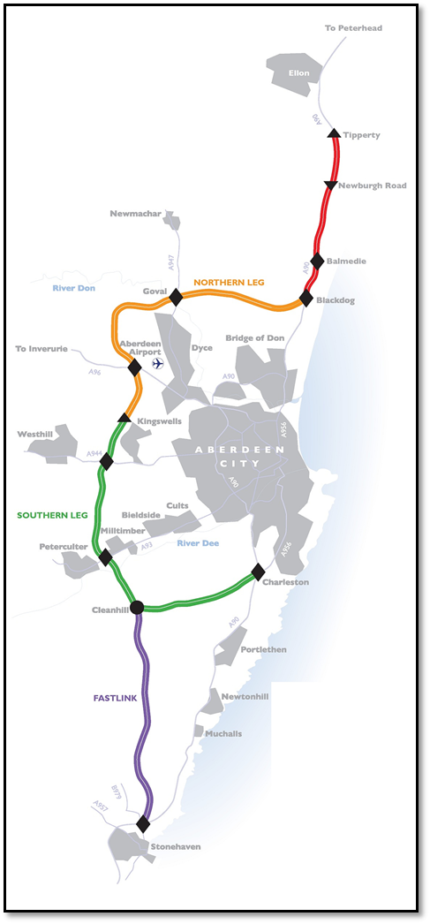

Figure 1: AWPR/B-T scheme extents

The AWPR/B-T is expected to be completed in 2018. The AWPR/B-T consists of four sections:

* Balmedie to Tipperty: 12 km from Blackdog to Tipperty
* Northern Leg: 16.1 km from North Kingswells to Blackdog
* Southern Leg: 18.7 km from Charleston to North Kingswells
* Fastlink: 11.5 km from Stonehaven to Cleanhill

The following statistics give an insight into the scale of the project:

|  |  |
| --- | --- |
| Principal Structures | 79 No. |
| Culverts | 78 No. / 4,200 m |
| Structural concrete | 106,000 m3 |
| Reinforcement | 17,000 T |
| Structural steelwork | 3,600 T |
| Parapets (steel RRS) | 9,000 m |
| Waterproofing (spray applied) | 77,700 m2 |
| PCC beams | 1268 No. / 23,000 m |

1. **CULVERTS**

There are 78 culverts along the AWPR/B-T route, each located in different geological strata at different depths and with varying flow requirements. In order to optimise delivery, it was decided to standardize the designs into five precast solutions; with off-site precasting being preferred in order to optimize the volume of concrete, along with the quantity of reinforcement required. This approach also reduced the required amount of site-batched concrete which, with 79 principal structures and an in situ concrete pavement, was already very high. The reduced concrete cover requirements for factory produced precast units reduced the volume of concrete required by 7%; and with a total of circa 5 km of culverts, this represents a significant saving. The tonnage of reinforcement could also be reduced by using greater numbers of shear links in the design, thus minimizing the size of the primary tension reinforcement and thus reducing the weight of reinforcement required.

The standard culvert width for smaller flows was dictated by health and safety requirements, taking account of access for future maintenance, and environmental considerations, including the requirements for 600 mm wide mammal ledges on either side of the culvert. A minimum depth of 250 mm of natural bed material to ensure continuity of the stream bed for migrating fish and low-flow provision in the form of a central channel were also incorporated.

The design adopted haunched corners to optimise the depth of section and reinforcement required at the corners to accommodate the hogging moments in these locations. Standard designs were developed for the headwalls which were cast in situ, also incorporating mammal ledges to meet with the stream banks. A U-shaped trough was adopted which offers scour protection to ensure the structure is not undercut during storm events.

1. **TWO-SPAN OVERBRIDGES – PRESTRESSED CONCRETE U-BEAMS**

There are 11 two-span prestressed concrete overbridges, with spans ranging from 21.5 m to 28.4 m and total lengths varying from 43 m to 56.8 m an example of the structural form is given in Figure 2. The deck cross sections vary from 12 m to 14.4 m in width with a 1 m cantilever. U-beams spaced at approximately 2.15 m centres were considered to be the optimum choice of beam combining strength and stability in the temporary condition. From the outset, the construction methodology was agreed with the CJV to optimise material costs and these efficiencies were achieved through a number of design innovations.

Firstly, the construction sequence was developed to minimize the deck slab reinforcement in the hogging regions by supporting the beams on temporary trestles around the central pier while the other end is supported on the abutment. The beam is effectively simply supported at which point the deck slab is cast, leaving only the section containing the diaphragms over the abutments and pier, thus the dead load of the wet concrete is taken as a sagging moment on the prestressed beam, optimizing the use of the prestress tendons within the beam and reducing the hogging moments over the central support allowing less longitudinal tension steel in the deck. In addition, by widening the central diaphragms over the pier by increasing the width of the in situ reinforced concrete the prestressed beams could be shorted in length. As a result, less de-bonding of the strands in the beam ends is required as the compression in the deck soffit is carried in the reinforced concrete element thus optimising the benefits offered by the two types of construction.

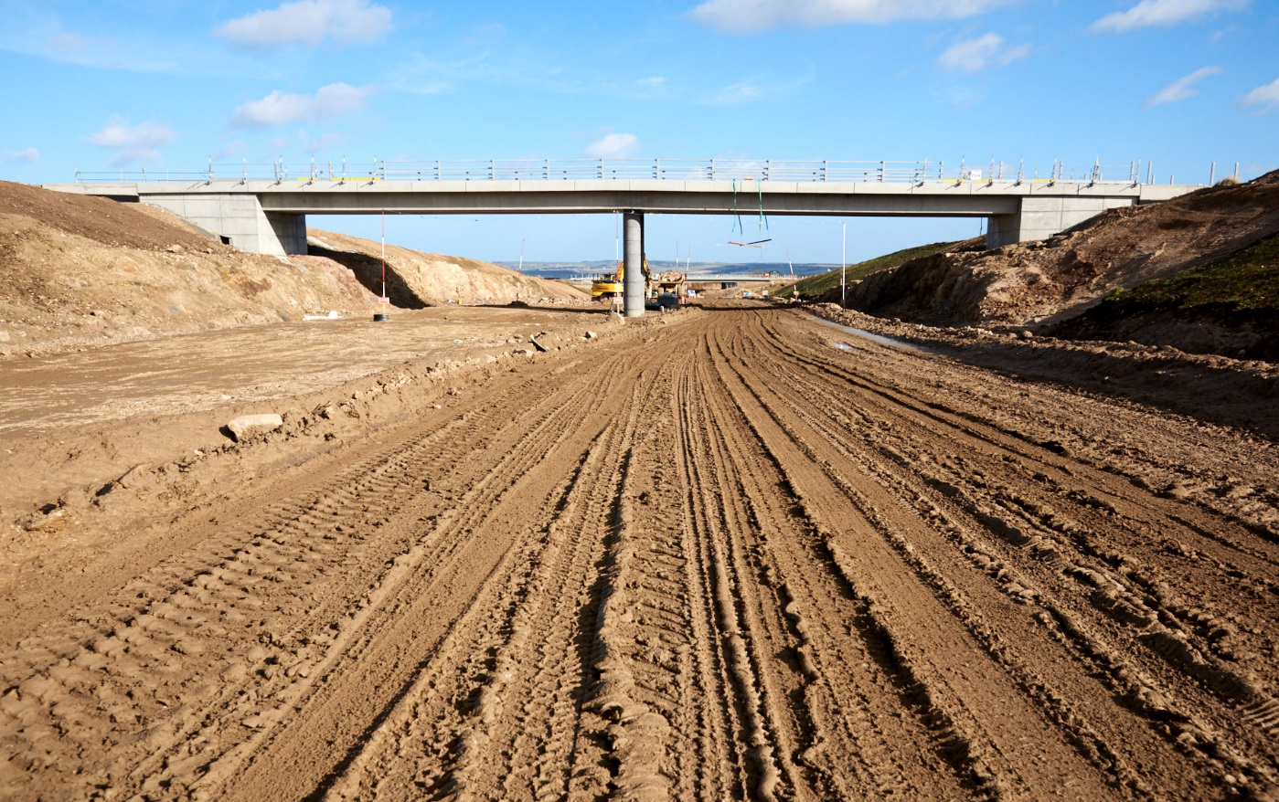

Figure 2: Typical Two-span overbridge

Secondly, cantilever outstands on the edge beams were minimized to ensure an efficient distribution of load between the inner and outer beams within the deck. Thirdly, a number of the two-span overbridges are located in rock cuttings which presented the opportunity to minimize both the size of the abutments and the central pier foundation. The approach required careful consideration of the geology of the slope beneath the small bankseat abutments which required to be assessed for not only the strength but also the jointing with the dip and strike of the rock beneath the foundations assessed to ensure that the cut face would not afford a failure plane for a wedge to become detached. The competency of the rock slope was assessed through detailed consideration of the boreholes which dictated the angle of the cut slope, typically taken as between 45° and 65°. A setback from the top of the slope of 1.5 m was adopted to allow for some over break and to allow the pressure beneath the foundations to dissipate and avoid shearing the top edge.

In this way, the design geometry was optimised to minimize the spans and thus the costs, not only by reducing the beam length and size but often to optimize the vertical road alignment, smaller beams, less construction depth and therefore less excavation required in the cuts. This design approach required careful control on site with geological surveys and inspections of the cut slopes prior to forming the bankseat abutments to ensure stability design assumptions were being met in practice. If the rock was weaker than anticipated, or had been over excavated, areas would be replaced with mass concrete and faced with stone; alternatively, less competent slopes could be slackened to increase their stability.

Beneath the piers spread footings were adopted, the width being optimized to reflect the high bearing capacity of the underlying rock. In this way, footings as narrow as 3 m were adopted with slots cut into the rock and the vertical sides of the excavation used as shutters to minimize the associated temporary works and formwork.

1. **STEEL COMPOSITE BRIDGES**

The project includes eight steel composite bridges with spans ranging from 44 m to 51 m. Both integral and simply supported designs were adopted, with simply supported structures utilised where the geometry dictated skews greater than 30°. Of the eight structures, the majority are single-span with only one two-span structure being required as shown in Figure 3 below. Steel composite bridges were primarily adopted for structures over live carriageways in order to minimize disruption and the associated lane closures. This approach also minimises future maintenance and inspections on the network.

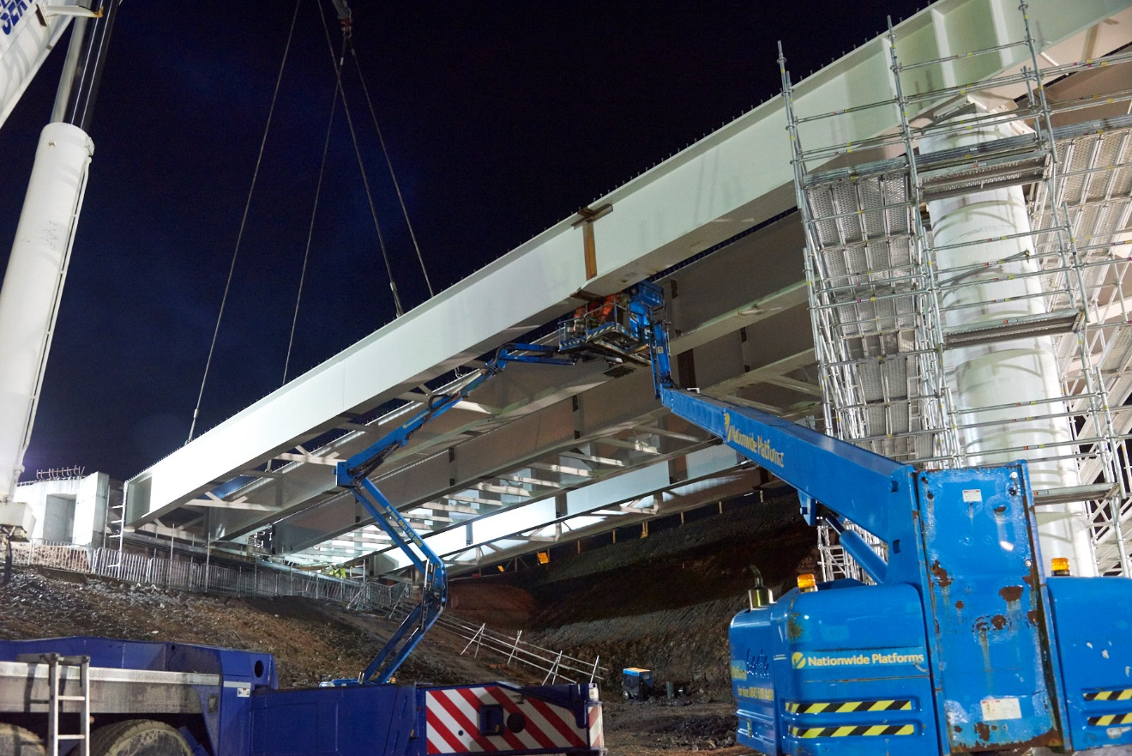

Figure 3: PS17 two-span steel composite overbridge

The deck design was developed using precast cantilever units which can be positioned by crane and secured to the bare steel prior to deck concreting. The construction methodology is simple and eliminates the need for significant cantilever formwork to be installed and subsequently removed over live carriageways.

Glass reinforced permanent formwork is positioned allowing the beams to support the wet concrete. Fifty percent of these panels can be lifted pre-installed prior to lifting pairs of beams into place, thus minimising the dangers to labourers working at height. From a design perspective, care is required in the design and detailing of such structures, particularly with regard to the pre cambering of the beams to ensure the correct profile of the final structure.

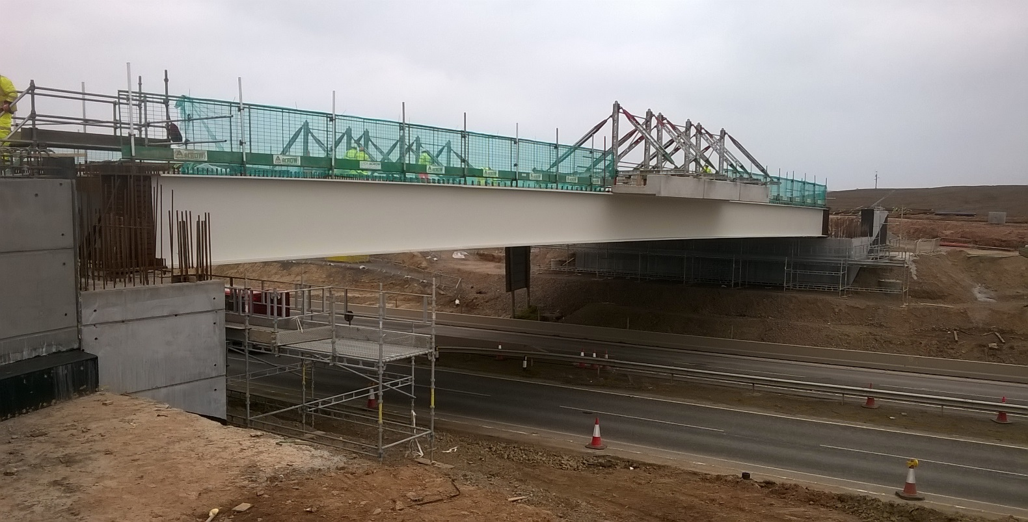

Figure 4: PS62 precast edge units being lifted into place

The construction sequence of placing pairs of beams before connecting them with regular transverse bracing linked to a plan bracing system prior to the placing of the precast edge units and wet concrete requires detailed consideration of the risk of lateral torsional buckling of the compression flange at each stage. Savings in steel can be achieved by optimising the deck pour sequence by using a central pour to act as a diaphragm to stabilize the beams against buckling while composite action between the steel and the concrete slab adds to the capacity of the deck, thus subsequent pours will be supported by the composite section and the beams restrained by the diaphragm at mid span.

The steel composite decks are more flexible than prestress beam bridges and as such can accommodate greater differential settlement between the supports. This flexibility was utilised to achieve more economic foundation designs with spread foundations adopted rather than piled. This saving was set against the higher cost of the steel girders when compared to adopting precast prestressed concrete beams.

1. **BEBO ARCH DESIGNS**

The project also includes two BEBO arch structures, both spanning watercourses which are located at the base of deep, steep-sided valleys. Figure 5 shows PS41a which carries the main line over the Boganjos Burn as constructed and as envisaged by the Revit model. Initial design considerations were for box culverts; however, with the depth of fill in both locations anticipated to be over 19 m the box culvert solutions would require significant reinforced concrete sections to resist the applied loads from overburden alone. The length of culvert was also an issue from a safety perspective. With lengths over 120 m each culvert would require intermediate manhole access to comply with confined space regulations. These access provisions, comprising vertical shafts approximately 19 m in height, would require internal landings to allow safe access. For these reasons, a more open arch structure, with a span of 15 m, was considered to be more appropriate as it catered for the watercourse and could also accommodate safe maintenance access strips down each side of the stream. To further increase the height within the structure, inverted T-sections were adopted for the foundations. The stem of the T was stepped in height to accommodate the variation in height arising from the natural slope of the watercourse, in this way the overall width and headroom could be maintained along its length allowing the greatest possible perception of openness for free flow of air and to encourage the use of the structures by mammals.

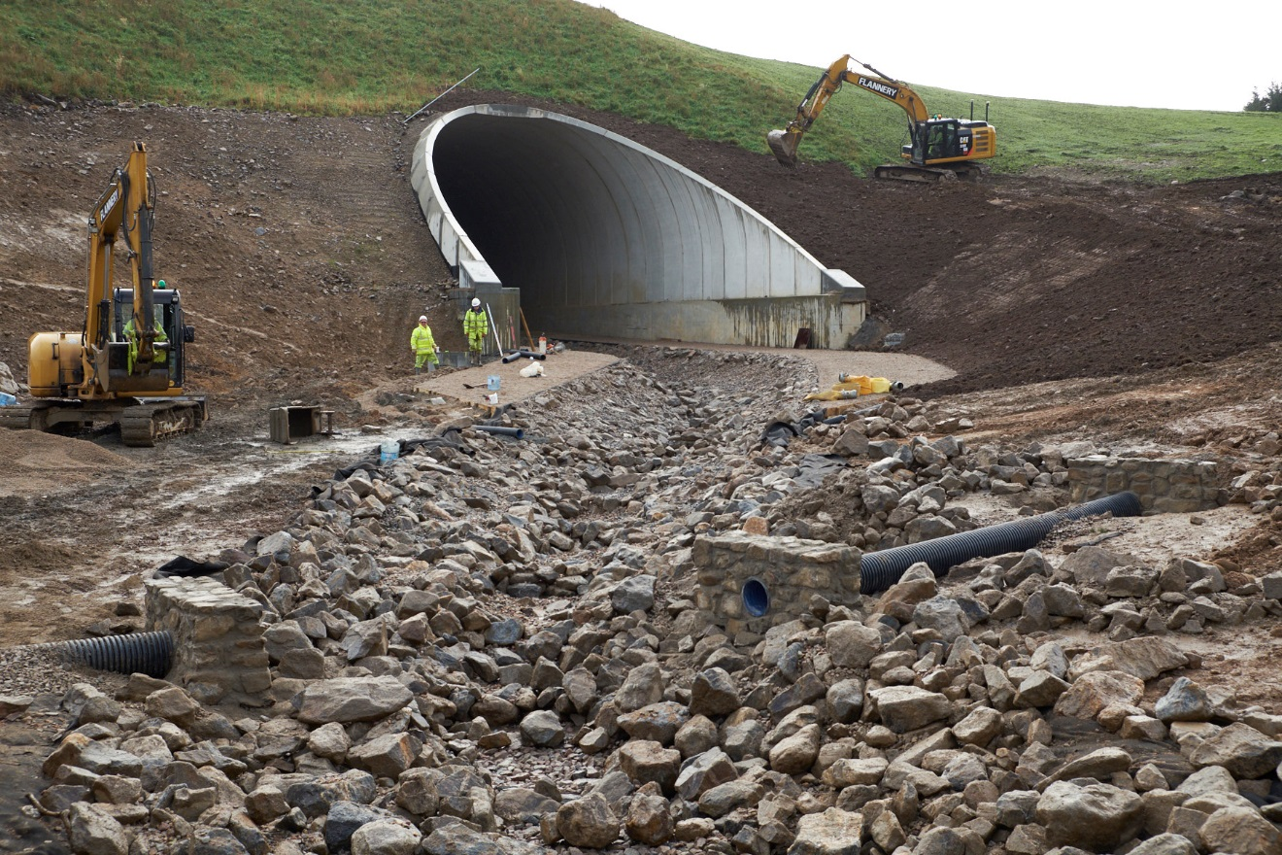

Figure 5: BEBO arch and Civils 3D model

The combined arch and foundation reduced the overburden to approximately 14 m at the crown.

The arch structures were fully waterproofed on their outer surfaces with spray applied waterproofing over the crown and bitumen waterproofing on the near vertical lower thirds. The BEBO Arch System comprises precast units 2.5 m in width and jointed at the crown with an in situ concrete stitch. The joints between the units were sealed with an epoxy bonded flexible strip, the arch was then encased in a porous layer of single-size fill to ensure water is free draining down to the drainage pipe at the back of the T-shaped foundations. The structures were then backfilled in a controlled fashion with fill placed in alternate layers no more than 1 m in height on each side of the arch to ensure stability throughout the construction phase.

Arch stability is reliant on the founding material; in both locations, unsuitable compressible material was removed from beneath the foundations to ensure the loads were carried to the underlying rock. Where the areas of soft unstable material were deep, the mass concrete was augmented with rock plumes to achieve a more economical use of the in situ concrete fill. The stream beds beneath the structure were constructed with rest pools for migrating fish and deeper channels to cater for times of low-flow. The resulting structures are aesthetically pleasing and blend into the landscape in an unobtrusive fashion.

1. **OIL PIPELINES STRUCTURES**

The route of the AWPR/B-T crosses the Forties Oil Field pipelines for both INEOS (BP) and Shell on five separate occasions. Accordingly, design and construction of these structures required detailed consultation with both companies and their technical representatives to ensure their requirements were fully understood and delivered. In the first instance, the dimensional requirements for each structure were established. The key criteria were headroom for future maintenance along with the required off-sets to the abutment walls and foundations from the edge of the pipe determined by considering the depth of foundation required to obtain a suitable founding medium while ensuring the stability of the soil supporting the pipeline. These requirements set the basic physical geometry of the portal frame structures which would carry the new road over the pipelines. Revit models as illustrated in Figure 6 were created to allow the relationship between the proposed structures and the pipeline to be fully considered prior to advancing the detailed design. These geometric parameters were then used to create soil models to determine the maximum settlement using Plaxis analysis an illustration of the anticipated displacements is provided in Figure 6. The structure and the embankment act to draw down an area creating a dishing effect, rather than a set limit on settlement, it was agreed that a maximum radius of deflection of the pipe would be specified to minimize the resulting stresses on the pipeline.

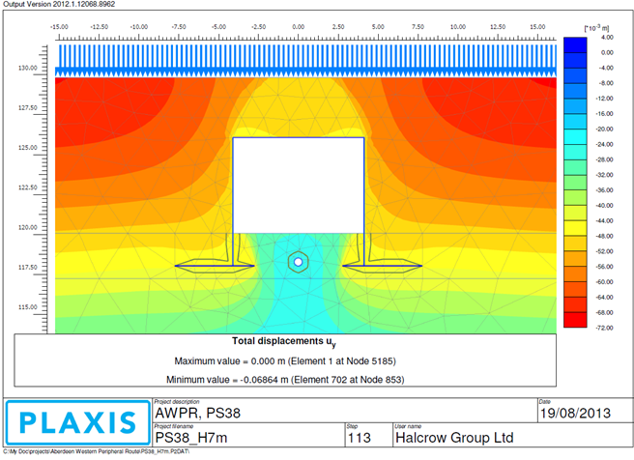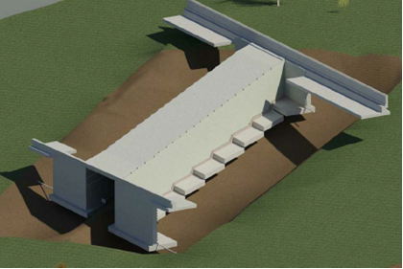

Figure 6: PS38 Revit model and Plaxis analysis

Spread foundations were preferred to piled foundations as spread foundations minimize vibration and the risks associated with large plant operating in close proximity to the pipeline. Spread foundations must however be offset to ensure the soil beneath and around the pipeline is not disturbed during the excavations to a suitable bearing medium. Deck choice was also driven by the safety parameters of the pipeline. An in situ concrete deck requires significant temporary works to be placed over the pipe to facilitate the formwork. There is also the associated risk of a failure of the system leading to a significant collapse. These risks were deemed to be greater than the use of prestressed T-beams acting with an in situ concrete deck to create the equivalent slab deck.

This approach could only be implemented in conjunction with a crash deck to restrain a beam or any other material should it fall from the crane. Method statements were agreed for the movement of the beams to ensure that slinging operations were no more than 300 mm above the crash deck to minimize the energy of any impact. The crash deck was supported on the abutments with a shelf incorporated on the toe of the abutment to support the temporary works. Couplers were used to minimize the projection of the reinforcement protruding from the top of the abutments, achieving a 300 mm height projection to allow the beams to be lifted into place and mitigating the risk of a drop-load on the crash deck.

* 1. **The Rail Bridge**

Structure PS45 (Figure 7) spans the Aberdeen to Inverness Railway line which is currently in the process of being upgraded to accommodate twin tracks. At the time of the detailed design, the new alignment of the proposed track upgrade had not been agreed. As a result, PS45 was oversized to accommodate the various options for the relocation of the tracks using the land boundaries of Network Rail to set the span and assuming a 4.5 m setback from the edge of the rail to the face of the abutment, avoiding collision load associated with a derailment.

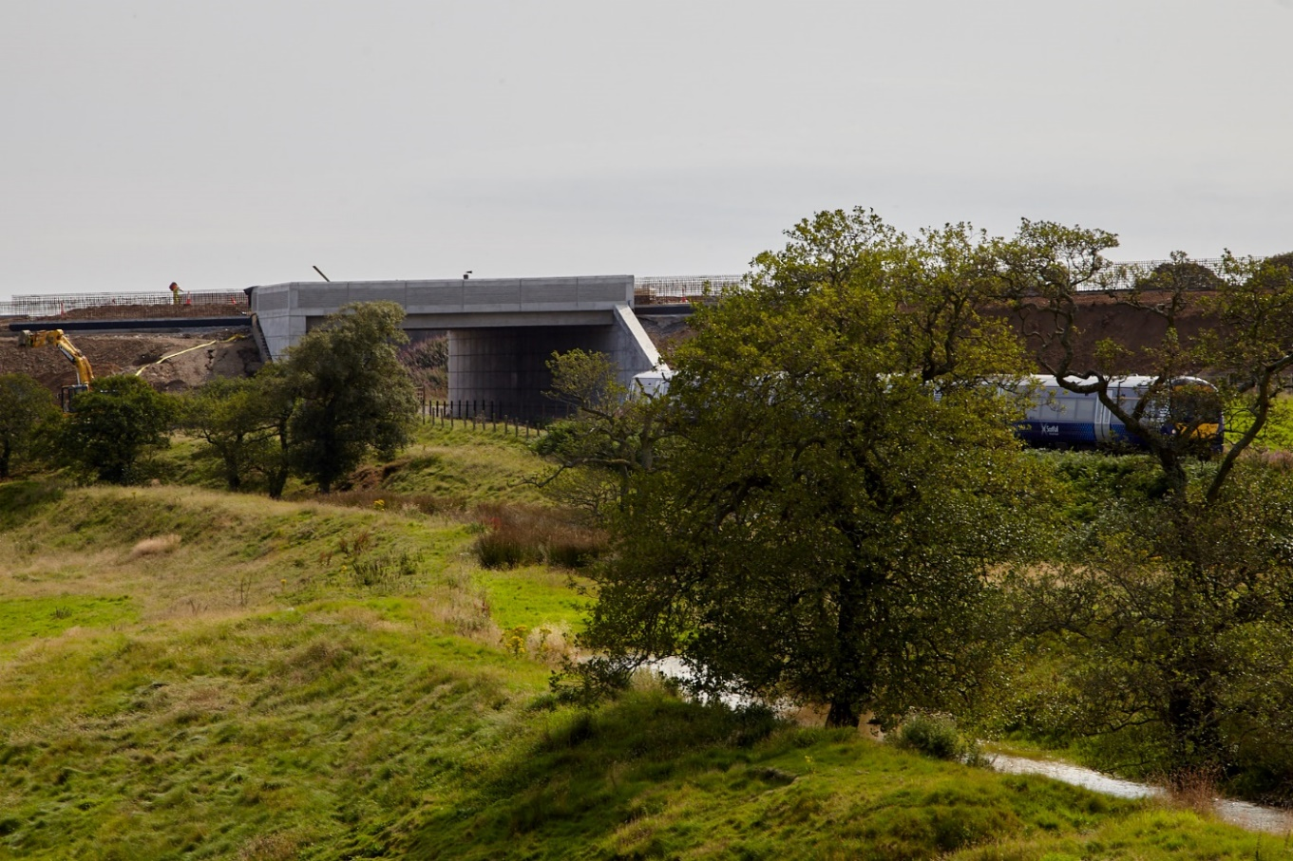

Figure 7: PS45 railway crossing

This approach was agreed with Network Rail through the consultation process thus setting the minimum span of 19 m. As the road alignment crosses the rail corridor with a significant skew, it was decided to construct a through-portal structure with beams placed perpendicular to the abutments to minimize the span of the precast U-beams. The resulting structure creates two triangles of deck on each side of the mainline which are effectively redundant. The Revit model shown in Figure 8 illustrates the approach.

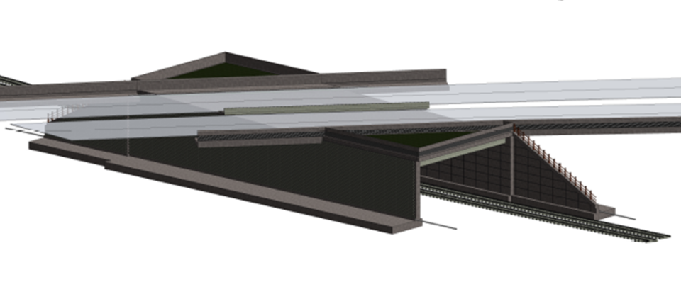

Figure 8: PS45 railway crossing Revit BIM model

To ensure the stability of the abutment while placing the beams, the abutments were designed as L-shaped cantilever walls to be backfilled 1 m below soffit level prior to landing the beams. In this way, the risk of overturning the abutments in the temporary condition was eliminated and the risk of operatives working at height mitigated by creating a graded approach to deck level behind the abutments. The 28 precast U-beams were placed in position along with the permanent formwork during a single possession of the line which meant disruption to the rail service was minimized.  Figure 9 below illustrates the construction sequence, with the abutments cast using a failsafe traveling formwork then backfilled before placing the prestressed beams and subsequently casting the deck.

|  |  |
| --- | --- |
|  | Abutment walls cast in travelling formwork |
|  | Abutments backfilled to 1 m below soffit level |
|  | Precast beams landed and deck cast |

Figure 9: PS45 construction sequence

The structure incorporates H4A high containment concrete parapets which extend a minimum of 45 m in advance of the structure and 18 m beyond to mitigate the risk of errant vehicles entering the rail corridor. The structure was designed to be supported on pad foundations on stiff glacial till, limiting the anticipated settlement to an estimated 15 mm. A 3D Plaxis analysis was undertaken to determine the anticipated settlement of the operational railway to ensure settlement of the track was within the acceptable limits set by Network Rail. The structure was modelled in Revit which created a fully representative BIM model which was used to facilitate the consultation with Network Rail in order to achieve the required consents.

* 1. **Major River Crossings**

There are two significant river crossings within the project, both located in river valleys within flood plains. The River Don is located to the north of Aberdeen with the River Dee to the south. Two alternative methods of construction and span configurations were considered for this location: a five-span launched post tensioned concrete box and a three-span balanced cantilever post tensioned segmental structure adopting cast in situ segments. An initial study also considered the optimal cross sectional arrangement with single and double cell options being considered in the preliminary stages. The River Dee bridge geometry did not lend itself to a launch solution as the main span of 120 m could not be reduced without the addition of piers in the river which was precluded from an environmental perspective.

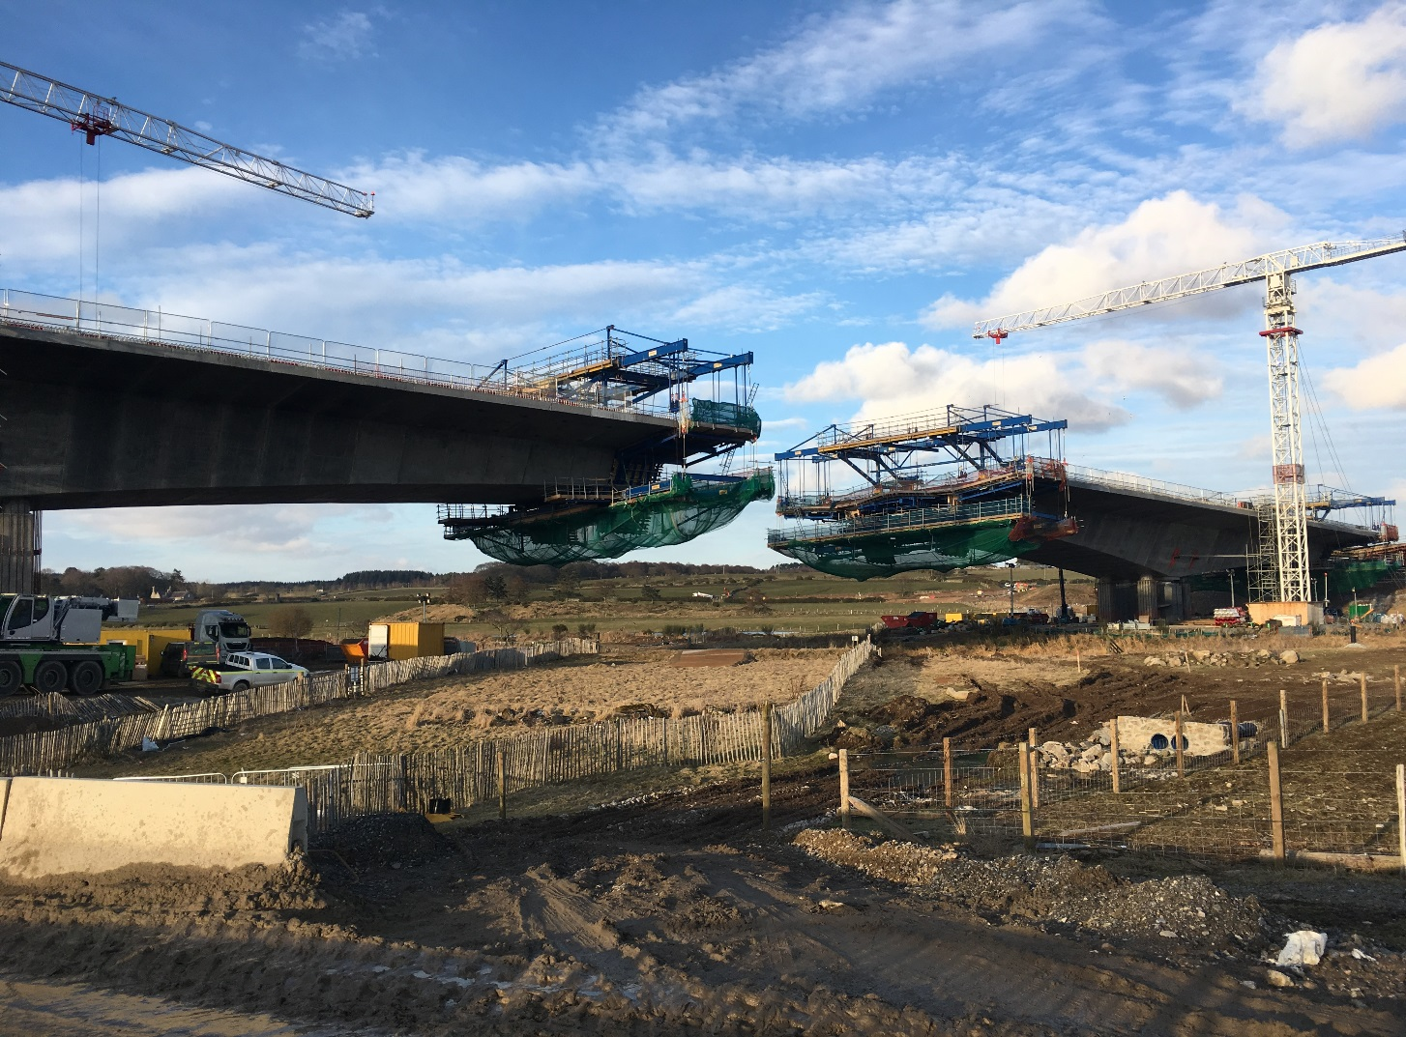

Figure 10: River Don Crossing

The decision was made to standardize the construction philosophy with balanced cantilever solutions adopted for both locations. For the River Don, this eliminated the need to raise the approach embankment to the south of the bridge prior to the start of the deck construction which eased the construction programme as this embankment would otherwise have been required to facilitate the temporary works as the casting yard and launch area.

The two bridges have similar span configurations; the River Dee has a maximum span of 120 m whilst the River Don has a main span of 130 m. Both structures have 75 m backspans. Cross sections are identical between the parapets, with an overall width of 26.1 m. Both incorporate dual carriageways, a central reservation and twin 2.5 m verges and associated hardstrips. The River Don is more complex as it is curved in plan as dictated by the road alignment. In profile, the structures have a curved soffit tapering from the piers which combines an elegant profile with structural efficiency whilst reducing the weight of cross section at midspan. During construction, the deck is supported on its piers and temporary works resting on the associated pilecaps. This stabilizes the structure as the segments are cast to alternating sides. The pile cap and piles must cater for a drop-load scenario where the effects of a collapse of the cantilever formwork in the extreme condition lead to a dynamic loading on the supporting system. The design of these elements is therefore fully integrated with the construction methodology.

In both locations, the foundations are piled through alluvial deposits and socketed into the underlying competent rock. The choice of pile was dictated by the depth of alluvial deposits and the need for rock sockets to carry the loads to the underlying competent rock in order to meet the required settlement criteria. Preliminary engineering considered a range of pile diameters and configurations which informed discussions with the piling subcontractor who considered the plant required and the production rates to allow the optimum size and number of piles required at each foundation to be determined.  Pile diameters were standardised across both structures leading to the adoption of 1.5 m bored concrete piles.

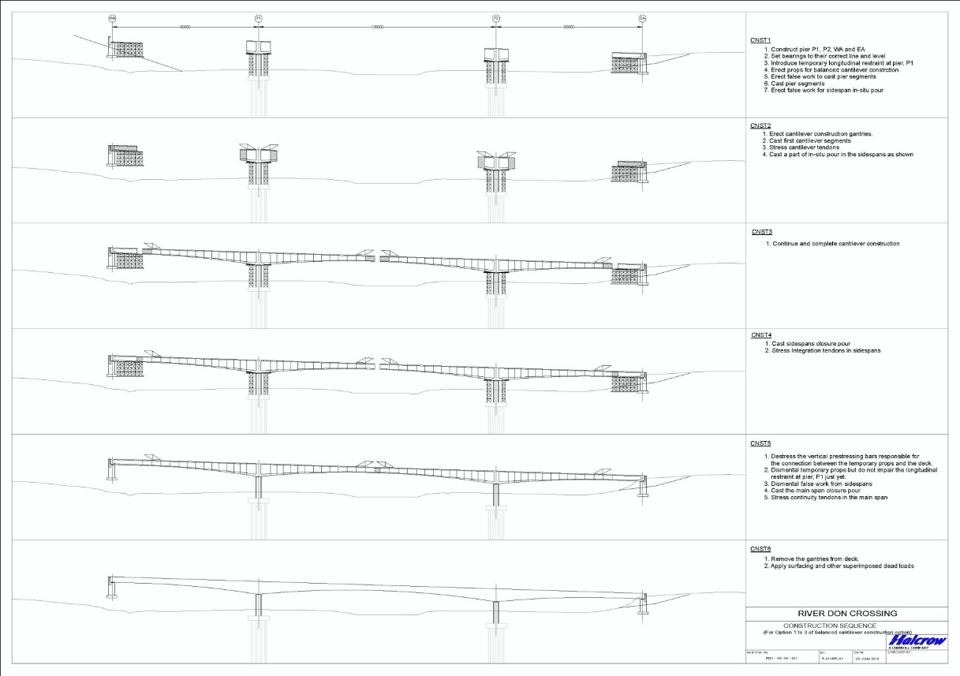

Figure 11: Balanced cantilever construction sequence

Pier widths were minimized in the detailed design to enhance the aesthetics of the structures and were limited to the minimum width required to accommodate the bespoke bearings detailed to support each bridge deck. Jacking points for future bearing replacement were therefore accommodated on the pilecaps. The abutments retain the large deck cantilever feature which continues till it meets with the embankment, minimizing the footprint of the abutment bearing gallery and maintaining the aesthetic line of the edge of the deck. The cantilever lightens the appearance of the structure by creating shadow on the webs of the girder and abutment, thus highlighting the parapet cope. The effect is to create elegant structures that when viewed from their river valley settings integrate into the landscape rather than dominating it.

# CONCLUSION

The Aberdeen Western Peripheral Route is due for completion in the Autumn of 2018, when it opens the road will support the regions sustainable economic growth and open new areas around the city to development. The new road will significantly reduce congestion in the city by taking traffic away from the urban road network, in doing so it will reducing journey times in and around the city, whilst improving road safety and reducing levels of air pollution in the city centre. The structures are key features in this new landscape defining the grade separated junctions and acting as landmarks along the route. The project has utilised multiple construction types which have been brought together using consistent finishes, colour schemes and components to ensure that while structural forms may vary the consistency of the themes remain. The number of structures involved has allowed significant savings to be made through standardisation in structural components and innovation to optimise the designs. New technology such as fully integrated 3-dimensional modelling of the structures, highway, drainage and services have minimised clashes during construction and created a digital data base for the client in which as built records and maintenance information is stored. The two balanced cantilever bridges are the signature images of the AWPR and these elegant structures symbolize the engineering achievement of this major investment in infrastructure for the future.

# REFERENCES

Aberdeen Western Peripheral Route / Balmedie – Tipperty Competition for the Design, Build, Finance and Operation of the Aberdeen Western Peripheral Route / Balmedie – Tipperty