|  |  |  |
| --- | --- | --- |
|  | **10th International Conference on Short and Medium Span Bridges**  **Quebec City, Quebec, Canada,**  **July 31 – August 3, 2018** |  |

**PROBABILISTIC LIFETIME DEMANDS ON ONTARIO BRIDGE BEARINGS**

Noade, Bryanna M.1,2 and Becker, Tracy C.1

1 McMaster University, Canada

2 [noadeb@mcmaster.ca](mailto:noadeb@mcmaster.ca)

**Abstract:** While bridge bearings are expected to be replaced during a bridge’s lifetime, when they should be replaced is currently determined predominantly by field inspection and engineering judgement. Quantifying the lifetime fatigue demands on bridge bearings is an important first step towards estimating a bearing’s life expectancy. The principal demands on bridge bearings, such as those arising from temperature fluctuation, traffic loading, and seismic events, are all location dependant. By combining these loadings for a specific region within Ontario, a framework for the probabilistic lifetime bridge loading is outlined. The framework for determining the probabilistic lifetime cyclical displacement demands is presented using a model of a multi-span girder bridge in OpenSees. The output gives information on the number and amplitude of displacement cycles for bridge bearings. Obtaining these loads and resulting displacements is the first step in future studies on property deterioration and optimal replacement time.

# **INTRODUCTION**

Bridge bearings support large vertical loads while accommodating translations and rotations. Their continued performance is critical as restraining this movement results in undesired forces and potential damage in the surrounding structure. Bearing manufacturers and bridge owners do not know the life expectancy of bridge bearings. The commentary of the Canadian Highway Bridge Design Code, CHBDC, (CSA 2014b) suggests that bearings should be replaced during a bridge’s design life of 75 or 50 years, depending on what version of the code the bridge was designed to. However, this is the only guidance towards bridge bearing replacement, and currently, the decision for replacement is based largely on visual field inspections and engineering judgement.

There is limited work investigating the life expectancy of bearings. Kumar and Sanchez-Silva (2008) found that the probability of bridge failure increases significantly with age due to accumulated damage from small repeated loadings. Thus, the lifetime loading is more critical than the extreme events when predicting failure or life expectancy. Roeder et al. (1990) performed experimental fatigue tests on steel-reinforced elastomeric bearings. The experiments showed that fatigue behaviour is influenced by parameters such as loading type, rate, and magnitude; but, the experimental loading was not representative of actual cyclic loading patterns experienced by a bearing. To date there have been no studies explicitly predicting the life expectancy of bridge bearings.

Quantifying the cyclic demands imposed on a bearing during a bridge’s lifetime is the first step in estimating a bearing’s life expectancy. In this study, a framework for the probabilistic lifetime bridge loading is outlined by combining the loadings from temperature and earthquakes. The demands can be used by bridge owners to set performance goals for bearings or by researchers to develop fatigue loading histories to further study bearing life expectancy.

Bearing loading is dependent on the geographical region. The province of Ontario, the most populous province in Canada, is used in this study. Ontario has large road networks with almost 3,000 multiple-span bridges. An archetype bridge design is chosen for this study. Due to the location of the province and its relative size, bridges within Ontario are exposed to varying loading conditions: large seismic hazards in the eastern region, high traffic demands due to the dense population in the central region, and large yearly temperature swings in the northern region.

# **METHODOLOGY**

The bridge bearing demands from temperature, earthquake, and traffic events are first analyzed separately before being combined. In this study the bridge demands are analyzed from a single geographical region, Toronto, Ontario.

## **Archetype Bridge**

For this study, particularly the earthquake analysis, a three degree of freedom model of an archetype bridge is modelled in OpenSees (McKenna 2010), see Figure 1 (a). The bridge is comprised of three 30 metre deck spans supported by two 8 metre concrete piers and two abutments. The deck rests on elastomeric bearings at nodes 1, 5, 9, and 13. The bearings at node 9 are fixed. Node 1, 5, and 13 have free moving bearings that accommodate the thermal expansion of the corresponding free deck lengths, which are 60, 30, and 30 metres, respectively.

The design displacement of the bearings is calculated based on the maximum and minimum effective temperatures depicted in the Canadian Highway Bridge Design Code, CHBDC, (CSA 2014a) and the effective construction temperature. For example, the Toronto maximum and minimum effective temperatures are -33°C and 50°C, respectively. The set temperature for the bearings, at which they have zero displacement, is found by assuming an effective construction temperature of 15°C based on the CHBDC. Thus, the change in temperature from the construction temperature can be up to 47 degrees. The maximum bearing design displacement is found to be 34 millimetres at node 1; this is calculated from the maximum change in temperature, the length of free deck span at the bearing node, and the thermal coefficient of steel, 12x10-6 m/(mK). The horizontal and vertical stiffness values are governed by the design displacement and the maximum compressive axial load experienced at a single bearing node (Goodco Z-Tech 2010). From this, the bearing length at node 1 is 450 mm, with a total vertical (ky) and horizontal (kx) stiffness of 562.6 kN/mm and 3.86 kN/mm, respectively. The free bearings at node 5 and 13 vary in length and stiffness from node 1 based on their design displacement and axial load. The fixed bearings at node 9 resemble the bearings at node 5 because of their equivalent compressive loads; but, with increased horizontal stiffness to account for the presence of anchors or shear keys.

In the OpenSees model, the bearings are represented by zero length elements with stiffness and damping specified for the three degrees of freedom. For the purpose of this study the stiffness of the rotational degree of freedom is equivalent to the vertical stiffness, and the damping ratio is 5% for all three degrees of freedom. The deck and piers of the bridge model are represented by elastic beam-column elements with 2% damping. The resulting first-mode period of the bridge’s dynamic response is 0.72 seconds.

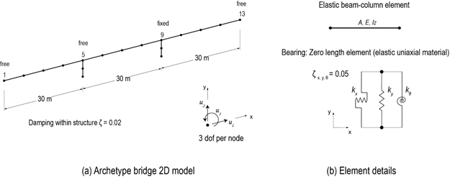

Figure 1: Bridge FEM details of an Ontario archetype structure

## **Temperature**

Historical records of daily mean temperatures are available from Environment Canada (2017). Missing temperature observations are approximated by linear interpolating between adjacent known values. A year of temperature data is converted to a time history of linear thermal expansions and contractions of the bridge deck, which translates to the displacement of the bridge bearings. The bridge deck displacements are calculated at the end of the longest unrestrained deck span (node 1 in Figure 1 (a)), where the largest thermal expansions occur. The bearing displacement is then found from the daily temperature change of the 60-metre deck span using the thermal coefficient of steel, 12x10-6 m/(mK). Figure 2 shows a two-week period of temperature data and the corresponding bearing displacement.

Using the rainflow cycle counting method (ASTM 1997, FEMA 2007), the number of cycles and their respective amplitudes are measured. The rainflow counting method is commonly used in fatigue analysis as it recognizes small amplitude cycles within larger cycles. Table 1 lists the rainflow cycle counts which correspond to the bearing displacement trend in Figure 2.

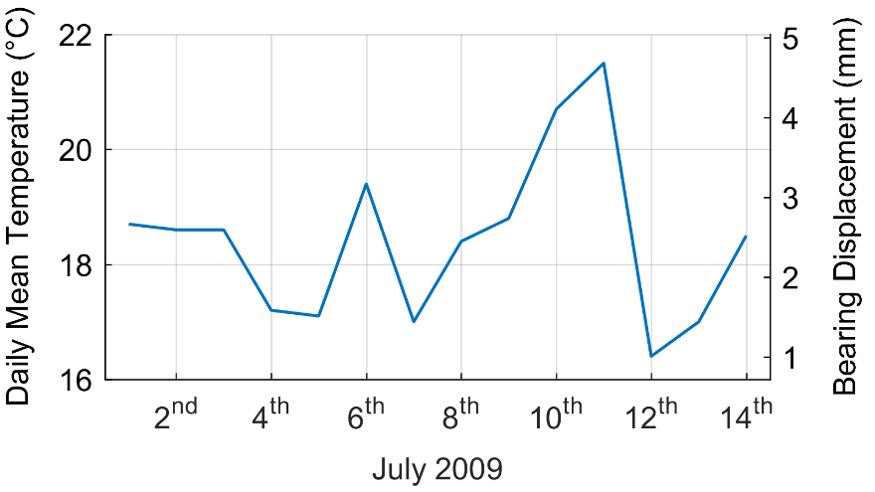

Figure 2: Temperature trends and corresponding bearing displacements for a two-week period

Table 1: Rainflow cycles from data in Figure 2

|  |  |  |
| --- | --- | --- |
| Cycle Amp.  (mm) | Cycle Mean  (mm) | Cycle Count |
| 0.58 | 2.09 | 0.5 |
| 0.83 | 2.34 | 0.5 |
| 0.86 | 2.30 | 0.5 |
| 1.62 | 3.06 | 0.5 |
| 1.84 | 2.84 | 0.5 |
| 0.76 | 1.76 | 0.5 |

For this study, 50 consecutive years of temperature data is used. Guay and Bouaanani (2016) suggest, that whenever available, the latest 50 years of temperature data should be used so the sample size is large enough to accurately capture temperature trends. The cycle counts are binned in intervals of 0-2%, 2-15%, 15-30%, 30-50%, and 50-100% bearing design displacement. The cycles within 0-2% design displacement are ignored. Using the cycle counts for all 50 years of data, cumulative distribution curves are created for each displacement bin assuming the data is normally distributed. These curves give the probability of having less than a number of cycles within the specified amplitude bin in a single year. An example of this is shown in Figure 3 using Toronto temperature data.

While the number and amplitude of the cycles is important, so is the mean about which the bearing cycles. While the mean of each cycle changes, overall a safe assumption is that the mean occurs at the displacement associated with average yearly temperature. The average yearly temperature in Toronto is 7.7°C, this is 7.3 degrees below the set temperature of 15°C. This results in a mean displacement of -5.3 mm. Thus, displacement cycles in Bin 3 could actually be displacing the bearing up to -22.3 mm, 66% of the design displacement.

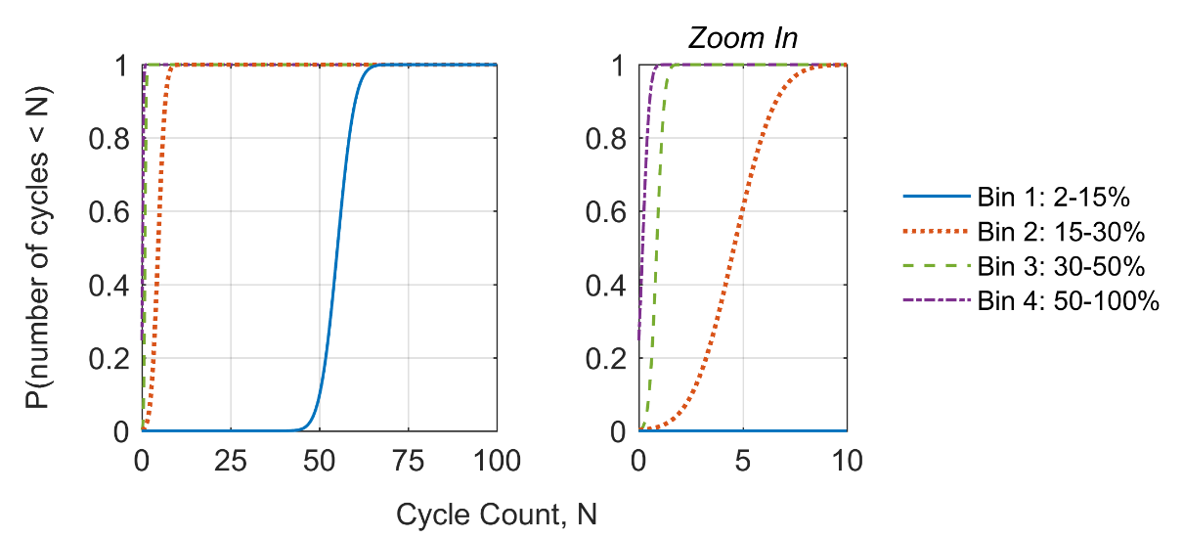

Figure 3: Temperature cumulative distribution curves for each cycle bin defined by design displacement

## **Earthquake**

To evaluate the bearing displacement cycles from earthquake loading, a range of earthquakes must be considered along with their probability of occurrence. For this study, ground motion suites scaled to the uniform hazard spectra for 2%, 10%, and 40% probability of exceedance in 50 years (0.000404, 0.0021, 0.01 per annum) are used. A suite of thirty or more ground motions is suggested by the CHBDC to obtain the dispersion of demands corresponding to each hazard level. For this research, synthetic ground motions for Eastern North America are used from Atkinson (2009) and chosen based on site specific deaggregation values outlined in Table 2. The ground motions are scaled from 0.1 to 1.5 seconds following the guidelines

Table 2: Toronto mean deaggregation values for a period of 0.5 seconds

(Canadian Hazards Information Service, 2017)

|  |  |
| --- | --- |
| Mean distance (km) | Mean magnitude (Mw) |
| 306 | 6.32 |
| 207 | 6.50 |
| 101 | 6.48 |

outlined in the commentary for the CHBDC. The ground motions of best fit are chosen for the suite by selecting the closest matched motions to the spectrum following guidelines by Atkinson (2009).

The OpenSees model of the archetype bridge is subjected to the suite of ground motions. The bearing displacement history is recorded for each ground motion, and rainflow counting is again used to extract number of cycles of varying amplitudes. The cycle counts are binned using the same bins as for temperature loading. Using the number of cycles from all time histories, cumulative distribution functions are created for each hazard level; an example of this can be viewed in Figure 4 from Toronto data. The cyclic demands for the three hazard levels are combined to find the mean annual cycle count for each bin from:

[1] $P\left(>number of cycles\right)= \sum{ \left[\left[1-P\left(<number of cycles \right|HL)\right]*Δλ_{HL}\right]}$

where Δλ is the range of annual rate of exceedance that each hazard level represents, as shown in Figure 5. For each hazard level, the probability the number of cycles of exceedance is multiplied by its corresponding Δλ. The summation over all hazard levels results in a probability of exceedance for each bin, shown in Figure 6. The area under the curve gives the mean annual number of cycles for the corresponding bin. The resulting mean cycles are given in Table 3. Cycle counts from temperature and earthquake analyses are combined for each bin by the summation of the mean cycle counts from each event. Table 3 summarizes these mean cycle counts and the combined results corresponding to a one-year period.

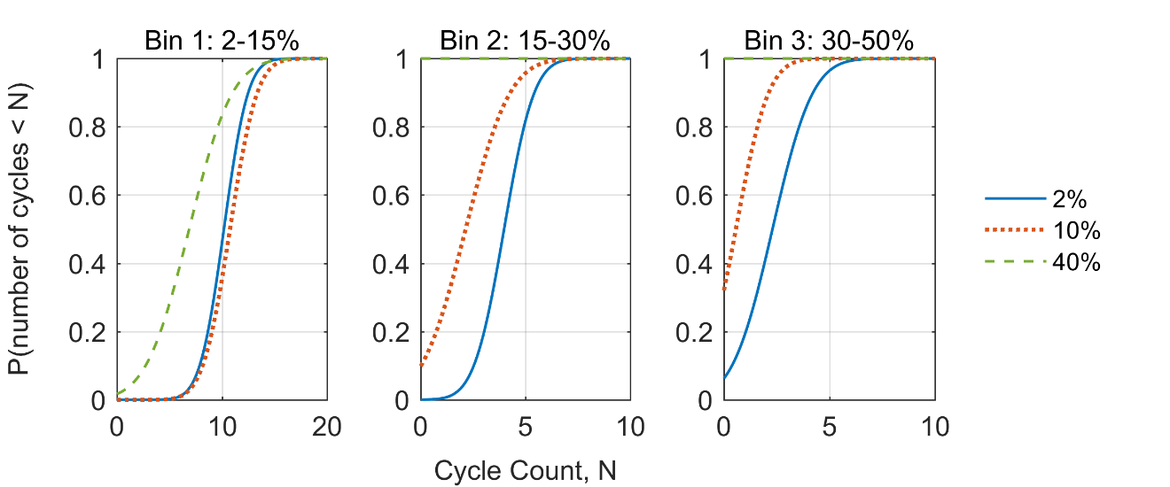

Figure 4: Seismic cumulative distribution curves for each cycle bin defined by design displacement

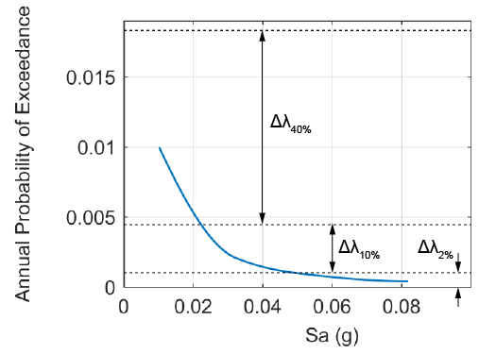

Figure 5: Toronto hazard curve for a period of 0.72 seconds

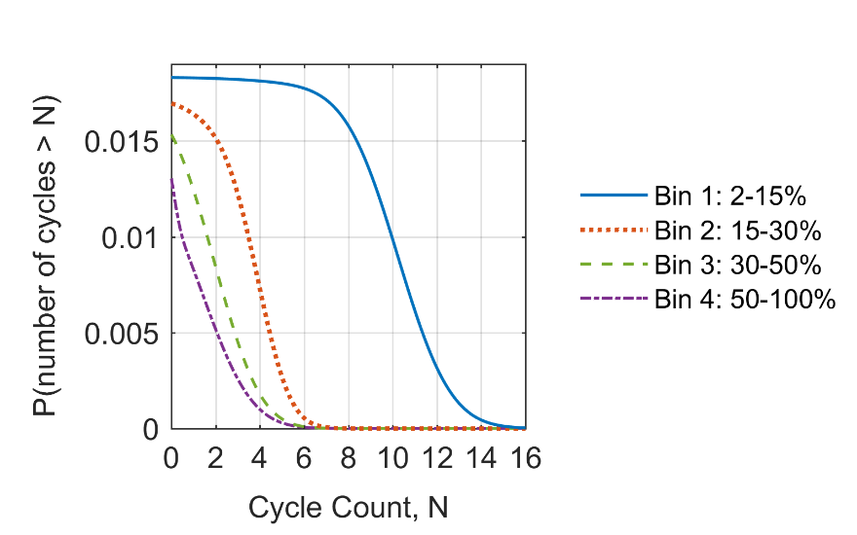

Figure 6: Probability of exceedance curves for each cycle bin defined by design displacement

Table 3: Event specific and combined mean cycle counts for a one-year period

|  |  |  |  |
| --- | --- | --- | --- |
| Bin No. | Mean Cycle Counts | | |
| Temperature | Earthquake | Combined |
| 1 | 55.09 | 1.85 | 56.94 |
| 2 | 4.57 | 0.63 | 5.20 |
| 3 | 0.86 | 0.35 | 1.21 |
| 4 | 0.18 | 0.23 | 0.41 |

**2.4 Traffic**

Loadings from traffic events are not considered in this study due to the lack of readily available traffic data within Ontario. Average annual daily traffic counts are available for highways across the province of Ontario; however, the data does not incorporate vehicle class. According to the U.S. General Accounting Office (1979) a single tractor-trailer causes the equivalent damage to 9600 passenger vehicles on the road. Thus, the percent of daily traffic that is caused by tractor-trailers is necessary for estimation of traffic loadings. Braking and acceleration forces of vehicles result in horizontal displacement demands similar to temperature and earthquake loading. Further data or probabilities of accident or sudden braking occurrence is required before horizontal traffic loadings can be taken into account in this study.

Typical traffic loading causes cyclic axial loading on the bearings; the value of this depends on the density of traffic flow and the vehicle weights. In this study vertical displacement demands were not analyzed but could be included with the same framework presented for temperature, creating cycle amplitudes, counts, and means. For this, detailed traffic records are necessary to quantify the vertical class and their frequency of occurrence. As vertical cycling occurs at a different frequency compared to horizontal cycling, this loading can be superimposed with the horizontal cycles to create testing protocols.

# **CONCLUSION**

This paper presents a preliminary method for developing the location dependant probabilistic lifetime demands on bridge bearings, including loading from temperature fluctuation, traffic, and seismic events. This loading history can aid in predicting the life expectancy of bridge bearings. The results from this study can be used to develop fatigue loading protocols to test bearings, thereby gaining valuable information regarding their life expectancy. Bridge consultants and owners can use an estimated life expectancy to aid in inspection and maintenance schedules; additionally, remaining life expectancy is important for hand-offs of bridge ownership. Future work will look at the variation of demand with location as well as bridge and bridge bearing design, adding demands from traffic loading, and incorporating constant loading conditions.

Acknowledgements

Support for this research came from the Natural Sciences and Engineering Council of Canada (NSERC).

References

ASTM. 1997. Standard Practices for Cycle Counting in Fatigue Analysis E 1049-85. American Society for Testing Materials, West Conshohocken, PA, USA.

Atkinson, G. M. 2009. Earthquake time histories compatible with the 2005 National building code of Canada uniform hazard spectrum. Canadian Journal of Civil Engineering, 36: 991-1000.

Canadian Hazards Information Service. 2017. Seismic Hazard Deaggregation.

CSA. 2014a. Canadian Highway Bridge Design Code S6-14. CSA Group, Toronto, ON, Canada.

CSA. 2014b. Commentary on CSA S6-14, Canadian Highway Bridge Design Code. CSA Group, Toronto, ON, Canada.

Environment Canada. 2017. Historical Climate Data. Retrieved from http://climate.weather.gc.ca/

FEMA. 2007. Interim Testing Protocols for FEMA 461, Determining the Seismic Performance Characteristics of Structural and Nonstructural Components. Applied Technology Council, Redwood City, CA, USA.

Goodco Z-Tech. *Elastomeric Bearings*. Canada: Canam Group Inc., 2010.

Guay, L. P., and Bouaanani, N. 2016. Assessment of low temperature exposure for design and evaluation of elastomeric bridge bearings and seismic isolators in Canada. Canadian Journal of Civil Engineering, 43: 851-863.

Kumar, R., and Sanchez-Silva, M. 2008. Effect of Cumulative Seismic Damage and Corrosion on the Life-Cycle Cost of Reinforced Concrete Bridges. Earthquake Engineering Structural Dynamics, 39: 887-905.

McKenna, F., Scott, M.H., and Fenves, G.L.. 2010. Nonlinear Finite Element Analysis Software Architecture Using Object Composition. Journal of Computing in Civil Engineering, 24(1): 95-107.

Roeder, C. W., Stanton, J. F., and Taylor, A. W. 1990. Fatigue of Steel-Reinforced Elastomeric Bearings. Journal of Structural Engineering, 116(2): 407-426.

U.S. Government Accountability Office. 1979. Excessive Truck Weight: An expensive burden we can no longer support CED-79-94*.* U.S. General Accounting Office , Washington, DC, USA.