|  |  |  |
| --- | --- | --- |
|  | **10th International Conference on Short and Medium Span Bridges**  **Quebec City, Quebec, Canada,**  **July 31 – August 3, 2018** |  |

**Design and Construction of PA Turnpike I-276/I-95 Interchange Project**

Li, YuWen1,4, Kemper, Richard2 and Zielinski, Bernard3

1 Gannett Fleming, Inc., USA

2 Gannett Fleming, Inc., USA

3 Pennsylvania Turnpike Commission, USA

4 [yli@gfnet.com](mailto:yli@gfnet.com)

**Abstract:** The Interstate 95 was designed and constructed to connect the eastern seaboard from Maine to Florida. However, I-95 mysteriously disappears for a few miles near the border of Pennsylvania and New Jersey (so-called “missing link”), forcing travelers to exit the interstate system and navigate a complex system of local roadways in order to pick-up I-95 again. Additionally, there is no direct connection between PA Turnpike I-276 and I-95, thus creating a gap in the interstate highway system. This paper is to present the design and construction of the I-276/I-95 Interchange Project, namely Section D. With a $143 million first contract awarded on 8/6/2014, and a $119 million second contract awarded on 7/8/2015, PA Turnpike Commission (PTC) is on its way to complete the “missing link”. There are 2 flyovers and 4 multiple span bridges (1,843 m total span length), 2 box culvert extensions, and 13 retaining walls/sound barrier walls (3,810 m total length) in the current contracts (Phase 1 of Section D). The two flyovers comprise both curved steel plate girders and chorded prestressed concrete bulb-tee beams, with maximum span length of 69 m for steel girders and 44 m for bulb-tee beams. Each flyover features an integral post-tensioned concrete pier cap and a twin I-girders steel straddle bent. Instead of using AASHTO standard spectrum for seismic design, a Site-Specific Seismic Study (SSSS) was performed for the project site. Seismic forces based on SSSS were significantly lower than using the AASHTO standard spectrum, which in turn yielded an approximate $3 million cost savings based on parametric studies.

1. **INTRODUCTION**

The PA Turnpike I-276 / Interstate I-95 Interchange Project involves a high-speed, fully directional interchange (known as Section D) between I-276 and I-95, the widening of I-276 from four lanes to six lanes, and the widening of I-95 to accommodate new ramps and merge lanes resulting from the construction of the interchange. Once completed, the portion of I-276 east of the I-95 interchange will be re-designated as I-95, and the portion of existing I-95 north of I-276 will be re-designated as I-295.

Conceptual TS&L (Type, Size and Location) studies for 15 bridges, 20 retaining walls, and 26 noise barrier walls in Section D were completed in 2006. Final design and construction of the structures within the interchange were broken into two project phases. Phase 1 includes structures along I-276 east of I-95 and the structures along I-95 south of I-276, including two flyovers. The remaining structures will be designed in Phase 2.

Table 1: Structures within Section D

|  |  |  |  |
| --- | --- | --- | --- |
| Structures | | Construction  Phase 1 (D10/D20) | Construction  Phase 2 (D30/D40) |
| Bridges | Total # Spans  Total Length (m)  Total Deck Area (m2) | 39  1,843  37,070 | 35  1,718  22,755 |
| Retaining Walls | Total Wall Length (m)  Total Wall Area (m2) | 3,810  19,950 | 915  4,870 |
| Sound Barrier | Total Wall Length (m) | 3,070 | 3,082 |
| Walls | Total Wall Area (m2) | 11,820 | 12,200 |

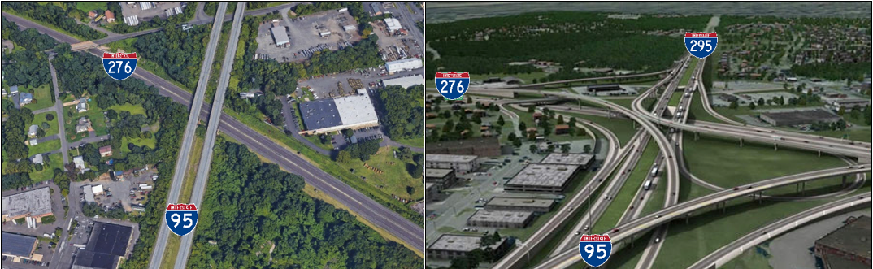

Figure 1: Current Disconnected I-276 / I-95 and Proposed I-276 / I-95 Interchange

1. **DESIGN CRITERIA**

The bridges and retaining walls were designed in accordance with the *AASHTO LRFD Bridge Design Specifications* (AASHTO 2004), and PennDOT Design Manual, Part 4 (PennDOT 2007). The sound barrier walls were designed in accordance with *AASHTO Guide Specifications for Structural Design of Sound Barrier* (AASHTO 1989), including the 1992 and 2002 Interims. The following decisions were made during preliminary engineering:

**Bridge Structure Types –** It was instructed by the PTC and PennDOT that only typical beam/girder bridges were to be considered within the interchange. Both prestressed concrete beams and steel plate girders were investigated to determine the proper structure types.

* For prestressed concrete beams, open sections such as AASHTO I-beams and Bulb-Tee Beams were preferred, considering savings for using a consistent beam type throughout a construction section.
* Use of field spliced prestressed concrete girders was not to be considered on this project.
* For steel plate girder bridges, web thickness transition was not allowed.
* Eliminate deck joints or move deck joints off the structures wherever possible.
* A 125-mm strip seal joint was approved for use as an alternate to a tooth dam joint to reduce construction costs and future maintenance.
* MSE abutments were not to be considered for this project.
* Both pot bearings and disc bearings were allowed for High Load Multi-Rotational bearings.
* For future redecking, the use of 3,350 mm travel lanes along with a reduction in the speed limit to 80 km/h is permitted. Redecking is assumed to occur 40 years after initial construction is completed.
* A combination of steel and concrete superstructures within a given structure was acceptable to both the FHWA, PennDOT, and the PTC on this project.
* For the purpose of studying bridge alternatives, the use of a combination of concrete and steel within a structure was considered an acceptable “Concrete” alternate. The patterns of A-B-A or A-B were acceptable. A bridge alternate was not considered if it resulted in an A-B-A-B pattern.
* Dual structures may have continuous (closed) abutments if widening of such structures was anticipated in the PennDOT’s 12-year plan.

**Retaining Wall Types –** Four alternative wall types were used throughout the interchange depending upon soil conditions, construction accessibility, velocity of stream at the100-year flood, and other constraints.

* MSE walls were not to be considered if a high water level in front of the wall is anticipated and the stream velocity is more than 610 mm per second.
* T-Walls were not to be recommended if anticipated settlement is more than 25 mm.
* Cast-in-place walls and soldier pile walls were the less desirable wall types and would be used only when MSE walls and T-Walls were not feasible or suitable for the site conditions and constraints.
* MSE walls were preferred for a back-to-back wall ramp. A back-to-back T-Wall will be evaluated during construction should the contractor propose it as an alternate.

**Sound Barrier Wall Types –** Both ground-mounted and structure-mounted concrete sound barrier walls were utilized on this project (Figure 2). Only steel posts were allowed for all sound walls with the maximum post spacing limited to 3.65 m. All steel posts are to be galvanized and then powder coated or painted. The maximum sound wall height measured from gutter line is limited to 5.50 m, and the maximum panel height is 2.45 m for a wall constructed with stacked panels. Minimum panel height is limited to 1.25 m.



Figure 2: Sound Barrier Walls

* Ground-mounted sound barrier walls were proposed along the roadways with bituminous pavement. The steel posts are anchored to 910 mm diameter drilled shafts.
* Where sound barrier walls are proposed along roadways with rigid concrete pavement, moment slab mounted barriers will support the sound barrier wall.
* Sound barrier walls atop retaining walls will also be mounted on moment slab barriers.
* Where sound barrier walls are required on bridges, the maximum height of sound barrier is limited to 3.05 m, the wall panels will be fabricated with lightweight concrete.
* The minimum structural thickness of the sound barrier wall panel is 125 mm. The wall panel thickness increases to 230 mm in the areas where sound absorptive material is required. For structure-mounted sound barrier walls with the 100-mm additional absorptive material, the thickness of the typical bridge or wall barrier was increased by 100 mm to offset the sound barrier wall away from the roadway to reduce the risk of sound wall panels being damaged by snow plows.

1. **CONTEXT SENSIVE DESIGN (CSD)**

The CSD elements (Figure 3) for the project were:

* For bridges over the Turnpike’s roadway, an Ashlar Stone formliner pattern was applied to the bridge substructures and barriers.
* For bridges over PennDOT’s roadway, horizontal grooves were applied to bridge abutments.
* Prestressed concrete fascia beams and steel fascia girders will be painted Dark Brown.
* Interchange flyover piers are hammer head units with an oblong column. Inlays are used on both sides and both ends of the columns. Circular columns are used where horizontal clearance is limited.
* Sound barrier wall panels have a tree bark pattern on the roadway side and an ashlar stone pattern on the community side.

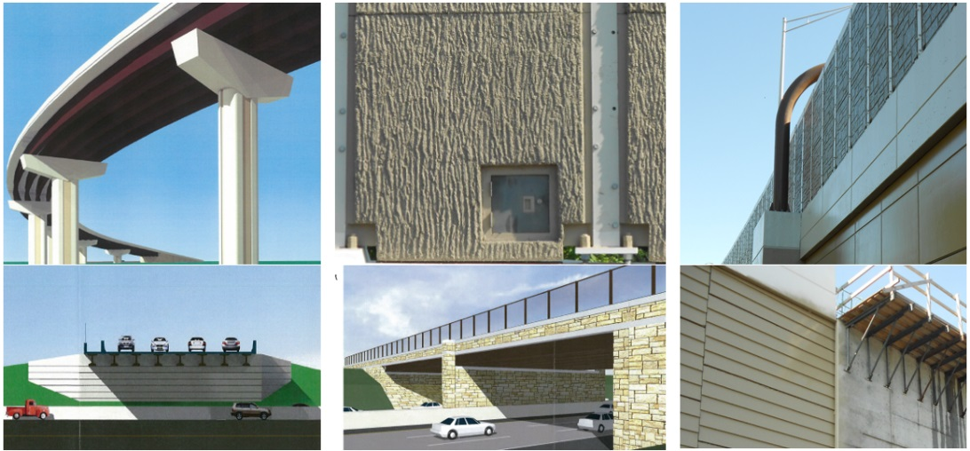

Figure 3: Context Sensitive Design Elements

1. **TURNPIKE MAINLINE STRUCTURES AND TRAFFIC CONTROL**

In the vicinity of the proposed interchange location, PA Turnpike I-276 is presently configured as a four-lane interstate facility. To the west of the project site, PA Turnpike has been widened to six lanes. To the east of the project area, the New Jersey Turnpike Extension is six lanes wide just across the Delaware River Bridge. The current (2014) average daily traffic (ADT) is 50,290 with 11% truck traffic. PA Turnpike I-276 mainline structures are being widened to accommodate a total of six lanes for mainline traffic, entrance and exit ramps, and 3,650 mm wide shoulders. Two 3,650 mm lanes in each direction are maintained through two stages of construction for both the Turnpike mainline and I-95 (Figure 4). Steel girder erection for the flyover spans over the two interstates at each location was accomplished through four (4) complete night-time shutdowns of the Turnpike, (i.e., “Plan X”) from 11:00 PM to 5:00 AM during weekends (Figure 5).

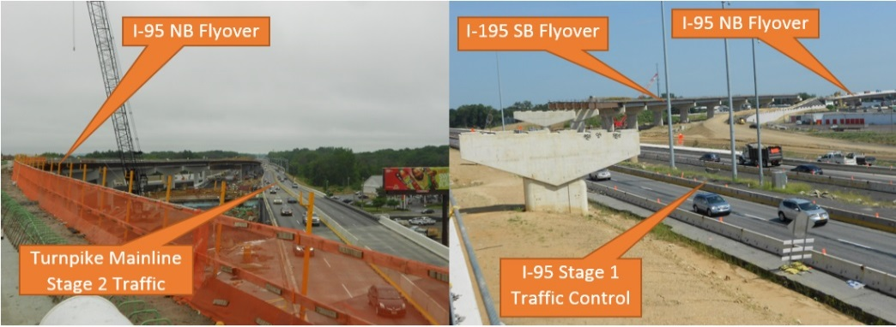

1. Section D10 (b) Section D20

Figure 4: Staged Construction of Turnpike Mainline (Section D10) and I-95 (Section D20)

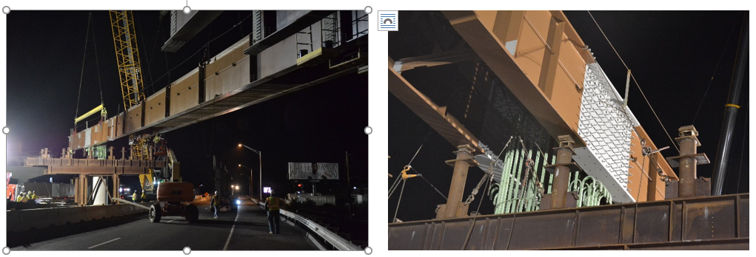

1. Erection of Girders in Pair (b) Erected Girders sit on Temp. Support

Figure 5: SB Flyover Girder Erection (Left) and Erected Girders at Integral Pier Cap (Right)

1. **MAJOR DESIGN ELEMENTS**
   1. **Noise Impact Assessment and Abatement Considerations**

There were eight (8) Noise Study Areas (NSAs) identified for the project. Noise impact criteria was defined as an applicable noise level of 66 dBA as per PennDOT criteria. When future (year 2030) noise levels are predicted to equal or exceed 66 dBA, or where the project is predicted to cause a substantial noise increase (≥10 dBA) in the future as compared to existing (year 2007) noise level, noise abatement must be considered. Based on future predicted noise level, the consideration of noise abatement was required for four (4) NSAs that affect 169 receptors. Noise barriers were determined to be feasible and reasonable, and noise levels can be decreased to levels at or below existing levels at most locations. As a result, a total of eleven (11) noise barrier walls were proposed for the project with a total wall length of 3,070 m and wall area of 11,820 square meter. The average cost per receptor was approximate $42,750.

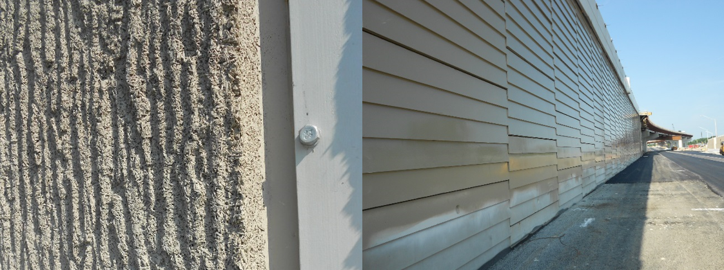

Figure 6: Absorptive-Faced Sound Wall Panel and Sawtooth-Faced Retaining Wall

Besides proposed noise barriers with 5.50 m maximum height, absorptive-faced sound barrier walls (Figure 6) were utilized for parallel barrier configuration (a barrier located on both sides of a highway) where the ratio of distance between the barriers to barrier-height is less than 10:1. Where a canyon created by the retaining wall that carries the I-95 NB ramp and noise barrier along I-95 SB, the face of the retaining wall was constructed with a “sawtooth” surface with a 1:10 batter to direct much of the reflective sound wave of the canyon (Figure 6).

* 1. **Pile Testing Program**

The majority of the Interchange Project’s structures were proposed to be founded on driven H-piles. It was estimated that about 2,250 piles were required to support the Phase I structures. All piles were to be driven to PennDOT Case 2 Absolute Refusal, defined as 20 blows per 25 mm in soft or decomposed rock, or in dense or hard soil strata. To better understand the pile drivability in a layer of saprolite, with a variable thickness of up to 11.50 m thick, and to evaluate the geotechnical resistance of the driven steel H-piles, a Pile Testing Program (PTP) was performed prior to the final design of the interchange structures. The PTP consisted of six (6) Grade 345, H-piles driven at three different locations, with three (3) HP310x110 and three (3) HP360x132. Table 2 summarizes the test results and the following conclusions can be drawn from the PTP.

* Absolute Refusal is a relative specification, it is a function of hammer type, efficiency, and driving procedure. A WEAP analysis should be performed prior to test driving to confirm suitability of the selected hammer. It was recommended that a hammer with a minimum transfer energy of 35.25 kN.m be used to install H-piles at the site. The measured PDA driving stresses were below the allowable driving stress of 275 MPa (80% of yield strength).
* With recommended minimum transfer energy, an open-ended diesel hammer with a rated potential energy of 58.61 kN.m achieved a larger geotechnical capacity than structural capacity for both HP310x110 and HP360x132 piles. To mitigate corrosion concerns at the site, 1.5 mm section loss must be considered for computing pile structural capacity. Therefore, HP360x132 piles were recommended for the project to achieve the maximum design efficiency.
* Results from the PTP and subsequent test piles during construction indicate that H-piles were able to penetrate through the soft saprolite S1 layer (Table 2) but were only able to penetrate 0.80 to 1.90 m into the dense saprolite, S2 layer (Table 2). Rather than assume pile tip elevations are at bed rock, pile tip elevations can be raised in areas with a thick S2 saprolite layer. This will affect the prices of furnished pile lengths and splices anticipated by the contractors. Saving will be realized during construction with reduced pile length.
* Pile extraction five days after the installation of pile TP-3A indicates that no damage to the pile or to the normal duty pile tip was observed. Therefore, only normal duty pile tips are recommended for the project.

Table 2: Pile Testing Program Summary

|  |  |  |  |  |  |  |  |  |  |  |  |  |  |
| --- | --- | --- | --- | --- | --- | --- | --- | --- | --- | --- | --- | --- | --- |
| Tested Piles | | Pile Length *(m)* | *1 TS1 m)* | *2 TS2 (m)* | *TS1 + TS2 (m)* | Pile Tip Relative to Top of Rock (*m*) | 3*Pu-str (kN)* | 4 *Pu-Geo* *(kN)* | *Pu-Geo / Pu-str* | *Avg.* | Skin Friction | Max Transfer Energy (*kN.m*) | Max Comp Stress (*MPa*) |
| HP310 | TP-1 | 11.0 | 1.7 | 1.9 | 3.6 | 0.6 above |  | 1997 | 1.18 |  | 10% | 35.6 | 263 |
| TP-2 | 13.7 | 5.5 | 1.2 | 6.7 | 4.9 above | 1700 | 1882 | 1.11 | 1.14 | 47% | 30.0 | 229 |
| TP-3 | 17.4 | 4.4 | 1.4 | 5.8 | 0.5 below |  | 1908 | 1.12 |  | 43% | 34.2 | 217 |
| HP360 | TP-1A | 10.3 | 1.7 | 1.3 | 2.9 | 0.6 above |  | 2100 | 1.03 |  | 23% | 35.1 | 223 |
| TP-2A | 13.6 | 5.5 | 1.1 | 6.6 | 4.9 above | 2033 | 2153 | 1.06 | 1.03 | 43% | 29.8 | 227 |
| TP-3A | 16.8 | 4.4 | 0.8 | 5.2 | 0.5 below |  | 2034 | 1.00 |  | 35% | 32.8 | 225 |

*1 TS1 – Thickness of Soft Saprolite Layer (S1), SPT > 40 blows for 300 mm*

*2 TS2 – Thickness of Dense Saprolite Layer (S2), SPT > 50 blows for 150 mm or less*

3*Pu-str – Factored Pile Structural Capacity = 0.35*Fy*As* 4 *Pu-Geo – Factored Pile Geotechnical Capacity = 0.65*CAPWAP Capacity*

* 1. **Site-Specific Seismic Study**

A site-specific seismic study was performed for the project to determine the design ground motions in terms of a response spectrum. Dynamic shear wave velocities (*Vs*) were obtained from five (5) Crosshole Seismic (CS) tests, each CS test consists of two or three boreholes spaced approximately 3.05 m center-to-center on the ground surface, the boreholes were cased with 100 mm diameter schedule 40 PVC casings. It was found that for overburdened soil, *Vs* ranged from 95 to 443 m/sec, while for saprolite and rock, *Vs* ranged from 410 to 1,870 ft/sec.



Figure 7: Seismic Design Spectrum: AASHTO Standard vs. Site-Specific

Site-specific design spectrum with damping of 5% was proposed for the project site (Figure 7). The spectrum is uniform for all structures with a deck area that exceeds 2,325 m2, with a hazard level equal to a 475-year earthquake event compatible with the PennDOT design manual. The design spectrum substantially reduced the design acceleration in the longer periods above 0.6 seconds as compared to the generic AASHTO specified spectrum, it also identified some soil amplification in the short period range below 0.3 seconds.

Site-specific spectrum design was applicable to three bridges as shown in Table 3. To investigate the benefits of site-specific seismic design, comparisons were performed for the 15-span I-95 SB flyover (DS13) and the column base moments are also presented in the table. A typical pier in Unit 2 was designed using forces from both spectrums. A 10x7x1.5 (meter) pile cap and 33 H-piles were required based on the seismic forces from the site-specific spectrum analysis, compared to a 12x10x1.8 (meter) pile cap and 37 piles if the AASHTO spectrum analysis was to be used. The saving to the substructures using the site-specific spectrum analysis with pile group stiffness considered was approximately $1.75 millions for DS13 and $1.50 millions for DS12, which was about 5% of the overall structure cost, and 20% of the substructure cost.

Table 3: Seismic Comparison – AASHTO Spectrum vs Site-Specific Spectrum

|  |  |  |  |  |  |  |  |  |
| --- | --- | --- | --- | --- | --- | --- | --- | --- |
| Bridge | Deck Area (m2) | Span Arrangement | Period  TLong. *(sec.)* | Period TTransv. *(sec.)* | Column Base Longitudinal Moment | | Column Base Transverse Moment | |
| MAASHTO *(kN.m)* | MS-Specific *(kN.m)* | MAASHTO *(kN.m)* | MS-Specific *(kN.m)* |
|  |  | Unit 1 (4-Span Steel) | 1.48 | 0.83 | Comparisons not performed | | | |
| DS12 | 11,520 | Unit 2 (6-Span PS Conc.) | 1.83 | 0.55 |
|  |  | Unit 3 (4-Span Steel | 1.03 | 0.55 |
|  |  | Unit 1 (4-Span Steel) | 1.53 | 0.75 | 83,040 | 24,939 | 42,215 | 17,790 |
| DS13 | 12,265 | Unit 2 (6-Span PS Conc.) | 1.78 | 0.78 | 26,456 | 7,692 | 61,010 | 25,470 |
|  |  | Unit 3 (4-Span Steel | 1.05 | 0.83 | 32,618 | 12,841 | 36,766 | 15,679 |
| DS14 | 2,555 | 4-Span PS Concrete | 1.22 | 0.35 | Comparisons not performed | | | |

* 1. **Hammer Head Integral Pier Caps**

Four post-tensioned integral pier caps were proposed for the interchange structures. Two were constructed in Phase 1: one at Pier 13 of the I-95 SB flyover (DS13) (Figure 8) and another one at Pier 2 of the I-95 NB flyover (DS12), both piers are located in the median of PA Turnpike I-276. Where the available vertical clearance is limited, integral pier caps have demonstrated to be an economical solution by improving the profile and span arrangements of the structures, and reducing the required embankment fill and retaining walls at approach roadways. Preliminary cost comparisons between using integral pier cap and raising bridge profile are presented in Table 4.



Figure 8: Hammer Head Integral Pier Cap for I-95 SB Flyover

Table 4 Integral Pier Caps

|  |  |  |  |  |  |  |  |
| --- | --- | --- | --- | --- | --- | --- | --- |
| Bridge | Cost of Integral Pier Cap | Roadway Embankment | Retaining Walls | RC Pier Cap | Abutments | Wings | Total Saving |
| DS12 | + $420,000 | - $1,110,000 | - $714,000 | - $100,000 | - $100,000 | 0 | - $1,600,000 |
| DS13 | + $396,000 | - $665,000 | 0 | - $30,000 | - $415,000 | - $100,000 | - $814,000 |

The design of an integral hammer head pier cap consists of the following aspects: layout of post-tensioning tendons, flexural design under strength limit states, stress checks under service limit states, stirrup designs for applied shear forces and torsions, and the design of shear studs at the interfaces between girders and cap concrete. As shown in Figure 8, the profile of post-tensioning tendons for a hammer head integral pier cap can be a simple circular shape with a radius $R={(L^{2}+M^{2})}/{2M}$. The tendons can be either uncoated Grade 1860 low-relaxation seven-wire strand or uncoated Type 2 Deformed Grade 1,034 high-strength bars. Mild reinforcement is conservatively ignored when sizing the tendon under strength limit state. Stresses in concrete were checked against the limits shown in Table 5.

Table 5 Allowable Stresses in Concrete of Integral Pier Caps

|  |  |  |  |  |
| --- | --- | --- | --- | --- |
| Stress | Initial Stress at Transfer of P/S | Final Stress under Design DL+P/S | Final Stress under Design Loads | Final Compression Stress under LL+0.5(DL+P/S) |
| Tension | 0.0948√*f’ci* | - | 0.0948√*f’c* | - |
| Compression | 0.6*f’ci* | 0.4*f’c* | 0.6*f’c* | 0.4*f’c* |

Transverse reinforcement (stirrups) was designed for both shear force and torsion. Five (5) legs of #19 stirrups spaced at 225 mm were required to resist the shear force, and three (3) additional #22 hoops spaced at 225 mm were required to resist the torsion (Figure 8). Approximately 100- #36 longitudinal torsional reinforcement bars were required based on Section 11.5.3.7 of ACI 318-11 (ACI 2011). These longitudinal bars were to be uniformly distributed along the perimeter of the section. However, the longitudinal torsional reinforcement at the bottom of the pier cap (in the compression zone) can be reduced per ACI Section 11.5.3.9, and similarly, according to ACI Section 11.5.3.10, the longitudinal torsional reinforcement at top of the pier cap can be reduced if the overstrength of the prestressing steel is to be used. As a result, only 74- #36 bars were needed: 27- #36 bars were provided on both sides of the pier cap, 9- #36 and 11- #36 bars were provided at top and bottom of the pier cap respectively (Figure 8).



Figure 9: Integral Pier Cap Design for Torsion

Torsion in the integral pier cap is resisted by shear resistance supplied by shear studs that are welded to the web and flanges of the steel girders (Figure 9). However, due to the large torsion in the pier cap, shear studs alone were unable to provide sufficient resistance. Torsion was designed to be resisted by the combination of shear studs and shear friction supplied by the longitudinal reinforcement steel. Shear friction is taken as *Vn = cAcv + μ[Avffy+Pc]* per AASHTO Section 5.8.4, where *cAcv* is cohesion in the interface, *μAvffy* is shear friction provided by longitudinal reinforcing steel, and *μPc* is shear friction due to permanent compression provided by the post-tensioning tendons. A total 185 studs were provided for girder G3 (Figure 5(b)). The torsional resistance provided by the shear studs was approximately 6,100 kN.m, which accounts for only about 18% of the 33,220 kN.m total torsion, while the remaining torsion was resisted by the shear friction.

* 1. **Twin Steel I-Girder Straddle Bent**

Two steel straddle bents were used that spanned over the I-95 and PA Turnpike I-276 roadways. Instead of using a traditional steel box girder, twin I-girders connected with diaphragms and tie plates were proposed (Figure 10).  Redundancy plates were also bolted to the bottom flanges. The bolted redundancy plates, and the robust full depth diaphragms and tie plates connecting each I-girder provide structural redundancy when the twin I-girder is analyzed as a system. Furthermore, High Performance Steel (HPS) Grade 485W was specified for the diaphragms, tie plates, web plates, bottom flanges and the redundancy plates to provide added strength and enhanced fracture toughness. The straddle bents were also designed and fabricated as fracture critical members (FCM).



Figure 10: Steel Straddle Bent for I-95 SB Flyover

Historically, out of three redundancies (Load Path, Structural, and Internal Member), only Load Path Redundancy is recognized in the classification of Fracture Critical Members for either design and fabrication or for in-service inspection of a bridge structure. FHWA 2012 Memorandum “Clarification of Requirements for Fracture Critical Members” (FHWA 2012) indicates that “*For in-service inspection protocol,* *Structural Redundancy demonstrated by refined analysis is now formally recognized and may also be considered for the classification of Fracture Critical Members*.” The three-dimensional (3D) system behavior of the straddle bent was investigated through a refined 3D non-linear Finite Element Analysis (FEA) by using LUSAS Bridge Software (LUSAS 2016). FEA was performed for four scenarios: full section; cracked web and bottom flange (BF); cracked bottom flange and redundancy plate (RP); and cracked web, BF and RP. The rating factors (in terms of factored live load) based on the FEA analyses are presented in Table 6. Based on the FEA analyses, the as-designed straddle bent provides sufficient load carrying capacity even with both the bottom flange and the redundancy plate of one of the two I-girders cracked. Structural redundancy is achieved through the full depth diaphragms and the tie plates.

Table 6 Rating Factors *(RF)1* of I-95 SB Straddle Bent based on FEA Results

|  |  |  |  |  |
| --- | --- | --- | --- | --- |
| Steel Grade | Full Section | Cracked  Web + BF | Cracked  BF + RP | Cracked  Web + BF + RP |
| All Gr. 345 | 3.25 | 2.25 | 1.85 | 0.91 |
| GR. 345 + Gr. 485 | 3.46 | 2.85 | 2.28 | 1.33 |

*1 RF = (φR - γDCDC - γDWDW) / γLL(1+IM)*

Figure 11 shows the deformed shape of the damaged straddle bent (web, bottom flange and redundancy plate are all cracked in one I-girder) after the ultimate capacity is reached. The deflection is 140 mm.

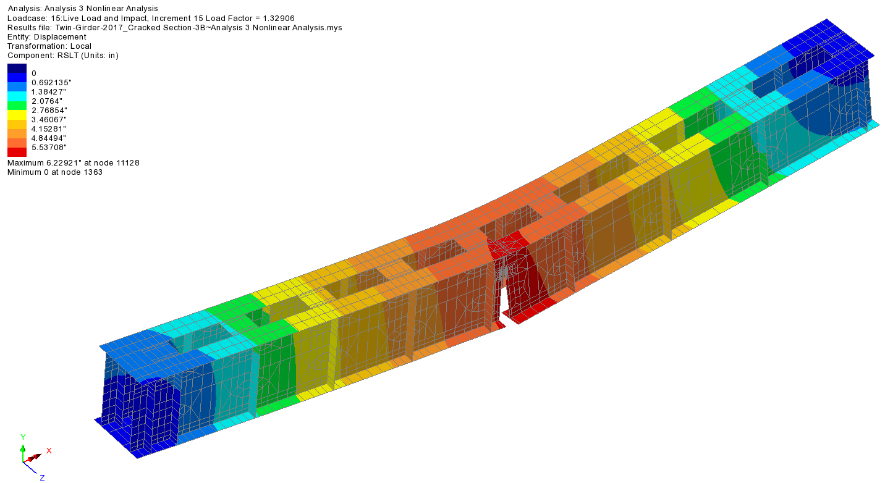

Figure 11: Non-Linear FEA of Cracked Twin I-Girder Straddle Bent

1. **CONCLUSIONS**

This paper presented the design criteria and major design elements of the first half of the PA Turnpike I-276 / I-95 Project (Phase 1). The first construction contract (D10) in Phase 1 has been completed in 2017 and second construction contract (D20) is expected to be complete by the end of 2018. Final design of the remaining interchange (Phase 2) has not yet started, so it is unclear as to when the fully functioning interchange will be operational.

**Acknowledgements**

Funding: Federal Highway Administration, Pennsylvania Turnpike Commission.

Owners: Pennsylvania Turnpike Commission, Pennsylvania Department of Transportation

Prime Consultant: Gannett Fleming, Inc.

Sub-Consultants: AECOM, Dawood Engineering, Inc., Specialty Engineering, Inc., Hunt Engineering Company, Borton Lawson Engineering.

Design Review Consultants: Jacobs Engineering Group, HNTB Corporation

Construction Manager: Urban Engineers, Inc.

Contractors: PKF-Mark III, Inc. (Construction Section D10)

James D. Morrissey, Inc. (Construction Section D20)

Steel Fabricator: High Steel Structures, Inc.

**References**

AASHTO. 2004. AASHTO LRFD Bridge Design Specifications, 3rd Edition, American Association of State Highway and Transportation Officials, Washington DC.

AASHTO/AWS. 2008. D1.5M/D1.5: 2008 Bridge Welding Code. Joint Publication of AASHTO and AWS, American Welding Society, USA.

PennDOT. 2007. Design Manual, Part 4 (DM-4), 2007 Edition. Pennsylvania Department of Transportation, Harrisburg, PA.

AASHTO. 1989. AASHTO Guide Specifications for Structural Design of Sound Barriers. American Association of State Highway and Transportation Officials, Washington, DC.

ACI, Building Code Requirements for Structural Concrete, ACI 318-11. American Concrete Institute, Farmington Hills MI.

FHWA. 2012. Memorandum “Clarification of Requirements for Fracture Critical Member.” Office of Bridge and Structures, Federal Highway Administration, USA.

LUSAS. 2016. LUSAS Bridge Software, Version 15.2. FEA Ltd., Kingston-Upon-Thames, UK.