|  |  |  |
| --- | --- | --- |
|  | **10th International Conference on Short and Medium Span Bridges**  **Quebec City, Quebec, Canada,**  **July 31 – August 3, 2018** |  |

**MATERIAL PROPERTIES OF THIN UHPC SLABS USED FOR TIMBER-CONCRETE COMPOSITE BRIDGE**

Holý, Milan1,2,3, Čítek, David2, Tej, Petr2 and Vráblík, Lukáš1

1 CTU in Prague, Faculty of Civil Engineering, Czech Republic

2 CTU in Prague, Klokner Institute, Czech Republic

3 [milan.holy@fsv.cvut.cz](mailto:milan.holy@fsv.cvut.cz)

**Abstract:** This paper deals with the material properties of Ultra High Performance Fiber Reinforced Concrete (UHPFRC or UHPC) and especially focuses on bending tests executed for the development of bridge deck segments for an innovative timber-concrete composite bridge system. In the first step, the precast bridge deck segment is designed as a thin slab made of UHPC of a constant thickness, without any ribs and without any reinforcement. Only steel fibres are used as a scattered reinforcement. The bending tests for determining flexural strength of UHPC were executed on the slab strips under similar boundary conditions as by the bridge deck segments. The slab strips of various thickness of 40, 50, 60, 70 and 80 mm were tested in 4-point bending tests with span 1900 mm and in 3-point bending tests with span 600 mm. Half of the test specimens were tested in casting position, other half were tested upside down. The obtained values of the flexural strength were compared with values from reference bending tests of the beams 150 x 150 x 700 mm, 100 x 100 x 400 mm and 40 x 40 x 160 mm. Different size of the tested specimen is discussed. An influence of the positioning of the slab with respect to the direction of casting and the influence of the deck thickness on the flexural strength is evaluated.

1. **Introduction**

The Ultra-High Performance Fiber Reinforced Concrete (UHPFRC, further only UHPC) is very promising material and its very favourable material properties allow to design very thin structures. Very subtle and aesthetical structures can be designed by combining timber and UHPC. This paper focuses on bending tests executed for the development of bridge deck segments for an innovative timber-concrete composite bridge system. The main objective was to determine the load-bearing capacity in bending of slabs with different thicknesses made of UHPC. The tensile response of UHPC is not an intrinsic property, and its quantification must account for both material formulation and manufacturing related factors. The bending tests for determining flexural strength of UHPC were therefore executed on the slab strips under similar boundary conditions as by the bridge deck segments. The impact of the casting method and the production process on the final orientation and distribution of the fibers have been experimentally studied through a number of different approaches. This issue is listed in more detail e.g. in (Duque et al. 2016) inclusive a literature review.

1. **Experimental program**

Currently, the experimental program for development of an innovative technology for the timber-precast UHPC composite footbridges is running at the Klokner Institute of CTU in Prague. The bridge system is designed for span range approximately 10-30 m and is established for pedestrians, cyclists and possibility of passage of vehicles weighting up to 3.5 tones.

* 1. **Bridge system**

The timber-concrete composite structure consists of two glulam beams coupled with precast bridge deck segments made of UHPC, see Figure 1. The precast bridge deck segments are designed as a thin slabs of a constant thickness made of UHPC, without any ribs and without any reinforcing bars, only steel fibres are used as a scattered reinforcement. In the first step, the full slab was chosen because of it’s easy production. By thin slabs with ribs, the problems related to differential shrinkage occur (cracks, distortion). From the author's experience, full slabs made of UHPC collapse gradually (not immediately) compared to slabs with ribs. The need for bar reinforcement will be verified by further testing of the entire segments. Shear connection is carried out by notches made of steel plates embedded in the timber beams supplemented with welded shear dowels (headed studs). The precast segments are provided with slots for the shear dowels, which are poured with UHPC after placing of the deck segments on the timber beams. The development of shear connection will be soon presented in other paper.

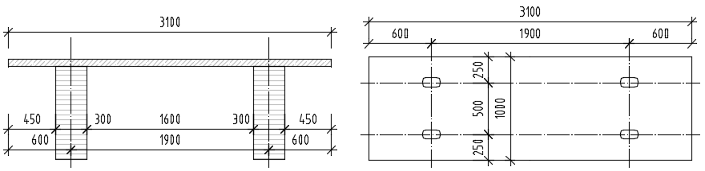

Figure 1: Cross-section of the load-bearing structure and ground plan of the deck segment with slots

The bridge deck segments are subjected to the combination of compression and bending in the longitudinal direction and to pure bending in the transverse direction. The transverse direction is crucial for design of the slab thickness. Statically, it is a double sided overhanging beam and the slab is stressed by positive and negative bending moments.

* 1. **Material**

Tested UHPC mixture consisted of the cement CEM II 52,5 N, fine aggregate with maximum size of 2 mm, slag, silica fume and steel fibres. Content of ingredients is listed in Table 1.

Table 1: UHPC mixture used for experiments

|  |  |  |
| --- | --- | --- |
|  | Ingredients | Content for 1 m3 |
|  |  | (kg) |
|  | Fine aggregate with maximal size of 2 mm | 1230 |
|  | Silica fume | 100 |
|  | Slag | 80 |
|  | Cement CEM II 52,5 N | 700 |
|  | Water | 165 |
|  | Superplasticizer | 40 |

A fiber reinforcement volume fraction of 2.0 % was used. The steel fibres were used non-deformed, cylindrical, brass coated high tensile strength steel with a diameter of 0.2 mm, a length of 13 mm, and a minimum tensile strength of 2200 MPa. Water to cement ratio was ca 0.24. Some laboratory tests were executed on cubes, cylinders and beams to determine the basic material properties of UHPC at the age of 28 days. UHPC specimens were cured in the moulds for 24 h after casting under polyethylene sheeting, then demoulded and cured for a further period under moist conditions of 95% relative humidity. The material properties are summarized in Table 2.

Table 2: Material properties of UHPC at the age of 28 days

|  |  |  |
| --- | --- | --- |
| Density | 2450 | kg/m3 |
| Compressive strength (cubes a = 100 mm) | 144,2 | MPa |
| Compressive strength (cylinder Ø150 mm) | 131,0 | MPa |
| Compressive strength (cylinder Ø100 mm) | 141,7 | MPa |
| Modulus of elasticity | 49,6 | GPa |

1. **Experiments for determination of flexural tensile strength**
   1. **Discussion on types of tests used in this study**

Based on different valid standards, there are several types of tests to determine the flexural strength of concrete (only in the Czech Republic, it can be applied about 5 different valid test procedures). The tests differ mainly in size of test specimen and in set-up. The tests are usually performed on beams loaded in a 4-point or 3-point bending with or without a notch. The accuracy of application and the interpretability of results of a particular test procedure for fibre-reinforced concrete structures are the subject of numerous debates. There is a fairly poor comparability of tests with each other.

In a four-point bending test, the middle third of the beam is stressed due to a constant bending moment without any shear force. The failure of test specimen occurs at the weakest point of the middle third of the beam. This test is therefore suitable for fibre-reinforced concrete elements due to the random nature of the distribution of the scattered reinforcement. However, it has a disadvantage that the failure occurs always in different places, so this test can’t be exactly reproduced. Another argument against this test is that the occurrence of pure bending moment is not typical for common structures, where the shear force also occurs and affects the failure.

In the case of a 3-point bending test, the failure does not occur at the weakest point of a beam, so the results are usually overestimated. Three-point bending test with a notch has a great advantage that the location of failure is exactly predefined and the crack opening can be measured. Based on this test, an inverse analysis can be performed to determine the stress-strain diagram of the material.

Because UHPC is a very fine-grained material, small test specimens can be used to measure the flexural strength. However, the size of the beam significantly influences the result of the evaluated flexural strength. Thin elements have higher strengths, which is probably caused due to better directed fibres on mold walls. Size effect is very well known factor in this type of heterogeneous material.

By thin elements, the fibres are usually distributed and oriented depending on the pouring of concrete and on the shape of the structural element. The load-bearing capacity of the bridge deck segment supposed to bending is strongly influenced by distribution of fibres. The bending tests for determining flexural strength of UHPC were therefore also executed on special test specimens - slab strips under similar boundary conditions as designed bridge deck segments.

* 1. **Reference tests**

Three-point bending tests on specimens with dimensions 100 x 100 x 400 mm and 150 x 150 x 700 mm with notch (according to ČSN EN 14651+A1) and 4-point bending tests on specimens with dimensions 150 x 150 x 700 mm, 100 x 100 x 400 mm without notch (according to ČSN P732452) were used as reference tests, see test set-up in Figure 2. Four-point bending tests had span 600 mm and 300 mm. Three-point bending tests had span 600 mm and 300 mm depth of notch 25 mm and 15 mm. The three-point bending tests with notch are controlled by sensor for crack opening CMOD (Crack Mouth Opening Displacement), which is located at the midpoint of the crack width and detects directly the crack opening. In addition, force and displacement of hydraulic cylinder and vertical displacement of slab are monitored. With respect to fine-grained UHPC, the beams usually used for cement testing of dimensions 40 x 40 x 160 mm (according to ČSN EN 196-1) were also used for 3-point bending test without notch with span 120 mm (according to ČSN EN 12390-5).

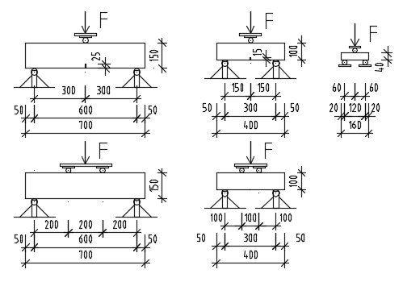

Figure 2: Test set-up for reference 3-point bending tests on specimens with dimensions 150 x 150 x 700 mm, 100 x100 x 400 mm with notch and 40 x 40 x 160 mm without notch and 4-point bending tests on specimens with dimensions 150 x 150 x 700 mm and 100 x100 x 400 mm

* 1. **Four-point bending test for slab strips**

Slab strips were designed with plan dimensions of 2000 x 250 mm with various thickness of 40, 50, 60, 70 and 80 mm for testing in 4-point bending. The four-point bending tests were carried out with span 1900 mm with load located approximately in thirds of span (630 mm from supports), see test set-up in Figure 3. The loading was controlled by displacement (speed 0.02 mm/s) in order to also obtain descending part of the stress-strain diagram. The force was measured on the hydraulic cylinder and the vertical displacement of slab was monitored with four point sensors. Two sensors were placed in both supports to measure the push of the supports and other two were placed in the middle of span to measure the deflection on both sides of slab (for detection of eventual torsion of slab). The slabs were tested upside as placed during casting (in this paper designated as normal position) in 4-point bending.

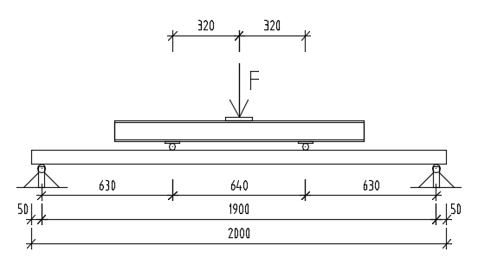

Figure 3: Test set-up for 4 point bending test on slab strips with width 250 mm

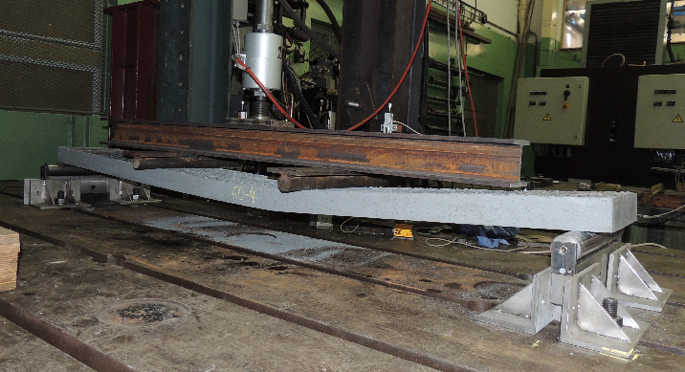

Figure 4: Slab with thickness of 60 mm with bend crack failure near the middle of span

* 1. **Three-point bending test for slab strips**

Because the long specimens from 4-point bending tests were broken in the middle third of span and the outer thirds of test specimens remained undamaged, the outer thirds could be further used for 3-point bending tests with span 600 mm. The set-up of the 3-point bending test is shown on Figure 5. Half of the test specimens were tested in normal casting position (N), other half were flipped upside down - in reverse position (R).

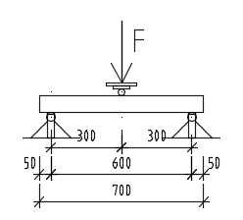 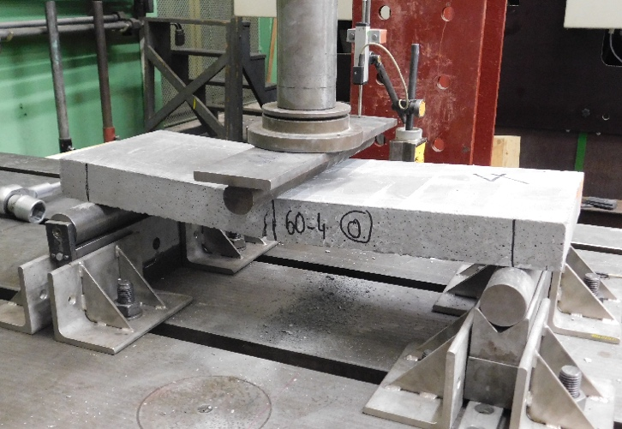

Figure 5: Test set-up and photo of the 3-point bending test on slab strips with width 250 mm

1. **Results and discussion**
   1. **Test outputs**

Test outputs of experiments are records of the force measured on the hydraulic cylinder depending on the deflection of the slab. The test outputs are shown in the following figures 6-9. The records of the 3-point bending tests were smoothed to achieve better clarity for comparing of multiple records in one diagram.

Figure 6: Load-deflection diagram of 4-point bending tests on slab strips with span of 1900 mm in normal casting position

Experience with UHPC application shows that thinner slabs are significantly more ductile than thicker slabs. This behavior is well evident in records of the 4-point bending tests for the slab thicknesses of 40, 60 and 80 mm (see Figure 6). The failure of the 40 mm thick slabs is achieved by approximately twice greater deflection than by the 80 mm thick slabs. However, some deviations from this trend can be observed by the 50 and 70 mm thick slabs. The ductility of the 70 mm thick slabs is comparable to the 80 mm thick slabs and their load-bearing capacity is only the same or slightly higher than by 60 mm thick slabs. It could be related to the transition from ductile behavior to more brittle behavior. The tests of the 50 mm thick slabs completely deviate from this trend, although the results within pair are very similar. The value of the fracture energy is in this case much lower compared to the other slab thicknesses. It indicates an obvious error in the distribution of the fibres. There was probably a mistake in pouring this batch in molds, because the specimens were concreted in laboratory in more batches over several weeks. In the next step, we plan to perform comparative experiments in the concrete factory under realistic conditions for the production of bridge deck segments, where the quality of pouring in molds should not fluctuate.

The 3-point bending tests on slab strips are more balanced. The load-bearing capacity of the 70 mm thick slabs and of the 50 mm thick slabs in normal position is slightly lower than expected.

Figure 7: Load-deflection diagram of 3-point bending tests on slab strips with span of 600 mm in normal casting position

Figure 8: Load-deflection diagram of 3-point bending tests on slab strips with span of 600 mm in reverse position (upside down)

Figure 9: Stress-deflection diagram of reference 3-point bending tests with notch and 4-point bending tests without notch on beams sizes of 100 x 100 x 400 mm and 150 x 150 x 700 mm

* 1. **Evaluated flexural strength**

The relationship between an evaluated flexural strength of an individual specimen fct and a peak load Fmax for linear-elastic behaviour is given by Equation 1 for the 3-point bending tests and by Equation 2 for the 4-point bending tests. Where L is the span, b is the average width and d is the average depth of the specimen.

[1] fct = 2 x Fmax x L / (3 x b x d2)

[2] fct = Fmax x L / (b x d2)

The evaluated flexural strength of UHPC from executed experiments were compiled into the following Tables 3 and 4.

Table 3: Comparison of mean flexural strength values from reference bending tests

|  |  |  |  |  |
| --- | --- | --- | --- | --- |
| Reference bending tests | | | | |
| Set | Test and specimens | | Evaluated mean  flexural strength  (MPa) | Comparison with set 1  (%) |
| 1 | Four-point load, 150 x 150 x 700 mm without notch | 12,5 | | 100% |
| 2 | Three-point load, 150 x 150 x 700 mm with notch | 13,5 | | 107% |
| 3 | Four-point load, 100 x 100 x 400 mm without notch | 17,5 | | 140% |
| 4 | Three-point load, 100 x 100 x 400 mm with notch | 19,1 | | 152% |
| 5 | Three-point load, 40 x 40 x 160 mm without notch | 29,9 | | 238% |

From the comparison of the reference bending tests in Table 3, it is evident, that the evaluated flexural strength is greater with the decreasing size of the test specimens. A smaller size of the test specimen is also corresponding to a shorter span length. The differences in the evaluated flexural strength are considerable, the specimens with dimensions 40 x 40 x 160 mm exhibit approximately 2.5 times greater flexural strength than the specimens with dimensions 150 x 150 x 700 mm. The values of the flexural strength evaluated from the 4-point bending test are approximately 8-9% less than the values from 3-point bending test.

Table 4: Comparison of mean flexural tensile strength values from 3-point and 4-point bending tests for investigated slab thicknesses in normal position (as casted) and in reverse position (upside down)

|  |  |  |  |  |  |
| --- | --- | --- | --- | --- | --- |
|  | Mean flexural tensile strength of UHPC slabs (MPa) | | | | |
| Test type / Slab thickness (mm) | 40 | 50 | 60 | 70 | 80 |
| Four-point bending test - normal position | 19,5 | 11,9 | 18,9 | 14,3 | 16,7 |
| Three-point bending test - normal position | 22,8 | 19,8 | 22,1 | 17,7 | 19,8 |
| Three-point bending test - reverse position | 19,5 | 18,3 | 17,4 | 14,3 | 15,5 |
|  | | | | | |
| Reverse to normal position ratio of 3-point tests | 85% | 92% | 79% | 81% | 78% |
| Four-point to three-point bending tests ratio | 85% | 60% | 86% | 81% | 84% |

From the comparison of the 3-point bending tests on the slab strips in normal and reverse position (see Table 4), it is evident, that the evaluated flexural strength of tested UHPC slabs in reverse position is approximately 20% lower than slabs in normal position. This difference is caused by distribution of fibres, because more fibres are distributed at the bottom surface in tension zone of N-beam, where they are also better directed due to formwork shape and casting process. In the upper part of cross-section of 2-3 mm thickness, there are almost no fibres in the concrete matrix.

The values of the flexural strength evaluated from the 4-point bending test are approximately 15-20% less than the values from 3-point bending test in normal position. This confirms the assumption that the results of 3-point bending test are overestimated compared to the average condition of the beam. The span length in the 4-point bending test was ca 3 times greater than in the 3-point bending tests. The difference in evaluated values of the flexural strength between the 3-point and the 4-point bending tests for slab strips was ca 2 times greater compared to the difference in the reference tests with the same span length.

Some trend of the decreasing flexural strength with the increasing thickness of slab can be observed. This trend is marked with dotted lines in the graphical comparison of evaluated flexural tensile strength values in Figure 10. Differences in evaluated flexural strength are approximately 3-4 MPa between 40 and 80 mm thick slabs. This descending trend is best observable in the 3-point bending test for reverse position, where the change in slab thickness by 10 mm corresponds to a change in evaluated flexural strength of about 1 MPa.

Figure 10: Graphic comparison of mean flexural strength values from 3-point and 4-point bending tests

1. **Conclusion**

The evaluated flexural strength is significantly different due to the various sizes of the test specimens. The specimens with dimensions 40 x 40 x 160 mm exhibit approximately 2.5 times greater flexural strength than the specimens with dimensions 150 x 150 x 700 mm. The bending tests for determining flexural strength of UHPC were therefore executed on the slab strips under similar boundary conditions as by the bridge deck segments. An influence of the positioning of the slab with respect to the direction of casting and the influence of the deck thickness on the flexural strength was evaluated. Some trend of the decreasing flexural strength with the increasing thickness can be observed. The position of the bridge segment by casting and by placement on site is important. The flexural strength of tested UHPC slabs in reverse position was approximately 20% lower than slabs in normal position. It was also found that the values of the flexural strength evaluated from the 4-point bending test are approximately 15-20% less than the values from 3-point bending test in normal position. This confirms the assumption that the results of 3-point bending test are overestimated compared to the average condition of the beam. The span length in the 4-point bending test was ca 3 times greater than in the 3-point bending tests. The difference in evaluated values of the flexural strength between the 3-point and the 4-point bending tests for slab strips was ca 2 times greater compared to the difference in the reference tests with the same span length.

In the next step, we plan to perform comparative experiments in the concrete factory due to some deviations in the executed 4-point bending tests. The experiments will be further supported by nonlinear numerical analysis, which could help to optimize the bridge deck segments. Parameters for the material model of UHPC will be optimized based on the experiments performed. In parallel, the system for timber and UHPC connection is being developed, and its development is also supported by experiments.

**Acknowledgements**

The presented results were obtained under the support of the research project TH02020730 of the Technology Agency of the Czech Republic (TACR).

**References**

AFGC. 2013. *Ultra high performance fibre-reinforced concrete: Interim Recommendations*, Revised edition, AFGC publication, France

Beton-Kalender 2013. 2013. *Teil 2, IX Ultrahochfester Beton UHPC*, Ernst & Sohn, Germany

Duque, L.F.M., Varga, I. and Graybeal, B.A. 2016. Fibre Reinforcement Influence on the Tensile Response of UHPFRC, *First International Interactive Symposium on UHPC - 2016*, Des Moines, IOWA, USA

Kolísko, J., Rydval, M. and Huňka, P. 2013. UHPC - Assessment of Steel Fibre Distribution and Matrix Homogeneity. *In fib Symposium TEL-AVIV 2013 Engineering a Concrete Future: Technology, Modeling & Construction - Proceedings.* Tel Aviv: IACIE Israeli Association of Construction & Infrastructure Engineers, Tel Aviv, Israel, p. 113-116.

Vítek, J. L., Coufal, R. and Čítek, D. 2013. UHPC - Development and Testing on Structural Elements. *Concrete and Concrete Structures 2013*, University of Žilina, Žilina, Slovakia, p. 218-223

Vítek, J. L., Čítek, D. and Coufal, R. 2013. UHPC Joints of Precast Elements. *Fibre Concrete 2013 - Technology, Design, Application,* CTU in Prague, Faculty of Civil Engineering, Prague, Czech Republic, p. 407-414.

Zhou, B. and Uchida, Y. 2009. Fibre Orientation in Ultra High Performance Fibre Reinforced Concrete and its Visualization, *Non-Destructive Testing in Civil Engineering*, Nantes, France