 | 10th International Conference on Short and Medium Span Bridges  Quebec City, Quebec, Canada,  July 31 – August 3, 2018 | 

AN OVERVIEW OF THE IMPLEMENTATION OF NATURAL SECURITY STRATEGIES ON BRIDGE STRUCTURES FOR CRIME PREVENTION
Mah, Andrew D.^{1,2}
¹ Morrison Hershfield Ltd., Canada
² amah@morrisonhershfield.com
Abstract: The task of securing our nation’s bridges against crime is often considered the responsibility of law enforcement and intelligence agencies, however, the bridge designer has a vital role in the security process. The typical engineering solution to addressing safety involves the implementation of mechanical security strategies such as closed-circuit television (CCTV), help phones, fences, and/or convex mirrors. However, these mechanical security strategies come at a cost and often involve associated maintenance and operating costs. This paper will examine natural security strategies, also known as Crime Prevention Through Environmental Design (CPTED), to enhance both mechanical and organized security strategies (law enforcement patrols and response) for crime prevention. By incorporating CPTED strategies for bridges, user comfort can be improved, bridge aesthetics can be enhanced, and a reduction in cost associated with mechanical security strategies may be realized. Challenges and barriers faced by bridge designers on implementing certain CPTED strategies and the limitations of CPTED will also be examined and discussed.
- INTRODUCTION
According to the 2011 National Household Survey conducted by Statistics Canada, 15.4 million Canadians commute to work daily either by driving, public transit, cycling, or walking; in Toronto alone, there are 2.3 million commuters (Statistics Canada 2016). Thus, continuity of the transportation network, including the protection of transportation critical infrastructure, is essential to maintaining the nation’s economy.
Bridges can be considered critical infrastructures in the transportation sector: they are necessary to ensure continuity of roads and rails, connect communities and economies, and allow for the complex interchange systems we see in today’s urban environment. Simply, without bridges, our transportation network would fail.
From a crime prevention perspective, bridges pose a unique problem: they are essential to connect people from one community to another, but they also act as a “bottleneck” with limited to no escape routes in the event of an ambush. Typical solutions to addressing safety involves the implementation of mechanical security strategies such as CCTV, help phones, fences, and/or convex mirrors; however, these strategies come at a cost and often involve associated long-term maintenance and escalating operating costs.
When it comes to law enforcement, most members of the public typically think of the traditional model: a crime is committed, law enforcement responds and an officer either apprehends the offender or initiates an investigation. However, law enforcement has evolved over the years and has taken a more progressive approach involving partnerships with residents, businesses, and governments, including engineers. This paper will look at how engineers can contribute to the crime prevention effort in safeguarding our nation’s bridges through a concept called “Crime Prevention Through Environmental Design”.
- OVERVIEW OF SECURITY STRATEGIES
There are different types of security strategies and each type of strategy plays a crucial part of the overall security program. In general, there are three major types of security strategies: organized, mechanical, and natural. These strategies can be used independently or in combination.
Organized security strategies involve the use of human resources, typically law enforcement and/or security guard patrols. While, organized security strategies are extremely important and arguably the most effective means of combatting crime, policing budgets and staffing are limited. As a result, other strategies are required as part of the overall security strategy to augment law enforcement efforts.
Mechanical security strategies involve the use of engineered elements to achieve surveillance, hardening, or provide an alternate means of addressing security deficiencies. For example, the installation of closed-circuit television (CCTV) is a mechanical security strategy used to address surveillance. Strengthened doors, locks, blast walls, fortified gates and barriers are some examples of hardening. Finally, the installation of convex mirrors and help phones are mechanical strategies used to address blind spots and areas of vulnerability. While these mechanical security measures are effective, they may require a substantial initial cost for installation and all will require ongoing maintenance and eventually replacement. Another major drawback is that the over-implementation of mechanical security measures can drastically reduce the infrastructure’s aesthetic value and consequently lower the user’s experience. For example, if a bridge is protected with barbed wire and surrounded with fortified gates and CCTV, people may begin to avoid using that bridge altogether due to the “militarization” of the protected asset.
Crime Prevention Through Environmental Design (CPTED) focuses on using natural security strategies. Natural security strategies involve the use of alterations to the built environment to achieve security through psychological influences. Examples of natural security strategies and associated design strategies will be discussed in the subsequent sections of this paper.
- HISTORY OF CPTED `
Crime Prevention Through Environmental Design, or abbreviated as “CPTED” (pronounced “Sep-ted”), is an approach to crime prevention that uses “proper design and effective use of a built environment that can lead to a reduction in the fear and incidence of crime and an improvement in the quality of life.” (Crowe 2013) The premise of CPTED is that careful design of a user space can create a psychological deterrence for undesirable behaviour while promoting the use of space for its intended purpose.
Jane Jacobs, author of the book The Death and Life of Great American Cities (Jacobs 1961), wrote that safety can be achieved by having clearly defined public and private spaces, “eyes upon the streets” from inside buildings, and continuous sidewalks to increase activity on the streets. It was from Jacob’s ideas that Dr. C. Ray Jeffery, a Florida State University criminology professor developed his concept of CPTED around. In 1971, Jeffery introduced the concept of CPTED in his book Crime Prevention Through Environmental Design (Jeffery 1971). Jeffery’s framework of crime prevention was based on the prior works by Jacobs and his knowledge of psychological learning theory. Jeffery argued that the way to reduce crime is to design the environment such that the opportunities for crime can be reduced or eliminated.
In 1972, architect Oscar Newman (Newman 1972) augmented Jeffery’s concept of CPTED by developing the “defensible space theory”. Basing his work off the prior works of sociologist Elizabeth Wood, Newman wrote the book Defensible Space: Crime Prevention Through Urban Design. He identified four design concepts and their relation to the occurrence of crime: territoriality (private versus public space), natural surveillance (the witness-potential of a space), image (the sense of security an infrastructure can project), and adjoining land use.
Throughout the years, other criminologists, researchers, and law enforcement agencies have built upon the founding concepts of CPTED to create the modern framework that is often used today in various jurisdictions. While there are slight variations in various CPTED models, the fundamental concepts remain largely unchanged. The design concepts presented in this paper follow the works of Timothy Crowe and focus on the design concepts of natural surveillance, natural access control, and territorial reinforcement.
- CPTED CONSIDERATIONS
Under the CPTED framework, the designer should consider the designation, definition, and design of the space (also referred to as “the 3 D’s” in CPTED). Designation refers to the intended purpose of the user space. For bridges, the main question is, “are all the elements on the bridge being used for its intended purpose?” For bridge structures, consideration should be made as to whether the bridge is being used for its intended purpose of transporting people (pedestrians/cyclists/vehicles/trains/transit) between two locations or does the space support unintended and undesirable activities such as loitering, graffiti, vandalism, or other crimes? One main strategy of CPTED is to place safe activities in unsafe locations and vulnerable activities in safe locations. By placing safe activities in unsafe locations, the overall perception of safety in the area is increased. Conversely, by placing vulnerable activities in safe locations, the risk to vulnerable users can be reduced. An example from the retail world would be the placement of an ATM in a high traffic area as opposed to a secluded alcove where the potential for robbery would be higher.
Definition refers to how well the boundaries of the space are defined. While bridges are considered public infrastructure, there are certain areas intended to be off-limits to the public. For example, if the intent of the bridge is to keep pedestrians on the sidewalk, there should be clear boundaries to keep pedestrians from wandering off the pathway.
Design refers to how well the built environment supports the intended use of the space. The design of the space should encourage the intended purpose and activities of the space while discouraging undesirable activities. For example, pedestrian access should permit the ease of movement of people across the bridge as opposed to lowering the user experience to the point that pedestrians are avoiding the bridge. In addition, the design of the bridge should assist in delineating boundaries of public access and restricted areas.
Not all “undesirable activity” is considered crime. Crime only encompasses undesirable behaviour that breaks the law. For example, depending on local laws, loitering in a public space may not be considered criminal but if the space was intended to be a transportation corridor where movement of people is expected, loitering could be considered an “undesirable activity”. Thus, people that commit undesirable activities are often referred to as “abnormal users” as opposed to “offenders” or “criminals”. Conversely, people that use the space for its intended purpose are referred to as “normal users”.
- CPTED DESIGN CONCEPTS
Upon completion of the CPTED assessment, design elements can be selected to address any shortcomings identified. CPTED consists of three main overlapping design concepts: natural surveillance, natural access control, and territorial reinforcement. Bridges are unique in that the number of physical design changes to allow for CPTED design concepts can be limited as most bridge designs are so optimized, all design components have designated purposes. However, achieving the three main design concepts for bridges is not impossible but sometimes requires “thinking outside the box”.
  - Natural Surveillance
The first design concept of CPTED is natural surveillance. Natural surveillance involves the placement and selection of design elements to maximize visibility and witness potential. The key concept to natural surveillance is to design the environment such that normal users can readily observe any abnormal users. The ability for normal users to observe abnormal or suspicious activities can either lead to effective citizen reporting or a deterrence in crime by creating an environment where the abnormal user may feel uncomfortable due to the potential of being caught.
Bridges present a unique challenge when implementing natural surveillance; in many cases, the total elimination of obstructions to improve sight lines is not feasible nor cost effective. For example, a pedestrian sidewalk cantilevered on the outside of a through truss structure will have sightline obstructions due to the superstructure elements. Eliminating these superstructure elements would not likely be feasible nor cost effective unless the project is a superstructure replacement. Thus, implementing natural surveillance is contingent on the anticipated type of bridge project: new construction/replacement or rehabilitation.
When evaluating the effectiveness of natural surveillance, the designer will need to consider the witness potential of the bridge and bridge elements. Some questions the designer should consider include the following:
- Will normal users of the bridge (pedestrians/cyclists/motorists/trains) be able to observe abnormal behavior when using the bridge as intended? i.e. Will a motorist from the travel lanes be able to notice abnormal activity occurring at the sidewalks while driving across the bridge?
- Can observers outside of the bridge see the activities happening on the bridge? i.e. Are there sources of surveillance from adjacent lands such as parks, buildings, other roads and sidewalks? Where are these potential sources of surveillance located relative to the bridge? Are there obstructions that could limit surveillance for these outside observers?
- What is the quality of the surveillance potential? i.e. Are there shadows, glare, or sudden changes in natural and/or artificial light that may obstruct a person’s ability to notice abnormal activity? Will a passing motorist be going too fast to notice suspicious activity? Are there bridge elements that can limit witness potential?
Based on these questions, the following bridge design considerations can be implemented.
- Structure type and configuration: Certain bridge structure types lend themselves better to natural surveillance. When elements that support user activity (i.e. the bridge deck) are placed above structural elements, obstructions that limit sight lines can be mostly reduced. As a result, for a new construction or superstructure replacement, consideration should be made for certain preferable deck configurations such as deck on girders and deck trusses.
- Pedestrian facility placement: In many cases, pedestrian facilities (sidewalks and walkways) are built at the same grade as the road elevation. However, if roadside safety dictates that pedestrian facilities are to be grade-separated, consideration should be made to elevate the pedestrian facilities as opposed to lowering. By placing the pedestrian facilities above the roadway elevation, witness potential of pedestrian activities can be improved as the pedestrian users will remain at or above the eye level of motorists.
For dedicated pedestrian grade separation structures (pedestrian underpass or overpass structures), the preference is to elevate the pedestrian structure over the roadway or railway in order to improve witness potential.
- Approaches: Bridge approaches should be designed to maximize sight lines. Sight distances are often not a problem for vehicles as they are dictated by local standards and codes. However, approaches for cyclists and pedestrians should be made as straight as possible to maximize sight distances. Preferably, sharp turns in the approach should be avoided for pedestrian facilities as the sudden change in alignment can create blind spots which are potential ambush areas.
- Lighting: It is recommended that pure white (LED or metal halide) lighting be utilized if possible to maintain a high color rendering index, therefore maximizing witness potential. Lux and uniformity of lighting should be based on the IESNA G-1-03 Guideline for Security Lighting for People, Property, and Public Spaces (IESNA 2017) as well as other local lighting standards. Cut-off fixtures should be used so that glare does not inadvertently reduce witness potential.
In the example bridge in Figure 1, good natural surveillance is provided with the use of straight approaches on the sidewalk. The elevated sidewalks provide good natural surveillance by improving the visibility of pedestrian users. Finally, the use of see-through exterior bridge rails maximizes witness potential on the bridge deck from outside observers.
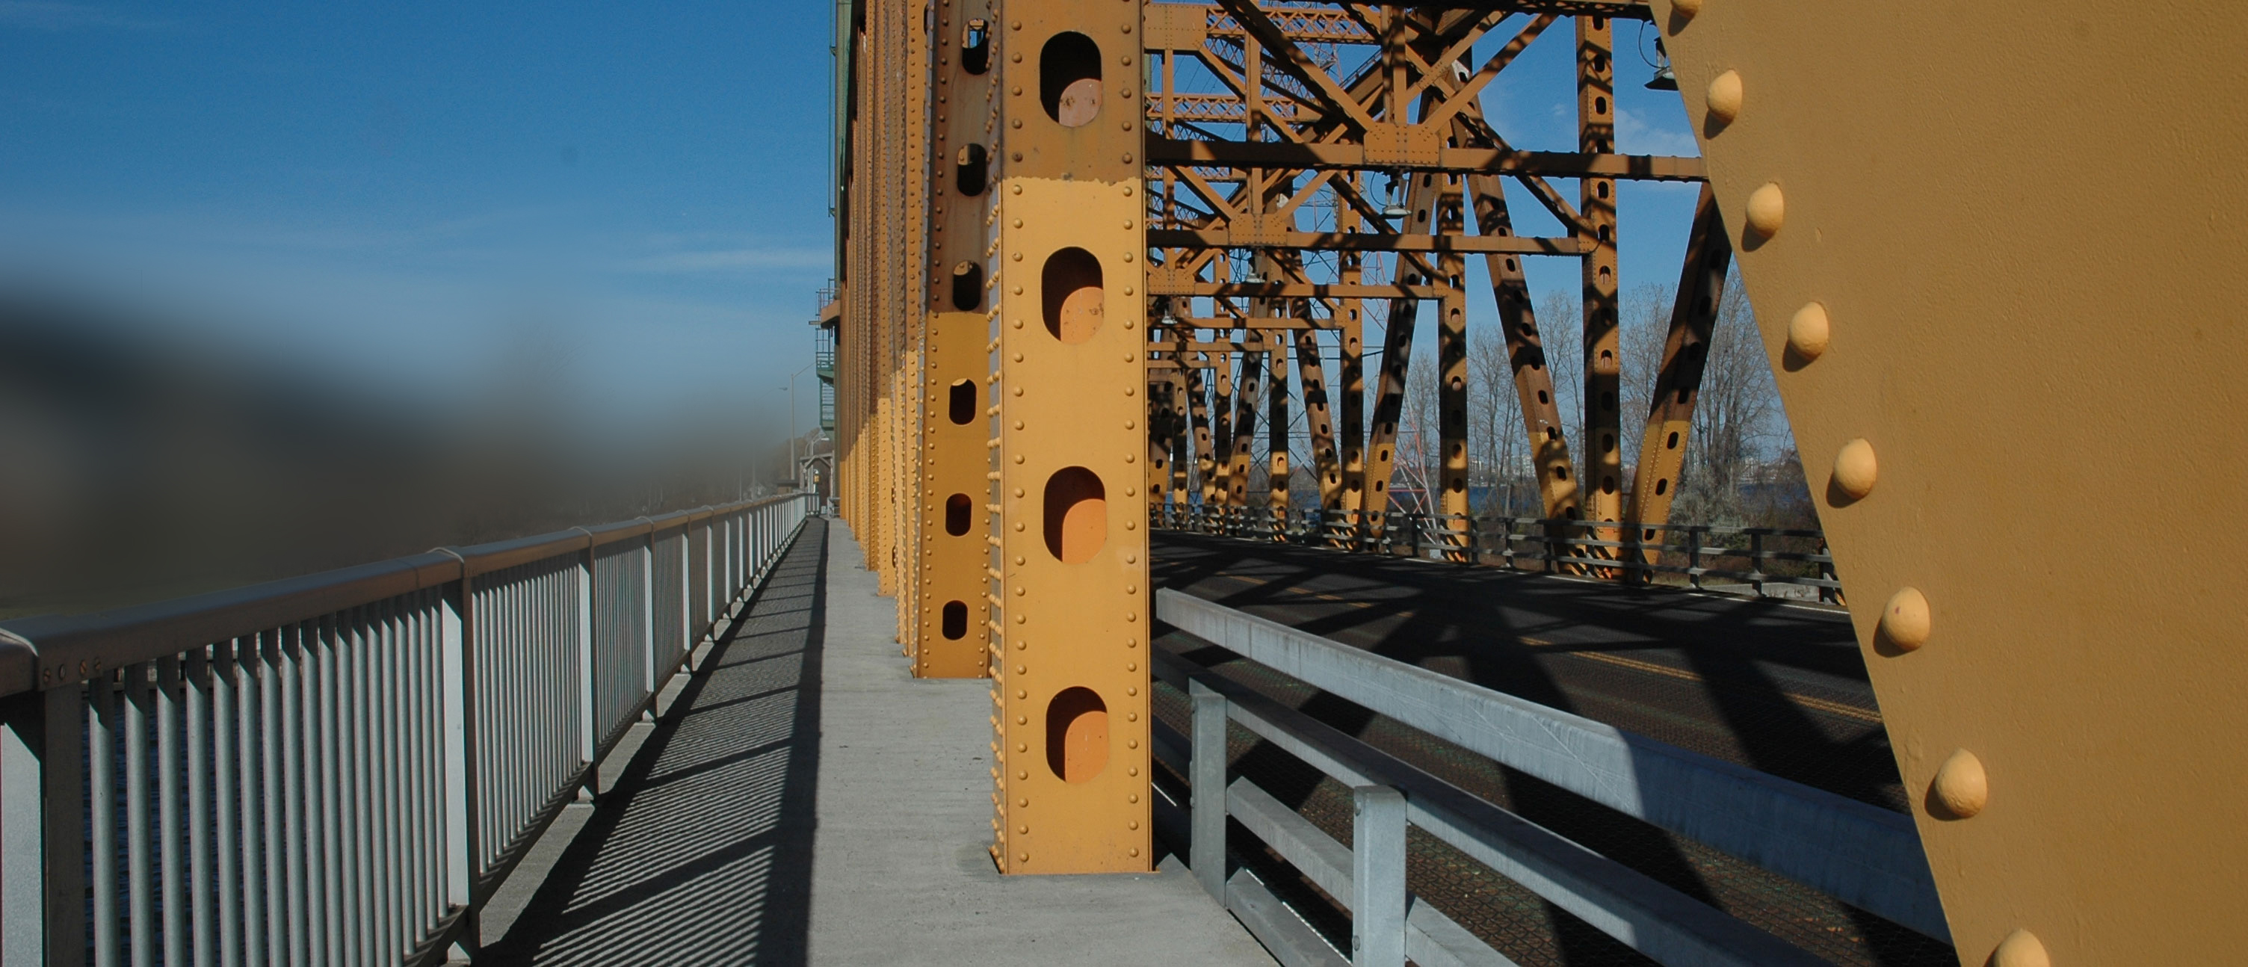
Figure 1: An example of a truss bridge featuring both good and poor natural surveillance design elements
The example in Figure 1 also illustrates elements that provide poor natural surveillance. The steel truss members extend above the deck and create partial visual obstructions of the walkway from the traffic lanes. The partial visual obstructions may limit the quality of witness potential from the roadway and, because the structural members are located within the pedestrian right-of-way, the areas behind each structural steel member could potentially be used for concealment by abnormal users. The high costs of changing the structure type just to eliminate the vertical truss members would only be realistic if the superstructure was already scheduled for a full replacement. Until then, other security strategies and other natural security strategies should be implemented to address these shortcomings.
  - Natural Access Control
Natural access control involves the placement of design elements to manage the movement of people into and through a site. The goal of natural access control is not necessarily to restrict access to abnormal users but rather to control the movement and flow of all users. This strategy creates an environment where abnormal trends in the flow of travellers become readily observable, creating the perception of risk to potential abnormal users and thus, discouraging undesirable behavior.
Design elements for natural access control include landscaping/vegetation, fences, low walls, planters, gradient changes, furniture, bike racks, garbage cans, and bollards. The effectiveness of natural access control is based on the premise that people will often take the path of least resistance. For example, if there’s an object is placed in a person’s path, they will often prefer to go around the object as opposed to going over it. Thus, through the strategic placement of certain design elements, the predicted movement of the users can be controlled. Natural access control should still allow for movement as natural access control elements should not impede the escape of a victim nor create safety hazards for normal users.
Bridges are typically structured in such a way such that the movement of pedestrians and vehicles at deck level are controlled by sidewalks and vehicle lanes; the default design of a bridge and its roadside safety code requirements contribute to the structure’s natural access control. However, certain elements, such as substructures and retaining walls are often prone to graffiti and vandalism. While these elements can be blocked off with chain link fence, in many instances, the fence does little to deter trespassing as evident from the graffiti, empty alcohol containers, and other litter typically found during bridge inspections. While installing a more robust and climb-proof fence is always a possibility, natural access control could be used to augment existing measures. Hostile vegetation consisting of thorny vegetation such as rose bushes or holly or evergreen shrubs could be planted in front of the chain link fence to create an additional natural barrier requiring a person wishing to climb over the fence to pass through the natural barrier of thorny vegetation. Another side benefit of using vegetation is that the greenery can “soften” the look of the physical barriers improving the overall aesthetics.
  - Territorial Reinforcement
Territorial reinforcement refers to the implementation of design elements to clearly define boundaries of a designated space, developing a sense of ownership that can lead to an increase in user vigilance. The goal of territorial reinforcement is to create an environment that feels safe to the normal user while creating a perceived risk to potential abnormal users. Simply, territorial reinforcement builds on the notion that when owners and users take pride in their physical environment, abnormal users will take note and be more apprehensive.
The following key aspects of territorial reinforcement includes the clear definition of space, activity generation, and maintenance:
- The space definition must clearly delineate public areas, semi-private areas, and private areas (areas accessible to the public, areas that are accessible to some, and restricted areas). The user should be able to understand clearly when they have left one zone and entered another zone. Some design elements that can be used as part of defining the space include signage, fencing, paving treatments, and landscaping.
- Activity generators serve to attract people, create activities and add life to the space thus helping to reduce the opportunities for crime. Some examples of activity generation for bridges can include seating, historic or educational placards, or street vendors. For bridges, the optimal placement of the activity generators would ideally be at the ends of the bridge which serve as the boundaries of the user space. As the access to a bridge is typically constrained at two ends, the placement of the activity generators at the ends serves to create a “social gateway”.
- Maintenance is essential to ensure that a sense of ownership is established but it also has a psychological effect by discouraging further undesirable behavior. If a space is well-maintained, it sends a message that the owners and users care about the space and would be more willing to report abnormal users (thus increasing the risk potential of the space to the abnormal user). On the contrary, when maintenance is neglected, it sends a message that the owners and users are either not present or do not care about the space and therefore, the risk to the abnormal user becomes lowered.
For bridges, territorial reinforcement can be applied by ensuring that the areas intended for public use (such as a sidewalk or vehicle lane on the deck) are well-defined through signage, line markings, or landscaping. The inclusion of public art or heritage architectural features can also serve to build a sense of community ownership of the bridge and deter undesirable activities. Various jurisdictions have found that the inclusion of public art can drastically reduce the amount of graffiti and tagging. For example, the South Park Business Improvement District in downtown Los Angeles found that graffiti was reduced by 96% on a test site after the introduction of a public art program (PR Newswire, 2016).
Consideration should be given to improving user comfort, especially for pedestrians and cyclists, to encourage full use of the bridge. If pedestrians and cyclists do not feel safe on the bridge (for example due to exposure to harsh elements or due to the architectural atmosphere of the structure), the bridge sidewalk will be used less and may begin to attract undesirable activities.
Finally, properties must be maintained so that unsightly deterioration on the bridge is not evident to the users. The “broken window theory”, first proposed in 1982 by James Wilson and George Kelling, theorizes that areas in disarray tend to attract undesirable activity (McKee 2017). Thus, a state of disarray can create a sense of fear which then pushes normal users away allowing abnormal users to move in and fill the void. Maintenance therefore serves to eliminate undesirable activities while simultaneously supporting normal users.
In the example pedestrian underpass structure in Figure 2, previous tagging/graffiti has been painted over with grey paint, likely by the infrastructure owner as part of the structural maintenance program. While maintenance is an effective strategy of territorial reinforcement, in this example, there is an opportunity do much more.
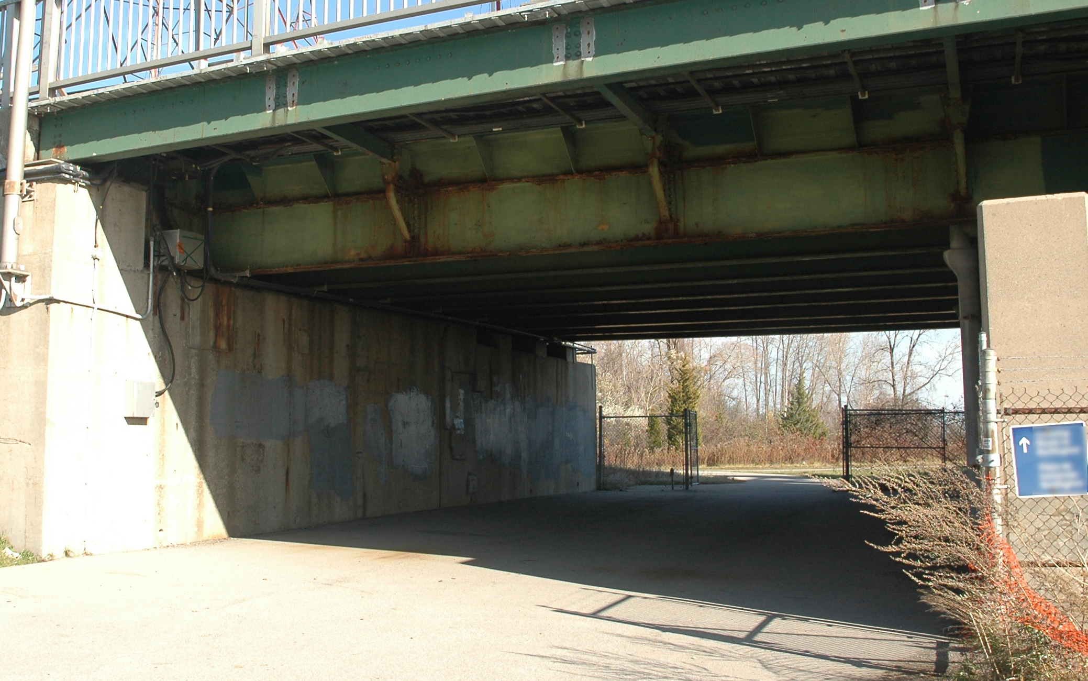
Figure 2: An example of a pedestrian underpass targeted by tagging/graffiti in the past
The owner could utilize public art as part of a territorial reinforcement strategy and engage a local artist to paint the concrete substructures with an artistic mural. The implementation of public art for this application may result in several benefits as follows:
- Public art typically prevents graffiti and tagging from returning (PR Newswire 2016).
- While bridges are often seen by the public as government-owned and operated properties, having local artists produce public art can return the sense of ownership back to the community.
- Public art can act as an activity generator and draw in normal users to admire the work which furthers the sense of ownership and increases opportunities for natural surveillance.
- Public art may be very cost effective as it provides local artists with a chance to showcase their work to a larger audience. As a result, with many public art programs, the works are donated by the artists.
- Artwork, particularly those that involving images of people, tends to create an artificial feeling of human presence that may further discourage undesirable behaviour.
- ADVANTAGES OF USING CPTED
The application of CPTED to bridge structures, reduces undesirable behavior and offers the following additional benefits:
- Enhanced user comfort: the premise of CPTED is to create an environment which supports the intended purpose of the space while discouraging undesirable activities. Thus, the implementation of CPTED often leads to an improvement of the user experience.
- Improved bridge aesthetics: as CPTED emphasizes the use of natural design elements that blend in with the built environment, CPTED can introduce security without compromising the visual harmony of the architectural environment.
- Reduced costs associated with other security strategies: while natural security strategies (CPTED) do not necessarily replace organized and mechanical security strategies, the introduction of CPTED as part of an overall security strategy can enhance the effectiveness of these other strategies, thus reducing their costs. For example, if the sight lines on a bridge deck are improved to enhance natural surveillance, fewer CCTV’s may be required as one CCTV may now be able to monitor a larger area where multiple cameras were required before.
- CONCLUSION
This paper has provided a brief overview of the core CPTED concepts and their application to bridges. However, CPTED is not a radical strategy requiring major design changes but rather a collection of very “common sense” design approaches that bridge designers may be unknowingly using already. By developing well-thought-out bridge designs in accordance to the CPTED framework, the bridge designer can make a positive contribution to the safety and security of our communities.

Acknowledgements
The author would like to thank the Government of Canada (Public Services and Procurement Canada) for their assistance and their permission to use Government of Canada infrastructure as examples for this paper. The author would also like to thank Cst. Tom McKay (Ret.), former Peel Regional Police and currently with CPTED Ontario, and Phil Gurski, former CSIS analyst and currently with Borealis Threat & Risk Consulting, for graciously donating their time to review the content of this manuscript. Finally, the author would like to thank his colleagues and mentors at Morrison Hershfield Ltd. for their ongoing advice, mentorship, and support.

References
Crowe, Timothy D. 2013. Crime Prevention Through Environmental Design. 3rd ed. Butterworth-Heinman , Boston, MA, USA.

IESNA. 2017. IESNA G-1-03: Guildline for Security Lighting for People, Property, and Public Spaces. Illuminating Engineering Society of North America, New York, NY, USA.

Jacobs, Jane. 1961. The Death and Life of Great American Cities. Random House, New York, NY, USA.

McKee, A. J. 2017. Broken windows theory. Encyclopedia Britannica. Retrieved on January 22, 2018 from https://www.britannica.com/topic/broken-windows-theory.

Newman, Oscar. 1972. Defensible Space: Crime Prevention Through Urban Design. Macmillan, New York, NY, USA.

PR Newswire. March 14, 2016. South Park BID Successfully Deters Graffiti Through Public Art Program. Retrieved from https://www.prnewswire.com/news-releases/south-park-bid-successfully-deters-graffiti-through-public-art-project-300235216.html.

Statistics Canada. September 15, 2016. Commuting to Work. Retrieved from http://www12.statcan.gc.ca/nhs-enm/2011/as-sa/99-012-x/99-012-x2011003_1-eng.cfm.

