 | 10th International Conference on Short and Medium Span Bridges  Quebec City, Quebec, Canada,  July 31 – August 3, 2018 | 

REHABILITATION OF BRIDGE COLUMNS USING HYBRID STRENGTHENING METHOD OF LONGITUDINAL CFRP AND TRANSVERSE GFRP WRAPS
Khorramian, Koosha¹, Sadeghian, Pedram^{1,2}
¹ Dalhousie University, Canada
² Pedram.Sadeghian@dal.ca
Abstract: In this paper, the viability of a hybrid fiber-reinforced polymer (FRP) system for rehabilitation of existing bridge columns is evaluated. A total of twelve plain concrete cylinders (150×300 mm) were prepared and strengthened with externally bonded longitudinal carbon FRP (CFRP) laminates and transverse glass FRP (GFRP) straps. The specimens were tested under pure compressive loading up to failure. The specimens were divided into four groups where each group consisted of three identical specimens including plain concrete specimens and strengthened specimens with CFRP strips and/or GFRP wraps. A group of plain concrete were also tested under axial load to assess the concrete compressive strength without any reinforcement followed by a group of specimens reinforced with eight longitudinal CFRP laminates bonded on the surface of specimens using high strength adhesives. The third groups dedicated to plain concrete specimens wrapped with lateral GFRP to recognize the confinement effect of GFRP wraps in strengthening the plain concrete and later separate their effect from the effect of longitudinal CFRP strips in fourth group. To determine the effectiveness of the lateral wraps on limiting the buckling and debonding length of CFRP strips, the fourth group were tested by keeping longitudinal CFRP laminates and adding the GFRP wraps. It was observed that the longitudinal CFRP strips and GFRP wraps, when applied separately to plain concrete, enhanced the load carrying capacity of the columns by 14 and 23 percent, respectively, while the gain in load carrying capacity for the hybrid system was 33 percent, which proves that hybrid systems take the advantage of both longitudinal CFRP strips and lateral GFRP wraps.
- INTRODUCTION
The bridges have been human assets and symbols of civilizations for a long time which make the societies keep the old bridges in place instead of constructing new ones. From another point of view to find a solution for a nearly old bridge, strengthening could be a cheaper and faster alternative to building the new one, specially by taking the advantages of new materials such as fiber reinforced polymers (FRPs) which provides physical characteristic comparable to steel while they are lighter and easier to handle than steel. Therefore, the investigation of FRP applications in rehabilitations of structural elements in bridges such as their decks and piers can have impacts in the improvement of bridge rehabilitation.

There have been many researches on the strengthening characteristics of wrapping the compression members with FRPs (Sadeghian et al. 2010, Hadi 2007, and Toutanji 1999) as well as applying longitudinal tensile FRP laminates in tensile sides of beams (Buyukozturk and Hearing 1998, Rahimi and Hutchinson 2001, and Malek et al.1998) which shows that FRPs are quiet effective strengthening systems in the mentioned applications. However, limited researches have been conducted on the strengthening influences of FRPs on compressive members using longitudinal components build with FRPs (Khorramian and Sadeghian 2017, Sadeghian and Fam 2015, and Gajdosova and Bilcik 2013).

The longitudinal FRP in compression members were not common in practice due to the doubts in compressive performance and recommendations provided by guidelines that suggest no application in compression (CAN/CSA S806 2012 and ACI 440.2R 2008). However, research showed that they contribute in the compression strength and stiffness in compression (Khorramian and Sadeghian 2017, Fillmore and Sadeghian 2018, and Brandon and Sadeghian 2017). There are two major strengthening methods to apply longitudinal elements on structures including near surface mounted (NSM) technique, implemented by making some groves in the concrete surface and mounting the longitudinal FRP, and the bonded technique in which FRP directly applies on the surface of the structural member. For the latter, the buckling and debonding of bonding agent and FRP or structural member can lead to premature failure due to lack of lateral support. However, this problem can be solved by providing the lateral support using FRP wraps. In addition, the wrapping itself can provide more confinement for the concrete which in turn provides triaxial stress state and enhance the stress-strain curve of concrete. Therefore, the current study devoted to the investigation of the behavior of concrete columns reinforced with a combination of longitudinal carbon FRP (CFRP) strips and glass FRP (GFRP) wraps which called “Hybrid” system in this study. The study includes an experimental program consisting of four groups including plain concrete, longitudinally reinforced, laterally reinforced, and hybrid reinforced specimens to evaluate the effect of each group alone and assess combined system performance.
- EXPERIMENTAL PROGRAM
  - Test Matrix
A total of twelve concrete cylinders (150×300 mm) were prepared and tested under pure compression loading. Three specimens were tested without any reinforcement as control group called “Plain” in this paper. Three specimens were reinforced longitudinally using eight CFRP strips with a rectangular cross section (25×1.2 mm) mentioned as “Longitudinal” as presented in Table 1. Three specimens were laterally reinforced with two GFRP wraps with a width of 300 mm covering the whole length of the cylinders as illustrated in Figure 1 which called “Transverse” group. The last group, called “Hybrid”, consists of a combination of eight longitudinal CFRP strips and two layers of transverse GFRP wraps. For specimens with longitudinal reinforcement, i.e. “Longitudinal” and “Hybrid” groups, the reinforcement ratio was 2.7 percent. To avoid premature failure, for all specimens, two GFRP straps with a width of 30 mm were installed on both ends of specimens as presented in Figure 1.
Table 1: Test Matrix
No. | Specimen ID | Longitudinal reinforcement | Transverse Reinforcement | Reinforcement code
1 | P1 | - | - | Plain
2 | P2 | - | - | Plain
3 | P3 | - | - | Plain
4 | L1 | 16 CFRP strips | - | Longitudinal
5 | L2 | 16 CFRP strips | - | Longitudinal
6 | L3 | 16 CFRP strips | - | Longitudinal
7 | T1 | - | GFRP wrap | Transverse
8 | T2 | - | GFRP wrap | Transverse
9 | T3 | - | GFRP wrap | Transverse
10 | H1 | 16 CFRP strips | GFRP wrap | Hybrid
11 | H2 | 16 CFRP strips | GFRP wrap | Hybrid
12 | H3 | 16 CFRP strips | GFRP wrap | Hybrid
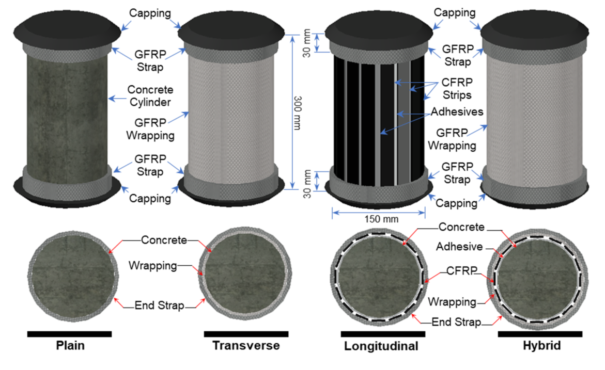
Figure 1: Schematic drawings of test specimens
  - Material Properties
In this study, a ready-mix concrete with maximum aggregate size of 12.5 mm and a slump of 200 mm were poured in plastic cylindrical moulds. The concrete strength, 28 days after casting, was determined by testing three 100×200 mm cylinders which leads an average of 48 MPa. For longitudinal reinforcement, unidirectional CFRP laminates with a length, width, and thickness of 295, 25, and 1.2 mm, respectively, were used. The average tensile strength, modulus of elasticity, and tensile rupture strain of CFRP laminates were reported as 3267.3 MPa, 177.78 GPa, and 0.0179 mm/mm, respectively, based on testing five coupons. For lateral reinforcement, unidirectional glass fabric was cut in sheets with length and width of 1100 and 300 mm, respectively, to cover two complete turn and 100 mm overlap of lateral reinforcement in form of wraps. The material properties are summarized in Table 2, where the properties have been provided by the manufacturer except for CFRP laminates and GFRP wrap.
Table 2: Material properties
No. | Material | Ultimate tensile strength  (MPa) | Modulus of elasticity  (GPa) | Ultimate tensile strain  (mm/mm) | Bond strength  (MPa)
1 | CFRP laminate* | 3267±348 | 178±1 | 0.0179±0.0023 | -
2 | GFRP wrap* | 502±23 | 32±3 | 0.0155** | -
3 | Bonding adhesive for CFRP | 25 | 5 | 0.0100 | 21
4 | Epoxy resin for GFRP | 50 | 3 | 0.0450 | -
- Results of five coupon tests.
** Derived by dividing modulus of elasticity by tensile strength.
  - Fabrication
The fabrication process is shown in Figure 2 and Figure 3. Plastic concrete molds were prepared, and their internal surface was covered with oil for lubrication [Figure 2(a)] and filled with the fresh concrete [Figure 2(b)] to give plain concrete cylinders [Figure 2(c)]. To finish the fabrication of “Plain” specimens, two end straps of GFRP were added to the plain concrete [Figure 2(d)] to prevent premature failure at the end of specimens. The Plain specimen, P1, is shown in Figure 2(e) in the testing machine before testing. For “Longitudinal” specimens, some guide lines were drawn on the surface of plain concrete [Figure 2(f)] on which CFRP strips [Figure 2(g)] were installed using adhesives [Figure 2(h)]. The Longitudinal specimens [Figure 2(i)] were then wrapped at their ends as shown in Figure 2(j). The Transverse specimens were prepared using one wrap of GFRP which covers the whole length of cylinders as well as two end straps [Figure 3(a)]. Using epoxy resin, GFRP wraps and straps were installed on plain concrete cylinders and cured as shown in Figure 3(b) through Figure 3(c). The combination of the process to prepare Longitudinal and Transverse specimens were used to build the Hybrid specimens as shown in Figure 3(e) through Figure 3(h). It is noted that there were two strain gauges applied on two opposite CFRP strips before start wrapping the whole specimen for Hybrid group.

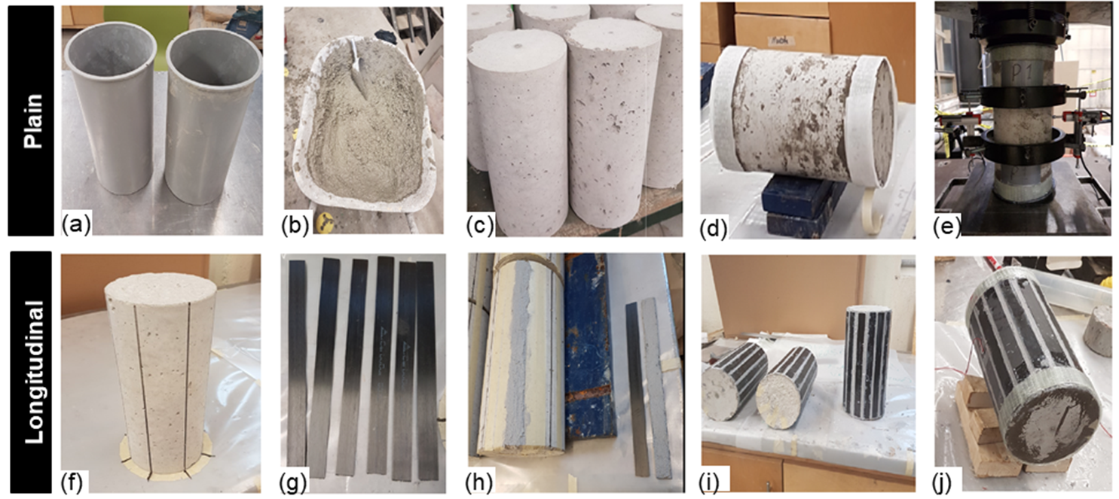
Figure 2: Fabrication of Plain and Longitudinal specimens: (a) molds; (b) fresh concrete; (c) concrete cylinders; (d) end straps; (e) Plain specimen on testing machine; (f) guide lines; (g) CFRP strips; (h) adhesives on concrete and CFRP; (i) Longitudinal specimens; (j) end straps for Longitudinal specimens
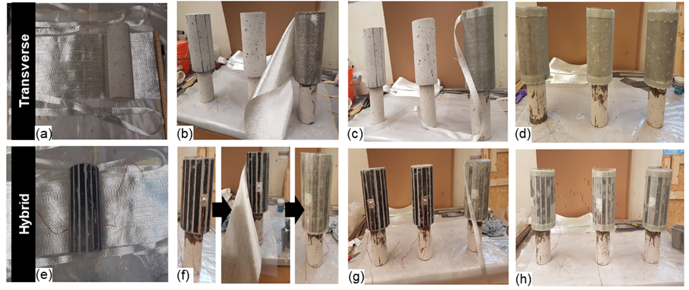
Figure 3: Fabrication of Transverse and Hybrid specimens: (a) plain concrete and Glass fabric; (b) GFRP wrapping; (c) end straps; (d) Transverse specimens; (e) CFRP reinforced concrete and glass fabric; (f) GFRP wrapping for Hybrid specimens; (g) end straps for Hybrid group; (h) Hybrid specimens
  - Test Set-up
The tests were done under pure axial loads using a universal testing machine with an ultimate capacity of 2 MN. The tests were performed using a displacement control approach with a rate of 1 mm/min. The specimens were centered between two jaws of the testing machine to minimize the eccentricity effects. To avoid premature failure both ends of all specimens were strengthened using GFRP straps to create confinement at the ends and neutralize the produced stress concentration at both ends. Moreover, two caps attached to both ends of the specimens to make the surface of concrete smooth and perpendicular to its longitudinal axis. Furthermore, a spherical steel platen attached to the top jaw of testing machine whose function was self centering the specimen and allow partial rotation to provide nearly pure concentric system of loading. The schematic test set-up and instrumentation is presented in Figure 4.
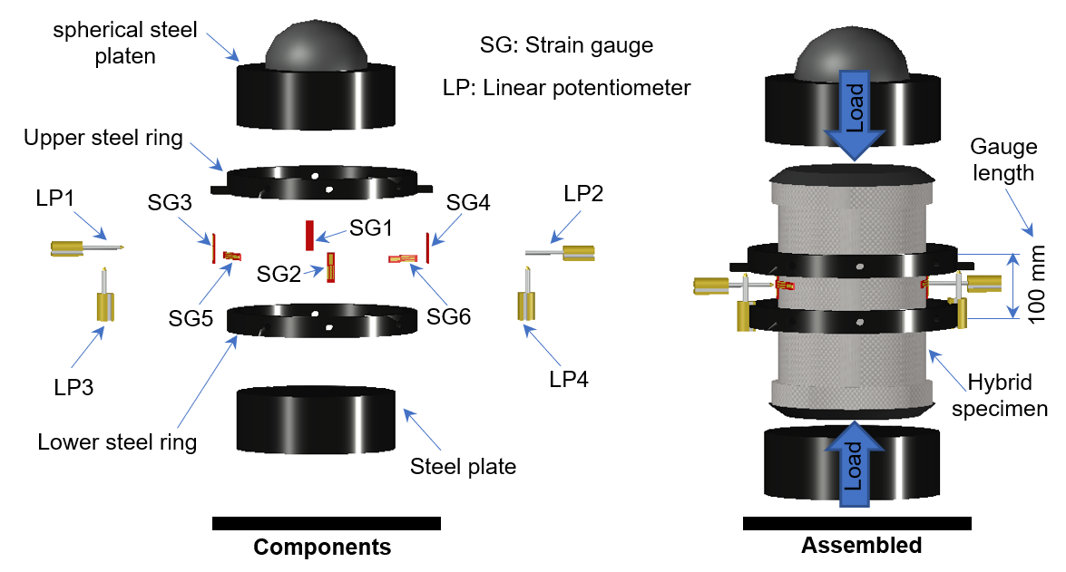
Figure 4: Schematic test set-up and instrumentation
The intention of instrumentation was to record the strains in the longitudinal direction as well as the lateral displacements corresponding to each load step. In this study, four linear displacement sensors (LPs) and six strain gauges were installed on specimens and the details of instrumentation for each group are presented in Table 3. The two first strain gauges (i.e. SG1 and SG2) were installed on the surface of two opposite CFRP strips at the middle height of the specimens to capture longitudinal strain of the laminates, where the other strain gauges were installed longitudinally (i.e. SG3 and SG4) and horizontally (i.e. SG5 and SG6) on the surface of GFRP wraps, as shown in Figure 4. To secure the data for longitudinal strain and to have a system for capturing the same quantities in groups without CFRP strips, two longitudinal LPs (i.e. LP3 and LP4) were installed on two steel rings. The steel rings were tied to the surface of the specimens and symmetrically distanced from the center of specimen to hold two LPs and plates at the opposite sides, as shown in Figure 4. The distance between the tips of bolts, which were in contact with specimen and hold the steel rings, was considered as the gauge length which was set to 100 mm. It is noted that, the longitudinal strain was then derived using the values of displacements recorded from these LPs divided by the gauge length. In addition to longitudinal measurements, two LPs (i.e. LP1 and LP2) were installed to center of the specimens to keep track of the expansion of the concrete specimens.
Table 3: Instrumentation
No. | Specimen group | LP1 | LP2 | LP3 | LP4 | SG1 | SG2 | SG3 | SG4 | SG5 | SG6
1 | Plain | X | X | X | X | - | - | - | - | - | -
2 | Longitudinal | X | X | X | X | X | X | - | - | - | -
3 | Transverse | X | X | X | X | - | - | X | X | X | X
4 | Hybrid | X | X | X | X | X | X | X | X | X | X
* X= The device installed for the test.
- RESULTS AND DISCUSSION
The discussion in this section devoted to four different specimens tested in this study (one from each group). It is highlighted that this is a research in progress and the results of all tests will be available in the presentation. This section includes a discussion about the modes of failure followed by comparison of load capacity as well as the load-strain curves.

3.1. Failure Modes
Figure 5 presents the modes of failure for first specimens in each test group in which failure modes were categorized as concrete crushing (CC) for Plain specimen, buckling of CFRP strips (BCF) for Longitudinal specimen, rupture of lateral GFRP wrap (RGF) for Transverse specimen, and combination of buckling of CFRP and rupture of GFRP (BCF→RGF) for Hybrid specimen. The Plain specimen failed when the longitudinal axial compressive strain approached the strain about 0.003 by spalling and crushing of concrete. The Longitudinal specimens did not fail until a CFRP strips buckled. It was observed that ten CFRP strips buckled almost at the same time, and after buckling the concrete crushed so that the specimen lost the whole capacity and the load drops completely down after failure. The Transverse specimen, on the other hand, sustained the load considerably after initial cracks were observed on the surface of GFRP wraps. For this specimen, the cracks initiated and progressed at the middle of the GFRP wraps to the sides and eventually the rupture of GFRP leads to concrete crushing and total failure of specimen. For Hybrid specimen, the failure starts with buckling of just one CFRP strips which triggered the local cracks in GFRP wraps. The specimen failed due to local rupture of GFRP wrap at the vicinity of the buckled CFRP strip. It was recognized that for Hybrid specimen, the load sustained when the load was about the peak load but not as strong as it lasts for Transverse specimen which is explained by the effect of CFRP buckling that weakened the GFRP wrap locally.

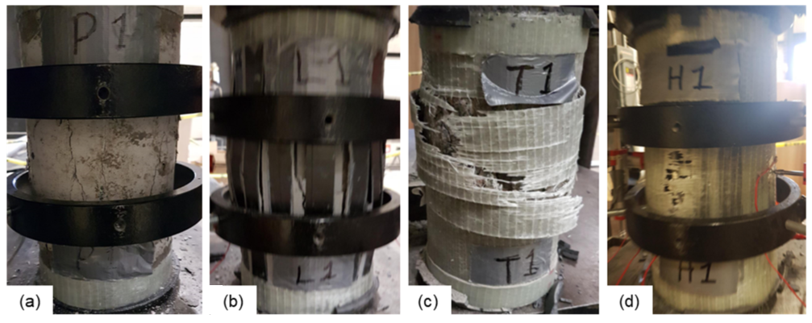
Figure 5: Modes of failure: (a) Plain specimens; (b) Longitudinal specimens; (c) Transverse specimens; and (d) Hybrid specimens

3.2. Load-Strain Behavior
Figure 6 presents the load-strain behavior of the tested specimens using the data from the LPs and the average value of LPs for both axial and lateral strains. It is noted that for the Hybrid specimen, since the value for LP#3 was not available after the peak load, the strains obtained from LP#4 were considered as average after the peak load. Figure 7 presents the same curves using the data acquired from strain gauges which was quiet compatible with values of LPs. The summary of load-strain curves is presented in Figure 7(d) in which the average axial and lateral strains obtained from LPs and strain gauges were shown as dotted and dashed lines, respectively, and the average of these two shown with a solid line.

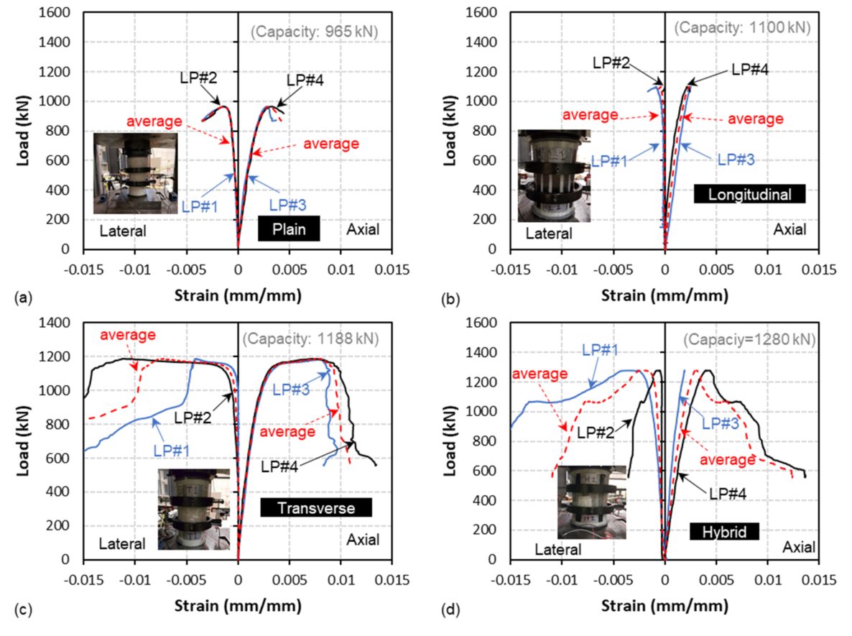
Figure 6: Load-strain diagram obtained by LPs: (a) Plain specimens; (b) Longitudinal specimens; (c) Transverse specimens; and (d) Hybrid specimens
The load-strain curves show that for Longitudinal specimen, there is a sudden drop after the peak load, and strain at peak load is even less than the crushing strain of concrete which means CFRP strips in compression were effective in load-carrying capacity. The Transverse specimen experienced large strains and a softening part before reaching the ultimate capacity which was in average four times the strain at which Plain specimen crushed. The Hybrid specimen gained the most capacity as well as a softening part by taking the advantage from both CFRP strips and GFRP wraps. For Hybrid specimen, at high load levels, the concrete reached high stresses and wanted to start expanding which caused the buckling of CFRP strip, however, the lateral support provided by GFRP wrap extended the strains for concrete and delayed the CFRP buckling. The GFRP wraps also provides more modulus of elasticity for the whole system and change the concrete stress strain behavior which caused survival of concrete in larger strains. In other words, CFRP strips served as additional stiffness and strength components while GFRP strips functioned as both lateral support for CFRP strips and confinement for the core concrete.

Overall, all strengthened groups showed gain in the capacity as presented in Figure 8. The gain in capacity was 13.99, 23.11, and 32.64 percent for Longitudinal, Transverse, and Hybrids specimens, respectively. It is noted that the gain in Hybrid specimen is almost 90 percent of the sum of gains in Longitudinal and Transverse specimens. Therefore, Hybrid strengthening system for concrete columns is efficient and the presence of both bonded CFRP strips and GFRP wraps is beneficial in terms of summation of characteristics by increasing the capacity as well as creating a softening part.
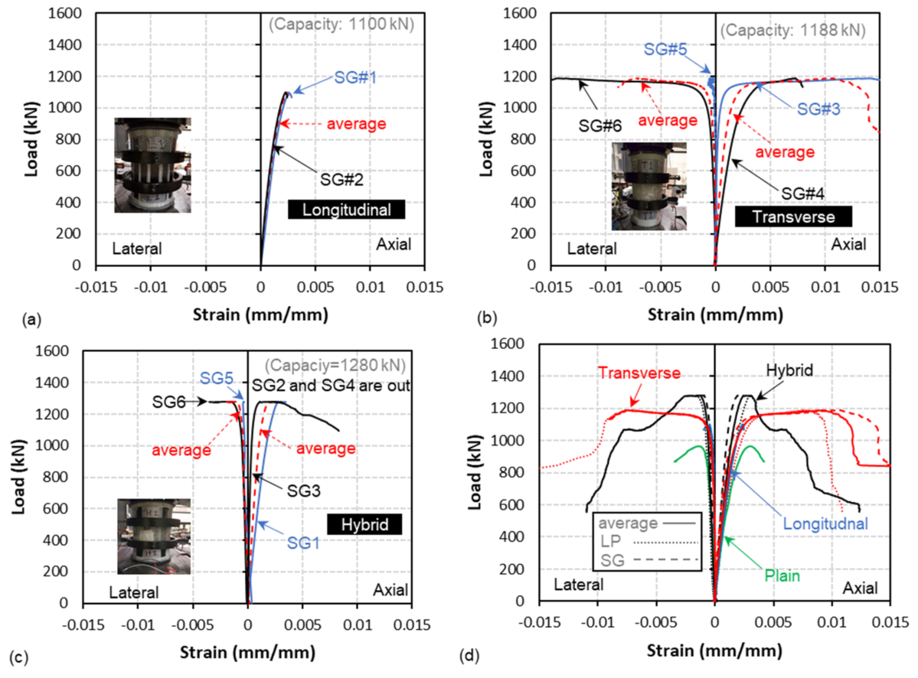
Figure 7: Load-strain diagram obtained by strain gauges and comparison of averages:
(a) Longitudinal specimens; (b) Transverse specimens; (c) Hybrid specimens; and (d) comparison of averages

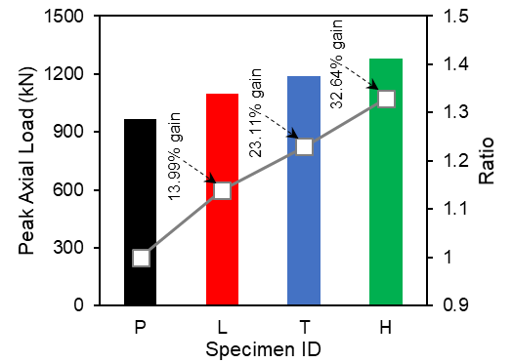
Figure 8: Summary of test results

It should be noted that the proposed system in this paper is a preliminary study on the behavior of the explained hybrid system on short columns to validate the capability of the system in material study level. However, the main application of the proposed hybrid system is for strengthening of slender columns. For slender columns, longitudinal CFRP strips can improve the stiffness of column and, in turn, enhance the axial capacity of the column while wrapping alone for this purpose might not be adequate. Therefore, further studies on investigation of the performance of the suggested system for slender columns is suggested by this paper.
- CONCLUSIONS
This paper assesses the performance of a hybrid strengthening system composing of longitudinal and transverse FRP applied on the surface of existing bridge piers and on columns. The study consists of four different strengthening groups including plain concrete cylinders and the plain cylinders strengthened only with bonded longitudinal CFRP strips (2.7% reinforcement ratio), only with transverse GFRP wraps, and a hybrid of both which were tested under pure compression loading condition up to failure. The study includes 12 specimens, however, since the study is still in progress, the result of one specimen per group (4 specimens) are presented in this paper. Based on the explained tests, the following conclusions could be drawn:
- Four modes of failure observed including concrete crushing, buckling of CFRP strips, rupture of GFRP wrap, and combined buckling of CFRP and rupture of GFRP. The ultimate strength achieved at crushing of concrete and buckling of CFRP strips for Plain and Longitudinal specimens, respectively. The ultimate strength of Transverse and Hybrid groups obtained at rupture of GFRP wraps and for the Hybrid group, after buckling of one CFRP strip.
- Both transverse and longitudinal methods of strengthening, alone, caused a strength gain with respect to plain cylinders. The gain in strength was 13.99, 23.11, and 32.64 percent for Longitudinal, Transverse, and Hybrid specimens which shows that the gain in Hybrid specimen is about 90% of sum of separate gain in longitudinal and transverse system for specimens tested in this study.
- The longitudinal system failed without any softening effect and very suddenly reached the peak load. However, the transverse system experienced a considerable softening part and approached the peak load after appearance of visual cracks and incrementally. The hybrid system has the softening part which did not last as transverse system last.
- The hybrid system takes the advantage of extra stiffness and strength that comes from both longitudinal and transverse systems, in addition to experiencing a softening part and avoid a sudden failure. Therefore, this paper recognizes them as strong strengthening system for members loaded under pure compressive loading.
- Overall, the hybrid system can be used more effectively for strengthening concrete bridge columns under combined axial load and bending moment. The longitudinal FRP laminates can provide axial and bending resistance and the transverse FRP wraps can provide confinement and lateral support for the longitudinal FRPs. This research is in progress and more results will be provided at the time of presentation. In addition, more research on large-scale columns is needed to evaluate the behaviour of the hybrid system for bridge rehabilitation applications.

Acknowledgement
The authors are grateful for the financial support of the Natural Sciences and Engineering Research Council of Canada (NSERC) and Dalhousie University in conducting this study.

References
ACI 440.2R. 2008. Guide for the Design and Construction of Externally Bonded FRP Systems for Strengthening Concrete Structures. American Concrete Institute, Farmington Hills, MI, USA.
Fillmore, B. and Sadeghian, P. 2017. Compressive Behaviour of Concrete Cylinders Reinforced with Glass Fiber Reinforced Polymer Bars. Canadian Society for Civil Engineering, CSCE Annual Conference, Vancouver, BC, Canada.
Buyukozturk,O. and Hearing, B. 1998. Failure behavior of precracked concrete beams retrofitted with FRP. Journal of Composites for Construction, ASCE, 2(3):138-144.
CAN/CSA S806-12. 2012. Design and construction of building structures with fibre-reinforced polymers. Canadian Standards Association, Mississauga, ON, Canada.
Fillmore, B. and Sadeghian, P. 2018. Contribution of Longitudinal GFRP Bars in Concrete Cylinders under Axial Compression. Canadian Journal of Civil Engineering, CSCE Annual Conference, In-press.
Gajdosova, K. and Bilcik, J. 2013. Full-scale testing of CFRP-strengthened slender reinforced concrete columns. Journal of Composites for Construction, ASCE, 17(2): 239-248.
Hadi, M. N.S. 2007. Behaviour of FRP strengthened concrete columns under eccentric compression loading. Composite Structures, 77(1): 92-96.
Khorramian, K. and Sadeghian P. 2017. Experimental and analytical behavior of short concrete columns reinforced with GFRP bars under eccentric loading. Engineering Structures, 151: 761–773.
Khorramian, K. and Sadeghian P. 2017. Strengthening Concrete Columns using NSM CFRP Laminates. 6th Asia-Pacific Conference on FRP in Structures, APFIS, Singapore.
Khorramian, K. and Sadeghian P. 2017. Short Concrete Columns Reinforced with GFRP Rebars Under Eccentric Loading. Canadian Society for Civil Engineering. CSCE, Vancouver, BC, Canada.
Khorramian, K. and Sadeghian P. 2017. Strengthening Short Concrete Columns Using Longitudinally Bonded CFRP Laminates. ACI SP: The 13th International Symposium on Fiber-Reinforced Polymer Reinforcement for Concrete Structures. American Concrete Institute, Farmington Hills, MI, USA.
Malek, A. M., Saadatmanesh, H., and Ehsani M. R. 1998. Prediction of failure load of R/C beams strengthened with FRP plate due to stress concentration at the plate end. ACI Structural Journal, 95: 142-152.
Rahimi, H. and Hutchinson, A. 2001. Concrete beams strengthened with externally bonded FRP plates. Journal of Composites for Construction, ASCE, 5(1): 44-56.
Sadeghian, P., Rahai A. R., and Ehsani M. R. 2010. Experimental study of rectangular RC columns strengthened with CFRP composites under eccentric loading. Journal of Composites for Construction, ASCE, 14(4): 443-450.
Sadeghian, P. and Fam, A. 2015. Strengthening Slender Reinforced Concrete Columns Using High-Modulus Longitudinal Reinforcement for Buckling Control. Journal of Structural Engineering, ASCE, 141(4): 04014127.
Toutanji, H. A. 1999. Stress-strain characteristics of concrete columns externally confined with advanced fiber composite sheets. ACI Materials Journal, 96(3): 397-404.

