 | 10th International Conference on Short and Medium Span Bridges  Quebec City, Quebec, Canada,  July 31 – August 3, 2018 | 

SHM SYSTEMS FOR REPAIR OPTIMIZATION
Schorn, Stephen^{1,2}, and Abouzeid, Amer¹
¹ Sixense, USA
² stephen.schorn@sixense-group.com
Abstract: Sixense recently worked on an instrumentation project for the Louisiana Department of Transportation and Development, complementing planned bridge maintenance with a system of strain gages and load cells. Repairs and strengthening were completed by the general contractor on an Interstate bridge east of New Orleans. While these repairs were realized, Sixense instrumented the steel external PT reinforcements with strain gages and the carbon fiber composite cables with load cells. The sensors were used during the addition of external PT to verify the stressing procedure. Due to the remote location of the bridge, the monitoring system had to be solar powered and communicate via a cellular modem to our secure servers. The first phase of the project was completed in the summer of 2014, including full installation of the sensors and hardware as well as setup of web-based software for viewing the collected data. This second phase continued into 2016.

- INTRODUCTION
Structural health monitoring (SHM) systems provide valuable information to a variety of groups. There are many reasons why one can choose to monitor a structure. One reason is to validate assumptions or the design itself, and can be done by utilizing load monitoring for example. Another purpose is to monitor the structure and evaluate its performance in relation to events. Events can occur intermittently such as earthquakes and high winds, or take place over extended periods of time such as the aging of the structure itself. Other motives for monitoring include the understanding or correlating of a problem to a behavior; for example, when there is unusual movement of a bridge or bridge element. Monitoring devices can provide information about components or behaviors of a structure, which then complement visual inspections to help provide a comprehensive view of a structure. Whether one is the owner of a structure, those in charge of maintenance, an inspection team, validating design assumptions, etc. the data collected from a structural health monitoring system can be useful.

A structural health monitoring system was installed on an interstate bridge outside of New Orleans, Louisiana. This system enabled the operating company to have a rapid diagnostic of the stressing procedure, and allowed the owner to determine the effectiveness of the repairs done to the bridge. Sensors and monitoring software provided data that was used to evaluate the performance of the structure during the repairs and years following. During repairs, the sensors were used to check the force in the bars. This acted as a check against the forces recorded by the hydraulic jacks used by the contractor for tensioning.

The bridge itself is comprised of two structures, one bridge carrying Eastbound traffic and the other carrying Westbound traffic. It is located east of the city of New Orleans, Louisiana. Each of the bridges are built with 4 spans, each 18 m (60 ft) in length.

Visual inspections offer a quick evaluation of the structure. A limitation to visual inspection is their ability to only take into account damage that is apparent on the superficial level of the structure (Wang et al. 2007). In particular at this location, the bridge substructure is often covered in water and inaccessible for visual inspection (Figure 1). A cofferdam has to be utilized to lower the water level to inspect this bridge. After a scheduled visual inspection, it was noticed that some of the internal post tensioning bars had broken or were in danger of corrosion and future defects. The owner decided to do some repair works on the bridge as well as add external post tensioning to reinforce the structure and provide redundancy in case more internal post tensioning (PT) began to degrade. Carrying interstate traffic, and being subject to water presence on the underside of the deck, this bridge needed some action. Before performing the site work, a safety visit was done (Figure 2).

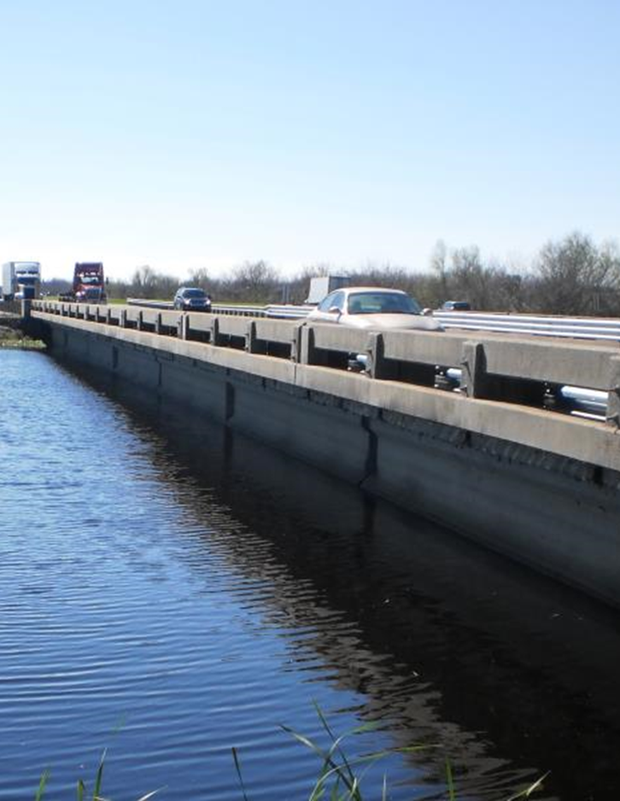

Figure 1: A span of the bridge showing its proximity to water, creating visual inspection access issues

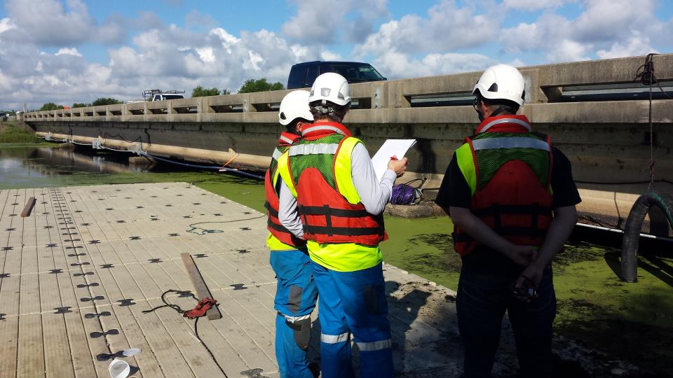

Figure 2: Before installation, a safety visit and planning mission was carried out
- REHABILITATION WORKS
Assessment of the bridge showed that it was suffering from stages of deterioration; as a result of this assessment, the owner took steps to strengthen the bridges in an attempt to improve the current situation. Rehabilitation works performed included patching, superstructure strengthening, and the addition of external post tensioned bars. These bars were of either steel or carbon fiber. Even with the rehabilitation, some deterioration may be undetectable; a monitoring system can provide information to reduce this concern (Johnson et al. 2001).
- STRUCTURAL HEALTH MONITORING
The structural health monitoring system on the bridge consists of roughly 110 measurement channels allocated to various spans of the bridges (Figure 3). The system was developed to provide reliable and secure solutions for real-time structure management. A powerful combination of hardware and software offers real time surveillance and continuous structural diagnosis, helping to optimize the performance of the bridge. As is important for any monitoring system, it offers the advantage of being hardware independent so it can be used with any type of acquisition unit asked for by the owner. It was modeled using a solution used in over 100 SHM systems worldwide, on a variety of bridge sizes and types.

The SHM system on the bridge includes multiple types of sensors in various locations to monitor a breadth of impacts on the structure. The sensors that were implemented on the structure include nearly 100 strain gages and 12 load cells (Figures 4 and 5). The placement of these sensors needed to be carefully designed to optimize the data acquired; without useful information from the structure, analysis of the data would be difficult. The system channels include 100 strain gages soldered by specialists onto steel bars used as external post tensioning. By placing these along the axis of the bars, they can measure strain in this direction and assess the fatigue of the elements. Monitoring systems help diagnose a structure’s response to events.

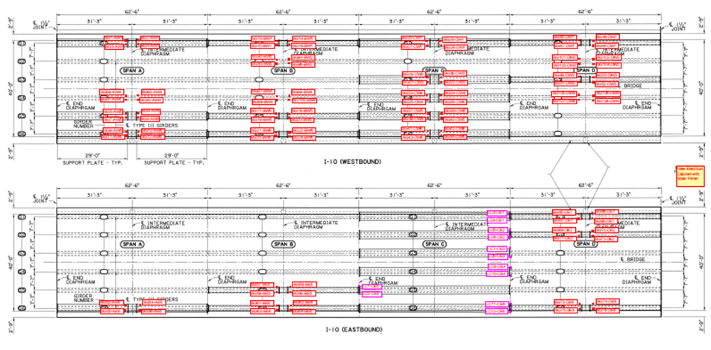

Figure 3: Bridge drawing showing dimensions and placement of the sensors, strain gages in red and load cells in pink
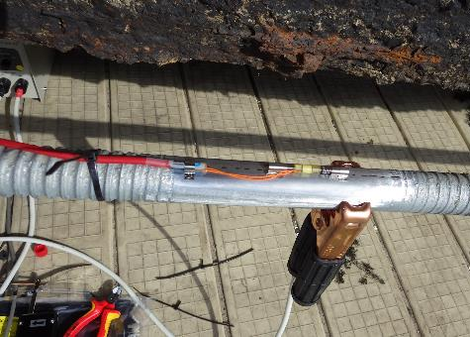

Figure 4: An example of a strain gage welded to a steel bar, before protection was put in place

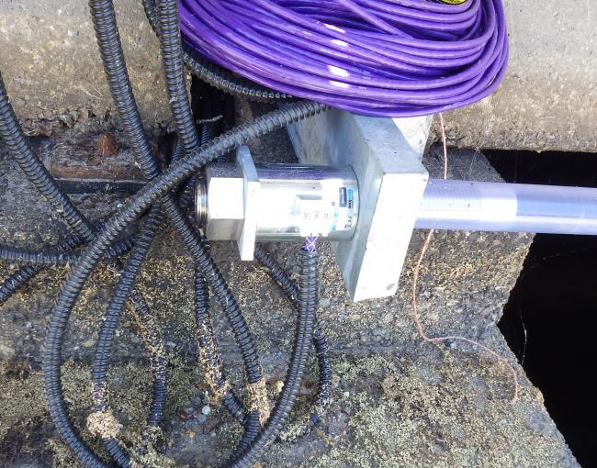

Figure 5: A load cell after installation on the carbon fiber rod, before tensioning
- POST TENSIONING MONITORING
In the context of the bridge, it was also proposed that a real-time monitoring system be provided to record the strain and force in external PT. Since the bars were both steel and carbon fiber, two types of sensors had to be used. Welding onto carbon fiber is not an option, so load cells were used to monitor 12 external carbon fiber rods. Strain gages were used on all of the steel PT bars.

Once all the bars were in place, and the sensors installed, the stressing procedure could commence. The owners had defined with the contractor the desired level of tensioning, which was able to be monitored with these sensors. Real-time outputs from the sensors are able to be analyzed as well as graphically viewed during the stressing procedure. Figures 6 and 7 show the reaction of strain gages and load cells during the tensioning process. Load cells directly gave the force exhibited by the bars. For strain gages, the data was output in Hz, which was ultimately converted to microstrain using the sensor manufacturer’s conversion formula. This microstrain was compared to the values expected during and after stressing. After initial stressing, the data was checked. It was determined that some relaxation had occurred in members, so an additional round of stressing was carried out by direction of the owner. This process ultimately led to an optimized repair (correct tension in the correct locations).

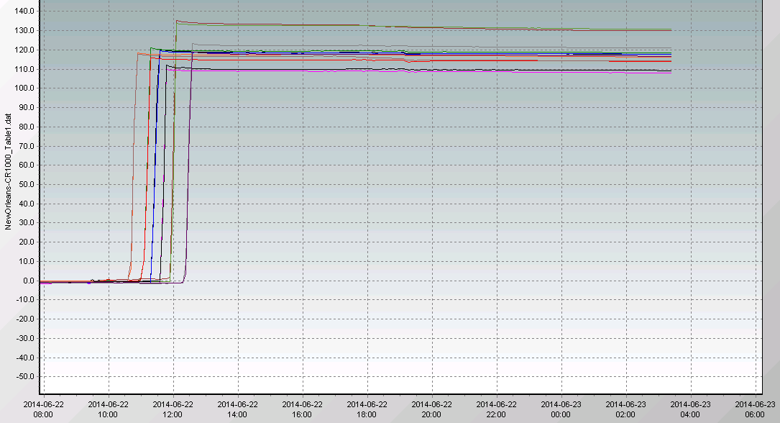

Figure 6: One eastbound span during tensioning, showing the 12 load cells forces in kN on the y-axis

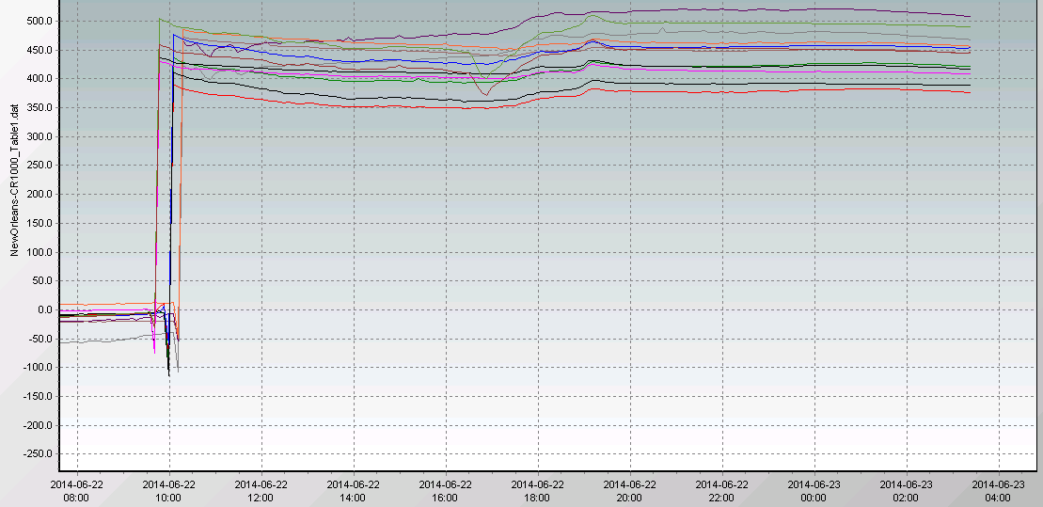
Figure 7: One eastbound span with 12 strain gages in place with y-axis showing microstrain

- DATA ACQUISITION AND PROCESSING
The data acquisition system on the bridge is composed of 1 main data logger unit located off the bridge, all connected to the sensors by a data cable network (Figure 8). Dataloggers and multiplexers within the unit digitizes the analog signals coming from the sensors. All data is collected, filtered, and processed by the main unit. Acquisition nodes can be placed at various points on the bridge to allow for the collection and reduction of cables. This can potentially lead to a savings on conduit, the cable lengths required, and installation time, and if necessary offer an opportunity to amplify the sensor signal. Whether the cables are collected in a node or junction box, the information is sent to the main data acquisition unit.

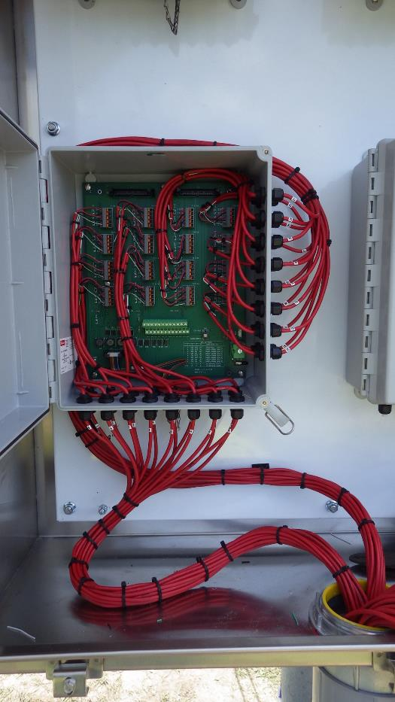

Figure 8: An example of a small unit used away from the bridge to collect data from sensors

Data acquisition units have the ability to communicate information using different methods, depending on the structure location and available resources. Data can be transmitted via a connected hardline such as fiber optics or Ethernet, a DSL modem, using wireless internet, or even a 3G/4G cellular network. In the case of this bridge, the acquisition unit sends the data collected from all the sensors via a 3G modem, powered by a battery and solar panel. This information is sent to a centralized database located at a secure datacenter. Various types of files are then created by the system. Historical files with low sampling frequency are used to model the long term evolution of the structure (Figure 9).

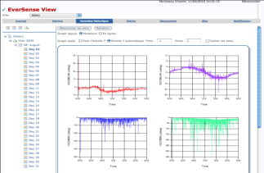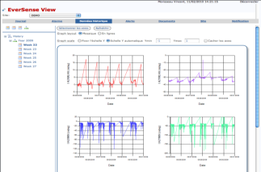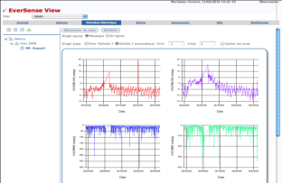

Figure 9: The collected sensor data can be viewed in daily, weekly, or yearly files

A large benefit to the owner of the bridge was that the software is customizable. Prior to implementation, alert levels can be set that if surpassed would automatically generate and send alerts. These alerts would be sent to those added to a predefined list of recipients, usually representing those with stakes in the bridge. The system’s functionalities also allow engineers to visualize remotely and in real time the status of the system via the web, including any measurements taken by the system. In case of specific events being detected by sensors on the bridge, the SHMS will generate an alert file that is automatically sent to the centralized server; as mentioned, the server would then immediately send a warning e-mail to individuals on a specific crisis management plan. Once notified, engineers and designers will directly be able to connect to the dedicated web page and obtain crucial information concerning the event. They can then use this information to initiate a follow-up action plan, such as an element specific or detailed inspection. Due to the situation of the bridge, including its advanced stages of deterioration, the client had high requirements in terms of uptime of the system.
- CONCLUSION
Installed in the summer of 2014, the SHMS of this New Orleans bridge has been collecting data continuously and retaining it for analysis. When a system is first installed on a structure, the data collected from the sensors combined with engineering expectations can provide baseline measurements for future comparison. Ultimately, the sensors helped identify the extent of PT bar relaxation, so each pair could be appropriately tensioned by the repair contractor. After stressing, the sensors would act as an alert system for the integrity of the bridge. Being an interstate bridge, this was on a hurricane evacuation route and thereby a critical structure for the area. Based on proven solutions and expertise, structural health monitoring systems allow engineers and designers to detect risks on a structure, and characterize the structural response. This information can be used to plan maintenance and optimize the life of the structure. The general monitoring of the bridge and the specific emphasis on adequate repair work and tensioning will contribute to safety as well as the life extension of the New Orleans bridge.

References
Johnson, E.A. H.F. Lam, L.S. Katafygiotis, and Beck, J.L. 2001. A Benchmark Problem For Structural Health Monitoring And Damage Detection. Structural Control for Civil and Infrastructure Engineering: 317-324.

Wang, Y., Jerome P. Lynch, and Law, K.H. 2007. A wireless structural health monitoring system with multithreaded sensing devices: design and validation. Structure and Infrastructure Engineering, 3(2): 103–120.

