 | 10th International Conference on Short and Medium Span Bridges  Quebec City, Quebec, Canada,  July 31 – August 3, 2018 | 

- Highway Approaches of the New Champlain Bridge Corridor
Demirdjian, Sevak^{1,4}, Najjar, Nicolas² and Cloutier, Jocelyn³
¹ SNC-Lavalin, Canada
² SNC-Lavalin, Canada
³ SNC-Lavalin, Canada
⁴ Sevak.Demirdjian@snclavalin.com
Abstract: The New Champlain Bridge project corridor extends over a length of approximately 8.5 km. The highway approaches of the bridge corridor include the reconstruction of two major interchanges in Montreal and the widening and reconstructing of both Highways 15 and 10 over 4.5-kilometers in highly urbanized neighbourhoods within Montreal and its suburbs. Highways are equipped with aesthetically pleasing retaining walls, EPS walls as well as noise barriers to satisfy the needs of the community. Furthermore, the construction of a new 470-metre bridge connecting Montreal Island to Ile des Sœurs (Nuns’ Island) represents one of the highlights of the highway approach corridor structures. Both cyclists and pedestrians will be able to safely travel over the project corridor on a multiple-use path and stop at one of the many belvederes to gain an exceptional view of the city. Durability is also a key design consideration, with a 125-year design life set as design criteria. Keywords: Champlain; highway interchanges; aesthetically; noise barriers; retaining walls; nun’s island bridge; multiple use path; durability.
- Introduction
The New Champlain Bridge including its approaches is one of the largest infrastructure projects in Canada. With an overall length of approximately 8,5 km, the project covers the New Champlain Bridge proper extending over a total length of 3.4 km, the 470 m new Nuns’ Island Bridge (IdS Bridge) and the improvement and reconstruction of its approaches (Hwy 15 in Montreal and HWY 10 in Brossard) over a length of some 4.5 km.
The works are being carried out within a dense urban setting and in close proximity to residents. Winter conditions and important environmental constraints also generate important challenges. The presence of a very narrow right-of-way and the presence of CN tracks very close to the works add to the complexity of the project.
The highway engineering joint venture (HEJV) was responsible for the design of all elements of the project, with the exception of elements related to the New Champlain Bridge structural design.
The description below starts with the highway (HWY) geometry and the major improvements compared to the current situation. A discussion concerning the different type of structures on the HWY portion of the project as well as geotechnical considerations, drainage, lighting, Intelligent Transportation System (ITS) and architectural aspect of this complex and challenging project are also addressed.
- Highway Geometry
The current Highway geometry on the Island of Montreal, which generally consists of 2 lanes per direction only, creates a bottle neck in the network and is the principal cause of major traffic congestion. To overcome this problem, the Project Agreement (PA) requires the reconstruction of the new highway with 3 lanes per direction and wide shoulders. Figure 1 shows the length and location of the various project components. Another particular aspect of this project is that the new corridor connects (to the east) to another major project known as the Turcot project. Major improvements can be summarized as follow:
- HWY 15: increased number of lanes, a new geometry for the entire corridor with three lanes in each direction of 3.7 m and shoulders of 3.0 m;
- Atwater Avenue: modification to an urban boulevard to accommodate pedestrians and cyclists;
- Lasalle Boulevard and wellington street: improved pedestrian links;
- Improvement of Gaetan-Laberge Boulevard: new access to Downtown Montreal;
- IDS new bridge with a wide pedestrian and bicycle link;
- New Champlain Bridge equipped with a dedicated public mass transit corridor and a pedestrian and bicycle link over its entire river crossing;
- Two lanes of bus-reserved traffic from Boulevard Pelletier in Brossard to overpass P12;
- Improved intersections;
- Integration of several new multiple-use paths;
- Improvements on the local roads; and
- Optimization of the geometry to improve security and safety including road safety audits.
- Geotechnical Condition
The new Champlain bridge corridor project has many geotechnical challenges, one of them being the different soils encountered along the corridor with varying conditions in Brossard, on Île des Sœurs (IDS) and on the Montreal side.
  - Montreal Areas
The major geotechnical challenges were encountered throughout the Montreal area of the project.
From Atwater avenue to Gaetan-Laberge Blvd, a heterogeneous fill was encountered over a loose silt layer. Both the heterogeneous fill and the silt layer will settle under the load of the new embankment. To mitigate unfavorable soil conditions, MSE walls will be built using a two stage construction technique in order to let the primary settlement occur during the first stage and only minor settlement to occur in the second stage which consists of the installation of the concrete facing panels of the walls. A test embankment has been built to measure the settlement as well as the time required to achieve the settlement of the silt layer.
From the IDS Bridge to Gaetan-Laberge Blvd, the highway is built over an old landfill. Settlement measurements done for the causeway-bridge detour built a few years ago were used, along with settlement measurements of a temporary fill built to establish the construction method to use for the new MSE walls. The proposed solution is the use of a two stage construction for the MSE walls built in this area. The first stage construction will be monitored to assess the time when the second stage can be constructed without adding large settlements. A surcharge is also recommended to reduce the consolidation time and account for the heterogeneity of the old landfill.
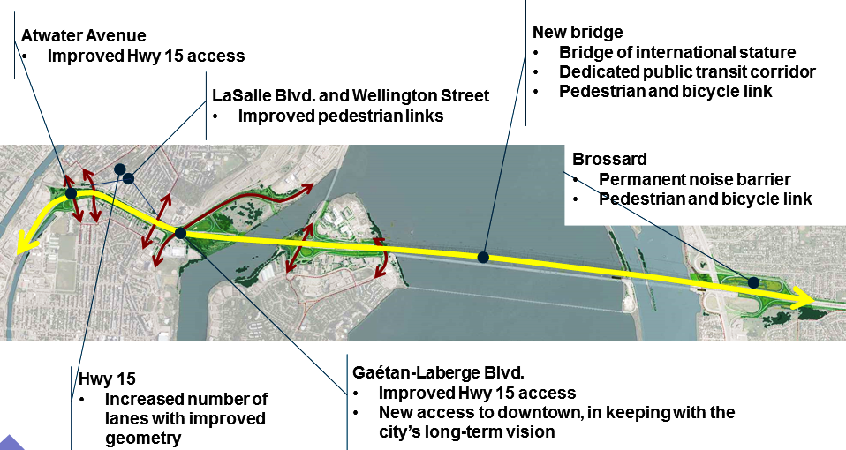
Figure 1: Overview of the Highway corridor
  - Île des Soeurs Area
In this area, heterogeneous fill was encountered and the geotechnical investigation was aimed at defining the thickness of the fill and its compressibility. It was concluded that the new highway fill and MSE retaining walls could be built over the fill with standard techniques except at one location where the new foundation will be located partly over existing foundation. Solutions were developed to keep the existing foundation in place while minimizing the differential settlement of the MSE walls that will be partly resting over existing foundations.
  - Brossard Area
In Brossard, a significant clay deposit is encountered under the new proposed highway which has an impact on the approach fill. Laboratory tests were carried out on intact clay samples recovered from boreholes to assess the consolidation settlement, and the time required to achieve the complete consolidation. The approach fill was constructed up to near final grade and settlement plates were installed to monitor the rate and magnitude of the settlement and to compare these to the results from the laboratory tests.
- Structures and Durability
Structures have been designed as per the requirements of the PA. Considering the construction phasing requirements, all structures in the southbound direction (heading towards Brossard) were designed first.
  - Overpasses
The design of the overpasses was relatively straight forward. In fact, the superstructure of most bridges consists of a slab on NEBT girders. The structures were analysed using the finite element method and this method was also necessary for structures with a high skew such as Gaetan-Laberge and for the design of the Atwater structure (NEBT beam of 1800mm and 43m span). Moreover, and given the span to depth ratio (L/H) for this structure in particular, post-tension cables have been incorporated to provide adequate structural capacity of the girders.
Most of the structures are semi-integral abutments or integral abutments. The principal advantages of this approach are reduced construction and maintenance costs. Indeed, expansion joints and bearings are no longer needed with those types of structures.
Due to the presence of a major sewer collector, namely the Saint Pierre collector (The St. Pierre Collector is a reinforced concrete culvert built in the 1930s that runs underneath the westbound lanes of the proposed highway and is one of the largest in North America) which is located near the new structures to be constructed, HEJV in collaboration with the contractor opted for piles drilled by oscillations rather than driven piles with the sole purpose of avoiding any transmission of vibration to the collector during the installation of the piles.
One of the complications identified in the recommendations stemming from the geotechnical investigations is the downdrag forces. Indeed, given the nature of the soil and to avoid over-sizing the piles to resist the downdrag forces (and thus optimize the diameter of the piles and the depth of the rock socket), MSE walls were designed and placed at the back of the piles (see Figure 2). With this approach, HEJV was able to optimize the design.
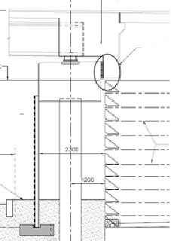

Figure 2: MSE wall behind abutment
A multimodal seismic analysis was carried out to verify the strength of the piles and the displacement of the deck, even with bridges having a single span, because of the very nature of the structures which incorporate integral and semi-integral abutments.
The New IdS Bridge (Fig. 3), consisting of 7 spans with an approximate length of 470 m (approximately 68 m/span), connects Montreal to IdS and consists of a reinforced concrete slab supported by 3200 mm deep steel plate-girders. The foundation for the piers and abutments are made of drilled piles. The advantage of proceeding this way is to avoid any cofferdam (which is time consuming and expensive) given the fact that the IDS piers are located in the river and are subjected to significant ice forces.
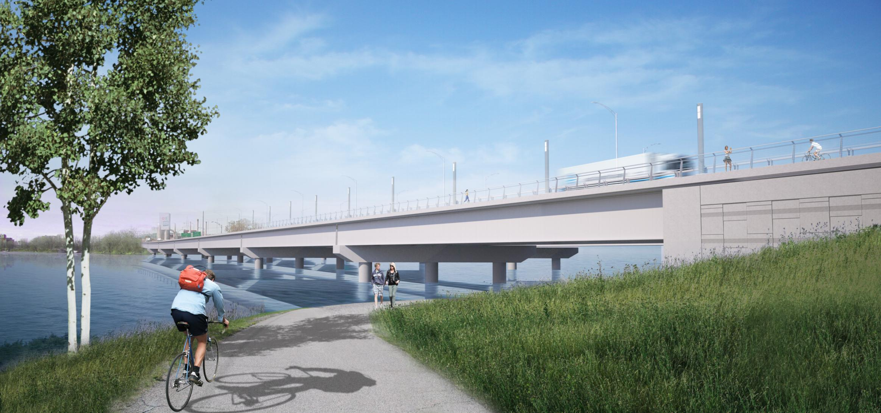
Figure 3. New IdS Bridge
The bridge comprises an expansion joints at each abutment and the bearings of the bridge are of pot bearing type. A finite element analysis was carried out with CSI Bridge for the complete design of the bridge as well as for the seismic analysis that was completed as an essentially elastic design. Thus no hinges are to be developed during a seismic event.
  - Walls
Two types of retaining walls are used for this project: mechanically stabilized earth (MSE) walls and expanded polystyrene (EPS) walls. The concept of MSE walls is based on the fact that it is the weight of the soil resting on the soil reinforcing straps that resists the lateral earth pressure. One of the greatest advantages of MSE walls is their flexibility and capability to tolerate deformation due to poor subsoil foundation conditions. Other advantages include speed of construction and ease of installation when compared to conventional cast-in-place concrete walls.
Due to the nature of the subsoils along the project corridor, and the expected settlement of the walls, the majority of MSE walls are being built in two stages. In the first step, the wire-faced MSE wall is constructed with the soil reinforcing straps embedded in the backfill. After wall settlement is complete, the concrete facing panels are installed and backfill material is placed between the panels and wire-faced wall. The panels and backfill are placed sequentially from the ground up, thereby ensuring the verticality and integrity of the finished MSE wall system.
EPS retaining walls consist of expanded polystyrene ‘geofoam’ blocks with a 1.5 m deep pavement system placed over top. Expanded polystyrene is a super lightweight closed-cell rigid-plastic foam comprised of approximately 98% air and 2% polystyrene. EPS retaining walls are traditionally used in locations where the subsoils are susceptible to long-term ground settlements and cannot accommodate the weight of a conventional granular-fill wall.
On this project, EPS walls are built over top of the St. Pierre Collector to ensure no additional load is added to this structure. The EPS walls are constructed by excavating the existing ground by a sufficient depth to offset the weight of the 1.5 m pavement system. The blocks are then placed in staggered alternating rows, concrete facing panels are installed to protect the exposed face of EPS blocks, and finally the pavement structure and roadway barrier system are constructed.
  - Durability
The project requirements are very clear about the durability requirements for the different elements. Conventional bridges and walls have a standard design life of 75 years. However the non-replaceable components of the New IdS Bridge and the New Champlain Bridge are required to have a design life of 125 years (refer to table 1) in order to satisfy the requirements of the Project Agreement (PA). A prescriptive requirement of the PA to achieve this is the mandatory use of stainless steel rebars for the deck slab as well as the exterior face of the foundations (where there is an expansion joint on the deck). Another example of material selection for durability purposes is the requirement that the free water to cementitious materials ratio of the deck slab concrete is not to be greater than 0.32, thus categorized as high performance concrete.
Table 1: Design life of components of major bridges as per the PA requirements
Component (Partial List) | Design Life  (years)
Non-Replaceable Components
Foundations (piles, pile caps, footings) | 125
Substructure (piers, abutments, tower) | 125
Superstructure (including deck slab) | 125
Replaceable Components
Bearings | 40
Expansion Joints | 30
Barriers | 50
Drainage System | 40
Bridge cables/Stays | 65
- Drainage and Landscape
The drainage of project corridor has a mixture of rural (ditches, swales, etc.) and urbanised design (storm sewers, collectors, etc.). It is adapted to the immediate environment of its surroundings.
Various special provisions were to be taken into consideration for the design to ensure that the best environmental practices are in place. The various systems used for the design must include provisions for runoff quality treatment, runoff quantity regulation and sensitive habitat for outlet locations. Various special provisions were to be taken into consideration for the design to ensure that the best environmental practices are in place.
The various systems used for the design needed to include provisions for runoff quality treatment, runoff quantity regulation and sensitive habitat for outlet locations.
The designed systems include sediment control systems in ditches, storm sewers and ponds. Different retention systems have been designed to laminate runoff. These systems are mostly open surface ponds located in various areas of the project. They have been integrated in the design to maximise the use of the project’s right-of-way and adapt to the aesthetic requirements.
They are vegetated and carefully graded accordingly. Various sensitive habitats were identified in preliminary studies. Outlets have been located to avoid any impacts on these habitats. The outlets were also located and designed with respect to the global aesthetic requirements of the project, including those of the main bridge. They have been included in the main piers with outlets at the bottom of the piers to respect the desired aesthetic. The outlet locations and heights needed to take into account the ice cover height to ensure they are in full operation even during winter conditions. Lastly, some outlets needed to be connected to the St-Pierre collector. This collector is fairly old, deep and is flowing under pressure on occasion. The design needed to properly laminate runoff in time and make connections to take into account the structural integrity of the collector as well as its hydraulic response. The use of ponds and light weight fill were required to achieve a design that does not exceed the existing hydraulic and structural loading conditions imposed on the collector.
The integration of surface work needed to be considered in the project’s aesthetic goals. Landscaping design was key to ensure that swales, ponds, and ditches were properly incorporated in the urban fabric. Careful consideration was taken on drainage slopes, vegetation selection and distribution to make sure the flow of the architectural finish on structure remains harmonious.
- Lighting and ITS
The lighting of the New Champlain Bridge corridor project has both aesthetic and functional objectives. The choice of the equipment, its colour and location needed to be carefully designed and selected to ensure their efficiency as well as to respect the overall vision of the architectural design of the project. Lighting had to be provided for roadways as well as for multiple-use paths (MUP) and sidewalks.
The main bridge includes both roadways and MUPs adjacent to each other, which made such a configuration challenging to ensure the respect of aesthetic requirements, as well as the lighting level required to achieve safety and efficiency goals. The spacing of each system and its location presented challenges with respect to different height requirements, spacing, aesthetic appearances, etc.).
The New Champlain Bridge also includes fully operated control rooms. This implies that various data collection is provided during the whole project. A fully integrated system was designed for the project as well as specific rooting lines for stakeholders. The design was quite a challenge since the ITS systems must pass through each structure and each box-girder of the main bridge. Special provisions were also included to allow maintenance accesses without impacting negatively on the aesthetics of the main bridge.
- Architecture and Urban Integration
The objective of the architecture and urban integration is to ensure that there is an aesthetically-pleasing harmony maintained throughout the corridor (see Figures 4 to 7).
Although the terms of reference and definition drawings are very clear about the architectural requirements of the New Champlain Bridge proper, it gives more latitude for the Highway portion of the project. HEJV had to adapt the design to reflect one very important aspect of the PA that is to adopt an approach that ensures that the highway corridor is in perfect visual continuity and unity with the New Champlain Bridge crossing over the Saint Lawrence River.
To achieve this, the geometry of the barriers for example as well as the retaining walls are related to those installed on the New Champlain Bridge proper. Accordingly, the walls have a horizontal vocabulary inspired by the abutments of the main crossing. The visual treatment of the retaining walls (Fig. 4) is a very important part of the architectural vision of the Project. Visually, retaining walls represent vertical surfaces along different Project zones. These surfaces are harmonized with the local environment, the New Champlain Bridge, the New IdS Bridge and the entire urban context.
Existing vegetation is preserved, wherever possible, and all surfaces categorized as naturalization areas, specifically from Boulevard LaSalle to Wellington Street. Ground cover planting and climbing plants were provided at all wall structures higher than 3m to lessen the visual impact of the infrastructure when viewed from the backyards of neighbouring properties.
To respect the urban integration requirements, the architects designed the vegetated environment, taking in account the visual quality and amenity of nearby residences in relation to the nearby infrastructure. For conscious social acceptability, respectful of the public health and to improve sustainability, urban integration and overall visual quality of urban spaces, the architects adopted the design criteria responsive to the concerns of the community. Mainly, diminution of the visual impact of the infrastructure; wise integration of green features; minimization of heat island effects; durability and minimization of maintenance in the choice of plants, trees and ground covers, and constant plant coverage.
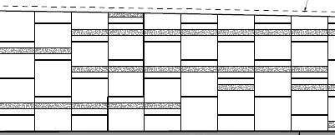
Figure 4: MSE walls architectural panels

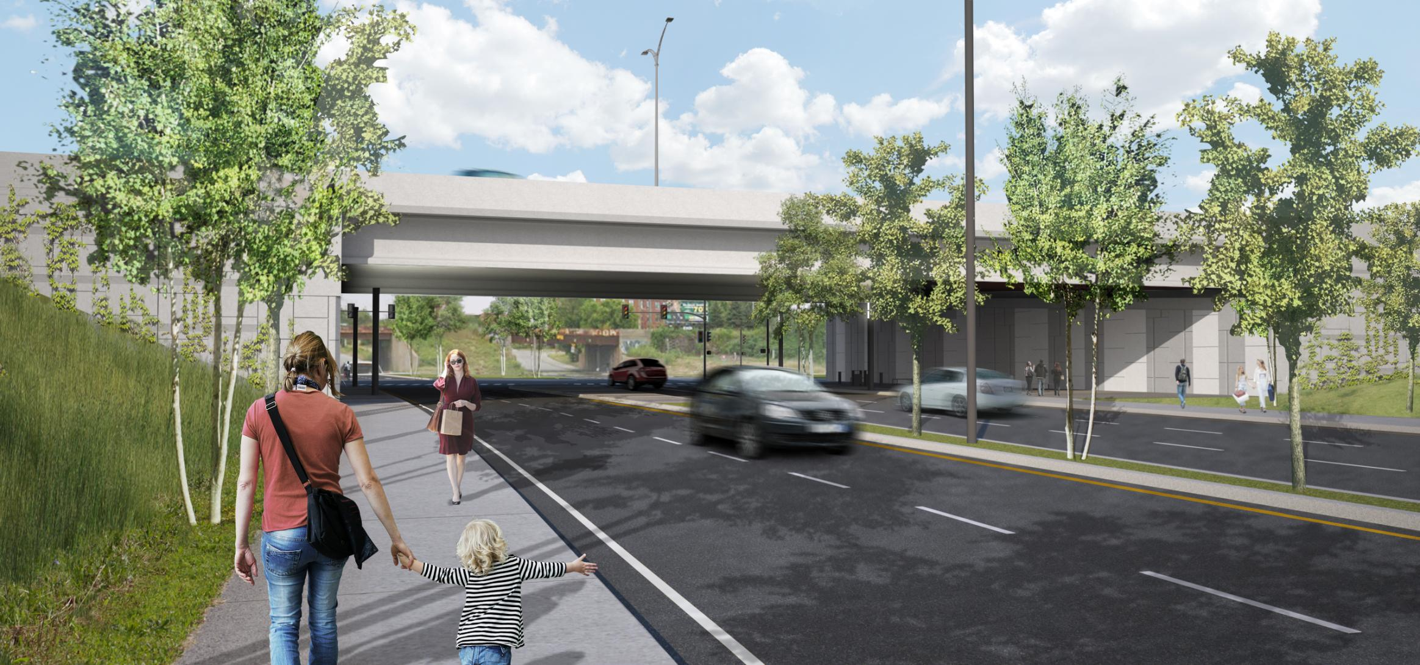
Figure 5: Atwater Interchange

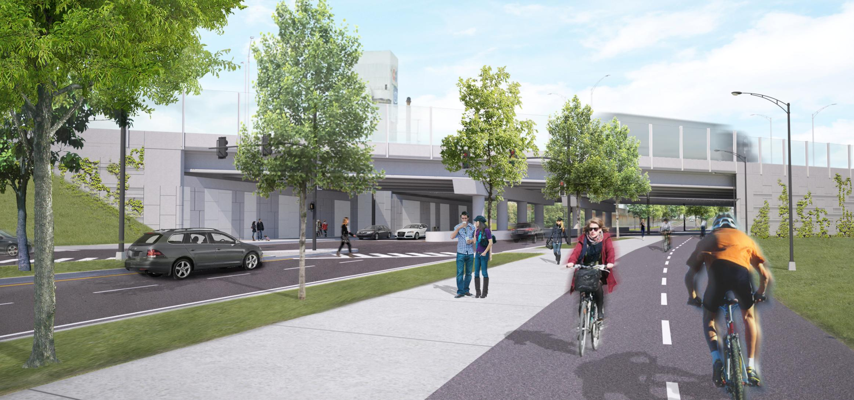
Figure 6: Atwater Interchange

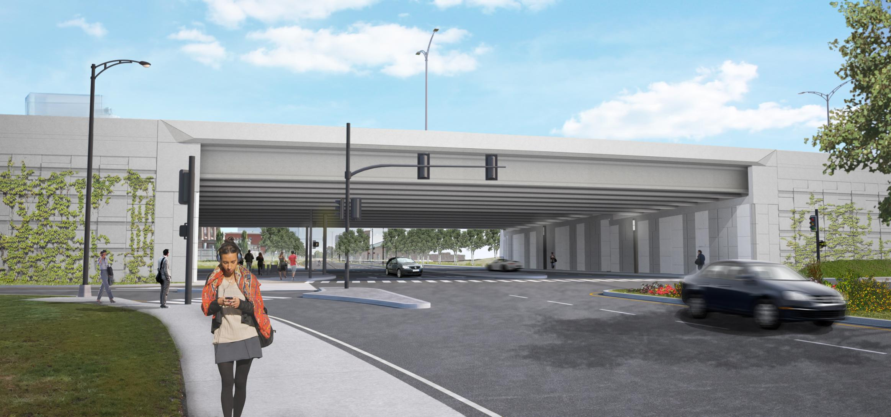
Figure 7: Gaetan-Laberge Interchange
- Conclusion
The Highway engineering joint venture was able to conceptualize, design, and deliver a durable, urban and architecturally pleasing modern infrastructure compliant with the requirements of the Project Agreement.
Typical of any PPP, thorough coordination between the different disciplines and close collaboration with the contractor have been a key to success. Many aspect of this project have been optimised without putting into jeopardy the deliverables and the quality control and quality assurance of the various deliverables.
As of the writing of this paper, the southbound direction is being constructed and should be completed by the end of 2017.
The construction of the northbound direction should follow after the phasing is completed.
At last, figures 8 and 9 show rendering of the New Champlain Bridge, daytime and night time; and figures 10 to 12 an overview of the île des Sœurs Bridge construction.
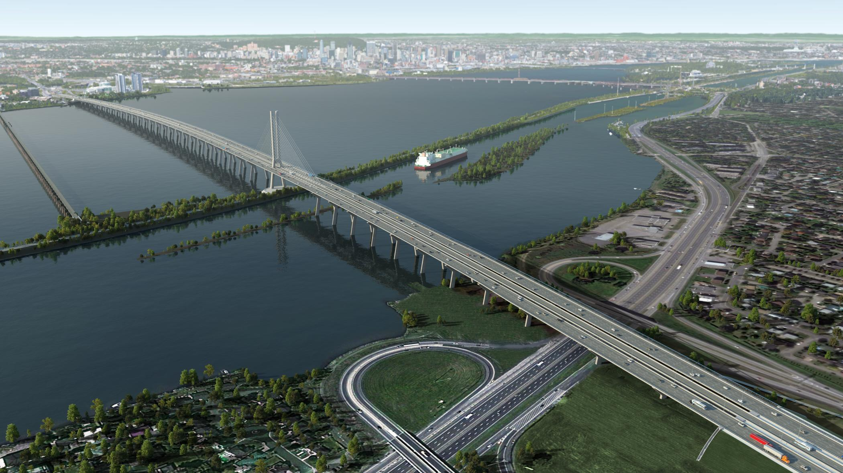
Figure 8: Daytime aerial view of the New Champlain Bridge

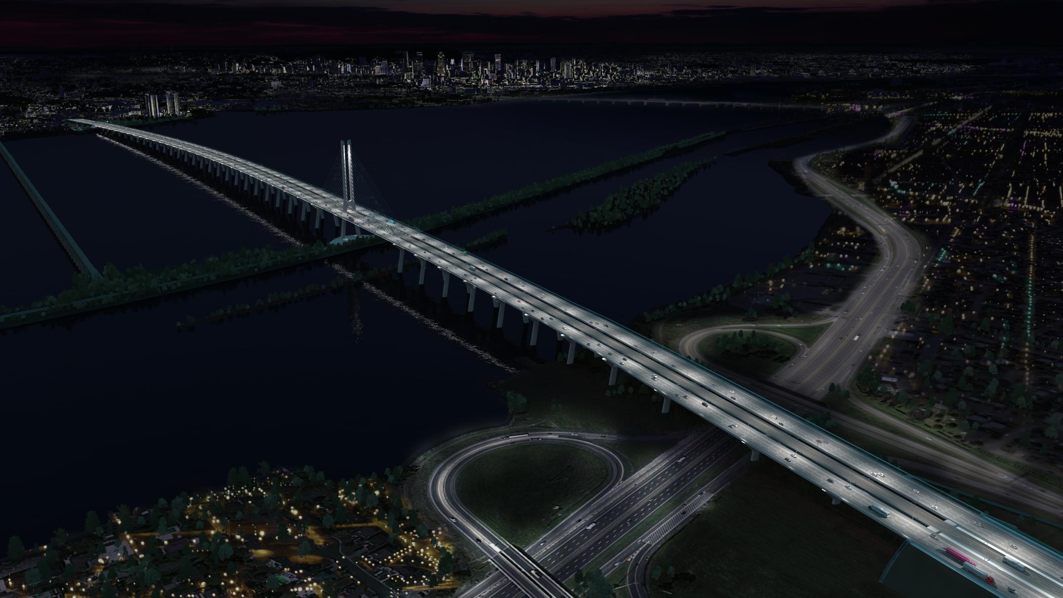
Figure 9: Night time aerial view of the New Champlain Bridge

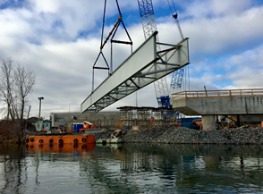
Figure 10: Erection of the girders of the IdS Bridge
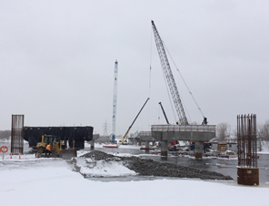
Figure 11: Overview of the site (New IdS Bridge)

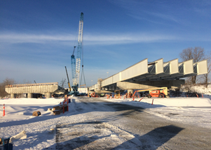
Figure 12: Girders on the new IdS north

Acknowledgements
The author acknowledges the support of the Owner Infrastructure Canada, Constructor partnership form by SNC-Lavalin Major Project Inc., Dragados Canada, Inc., and Flatiron Constructors Canada Limited, and the Design joint-venture of SNC-Lavalin Inc. and MMM Group Limited.

References
2014. The New Bridge for the St. Lawrence Corridor Project: Project Agreement.

