 | 10th International Conference on Short and Medium Span Bridges  Quebec City, Quebec, Canada,  July 31 – August 3, 2018 | 

SEISMIC PERFORMANCE OF CIRCULAR COLUMNS RETROFITTED WITH SPRAYED-GFRP COMPOSITES
Mohit, Syed¹, Parghi, Anant² and El-Salakawy, Ehab^{3,4}
¹ M.Sc. Student, University of Manitoba, Canada
² Post-Doctoral Fellow, University of Manitoba, Canada
³ Professor, University of Manitoba, Canada
⁴ ehab.el-salakawy@umanitoba.ca
Abstract: Reinforced concrete (RC) bridges constructed before 1970 are often reported seismically deficient due to inadequate detailing or corrosion of steel reinforcement. Rehabilitation of these bridges is more cost-effective and time saving than reconstruction. Conventional rehabilitation methods such as steel plates and RC jacketing increase the cross-sectional area; hence considerably increases the structural mass, changes aesthetic of the structure and needs heavy equipment’s and skilled workmanship. Moreover, steel itself is susceptible to corrosion. Fibre reinforced polymer (FRP) wraps are usually unidirectional; need extra surface preparation and its application on irregular structures is complicated. Recently, the new sprayed-FRP composites technique is introduced to overcome these limitations. In this study, three large-scale seismically deficient RC circular columns of 305 mm diameter and 1,525 mm shear span were used to investigate the feasibility of sprayed-FRP retrofitting technique. One specimen was strengthened without prior loading, while the other two specimens were rehabilitated after being partially (up to 2.5% drift ratio) and fully damaged. A 3.0 mm thickness of sprayed-GFRP coating was used for all specimens. The columns were tested under quasi-static reversed-cyclic lateral load along with constant axial load. The applied axial load was equal to 20% of axial load carrying capacity of the column. Sprayed-GFRP composites of 3-mm thickness was unable to restore the full strength of seismically damaged RC columns. However, they increased the drift capacity of partially damaged column by 77.8% while maintaining the original lateral load carrying capacity.

Introduction
Several RC structures constructed throughout the 20th century were reported to be intensively damaged after recent earthquake events. Additionally, these structures deteriorated due to aging and adverse environmental conditions. Lately, more than half of the bridges in the USA were reported not suitable for conventional use and in need of immediate repair work (Lee et al. 2008). Insufficient lap length of the starter bars and poor detailing of the lateral reinforcements were reported as the two main causes of bridge column distortion under seismic load (Paulay et al. 1981, Haroun and Elsanadedy 2005).
Various rehabilitation methods are available to upgrade the seismic performance of existing building and bridge columns. Steel plates and FRP wraps are the most common methods used as confinement techniques to improve the ductility and capacity of columns (Chai et al. 1991, Haroun and Elsanadedy 2005). The RC jacketing techniques often lead to a large increase in the self-weight of the structure which consequently cause preposterous expenditure. Also, steel plates used in these types of rehabilitation work is vulnerable to corrosion. Previous studies (Saadatmanesh et al. 1994, Seible et al. 1995, Samaan et al. 1998, Saadatmanesh et al. 1996, Xiao and Ma 1997, Chang et al. 2004, Haroun and Elsanadedy 2005 and Han et al. 2014) have investigated the lateral load carrying capacity of columns applying FRP laminates as an external confinement. The results of these studies have demonstrated that shear failure was prevented and significant improvement was obtained in the ductility of retrofitted columns. However, FRP laminate reinforcement system has many shortcomings, for instance, the requirement for prior surface treatment, installation problem at joints and relatively expensive materials cost. The FRP laminates by wet lay-up technique is also very sensitive to surface roughness of RC structures which can lead to the delamination from the concrete substrate due to a partial stress concentration at defective interfaces (Karbhari 2007). To overcome the aforementioned issues, a new retrofitting technique, sprayed fibre reinforced polymer (sprayed-FRP) composites, which has been used for boats and automobiles, was introduced in the mid 1990’s to the FRP strengthening arena of concrete structures (Banthia and Boyd 2000). This method consists of resin (epoxy, vinyl ester or polyester) and randomly oriented chopped fibres of controlled length. The spray layup process consists of a spray gun which chops fibre into predetermined lengths, merge with the resin mix stream and projects simultaneously to desired thickness on concrete surface.
It has been proven that sprayed-FRP composites can be well bonded even to the uneven concrete surface (Boyd 2000). Previous research demonstrated that sprayed-FRP composites can considerably increase the load carrying capacity, ductility and energy absorbing of concrete beams (Lee and Hausmann 2004, Banthia et al. 2002) compared to carbon-FRP laminate-wrapped beams. The sprayed-FRP techniques offered other advantages compared to conventional FRP jackets, such as strong bond capacity, ease of construction and installation, and better cost effectiveness (Boyd 2000, Banthia and Boyd 2000). Lee et al. 2016 reported that the optimum fibre length and fibre-resin ratio as 38 mm and 1:2, respectively, which was used to rehabilitate rectangular RC columns. Spray thickness was 4.2 mm for glass fibre with vinyl ester resin. An increase in shear strength and deformation capacity of 31 and 43%, respectively, was recorded. Peng et al. 2014 rehabilitated three full scale partially damaged (up to yielding of longitudinal reinforcement) RC square columns with sprayed-basalt (B) FRP of 4.5 and 7 mm thickness and with sprayed-BFRP/ carbon (C) FRP (7:3) of 4.5 mm thickness in vinyl-ester resin. Columns were tested under lateral cyclic load and simultaneous constant axial load. It was observed that the increase in sprayed-BFRP thickness from 4.5 to 7 mm increased the ductility and energy absorption capacity by 5% and 34.8%, respectively. However, for the same thickness, replacement of 30% BFRP fibres with CFRP fibres increased the ductility and energy absorption capacity by 30% and 33.9%, respectively.

Experimental program for seismic strengthening of columns
Three full scale circular columns, deficient in lap splice length, were designed and constructed to evaluate the efficiency of strengthening with sprayed-FRP technique. All columns had a diameter and a shear span length (distance between footing-column interface and the point of lateral load application) of 305 and 1,525 mm, respectively. The columns were longitudinally reinforced with 6-15M rebar (reinforcement ratio of 1.64%) satisfying the minimum number of bar requirements (CSA-A23.3 2014) for circular columns, and laterally confined with 10M spiral with a pitch of 75 mm. Lap splice length was 20d_{b} (d_{b} = Diameter of longitudinal reinforcement) equal to 320 mm whereas the Canadian standards (CSA-A23.3 2014) recommends not to use less than 40d_{b}. These specimens represented a portion of a column between the foundation and point of inflection located in the first storey of a building. Table 1 shows the parameter and testing scheme of the column specimens. Two of the columns specimens were pre-damaged before applying a 3 mm thick layer of sprayed-glass FRP, then re-tested to failure. Each column specimen was designated by two characters. Frist character represent the state of specimen at which it was rehabilitated. Here “D”, “PD” and “I” represent fully damaged, partially damaged and intact, respectively. Second character denotes the thickness of sprayed-FRP. Here, “0” means no spray was applied before testing and “3” means that the specimen was rehabilitated with 3 mm thick sprayed-GFRP before testing. For example, Specimen D-0 was fully damaged up to failure, then patched and retrofitted using sprayed-GFRP which denoted as D-3. Specimen PD-0 was partially damaged, then repaired and retrofitted using sprayed-GFRP and named as PD-3. Specimen I-3 was strengthened without prior damage, then tested up to failure.
Table 1: Detailing of the specimens
Specimen ID | Sprayed-GFRP Thickness (mm) | Remarks
D-0 | 0.0 | Tested until failure
PD-0 | 0.0 | Tested up to 2.5% drift ratio
D-3.0 | 3.0 | D-0 rehabilitated with 3 mm sprayed-GFRP
PD-3.0 | 3.0 | PD-0 rehabilitated with 3 mm sprayed-GFRP
I-3.0 | 3.0 | Strengthened and tested up to failure

Materials
Ready-mix concrete with a targeted 28-day compressive strength of 35 MPa was used. Regular G400 No.15M steel bars were used as longitudinal reinforcement and No.10M continuous spiral was used for lateral confinement. Continuous roving glass fibres (Owens Corning Composite Materials 2015), an epoxy bi-phenolic vinyl-ester resin (Polynt Composites Canada Inc. 2017) and a curing agent (United Initiators Inc. 2017) was used in the rehabilitation process. Table 3 shows the properties of vinyl-ester and glass fibre, respectively according to manufacturer technical data sheet. All columns were retrofitted with 3 mm sprayed-GFRP coating for the full column length.
Table 3: Properties of vinyl ester and glass fibre as provided by manufacturer (Owens Corning Composite Materials 2015, Polynt Composites Canada Inc. 2017)
Material | Diameter  (µm) | Specific gravity  (g/cm³) | Viscosity  (cps) | Gel time  (min.) | Tensile strength  (MPa) | Tensile modulus (GPa) | Elongation at failure (%)
Vinyl ester | -- | 1.03-1.07 | 450-700 | 15-25 | 84 | 3.75 | 7.5
Glass fibre | 11 | 2.6 | -- | -- | 3100-3800 | 80-81 | 4.6

Construction of Specimens
In each specimen, the longitudinal reinforcement of the columns was extended into the footing using starter bars. These bars were lapped into the main longitudinal reinforcement of the column over a length of 320 mm (20 times the longitudinal bar diameter). The embedded length of these dowel bars was 575 mm satisfying the minimum required length specified in the CSA-A23.3 (2014). Moreover, this embedded length was reported to be adequate against slippage in previous studies (Ali and El-Salakawy 2016, Naqvi and El-Salakawy 2016). All the specimens were cast using ready mix concrete. The footing was cast one week before the column to simulate the actual construction practice. A concrete block of 505 × 305 × 400 mm was constructed monolithically at the top of each column to facilitate the axial and lateral load transfer from the actuators to the column. All column specimens had a massive footing (1,400 × 900 × 600 mm) to provide adequate fixity to the specimens while testing. The footing was reinforced with 15M bars at top and bottom in both directions. Six dowel bars of size 15M were cast with the footing.

Strengthening Process
Before applying the sprayed-GFRP to the partially and fully damaged columns, these specimens were repaired using normal cement mortar and cured with wet burlap for one week. At the beginning of rehabilitation process, a prime coat of vinyl-ester resin and methyl ethyl ketone peroxide (MEKP) catalyst was sprayed on specimen surface and left to set for approximately 30 minutes. This layer prevented the slipping down of sprayed-GFRP composite while spraying. Then, the same gun was used to chop and spray around 26 mm long glass fibres simultaneously with resin and catalyst up to 3 mm thickness (Fig. 1a). The targeted fibre concentration was 30-35%. The catalyst concentration was always 2% of resin volume. A ridged aluminium compaction roller was used to rollout the entrapped air voids for consistent thickness and impregnation of the composite (Fig. 1b). The thickness of sprayed-GFRP was measured using measurement device (Fig. 1c).
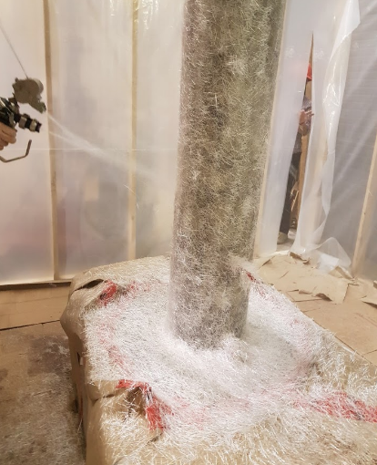 | 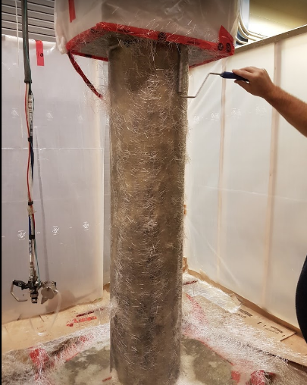 | 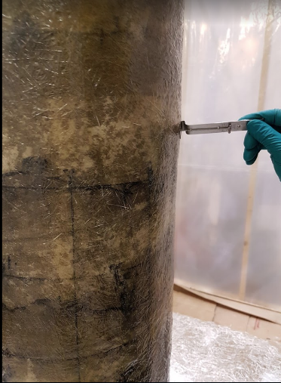
(a) | (b) | (c)
Figure 1: Sprayed-GFRP application process

Instrumentation, Test Setup and Loading Scheme
Column rotation was measured using four linear variable displacement transducer (LVDT) placed along the line of lateral load application. Eight strain gauges were used in each column to monitor yielding of longitudinal bar and slippage of lap splice. The propagation of cracks while testing was monitored visually and marked carefully at the end of each loading cycle. Each specimen was subjected to low frequency (0.01 Hz) reversed cyclic load while simultaneously applying a constant axial load of 500 kN (20% of axial load capacity). In order to apply the axial load, a hydraulic jack was instrumented on the top of the column (Fig. 2). The lateral loading cycle was applied incrementally in two phases, Phase I was conducted in a load-control mode, while for Phase II, the load was applied in displacement control mode. In load-controlled mode the first two cycles were cracking (35 kN) and service (62 kN) cycle. In Phase II, ACI Committee 374 (2005) recommendation was followed to determine the drift and number of cycles.
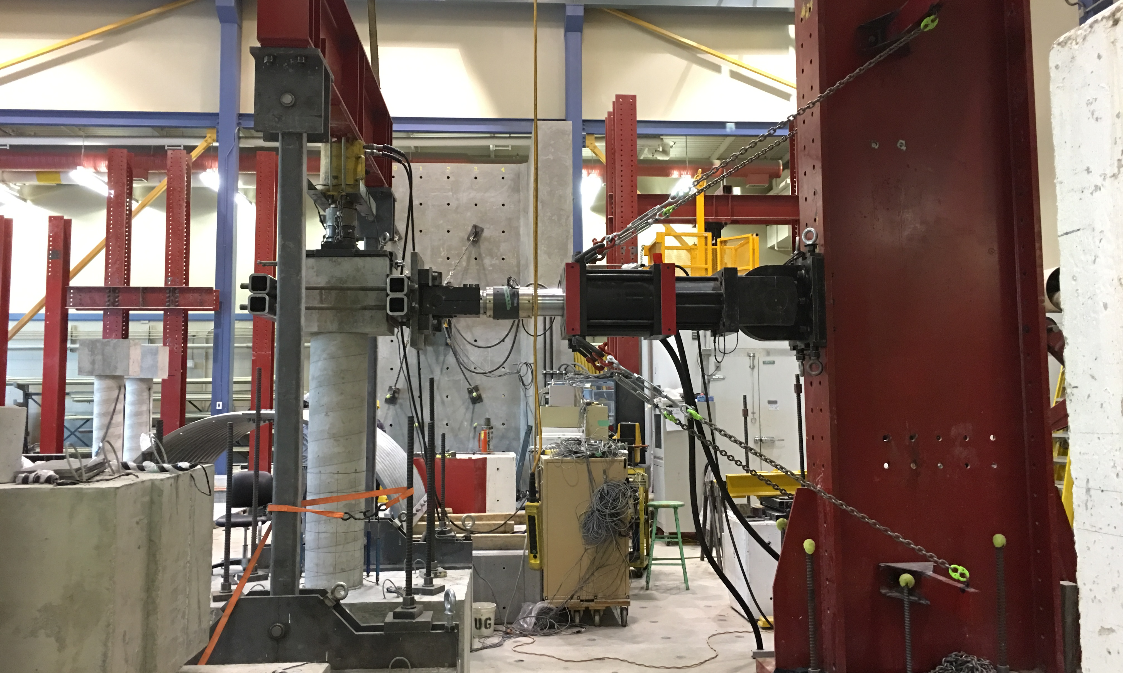
Actuator
Hydraulic jack
Specimen
Figure 2: Test setup

Results and discussion
- General Behavior and Mode of Failure
Figure 3 (a)-(d) shows the failure mode of D-0, D-3, PD-3 and I-3, respectively. Specimen D-0 showed the first crack at 37 kN at a distance approximately 330 mm from footing surface. With the continuation of the test several evenly distributed cracks were observed with in a distance of 700 mm from the footing surface within service cycle. These crackes mainly followed the position of spirals reinforcements. Concrete cover spalling started at 2.5% drift ratio at the hinging region (300 mm from footing surface). At 3.5% drift, the longitudinal reinforcement was exposed due to the spallinlg of concrete cover. At 4.5% drift, core concrete crushed at the footing column interface and the column failed (fig. 3a). After repairing with cement mortar and rehabilitating using sprayed-GFRP, the specimen was again tested under same loading scheme. Rehabilitated specimen D-3 failed suddenly by rupture of sprayed-GFRP at the first service cycle while pushing (Fig. 3b). The fracture occurred vertically at hinging region with a length around 300 mm. Fracture of sprayed-GFRP occurred mainly due to matrix rupture rather than fibre pull-out and fibre rupture. No concrete crushing was visible during the failure. Confiment on pulling side failed in a similar manner but at 6% drift ratio. At 8% drift rario, crushing of repaired concrete was observed along with widening of fracture of the sprayed-GFRP confinement.
For specimen I-3, the first visible crack on sprayed-GFRP coating was observed near the footing surface at 4.5% drift. It initiated from the location of threaded bars which were embeded in column surface for rotation measurement. Speciemn failed at 6% drift by simultaneous rupture of sprayed-GFRP coating and concrete crushing (Fig. 3c). The fracture occurred vertically and it propagated around 200 mm from the bottom of the column. From the close observation of fractured confinement, it can be concluded that the failure of sprayed-GFRP confinement mainly occurred by matrix rupture as there was heardly any indication of fibre rupture and fibre pull-out. Internal reinforcement was exposed due to concrete crushing.
Specimen PD-0 showed first crack at 35 kN at a distance approximately 180 mm from footing surface. With the continuation of the test several cracks were observed with in a distance of 700 mm from the footing surface until 2.5% drift ratio. No visible concrete spalling was observed. After retrofitting, specimen PD-3 was tested up to failure. The first visible crack on sprayed confinement was observed at 4.5% but the specimen ultimately failed at 8% drift ratio (Fig. 3d). Fibre pullout and fibre rupture was also observed along with martix rupture on cracked confinement.
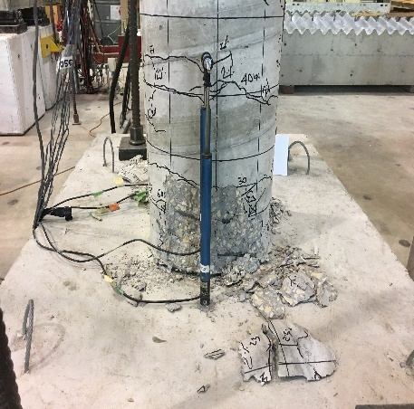  D-0 at 4.5% | 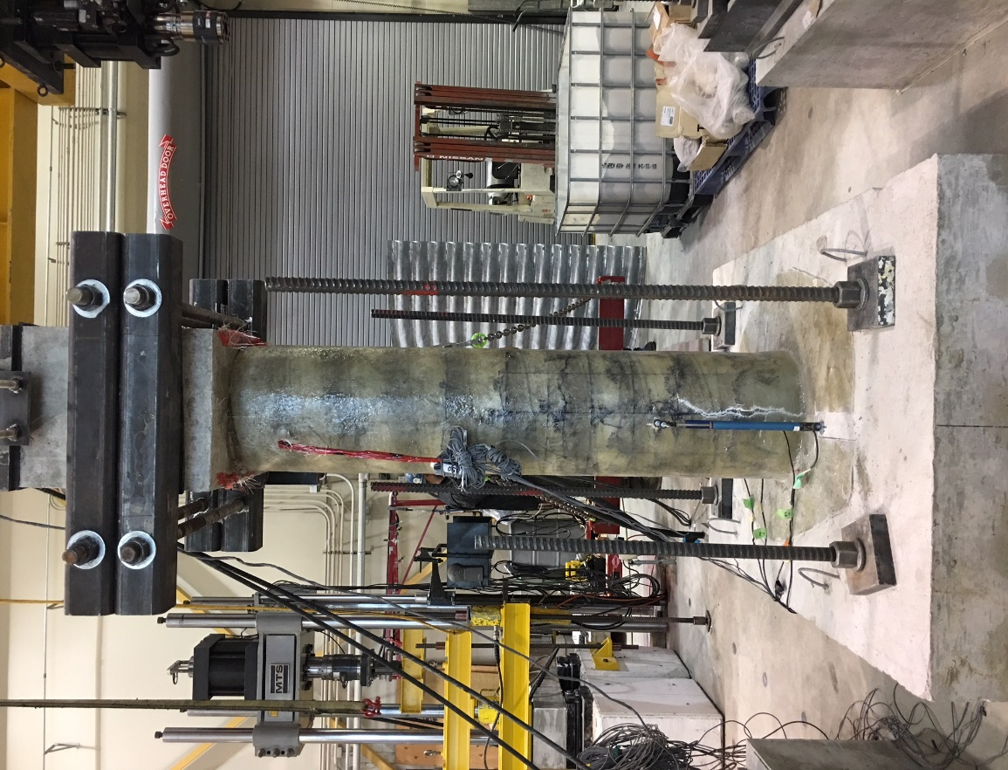  D-3 at service cycle | 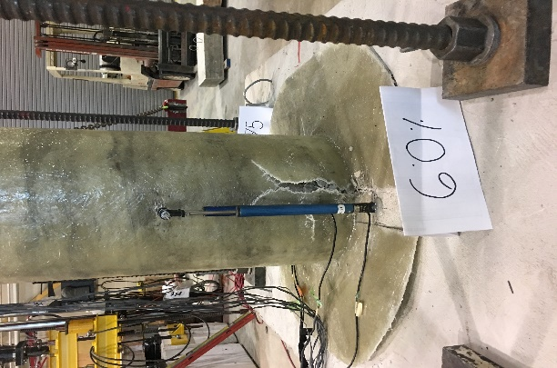  I-3 at 6.0% | 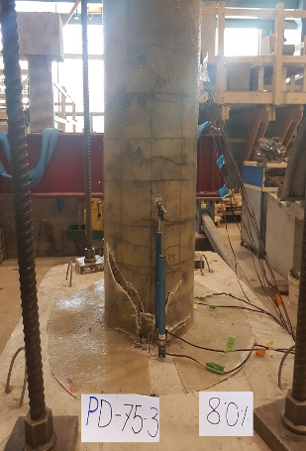  PD-3 at 8.0%
(a) | (b) | (c) | (d)
Figure 3: Faliure mode of specimen (a) D-0 (b) D-3 (c) PD-3 (d) I-3
- Lateral Load-Drift Response
Specimen D-0 showed almost constant lateral load capacity from 1.5% drift ratio to 3.5% drift ratio. Maximum lateral load of +77.5 kN (pushing) and -85.4 kN (pulling) was observed at 3.5% drift ratio (Fig. 4a). At the last cycle of 4.5% drift ratio the column lateral load capacity decreased by 25%. After rehabilitation, specimen D-3 failed at 54 kN (30.3% lower than column actual capacity) while pushing by confinement rupture (Fig. 4b). Similar failure was observed for specimen I-3 although it sustained 6% drift (Fig. 4c). Maximum lateral load of +82.96 kN (pushing) and -91.8 kN (pulling) was recorded at 3.5% drift ratio. On average the sprayed-GFRP strengthening system increased the lateral load carrying capacity by 7.2% compared to the original column. For specimen PD-0, maximum lateral load was recorded at 2% drift ratio as +87.1 kN (pushing) and -77.2 kN (pulling) (Fig. 4d). After rehabilitation; maximum lateral load resistance of specimen PD-3 was recorded 8.7% lower while pushing (+79.5 kN at 4.5% drift ratio) and 16.5% higher while pulling (89.97 kN at 3.5% drift ratio) (Fig. 4e). Lateral load resistance gradually decreased up to 8% drift ratio and at the last cycle lateral load capacity dropped by 25%.

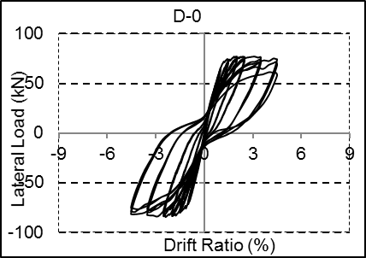  (a) | 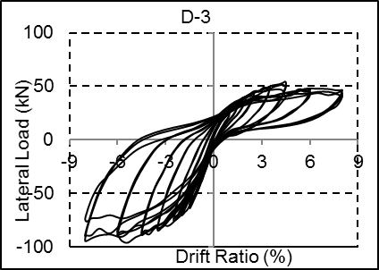  (b)
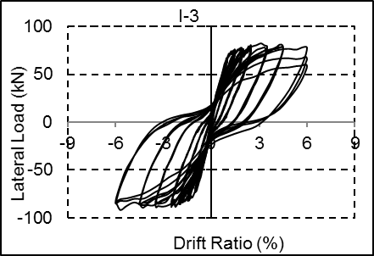  (c) | 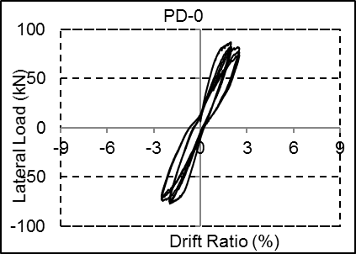  (d)
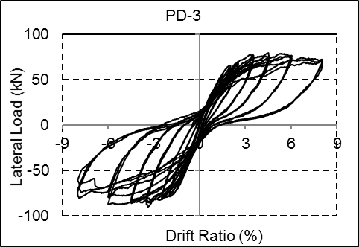
(e)
Figure 4: Lateral load vs drift ratio response

Conclusions
Besed on the esperimental results, the following conculusions were obtained:
- Sprayed-GFRP composite can be used as a practical strenghtening system for RC circular column in seismic region. Although the increase in lateral load capacity was approximately 7%, the increase in energy dissipation capacity was found to be 170%.
- Sprayed-GFRP of 3 mm thikness was found inadequate to restore the strength of tested seismically damaged RC columns. Further research is required considering increased spray thickness for seismic rehabilitation of damaged RC circular column.
- Sprayed-GFRP composite system increased the dispalcement capacity of partially damaged RC circular column by 77.8% while maintianing almost same lateral load carrying capacity. This new technique can be used to restore lateral load capacity of partially damaged columns of buildings and bridges in seismic region.

Acknowledgements
The financial contributions of the University of Manitoba Graduate Fellowship (UMGF), NSERC-Engage grant and MITACS-Accelerate are gratefully acknowledged. The authors would like to thank the technical staff of W.R. McQuade Heavy Structures Laboratory at the University of Manitoba for providing assistance during testing.

References
ACI Committee 374. 2005. Acceptance Criteria for Moment Frames Based on Structural Testing and Commentary. ACI 374.1-05 (Reapproved 2014). Farmington Hills (Mich): American Concrete Institute.
Ali, M. A., and El-Salakawy, E. 2016. Seismic Performance of GFRP-reinforced Concrete Rectangular Columns. Journal of Composite Construction, ASCE, 20(3), 04015074(1-2).
Banthia, N., and Boyd, A. J. 2000. Sprayed Fibre-reinforced Polymers for Repairs. Canadian Journal of Civil Engineering, 27(5), 907–915.
Banthia, N., Nandakumar, N., and Boyd, A. 2002. Reinforced Polymers: From Laboratory to a Real Bridge. Concrete International, 24(11), 47–52.
Boyd, A. J. 2000. Rehabilitation of Reinforced Concrete Beams with Sprayed Glass Fibre Reinforced Polymers. Ph.D. Thesis, Dept. of Civil Engineering, University of British Columbia, Canada.
CAN/CSA-A23.3. 2014. Design of Concrete Structures. Canadian Standards Association, Mississauga, Ontario, Canada, 258.
Chai, Y. H., Priestley, M. N. J., and Seible, F. 1991. Seismic Retrofit of Circular Bridge Columns for Enhancing Flexural Performance. ACI Structural Journal, 88(5), 572–584.
Chang, S., Li, Y., and Loh, C. 2004. Experimental Study of Seismic Behaviors of As-built and Carbon Fibre Reinforced Plastics Repaired Reinforced Concrete Bridge Piers. Journal of Bridge Engineering, ASCE, 9(4), 391–402.
Han, Q., Wen, J., Du, X., and Jia, J. 2014. Experimental and Numerical Studies on Seismic Behavior of Hollow Bridge Columns Retrofitted with Carbon Fibre Reinforced Polymer. Journal of Reinforced Plastic and Composite, 33(24), 2214–2227.
Haroun, M. A., and Elsanadedy, H. M. 2005. Fibre-reinforced Plastic Jackets for Ductility Enhancement of Reinforced Concrete Bridge Columns with Poor Lap-splice Detailing. Journal of Bridge Engineering, ASCE, 10(6), 749–757.
Karbhari, V. M. 2000. Durability of Composites for Civil Structural Applications. Woodhead Publishing/CRC Press, Canbridge/Boca Raton, Net Library, Inc., 384.
Lee, H. K., and Hausmann, L. R. 2004. Structural Repair and Strengthening of Damaged RC Beams with Sprayed FRP. Composite Structures, 63(2), 201–209.
Lee, H. K., Hausmann R. L. and Seaman, W. C. 2008. Effectiveness of Retrofitting Damaged Concrete Beams with Sprayed Fibre-reinforced Polymer Coating. Journal of Reinforced Plastics and Composites, 27(12), 1269-1286.
Lee, K. S., Lee, B. Y. and Seo, S. Y. 2016. A Seismic Strengthening Technique for Reinforced Concrete Columns using Sprayed FRP. Polymers, 8(4), 107-128.
Naqvi, S. and El-Salakawy, E. 2016. Lap Splice in GFRP-RC Rectangular Columns Subjected to Cyclic-Reversed Loads. Journal of Composite Construction, ASCE, 21(4), 04016117(1-2).
Owens Corning Composite Materials. 2015. Continuous Filament Glass Fibre: Roving and Dry Chopped Strands. Safe Use Instruction Sheet, Tolendo, Ohio.
Paulay, T., Zanza, T. M. and Scarpas, A. 1981. Lapped Splices in Bridge Piers and in Columns of Earthquake Resisting Reinforced Concrete Frames. Research report, Department of Civil Engineering, University of Canterbury, New Zealand, 81(6), 1-117.
Peng, Y., Gu, Q., Gao, R. and Bitewlgn, G. 2014. Experimental Research on Seismic Behavior of Seismically Damaged RC Frame Column Strengthened with Sprayed Hybrid BF/CFRP. Applied Mechanics and Materials, 501, 1592-1599.
Polynt Composites Canada Inc. 2017. 41X Epoxy Vinyl Ester Resin (EPOVIA© KRF-1001 MV). Safety Data Sheet, Quebec, Canada.
Saadatmanesh, H., Ehsani, M. R., and Jin, L. 1994. Strength and Ductility of Concrete Columns Externally Reinforced with Fibre Composite Straps. ACI Structural Journal, 91(4), 434–447.
Saadatmanesh, H., Ehsani, M. R., and Jin, L. 1996. Seismic Strengthening of Circular Bridge Pier Models with Fibre Composites. ACI Structural Journal, 93(6), 639–647.
Samaan, M., Mirmiran, A., and Shahawy, M. 1998. Model of Concrete Confined by Fibre Composites.” Journal of Structural Engineering, ASCE, 124(9), 1025–1031.
Seible, F., Burgueno, A., Abdallah, M. G., and Nuismer, R. 1995. Advanced Composites Carbon Shell System for Bridge Columns under Seismic Loads. In: Proceedings, National Seismic Conference on Bridges and Highways, San Diago, California, USA.
United Initiators, Inc. 2017. NOROX MEKP-925H. Material Safety Data Sheet, Helena, USA.
Xiao, Y., and Ma, R. 1997. Seismic Retrofit of RC Circular Columns using Prefabricated Composite Jacketing. Journal of Structural Engineering, ASCE, 123(10), 1357–1364.

