|  |  |  |
| --- | --- | --- |
|  | **10th International Conference on Short and Medium Span Bridges**  **Quebec City, Quebec, Canada,**  **July 31 – August 3, 2018** |  |

**INVESTIGATION OF THE TRANSVERSE MOMENTS AT THE INTERIOR SEGMENT OF DECK SLAB OVERHANG SUBJECTED TO CHBDC TRUCK LOADING**

Pourmand, Hanieh1,3, and Sennah, Khaled2

1 Ryerson University, Canada

2 Ryerson University, Canada

3 [hpourmand@ryerson.ca](mailto:hpourmand@ryerson.ca)

**Abstract:** Clause 5.7.1.3 of the Canadian Highway Bridge Design Code of 2014 introduced an equation for the calculation of the transverse moment in deck slab cantilever due to truck loading. It also specifies table 5.15 which limited to unstiffened and New Jersey barrier. The drawback of this Clause is that it does not take into account the effect of the length of the bridge or the barrier wall on the response. Also, the equation is limited to a one type of barrier shape (New Jersey barrier) while CHBDC specifies barrier shapes, namely, TL-5, TL-4, TL-2 and TL-1. As a result, the objective of this study is to investigate the applied transverse moment at the middle portion of the cantilevered slab. For this study, stiffened and unstiffened cantilever deck slabs are considered. The finite element (FE) analysis has been conducted on bridge deck cantilever with various end stiffening arrangements including the TL-5 barrier shape mentioned above, along with the concrete curb supporting intermittent steel parts carrying the bridge railing. In FE modelling, the key parameters considered include barrier longitudinal length, deck cantilever length and deck slab thickness. The barrier length and cantilever length range from 5 to 20 m and 1 to 3 m, respectively. Based on the data generated from this parametric study, charts and tables for the transverse moment (My)at the middle portion of the deck slab cantilever due to CHBDC truck loading were presented.

# INTRODUCTION

An extensive study has been conducted over time on figuring out the intensity of bending moment due to wheel loads on bridge cantilever overhang to produce a user-friendly method that can be adopted instead of applying more rigorous methods. Generally, these simplified methods are based on assumption of ′isolating the deck slab overhang from the internal slab panels of the bridge on fixed supports retrained from any movement and rotation. Bakht and Holland (1976) developed a semi-graphical solution based on the assumption of an elastic cantilever overhang with isotropic material. This method can be applied for calculating moment intensity all over the deck slab overhangs with linearly varying thickness. The formula is in the form of:

|  |  |  |
| --- | --- | --- |
| [1] | $$M_{y }=-\frac{PA^{'}}{π}\left[\frac{1}{cosh \frac{A^{'}x}{\left(c-y\right)}}\right]$$ |  |

where P is the intensity of applied load. Coefficient A′ is function relative to the position of the load (P) with respect to the root of cantilever slab and it depends on: the thickness ratio tr =t2/t1, cr = c/a and yr = y/r. A′ can be found through graphical charts (Figure 1).

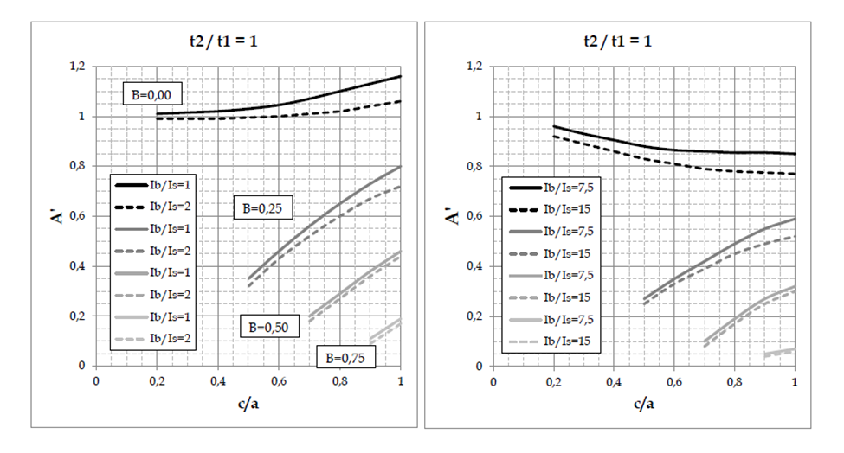

Figure 1: Values of A′ for various thickness ratio (Adapted from Bakht and Holland (1976))

# Dilger el al. (1990) applied the same equations that Bakht and his coworkers used, but they introduced a new value for B which is A′/2. Coefficient B is the function of tr, cr, yr and a new parameter Sr = S/Sc. Sr is the ratio of internal slab to cantilever slab. In addition, they added a stiffness factor. Both simplified methods developed by Bakht and Holland (1976) and Dilger el al (1990) can be used to determine the magnitude of moment in cantilever deck, while any method on the intensity of moment in the first internal panel was not provided. Mufti et al. (1993) proposed a simplified method for determining the intensity of hogging moment in the first internal panel due to a concentrated load on the deck slab overhang. Mufti et al. (1993) solved the problem based on some simplification. For instance, they reached to the point that, the girders can be supposed to be non-deflecting. Furthermore, it can be assumed that the deck slab is simply supported over the girder close to external girder. Based on such these simplification, Mufti et al. (1993) proposed two equations for finding the magnitude of the bending moment in both cantilever overhang and first internal panel as follows:

|  |  |  |
| --- | --- | --- |
| [2] |  |  |

|  |  |  |
| --- | --- | --- |
| [3] | $$M_{yi}= -\frac{2PB_{i}}{π}\left[\frac{c^{4}{\left(S-y_{i}\right)}^{4}}{{\left[{c^{2}\left(S-y_{i}\right)}^{2}+{S^{2}\left(B_{i}x\right)}^{2}\right]}^{2}}\right]$$ |  |

Equation 2 is for finding transverse moment intensity in the cantilever slab and equation 3 is for calculation of transverse moment in the internal panel due to the concentrated load applied on cantilever slab. Value of Bc and Bi can be found through tabulated tables Mufti et al. (1993) prepared. Figure 2 demonstrates the notation used in above relationships.

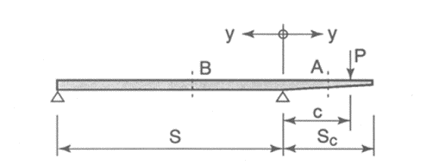

Figure 2: Notation for cantilever slab and internal panel (Adapted from Mufti et al. (1993))

Based on findings by Bakht and Holland (1976), Dilger et al. (1990) and Mufti et al. (1993), Canadian Highway Bridge Design Code (CSA 2014) proposed a simplified method of calculating the transverse moment in cantilever slab due to live loading. A function is providing by CHBDC to determine the transverse bending moment (My) in deck slab overhang with a uniform or varying thickness ratio due to truck loading as follows:

|  |  |  |
| --- | --- | --- |
| [4] | $$M_{y}=\frac{2PA}{π{\left[1+{\left(\frac{Ax}{c-y}\right)}^{2}\right]}^{2}}$$ |  |

Where, P is magnitude of concentrated load on cantilever, A is a coefficient can be found through graphical charts demonstrated on Figure 5.4 of CHBDC, and depends on factors such as thickness ratio, and ratio of distance of load (P) to the root of cantilever slab and cantilever span length. Other notation demonstrated on the same figure as well.

Another option specified by in clause 5.7.1.3 of the CHBDC for determining the transverse moment intensity due to the CL-625 Truck, is to obtain the corresponding value from Table 5.15 provided in this clause 5.7.1.3 of the code as shown in Table 1. However, the downsides of the simplified method which provided the clause 5.7.1.3 of CHBDC includes: the effect of length of barriers and types of barrier wall are not considered, the equations used to develop the charts consider wheel load as concentrated load while in reality the wheel load distributed over 250x600 mm plan area, the loading cases to develop the table 5.15 is not specified. Therefore, a practical-design-oriented parametric study was carried out in this research, using the commercially available SAP2000 finite element software on more than 1080 deck slab cantilevers to study the peak intensity of transverse moment, resulted from the applied wheel loads at the middle portion of deck slab overhang.

Table 1: Maximum cantilever moments due to CL-625 loading condition included ID, (CSA 2014)

|  |  |  |  |  |  |  |
| --- | --- | --- | --- | --- | --- | --- |
|  | Unstiffened edge | | | Edge stiffened with New Jersey barrier | | |
|  | Maximum My, kN.m/m | | | Maximum My, kN.m/m | | |
| Sp, m | rt = 1.00 | rt = 0.75 | rt = 0.5 | rt = 1.00 | rt = 0.75 | rt = 0.5 |
| 1.00 | 41 | 43 | 44 | 37 | 41 | 45 |
| 1.50 | 43 | 47 | 51 | 34 | 37 | 41 |
| 2.00 | 53 | 57 | 60 | 35 | 39 | 43 |
| 2.50 | 60 | 65 | 70 | 37 | 40 | 43 |
| 3.00 | 92 | 99 | 107 | 70 | 74 | 77 |

# NUMERICAL MODELLING OF CANTILEVER DECK SLAB

In this study, SAP2000 software version 19 (CSI 2015), which is a powerful tool for the finite element analysis, was employed in combination with Application Programming Interface (API). For the purpose of sensitivity and parametric studies, above 1080 finite element modeling were generated by SAP2000 software. The FE prototypes created by thin shell elements with six degree of freedom nodes. The cantilever deck slab is separated from rest of the bridge over fixed supports at its root. In addition, the modelling created by centerline approach which illustrated in Figure 3.

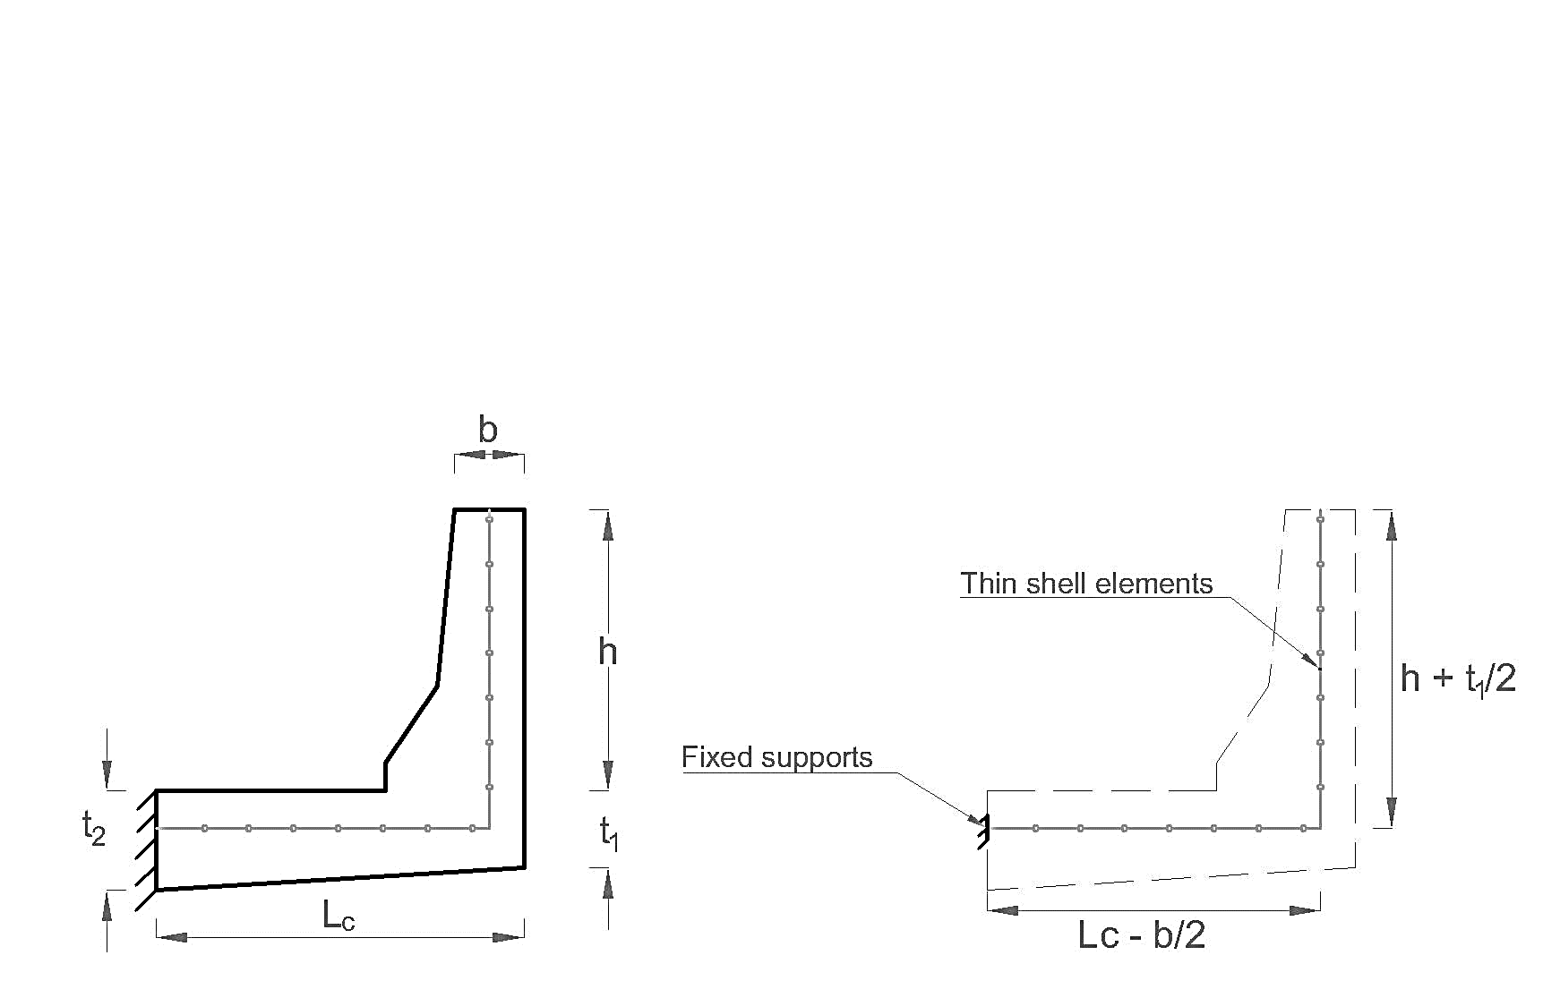

Figure 3: Centreline approach adopted to model cantilever slab and barrier wall

To acquire the most possible accuracy, the dimension of finite elements was considered as 50x50 mm with aspect ratio of 1 in both cantilever slab and barrier wall. Nevertheless, the aspect ratio exceeded by 10% in places such as varying thickness barriers. Also, the specific concrete properties defined in SAP 2000 to assign to the deck slab and barrier wall. The material behaviour considered as elastic and isotropic with compressive strength (f’c) of 30 MPa. Other properties of concrete such as specific weight, modulus of elasticity (Ec), and Poisson’s ratio were taken as 24 kN/m3, 4500, and 0.2, respectively. The barrier configurations adopted in this study depicted in Figure 4, and the loading cases which applied in middle portion of cantilever slab is shown in Figure 5.

|  |  |  |
| --- | --- | --- |
|  |  |  |
| 1. TL-5 barrier | 1. Curb | 1. Unstiffened edge |

Figure 4: Edge stiffening types considered in this study

|  |
| --- |
|  |
| 1. Cantilever slab with truck axle 4 |
|  |
| 1. Cantilever slab with truck axles 2 and 3 |
|  |
| 1. Cantilever slab with truck axles 1, 2, and 3 |
|  |
| 1. Cantilever slab with truck axles 3, 4, and 5 |
|  |
| 1. Cantilever slab with truck axles 2, 3, 4, and 5 |

Figure 5: Plan views of the deck slab cantilever with different loading case

# RESULTS FROM THE SENSITIVITY STUDY

To produce the FE prototypes for the parametric study, a sensitivity study conducted to investigate which loading cases illustrated in Figure 5 produced maximum transverse moment in deck slab overhang. This study was carried out on the cantilever slab stiffened with TL-5 barrier with a constant thickness of 200 mm. The barrier length (Lb) considered ranging between 5 m to 20 m, and cantilever length (Lc) varied from 1 m to 3 m. As per this study, it seemed that for the cantilever lengthsmaller than 1.5 m the case (a) which depicted in Figure 5, produces the maximum moment for all barrier length. However, for Lc = 1.5, 2, 2.5, and 3 m, case (b) is dominant for Lb = 5, 6 m, case (c) for Lb = 8, 10, 12 m, and case (e) for Lb = 20 m. As a result, the loading cases which applied for parametric study followed the same pattern which concluded in sensitivity study. Some results illustrated in graphs in Figure 6 to elaborate the dominant loading case.

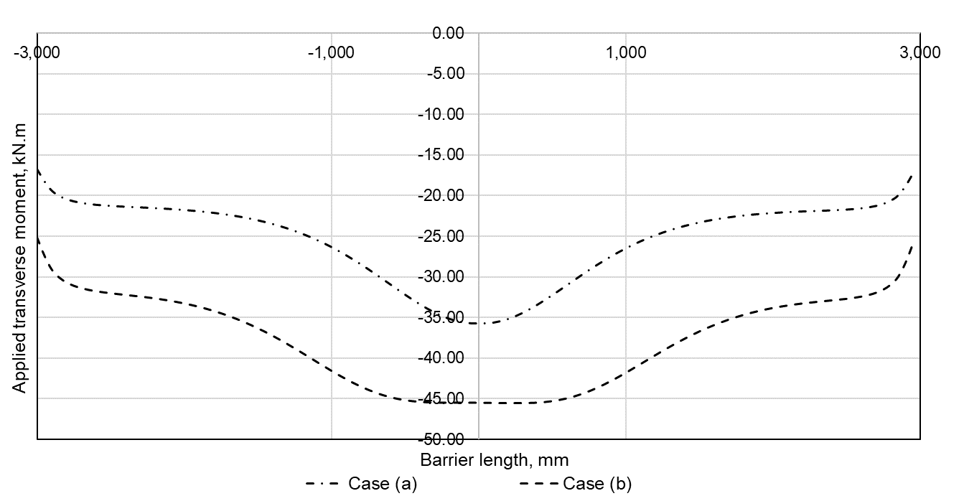

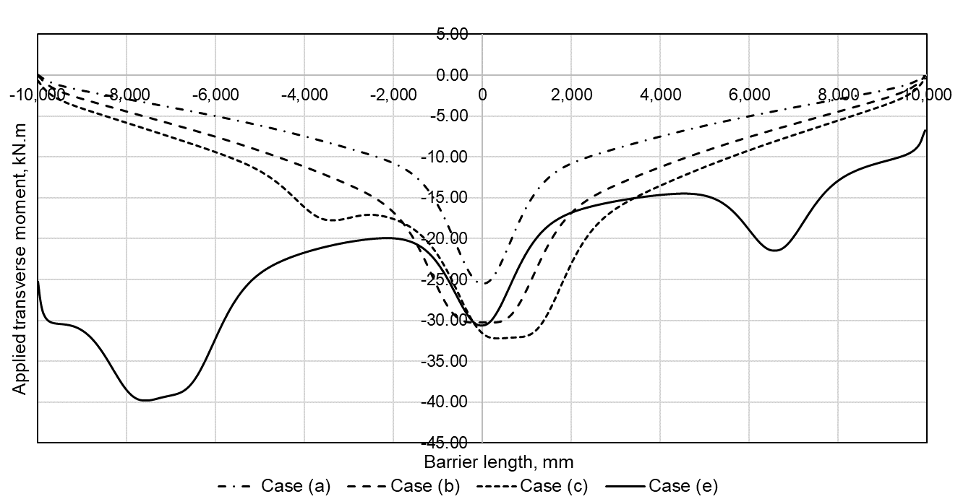

Figure 6: Results from Sensitivity study, Cantilever slab stiffened with TL-5 barrier of 6 m (top), Cantilever slab stiffened with TL-5 barrier of 20 m (bottom)

# RESULTS FROM THE PARAMETRIC STUDY

As explained earlier, a vast parametric study on 1080 Finite Element modeling carried out to study the magnitude of transverse moment (My) which created in deck slab overhang when subjected to CL-625-ONT. The key parameters considered in this study included: type of edge stiffening, slab thickness and thickness ratio, length of cantilever slab in transverse direction (Lc), and length of barrier (Lb). Table 2 demonstrates the range of these parameters.

Table 2: Range of parameters considered in this study

|  |  |  |  |  |  |  |
| --- | --- | --- | --- | --- | --- | --- |
|  | Lc  (m) | Lb  (m) | t1  (mm) | t2/t1 | b  (mm) | H  (mm) |
| TL-5 | 1, 1.5, 2, 2.5, 3 | 5, 6, 8, 10, 12, 20 | 200, 250, 350 | 1, 1.2, 1.5, 2 | 225 | 1140 |
| Curb | 1, 1.5, 2, 2.5, 3 | 5, 6, 8, 10, 12, 20 | 200, 250, 350 | 1, 1.2, 1.5, 2 | 300 | 400 |
| Unstiffened | 1, 1.5, 2, 2.5, 3 | 5, 6, 8, 10, 12, 20 | 200, 250, 350 | 1, 1.2, 1.5, 2 | N/A | N/A |

The graph demonstrated in Figure 7 shows the results for unstiffened cantilever slab. As it can be seen, the calculated maximum transverse moment for each run plotted against the barrier length for various cantilever length (Lc), and slab thickness ratio. Therefore, by scrutinizing through this graph the relationship between the transverse moment created in cantilever slab with cantilever length, barrier length, and slab thickness ratio can be found.

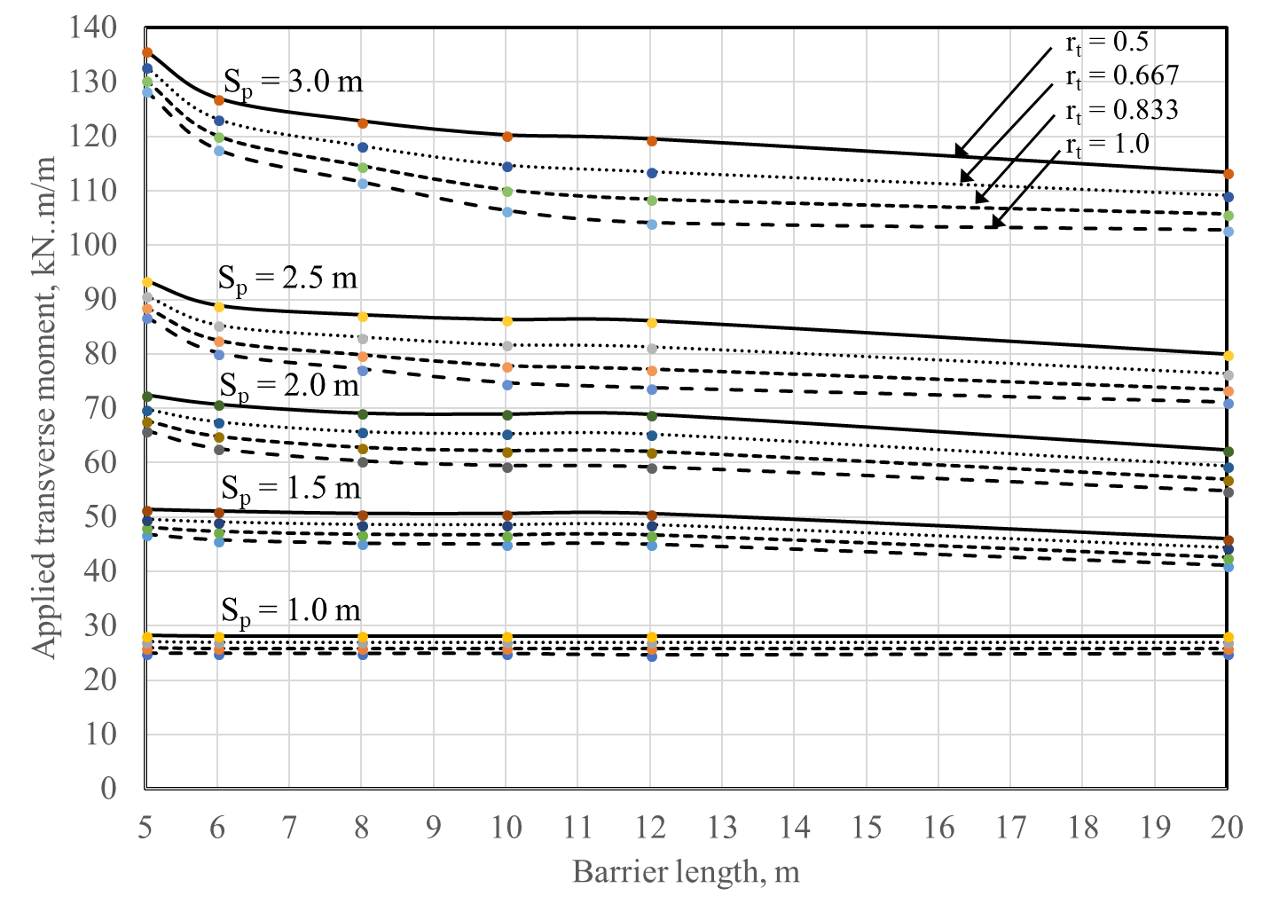

Figure 7: Applied transverse moment in middle portion of deck slab overhang with unstiffened edge due to unfactored CL-625 truck wheel loads including DLA

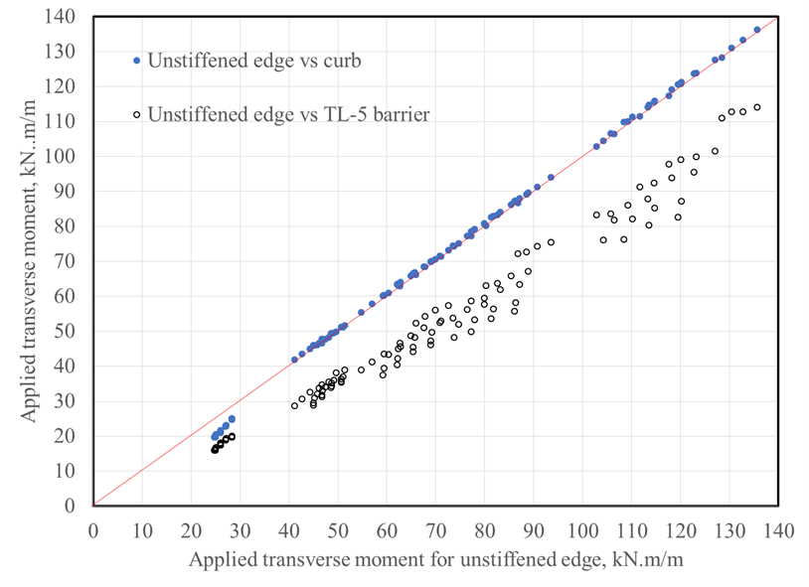

Figure 8: Comparison of applied transverse moments for deck slab overhang with unstiffened edge, curb and TL-5 New Jersey barrier

As it can be seen from the graph shown in Figure 8, the applied transverse moments of deck slab overhang with a curb (400x350 mm cross-section) are identical to those for unstiffened edge with cantilevers lengths 1.5, 2, 2.5 and 3 m; values for unstiffened edge are greater than those with a curb by no more than 2% in all studied geometries. However, for 1 m cantilever length, the applied transverse moments for deck slab overhang with a curb are 20%, 18%, 15% and 10%, less than those for deck slab overhang with unstiffened edge for rt = 1, 0.833, 0.667 and 1, respectively. These percentage reductions in moments are calculated as average value of all values for barrier lengths, 5, 6, 8, 10, 12, and 20 m. So, it conservative to consider the transverse moments in Table 5.15 which will be proposed for CHBDC 2019 for unstiffened edge to apply for overhang with a curb as well. The comparison between the calculated moment from the Table 5.15 of CHBDC 2014, and the charts shown in Figure 5.4 of CHBDC 2014 with obtained results from parametric study, demonstrated in Table 3. As it can be observed, the results using Table 5.15, and Charts in Figure 5.4 in CHBDC 2014 for cantilever length (Sp = 1 m) is overestimated since the equations used to develop the charts consider wheel load as concentrated load while the FEA modelling considers the wheel load distributed over 250x600 mm plan area which is a more exact method to simulate the axel load of CL-625 truck.

Table 3: Maximum cantilever moments, My, due to unfactored CL-625-ONT Truck wheel loads (ID included) at interior portion of cantilever deck, kN.m/m

|  |  |  |  |  |  |  |
| --- | --- | --- | --- | --- | --- | --- |
| Unstiffened edge | | | | | | |
|  | rt = 1 | | | rt = 0.5 | | |
| Sp, m | CHBDC 2014 | Using Chart in Figure 5.4, CHBDC 2014 version | Proposed  (Lb = 20 m) | CHBDC 2014 | Using Chart in Figure 5.4, CHBDC 2014 version | Proposed  (Lb = 20 m) |
| 1 | 41 | 40.73 | 25 | 44 | 44.78 | 28 |
| 1.5 | 43 | 47.01 | 41 | 51 | 52.90 | 46 |
| 2 | 53 | 60.35 | 55 | 60 | 69.12 | 62 |
| 2.5 | 60 | 80.86 | 71 | 70 | 90.98 | 80 |
| 3 | 92 | 87.43 | 103 | 107 | 99.70 | 113 |

# PROPOSED UPDATE TO CHBDC 2019

As per this study, a proposal submitted to update clause 5.7.1.3 of CHBDC, version 2019. The proposed table to the code committee is shown as Table 4. According this suggested update, to determine maximum transverse moment (My) in a cantilever concrete deck slab of constant or linearly varying thickness, the critical combination of CL-W wheel loads shall be considered. The intensity of unfactored transverse moment, including dynamic load allowance, shall be obtained from Table 3 (as shown here) for edge stiffened and unstiffened cantilever slab. Moreover, linear interpolation for this intensity shall be used for longitudinal length of the deck overhang falling between those specified in the proposed Table 5.15 of CHBDC 2014.

Table 4: Maximum cantilever moments, My, due to unfactored CL-625 Truck wheel loads (ID included)

|  |  |  |  |  |  |  |  |  |  |  |
| --- | --- | --- | --- | --- | --- | --- | --- | --- | --- | --- |
|  | **Unstiffened edge** | | | | | **Edge stiffened with New Jersey barrier** | | | | |
|  | **Maximum *My* , kN.m/m** | | | | | **Maximum *My* , kN.m/m** | | | | |
| **Sp, m** | **L, m** | ***rt* = 1.0** | ***rt* = 0.833** | ***rt* = 0.667** | ***rt* = 0.5** | **L, m** | ***rt* = 1.0** | ***rt* = 0.833** | ***rt* = 0.667** | ***rt* = 0.5** |
| 1.0 | All | 25 | 26 | 27 | 28 | All | 17 | 18 | 19 | 20 |
| 1.5 | 5 | 47 | 48 | 50 | 51 | 5 | 35 | 36 | 38 | 39 |
| 12 | 45 | 47 | 48 | 50 | 6 | 32 | 34 | 36 | 38 |
| ≥ 20 | 41 | 43 | 45 | 46 | ≥12 | 29 | 31 | 34 | 35 |
| 2.0 | 5 | 66 | 68 | 70 | 73 | 5 | 53 | 54 | 56 | 57 |
| 12 | 59 | 62 | 65 | 69 | 6 | 47 | 49 | 51 | 53 |
| ≥ 20 | 55 | 57 | 59 | 62 | ≥ 12 | 39 | 41 | 44 | 46 |
| 2.5 | 5 | 87 | 89 | 91 | 94 | 5 | 72 | 73 | 74 | 76 |
| 6 | 80 | 83 | 85 | 89 | 6 | 63 | 64 | 66 | 67 |
| 12 | 74 | 77 | 81 | 86 | 12 | 48 | 50 | 54 | 56 |
| ≥20 | 71 | 74 | 76 | 80 | ≥ 20 | 53 | 54 | 56 | 58 |
| 3.0 | 5 | 129 | 131 | 133 | 136 | 5 | 111 | 112 | 113 | 114 |
| 6 | 118 | 120 | 123 | 127 | 6 | 98 | 99 | 100 | 102 |
| 10 | 107 | 110 | 115 | 120 | 12 | 76 | 77 | 80 | 83 |
| ≥ 20 | 103 | 106 | 109 | 113 | ≥ 20 | 84 | 85 | 86 | 88 |

# CONCLUSIONS

Substantially, from this study the following fundamental results were deduced:

1. As it can be seen from sensitivity study, the dominant loading case to produce maximum transverse moment in cantilever slab depends on cantilever length and barrier length.
2. The applied transverse moments of deck slab overhang with a curb (400x350 mm cross-section) are very close to the results obtained from unstiffened edge. As a result, in the proposed table to CHBDC, the results for the unstiffened cantilever slab can be applied to the deck slab overhang with a curb cross section.
3. The results using Charts in Figure 5.4 in CHBDC for Sp = 1 is over exceeded by almost 40% from the results which obtained from finite element analysis. Since the equations used to develop the charts consider wheel load as concentrated load while the FEA modelling considers the wheel load distributed over 250x600 mm plan area.
4. Barrier lengths shown in Table 5.15 were selected based on the beginning and ending of each straight portion of each curve in the above figures, since the developed equations overestimate the moments with significant margins. So, the values in Table 5.15 are identical to those obtained from the computer modelling.

# References

Bakht, B., and Holland, D. 1976. A Manual Method for the Elastic Analysis of Wide Cantilever Slabs of Linearly Varying Thickness. *Canadian journal of civil engineering*, **3**(4): 523-530.

CSA. 2014a. *Canadian Highway Bridge Design Code,* CAN/CSA-S6-14. Canadian Standard Association, Toronto, Ontario, Canada.

CSA. 2014b. *Commentary on the Canadian Highway Bridge Design Code*, CAN/CSA-S6.1-14, Canadian Standard Association, Toronto, Ontario, Canada.

CSI. 2015. *SAP2000 software, Integrated Finite Element Analysis and Design of Structures, version 19.* Computer and Structure Inc., Berkeley, California, USA.

Dilger, W., Tadros, G., and Chebib, J. 1990. Bending Moments in Cantilever Slabs. *Developments in Short and Medium Span Bridges:*  *Engineering '90*, Canadian Society for Civil Engineering, Montreal, Canada, **90** (1): 265-276.

Mufti, A., Bakht, B., and Jaeger, L. 1993. Moments in Deck Slabs Due to Cantilever Loads. *Journal of structural engineering*, **119**(6): 1761-1777.

Pourmand, H. (2017). *Investigation of the transverse and longitudinal moments at the transverse free end of deck slab cantilevers subjected to CHBDC truck loading*. (MASc Thesis), Ryerson University, Canada