 | 10th International Conference on Short and Medium Span Bridges  Quebec City, Quebec, Canada,  July 31 – August 3, 2018 | 

BEHAVIOUR OF CONCRETE PRISMS REINFORCED BY VARIOUS TYPES OF GLASS FIBRE REINFORCED POLYMER (GFRP) BARS

Abdulsalam, Bahira^{1,7}, Farghaly, Ahmed², Gagné, Richard³, ElSafty Adel⁴ Parvez Alam⁵ and Benmokrane, Brahim⁶
¹ Founder CIISolutions Composite Infrastructure Innovation Solutions Corp, ON, Canada.
² Research Associate, Department of Civil Engineering, University of Sherbrooke, Canada
³ Professor, Department of Civil Engineering, University of Sherbrooke, Canada
⁴ Professor, School of Engineering, University of North Florida, USA
⁵ Senior Lecturer, School of Engineering, Institute for Materials and Processes, The University of Edinburgh, UK
⁶ Professor, Canada Research Chair in Advanced Composite Materials for Civil structures, NSERC Research Chair in Innovative FRP Reinforcement for Concrete Infrastructures, Dept. of Civil Eng., University of Sherbrooke, Sherbrooke, Quebec, Canada.
⁷ bahira.abdulsalam@compositeinfrastructure.com
Abstract: A percentage of North American bridges have been found to be structurally deficient. While the number of structurally deficient bridges is decreasing, the average age of American bridges continues to rise and many of the nation’s bridges are approaching the end of their design life. Fiber Reinforced Polymer (FRP) Bars are non-corrosive and currently used as reinforcement for Infrastructure applications. Public authorities in North America have now included FRP as a premium corrosion resistant reinforcing material in their corrosion protection policies. This paper is concerned with the tensile behavior of silica fume concrete tie members. Individual concrete ties were reinforced with a single glass fiber-reinforced plastic (GFRP) bar protruding through the tie axis. GFRP reinforcing bars with different surface properties, diameters, and mechanical properties were researched to determine the effects these parameters would have on the failure characteristics and mechanical properties of concrete ties. Sand-coated, grooved, and helically wrapped GFRP bars were used and were furthermore found to influence the load carrying capacity of the concrete ties, as well as their cracking-patterns. Optical microscopy was performed for specimens sawn through their cross-sections revealed delamination of resin-rich outer layer of the rebars, from the rebar cores. Internal delamination of the rebar is considered a bond failure mechanism that controls the post-cracking behavior of the concrete tie members. Test results indicated a consistant trend in all tested samples that indicates a slight reduction in the ultimate tensile strength of GFRP bars embedded in concrete prims.

Introduction
Glass Fiber Reinforced Polymer Bars (GFRP) rebars are classified as non-corrosive tensile reinforcement. GFRP bars are an attractive alternative for steel reinforcement due to several advantages ACI Committee 440 (2015). In addition to their non-corrosive characteristics, GFRP bars have a high strength to weight ratio. Singly reinforced concrete prisms can efficiently represent the tensile zone in concrete to a considerable extent. A limited effective tension area exists represents the area of concrete influenced by the presence of reinforcement (Vogel and Svecova 2008). The wide variation in the surface geometries and the mechanical characteristics of FRP bar adds to its complexity. The intact concrete between adjacent cracks can still carry tensile stresses after cracking occurs in reinforced concrete members. This phenomenon, known as tension stiffening is principally generated due to the bond between reinforcing bars and its surrounding concrete. The tensile test of singly reinforced axially loaded members indirectly investigates the bond. It should also be pointed out that most of the proposed bond models were derived from the pullout tests by using a single well-confined bar. However, such conditions substantially differ from the tension zones of RC bending elements as the nominal cover required in design codes may be insufficient to secure effective bond-confinement (Hong and Park 2012).
The axially loaded tension members investigate bonding at the mesoscale (FIB 2007). Wambeke and Shield (2006) report that the surface conditions of the bars; helical lug, spiral wrap, and sand coated do not influence the bond strength results for both splitting and pullout modes of bond failures. From this study it was found that the bar surface did not appear to affect the bond strength results nor did the presence of confining reinforcement. Several researchers tested the bond strength of FRP bars under monotonic loading and noted that the bond strength of the FRP bar appears to be influenced by the interlaminar shear strength just below the resin rich surface layer of the bar (Achillides and Pilakoutas 2004; Shima et al. 1993; Okelo and Yuan 2005; and Lee et al. 2007). It has generally been assumed that bonds develop radial stresses, proportional in magnitude to the bond stress. Furthermore, it is generally assumed that the radial pressures are uniformly distributed along the interface as hydraulic pressures. This assumption negates experimental evidence that bars of different rib geometries develop different bond strengths under otherwise identical conditions (FIB bulletin 2000). FRP rebars rely on adhesion and friction as bond stress transfer mechanisms. Contrarily, deformed steel rebars rely on a longitudinal and radial bearing between bar ridges and the concrete to transfer bond stresses (MacGregor, and Wight, 2005).
Most of available knowledge on bond strength of FRP bars is based on direct pull-out tests. In direct pull-out testing, the concrete specimen is only compressed and therefore does not hinge or crack. Unlike steel strength, unit strength of an FRP bar can vary with its diameter (ACI 440.1 2006). According to FIB (2007), FRP rebar becomes thinner at higher loads which is a natural phenomenon due to Poisson effect however it could be more pronounced in FRP compared to steel . Splitting cracks may develop in the concrete cover that reduces bond. FIB (2007) also suggests that the loss of bond in FRP bars results from the sudden loss of grip between FRP bars and concrete. Rebars with larger diameters have a more significant shear-lag effect. Therefore, a larger-diameter rebar has a lower average tensile strength. Triaxial loading was found to have an effect on the strength of unidirectional composites (Hine et al. 2005). It was also found that, with increasing bond pressure the longitudinal modulus increases slightly while the longitudinal strength decreases. Lisa and Shamim (2015) investigated the relative performance of GFRP bars with various surface profiles. They found that the surface profile of the tested GFRP bars is influencing the post-peak bond behavior of the bars. They explained the less-ductile post-peak responses in some of the tested bars with the shearing that occurred between the bar core and the sand coating. Considerable research in recent years has been conducted to investigate the FRP reinforcement for concrete structures. Multiple modes of bond failure have been explored through pullout tests. The internal degradation of FRP bars is one of the possible modes of bond failure. The effect of internal debonding of FRP bars on the axial strength and stiffness of the FRP bars has not yet been explored. This research provides important insights to the effects of bonding and surface topography on the tensile properties of concrete ties reinforced with GFRP bars.

Experimental Program
The experimental program consisted of two parts; (1) the testing of bare rebars under tensile loading and and (2) the testing concrete prims reinforced with single GFRP rebars under tensile loading. All prisms were singly reinforced with a single GFRP bar protruding through the prism axis and extending through the concrete. GFRP bars were used to reinforce the concrete prism. The following explains the details of the test program.

Bare Bar Tests
Here SC refers to sand coated, HR helically wrapped, and GR for grooved bars, while the digit refers to the bar size, all bars used are (#5) with nominal diameter of 15.9 mm. The sand coated bars (SC) had sand particles bonded to the bar surface. While, the helically wrapped bars (HR) were tightly wrapped with a helical fiber strand to create indentations along the bar with sand particles bonded to the surface. Grooved bars (GR) had small grooves on the bar surface to act as ribs. The FRP rebars were tested in tension using the standard test method specified by the ACI 440 3R (2004). The three types of GFRP rebars are shown in Fig 1. The mechanical properties of the bars provided by the manufacturer are shown in Table 1. The test matrix of bare rebars was classified into three groups: SC5, HR5, GR5 as shown in Table 2.
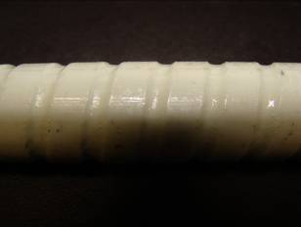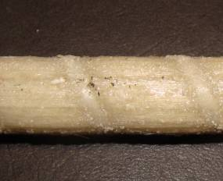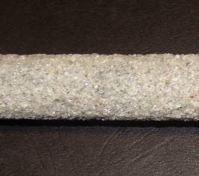
Figure 1: GFRP Rebars from left to right grooved GR, helically wrapped HR and Sand Coated SC
Table 1: Mechanical Properties of GFRP bars by the Manufacturer
Bar Type* | Bar Size | Nominal Diameter  (mm) | Cross Sectional Area (mm²) | Tensile Strength (MPa) | Modulus of Elasticity (GPa)
Sand Coated (SC) | #5 | 15.9 | 217 | 683 | 48.20
Helically Wrapped (HR) | #5 | 15.9 | 224 | 655 | 40.80
Grooved Bar (GR) | #5 | 15.9 | 201 | 1000 | 60.00
Table 2: FRP Rebar Specimen Identification
Serial | Specimen ID | Surface Texture | Bar Size | Nominal Diameter (mm) | Bar Area (mm²)
1-5 | HR5-1-5 | SC | #5 | 15.9 | 217
6-10 | SC5-1-5 | HR | #5 | 15.9 | 224
11-15 | GR5-1-5 | GR | #5 | 15.9 | 201
SC refers to Sand Coated bars, HR to helically wrapped and GR are grooved bars, no 1,2,3,4,5 represent the number of specimen for each type of bars tested.

Concrete Prism Tests
Nine singly-reinforced concrete prisms were constructed using silica fume concrete mixed onsite. All prisms were centrally reinforced with single GFRP rebars protruding through the prism axis. GFRP rebars used to reinforce the concrete prism are identical to the bars described in the previous section (Table 1), and that is for the comparative evaluation of the tensile behavior.

Concrete material properties
Silica-fume concrete was used for casting the concrete prism specimens of a targeted 28-day concrete compressive strength of 45 MPa. Concrete was made with 0.45 water-cement (w/c) ratio and type GUB-SF cement. 20 mm maximum size aggregate (MSA) was used. Polynaphthalene based superplasticizer (SP) and a synthetic detergent-based air-entertaining agent (AEA) were used.

Details of the prism specimens
Table 3 includes the details of the concrete prism test specimens. The prisms had identical length of 1300 mm with identical cross section (100×100). The test parameters included different surface textures of the bars such as sand coated (SC), helically wrapped (HR), and grooved (GR) bars. The test parameters also included reinforcement ratios (Rft Ratio) ranging between 2.01 and 2.24%. The specimens were divided into three different series GSC5, GHR5, GGR5. Each series was composed of three specimens each of 100 x100 mm cross section. The series GSC5, GHR5, GGR5, consisted of three identical specimens as listed in Table 3. The specimens SC5C, HR5C, and GR5C were not instrumented with strain gages to eliminate strain-gage placement effects on the specimen behavior.
Table 3: Details of Test Specimens
Serial No | Specimen ID | Specimen ID | Bar | Rft Ratio | Bar Area (mm²)
1 | GSC5 | SC5A | SC | 2.24 | 197.9
2 |  | SC5B | SC | 2.24 | 197.9
3 |  | SC5C | SC | 2.24 | 197.9
4 | GHR5 | HR5A | HR | 2.17 | 217.9
5 |  | HR5B | HR | 2.17 | 217.9
6 |  | HR5C | HR | 2.17 | 217.9
7 | GGR5 | GR5A | GR | 2.01 | 201.9
8 |  | GR5B | GR | 2.01 | 201.9
9 |  | GR5C | GR | 2.01 | 201.9
Nominal diameter is #5 for all tested samples, and concrete area is 100x100cm

Specimen preparation, concrete casting and instrumentation
Concrete prisms were cast in one batch with no pre-induced cracks. Specimens were cured at 100% relative humidity and 20ºC by storing them inside a fog curing room up until the age of testing to minimize the effects of concrete shrinkage. Before placing the test specimens in the mechanical testing machine, an anchorage system of steel tubes was installed at the bar ends for all test specimens. The anchorage system consisted of a steel tube filled with an expansive cementations grout (water to powder ratio of 0.35) used to provide confinement pressure on the GFRP bar ends. The length, thickness, and specifications of the used steel tubes were based on ACI 440 3R (2004) for proper restraint. Figure 2 shows the preparation of test specimens.
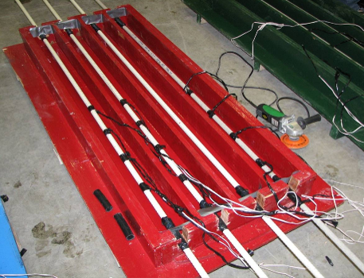
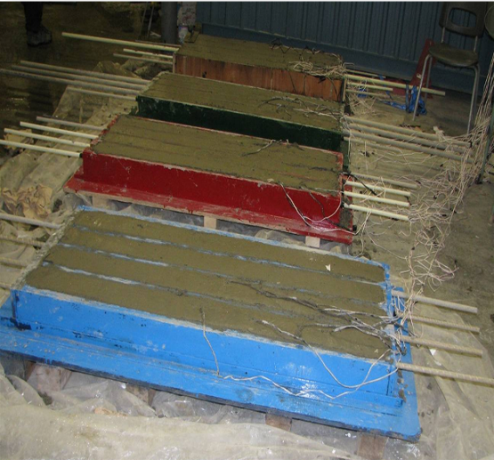
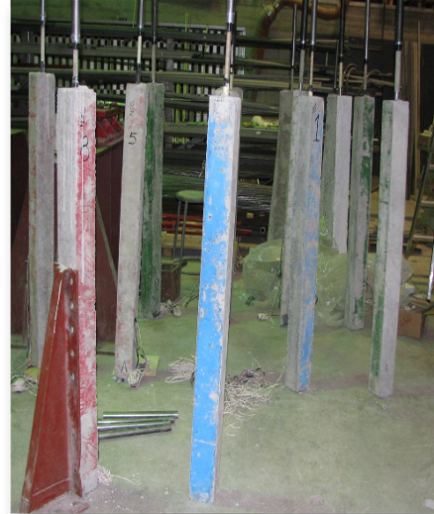

Figure 2: Preparation of Test Specimens
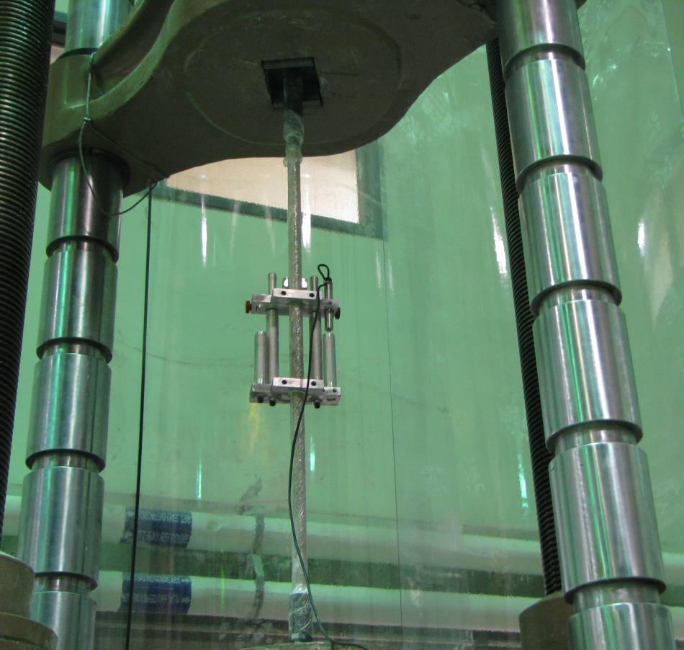
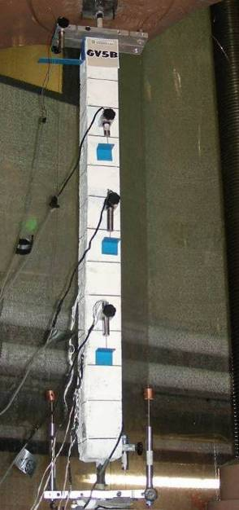
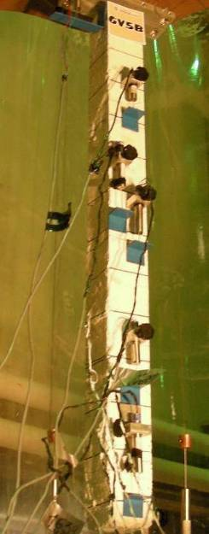
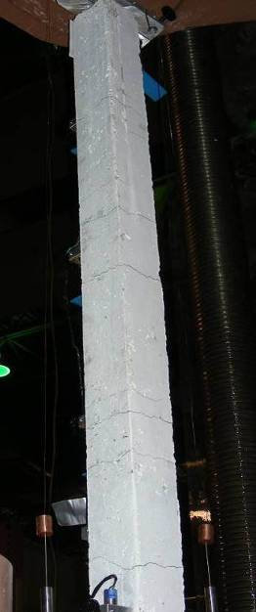

Figure 3: Test Specimens and Test Setup Before, During and After failure
Before concrete casting each rebar was instrumented using four strain gages equally spaced and attached to the rebar surface. When the specimens were setup for testing, two linear variable differential transformer (LVDT) displacement transducers were attached to steel wires and affixed to the top of the specimen. By doing this the elongation from both sides could be measured and from which the average value could be calculated, as shown in Figure 3.

Test Setup and Procedure of Concrete Prisms
The tensile strain developed in the reinforcing rebar, crack development total specimen elongation and the load were monitored. Fig. 3 shows the test setup of the concrete prism specimen at stages before, during, and after testing. The bare rebar tests were performed to capture the experimental mechanical propertied for the GFRP rebars. The specimens were vertically installed in a universal testing machine and tensile loads were applied under load control at a rate of 0.1 kN/sec until failure. Loading was stopped on the appearance of cracks for initial readings and for the installation of measurement devices. After the crack stabilization stage, the specimens were loaded continuously up to 75% of the ultimate load carrying capacity. The loading was stopped to allow the detachment of the LVDT displacement transducers, after which the loading was resumed until complete failure of the specimen.

Experimental Test Results

Test Results of Rebars under Tensile Loading
All types of GFRP rebars tested failed by tensile rupture of the rebar. Linear stress-strain relationships of all types and specimens were monitored up to failure. Splitting of the fibres was the controlling failure mode of all types of the GFRP rebars tested. Figure 4 shows the three types of GFRP rebars after testing. Table 4 provides information about the tensile capacity, ultimate tensile strength, modulus of elasticity of the test specimens.
Table 4: Test Results Tensile Properties of FRP bars
Group ID | Statistical measure | Tensile Capacity  (kN) | Ultimate Tensile  Strength (MPa) | Ultimate Strain  (Microstrain) | Modulus of Elasticity (GPa)
GHR#5 | Average | 149 | 744 | 17712 | 40.60
 | STDV | 5.90 | 29.5 | 1482 | 1.14
 | COV% | 0.040 | 0.04 | 0.08 | 0.03
GSC#5 | Average | 146.10 | 737 | 15293 | 48.00
 | STDV | 5.98 | 30 | 640 | 0.72
 | COV% | 0.04 | 0.04 | 0.04 | 0.01
GGR#5 | Average | 251 | 1247 | 20454 | 60.00
 | STDV | 8.80 | 43.9 | 921 | 1.10
 | COV% | 3.50 | 3.5 | 4.5 | 1.90
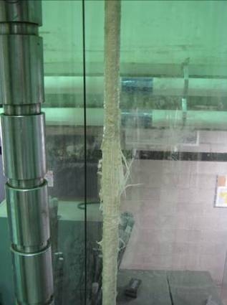
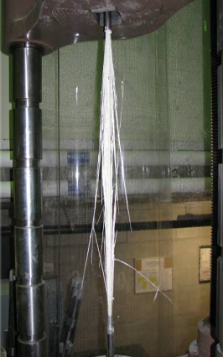

Figure 4: GFRP bars after failure

Test Results of Concrete Prisms

Failure modes and ultimate capacities
The expected failure mode of GFRP reinforced specimens was generally brittle and explosive as expected due to the brittle nature of both FRP rebars and concrete. From our observations the failure of the specimen was initiated by concrete cracking followed by the progressive debonding of the rebar from the concrete followed by the progressive FRP delamination or shearing off and finally by tensile rupture of FRP rebars. Figure 5 shows failure modes in three samples Splitting appeared very clearly in specimens reinforced with GR rebars. SC5A rupture location was just above the steel anchor, while in HR5A the rebar ruptured at approximately mid height of the prism, GR5A no rupture was observed in the bar. The ultimate capacity of the prisms is presented in Table 4. Ultimate capacity was148 kN for GSC5 and SC5C was127 kN. SC5B ultimate strength could not be recorded due to technical problem. The three prisms of series GHR5 failed at 122, 133 and 127 kN. That showed a decrease in the average ultimate capacity compared with series GSC5 due to the different of bar type. Specimens of series GGR5 failed at 232, 228 and 230 kN. Test results revealed that each group of repeated specimens gave very close ultimate tensile capacities. Specimens reinforced with HR bars with lightly sand coated and helically wrapped had R_{avr} of 0.84. In series GSC5 with sand coated bars and reinforcement ratio of 2.24%, the R_{avr} was 0.94. While, in GHR5 with a nearly similar reinforcement ratio of 2.17 % but helically wrapped bars, the R_{avr} was 0.89 with around 5% reduction comparing to series GSC5 indicating an influence of the surface texture on the R value. Similarly, the reduced reinforcement ratio (comparing GGR5 to GHR5) resulted in 0.8% increase in R_{avr}. The effect of the surface texture of the FRP bar on reducing in its tensile strength when placed in concrete was pronounced and confirmed. This is considered one of the factors contributing to the knockdown effect of the tensile capacity of FRP bars. More detailed investigations are needed to verify this comparison at various stages of loading using different concrete types.
Table 5: Ultimate Capacities of Test Specimens
Group* | ID | P_{ubar} (MPa) |  | P_{uprism} (MPa) | $ρ_{f}$% | R=P_{uprism}/P_{ubar}
GSC5 | SC5A | 146 |  | 148 | 2.24 | 1.01
 | SC5B | 146 |  | NR | 2.24 | NR
 | SC5C | 146 |  | 127 | 2.24 | 0.87
 | HR5A | 150 |  | 122 | 2.17 | 0.81
 | HR5B | 150 |  | 133 | 2.17 | 0.87
 | HR5C | 150 |  | 127 | 2.17 | 0.84
 | GR5A | 250 |  | 232 | 2.01 | 0.92
 | GR5B | 250 |  | 228 | 2.01 | 0.91
 | GR5C | 250 | 230 |  | 2.01 | 0.92
*P_{uprism} is the ultimate load for the concrete prism, P_{ubar} is the ultimate strength of the bare bar (unbonded), R is Pup/Pub while R_{avr} = Average R for each series.
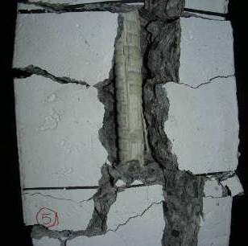
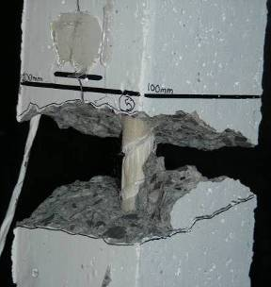
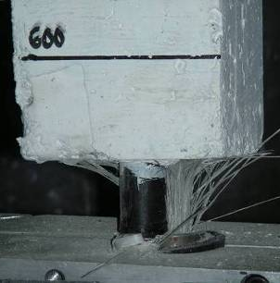

(c) GR5A
(b) HR5A
(a) SC5A

Figure 5: Failure Modes of GFRP Reinforced Concrete Ties SC5A, HR5A and GR5A

Stress Strain behaviour
The typical stress strain curve for the tie members ((σ−ε) shows three distinctive regions pre-cracking stage, cracking development stage and post cracking stage. Figure 6 a. shows ((σ−ε) curve for CO specimen compared to the bare rebar. Figure 6 b shows the stress average strain relationships of the three bar types showing GCo having higher stiffness compared to GA and GV. The typical stress-strain behavior of the tie members (σ−ε) shows three distinctive regions. The first region was pre-cracking behavior with mostly composite action. The second one was crack development stage with large reduction in stress gradient of the concrete prism. The third region was post cracking stage with loss of bond between FRP bars and concrete. The mean reinforcement strain for test specimens measured by strain gages was compared to that taken from the LVDT measurements. It was found that both curves followed the same trend. The strains indicated for the specimens represent the mean strains as recorded by strain gages. A negative tension stiffening effect was observed in all specimens at the post cracking stage. This behavior was not only observed for the average measure strain also for all the strains measured at three different locations of the test specimen as well as for the calculated composite strain in all tested specimens. Figure 6 shows the experimental stress strain relationships for the three strain gages installed on the specimen GCO5B which shows nearly identical behaviours at all the points of strain measurements along the prism. Mid is the middle point, E is the edge point and m is a point at ¼ of the height of the prism. The bare bar average stress strain curve of Co series 1 specimens was found to be linear till failure it was plotted against the stress strain relationships of the tested specimen and there was a reduction in the stress level starting at around 150 MPa. Typical behaviour of the test samples was also clear one of the specimens at Frrgani et al 2018 however the behaviour was not discussed. In this work a clear explanation of why the strength of the prism specimen falls under the strength of the bare bar. Reasons of this reduction are discussed through the optical microscopy and the discussion in the following sections. Figure 7 shows the stress average strain relationship for the three types of specimens are plotted and the figure shows similar behaviour of the three types of bars however the specimens reinforced with the grooved bars had slightly higher stiffness which is referred to the rebar higher modulus of elasticity.
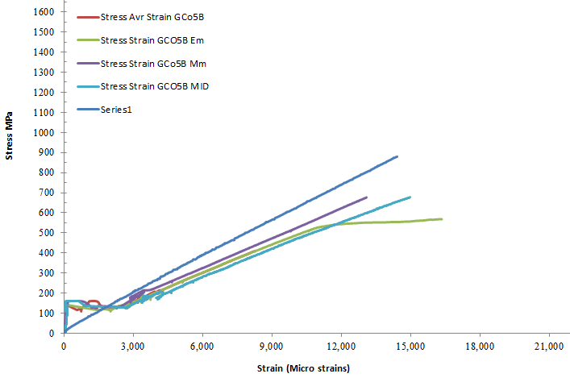

Figure 6: Stress average Strain Relationships of GCO 5B and Co

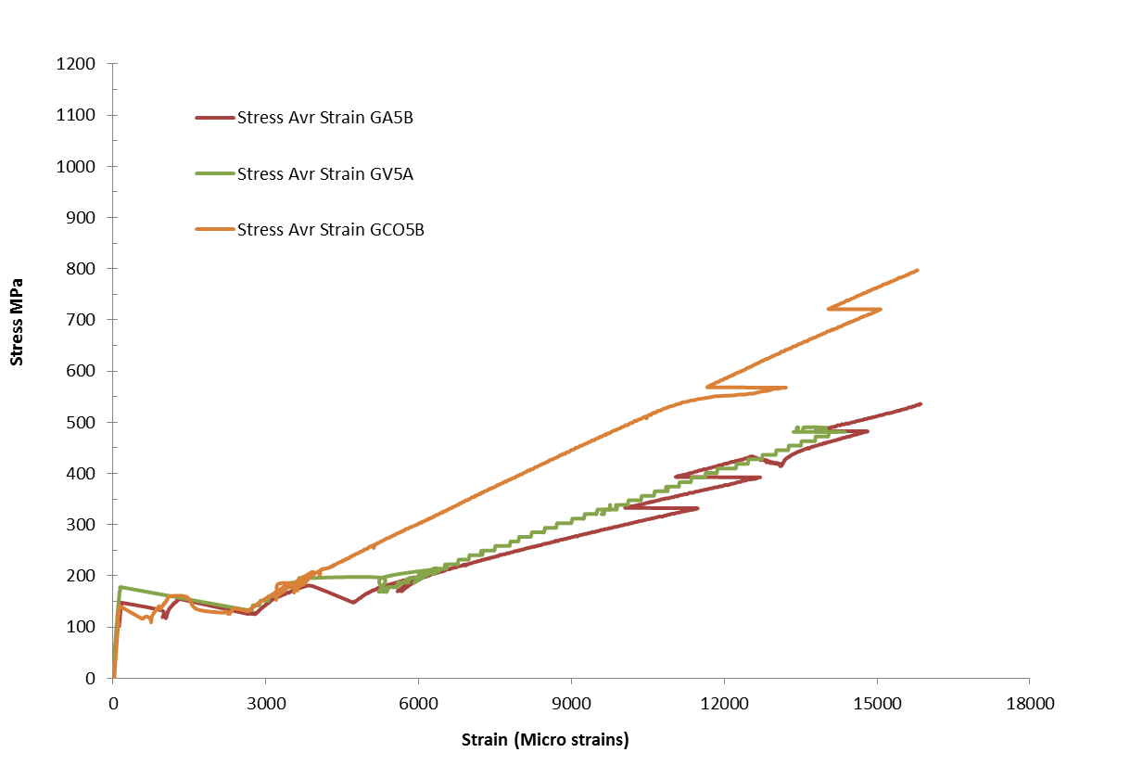

Figure 7: Stress average Strain Relationships of GA5, GV5 and Co5

Optical microscopy
Optical microscopy was used to get a closer look into the concrete bar interface on the transverse and longitudinal sections of specimens. To investigate the final internal cracking pattern and the final FRP bar failure pattern, transverse and longitudinal cross section of selected parts of the specimens was cut using a concrete saw into two separate parts along the bar axis and scanned using optical microscopy. Figure 8 shows longitudinal sections of sand coated bars after failure indicating clearly the intimate contact between the bar and the surrounding concrete. Fig. 8 shows FRP internal delamination in the FRP bar. The same phenomenon was noted in helically wrapped GFRP bars a crack in the internal structure of the helically wrapped FRP bar. This confirms an internal separation due to shear lag in the FRP bar. The grooved bar type also indicates the same phenomena after failure. The results agree with Ahmed et al (2011) in their study they performed tensile tests and studied the bond between carbon fibre-reinforced polymer (CFRP) bars and ultra-high-performance fibre reinforced concrete, a post-test examination revealed that damage occurred only in the outer layers of the CFRP bars. It shows clearly the difference in the internal structure of the FRP bar between the rod core and the outer layer and surrounding part of the bar. This behavior is somehow similar to that of the sand coated bar. This can be explained by the high resistance of FRP-concrete interface provided by bond of the outer layer and the weaker internal shear resistance of the bar. Further research is required for the delamination detection and about capturing the onset of cracking within the FRP bar that were out of scope of the current experimental program.
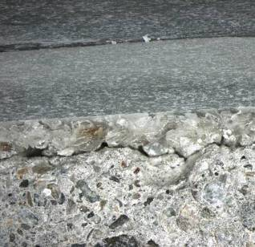
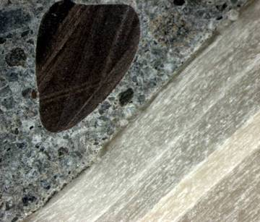
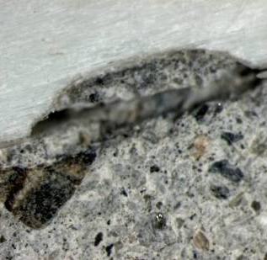

Figure 8: Optical Microscopy of FRP bars after failure
- Discussion
Large differences in stiffness between the cracked and un-cracked section resulted in substantial variation in stress in the reinforcement from the cracked to the un-cracked section. The need for attentiveness in design relating to surface shear stresses advised through FIB (2006) is confirmed through these tests. This study shows that the tensile rupture of FRP reinforcement depends not only on its type, but also on its bond characteristics. The failure behavior of composite materials is often a combination of multiple different mechanisms. Interlaminar failure such as fiber debonding and matrix cracking can give rise to delamination and vice versa. Zeng et al. (1997) showed that shear yielding or debonding of the interface between fibers and matrix can cause a reduction of the stress concentrations induced by failure of the fibers, matrix and interface. This in turn may directly affect the tensile strength of unidirectional composites. Force transfer from the concrete to the bar occurs through the bonded surface as shear stresses. When an FRP bar is pulled in tension, its surface fibers become more stressed than its core fibres. This causes a differential movement between the core and the surface fibres resulting in non-uniform normal stress distributions across the bar cross section, being maximum around the edge and minimum at the core. Specifying the location of failure has been controversial for researchers in identifying the most appropriate failure criterion for composites. Based on their observations of specimen failure in tension with different orientations of the fibers, Paris et al. (2001) concluded that there are only two mechanisms of fiber or matrix failure. With respect to matrix failure, they do not distinguish whether failure is at the interface or inside the matrix, and they have thus proposed that both contribute to the appearance of failure. Surface shear stresses represent an additional stress component on the external fibers, which contributes to over stressing of the external fibers of the bonded FRP bar. The additional stress component acting in the radial direction on the FRP bar increases in the maximum bond zones. As a result, the bar was exposed to squeezing and matrix failure may occur resulting in internal separation within the FRP bar. This results in weakening of the interface that in some cases appears as a complete separation between bar’s fibers (internal debonding). It was found that the higher the roughness of FRP bars embedded in concrete, the lower its achieved tensile strength. Similar test observations were reported by Vallée et al. (2010) who investigated pultruded FRP, with E-glass ﬁbers embedded in an isophthalic polyester resin. All investigated adhesively bonded joints, featuring FRP adherents, failed in a brittle manner, independently of whether they involved brittle or ductile adhesives. The FRP joints almost always failed by splitting just below the end of the overlap, corresponding to the resin richer layer between the ﬂeece and the roving. Similar conclusions were found by Lee et al. (2007) while investigating the interfacial bond strength of glass-fiber reinforced polymer (GFRP) bars in high-strength concrete cubes. A reduction factor for the ultimate tensile strength of GFRP bars is suggested to account for the bond effect on the FRP bars. A suggested empirical R factor of 0.9 was determined through the average values through this experimental program.
- Conclusions
This research investigated the tensile behaviour of concrete tension members reinforced with FRP bars, the effect of bond on tension stiffening, and the mechanical properties of GFRP bars used in nice axial concrete tension members. Comparing the observed modes of failure for sand coated and grooved bars indicates that the lower circumferential bond on the FRP bar concrete interface for ribbed bars resulted in higher splitting cracks and the lower reduction in the axial strength at failure with respect to sand coated bars. The mode of FRP concrete bond failure has a significant influence on the tension stiffening effect. The tensile rupture of FRP reinforcement depends not only on its mechanical characteristics, but also on its bond characteristics. The surface texture of the FRP bar plays an important role in the bond failure mode of the FRP reinforced specimen. Rebar squeezing, shear lag, and internal delamination in GFRP bars are important phenomena to investigate their effect on the tensile behavior of bonded FRP bars. The use of silica fume concrete enhances the FRP/concrete bond. It should be noted the scope of this research included one concrete type/strength and only glass FRP bars. Further research is needed to investigate the bar behavior and effect of different concrete types and grades and other FRP bar types.
Acknowledgments
The authors would like to express their special thanks and gratitude to the Natural Science and Engineering Research Council of Canada (NSERC), and the technical staff of the structural lab in the Department of Civil Engineering at the University of Sherbrooke.
References
ACI Committee 440 (2015). “Guide for the design and construction of concrete reinforced with FRP Bars (ACI 440.1R-15)” ACI, Farmington Hills, MI, 83 pp.
Ahmad F. Foret G. and Le Roy R., 2011. Bond between Fiber Reinforced Polymer Bars CFRP bars and Ultra High Performance Fiber Reinforced Concrete. 25(2), 479-485.
Achillides Z., and Pilakoutas, K., 2004. Bond Behavior of Fiber Reinforced Polymer Bars under Direct Pullout Conditions, Journal of Composites for Construction. 8, 173 (2004); (9 pages), 8(2).
Batdrof, S., B., 1982. Tensile Strength of Uni-directionally Reinforced Composites Reinforced Plastic Composite. Journal of Reinforced Plastics and Composites 1(2): 153-164.
Fédération Internationale du Béton, FIB 2007. FRP reinforcement in RC structures. Task Group 9.3, Lausanne, Switzerland., pp 160.
Fergani, H., Di Benedetti, M., Oller, C.M., Lynsdale, C., Guadagnini, M., Long-Term Performance of GFRP Bars in Concrete Elements Under Sustained Load and Environmental Actions, Composite Structures (2018), doi: https://doi.org/10.1016/j.compstruct.2018.02.002
Hong, S., and Park, S. K. 2012. Uniaxial Bond Stress-Slip Relationship of Reinforcing Bars In Concrete. Advances in Materials Science and Engineering, 2012(2012), pp12.
Okelo R., and Yuan R. L., 2005, Bond Strength of Fiber Reinforced Polymer Rebars in Normal Strength Concrete. Journal of Composites for Construction. 9 (3): 203–213.
Paris F., 2001. A Study of Failure Criteria of Fibrous Composite Materials. National Aeronautics and Space Administration NASA/CR- 2001-21066
Shima,H., Suga, T, and Honma, M. 1993. Local Bond Stress-Slip Relationship of Continuous Fibre Reinforcing Materials Obtained By Pull Bond Test With Long Embedment. Trans. Japan Concr. Inst., 15, 297–304.
Valee, T., 2010. Influence of Stress-Reduction Methods on The Strength of Adhesively Bonded Joints Composed of Orthotropic Brittle Adherends. International Journal of Adhesion and Adhesives 30(7): 583–594.
Vogel, H., And Svecova, D., 2008. New Approach for Estimating the Deflection of Beams Reinforced With FRP Reinforcement. Journal of Composites for Construction ASCE,12(6):579-587.
Lisa Vint, L., and S., Shamim 2015. Investigation of Bond Properties of Alternate Anchorage Schemes for Glass Fiber-Reinforced Polymer Bars. Structural Journal, 112(1)
Wambeke, Brad W and Shield, Carol K 2006, Development Length of Glass Fiber-Reinforced Polymer Bars in Concrete. ACI Structural Journal 103(1): 11-17.
Zeng, Q. D., Wang, Z. L. & Ling, L., 1997. Study of the Influence of Interfacial Damage on Stress Concentrations In Unidirectional Composites. Composites Science and Technology, 57(1).

