 | 10th International Conference on Short and Medium Span Bridges  Quebec City, Quebec, Canada,  July 31 – August 3, 2018 | 

Investigation of Structural Behavior and Health Monitoring Plans for a Double Track Steel Truss Railway BRIDGE
Rageh, Ahmed^{1, 2}, Eftekhar Azam, Saeed¹ and Linzell, Daniel G.¹
¹ University of Nebraska-Lincoln, USA
² a.eissa.rageh@huskers.unl.edu
Abstract: Current practice to evaluate bridge health and integrity in the U.S. is primarily based on subjective, visual inspection at a prescribed frequency, which can vary from six months to two years. These inspections provide qualitative insight on bridge health. Subsequent quantitative assessments of resulting structural integrity may be necessary to better ascertain current condition. Sensor, computing and signal processing advancements provide opportunities to develop autonomous, robust, continuous Structural Health Monitoring (SHM) systems. Most modern monitoring schemes center on extracting dynamic model parameters and updating those parameters using measurements to detect, localize, and quantify damage. Preliminary results from a project focusing on developing and refining a health monitoring schema based on strain measurements from a double track steel truss railway bridge are summarized.
- INTRODUCTION
Even though railroads have been part of worldwide transportation networks for over 150 years, they are still an integral part of modern society. Bridges are a key component of any rail system and, if removed, cause disruptions that could affect safety and will effect system efficiency and increase cost. In the United States many of these bridges are steel trusses or plate girders constructed in the 19th and early 20th centuries. During this period rivets and use of eyebars and connecting pins were common construction practices (DelGrego et al., 2008, Imam et al., 2004). Many of these bridges are still in use and, akin to highway bridges in the U.S, are subjected to increased railway traffic, load and speed. Visual inspection at prescribed intervals is still the primary practice to evaluate the integrity of these bridges (AREMA, 2015, Edward & Băncilă, 2012, Roach et al., 2012). Visual inspection is costly, heavily dependent on human interpretation and does not guarantee bridge safety between consecutive inspection events.
The work presented here summarizes initial steps and findings associated with a larger effort focused on developing a cost-effective, optimized, robust, health monitoring system that takes advantage of repeatable patterns found on most, if not all, steel railway bridges. The intention of this work is to develop a system that can be broadly utilized on a network of bridges. Research encompassed: (i) sensitivity analyses focused on identifying change in bridge member response due to varying deficiency levels; (ii) field testing to estimate bridge response under actual loading configurations; (iii) model calibration; and (iv) proposing SHM instrumentation plans based on the sensitivity analyses.

BACKGROUND
Developing cost-effective, bridge SHMs requires thorough understanding of original design and construction, history and, especially, current condition and behavior. Understanding the behavior of “healthy,” riveted, steel bridges and variations of structural response caused by fatigue and other damage are crucial initial steps when SHMs for these types of structures are developed. A brief summary of relevant literature summarizing bridge condition evaluation protocols and studies and SHM of steel bridges along with studies focused on behavior and common deficiencies associated with riveted members and connections is provided below.
As bridges age, the number of potential defects naturally increases. For steel railway bridges, these defects can include corrosion, subsequent connection degradation and fatigue (Chotickai & Kanchanalai, 2010). Assessing bridge condition is commonly accomplished via visual inspection at a prescribed frequency, an approach that is costly, unsafe and subject to human interpretation. In one study, Phares (Phares et al., 2001) examined visual inspection reliability and accuracy by studying how the condition of a set of steel bridges was evaluated (“rated”) via visual inspection using experienced inspectors. The study indicated that less than 8% of the inspectors reported important, localized defects and they tended to avoid assigning “low” or “high” (i.e. bad or good) rating scores.
A number of SHM studies were completed looking at various challenges specific to riveted, steel bridges. Those studies utilized wireless monitoring systems and demonstrated that those systems could provide accurate data that could be useful for fatigue assessment (Bischoff et al., 2009). To help organize and prioritize SHM for railway bridge research needs, Moreu and LaFave (Moreu et al., 2012, Moreu & LaFaye, 2011) completed a survey of railway bridge engineering experts that highlighted the need to standardize SHM systems based on bridge type.
To establish an effective SHM system, optimal sensor placement is needed to identify and assess damage. Several studies were completed that helped establish sensor placement schemes on various type of structural systems via finite element analyses to help optimize location, maximize data value and, ultimately, minimize sensor numbers. Those studies involved different algorithms and optimization functions to determine optimized placement schemes sufficient to characterize dynamic properties. Examples included SHM of a tower (Papadimitriou, 2004), the Nottingham suspension bridge (Meo & Zumpano, 2005), a single, twelve-bay truss (Liu et al., 2008) and the Guangzhou New TV Tower (Yi et al., 2011).
A detailed understanding of the structural behavior is necessary when developing a SHM. To examine integrity and verify capacity under actual loading configurations, one study filed tested a single track, through, riveted truss railway bridge (RTB) using a special train (Tobias et al., 1993). The research found that a 3D finite element model with all members rigidly connected produced stresses that matched field results well and, as a result, stringers were subjected to considerable end moments. Al-Emrani (Al-Emrani et al., 2004) also examined a deck RTB to estimate overlooked secondary effects caused by interaction between various components. Results showed that secondary internal forces, including axial forces in stringers and lateral bending in floor beams, developed in the flooring system.
Multiple investigators state that, for RTBs, a common fatigue prone detail is the stringer-to-floor beam connections. These connections are commonly more rigid than originally designed and, as a result, subjected to unplanned bending moments (Al-Emrani et al., 2004, Al-Emrani, 2005, Chotickai & Kanchanalai, 2010, Haghani et al., 2012, Imam et al., 2004, Imam et al., 2005, Spyrakos et al., 2004, Tobias et al., 1993).

STUDIED BRIDGE AND NUMERICAL MODEL
A simply-supported truss span of a double track, RTB was selected as a testbed for analysis and subsequent development of optimized SHM plans. The selected bridge span has 6 panels and is composed of two main trusses spaced at 9.30 m and having a depth and span of 9.75 and 44.7m, respectively. Truss members are either built-up riveted sections or eyebars. Transverse floor beams and stringers are built-up, riveted I-sections, with the floor beams spaced at 7.45 m o/c. Single angles make up the floor system lateral bracing. Geometry of the examined span is shown in Figure 1. A 3D model consisting of frame elements was developed in SAP 2000 (Schueller, 2008). The model contained the two trusses, stringers, floor beams, floor system lateral bracing and truss struts. Stringers and floor beams were modelled as being rigidly connected. An isometric view of the model is shown in Figure 2.
Proposed initial model results under uniform loading configurations showed that: (i) truss flooring system members may experience high axial forces, forces not addressed when the truss was designed an constructed; (ii) double track trusses exterior stringers, adjacent to the truss bottom chords, could experience high axial tensile while interior stringers experience low axial compressive forces; and (iii) floor beams may experience appreciable lateral bending moment at exterior stringer intersections.
Figure 1: Investigated truss geometry
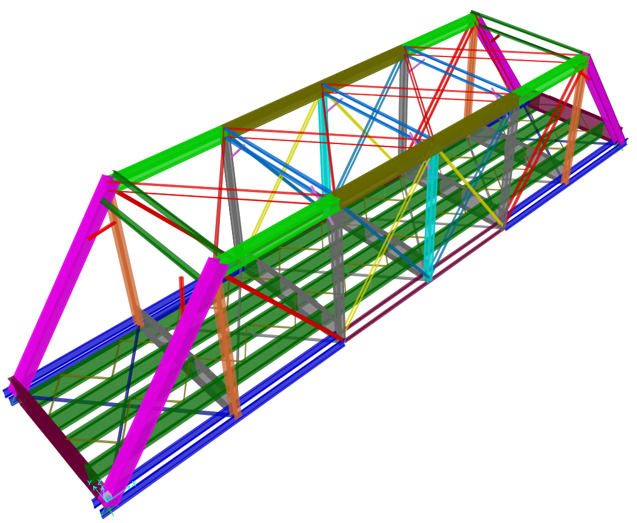
Figure 2: Model isometric view

SENSITIVITY ANALYSES
The model was first calibrated via comparisons to results from earlier field tests (Tobias et al., 1993). Once calibrated, sensitivity analyses were performed that mimicked various levels of commonly reported deficiencies for bridges of this type (Al-Emrani et al., 2004, Al-Emrani, 2005, Chotickai & Kanchanalai, 2010, Haghani et al., 2012, Imam et al., 2004, Imam et al., 2005, Spyrakos et al., 2004, Tobias et al., 1993). Deficiencies that were mimicked in the models included: (i) cracks or missing rivets in stringer-to-floor beam clip angle connections; (ii) disconnected stringer laterals; (iii) disconnected bottom laterals; (iv) loose eyebars; and (v) frozen roller supports. Information from these analyses ultimately provided valuable guidance when preliminary SHM instrumentation plans were developed and optimized. The sensitivity study was completed assuming one track was loaded, arbitrarily selected to be Track 1 in Figure 1. Live loads consisted of a routine train loading configuration obtained from weigh in motion (WIM) systems in close proximity to the actual bridge. Trains that were selected had the highest axles loads from the WIM data set. The two leading locomotives and first 8 cars in this train were included in the model.
Twenty analyses were completed with one deficiency simulated for each analysis so that change in structural response as a function of degradation could be quantified. Modeled deficiencies and their locations were (see Figure 3): (i) stringer end in- and out-of-plane moment resistance; (ii) removal of stringer and lower lateral bracing members; (iii) 50% reduction in eyebar cross-sectional area; and (v) partially restrained roller supports. For each of the 20 model runs, internal forces at 36 different locations and displacements at the truss midspan were examined. Those locations were selected because they were in close proximity to simulated deficiencies where maximum changes in response were anticipated. They were termed “instrumented” locations and are shown in Figure 4.
Figure 3: Simulated deficiency locations
Examinations were accomplished by studying the change in stress at each “instrument” location caused by a simulated deficiency. Stress time histories at each location were plotted for deficient and healthy conditions to establish the influence of each simulated deficiency on structural response. Healthy and deficient stress time histories were compared to determine appropriate “instrument” locations that would optimally provide beneficial information on bridge health.

Figure 4: Instrumented locations

FIELD TESTING AND MODEL CALIBRATION
Two field testing events, each involving multiple train passes, were completed to help determine bridge behavior, provide further model calibration opportunities and, ultimately, to better inform and optimize health monitoring schemes. A summary of instrumentation and accompanying computational work is provided below.

Instrumentation
Field instrumentation consisted of strain sensors placed at optimal locations to evaluate the structural behavior as identified from the initial model. As shown in Figure 5, a wireless data acquisition system and strain transducers was utilized to record bridge response. A total of 72 strain sensors were initially implemented. Data was collected on December 18, 2016, with 7 trains traversing the bridge on both tracks in different directions and at varying speeds. Initial placement of the 72 strain transducers was based on information from former research work and results from the aforementioned analytical studies. A vast majority of the sensors were placed onto the floor system supporting the rails and ties.

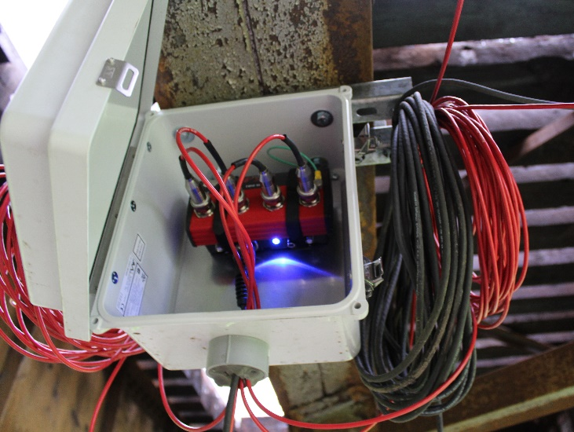  (a) | 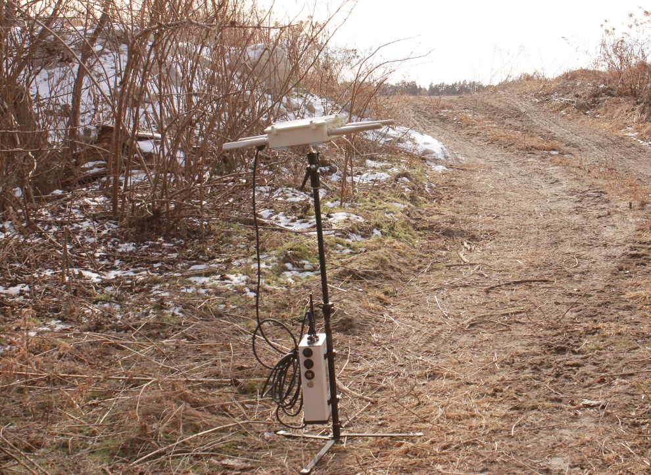  (b) | 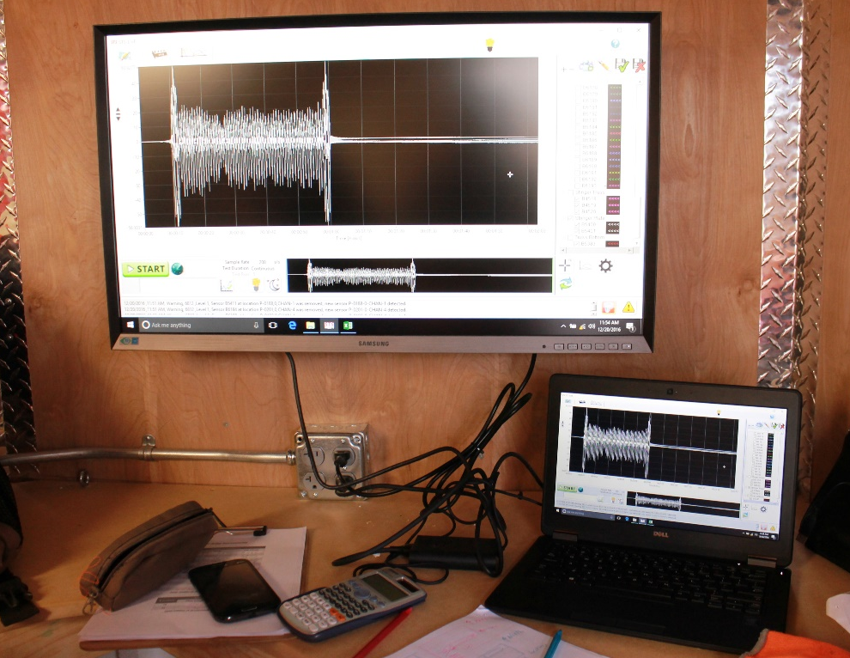  (c)
Figure 5. BDI system: (a) wireless nodes; (b) base station; and (c) representative field results.
Sensors that were place on the truss were located on left truss lower chord member L3-L4 at midspan with a total number of 2 sensors installed (Figure 6). Sensors were placed here because analytical models predicted that this member would be subjected to axial force and out-of-plane bending moments under train loads. Floor system sensors were placed on stringers, floor beams, and lower lateral bracing between stringer members and truss panel points as shown in Figure 6. For the floor beams, the model predicted that FB4 in Figure 6 would be subjected to significant out-of-plane bending in addition to axial forces and in-plane bending. This behavior was attributed to stringers shear and axial forces applied vertically and laterally on FB4 and, as a result, 8 strain sensors were placed at its midspan and ends.
Stringers 1 and 2 were heavily instrumented because model results indicated significant axial tensile force in Stringer 1 when loads traversed the bridge and, conversely, minor compressive forces in Stringer 2. A total of 8 sections were instrumented with 3 sensors each to capture axial and in- and out-of-plane bending strains. Sections near floorbeam connections were used to examine end-fixity levels and mid-span sections to examine bending effects. Lateral bracing members, those used to brace stringers against lateral bending and those used to brace the truss against wind loads, were also instrumented. Bracing members that were selected using information provided by the owner and are designated as Locations 13, 14 and 15 in Figure 6. Each section was instrumented with 1 or 2 sensors to estimate their structural response under live loads.
Figure 6. Instrument locations for testing event 1: (a) truss; (b) stringers and floor beams; and (c) lateral bracing.

Field comparisons against initial, calibrated model
Data was collected during 7 train passes of varying length, speed, weight and direction. Five of those trains traversed the bridge on eastbound Track 2 (see Figure 1), where most of the instrumentation was located as shown in Figure 6. The bridge owner provided WIM information for four of the seven trains. Bridge response to those four trains was examined using the initial, calibrated model mentioned earlier with the 1st ten cars, including locomotives, being simulated.
Comparisons between unfiltered field data and model predictions at the 72 instrumented locations were completed. As a result of these comparisons, additional model refinement occurred. These modifications included: (i) explicitly modelling the rails and ties; (ii) applying floor system offsets in the vertical direction to better represent member positions; (iii) and modifying stringer end fixity.
Representative stress time histories from the final, calibrated model and field data are shown in Figure 7 for floor beam FB4 at Stringer 4 at FB4 right (East) and left (West) bottom flange tips. These time-histories show good correlation between field and model results. The comparison also indicated that the floor beam was subjected to appreciable out-of-plane bending at this location, which was typically the case for floorbeam-stringer at intersections.
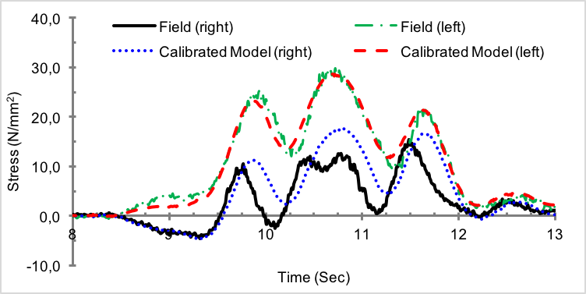
Figure 7. Representative bottom flange stress time-history comparisons, FB4 at Stringer 4
As second set of representative comparative results at the east end of Stringer 1, denoted as Location 6 in Figure 6, are shown in Figure 8. These time-histories again show good correlation between field and model results and indicate that stringers experience stress cycles at their ends irrespective of which track was loaded.

INITIAL OPTIMIZED SHM PLANS
Information from the final, calibrated model was used to develop and propose an optimized instrumentation plan, which included sensors placed on members cross sections as follows: (i) one strain sensor on stringer bottom flanges at mid-width; (ii) one strain sensor on stringer laterals; (iii) one strain sensor on truss bottom laterals; and (iv) two strain sensors on main truss eyebars. A representative, proposed SHM plan, one which utilized 42 strain sensors, is shown in Figure 9. This plan incorporated strain sensors at 20 stringer ends, on 12 stringer laterals, 6 truss bottom laterals and 2 main truss diagonals.
The data acquisition system solar panel power supply limitations dictated further optimizing sensor numbers, as a result, the 42 sensors were reduced to 24 utilizing additional analyses. The further reduced and deployed plan included sensors at 20 stringer ends, on 2 bottom laterals and 1 main truss diagonal. The solar power source and remote data acquisition system used to collect and transmit data are shown in Figure 10.

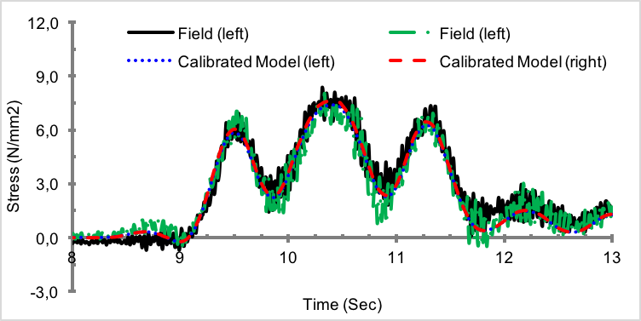
Figure 8. Bottom flange stress time-history comparisons, calibrated model, Train 3, east end of Stringer 1, truss panel L3-L4

Figure 9. Proposed SHM instrumentation plan (1)
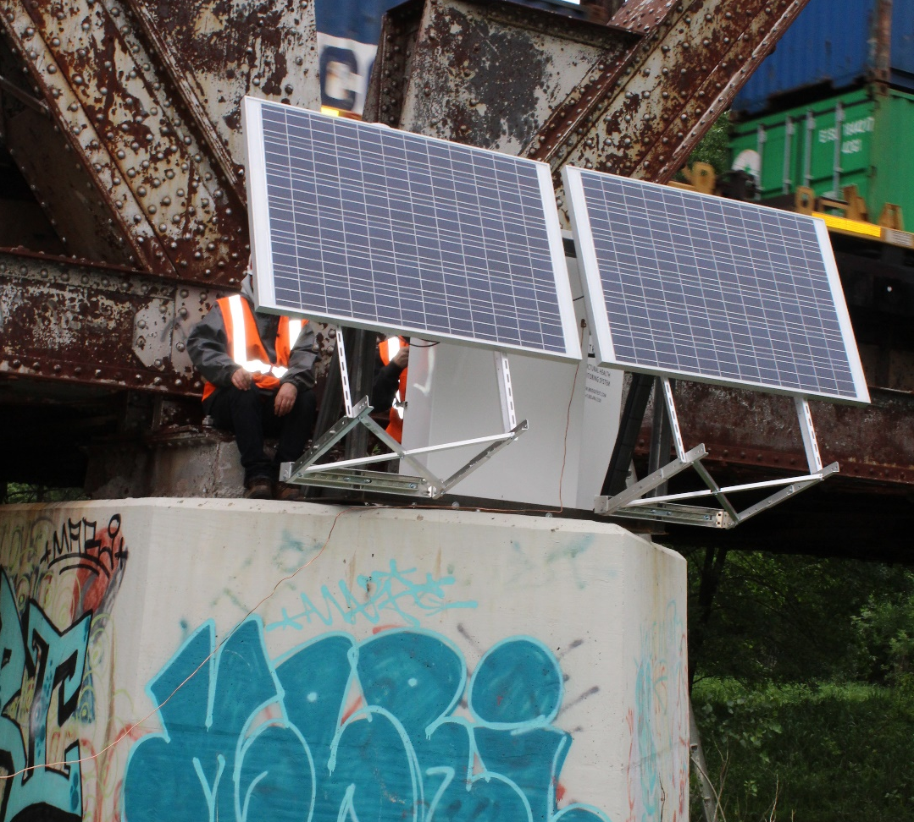
Figure 10. Monitoring system logger cabinet and solar panels

CONCLUSIONS
Research discussed herein summarizes initial steps of a large-scale effort focused on developing a cost-effective, optimized, robust health monitoring system that takes advantage of repeatable patterns found on most, if not all, riveted steel railway bridges. The ultimate goal is to develop a bridge monitoring system that could be efficiently, inexpensively and broadly deployed on a railway bridge system. Initial work completed for the project encompassed sensitivity analyses, field testing and model calibration, with efforts focusing on a single truss in a large, multi-span, railway bridge. Research that was completed focused on computationally-based methods to optimize SHM plans for this and other, similar bridges. Research is still underway to validate those proposed plans via continuous monitoring.

References

Al-Emrani, M. (2005). Fatigue Performance of Stringer-to-Floor-Beam Connections in Riveted Railway Bridges. Journal of Bridge Engineering, 10(2), 179-185. doi:2(179)
Al-Emrani, M., Akesson, B., & Kliger, R. (2004). Overlooked Secondary Effects in Open-Deck Truss Bridges. Structural Engineering International, 14(4), 307-312.
AREMA, L. (2015). American Railway Engineering and Maintenance-of-Way Association. Manual for Railway Engineering.
Bischoff, R., Meyer, J., Enochsson, O., Feltrin, G., & Elfgren, L.Event-Based Strain Monitoring on a Railway Bridge with a Wireless Sensor Network. Structural Health Monitoring of Intelligent Infrastructure.
Chotickai, P., & Kanchanalai, T. (2010). Field Testing and Performance Evaluation of a Through-Plate Girder Railway Bridge. Transportation Research Record: Journal of the Transportation Research Board, (2172), 132-141.
DelGrego, M. R., Culmo, M. P., & DeWolf, J. T. (2008). Performance Evaluation through Field Testing of Century-Old Railroad Truss Bridge. Journal of Bridge Engineering, 13(2), 132-138. doi:2(132)
Edward, P., & Băncilă, R. (2012). General Principles Regarding the Rehabilitation of Existing Railway Bridges. InTech.
Haghani, R., Al-Emrani, M., & Heshmati, M. (2012). Fatigue-Prone Details in Steel Bridges. Buildings, 2(4), 456-476. doi:10.3390/buildings2040456
Imam, B., Righiniotis, T. D., & Chryssanthopoulos, M. K.Connection Fixity Effects on Stress Histories in Riveted Rail Bridges. Bridge Maintenance, Safety, Management and Cost,
Imam, B., Righiniotis, T. D., & Chryssanthopoulos, M. K. (2005). Fatigue Assessment of Riveted Railway Bridges. Steel Structures, 5(5), 485-494.
Liu, W., Gao, W., Sun, Y., & Xu, M. (2008). Optimal Sensor Placement for Spatial Lattice Structure Based on Genetic Algorithms. Journal of Sound and Vibration, 317(1), 175-189.
Meo, M., & Zumpano, G. (2005). On the Optimal Sensor Placement Techniques for a Bridge Structure. Engineering Structures, 27(10), 1488-1497. doi:10.1016/j.engstruct.2005.03.015
Moreu, F., LaFave, J., & Spencer, B. (2012). Structural Health Monitoring of Railroad Bridges—Research Needs and Preliminary Results. Structures Congress 2012 (pp. 2141-2152) doi:10.1061/9780784412367.188
Moreu, F., & LaFaye, J. M. (2011). Current Research Topics--Railroad Bridges and Structural Engineering. ( No. 107). New York: Simmons-Boardman Publishing Corporation.
Papadimitriou, C. (2004). Optimal Sensor Placement Methodology for Parametric Identification of Structural Systems. Journal of Sound and Vibration, 278(4), 923-947.
Phares, B. M., Rolander, D. D., Graybeal, B. A., & Washer, G. A. (2001). Reliability of Visual Bridge Inspection. Public Roads, 64(5)
Roach, D. P., Jauregui, D. V., & Daumueller, A. N. (2012). Development of a Structural health Monitoring System for the Life Assessment of Critical Transportation Infrastructure. United States: USDOE. doi:10.2172/1035338
Schueller, W. (2008). Building Support Structures, Analysis and Design with SAP2000 Software. Computer and Structures Inc., Berkeley,
Spyrakos, C. C., Raftoyiannis, I. G., & Ermopoulos, J. C. (2004). Condition Assessment and Retrofit of a Historic Steel-Truss Railway Bridge. Journal of Constructional Steel Research, 60(8), 1213-1225. doi:10.1016/j.jcsr.2003.11.004
Tobias, D. H., Foutch, D. H., & Choros, J. (1993). Investigation of an Open Deck Through-Truss Railway Bridge: Work Train Tests.
Yi, T., Li, H., & Gu, M. (2011). Optimal Sensor Placement for Structural Health Monitoring Based on Multiple Optimization Strategies. The Structural Design of Tall and Special Buildings, 20(7), 881-900. doi:10.1002/tal.712

