|  |  |  |
| --- | --- | --- |
|  | **10th International Conference on Short and Medium Span Bridges**  **Quebec City, Quebec, Canada,**  **July 31 – August 3, 2018** |  |

**EXPRIMENTAL INVESTIGATION ON EXTERNALLY PRESTRESSED SEGMENTAL BRIDGES UNDER TORSION USING DIFFERENT JOINTS**

El-Shafiey, Tarek1, Khalil, Abdel-Hakeem2, Etman, Emad3, Hussein, Mohammed4 and Abdelaziz, Mahmoud5

1,2,3,4 Professors, Faculty of Engineering, Tanta University, Egypt

5 Assistant lecturer and PhD student, Faculty of Engineering, Tanta University, Egypt

5 [eng.mahmoud_abdelaziz@yahoo.com](mailto:eng.mahmoud_abdelaziz@yahoo.com)

**Abstract: E**xternally **P**restressed **S**egmental **B**ridges (**E**.**P**.**S**.**B**) are widely used in constructing bridges. A large amount of research is conducted to study the behavior of E.P.S.B under flexure to get benefit from the nonlinear stage. But some researches which studied the behavior of E.P.S.B under torsion recommended designing the segmental bridges at the full prestressing stage. This recommendation was a normal result because of the unacceptable twist at the adjacent segments at the open joints due to torsion. This paper is conducted to test two specimens with two innovative joints under Moment, shear and torsion. The innovative joints were designed to restrict the twist at the adjacent joints. The results were compared against a monolithic specimen, a specimen with multi typical shear keys as well as specimens with large depth reinforced keys. The suggested techniques didn’t affect the construction fabrication facilities or structure advantage. The results showed that the use of large depth reinforced shear keys or steel shear connectors between segments or a UHP-SHCC joint at the tension flange a significant improvement in the specimen’s deformations, the ultimate capacity and reducing the severity of the failure.

1. **INTRODUCTION AND REVIEW**

Externally prestressed segmental bridges (E.P.S.B) are one of the major new developments in bridge engineering in the last few years. It has many advantage such as; the main construction operations; concreting and prestressing, are independent of each another which resulted in shorter construction time. Also, It allows the monitoring and replacement of tendons or segments….etc, Picard et al 1995 and , Rombach 2002. The first cast-in-place S.B.G.B built by the cantilever method was completed in 1950 in Germany. This bridge collapsed in 1978 due to corrosion of anchors, Podolny 1988. The first international code included limitations and specification for E.P.S.B was issued in USA in 1982 – AASHTO 82. This code gave recommendations and limitations to design the segmental bridges at full prestressing stage. Till now most international codes recommended to design these bridges at the full prestressing stage and didn’t allow the joints to open. Some researchers tried to make use of the nonlinear stage and studied the behavior of E.P.S.B under moment and/or shear. The aim of these researches was to get method to calculate the ultimate load capacity as well as improving the nonlinear behavior. Other researchers were oriented to calculate the dry joint capacity and improve the joints between segments. Other researchers were constructed to study the behavior of these structures under combined moment, shear and torsion. The researches which studied the behavior of E.P.S.B under torsion recommended, designing the segmental bridges at the full prestressing stage, Elshafiey et al 2017. This recommendation was a normal result because of the unacceptable twist at the adjacent segments at the open joints due to torsion. The main reason of the unacceptable twist is; as the flexural moment opens the joint the tension side is freely to twist under torsion. At the tension zone, the adjacent segments at this load level will not be in compatible twist which resulted in unrecoverable deformations after load release. For this purpose, different techniques of joints have been developed and tested in this paper.

1. **EXPERIMENTAL PROGRAM**
   1. **Specimen description and reinforcement details:**

In segmental bridges applications, the first segment is fixed to the support by internal tendons, Figure 1.a. The other segments are assembled by tendons Figure 1.b. In continuous span bridges, the internal support and the part bounded by the contra flexure points, the first dry joint between the first and the second segment is subjected to; moment, shear and torsion. The tested specimens represent the area bounded by section at first dry joint and section at contra flexure point (a half of negative moment zone), Figure 2. Figure 3.a shows an isometric for the specimen after assembled with external tendons in the test direction as well as overall dimensions and reinforcement details.

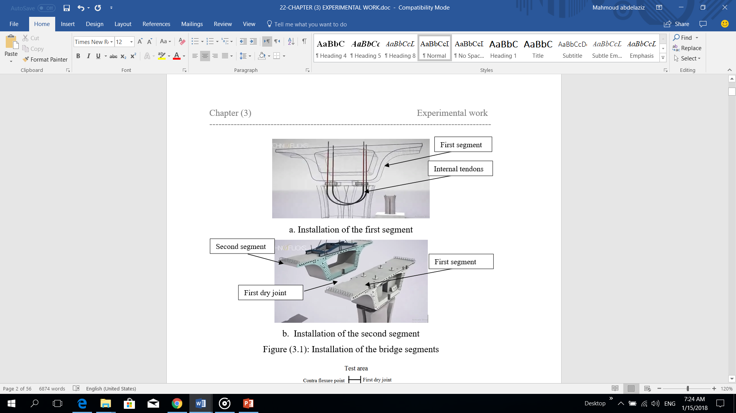

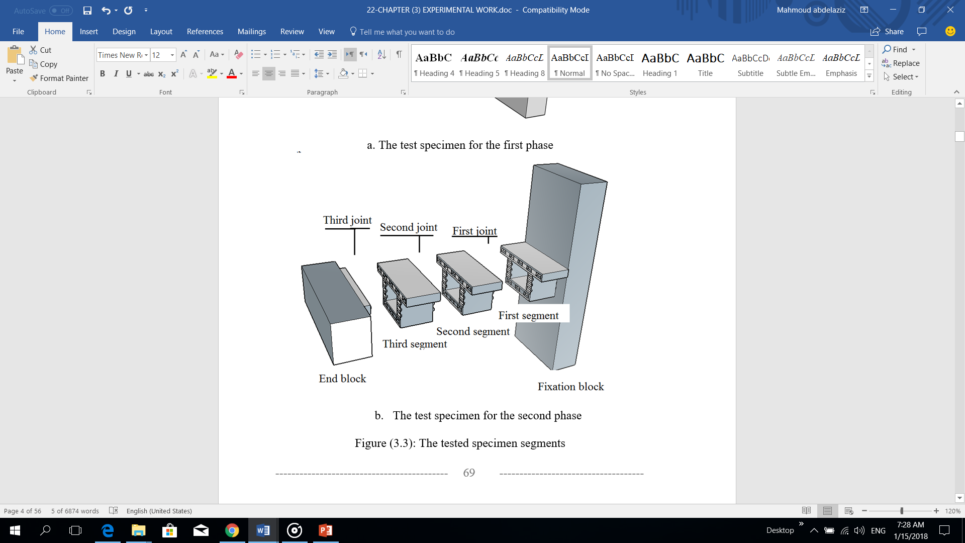

Figure 1: Installation of the bridge Figure 2: The test specimen segments

Each specimen consists of; a fixation block with a connected part of 300 mm in height, two segments of one-tenth scale of B.G. B and the end block segment with a solid part of 50mm in height. Figures 3 shows the overall dimensions and reinforcement details.

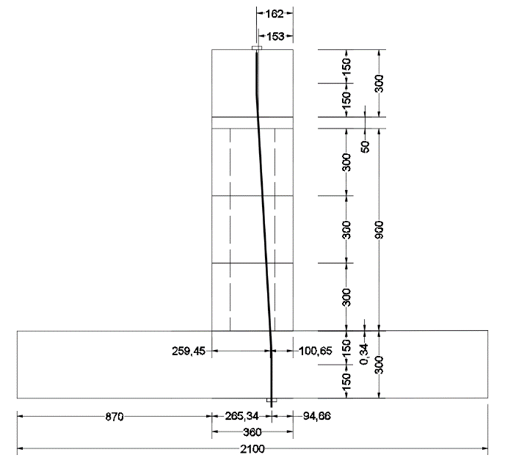

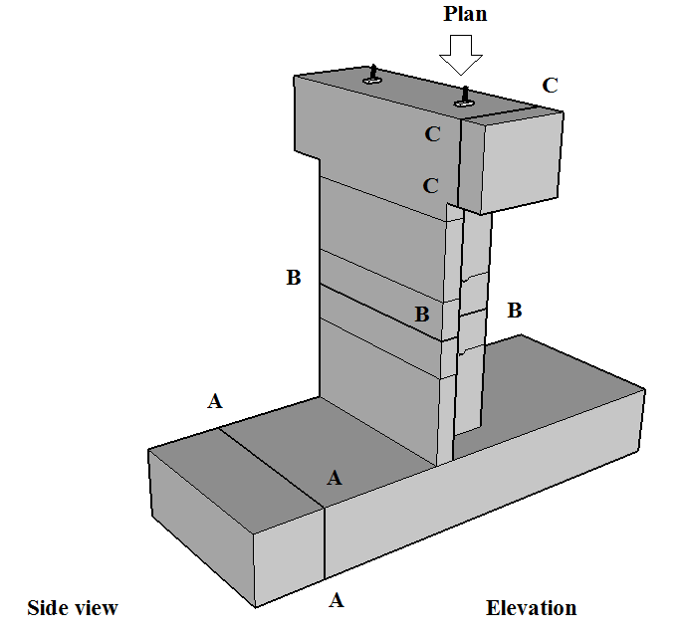

1. Isometric for the segmental specimens b. elevation, dimensions (in mm)

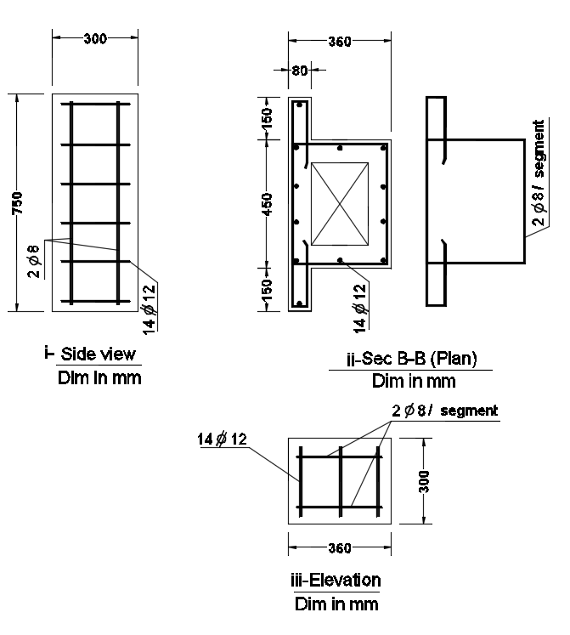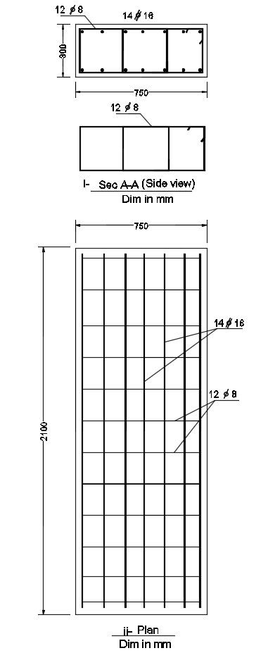

c. Fixation block dimensions’

and reinforcement detailing

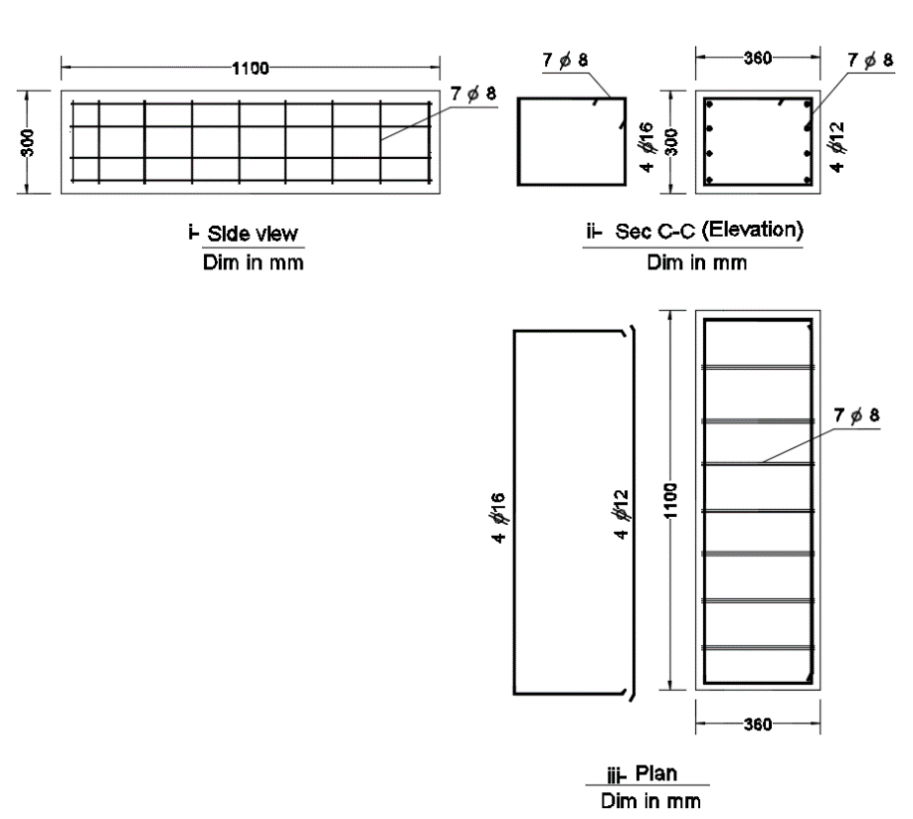

d. End block dimensions and e. beam segment dimension and detailing reinforcement detailing

Figure 3: Overall dimensions and reinforcement detailing

* 1. **Experimental program and parameters:**

All specimens’ tendons were stressed at 0.26 of the yield tendon stress to have low normal stress as it is the wrist case. All specimens were subjected to eccentric load at the end block by 0.4 m to have high torsional level. The test specimens are shown in table 1. The experimental program consists of five specimens. The first one was monolithic. The second specimen was segmental and constructed with multi small amplitude shear keys with a distribution identical to the segmental bridges’ applications, Figure 4. Three specimens were constructed with different techniques of joints. The first technique was constructed with four large depth reinforced shear keys (two shear keys are formed at the two webs as well as another two shear keys are formed at the two flanges, Figure 5. The second technique was constructed with steel shear connectors instead of the ordinary concrete shear keys, Figure 6. The third technique is segmental with three large reinforced shear keys, one at the compression flange and another two large keys at the two webs. Besides, the tension slab of the last specimen is connected to be continuous across every dry joint by a UHP-SHCC joint and hooked steed splice. This technique gives the continuity for the tension slab, Figure 7. The suggested techniques don’t affect the construction methods’ advantages.

Table 1: The experimentally tested specimens.

|  |  |  |  |
| --- | --- | --- | --- |
| Specimen notation | Joint description | Stirrups | Additional reinforcement at the shear keys |
| M | Monolithic specimen | 7 φ 8 /beam part | - |
| MK | Adjacent segments interlocked by multi small shear keys | 2 φ 8 /segment | - |
| ORK | Adjacent segments interlocked by large depth reinforced shear key | 2 φ 8 /segment | 2 φ 10 |
| SCN | Adjacent segments interlocked by steel shear connectors | 5 φ 8 /segment | - |
| UHP-S | Adjacent segments interlocked by large depth reinforced shear key and connected at the tension slab by UHP-SHCC joint. | 2 φ 8 /segment | 2 φ 10 |

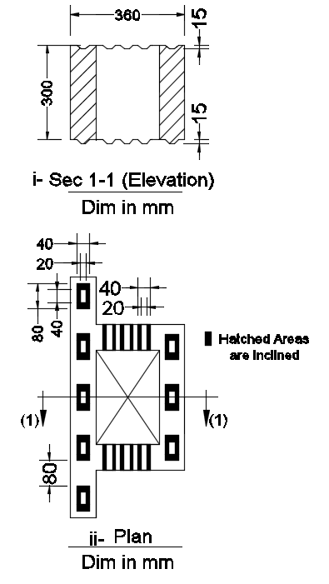

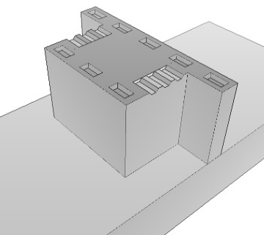

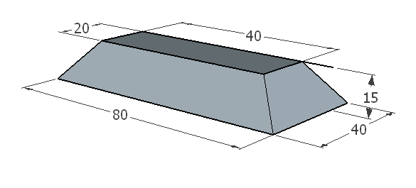

a-Isometric for fixation block b- shear key dimension c- shear keys distribution

Figure 4: Beam segment and joint details for specimen MK

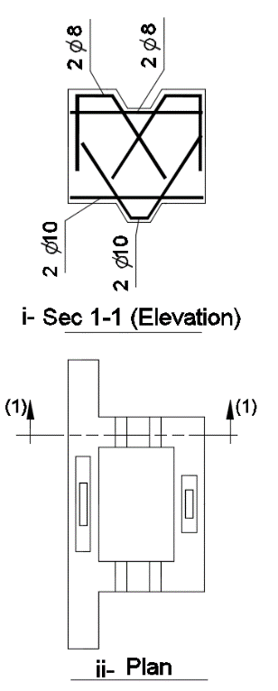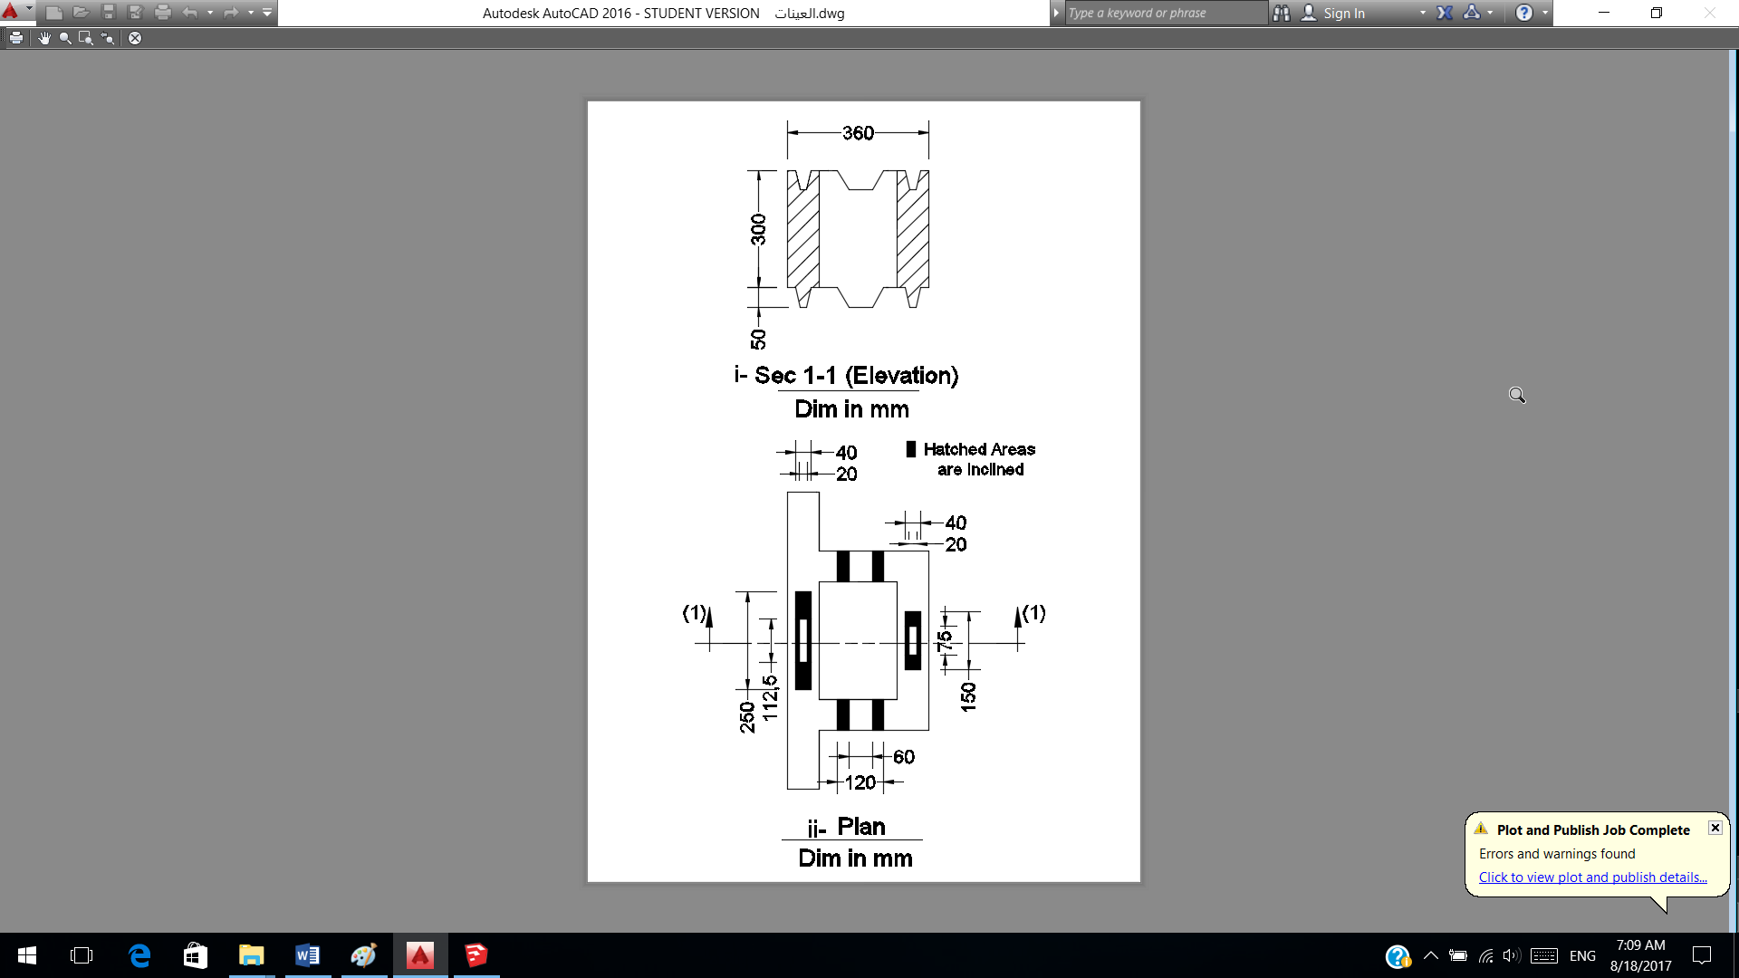

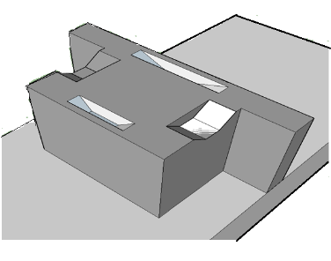

a- Isometric for Fixation block b- beam segment e- additional steel at shear keys

Figure 5: Beam segment and joint details for specimen ORK

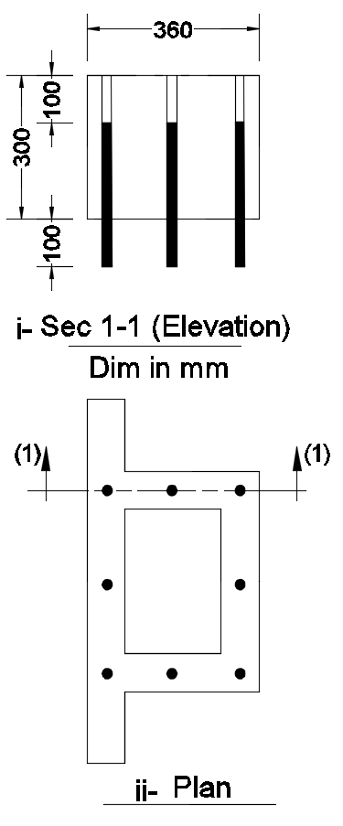

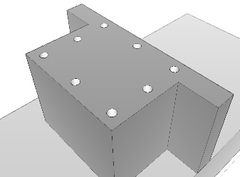

a-Isometric for fixation block b- beam segment c- shear connectors distribution

Figure 6: Beam segment and joint details for specimen SCN

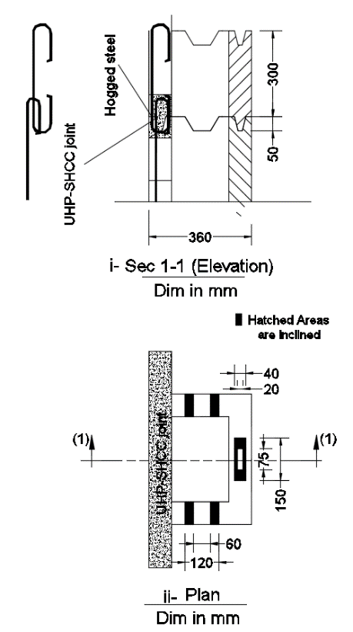

a-UHP-SHCC Joint b- shear keys distribution d- additional reinforcement

Figure 7: Beam segment and joint details for specimen UHP-S

* 1. **Material properties**

Table 2 and 3 show the concrete mix and UHP-SHCC mix properties, respectively. The actual yield stress for the used deformed bars of 12 mm was 460 MPa. The smooth wires have had a diameter of 8mm were of actual yield stress 285 MPa. The used tendons were with 15.24 mm in diameter. The actual yield stress for the tendons was 1696 MPa, and the ultimate stress was 1886 MPa.

Table 2: The concrete mix properties

|  |  |  |  |  |  |  |
| --- | --- | --- | --- | --- | --- | --- |
| Cement | Sand | dolomite | Max Ratio Water/Cement | Super plasticizer | Cube Comp. strength | Tensile stress |
| 500 Kg | 387.5 Kg | 1175 Kg | 0.28 | 8.0 Littre | 40 MPa | 3.61 MPa |

Table 3: UHP-SHCC mix properties

|  |  |  |  |  |  |  |
| --- | --- | --- | --- | --- | --- | --- |
| Cement | Sand | Silica fume | fiber | Water | Super plasticizer | Tensile stress |
| 50 Kg | 5.88 Kg | 8.8 Kg | 0.7 Kg | 11.62 Littre | 1.17 Littre | 5.8 MPa |

* 1. **Testing setup and instrumentations**

After specimens curing, every specimen passed through two phases, post-tensioning phase and testing phase. The recorded prestressed strains were read from electrical resistance strain gauges mounted on surface of the external tendons at mid-length. The instrumentations were located at relevant points of the test specimens. The overall test setup shown in Figure 8.

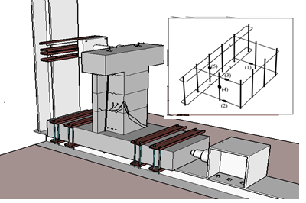

Figure 8: Test set up Figure 9: Positions of strain gages

The stability load at Fixation block was applied incrementally in an increment of 25 kN up to reaches 250 kN measured by the load cell attached to the mechanical jack. Electrical resistance strain gauges were mounted on the surface of the longitudinal reinforcing and transversal stirrups as shown in Figure 9 for steel of first segment. The deformation may be measured by LVDTs and concrete strains may be measured by pi-gages. LVDTs is used to mesure the deformation at six points as shown in Figure10.six pi-gauges with 100mm length, were mounted on the surface of the specimen at different locations as viewed in Figure 11. The readings of all LVDTS, strains, and pi-gauges were then recorded for zero load. The applied load was applied incrementally in an increment of from 1.0 to 5.0 kN up to failure and measured by the load cell attached to the manual jack.

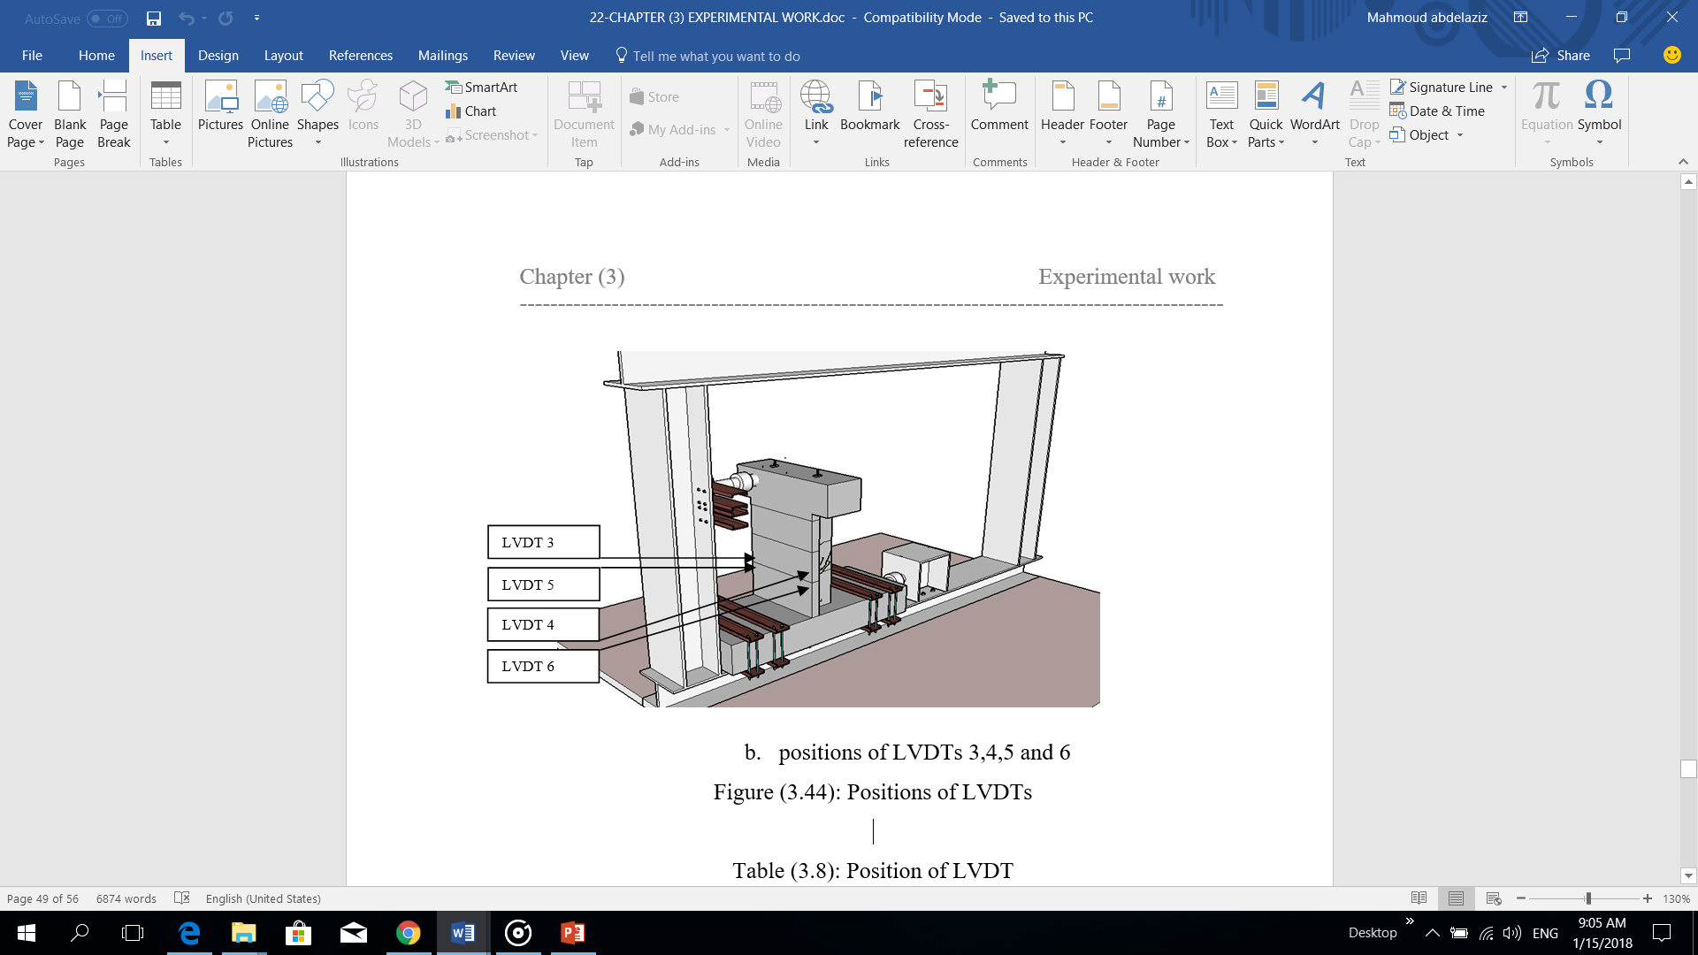

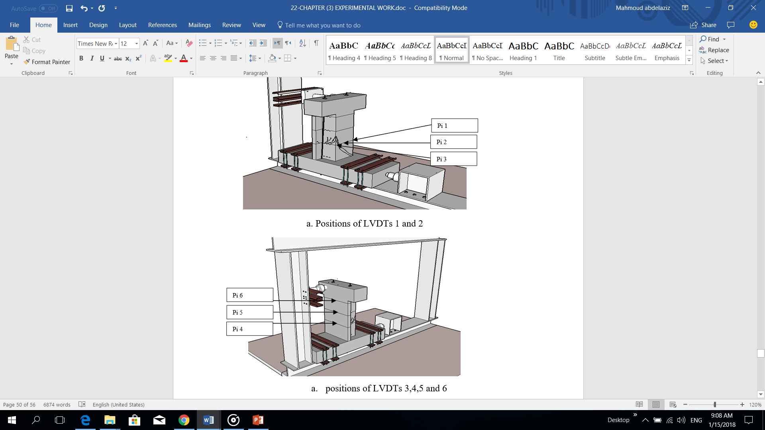Figure 10: Positions of LVDTs

Figure 11: Positions of pi gages

1. **EXPERIMENTAL RESULTS**

The results include; crack propagation, modes of failure, load, deflections, twist, tendons’ strains, concrete strains, opening between segments and internal steel strains.

**3.1 Cracking behavior and modes of failure**

All cracks were marked on the tested specimens up to failure. The value of the applied load was inscribed at the extent of each crack at that load level. For the segmental specimens, the crack propagation was developed behind the first dry joint. **For the monolithic specimen M**: Figure (12) shows the crack patterns at failure for the specimen M. Under loading, the first visible crack was noticed at the tension flange at 48.25 kN which is 43% of the ultimate load (0.43 Pu), Figure (12 a). By increasing the applied load, the first diagonal crack developed at the web near the applied load due to combined shear and torsion at 56 kN (0.50 Pu) with angle 70 degrees, Figure (12 d). Under loading, multiple cracks developed at the tension slab then extended to the web near the applied load, Figure (12 a). The first torsional crack developed at the compression flange at 90 kN (0.81 Pu), Figure (12 c). At 99 kN (0.89 Pu) the cracks started to develop at the web far from the applied load, Figure (12 b). Finally, the specimen failed with combined shear stresses at the web near the applied load at 111.18 kN. **For the specimen MK**, under loading the first joint opened at 40 kN which is 73% of the ultimate load (0.73 Pu) however it was 17 % less than the cracking load of the specimen M. No cracks occurred until the depth of opening reached the tendon position. Diagonal crack due to flexure and torsion started at 41.2 kN (0.76 Pu) at the web far from the applied load. This was 26.4% less than that obtained in specimen M, Figure (13 a). Another crack was depicted on the near web at 42 kN (0.77 Pu) due to combined shear and torsion, Figure (13 b). The two main diagonal cracks (the crack at the web near the applied load and the crack at the web far from the applied load) width developed dramatically; this due to twisting of tension side of the first segment and obstruction of the compression side. By increasing the applied load, the specimen’s main diagonal cracks at the web far from the applied load and the web near the applied load undergo wider, and the specimen was also, twisted. A failure plane was noticed to happen, connecting the far and the near side cracks in a compression failure manner, Figure (14 b). At this stage, the physical failure criteria are considered. The ultimate load of Mk was 54.7 kN, this was 49% of the ultimate load of the specimen M. Figure (13 a and b) shows the crack pattern after failure. The mode of failure could be classified as a skew bending failure. **For the specimen ORK**, under loading the first joint opened at a load of 40 kN which is 61% of the ultimate load (0.61 Pu). It was 17 % less than the cracking load of the specimen M however; it was the same value as the specimen MK. No cracks noticed until the depth of opening reached the tendon’s location. At 43 kN (0.65 Pu), a diagonal crack due to combined shear and torsion started to appear at the web near the applied load by a decrease about 26% if it is compared with the specimen M and it was the same load level for specimen MK, Figure (14 b). Under loading, a diagonal crack due to stress concentration started at 49 kN (0.74 Pu) at the web far from the applied load by an increase about 18 %, if it is compared with specimen MK, Figure (14 a). The two main diagonal cracks’ width is developed faster at the web near the applied load and the web far from the applied load but with a smaller width than specimen MK; this is due to twisting of the first segment and obstruction of large web shear keys and compressed areas between segments. By increasing the applied load, the specimen’s main diagonal cracks at the web far from the applied load and the web near the applied load is noticed much wider. At the ultimate load, a compression failure takes place at the compression slab from the ends of the two main diagonal cracks. At this stage, the physical failure criteria are considered, Figure (14 a and b). The specimen’ reached a load of 66 kN by a decrease about 41 % if it is compared with the specimen M and with an increase about 20 % if it is compared with the specimen MK. Figures (14 a and b) show the crack pattern at failure. The mode of failure could be classified as a skew bending failure. **For the specimen SCN**, the specimen behaves like the monolithic specimen. Under loading, the first joint opened at 40 kN (0.36 Pu) by a decrease about 17 % if it is compared with the cracking load of the specimen M and it is the same value as specimen MK. At this load level, Clear friction sound is heard between the two segments adjacent to the first joint and stopped rapidly. No cracks noticed also, until the depth of opening reached the tendon location. At 42 kN (0.37 Pu) a diagonal crack due to combined shear and torsion started to appear at the web near the applied load by a decrease about 26% if it is compared with the specimen M and it is the same value as specimen MK, Figure (16 c). Under loading, at 56 kN (0.50 Pu) a diagonal crack started at the web far from the applied load with an increase about 36 % if it is compared with specimen MK, Figure (15 a). At 70 kN (0.63 Pu), the second joint started to open, and some cracks developed at the web far from the applied load, the web near the applied load and the tension flange, Figure (15 a, b and c). At 105 kN (0.95 Pu), the width of the main diagonal crack at the web near the applied load was developed faster while the width of the main diagonal crack on the web far from the applied load is still constant. This is due to twisting of first segment and obstruction of steel shear connectors and compressed areas at the joint. By increasing the applied load, the specimen’s main diagonal cracks at web near the applied load and web far from the applied load is undergone much wider. At the ultimate load, a compression failure took place at the compression slab from the ends of the two main diagonal cracks. At this stage, the load starts to decrease faster, and failure criteria are achieved. The specimen reached a load of 111.18 kN. It is the same ultimate load as specimen M and with an increase about 103 % if it is compared with the specimen MK, Figure (15 c). Figure (15 a, b and c) show the crack pattern after failure. **For the specimen UHP-S**, under loading, the first joint cracked at 51.1 kN (0.31 Pu) with an increase about 6 % if it is compared with specimen M, Figure (16 b). There is no friction sound heard as S5, MK, ORK or SCN. Due to combined stresses (shear and torsion), a diagonal crack started at 60.18 kN (0.37 Pu) with an increase about 7.5% if it is compared with specimen M and increase about 51 % if it is compared with specimen MK with an angle 70o. This diagonal crack developed at the web near the applied load as the specimen M, Figure (16 c). Under loading, the specimen behaves with the same behavior as the specimen M. Some cracks developed at the tension flange, Figure (16 b), then under loading, the cracks were extended to the compression flange through the web near the applied load, Figure (16 c). At a load of 86 kN (0.53 Pu), the cracks started to took place at the web far from the applied load, Figure (16 a). The first torsional crack developed at the compression flange at 122 kN (0.75 Pu) from the end of the cracks that developed at the web near the applied load, Figure (16 c). Finally, the specimen failed in the tension zone at the UHP-SHCC joint then compression failure took place at the compression zone at a load of 162.86 kN. Figure (16) shows the failure mechanism for the specimen UHP-S. From the laboratory observations, the use of UHP-SHCC joint at the tension flange is the best the solution because it does not affect the construction methods and compensate the longitudinal side steel required by torsion at the tension side. The use of this technique restricts the deformations of the tension flange under torsion which is the main reason for failure as discussed before.



Figure 12: Crack pattern for specimen M Figure 13: Crack pattern for specimen MK



Figure 14: Crack pattern for specimen ORK Figure 15: Crack pattern for specimen SCN

 Figure 16: Crack pattern for specimen UHP-S

**3.2 Deformation characteristics**

The deflection and twist are calculated from LVDT1 and LVDT 2 see figure (10 a). Figure (17) shows the load plotted against average deflection. The relationship was linear up to vertical loads of 48.25, 40, 40, 40, and 51.1 kN for M, MK, ORK, SCN and UHP-S, respectively. After that, the response becomes nonlinear up to 111.18, 54.7, 66, 111.18 and 162.86 kN. Finally, failure occurred. The specimen constructed with multi small shear keys (MK) shows a decrease by 17 % and 50.7 % in the linear stage and the ultimate load respectively than specimen M. The specimen constructed with one large reinforced shear key ORK shows a decrease by 17 % and 40.5% in the linear stage and ultimate load respectively than specimen M. Also, the specimen with large one reinforced key ORK shows an increase by 0.0 % and 21% in the linear stage and the ultimate load respectively than the specimen with the ordinary multi small shear keys. On the other hand, the specimen with the steel shear connectors (SCN) shows a decrease of 17% and 0.0% in the linear part and the ultimate load respectively than specimen M. The specimen with the steel shear connectors also, shows an increase of 0.0% and 103% in the linear part and the ultimate load respectively than the specimen with the ordinary multi shear keys. The specimen with the UHP-SHCC joint at the tension slab (UHP-S) shows an increase of 6% and 46% in the linear part and the ultimate load respectively than the specimen M. The specimen with the UHP-SHCC joint at the tension slab UHP-S also, shows an increase of 27.5% and 196% in the linear part and the ultimate load respectively than the specimen with the ordinary multi shear keys. Figures (18), (19) shows the relationship between the load and the twist for all the specimens. Figure (20) shows the twist at the specimen’s end plotted against the twist angle at the first segment after the first dry joint for the specimens. From the curves, it can be noticed that the ordinary small amplitude shear keys are the reason of 90% of the total twist. It can be concluded also, that the suggested systems are good choice to increase the joint efficiency and increasing the ultimate capacity.

|  |  |
| --- | --- |
| UHPS  M  SCN  ORK  MK | UHPS  M  SCN  ORK  MK |
| Figure 17: The load plotted against the average deflection between point 1&2 | Figure 18: The load plotted against the twist at the specimen’s end |
| UHPS  M  SCN  ORK  MK | UHPS  M  SCN  ORK  MK  N/A |
| Figure 19: The load plotted against the twist after the first dry joint | Figure 20: The twist at the specimen’s end plotted against the twist after the first dry joint |

**3.3. Tendons’ strains and longitudinal steel strains**

Figures (21) shows Load plotted against average of tendons’ strain. The use of the steel shear connectors has a good effect of decreasing the tendon's strain at the same load level if it is compared with the specimen with the multi shear keys at the nonlinear stage. The use of the UHP-SHCC joint at the tension slab improves the steel’s strain because of the participating in tension force. This because of the use of the UHP-SHCC joint shows an increase in the linear stage and shows more stiffness in the nonlinear stage. Figure (22) shows the load plotted against the strain of the longitudinal steel’s strain for the specimens UHP-S and M. The UHP-S specimen shows a good participation of longitudinal steel stain due to changing the mode of failure from combined shear and torsion to compression failure.

**3.4 concrete strains and opening between segments**

Figure (23) shows the load plotted against the concrete strain at two points at the compression zone. Figures (24) shows the load plotted against the opening between segments at the tension side at joints 1and 2, respectively. From the figures and after joint opening, the neutral axis of the compression flange becomes inclined with a larger depth at the web far from the applied load due to warping effect. That may explain the variation between the two tendon strains. The monolithic specimen M shows less concrete strain at the linear stage. At the nonlinear stage, the specimen ORK shows the same trend of the concrete strain as MK. By increasing the ultimate load, in this case, the ultimate concrete strain is increased. At the nonlinear stage, specimen SCN shows a trend of the concrete strain between specimen M and specimen MK. The specimen SCN has a good behavior to distribute joint opening among the joints. At the nonlinear stage, the specimen UHP-S (with a UHP-SHCC joint) shows less concrete strain if it is compared with specimens MK and ORK and shows fewer deformations this is because of continuity of steel at the tension slab due to continuity effect. The UHP-SHCC joint shares to resist the tension force as well as the twist deformation because of torsion.

|  |  |
| --- | --- |
| UHPS  M  SCN  ORK  MK | UHPS  M |
| Figure (21): The load plotted against the average tendons’ strain | Figure (22): The load plotted against the strain of the longitudinal steel at tension |
| UHPS  M  SCN  ORK  MK | UHPS  M  SCN  ORK  MK |
| a. Load against concrete strain at point (1) | b. Load against concrete strain at point (2) |
| Figure (23): The load plotted against the compression concrete strain at the first joint (compression zone | |

|  |  |
| --- | --- |
| UHPS  M  SCN  ORK  MK | SCN |
| a. Load plotted against the opening at joint 1 | b. Load plotted against the opening at joint 2 |
| Figure (24): The load plotted against the opening at joints | |

* 1. **conclusions**

1. The beams with shear-keyed joints behave with the same behavior as the monolithic beams before the joint opening, but after the joint opening, the behavior of the beam with shear-keyed joints are different from the monolithic beams.
2. The monolithic beams which may be the ideal solution to resist torsion showed an increase of 102% and 225% in the linear stage and the ultimate load, respectively if it is compared with the segmental beams with the ordinary shear keys. Also, the diagonal cracks are delayed by 27% improvement in the applied load.
3. Using large depth reinforced shear keys between segments shows a significant improvement in the beam’s deformations, the cracking behavior, the ultimate capacity and reducing the severity of the failure due to large contact and distribution of stresses at a deep level.
4. Using of steel shear connectors instead of ordinary shear keys shows an increase of 103% in the ultimate load if it is compared to the beam with the ordinary shear keys. Also, the diagonal cracks are delayed by an increase of 10 % in the load. Also, this technique shows a good recovery to most deformation after the load release. The beam gives the same behavior of the monolithic beam and the same ultimate load
5. The beam with the UHP-SCC joint at the tension flange shows an increase by 200% and 194 % in the linear part and the ultimate load, respectively if it is compared to the beams with the ordinary shear keys. Also, the diagonal cracks are delayed by increasing the load by 52 %. Also, this technique shows excellent recovery to most deformation after load release. The beam gives the same behavior as the monolithic beam and an increase about 50% in the ultimate load.

**REFERENCES**

A. Rombach and R. Abendeh, “Bow-shaped segments in precast segmental bridges,” *Eng. Struct.,* vol. **30**, pp. 1711–1719, 2008.

AASHTO. LRFD bridge design specifications, **5**th ed. *American Association of State Highway and Transportation Officials*, Washington (DC); 2010.

ACI 318. *Building code requirements for structural concrete and commentary*. Michigan (USA): American Concrete Institute; 2011.

Aravinthan T, Mutsuyoshi H, Niitsu T, Chen A. Flexural behavior of externally prestressed beams with large eccentricities. *Trans Jpn Concrete Inst* 1998;**20**:165–70.

ATEP. *Design and construction of bridges and structures with external prestressing. Madrid*; September 1996 [in Spanish].

BS8110. Structural use of concrete – Part **1**: Code of practice for design and construction. London (UK): *British Standards Institution* BSI; 1997.

Buyukozturk, O., Bakhoum, M., and Michael Beattie, S. (1990). Shear Behavior of Joints in Precast Concrete Segmental Bridges. *J. Struct. Eng*., **116**(12), 3380–3401.

C. Sivaleepunth, J. Niwa, D. H. Nguyen, T. Hasegawa, and Y. Hamada, SHEAR CARRYING CAPACITY OF SEGMENTAL PRESTRESSED CONCRETE BEAMS, *Doboku Gakkai Ronbunshuu*, vol. **65**, no. 1, pp. 63–75, 2009.

ECO- 207, Egyptian code of practice, *Special App -Bridge Code-Segmental Bridges*-DRAFT **m8**, 2013.

Eurocode 2. Design of concrete structures – Part 1-1: *General rules and rules for buildings*. BS EN 1992-**1-1**; 2004.

G. Rombach. Precast segmental box girder bridges with external prestressing - design and construction - Structural elements of segmental bridges. *Tech. Univ. Hamburg-harbg*., vol. **1**, no. 1, pp. 1–15, 2002.

H. Jiang, Q. Cao, A. Liu, T. Wang, and Y. Qiu, Flexural behavior of precast concrete segmental beams with hybrid tendons and dry joints, Constr. *Build. Mater.*, vol. **110**, pp. 1–7, 2016.

Haibo Jiang, Qi Cao, Airong Liu, Tianlong Wang, Yun Qiu Flexural behavior of precast concrete segmental beams with hybrid tendons and dry joints *Construction and Building Materials 110* (2016) **1.7**

J. Turmo, G. Ramos, and A. C. Aparicio, FEM study on the structural behaviour of segmental concrete bridges with unbonded prestressing and dry joints: Simply supported bridges, *Eng. Struct*., vol. **27**, pp. 1652–1661, 2005.

Lee, C. H., Kim, Y. J.,Chin, W. J. Shear Strength of Ultra High Performance Fiber Reinforced Concrete (UHPFRC) Precast Bridge Joint. *6th International RILEM conference*. 2012; **2**:413–420.

Li. Guoping, Yang. Donghui, Lei. Yu. Combined Shear and Bending Behavior of Joints in Precast Concrete Segmental Beams with External Tendons. *Bridge Engineering J*. 2013;**18**(10):1042–1052.

M.P. Anwar and R. Rashid Algorafi, M.A., A.A.A. Ali, 1M.S. Jaafar,2I. Othman, Effect of Torsion on Externally Prestressed Segmental Concrete Bridge with Shear Key, *Am. J. Eng*. Appl. Sci., vol. **2**, no. 1, pp. 54–60, 2009.

M. A. Algorafi, A. A. A. Ali, I. Othman, M. S. Jaafar, and M. P. Anwar, Experimental study of externally prestressed segmental beam under torsion*, Eng. Struct*., vol. **32**, no. 11, pp. 3528–3538, 2010.

M. A. Al-Gorafi, A. A. A. Ali, I. Othman, M. S. Jaafar and M. P. Anwar. Externally Prestressed Monolithic and Segmental Concrete Beams under Torsion: A Comparative Finite Element Study. OP Conference Series: *Materials Science and Engineering*, 2011.v, **17**, doi:10.1088/1757-899X/17/1/012041

M. A. Algorafi, A. A. A. Ali, I. Othman, M. S. Jaafar, and R. A. Almansob, Evaluation of Structural Behavior of Externally Prestressed Segmented Bridge with Shear Key under Torsion, *J. Struct. Eng*.vol. **1**, no. 1, pp. 28–35, 2011.

Picard, A., Massicotte, B. and Bastien, J. Relative efficiency of external prestressing. *J. Struct. Eng.*, ASCE, 121(**12**)- 1995, 1832-1841.

Takebayashi T, Deeprasertwong K, Leung YW. A full-scale destructive test of a precast segmental box girder bridge with dry joints and external tendons. *Proc Inst Civil Eng Struct Build* 1994; **104**:297–315.

Turmo J, Ramos G, Aparicio AC. FEM study on the structural behaviour of segmental concrete bridges with unbonded prestressing and dry joints: Simply supported bridges. Engineering Structures 27 (2005) 1652–1661.

T. El-Shafiey, A. Khalil, E. Etman, M. Hussein and M. Abelaziz, [SIGMENTALBOX GIRDER BRIDGES WITH EXTERNAL PRESTRESSING UNDER COMBINED SHEAR, MOMENT AND TORSION: REVIEW PAPER](https://www.researchgate.net/publication/315796549_SIGMENTALBOX_GIRDER_BRIDGES_WITH_EXTERNAL_PRESTRESSING_UNDER_COMBINED_SHEAR_MOMENT_AND_TORSION_REVIEW_PAPER?ev=prf_ov_fet_res&_iepl%5BviewId%5D=qWRmZ9q3xCYbmnoctmvBEKnwM1AyyKY1ANii&_iepl%5Bcontexts%5D%5B0%5D=prfhpi&_iepl%5Bdata%5D%5BstandardItemCount%5D=2&_iepl%5Bdata%5D%5BuserSelectedItemCount%5D=0&_iepl%5Bdata%5D%5BtopHighlightCount%5D=1&_iepl%5Bdata%5D%5BstandardItemIndex%5D=2&_iepl%5Bdata%5D%5BstandardItem2of2%5D=1&_iepl%5BtargetEntityId%5D=PB%3A315796549&_iepl%5BinteractionType%5D=publicationTitle). *International Conference on Advances in Structural and Geotechnical Engineering 2017* At 27-30 March 2017, Hurghada, Egypt

T. El-Shafiey, A. Khalil, E. Etman, M. Hussein and M. Abelaziz. [EXPRIMENTAL INVESTIGATION ON THE BEHAVIOR OF SIGMENTALBOX GIRDER BRIDGES WITH EXTERNAL PRESTRESSING UNDER COMBINED SHEAR, MOMENT AND TORSION](https://www.researchgate.net/publication/315796399_EXPRIMENTAL_INVESTIGATION_ON_THE_BEHAVIOR_OF_SIGMENTALBOX_GIRDER_BRIDGES_WITH_EXTERNAL_PRESTRESSING_UNDER_COMBINED_SHEAR_MOMENT_AND_TORSION?ev=prf_ov_fet_res&_iepl%5BviewId%5D=hILpJ7E5o7JvVnWUAUMqIWo5B4gb7sQTg7ET&_iepl%5Bcontexts%5D%5B0%5D=prfhpi&_iepl%5Bdata%5D%5BstandardItemCount%5D=2&_iepl%5Bdata%5D%5BuserSelectedItemCount%5D=0&_iepl%5Bdata%5D%5BtopHighlightCount%5D=1&_iepl%5Bdata%5D%5BstandardItemIndex%5D=1&_iepl%5Bdata%5D%5BstandardItem1of2%5D=1&_iepl%5BtargetEntityId%5D=PB%3A315796399&_iepl%5BinteractionType%5D=publicationTitle). *International Conference on Advances in Structural and Geotechnical Engineering* 2017 At 27-30 March 2017, Hurghada, Egypt

Walter Podolny. Construction and Design of Prestressed Concrete Segmental Bridges. *Ph.D. Bridge Division Office of Engineering Federal Highway Administration U.S*. Department of Transportation, 1988.

Zhou X, Mickleborough N, Li Z. Shear strength of joints in precast concrete segmental bridges. *ACI Struct J* 2005;**102**(1):3–11.

Z. Huang, M. Asce, and X. L. Liu, Modified Skew Bending Model for Segmental Bridge with Unbonded Tendons, *ASCE* pp. **59–63**, February,2006.