 | 10th International Conference on Short and Medium Span Bridges  Quebec City, Quebec, Canada,  July 31 – August 3, 2018 | 

DETECTION OF STRUCTURAL DAMAGE UNDER VARYING ENVIRONMENTAL CONDITIONS
Shahsavari, Vahid^{1,3}, Chouinard, Luc ² and Bastien, Josée¹
¹ Department of Civil Engineering and Water Engineering, Université Laval, Québec, Canada
² Department of Civil Engineering and Applied Mechanics, McGill University, Montréal, Canada
³ Vahid.Shahsavari.1@ulaval.ca
Abstract: Changes in environmental conditions, especially air temperature, have a significant effect on results from dynamic tests on bridge structures. When these tests are used for the purpose of damage detection and damage localization, these effects can easily mask changes in dynamic properties associated with damage. The purpose of this project is to perform a series of tests under controlled conditions to estimate the relative contributions of damage and temperature effects on the dynamic properties of a beam and to propose procedures to improve damage detection under varying temperatures. In this instance, an instrumented beam is subjected to temperature variations between 5ºC and 25ºC and two levels of damage at two locations along its length. The two levels of damage correspond to incremental damage of 12% relative to the moment of inertia of the beam. For this application, the detection of damage is based on the analysis of the wavelet coefficients applied on the first mode of vibration of the beam. A Principal Component Analysis (PCA) of the wavelet coefficients is used to filter noise by retaining only the first component that explains most of the variance observed in the wavelet coefficients. The scores of the first component are found to be highly correlated with the damage level. Given damage, a Likelihood Ratio (LR) test is performed to find the most likely locations of damage along the length of the beam. The results indicate that for a temperature range of 20ºC, temperature effects can affect mode shapes and easily mask incremental damage corresponding to a 12% reduction in stiffness without a proper correction.
- INTRODUCTION
Natural frequencies and mode shapes are the most popular global health parameters of bridges that are used for damage detection. However, changes in these global properties can also be induced by changing environmental conditions. Most notably, variations in air temperature can induce changes in the state of expansion joints, boundary conditions or deflections of the bridges, which affect the stiffness and measured vibration responses (Mosavi et al. 2012). In order to achieve reliable structural assessments, an effective Structural Health Monitoring (SHM) program needs to discriminate between irreversible changes in dynamic properties due to structural damage to those from reversible thermal effects. In real structures, a practical difficulty occurs when damage-induced changes in frequencies or mode shapes at small damage levels are of the same order of magnitude as those due to environmental conditions (Wenzel et al. 2005). Several investigators have previously investigated the effect of temperature on the natural frequencies and mode shapes of bridge structures. Cornwell et al. (1999) found that the frequencies of the Alamosa Canyon Bridge for the first three modes varied by approximately 4.7%, 6.6% and 5.0% respectively during a 24-h test period in the summer. In the latter case, changes in modal frequencies are related to temperature differentials of more than 25°C across the bridge deck. Cross et al. (2013) analyses the effect of environmental and operational conditions on the first five modal frequencies of the Tamar suspension bridge during a three year period and report a maximum change of 4.5% in the frequency of the first mode for a 20°C variation.

In general, an increase in ambient temperature affects the stiffness matrix of a structure and results in a decrease in natural frequencies. Note that changes in the damping ratio are not considered in this work since they are poor indicators of low levels of damage given the larger uncertainties for damping estimation as compared to those of frequencies and mode shapes (Xia et al. 2012, Li et al. 2010). Few studies have investigated the effect of temperature on mode shapes. Xu and Wu (2007) perform numerical analyses on a cable-stayed bridge and conclude that a 10% reduction in stiffness of the girder causes smaller changes in the first two modes than temperature gradients of 40°C. Balmes et al. (2008) report changes of 16%, 8%, 5%, and 3% respectively in the frequencies of the first four modes of an intact beam due to a 20°C change of temperature , whereas changes in the mode shapes are less than 1% for the same temperature change or when a 1% change in stiffness is introduced in the beam. In theory, mode shapes for intact prismatic beams are independent of temperature, while damaged beams may show some changes associated with local defects.
In order to differentiate between temperature and damage-related changes in modal properties, observations are required over a range of temperatures for known states of damage. Classical statistical methods can be used to estimate a relation between temperature and frequencies (Xia et al. 2012). Yan et al. (2005) use the Principal Component Analysis (PCA) to analyse the first four natural frequencies of a concrete box girder bridge as a function of temperature and damage level (concrete spalling, settlement of pier, anchor failure, etc.) over a one year period. The analysis is performed on the covariance matrix of measured frequencies and the PCA models are estimated for the reference (undamaged) state for varying environmental conditions. Assuming that the residual error of reconstruction of the input data remains small in the presence of no damage, significant increases in the latter are associated with damage. Hu et al. (2012) develop a damage detection novelty index based on the residual errors of the reconstructed data from natural frequencies identified at different times. A PCA analysis is performed on the frequencies for the eight vertical bending modes of the Pedro e Inês footbridge using three years of continuous monitoring with temperature variations of 35°C. The results indicate that the maximum changes in the natural frequencies vary between 2.7-3.9% and the correlation analysis of the natural frequencies with temperature reveals that frequencies tend to decrease linearly with temperature. Reynders et al. (2014) compare linear and nonlinear PCA techniques to account for eliminating nonlinear effects of varying temperature on four eigenfrequencies of a three-span prestressed concrete bridge for temperatures varying from -5°C to 40°C. The bridge was progressively damaged by introducing realistic patterns of damage at the end of the monitoring period. The results demonstrate that the nonlinear approach outperforms the linear approach when two groups of random variables are nonlinearly related.
The detection of damage through changes in the natural frequencies can easily get masked due to the influence of environmental conditions, especially for low levels of incremental damage. The procedures reviewed are mainly addressing the variability in the measured frequencies and no formal test is proposed to determine if the changes that are observed in the residuals of the reconstructed data are statistically significant. Finally, the tests only address changes in natural frequencies and cannot be used for damage localization. Unlike previous studies in which very limited research had been performed on the effect of temperature on mode shapes, the focus of this research is to investigate the effect of temperature change on the mode shapes. The studies reviewed throughout the literature mainly deal with long-term monitoring of the changes of natural frequencies due to varying ambient conditions and fail to provide information as to the location of damage. This paper aims to address the undesired effect of temperature on the mode shapes in relation to the detection and localisation of damage. Since mode shapes can also be affected by temperature, experimental tests are performed in a climate controlled room and a mathematical algorithm has been established to introduce a temperature correction factor, aiming to minimize the adverse effect of temperature and false indications of damage.
- METHODOLOGY
This section summarizes the main features of the detection procedure used in this work. A detailed description of the methodology can be found in Shahsavari et al. (2017a,b). The Continuous Wavelet Transform (CWT) (Daubechies 1992) is a common signal processing tool which has been used initially for the analysis of time series but that can also be applied to any sequence of observations in space. In the case of damage detection, CWT has been applied to mode shapes in order to detect small anomalies that can be correlated to damage (Alvandi 2009). The CWT of a one-dimensional function f(x) (mode shape in this application) is defined as:
[1] $\text{CWT}(x)=\frac{1}{\sqrt{\left|s\right|}}\int_{−∞}^{+∞}{f\left(x\right)}ψ^{}\left(\frac{x−u}{s}\right)\text{dx}$
where ѱ*(x) represents the complex conjugate of the wavelet mother function ѱ(x), s and u denote the scale and the position parameters of the mother wavelet, and CWT(x) is defined as the wavelet coefficient in the vicinity of x., which are locations of pseudo sensors or sampling points (nodes) along the mode shape. Wavelet functions have various shapes and mathematical characteristics (Daubechies 1992). In this paper, it has been found that the Symlet wavelet complies with the admissibility conditions to perform the wavelet analysis. Wavelets have been used with success for damage detection in several applications (Alvandi et al. 2009, Wu and Wang 2011) but were found to be sensitive to the presence of noise and varying environmental conditions for detecting low levels of incremental damage. Damage detection can be implemented through statistical tests on location parameters to determine objectively if the mean (or median) coefficients between two measurement sessions are different at a given significance level. For low levels of damage, damage detection can be compromised due to a low signal to noise ratio in the observations. In those cases, a Principal Component Analysis (PCA) is performed to reduce noise (Shahsavari et al. 2017a,b). The Principal Component Analysis (PCA) (Pearson 1901) is mostly used for noise reduction, data compression and the meaningful extraction of information in large data sets. In this context, however, the PCA has been used to filter out noise from experimental measurements and to replace wavelet coefficients with a few new variables explaining dominant patterns of variation in the wavelet coefficients. Given that wavelet coefficients achieve their maximum magnitudes near damaged zones in the mode shape, the dominant variations of the wavelet coefficients are assumed to be highly correlated with damage. The input data set of the PCA model is the matrix [X] containing the wavelet coefficients for two consecutive surveys [X1] and [X2] (e.g. damaged, undamaged, or at different temperatures):

[2] | $$X=\left[\frac{X_{1}}{X_{2}}\right]=\left[\begin{matrix}x_{\text{11}} & x_{\text{12}} & x_{\text{13}} & \text{.} \\ x_{\text{21}} & x_{\text{22}} & x_{\text{23}} & \text{.} \\ \text{.} & \text{.} & \text{.} & \text{.} \\ x_{m1} & x_{m2} & x_{m3} & \text{.}\end{matrix}\begin{matrix}\text{.} & \text{.} & \text{.} & x_{1n} \\ \text{.} & \text{.} & \text{.} & x_{2n} \\ \text{.} & \text{.} & \text{.} & \\ \text{.} & \text{.} & \text{.} & x_{\text{mn}}\end{matrix}\right]$$

where m denotes the total number of observations by summing up the total number of repeat measurements (or sample size N) in each survey (m = N₁ + N₂); and n represents the total number of locations (or node positions) along the given mode shape. The PCA of the data matrix [X] of dimensions m by n is defined as the eigenvalue decomposition of the sample covariance (or correlation matrix) using the Singular Value Decomposition (SVD) algorithm. The first few components correspond to the signal components of the data while the higher components are related to noise. For each component, scores can be computed which are proportional to the correlation between the observations at a given time and component.

The scores associated with the first principal component are highly correlated with damage and have been used fora damage localization using a modified Likelihood Ratio (LR) test (Kendall and Stuart 1979, Shahsavari et al. 2017a). For a given data set that comprises two sets of observations for an increasing level of damage, the LR test compares the likelihood of the scores for the reference or full model with the likelihood of the scores for the alternative model by removing sequentially one of the nodes. Removing one of the nodes is equivalent to removing one instrument from the monitoring network. The node that is the closest to the damaged area has the most influence on the likelihood function. For two groups of observations (undamaged, damaged) with random variables, the LR test is performed relative to the scores measured in the damaged state. The result of the LR test is shown as a function of node position and since the model with the removed node close to the damage location is expected to be least informative (or likely) in comparison to the full model, the LR reaches its maximum value at this location. In field applications, the results of the LR test could be less reliable due to temperature effects. Therefore, statistical investigations to correct for the effect of the temperature are important for a robust damage detection decision rule.
- EXPERIMENTAL SETUP AND PROTOCOL
An experimental bolted-beam of length L = 3 m and uniform cross section (W150×37) is used for this study in an environmentally-controlled room. The beam comprises three assembled sections where damage can be simulated by adding or removing sets of plates and bolts (Figure 1). The damage locations are fully assembled and bolted for the reference or initial state. The first or initial state of damage (known as state E0 in this paper) corresponds to the beam in its fully bolted configuration at each joint. The incremental level of damage (state E1) is induced by removing a set of bolts and plates at the two damage locations (Figure 2). The reduction of rigidity corresponds to an equivalent crack of 4% (state E0) and 10% (state E1) of the cross-section for an equivalent rectangular section. Each set of vibration measurements are repeated 25 times under random excitations using sixteen sensors equally spaced along the length of the beam. This large number of sensors improves the signal to noise ratio and the estimation of the wavelet coefficients.

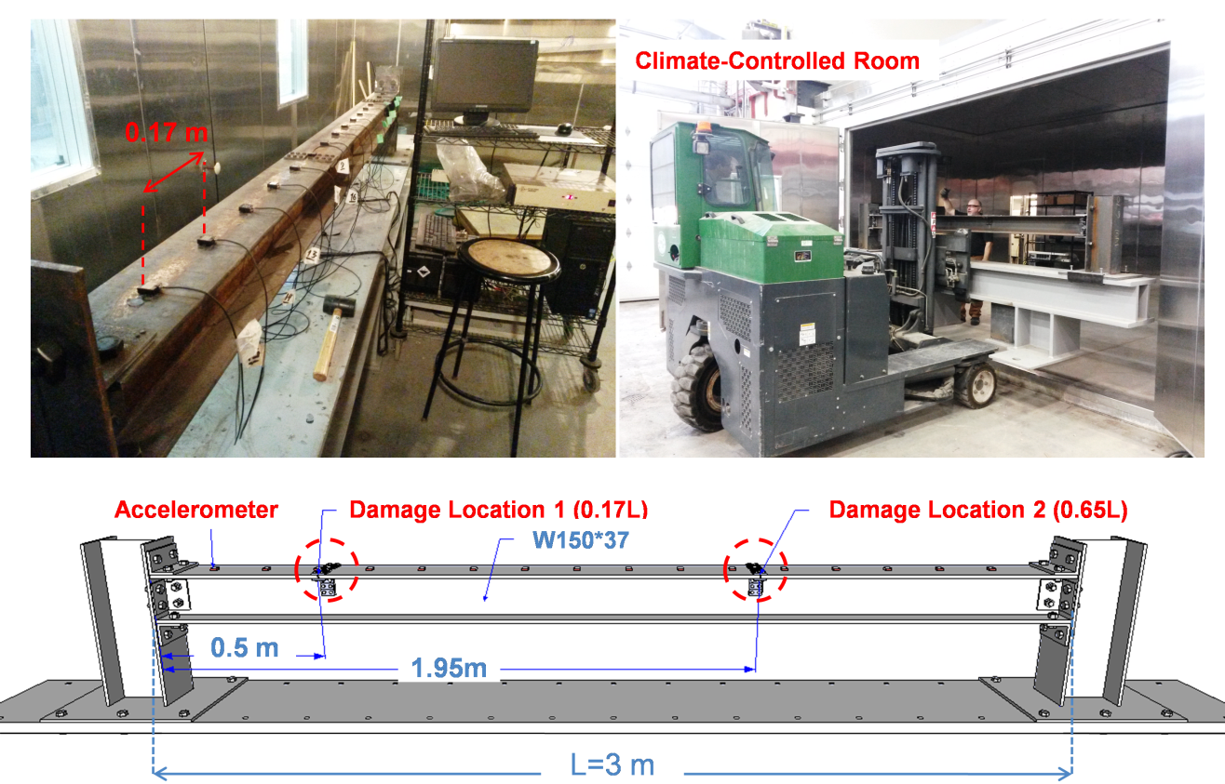
Figure 1: Experimental test setup in a climate-controlled room

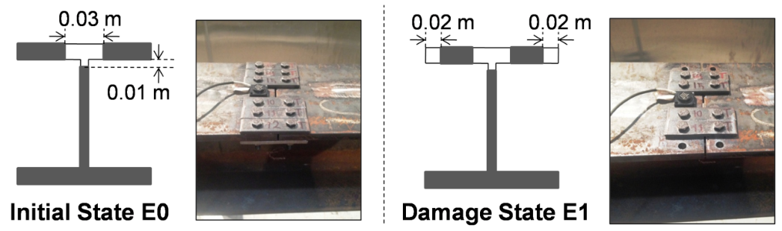
Figure 2: Damage-induced modifications in the beam at the initial state E0 and the damage state E1

Given the experimental restrictions for performing the measurements at the highest/lowest possible temperature values, the measurements are performed in an environmentally-controlled room at two reference temperatures (5°C and 25°C) and the two damage levels (E0 and E1). Figure 3 illustrates typical relations observed between the wavelet coefficients computed along the beam at the location of the sensors. This matrix plot shows the scatter plot of wavelet coefficients at different locations along the beam. The red line represents the best linear fit to the data. In our case, a linear relation appears to be most appropriate and the scatter is consistent with the first PCA explaining most of the variability in the data. Hence, the experimental protocol is defined as follows: Setup 1: Damage state E0 at 5°C; Setup 2: Damage state E0 at 25°C; Setup 3: Damage state E1 at 5°C; Setup 4: Damage state E1 at 25°C. Table 1 describes the parameters for each experimental setup. The setups are used to evaluate: 1) the effect of temperature, 2) the effect of incremental damage, and 3) the combined effect of damage and temperature. Note that the relation presented in this paper is established with air temperature measured at different locations along the bridge. These measurements may not always be representative of the average temperature for the main structural elements of a bridge and do not account for thermal inertia, which may result in larger scatter in field applications. In our case, measurements were made after the temperature across the entire beam had stabilized and was uniform across the entire beam.

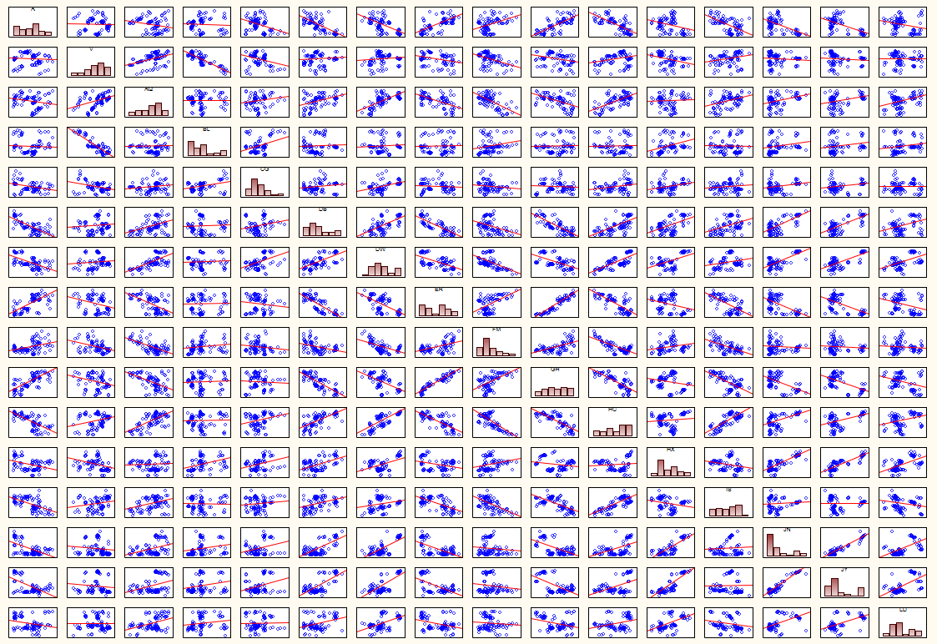
Figure 3: Scatter plot of wavelet coefficients at the locations of the sensors while the red line in each box corresponds to the best linear fit to the data
Table 1: Parameters for test setups for the experimental program
Data | Damage Level (E) | I/Io* | Stiffness Reduction (%) | Damage Locations | Equivalent Crack Height (m) | Measurements # | Temperature (°C)
Setup 1 | E0 | 0.88 | 12 | 0.17 L** and 0.65 L | 0.04 h | 25 | 5
Setup 2 | E0 | 0.88 | 12 | 0.17 L and 0.65 L | 0.04 h | 25 | 25
Setup 3 | E1 | 0.72 | 28 | 0.17 L and 0.65 L | 0.10 h | 25 | 5
Setup 4 | E1 | 0.72 | 28 | 0.17 L and 0.65 L | 0.10 h | 25 | 25
* I= Moment of inertia for the beam section in the damaged condition, Io= Moment of inertia for an intact section.
** L= Length of the beam.
- CORRECTION OF PCA SCORES FOR THERMAL EFFECTS
In this work, the wavelet coefficients obtained at locations along the beam for the first mode shape are used to perform a Principal Component Analysis (PCA). Table 2 presents the percentage of explained variance computed by the PCA analysis of the wavelet coefficients for various combinations of experimental as a function of temperature and damage level. The four setups represent all possible outcomes for two consecutive surveys on the beam. Previous work with the wavelets was limited to the detection of damage between states at constant temperatures (i.e. setups 1 and 3).

Table 2: Percentage of explained variance (%) for the first four Principal Components (PCs) at different experimental conditions
Group | Experimental Conditions | Data Sets | PC 1 | PC 2 | PC 3 | PC 4
A | Temperature Effect | Set 1 (E0 at 5°C) – Set 2 (E0 at 25°C) | 57% | 12% | 9% | 6%
A | Temperature Effect | Set 3 (E1 at 5°C) – Set 4 (E1 at 25°C) | 73% | 12% | 7% | 2%
B | Damage Effect | Set 1 (E0 at 5°C) – Set 3 (E1 at 5°C) | 72% | 13% | 4% | 4%
B | Damage Effect | Set 2 (E0 at 25°C) – Set 4 (E1 at 25°C) | 78% | 8% | 6% | 4%
C | Damage and Temperature Effect | Set 1 (E0 at 5°C) – Set 4 (E1 at 25°C) | 85% | 6% | 3% | 2%
C | Damage and Temperature Effect | Set 2 (E0 at 25°C) – Set 3 (E1 at 5°C) | 50% | 23% | 11% | 6%
In all cases, the first Principal Component (PC) explains most of the variance observed in the wavelet coefficients. The percentage of variance explained by the first component varies as a function of the state of the beam. Since temperature and damage effects tend to increase anomalies present in the first mode shape, the highest percentage of variance explained corresponds to the case when a damage increment is combined with an increase in temperature while the lowest percentage is when a damage increment is combined with a decrease in temperature.

The principal components by themselves are not very informative as to the locations of damage. Figure 4(a) illustrates the first principal component corresponding to an increase of temperature from 5ºC to 25ºC in the state E0 to the one for an increment of damage from the state E0 to E1 at constant temperature (5ºC) and indicates that the temperature effect does not produce a significant difference on the first component compared to incremental damage. Note that the dashed lines correspond to the two locations of defects along the beam. The values are larger for the damage location near the center of the beam (0.65L), which is attributed to a higher signal to noise ratio at this location. Figure 4(b) shows the effect of temperature (from 5ºC to 25ºC) in the state E1 compared to the effect of incremental damage at constant temperature (25ºC). Again, the effects of temperature and incremental damage on the principal component appear similar. Figures 4(c) and 4(d) compare the first principal components for the combined effects of temperature and incremental damage to an increment of damage at constant temperature (5ºC and 25ºC respectively) and indicate that the first principal component provides similar patterns for the temperature and damage effects.

Figure 4: Comparion of first principal component corresponding to: a) E0 (5ºC to 25ºC) and (E0 to E1) at 5ºC, b) E1 (5ºC to 25ºC) and (E0 to E1) at 25ºC, c) (E0 at 5ºC, E1 at 25ºC) and (E0 to E1) at 5ºC, d) (E0 at 25ºC, E1 at 5ºC) and (E0 to E1) at 25ºC.

Previous studies performed at constant temperature indicate that changes in the scores of the first principal component are good indicators of incremental damage (Shahsavari et al. 2017a). The first set of results compares surveys performed at different temperatures first for the damage level E0 and second for the damage level E1 (Figure 5(a)). In both cases, the tests are performed at 5°C and 25°C and show statistically significant changes in the scores between the two temperatures when there is no incremental damage. This increase in the scores could be wrongly interpreted as incremental damage if the latter are not corrected properly for the reversible temperature effect. Figure 6 shows the results obtained from the Likelihood test corresponding to each setup. The Likelihood Ratio, LR, (Figure 6(a)) correctly identifies the locations of the defects, which correspond to the location of the bolt and plate assemblies indicated by a red dashed line. The two locations of damage are located simultaneously with a higher likelihood at 0.65L. This can be attributed to the higher signal to noise ratio near the center of the beam. In addition, Figure 6(a) illustrates that the proposed approach can be used to locate existing damage in the structure by performing the analysis for the surveys recorded in different temperatures.

Figure 5: a) Scores for the temperature effect (5ºC to 25ºC) for damage levels E0 (red) and E1 (blue), b) Scores for incremental damage (E0 to E1) at constant temperature (5ºC in red, 25ºC in blue), c) Scores as a function of both temperature and incremental damage (E0 at 5ºC to E1 at 25ºC in red, E1 at 25ºC to E1 at 5ºC in blue)

Figure 6: Likelihood Ratio (LR) test applied to the scores of the first component for the localization of damage locations

For an actual bridge, the measurements can be performed in regular intervals and different temperature. Given a continuous monitoring program, any damage-induced change in the state of the structure will be exhibited as high values in the likelihood results. The second set of results compares surveys performed at constant temperature in the presence of incremental damage (first for the state E0 and second for the state E1). Figure 5(b) shows a statistically significant increase in the scores due to incremental damage which is similar in magnitude to the temperature effect. The Likelihood Ratio (LR) correctly identifies the locations of the defects, which correspond to the location of incremental damage (Figure 6(b)). The final set of results compares the combined effects of temperature and incremental damage (Figure 5(c)). The first case corresponds to an increase in both temperature and damage level, while the second case corresponds to an increase in damage level combined to a decrease in temperature. In the first case, both temperature and incremental damage contribute to an increase in the scores between the two surveys which amplifies the differences between the two distributions. For the second case, the decrease in temperature has an opposite effect on the scores as compared to incremental damage. The combination of the two effects is to decrease the difference between the two distributions and the probability of detection of incremental damage. A similar effect is noted for the likelihood ratio which fails to detect with high certainty the location of damage at 0.17L (Figure 6(c)).

Effects associated with temperature are assumed to be perfectly reversible while those associated with damage are irreversible, which can be used to estimate a correction factor for temperature given that data is collected for the initial state of damage over a range of temperatures. In order to estimate the temperature correction, it is required that scores are computed in relation to the same principal component that accounts for both temperature effects and incremental damage. A comparison of wavelet scores for the 4 setups shows similarity (Figure 7), which justifies performing the PCA for the entire set of observations. The similarity between setups may partly be due to the fact that the damage locations are the same in all cases and this may not be true if incremental damage occurs at a previously undamaged location. The corresponding PCA scores associated with the first principal component for the combined data set are shown in Figure 8 for each setup.

Figure 7: Wavelet coefficients for the first mode shape and for each of the first four setups

Score Values
Measurements
Figure 8: PCA scores for each setup indicating significant differences in the average scores due to changes in temperature and damage level

Given the linear relation of the scores, the correction for temperature is obtained from measurements at the two reference temperatures (5ºC and 25ºC) for the initial state of damage. In the latter, the average difference in scores for a temperature increase of 20ºC is 1.95. It should be noted that damage detection is not affected significantly in this case due to temperature effects since the effect of damage and temperature both contribute to an increase in scores. For example, given that there is no incremental damage for the two cycles of inspections (E0 at 5ºC and E0 at 25ºC), damage would be detected at the next inspection cycle if incremental damage occurred (E1 at 5ºC). The relevance of the temperature correction is primarily to relate changes in scores to the degree of damage at the same reference temperature. In this instance, if the results of the surveys correspond to setups 1-4, the difference in scores is attributed to both an increase in temperature and incremental damage. The average difference in scores between the two surveys is amplified and is equal to 2.80. Hence, the corrected difference in average scores due to incremental damage is obtained by subtracting the effect of temperature for the initial state of damage (2.80 -1.95 = 0.85). The likelihood test corresponding to adjusted scores indicates that the proposed procedure is efficient in minimizing false alarms due to temperature effect (see Figures 9 and 10). For setups 2-3 the difference in scores is attributed to a decrease in temperature and incremental damage and is smaller since temperature and incremental damage have opposite effects on scores. Figures 9 and 10 illustrate the result of the likelihood test for the scores computed before and after correction for the temperature effect indicating that the correction procedure has been able to identify more clearly damage location at 0.17L and to compensate the reversible effect of temperature for damage detection. The results indicate that mode shapes can also be affected by temperature effects, but this effect can be corrected since the effects of temperature and damage are both additive in terms of the scores obtained from the analysis with wavelets. An important finding from the results is that the principal components are not affected significantly by temperature such that the change in scores can be used to develop correction factors.

Figure 9: Likelihood test result before (a) and after (b) correction for increasing effect of temperature

Figure 10: Likelihood test result before (a) and after (b) correction for decreasing effect of temperature

Conclusions

The effect of temperature on a damage detection procedure based on wavelet coefficients associated with the first mode shape was investigated. An experimental program was performed on a beam under temperature controlled conditions for two damage levels. A change in temperature affects wavelet scores which could wrongly be interpreted as damage. Given that temperature effects on wavelet scores are reversible, a temperature correction was derived for the range of temperatures investigated and applied to scenarios where a beam is simultaneously subjected to temperature changes and increasing levels of damage. Results indicated that the proposed procedure is efficient to correct for reversible temperature effects for both damage detection and localisation.

Future Work

Further investigations are still required to optimize the solution and to advance the likelihood result under combined effects of the temperature and damage. The validation of the procedure on a bridge is the next step of investigation. If the measurements are recorded regularly in the initial age of the structure before any damage is introduced or increased, a more reliable database can be obtained to produce a more realistic temperature correction factor.

Acknowledgement

This study is supported through a CREATE grant from the Natural Sciences and Engineering Research Council of Canada (NSERC) and the CRIB Research Center (Université Laval).

References

Alvandi A. Bastien J. Gregoire E. and Jolin M. 2009. Bridge Integrity Assessment by Continuous Wavelet Transforms, Structural Stability and Dynamics, 9(1): 11-43.
Balmes É. Basseville M. Bourquin F. Mevel L. Nasser H. and Treyssede F. 2008. Merging Sensor Data from Multiple Temperature Scenarios for Vibration Monitoring of Civil Structures, Structural Health Monitoring, 7(2): 129-42.
Cornwell P. Farrar C.R. Doebling S.W. and Sohn H. 1999. Environmental Variability of Modal Properties, Experimental Techniques, 23(6): 45-8.
Cross E. Koo K. Brownjohn J. and Worden K. 2013. Long-Term Monitoring and Data Analysis of the Tamar Bridge, Mechanical Systems and Signal Processing, 35(1): 16-34.
Daubechies, I. 1992. Ten Lectures on Wavelets: Society for Industrial and Applied Mathematics.
Hu W.H. Moutinho C. Caetano E. Magalhães F. and Cunha Á. 2012. Continuous Dynamic Monitoring of a Lively Footbridge for Serviceability Assessment and Damage Detection, Mechanical Systems and Signal Processing, 33: 38-55.
Kendall M. and Stuart A. 1979. The Advanced Theory of Statistics. Statistical Inference and Relationship. 2nd ed., Charles Griffin, London.
Li H. Li S. Ou J. and Li H. 2010. Modal Identification of Bridges under Varying Environmental Conditions: Temperature and Wind Effects, Structural Control and Health Monitoring, 17(5): 495-512.
Mosavi A.A. Seracino R. and Rizkalla S. 2012. Effect of Temperature on Daily Modal Variability of a Steel-Concrete Composite Bridge, Bridge Engineering, 17(6): 979-83.
Pearson K. LIII. 1901. On Lines and Planes of Closest Fit to Systems of Points in Space. Philosophical Magazine Series 6, 2(11): 559-72.
Reynders E. 2012. System Identification Methods for (Operational) Modal Analysis: Review and Comparison, Archives of Computational Methods in Engineering, 19(1): 51-124.
Reynders, E. Wursten, G. and De Roeck, G. 2014. Output-Only Structural Health Monitoring in Changing Environmental Conditions by Means of Nonlinear System Identification, Structural Health Monitoring, 13(1): 82-93.
Shahsavari V. Chouinard L. and Bastien J. 2017a. Wavelet-Based Analysis of Mode Shapes for Statistical Detection and Localization of Damage in Beams Using Likelihood Ratio Test, Engineering Structures, 132: 494-507.
Shahsavari V. Bastien J. Chouinard L. and Clément, A. 2017b. Likelihood-Based Testing of Wavelet Coefficients for Damage Detection in Beam Structures, Civil Structural Health Monitoring, 7(1): 79-98.
Wenzel H. and Pichler D. 2005. Ambient Vibration Monitoring, John Wiley & Sons.
Xia Y. Chen B. Weng S. Ni Y.Q. and Xu Y.L. 2012. Temperature Effect on Vibration Properties of Civil Structures: A Literature Review and Case Studies, Civil Structural Health Monitoring, 2(1): 29-46.
Xu Z.D. Wu Z. 2007. Simulation of the Effect of Temperature Variation on Damage Detection in a Long-Span Cable-Stayed Bridge, Structural Health Monitoring, 6(3): 177-89.
Yan A.M. Kerschen G. De Boe P. and Golinval J.C. 2005. Structural Damage Diagnosis under Varying Environmental Conditions—Part II: Local PCA for Non-Linear Cases, Mechanical Systems and Signal Processing, 19(4): 865-80.

