|  |  |  |
| --- | --- | --- |
|  | **10th International Conference on Short and Medium Span Bridges**  **Quebec City, Quebec, Canada,**  **July 31 – August 3, 2018** |  |

# **IRONBRIDGE, THE FIRST METAL BRIDGE**

# **IN THE HISTORY OF CONSTRUCTION**

Prof. Siviero, Enzo1, Arch. Martini,Viviana2

1 Rector of the eCampus University, Italy

2 PhD University of Nova Gorica, Slovenia

info@esap.it; viviana.martini@hotmail.it

**Abstract:** The Iron Bridge, which was completed in 1779 and opened in 1781, is the first metal bridge in the history of construction. It is also known as the “Coalbrookdale bridge”, after the name of the nearby town. The area surrounding the bridge was one of the first areas of England where, in the down of the Industrial Revolution, ferrous metals were produced with methods that were, at the time, modern.

The bridge design is believed to be the work of architect Thomas Farnolls Pritchard, based on an idea of John Wilkinson, entrepreneur and pioneer of the steel industry.

The bridge, with a span of 30,63 m and weighing a total of 384 tonnes, consists of five parallel circular arched ribs developed by assembling cast iron components in situ; it is part of a Museum System that includes all the industrial settlements of the early industrial revolution age present in the area. In 1986, it was included, together with the Ironbridge Gorge, on the UNESCO World Heritage List.

The work is of considerable importance, not only in historic, technological and constructive terms: here, architecture and engineering are revealed to the full, making the bridge into a place.

This is why in this work, the constructive archetype is connected with the notion of genius loci, genius artist and genius materials, in a very rich combination of expressions whose osmosis forms a set of meaning that include the place and its identity and which go beyond the work itself.

1. **Before the bridge**

The Severn Gorge in Shropshire was created after the last ice age, 15.000 years ago, when a huge lake overflowed east of the Welsh mountains and carved a deep chasm through layers of coal, iron-ore, clay and limestone (Fig. 1). This spectacular gorge, rich in raw materials, with its river leading to the Bristol Channel, had all the resources necessary to become an important industrial area. Coal and limestone were exploited from the Middle Ages and iron was made here from the time of Henry VIII. In 1709, Abraham Darby I led to way to cheap and plentiful iron production by using coke as fuel, instead of charcoal.

Coalbrookdale - the name by which this area was then known- became one of the most important industrialised areas in the world during the eighteenth century. Indeed, it was said that the Severn was the second busiest river in Europe.

In 1758, 400 vessels were trading between Gloucester and Welshpool, and within fifty years this number was doubled. By the 1750s, six or more ferry crossing operated in as many miles. They were essential for transporting raw materials across the river to the ironworks and other industries in the valley.

The only other permanent crossing was the medieval Buildwas Bridge, 3 km upstream. For boats which navigated the river, the water was often too shallow in summer and in winter too swift and high, so industry was often at the mercy of the Severn. The proposal of a new bridge was inevitable, and Abraham Darby III, the ironmaster, was commissioned to build it.

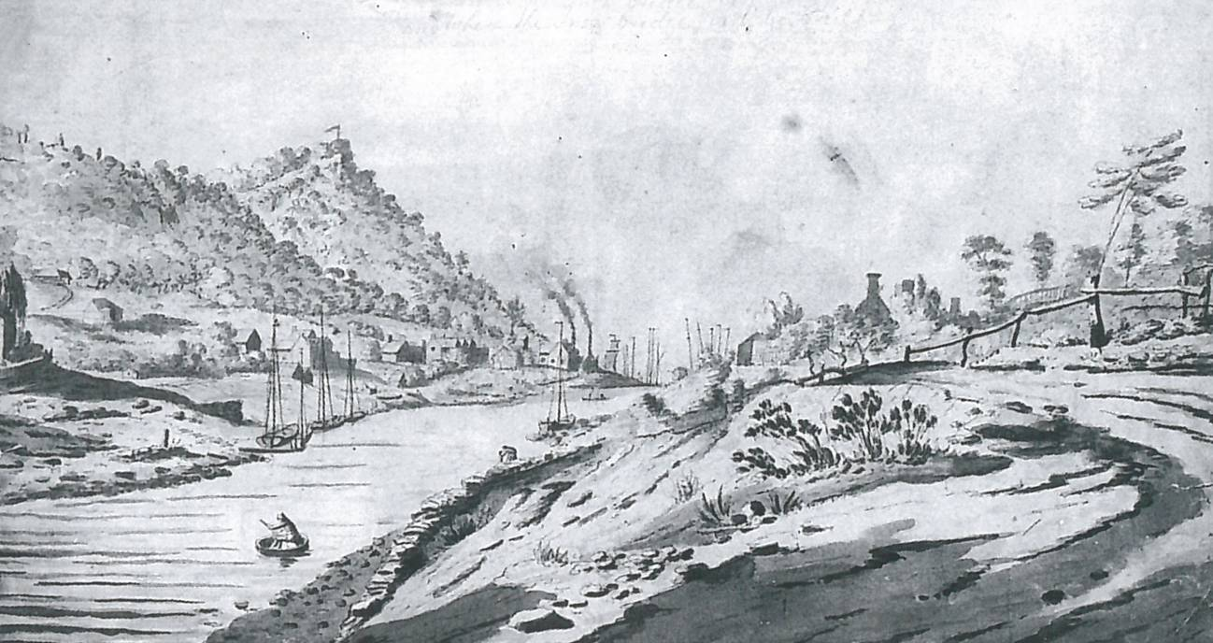

Figure 1: View of the Severn by William Williams, 1777.

https://www.ironbridge.org.uk/our-story/the-iron-bridge/

1. **The construction of the bridge**

The building of the bridge was partly a public relations exercise, advertising the versatility of cast-iron and the skills of Abraham Darby III and his Coalbrookdale company.

The height of the Bridge and the full circle reflected in the water cannot be accidental, although the semi-circular shapes were easier for the foundry pattern-makers, who had never before had to work with such sizes (Fig.2).

The bridge was promoted by the eighteen-century equivalent of a media campaign. The painting Darby commissioned to advertise it show nothing of the pollution of the Gorge, famous for having more furnaces and forges within 3 km of riverbank than anywhere else in the world. Instead, just one lazy wisp of smoke curls up from the chimney of what seems to be a cottage-actually a lead-smelter.

Darby paid an 18 - shilling bill for advertising the views six months before the Bridge officially opened. Thomas Jefferson, later third President of the USA, is known to have bought Iron Bridge engravings through a friend in London, whilst Minister to France in 1786. In 1773 Thomas Farnolls Pritchard, a Shrewsbury joiner turned architect, wrote to the local ironmaster and entrepreneur, John Wilkinson, suggesting an iron bridge across the river.

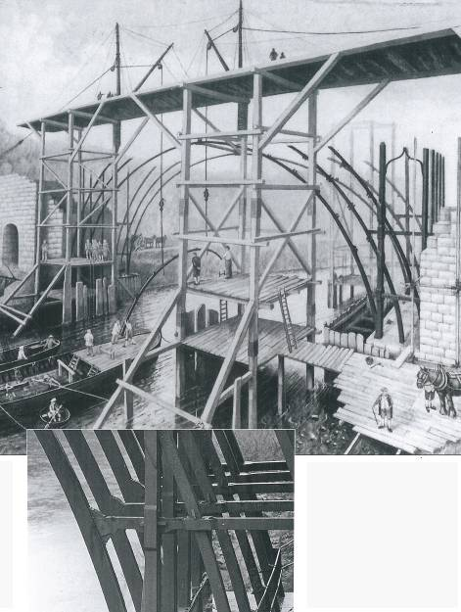

Figure 2: A twentieth-century theoretical reconstruction of how the Iron Bridge might have been built, by Harry Hodson, a Manchester foundry pattern-maker.

https://www.ironbridge.org.uk/our-story/the-iron-bridge/

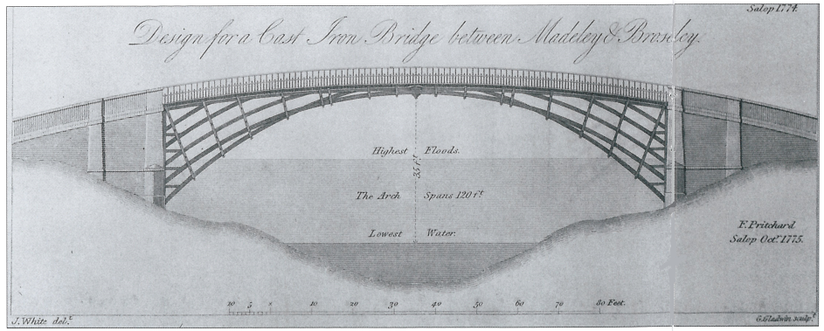

Figure 3: Pritchard's design of the Bridge. https://tishfarrell.com/tag/abraham-darby-iii/

Wilkinson was an enthusiast, sometimes known as "Iron Mad" Wilkinson. His 1775 design proposed a single arch, avoiding the need to build piers in the river-and thus causing no obstacle to boats (Fig. 3).

A group of local businessmen commissioned the ironmaster Abraham Darby III, who estimated its cost at £3,200. In 1776, the Act of Parliament was passed authorising the Bridge, and shares were issued to raise the money. Yet, as late as May 1776, an advertisement appeared asking for tenders to build the Bridge from stone, brick or timber, indicating the uncertainty still felt about the use of iron.

Wilkinson later transferred his shares to Darby, who planned to build the Bridge of iron. Work began in November 1777. Pritchard died that same year, never to see the Bridge, but it is known that in 1779 his brother received nearly £40 from Darby as payment for his late brother's drawings and models, although the final construction was a modification of Pritchard 's original design. Darby's bridge was to be the first in the world to use cast-iron structurally, and artists and writers, spies and engineers came from all over the world to marvel at the most incomparable piece of architecture. (Fig. 4)

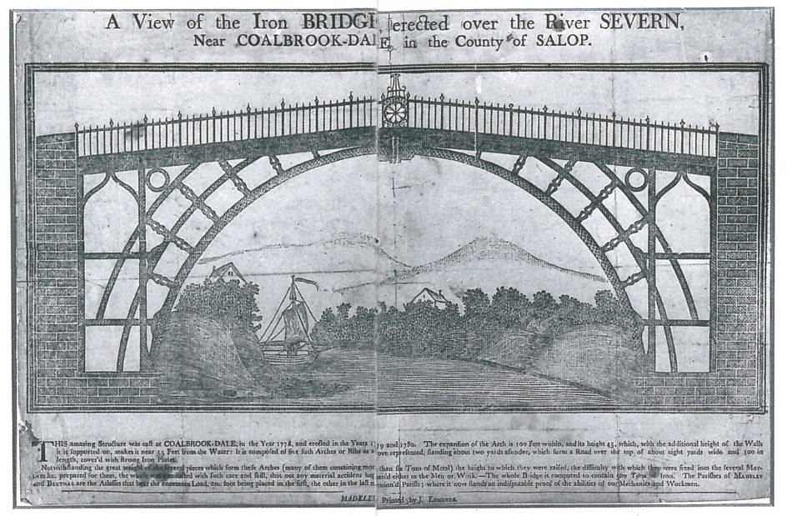

Figure 4 - The Iron Bridge, ca 1790

1. **The Iron Bridge**

Although so many early images of the bridge survive, as well as extensive archives, only one sketch of it under construction is known, by Swedish professor Elias Martin (Fig. 5).

However, the engineering features of the Bridge may help to explain how it was built. Although Darby began work in November 1777, his own-account-book indicates that the ironwork did not begin to go up until May 1779. The first main iron rib was probably raised on 1 and 2 July, and on 16 August a bill for £6 for drink (https://www.ironbridge.org.uk/our-story/the-iron-bridge/) suggests a celebration for finishing this part of the work. The rives was normally too low for river navigation in these summer months anyway, hence the lack of obstruction.

The ribs were cast in two pieces and joined at the centre. The whole bridge covers a span of 30,63 m. Each half-rib weighs nearly 6 tonnes, about the same as eight family cars. The total amount of iron used was 384 tonnes.

Various experiments and reconstructions have been undertaken by students, architects, foundry men and historians, but exactly how the Bridge was raised is still uncertain. It is known from his accounts that Darby used scaffolding, and this may have been linked by a platform built from one bank to the other.

The stone abutments - the supporting structures on each bank of the river into which the iron arches were fixed - went up after the ironwork was erected. From November 1777, preparation of the site and the linking roads occupied much of Darby's time and effort.

Both Pritchard and Darby's foreman Thomas Gregory, built models, which may have been used to rehearse the method of construction. It is also possible that Darby practised raising the iron arches on dry land first, perhaps using wooden patterns like the replica seen today in the Tollhouse on the Bridge.

The iron parts were cast in opera sand moulds, and the joints are based on traditional carpentry methods, including dovetails, wedges, mortises and tenons.

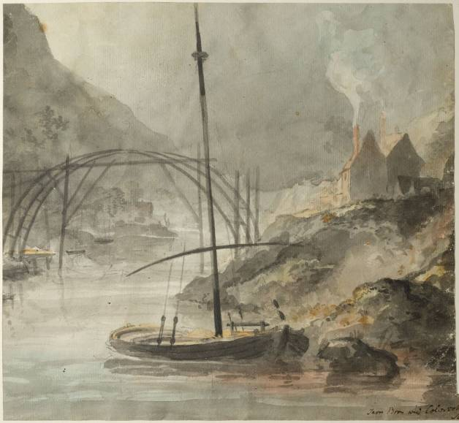

Figure 5 - Elias Martin, The Iron Bridge sketch, (1779).

1. **Iron Bridge Gorge on the World Heritage List**

The Iron Bridge was inscribed on the World Heritage List in 1986. It is known throughout the world as the symbol of the Industrial Revolution. It contains all the elements of progress that contributed to the rapid development of this industrial region in the 18th century, from the mines themselves to the railway lines. Nearby, the blast furnace of Coalbrookdale, built in 1708, is a reminder of the discovery of coke.

The bridge at Ironbridge, the world's first bridge constructed of iron, had a considerable influence on developments in the fields of technology and architecture (http://whc.unesco.org/en/list/371).

*(...)The Ironbridge Gorge provided the raw materials that revolutionised industrial processes and offers a powerful insight into the origins of the Industrial Revolution and also contains extensive evidence and remains of that period when the area was the focus of international attention from artists, engineers, and writers. The property contains substantial remains of mines, pit mounds, spoil heaps, foundries, factories, workshops, warehouses, iron masters’ and workers’ housing, public buildings, infrastructure, and transport systems, together with the traditional landscape and forests of the Severn Gorge. In addition, there also remain extensive collections of artifacts and archives relating to the individuals, processes and products that made the area so important.*

*Today, the site is a living, working community with a population of approximately 4000 people as well as a world renowned place to visit. It is also a historic landscape that is interpreted and made accessible through the work of a number of organisations, in particular, the Ironbridge Gorge Museum Trust (established in 1967 to preserve and interpret the remains of the Industrial Revolution within the Ironbridge Gorge) and the Severn Gorge Countryside Trust (established in 1991 to manage the woodland, grassland and associated historic structures in the Gorge.*

*The bridge is defined as a masterpiece of human genius:*

*Criterion (i): The Coalbrookdale blast furnace perpetuates in situ the creative effort of Abraham Darby I who discovered the production technique of smelting iron using coke instead of charcoal in 1709. It is a masterpiece of man's creative genius in the same way as the Iron Bridge, which is the first known metal bridge. It was built in 1779 by Abraham Darby III from the drawings of the architect Thomas Farnolls Pritchard.*

*It also exhibit an important interchange of human values, over a span of time or within a cultural area of the world, on developments in architecture or technology, monumental arts, town-planning or landscape design; it is an outstanding example of a type of building, architectural or technological ensemble or landscape which illustrates significant stages in human history and it is directly or tangibly associated with events or living traditions, with ideas, or with beliefs, with artistic and literary works of outstanding universal significance.*

*The Criterion of inscription, in fact, confirm these statements:*

*Criterion (ii): The Coalbrookdale blast furnace and the Iron Bridge exerted great influence on the development of techniques and architecture.*

*Criterion (iv): Ironbridge Gorge provides a fascinating summary of the development of an industrial region in modern times. Mining centres, transformation industries, manufacturing plants, workers' quarters, and transport networks are sufficiently well preserved to make up a coherent ensemble whose educational potential is considerable.*

*Criterion (vi): Ironbridge Gorge, which opens its doors to in excess of 600,000 visitors yearly, is a world renowned symbol of the 18th century Industrial Revolution.*

In 2010, nearly 1 million people visited the Ironbridge Gorge and its museums. The Victorian Town Open Air museum at Blists Hill was established before inscription and incorporates scheduled industrial monuments, reconstructed 19th century buildings and new buildings based on local examples. Care is taken to ensure that the relationship between the original buildings and monuments on the property and the other structures, which do not form part of the historic attributes of the property, is clearly stated ensuring authenticity in shape and materials is not compromised (Fig. 6).

The property encompasses an extraordinary concentration of mining zones, foundries, factories, workshops and warehouses which coexist with the old network of lanes, paths, roads, ramps, canals and railroads as well as substantial remains of traditional landscape and housing.

The ironmasters' houses, the workers' living quarters, public buildings and infrastructure are all within the five identifiable areas of Coalbrookdale, Ironbridge, Hay Brook Valley with Madeley, Jackfield and Coalport, which are enclosed by a common boundary.

The technologically revolutionary Iron Bridge spanning the River Severn Gorge is the focal point of the property and, together with the attributes above, includes all that is necessary to convey the former pioneering intense industrial past within its green landscape and thus the Outstanding Universal Value of the property.

The landscape is also a crucial part of the property, and it needs to be managed as a coherent whole, with key views across the valley identified and protected.

With careful attention to details, materials and techniques, most of the historic buildings, structures and urban and rural patterns have retained their essential and authentic historic character, although, some industrial monuments await conservation work. For all these reasons, the The Iron Bridge and its surroundings were inscribed on the World Heritage List (Fig. 7).

The work is of considerable importance, not only in historic, technological and constructive terms: here, architecture and engineering are revealed to the full, making the bridge into a place. This is why in this work, the constructive archetype is connected with the notion of *genius loci, genius artist and genius materials*, in a very rich combination of expressions whose osmosis forms a set of meaning that include the place and its identity and which go beyond the work itself.

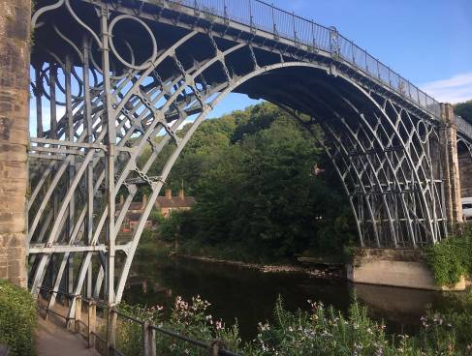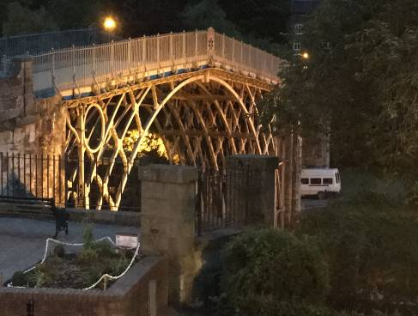

Figure 6: The Iron Bridge on the World Heritage List (Photos Prof. E. Siviero).

The bridge shows its authenticity in the shape and materials,

as required for the properties included on the WHL.

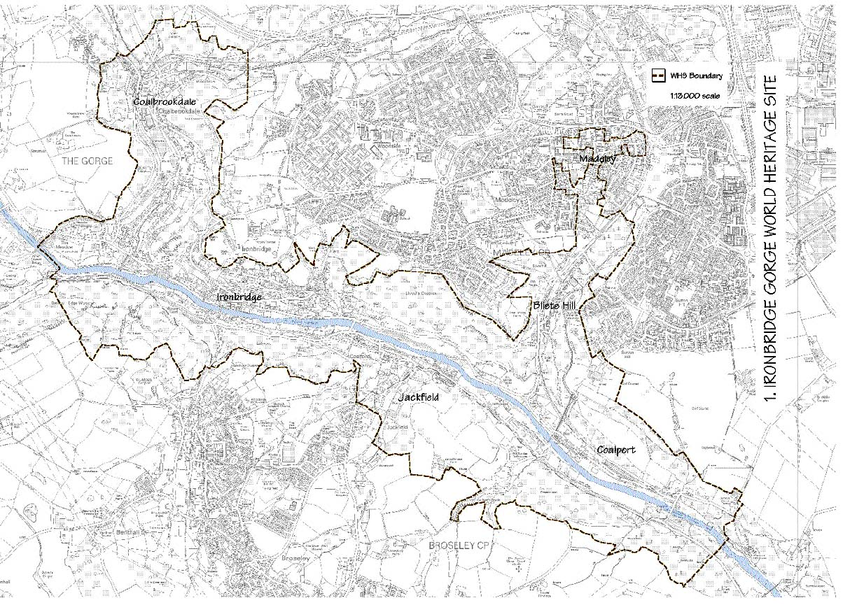

Figure 7: Ironbridge Gorge: map of the World Heritage property

**References**

AA.VV. 2016. The Iron Bridge and town. Peterborough: Jarrold Publishing.

Sealey A. 1976. Bridges and Aqueducts. London: Hugh Evelyn Limited.

Sweetman A., Lassalle-Cehel J., Baron Thaidigsmann C., Vazquez De La Cueva J. 2004. La ingenieria civil en la pintura, Sala De Exposiciones De La Real Academia De Belles Artes De San Fernando. Madrid: Ministerio de Fomento.