|  |  |  |
| --- | --- | --- |
|  | **10th International Conference on Short and Medium Span Bridges**  **Quebec City, Quebec, Canada,**  **July 31 – August 3, 2018** |  |

**EXTENDING LONGEVITY OF CONCRETE STRUCTURES USING CONTINUOUSLY GALVANIZED REINFORCING STEEL**

M. Gagné1,3, S. Pole 1, F. Goodwin 1 and G. Dallin 2

1 International Zinc Association, Canada

2 Galvinfo Centre, Canada

3 [mgagne@zinc.org](mailto:mgagne@zinc.org)

**ABSTRACT:** Corrosion affects everyone around the world, leading to expensive repairs and intensive maintenance programs. In addition to cosmetic concerns, corrosion of reinforcing steel in concrete structures leads to concrete failure, impacting the public with delays and detours. Many maintenance programs include the use of zinc anodes to delay corrosion. By using galvanized reinforcing bar from the beginning, similar results are achieved for the full lifetime of the structure. The galvanizing industry has continued to innovate as technology improves. In addition to traditional general (batch) galvanizing, reinforcing bar can now also be coated in a continuous process. This innovative process takes the technology used in the sheet steel industry, and applies it to reinforcing steel. With the increasing challenge to secure funding for repair and maintenance programs, this paper highlights how to prevent corrosion from the outset.

# **INTRODUCTION**

Galvanizing is by far the most effective way to protect steel from corrosion (Porter, 1994). The long life of exposed galvanized steel structures, such as transmission poles and street furniture, is a testament to the excellent corrosion protection provided by zinc coatings to steel. The zinc coating acts first as a barrier protection, isolating the base steel from corrosive elements, and secondly by cathodic protection, acting as a sacrificial anode to protect the steel should the coating be compromised.

The corrosion protection provided by zinc will also extend the life of steel-reinforced concrete structures exposed to aggressive environments that promote corrosion of steel reinforcement. Galvanizing increases resistance to chloride corrosion both by increasing the threshold chloride level where corrosion begins and by slowing the rate of corrosion after that threshold is exceeded, and is also very effective in combating the effects of carbonization-induced reinforcement corrosion (Yeomans, 2004).

Field studies highlight the long-term performance of galvanized reinforcing steel as a successfully established practice for extending the life of concrete structures in many countries. A recent study conducted in Canada revealed that galvanized steel was found to have 5-10 times lower corrosion rate than carbon steel in heavily contaminated concrete containing 2% of chlorides by mass of cement, depending on environmental exposures. The corrosion rate of carbon steel was found to increase exponentially with time in a very corrosive environment, while galvanized steel maintained a stable and much lower corrosion rate. The low corrosion rates of galvanized rebar explained the fact that no corrosion induced cracking was found on columns of two concrete highway bridges after almost 50 years in service (Zhang, 2015).

Steel reinforcement can be in the form of wire, prestressed strand or reinforcing bar (rebar). In the case of rebar, the most widely used method to apply the zinc is by the batch hot-dip method. It involves the immersion of cleaned steel bars into a bath of molten zinc at 450°C for several minutes. During immersion in the molten zinc, a metallurgical reaction occurs between the steel and the zinc, which produces a coating on the steel made up of a series of layers of zinc-iron intermetallics (Gamma, Delta, Zeta), which grow out from the steel/zinc interface leaving a layer of essentially pure zinc (Eta phase) at the surface of the coating. Batch hot-dip coatings can have a mass of up to about 1,100g/m2 (~150 microns thick). The composition of these coatings, including the thickness of the zinc surface layer, can vary as a function of the chemistry of the steel being coated and of the operating parameters of the zinc bath. Batch hot-dip coatings on reinforcing steel are almost always completely composed of the intermetallic phases due to the chemistry of the steel.

The new continuously galvanized rebar (CGR) is produced by a similar method used for the continuous galvanizing of steel sheet. These highly formable coatings can be bent, stretched and twisted, and are limited only by the formability of the base steel, as demonstrated by automobile car bodies. The formation of the zinc-iron alloy layers that occurs during the batch hot-dip process is avoided in the new process by adding a small percentage (0.20%) of aluminum to the zinc bath and by having much shorter immersion times (1 to 10 seconds). Aluminum acts as an inhibitor to the zinc-iron reaction, forming an extremely thin (less than 1 micron), iron-aluminum-zinc inhibition layer, and allows the production of an essentially pure, yet very formable, zinc coating on the rebar, similar to the steel sheet coatings described above. The continuously galvanized coating above the thin inhibition layer will have the same, essentially pure, zinc composition regardless of the chemistry of the steel being coated.

# **HISTORY**

* 1. **Galvanizing Steel**

Galvanizing steel for corrosion protection has been a common practice for over 150 years, and we now see everything from nails to the steel of prestige bridges being galvanized to ensure longevity of the built world. Originating in the 1950’s, galvanized reinforcing bar in concrete is proven technology with multiple case studies of structures lasting decades before requiring any maintenance. Prestige buildings, including the Sydney Opera House, have used galvanized steel to ensure the structure retains its durability and aesthetic appeal.

As recently as the late 1970’s we saw a switch from uncoated steel to galvanized steel for the auto industry, and now all automobiles are made from galvanized sheet steel. While galvanized reinforcing steel has been around for decades, the bridge industry is poised for a resurgence of its popularity as other “in vogue” options are being deemed ineffective and costly.

* 1. **Continuously Galvanized Rebar Production**

There have been two multi-strand CGR lines operating internationally, one in China and one in the United Arab Emirates. As of 2017, North American production began with a multi-strand line installed in the United States.

# **CORROSION OF STEEL REINFORCING BAR IN CONCRETE**

* 1. **Passivation in Concrete**

Zinc coatings passivate very quickly when exposed to fresh concrete. This passivation enhances the long term corrosion protection of the galvanized rebar during years of service. The initial passivation of a zinc coating when embedded in concrete occurs within hours, and is affected by the chemistry of the surface layer. A coating with a pure zinc layer is known to be more completely passivated than one that is an intermetallic zinc-iron phase (Yeomans, 2004).

The initial passivation of galvanized coatings in concrete is controlled by the relationship between the cement alkali content and the zinc corrosion rate. The pH of cement in contact with the zinc coating controls the formation of a compact and adherent layer of calcium hydroxyzincate (CHZ), a compound that passivates the surface of the zinc coating from further reaction with the concrete. The threshold for passivation of zinc in concrete pore solutions is at a pH of between 12.8 and 13.2 +/- 0.1 (Tan & Hansson, 2008). pH levels greater than 13.2 do not develop in concrete pore solutions during the first few hours if sulphate is used as a settling regulator, or enough alkaline sulphates are present. The passivation layer develops during the first few hours after mixing when the pH of the concrete solution is lower than 12.8 +/- 0.1. If pH is between 12.8 and 13.2 the layer develops slowly and the galvanized coating may continue to react until the passivating layer is formed. In any case, regardless of the pH level of the concrete, the presence of a pure zinc layer is key to the rapid formation of a compact passivating film of CHZ on the galvanized rebar.

* 1. **Corrosion in Concrete**

The corrosion of rebar in concrete occurs when aggressive species, such as chloride ions or a carbonation front, reach the reinforcement. In order to initiate corrosion of galvanized rebar, these aggressive species have to disrupt the physical barrier of the CHZ film. Carbonation lowers pH from highly alkaline to neutrality (pH 7), where the rate of Zn corrosion is very low. As a result, galvanized rebar does not generally corrode in carbonated concrete, unlike black steel. Chlorides are more aggressive and are the most frequent cause of reinforcement distress. Chloride ions come from the raw construction materials, marine environments or de-icing salts. Zinc has a higher threshold value for initiation of corrosion caused by chloride ions than black steel. The concentration of chloride ions required to start corrosion of zinc is up to 4 times higher than the concentration needed to start corrosion of black steel (Yeomans, 2004). This behaviour depends on the source of the chloride ions, the state of the galvanized surface (including protection afforded by zinc corrosion products), and the degree of protection provided by the concrete cover.

Chloride ion induced corrosion of steel in concrete proceeds through a two-stage mechanism of initiation and propagation (Tuutti, 1982). Efforts to achieve long-term durability of reinforced concrete have been mostly directed at delaying initiation of corrosion of the rebar, i.e. postponing as long as possible the start of the propagation stage. The presence of a pure zinc layer on the surface of the steel rebar is the best way to delay the onset of corrosion of the rebar (Yeomans, 2004). The passivating film of CHZ is the first line of defense. The pure zinc layer will then corrode uniformly at less than one-tenth the corrosion rate of the base steel, thereby extending the onset of corrosion of the steel rebar ( Tan & Hansson, 2008). Through galvanic protection, the zinc will continue to protect the steel as the coating is consumed or damaged. It should also be noted that the zinc corrosion products migrate away from the corrosion site and help densify the concrete surrounding the rebar, further delaying the onset of corrosion, and also increasing bond strength (Yeomans, 2004).

In concrete, the critical chloride level needed to initiate corrosion of bare steel is 0.65 kg/m3 (Kinstler, 2002). In a 1992 International Lead Zinc Research Organization (ILZRO) performance evaluation report, a bridge in Boca Chica, FL reached this level of chloride in the concrete within 3 years, and the galvanized reinforcing bars in place showed no corrosion distress 19 years later. (Stejskal, 1992)

As illustrated in Figure 1, both black steel and galvanized rebar inserted in concrete go through a dormant (initiation) period. This is labeled as “A” for bare steel and a longer period “C” for galvanized steel. After the initiation period, the corrosive species build up at the metal/concrete interface and corrosion begins. Bare steel begins to corrode rapidly at this point, as shown by the steep slope of the line in period “B” in Figure 1, until cracks, spalling and other damage appears on the concrete structure. Galvanized steel corrodes much more slowly through period "D" where even remnant zinc areas will continue to cathodically protect bare steel areas, providing a much longer timeline until damage to the concrete structure appears.

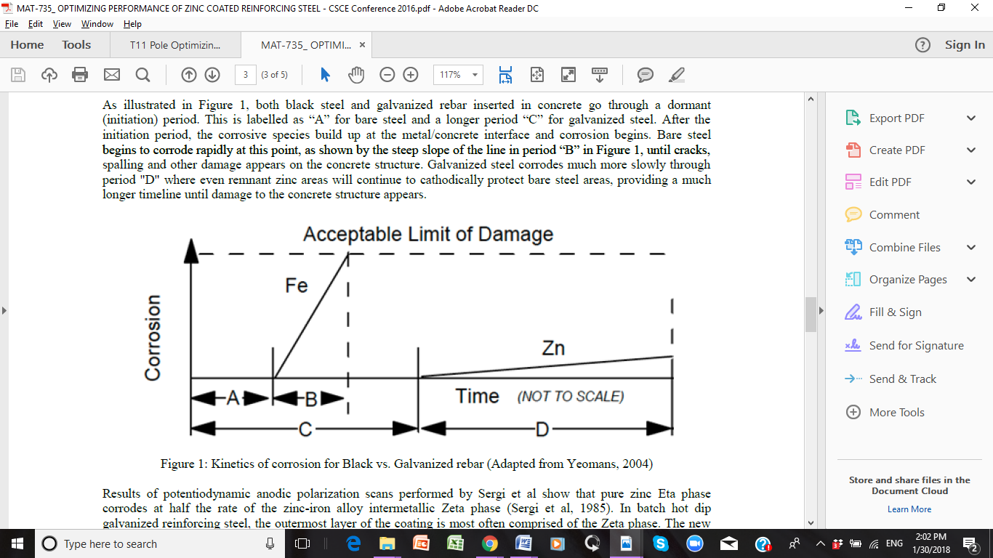

Figure 1: Kinetics of corrosion for Black vs. Galvanized rebar (Adapted from Yeomans, 2004)

* 1. **Bond Strength in Concrete**

The calcium hydroxyzincate layer also serves to strengthen the bond between the reinforcing steel and the concrete. The figure below looks at strength in terms of load slip, highlighting the reduced slip of galvanized rebar compared to both black and epoxy bars. Based on this data, it is actually possible to reduce the lap lengths of galvanized rebar below the requirements of black bar. In practice this means there needs to be no change of lap lengths to switch in galvanized bars. (Yeomans, 2004)

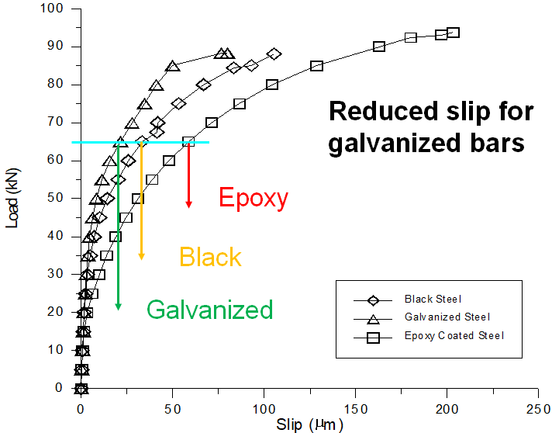

Figure 2: Load-Slip Characteristics of Reinforcing Steel (Adapted from Yeomans, 2004)

# **CONTINUOUSLY GALVANIZED REBAR**

The CGR coating process uses a small amount of Al (0.2%) in the zinc bath to produce a coating that is almost pure zinc except for an approximately 0.1 micron thick ternary intermetallic alloy layer (Fe2Al5Znx) at the zinc/steel interface. Such a coating, with 40-60 microns of pure zinc, can successfully withstand the subsequent reinforcing bar forming operations because of its very thin alloy layer (the same as that produced on continuously galvanized sheet products), is very adherent due to the metallurgical bond, and can be bent, stretched or twisted with minimal cracking, and no peeling or flaking.

# **Corrosion Protection**

The pure zinc layer produced in the continuous galvanizing process has the potential to resist corrosion in concrete to an extent equal to that of much thicker zinc-iron coatings (Yeomans, 2004).

Results of potentiodynamic anodic polarization scans performed by Sergi et al show that pure zinc Eta phase corrodes at half the rate of the zinc-iron alloy intermetallic Zeta phase (Sergi et al, 1985). In batch hot dip galvanized reinforcing steel, the outermost layer of the coating is most often comprised of the Zeta phase. The new continuously galvanized rebar coatings will be comprised entirely of pure zinc, and are expected to corrode at half the rate of the zinc-iron intermetallic layers. Half the coating thickness will be required to provide equivalent corrosion protection.

More recent results from Tan and Hansson (Tan & Hansson, 2008) confirm that the corrosion rate for a coating with a pure zinc surface layer is half the rate of an annealed coating composed entirely of zinc-iron intermetallic phases. They measured the average depth loss of coating thickness for the formation of the passivating CHZ layer on a pure zinc coating as compared to a fully annealed coating as listed in Table 1. Both coatings are fully passivated, although only 0.45 microns of the pure zinc coating are consumed, while 1.18 microns of the annealed coating are consumed. The depth losses are considered insignificant when compared to the total coating thickness, but support the previous work showing that a pure zinc coating will last twice as long as a coating composed of zinc-iron intermetallic phases.

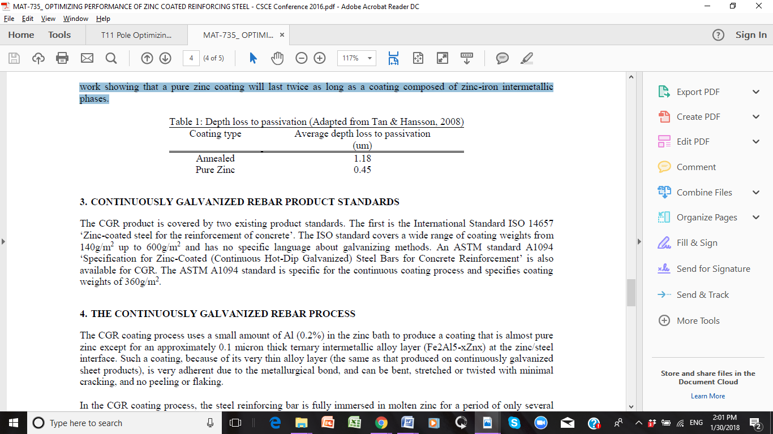

# **Product Standards**

The CGR product is covered by two existing product standards. The first is the International Standard ISO 14657 ‘Zinc-coated steel for the reinforcement of concrete’. The ISO standard covers a wide range of coating weights from 140 g/m2 up to 600 g/m2 and has no specific language about galvanizing methods. An ASTM standard A1094/A1094M ‘Specification for Zinc-Coated (Continuous Hot-Dip Galvanized) Steel Bars for Concrete Reinforcement’ is also available for CGR. A1094/A1094M is specific for the continuous coating process and specifies a coating weight of 360 g/m2.

# **Production Process**

In the CGR coating process, after mechanical cleaning and fluxing, the steel reinforcing bar is fully immersed in molten zinc for a period of only several seconds before cooling. Including the preheating stage, the total time the steel is at the temperature of the molten zinc (465°C) is 4-5 seconds. This allows all grades of steel (normal and high strength) to be galvanized with no change in the coating structure or mechanical properties. All grades, including high strength, will have the same coating of essentially pure zinc. A conceptual continuous galvanizing process line is shown in Figure 2.

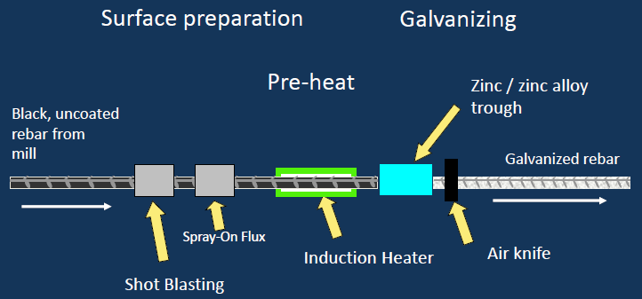

Figure 3: Proposed process for continuous galvanized of reinforcing bar (Courtesy of Coating Controls)

The heat-to-coat method for galvanizing shown in Figure 2 uses an inert atmosphere to de-oxidize the steel before galvanizing. Flux based versions of this process are being used to produce cut lengths of CGR. Using a flux to deoxidize the steel allows for more flexibility in production schedules. To improve productivity, multiple strands can be run side-by-side at speeds from 10 to perhaps 80 metres per minute. The induction heating step is used to dry the flux, and/or to preheat the bar surface temperature before galvanizing, allowing the normal continuous galvanizing iron/aluminum reaction to occur that forms the thin and ductile intermetallic alloy layer.

This process could be used to convert black coils of reinforcing bar into galvanized coils that could be sent for subsequent processing into galvanized rebar cut lengths and formed parts. One concern about doing this is the added cold work that might create unacceptable strain ageing in the rebar from the extra uncoiling, straightening and recoiling involved in such a process. The rapid induction heating step would be expected to largely relieve any stresses created prior to galvanizing by taking advantage of the ‘uphill quenching’ effect. (Dieter, 1961) This would result in a galvanized coil of rebar with very similar cold work stresses as current black rebar coils have prior to being formed into parts.

# **Installation**

With the durability of galvanized rebar, bars can be installed without any additional considerations. As previously mentioned, the pure zinc coating results in bars that can be formed after coating, which allows for field bending as needed.

# **CONCLUSIONS**

A new continuously galvanized rebar product has been developed with excellent corrosion resistance and exceptional formability. Galvanizing increases resistance to chloride corrosion both by increasing the threshold chloride level where corrosion begins and also by slowing the rate of corrosion after that threshold is exceeded, and is immune to corrosion at the pH levels of carbonization-induced reinforcement corrosion. These highly formable CGR coatings can be bent, twisted and stretched and are limited only by the formability of the base steel.

Continuously galvanized reinforcing bars will significantly increase the life of reinforced concrete structures and maximize the potential investment in public infrastructure and other construction projects.

**REFERENCES**

Dieter, G.E. 1961. *Mechanical Metallurgy*, p. 418, McGraw-Hill, New York

Gagne, M. et al. "Optimizing Performance of Zinc Coated Reinforcing Steel in Concrete Structures," in *CSCE Resilient Infrstructure*, London, ON, 2016.

Kinstler, T.J. 2002. Research and Update on Galvanized Reinforcing Steel,

www.galvanizedbar.com

Porter, F.C. 1994. Corrosion resistance of zinc and zinc alloys, Marcel Dekker, New York, NY

Sergi, G., Short, N.R., Page, C.L. 1985. Corrosion of Galvanized and Galvannealed Steel in

Solutions of pH 9.0 to 14.0 *Corrosion*, 41(11) 618-624

Stejskal, B. 1992. Project ZE-389, Evaluation of the Performance of Galvanized Steel

Reinforcement in Concrete Bridge Decks, Construction Technology Laboratories, published

by ILZRO

Tan, Z.Q., Hansson, C.M. 2008. Effect of surface condition on the initial corrosion of galvanized

reinforcing steel embedded in concrete, *Corrosion Science* 50, 2512-2552

Tuutti K, 1982 *Corrosion of Steel in Concrete*, Swedish Cement and Concrete Research

Institute, Stockholm

Yeomans, S. R. 2004. *Galvanized Steel Reinforcement in Concrete*, Elsevier Ltd, Oxford

Zhang, J. Baldock, B. 2015. Condition Assessment and Corrosion Mitigation of Galvanized

Steel Reinforcement in Concrete Structures, NRC-CNRC, Ottawa