|  |  |  |
| --- | --- | --- |
|  | **10th International Conference on Short and Medium Span Bridges**  **Quebec City, Quebec, Canada,**  **July 31 – August 3, 2018** |  |

**Nonlinear Effective Stiffness Equation for Slender Circular Steel-Reinforced CFFT Columns**

Maha Hussein Abdallah1, Hamdy M. Mohamed2, Radhouane Masmoudi3, Ahmed Moussa4

1 PhD candidate Department of Civil Engineering, University of Sherbrooke, Quebec, Canada, J1K2R1. [Maha.Abdallah@Usherbrooke.ca](mailto:Maha.Abdallah@Usherbrooke.ca)

2 Research Associate-Lecturer, Department of Civil Engineering, University of Sherbrooke, Canada, Associate Professor, Helwan University, Cairo, Egypt. [Hamdy.Mohamed@Usherbrooke.ca](mailto:Hamdy.Mohamed@Usherbrooke.ca)

3 Professor of Civil Engineering Department of Civil Engineering University of Sherbrooke, Quebec, Canada,J1K2R1,corresponding_author_email:Radhouane.masmoudi@usherbrroke.ca

4 Professor of Concrete Structures, and former Dean, Helwan University. Dean of faculty of Engineering, Badr University in Cairo, BUC, E-mail: ahmousa2@yahoo.com.

**ABSTRACT:** When designing a column, structural engineers must take into consideration the impact of second order or P-delta effects to determine if loads applied to a structure in its deformed position significantly increase internal forces (i.e. by more than 5%). The accuracy of evaluating the effect of the second order effects depend mainly on the realistic determination of the effective flexure stiffness of the column *(EI)*. Current codes and design provisions on the effective stiffness (*EIe*) of the columns are reviewed along with past studies considering the presence external FRP confinement on the effective stiffness expressions. This study was conducted to examine the influence of different variables on *EI* used for design of slender circular columns under short term loads including the variables presented due to the existence of external confinement in terms of FRP tube. Over 2000 isolated circular reinforced CFFT columns each with a different combination of specified properties of variables, in symmetrical single curvature bending, were simulated to generate the stiffness data. A new nonlinear design equation to compute (*EI)* of reinforced concrete columns was then developed from the simulated stiffness data considering the stiffness effect of external FRP tube.

**1 Introduction**

Concrete-filled fiber reinforced polymer (FRP) tubes (CFFT) have been widely investigated in recent year, where it proved to have significant effect when used as an external confinement in improving the strength and ductility of concrete columns. When a CFFT column with length (L) subjected to eccentric load, it deflects laterally and exhibit an additional eccentricity (midheight deflection) which results in an additional moment along its height. This additional moment is considered as the second order moment which controls the maximum moment acting on the column as shown in Figure (1). It may be noted that a CFFT column under single curvature bending is considered the worst case scenario for causing secondary moments. The accuracy of evaluating the effect of the second order effects depend mainly on the realistic determination of the effective flexure stiffness of the column *EIe*. Due to the importance of strength and stiffness for structure members, different design codes provide expressions to calculate these properties. However, there is no uniﬁed equation for calculating the stiffness of concrete members confined with FRP tube. The ACI Building Code 318-14 allow the use of the moment magnifier method to calculate the second order moments in columns. This approach is affected by the critical buckling load (*Pcr*) which is strongly affected by the effective flexure stiffness *EIe*. The AISC design specification introduces an equation for stiffness of composite members (for example a member confined with steel tube).

This paper introduces an extensive study on the effective flexure stiffness of slender (CFFT) columns. On the basis of a theoretical simulation, variables influencing the effective stiffness expressions are discussed. The main parameters considered are: the eccentricity ratio (*e/D*), slenderness ratio (*L/D*) and axial load ratio (*Pu/Po*). Nonlinear design equation is developed to compute (*EIe*) of steel reinforced CFFT circular columns. The proposed equations are applicable for any load levels including both service and ultimate loads.

**2 Review for Current Codes and Past Studies on Stiffness Expressions**

Many codes and design provisions proposed several methods to determine the stiffness for different structure elements. They consider the stiffness as an important design parameter where it is required for defining buckling capacity, deflections, and serviceability criteria. For instance, columns stiffness have been studied for either reinforced concrete columns or columns confined with steel tubes. AISC (2016) suggested the following stiffness equation for composite columns confined with steel tube;

[1] 

Where *C*1 = coefficient for calculation of effective rigidity of an encased composite compression member [2] = 

According to ACI 318-14, the moment magnifier method is used to calculate the second order moments in columns. This approach is affected by the critical buckling load (*Pcr*). For calculating the critical axial buckling load, the primary concern is the choice of a stiffness *EIe* that reasonably approximates the variations in stiffness due to cracking, creep, and nonlinearity of the concrete stress strain curve. Thus to consider the maximum bending moment which includes the second order effects occurring along the height of the column the following equations are used;

[3] 

[4] 

[5] 

where *M2* is the large factored end moment on a compression member, C*m* is coefficient accounting for non-uniform moment, *Pcr, Pu* = critical axial force and ultimate axial force, respectively.

For a pin-ended column of length L subjected to equal end moments with single curvature bending,  can be approximated as:

[6] 

*EIe*  shall be calculated by the following equation

[7] 

In brief, ACI 318-14 equation for *EIe* is independent from the load applied on the column while many other authors as confirm that the effective flexure stiffness depends on the loads applied by means of relative eccentricity. For FRP confined RC columns an expression was suggested based on ACI expression where the contribution of external FRPs to the stiffness equation can be considered as follows:

[8] 

Thus, they assume that contribution of the external FRP is the same as that of reinforcing steel in the overall stiffness of the column, the accuracy of this equation will be discussed later in this paper.

In these equations,

,  = modulus of elasticity of concrete and steel bars respectively, MPa.

,  ,  = Cross section area of Concrete, Steel bars and Steel tube, mm2

 = moment of inertia of gross concrete section, neglecting reinforcement, mm4

= moment of inertia of steel tube about the elastic neutral axis of the composite section, mm4

 =moment of inertia of Steel about centroid of section, mm4

,  = the modulus of elasticity and moment of inertia of the external FRP, respectively.

**3 Theoretical Stiffness Equation**

A theoretical model based on secant formula developed by Timoshenko and Gere (1961) for pin-ended slender column subjected end moments was used in this study as follow,

[9] 

, ,  were shown in Figure (2) which present the schematic cross section and column axial load-bending moment interaction diagrams. The cross section and column axial load-bending moment interaction diagrams were drawn following the same steps mentioned in Choo et al. (2006)

**3.1 Parameters used for Simulation of Theoretical Stiffness for CFFT Columns**

To simulate the theoretical stiffness for CFFT columns, different combinations of specified parameters for the components of the circular CFFT columns are used. Table (1) shows the different parameters used in this study for concrete, reinforcing bars (Steel) and FRP tube. Most of the parameters used were extracted from previous experimental data and mentioned as influence parameters in literature. For concrete, concrete compressive strengths (${f^{'}}_{c}$) is considered an important parameter to be studied (Khuntia and Ghosh 2004) while for reinforcing steel a specified yield strength ($f_{y}$) of 462 MPa was used with a variety in reinforcing ratio ( $ρ_{b})$ (Mohamed and Masmoudi, 2008, 2010). Three slenderness ratio *(L/D)* and 8 eccentric ratio *(e/D)* were also used, the slenderness ratios used (10, 15 and 20) and the end eccentricity ratio *(e/D)* ranged from (0.05 to 0.65) as this is the usual range for reinforced concrete buildings (Mirza and MacGregor, 1982). For the FRP tube the important parameters shall be studied including the confinement reinforcement ratio () which depends on the thickness and internal diameter of the tube, and the tensile strength and young’s modulus the tube in the longitudinal direction (,) (Mohamed and Masmoudi ,2011, 2012), where the longitudinal direction of the tube act as longitudinal reinforcement that resist the overall buckling of the column. The theoretical *EI* for each of CFFT column studied was computed from Equation 9 and using ( &) from the cross section strength and slender column interaction diagrams.

**3.2 Comparison between available effective *EIe* equation and theoretical *EIth* values**

As Equation 8 consider the presence of external confinement on RC column, the accuracy of this equation shall be studied. Thus, this equation will be compared to the theoretical *EIth* values computed from Equation 9 for all simulated steel reinforced CFFT columns. The result of this comparisons plotted in Figure (3), which shows histogram and statistics of the ratios of theoretical *EIth*to Equation 8 *EIe*values. Note that, stiffness ratios (*EIth*/ *EIe*) greater than one indicate that *EIe* is conservative, and values of (*EIth*/ *EIe*) less than one indicates that *EIe* is non conservative. It is shown that the average stiffness ratio equals 1.42 with a coefficient of variation of 0.28. These values are considered quite high, thus Equation 8 is considered an inaccurate equation and it is necessary to develop new equation that take into consideration all the important aforementioned parameters.

**3.3 Format of and variables used for proposed EIe Equation**

The variables used for developing of the *EIe* equation proposed in this study were divided into three groups: 1) variables affecting the contribution of the confined concrete to overall effective stiffness of CFFT columns; 2) variables affecting the contribution of steel longitudinal reinforcement  to the overall effective stiffness of CFFT columns; 3) variables affecting the contribution of the FRP tube  to the overall effective stiffness of CFFT columns. Therefore, a modified version is proposed for steel reinforced CFFT column as follows;

in which  are dimensionless reduction factors (effective stiffness factors) for concrete, longitudinal steel bars and FRP tube, respectively. The reduction factor represents the effect of different variables that influence the contribution of concrete to the overall column stiffness and can be linear or nonlinear function of these variables. If  is taken as a linear function ofand  and  assumed to be equal to, thus, equation for steel CFFT column becomes;

[10] 

In Equation 10  is a constant (equivalent to intercept of a simple linear equation) and the remaining values are dimensionless factors corresponding to independent variables  and. A correlation analysis of the theoretical *EI* data was conducted and the results indicated that both the eccentric ratio *(e/D)* and slenderness ratio *(L/D)* have the most significant effect on the stiffness beside the effect of the axial load ratio *(Pu/Po)*. These results agreed well with what was mentioned before by several researchers on the factors affecting the contribution of concrete to the stiffness of slender columns. Therefore the following equations can be assumed, for steel reinforced CFFT columns;

[11] 

**3.3 Analysis of the Theoretical Stiffness Data using the Multiple Regression Method**

It is important to conduct regression analysis of the theoretical stiffness data for steel CFFT columns to estimate values of coefficients of key variables that affect the flexure stiffness of CFFT columns. The multiple regression analysis was conducted using the simulated theoretical flexure stiffness data *EIth* resulting from Equation 9 for steel reinforced CFFT columns and substituted in Equation 11. The resulting equation for steel CFFT columns, is;

[12] 

**3.4 Proposed *EIe* Equation for Steel Reinforced CFFT Columns**

The purpose of conducting the regression analyses of the theoretical stiffness data for steel CFFT columns was to estimate the values of coefficients related to some variables that affect the flexure stiffness. Equation 12 shows a value of . A value of 0.8 for  appears to be a reasonable approximation and was used for developing a more refined *EIe* equation through curve fitting to the simulated theoretical stiffness data. the dimensionless reduction coefficient for FRP tube appeared to be ranged from approximately 0.9 to 1, thus, to incorporate the parameters that affect the stiffness of FRP tube a simplified equation was suggested as follows;

[13] 

[14] 

where  is the confinement reinforcement ratio ();is the strength- reinforcement index of the FRP tube and concrete; = the tensile strength of the FRP tube and modulus of elasticity of the FRP tube in the longitudinal direction, respectively. Concrete dimensionless reduction factor, is a function of eccentric ratio *e/D*, the slenderness ratio *L/D* and the axial load level *Pu/Po*, thus with the aid of a spreadsheet and using trial and error procedure to develop an approximate equation for using the theoretical stiffness data and the assumed dimensionless reduction factor for steel and for the FRP tube; the following equation for was obtained;

[15] 

where  for  and  for .

Therefore, the proposed *EIe* equation for steel reinforced CFFT columns, respectively, can be written as follow;

[16] 

Note that, this equation can be used at any load level. To test the accuracy of this equations *EIe) proposed*will be compared to the theoretical stiffness data and the available experimental data. Figure (4) shows comparison between Equation 16 and the theoretical stiffness data *EIth*in the form of histograms. It was clear that the mean value for the proposed equation with the theoretical data is nearly equal 1 with a coefficient of variation of 0.1. This indicates the accuracy of the proposed equations for steel reinforced CFFT columns.

**4 Conclusion**

This paper presents new design equation for the effective flexure stiffness of circular slender Steel reinforced CFFT columns. The CFFT columns were subjected to short-term loads in a symmetrical single curvature bending. A theoretical statistical simulation of the parameters that affect the flexure stiffness (*EIe)* was conducted. The design equation take into consideration the variation in three parameters including; eccentricity to diameter ratio(e/D), slenderness ratio *(L/D)* and the axial load level *(Pu/Po*), thus, the proposed equations are applicable for any axial load level including service and ultimate loads. Based on the results of this study, the following conclusions can be drawn;

1. Increasing the eccentric and axial load ratios result in a reduction in the effective flexure stiffness *(EIe)* of the slender CFFT column. Thus, a new stiffness reduction factor for concrete was suggested, where.
2. Stiffness reduction factor for reinforcing bars  was proposed for steel reinforced CFFT columns.
3. The effectiveness of the confinement induced by the external FRP tube was taken into consideration in the formulation of the design equation where a new stiffness reduction factor for FRP tube was proposed.  depends mainly on the strength-reinforcement ratio of FRP tube and concrete () and was formulated as ().

Table 1 - Different parameters of reinforced CFFT Columns ̽

|  |  |  |  |
| --- | --- | --- | --- |
| CFFT Column Components | Properties Studied | Specified Values | No. of Specified Values |
| Concrete | $${f^{'}}_{c}$$ | 25,30,40 (MPa) | 3 |
| Steel reinforcing bars | $$f_{y}$$ $$ρ_{s}$$ | 462 (MPa)  1%, 3%,5% | 1  3 |
| FRP Tube | D  t | 57.9, 146 (MPa)  8785 ,12000 (MPa)  152, 320 (mm)  2.54, 6.4 (mm) | 2  2  2  2 |
| Section Properties | L/D  e/D | 10,15,20  0.05;0.1;0.2;0.3;0.4;0.5;0.6;0.65 | 3  8 |
| |  | | --- | | ̽ Total number of simulated Steel CFFT columns= 3*1*3*2*2*2*2*3*8= 1728, with each CFFT column has a different combinations of specified parameters shown above. | | | | |

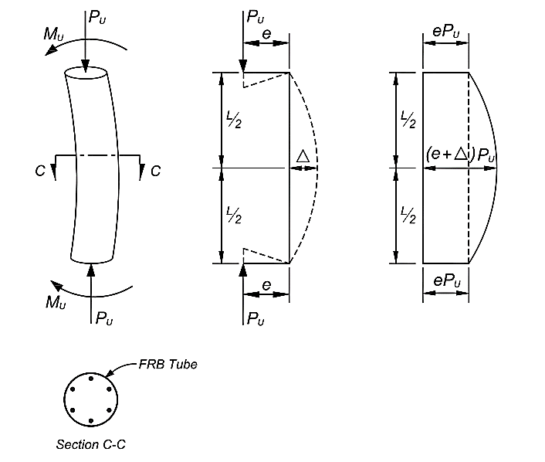

**(a) (b) (c)**

Figure 1- Type of CFFT Column Studied: (a) Symmetrical single curvature pin-ended CFFT column; (b) Forces on the column; (c) Bending moment diagram (M= Pu (e+∆))

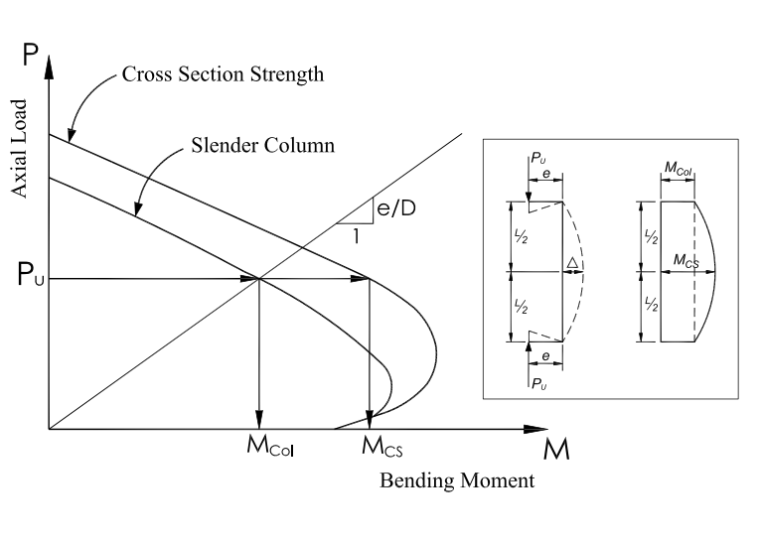

Figure 2- Schematic axial load-bending moment interaction diagram for cross section and slender CFFT column

Figure 3- Comparison between Equation (8) and theoretical equation

Figure 4- Comparison of proposed design equations with simulated theoretical data for Steel reinforced CFFT columns (Eq. (16)

**REFERENCES**

ACI 318-14. ; 2014. Building code requirements for structural concrete. Farmington Hills, MI: American Concrete Institute.

AISC. Specifications for structural steel buildings. ANSI/AISC 360-16. Chicago.

Choo, C. C., Harik, I. E., and Gesund, H. 2006. Strength of Rectangular Concrete Columns Reinforced with Fiber-Reinforced Polymer Bars. *ACI Structure Journal*, ACI, 103(3), 460–466.

Khuntia M., Ghosh S. K. 2004. Flexural stiffness of reinforced concrete columns and beams: analytical approach. *ACI Structure Journal*, ACI, 101; 351-363.

Mirza S. A. MacGregor J. G. 1982. Probabilistic study of strength of reinforced concrete members. *Canadian Journal of Civil Engineering*, 9(3), 431-448.

Mohamed, H.M., and Masmoudi, R. 2008.Compressive Behaviour of Reinforced Concrete Filled FRP Tubes. *ACI Special Publication*, SP, SP-257-6, pp. 91-109.

Mohamed H.M. Masmoudi R. 2010. Axial load capacity of concrete-filled FRP tube columns: Experimental versus Theoretical Predictions. *Journal of Composite for Construction*, ASCE, 14(2), 231–243.

Mohamed, H. Masmoudi, R. 2011.Deflection prediction of steel and FRP-reinforced concrete-filled FRP tube beams. *Journal of Composite for Construction*, ASCE, 15(3): 462-472

Mohamed, H.M., and Masmoudi, R. 2012.Effect of test parameters on flexural strength of circular fiber-reinforced polymer-confined concrete beams. *Journal of Reinforced Plastics and Composites*, 31(13):897-914.

Timoshenko, S. P., and Gere, J. M. 1961, Theory of Elastic Stability, 2nd Edition, McGraw-Hill Book Co. New York, 541.