 | 10th International Conference on Short and Medium Span Bridges  Quebec City, Quebec, Canada,  July 31 – August 3, 2018 | 

- DETERMINISTIC AND PROBABILISTIC ASSESSMENT OF LIVE LOAD EFFECTS ON AN EXISTING TRUSS BRIDGE
Hernández-Martínez, Alejandro¹, García-Soto, Adrián D.^{1,3}, Hernández-Barrios, Hugo² and Valdés-Vázquez, Jesús G.¹
¹ Civil Engineering Department, Engineering Division, Universidad de Guanajuato, Mexico.
² Civil Engineering Faculty, Universidad Michoacana de San Nicolás de Hidalgo, Mexico.
³ adgarcia@ugto.mx
Abstract: Live load effects on bridges are commonly considered for design and evaluation purposes. However, it is not common to use extensive and realistic information to inspect the structural behaviour of each element of an existing truss bridge under truck loading. Bridges in Mexico are designed by code, but most live load models used by Mexican designers are often the result of engineer’s judgment and are not formally calibrated, and/or the reliability levels using such models are not explicitly established. Therefore, in this work, an existing truss bridge in southwest Mexico is considered as a realistic case study to investigate live load effects. Weigh-in-motion (WIM) data are employed to analyze how much the response differs compared to that expected by code design for a basic load combination. A recently proposed live load model developed for bridge design in Mexico is employed for such purpose, since this model was calibrated for a target reliability level and girder bridges. First a description of the truss bridge, existing live load models (for deterministic analysis), WIM data and used software is given. Then, and extensive number of heavy trucks extracted from WIM database are run over the bridge, and statistical information of the demand on the truss members are collected and probabilistically characterized. Finally, the probabilistic demands are discussed. Note that for computing the load effects for thousands of considered heavy trucks, a program was codified and expressively developed for the study, since no commercial software is adequate for such a task. It was found that live load models developed for girder bridges may not be suitable for designing truss bridges, and that this can also have implications in reliability and code calibration issues.
- INTRODUCTION
The study of live load effects of bridges subjected to vehicular loads using WIM data is a widely study topic in recent years. However, focus of extensive computing of axial loads on truss bridges is not as common. Many studies deal with simple span bridges (Liu et al., 2017) and/or few cases of continuous bridges. Some recent works study live load effects generated by vehicles from WIM data considering multiple presence statistics (Gil and Kang, 2015) or multiple girders for simple span bridges (Anitori, et al. 2017;). Regarding truss bridges there also some recent studies, however they deal with live loads from code models or testing trucks (Laurendeau et al., 2015) or other issues, but not extensive use of a WIM database for a probabilistic study of axial loads on each truss member is found. Recent studies dealing with continuous bridges have found that live load models developed by using simple spans could be adequate to reproduce the loads effects for continuous bridges under the same traffic conditions (García-Soto et al., 2015); however, the adequacy of using live load models for simple spans on truss bridges needs revision. Other recent studies include simple-span and two-span continuous bridges for carrying out calibration of live load factors (Eamon et al., 2016), live load factors by considering continuous bridges subjected to special loads generated by extremely heavy mining trucks (Oudah et al., 2017), simplified probabilistic models for load effects projection (Soriano et al., 2017), but not much is investigated regarding probabilistic analysis of live load effects on truss bridges by using WIM data. Therefore, the main objective of this study is to carry out a probabilistic analysis of load effects on existent bridge truss elements by using WIM data, and use it to investigate the adequacy of designing truss bridges with live load models developed for simple or continuous spans.
- BRIDGE DESCRIPTION
For this study the “El Infiernillo” (The little hell) bridge is considered. It is in Mexican federal toll highway 37 Morelia- Lázaro Cárdenas in the border between Michoacán and Guerrero states in southwest Mexico. This highway is strategic, since it connects Morelia (Capital City of Michoacán state) with Lázaro Cárdenas Harbor in the Pacific, key site for exporting and importing products. The bridge has a total length of 360 m along 8 spans; three spans in each extreme approximately 26 m long, and two central spans 102 m long. For the extreme spans prestressed concrete beams were employed, while for the longer spans trusses were used; one of them is depicted in Figure 1. The bridge accommodates two-lane traffic (one for each direction), and spans over the reservoir of the dam with the same name (“El Infiernillo”), which was built between 1961 and 1962 and is one of the main hydroelectric facilities in the country by its power generation capacity. Both main trusses are connected in the lower nodes (inferior part of Figure 1) with a traversal truss, as depicted in Figure 2, which supports a concrete slab and steel beams (forming a composite system through shear connectors), over which the asphalt wearing surface is allocated.
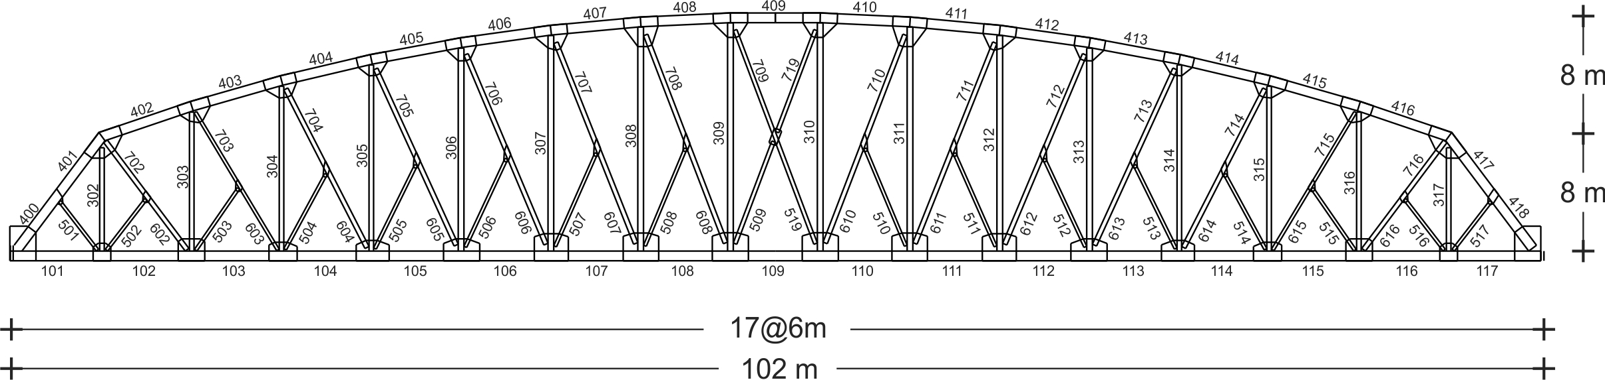
Figure 1 Truss in central spans for “El Infiernillo” bridge
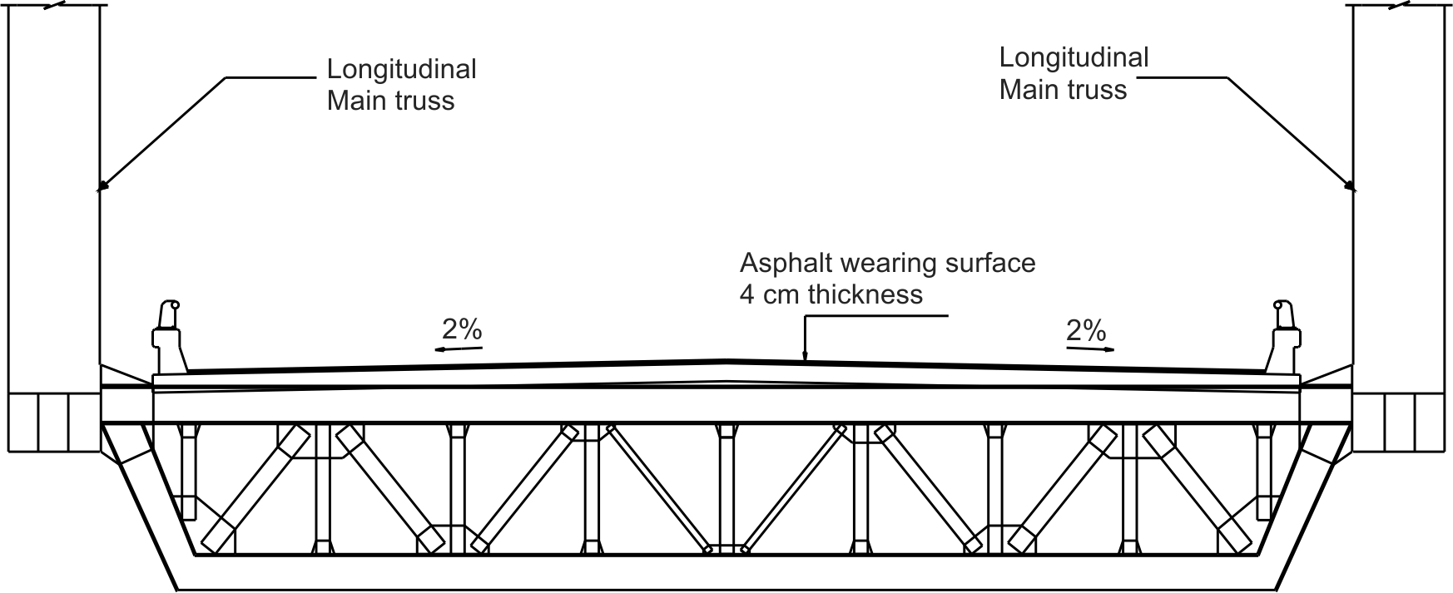
Figure 2 Transversal truss
Bridge design regulations in Mexico depends on the Ministry of Communications and Transportation (SCT, by its initials in Spanish), which allows the use of the AASHTO code as supporting information, but the prescribed live load models are different, because of the differing traffic conditions in Mexico. Therefore, it is not uncommon that Mexican practitioners check their designs by using different live load models like the AASHTO HS-20 (AASHTO, 2014), like the heaviest truck configurations allowed in Mexico, the T3-S3 (Figure 3) and T3-S2-R4 (Figure 4), or like the IMT 66.5 (Figure 5; Rascón, 1999). The first three models are supposed to be representative of realistic configurations, while the latter is a notional model aimed at covering the envelope of traffic configurations, without representing a real configuration itself.
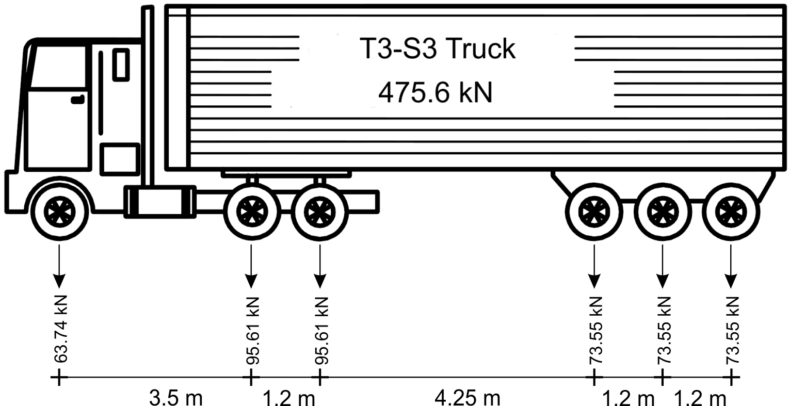
Figure 3 T3-S3 truck model for live load analysis

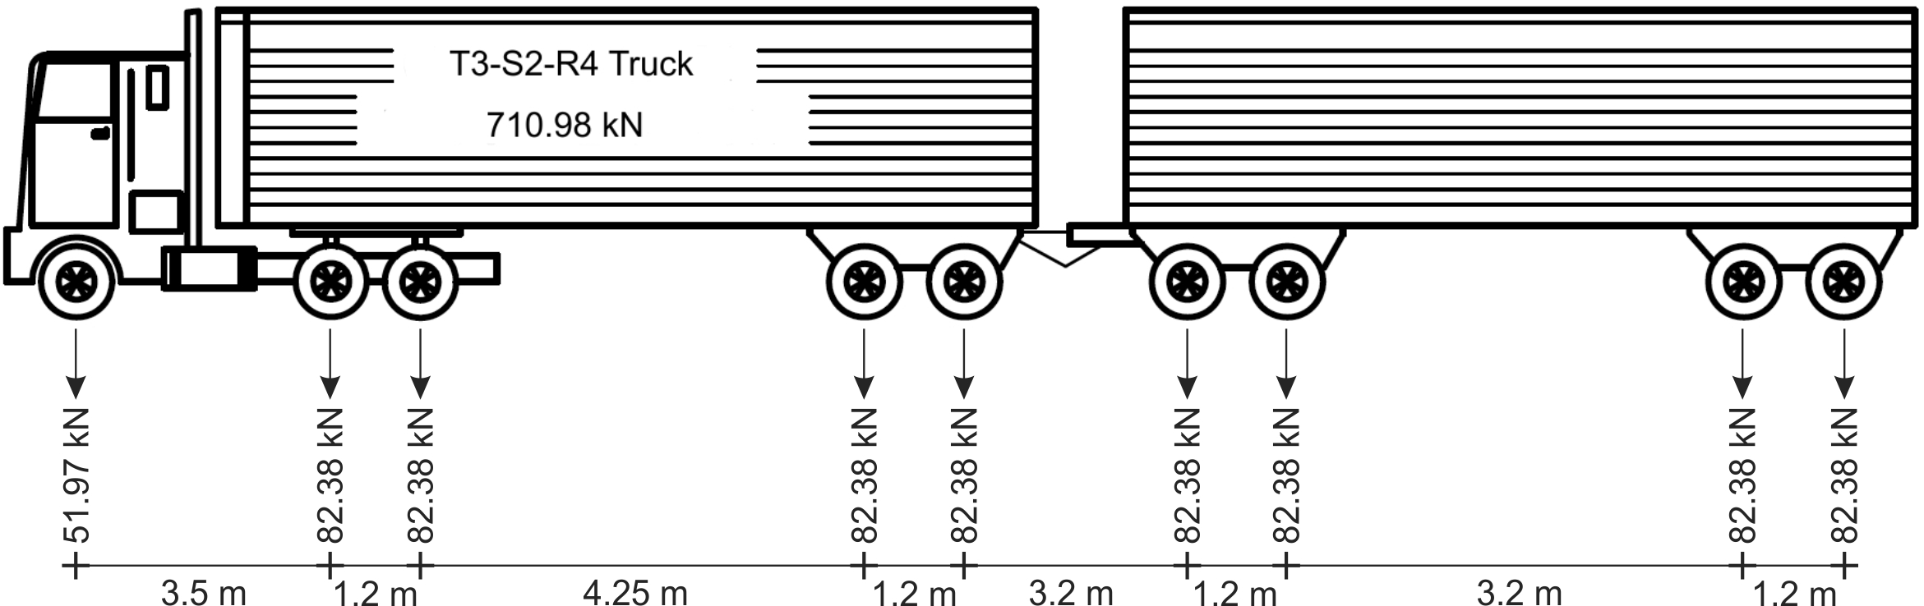
Figure 4 T3-S2-R4 truck model for live load analysis

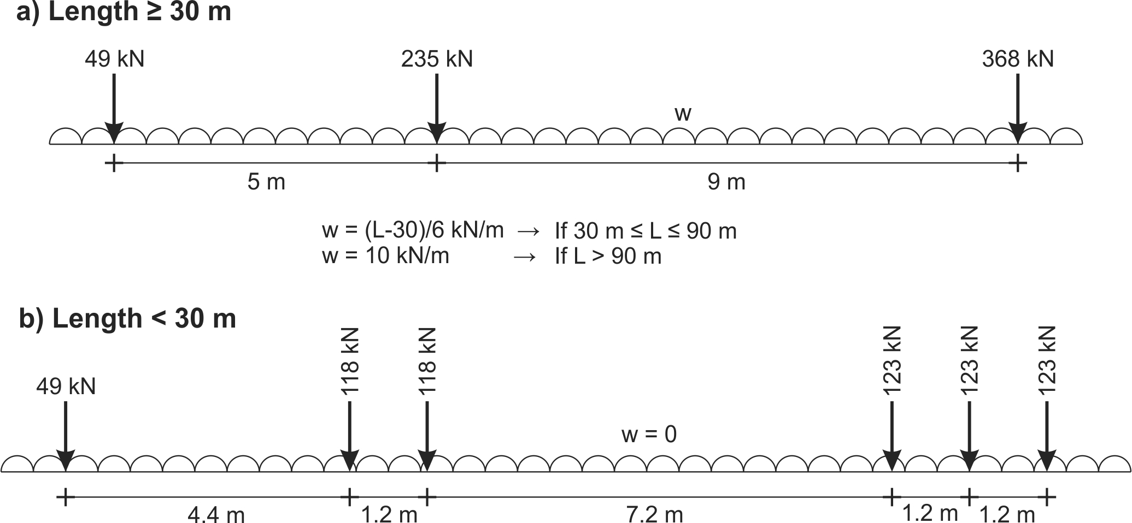
Figure 5 IMT 66.5 model for live load analysis

Fort the specific case of the “El Infiernillo” bridge project, SCT indicated that the T3-S2-R4 live load model (Figure 4) should be employed, with a simultaneous occurrence of three of those trucks over the bridge. The IMT 66.5 model was implemented in 2004, and the bridge construction ended in 2002; thus, it was not used as a design model. Since the HS-20 and T3-S3 models are lighter and the bridge is long enough to neglect issues normally present at shorter spans, the authors think that it is the reason the head engineers from SCT did not ask for the use of such models, since they may have expected lower load effects than those generated by the heavier T3-S2-R4 model. It is noteworthy to point out that the above-mentioned models are developed for bridges whose main load effects are those corresponding to beams (i.e., flexure moment and shear force). However, the bridge superstructure being investigated is composed primarily by trusses, and the most important load effect in this case is axial force.
- CHARACTERISTICS OF WIM DATABASE
For this study a database recorded by weigh-in-motion (WIM) equipments located in federal highway 90 are used. The highway connects the cities of Irapuato and La Piedad in Mexico, as shown in Figure 6
Figure 6 WIM stations at Federal road 90 Irapuato-La Piedad
The considered bridge is not in the highway where the WIM data was collected, for unfortunately there is not permanent WIM sites over there. However, Irapuato-La Piedad highway is relatively close, and it is one of the main highways transporting products to harbors; in fact, it connects to highway 37 towards the Pacific coast in direction to Lázaro Cárdenas. Therefore, the traffic information is deemed representative for the bridge under study. Additionally, this is the same database used before for developing the model proposed by García-Soto et al. (2015); this is advantageous, to investigate whether the use of this model is applicable and adequate for designing truss bridges. For the scope of this study, the data from Stations 1 and 8 (Figure 6) recording during January-March 2009 around 4 million vehicles, is used. A frequency distribution of the whole dataset in terms of gross vehicular weight (GVW) can be observed in Figure 7.
Most of the recorded information corresponds to two-axle light vehicles, but if all those cases are disregarded, a database with only around 800 thousand vehicles is left, and its different frequency distribution is shown in Figure 8.
Figure 7 Gross vehicular weight of vehicles in database

Figure 8 Gross vehicular weight for vehicles with three or more axes
- SOFTWARE FOR DATABASE ANALYSIS
Commercial software for bridge design can perform live load analysis. However, they are rather focused on graphic interfaces and only a few truck models, and analyzing a database of millions of vehicles (like the one used here) is just not feasible for such software (let alone if a reasonable amount of time and using regular computational resources is of interest). Therefore, using the source code of the program AMER 1.0 © developed by Hernández-Martínez (2015a) for academic purposes, and as supplementary aid of the book “Basic Aspects of the Direct Stiffness Method” (Hernández–Martínez, 2015b; in Spanish), a new version of the program was developed (version 2.0) by modifying and adapting it to cope, among other issues, with live load analysis of trusses by reading the recorded vehicle information directly from the WIM database, and aimed at obtaining the required information (e.g., axial loads) by optimizing the computing time. Both, the software AMER 1.0 © and the book are freely available at the web site http://di.ugto.mx/GEMEC/. It is expected that the new version AMER 2.0 © will be available for downloading in 2018, after some testing and proofs on functioning and stability.
For the scope of the present study, the truss in Figure 1 is analyzed as a 2D structure. To include the effect of the roadway supporting structure, which is a continuous slab, and for consistency with the principle that loading should act exclusively on the nodes for trusses (which is the case for this bridge), fictitious elements were attached to the lower chord at the same nodes, but only for modeling the road surface and transfer the forces from the vehicles to the truss nodes. In other words, such fictitious elements work as a continuous beam supported at the nodes and transfer only the “reactions” as concentrated loads. The fictitious (or dummy) bars have a shear and flexure stiffness representative of those of the structure supporting the road surface and are situated in the lanes where the vehicles run. The truss is analyzed by running each vehicle by 10 cm increments in both traffic directions. The software determines in the user-defined elements the maximum or minimum values of load effects for each case. Finally, the results are reported in an output file, ordered by element and by vehicle. Rather than discussing in detail the deterministic values of axial loads generated by each vehicle in the truss analyzed as described above, the whole set of data is used to perform the probabilistic analysis shown below.
- PROBABILISTIC ANALYSIS
The truss bridge, developed software and structural analysis methodology described in the previous sections, is used to gather the axial loads generated to all truss elements for the bridge under study by running the vehicles in the above-mentioned WIM data along it, so that a probabilistic analysis with such information can be performed. To carry out the probabilistic analysis the axial loads for the whole database in all the truss are used to inspect the empirical cumulative distribution function (CDF). Some of the truss elements are arbitrarily selected to show the empirical CDF of axial forces (absolute values) in Normal and Lognormal probability papers and is depicted in Figure 9a and Figure 9b; the legends correspond to the truss element as numbered in Figure 1. To obtain the CDFs in Figure 9a and 9b, samples of the maximum axial loads computed from each of the 171 recorded days for four-lane traffic are used, as has been carried out before for simple and continuous spans (García-Soto et al., 2015). The empirical probability distribution will be transformed later into empirical probability distribution of annual extreme truck load effects. For the assessment of the empirical probability distribution of daily extreme vehicle axial loads, the pairs (x_{i}, i/(n+1)) are used, where n (equal to 171) is the number of samples, and x_{i} denotes the ordered axial forces in increasing order.
In Figures 9a and 9b the legends correspond to the truss element in tension; the axial forces are plotted in absolute values. As expected, but now from a probabilistic standpoint, it can be observed that larger axial forces are found in the chords elements in tension (e.g. element 109), that other elements in the truss have smaller tensions (e.g. elements 309 and 708) and that elements in the upper chord have zero tensile axial load (e.g., element 405); elements corresponding at the same diagonal have the same values and are undistinguishable in Figures 9a and 9b (e.g., elements 608 and 708). Members in compression exhibit a similar probabilistic behavior and, although they are not shown for brevity, it was observed that for this case the lower chord elements have zero axial load values, that the upper chord elements have the largest axial load values, that some elements have zero force values either in tension or compression, and that other elements present reversing axial loads (tension and compression) depending on the position of the trucks over the bridge.
Compared with previous studies for bending and shear, the CDFs for axial loads have a different shape. However, from Figures 9a and 9b it is observed that the normal and lognormal PDFs roughly follow the trend of the empirical data (at least part of it). Therefore, it was decided to adopt the Gumbel distribution for fitting the information to the annual maximum flexure moments and shears, also because it has been done in previous studies for other load effects (e.g., García-Soto et al., 2015), and a comparison will be given later. The Gumbel distribution is given by
[1]
where the parameters  and u are determined using the least square method for the distribution fitting. For the same truss elements of the considered bridge used before, the empirical probability distributions for annual extreme are shown in Figure 9c and Figure 9d, for tensile and compressive forces, respectively. It can be observed from Figures 9c and 9d, that the Gumbel variate fits approximately good (with more or less adequacy depending on the selected truss element) the empirical annual distribution of axial loads, at least in the upper tail region. It is pointed out that a more rigorous assessment of the fitting is desirable and recommended for future studies (e.g., by using the maximum likelihood method, criteria as the Akaike information criterion, other aspects from the extreme value theory, etc.).
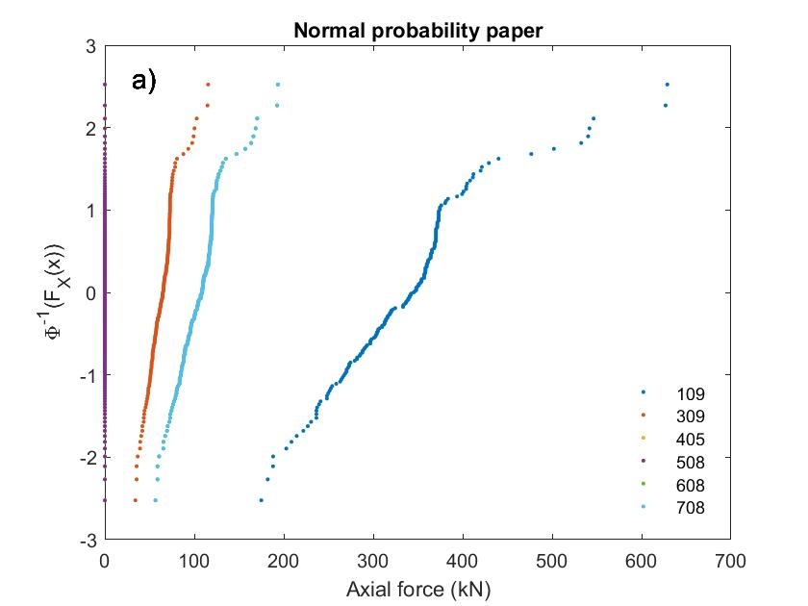 | 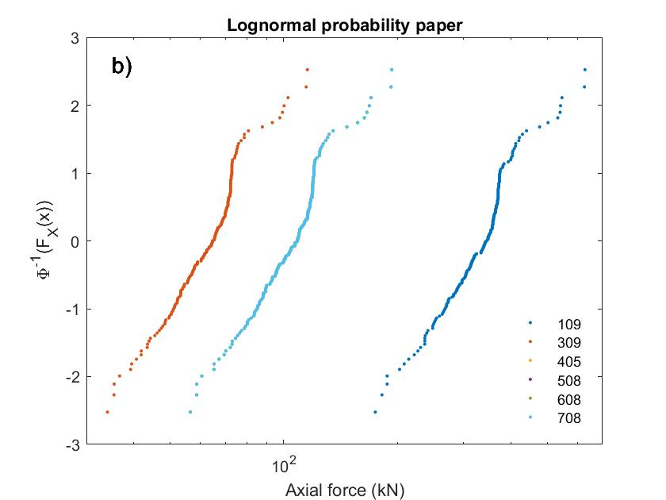
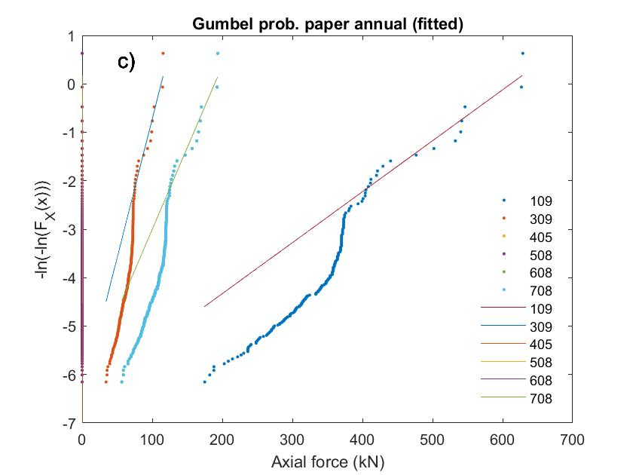 | 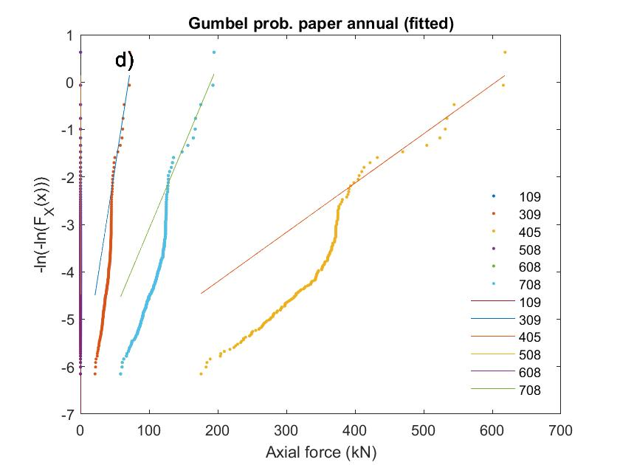
Figure 9 Empirical CDFs in different probability papers: a) Daily tensile axial forces, Normal; b) Daily tensile axial forces, Lognormal; c) Gumbel annual empirical and fitted (tension); c) Gumbel annual empirical and fitted (compression)
To preliminary inspect the adequacy of using a live load model developed for other types of bridges (for the same WIM database), the nominal model developed by García-Soto et al. (2015) is run over the truss bridge in the same way as the vehicles in the WIM database, and the tension and compression forces are extracted for each element and used for Table 1 (in fact, only half of the truss elements are listed, for symmetry reasons). In Table 1 the maximum axial loads (tensile and compressive) obtained directly from the WIM vehicles are listed, together with the resulting ratios of the axial loads from the nominal model to the maximum loads from the WIM data, r_{Nom}/Max, so that the adequacy of using a live load model developed for simple spans in a truss bridge can be inferred; this can be done as a first rough approach by comparing the obtained ratios, to the factor used to define the nominal model which was equal to 0.49 for the same WIM database. Note that the nominal model was established based on the 50-yr projected values for flexure moment and shear (García-Soto et al., 2015). It can be seen from Table 1 that r_{Nom}/Max is approximately 0.4 for many of the truss elements, and if the fitted Gumbel distributions are employed to project the axial loads for certain return periods, these ratios are even lower. This means that a live load model developed for simple spans may not be entirely suitable for truss bridges (or other kind of bridges for that matter), since it may underestimate the axial loads for similar reliability levels (this is the case at least for the considered truss, and several members). Moreover, the ratio r_{Nom}/Max is not uniform for all elements in the truss; consequently, an impact in the uniformity of reliability levels among the whole set of truss elements is expected; this will also have an impact in code calibration tasks. Therefore, it is concluded that a live load model specifically developed for truss bridges may lead to more uniform demands for all truss elements, and presumably to more consistency if reliability analyses are of interest. Nonetheless, more research considering a set of common truss bridges and other aspects (e.g., multiple presence) is recommended to further investigate this issue. Moreover, it is acknowledged that the study is limited to only one truss bridge (and one nominal truck and WIM database), and more cases need revision to state in a more categorical way the possible inadequacy of using live load models developed for simple spans for designing truss bridges, and it is noted that no consideration on the deterioration of the existing truss bridge, such as loss of cross-sectional area, reduced stiffness, etc. was incorporated in the analysis. The preceding issues are out of the scope of the present study but strongly recommended for future investigations.
Table 1 Maximum axial loads from WIM database and ratios of nominal to maximum values
Element | Max. Tensile  (kN) |  | Max. Compressive  (kN) |  | Element | Max. Tensile  (kN) |  | Max. Compressive  (kN)
Element | Load | r_{Nom}/Max | Load | r_{Nom}/Max | Element | Load | r_{Nom}/Max | Load | r_{Nom}/Max
101 | 295.58 | 0.39 | 0 | - | 501 | 0 | - | 0 | -
102 | 295.58 | 0.39 | 0 | - | 502 | 0 | - | 0 | -
103 | 440.65 | 0.39 | 0 | - | 503 | 0 | - | 0 | -
104 | 523.95 | 0.40 | 0 | - | 504 | 0 | - | 0 | -
105 | 575.74 | 0.40 | 0 | - | 505 | 0 | - | 0 | -
106 | 608.11 | 0.40 | 0 | - | 506 | 0 | - | 0 | -
107 | 627.01 | 0.40 | 0 | - | 507 | 0 | - | 0 | -
108 | 635.44 | 0.41 | 0 | - | 508 | 0 | - | 0 | -
109 | 628.74 | 0.39 | 0 | - | 509 | 103.89 | 0.42 | 92.65 | 0.42
302 | 247.75 | 0.66 | 0 | - | 519 | 103.89 | 0.42 | 92.65 | 0.41
303 | 144.38 | 0.54 | 202.35 | 0.40 | 602 | 273.35 | 0.39 | 72.80 | 0.65
304 | 173.65 | 0.51 | 176.53 | 0.40 | 603 | 222.79 | 0.40 | 126.74 | 0.54
305 | 191.14 | 0.48 | 163.96 | 0.40 | 604 | 201.49 | 0.40 | 153.22 | 0.51
306 | 205.24 | 0.45 | 158.70 | 0.40 | 605 | 192.31 | 0.40 | 170.02 | 0.48
307 | 211.50 | 0.44 | 157.17 | 0.41 | 606 | 189.73 | 0.40 | 184.07 | 0.45
308 | 213.05 | 0.42 | 157.64 | 0.41 | 607 | 190.62 | 0.41 | 191.37 | 0.43
309 | 115.51 | 0.42 | 71.64 | 0.42 | 608 | 193.43 | 0.41 | 194.58 | 0.42
400 | 0 | - | 492.63 | 0.39 | 702 | 273.35 | 0.39 | 72.80 | 0.65
401 | 0 | - | 492.63 | 0.39 | 703 | 222.78 | 0.40 | 126.74 | 0.54
402 | 0 | - | 465.40 | 0.39 | 704 | 201.49 | 0.40 | 153.23 | 0.51
403 | 0 | - | 545.09 | 0.40 | 705 | 192.29 | 0.40 | 170.00 | 0.48
404 | 0 | - | 591.58 | 0.40 | 706 | 189.73 | 0.40 | 184.07 | 0.45
405 | 0 | - | 618.65 | 0.40 | 707 | 190.61 | 0.41 | 191.37 | 0.43
406 | 0 | - | 633.06 | 0.40 | 708 | 193.42 | 0.41 | 194.58 | 0.42
407 | 0 | - | 638.15 | 0.41 | 709 | 103.89 | 0.42 | 92.65 | 0.41
408 | 0 | - | 635.53 | 0.41 | 719 | 103.89 | 0.42 | 92.65 | 0.42
409 | 0 | - | 632.96 | 0.39
- Conclusions
In this study the description of an existent truss bridge is given, together with some technical issues. An expressively updated software, originally developed for deterministic analysis of structures, is modified an adapted to perform millions of analyses by running vehicles in a WIM database over the entire length of the bridge with increments of 10 cm, and in both directions of analysis. It was decided to do so, because some revised live load models, used to analyze this and other bridges in Mexico, are usually developed for simply supported bridges and optimized for flexure moments and shear forces; however, the bridge considered is built with trusses, and the relevant load effect is axial force. Therefore, rather than giving details of each deterministic analysis, the results are employed to carry out a probabilistic analysis. It is concluded that a Gumbel distribution seems to fit adequately the extreme axial forces. It is found that live load models developed for simple spans may not be entirely suitable for truss bridges (or other type of bridges), since tensions and compressions in truss elements may be underestimated. Moreover, the results are not uniform for all elements in the truss, when using a live load model developed for simple spans; therefore, an impact in the uniformity of reliability levels in the truss elements, as well as an impact in code calibration tasks (an in turn in truss bridge design) are expected. Therefore, it is concluded that a live load model specifically developed for truss bridges may be desirable, since it will lead to more uniform demands for all truss elements, and presumably to more consistency in terms of probabilities of failure. Further research considering common truss bridges, and other issues as multiple presence and reliability analysis, is recommended in future studies

Acknowledgements
The financial support by the National Council of Science and Technology of Mexico, CONACYT (Project “Problemas Nacionales 2014” No. 248162), and by Universidad de Guanajuato is gratefully acknowledged. We are thankful to the Technical Committee and two anonymous reviewers for their comments and suggestions which helped to improve this study.

References
AASHTO. 2014. Bridge design specifications. American Association of State Transportation Officials, 6th Edition, Washington D.C.
Anitori, G., Casas J.R.., and Ghosn M. 2017. WIM-based live-load model for advanced analysis of simply supported short- and medium-span highway bridges. Journal of Bridge Engineering, 22(10): 1-11.
Eamon, C.D., Kamjoo V., and Shinki K. 2016. Design live load factor calibration for Michigan highway bridges. Journal of Bridge Engineering, ASCE, 21(6): 1-14.
García-Soto A.D., Hernández-Martínez A., Valdés-Vázquez J.G. and Vizguerra-Alvarez R.A. 2018. Extreme live load effects on short and medium span continuous bridges from Mexican WIM data. 10th International Conference on Short & Medium Span Bridges 2018, Canadian Society for Civil Engineering, Quebec City, Quebec, Canada. 10 p paper in CD proceedings.
García-Soto, A.D., Hernández-Martínez A., and Valdés-Vázquez J.G. 2015. Probabilistic assessment of a design truck model and live load factor from weigh-in-motion data for Mexican Highway bridge design. Canadian Journal of Civil Engineering, 42: 970-974.
Hernández-Martínez, A. 2015a. Aspectos básicos del método de rigideces (Basic aspects of the direct stiffness method). Universidad de Guanajuato (in Spanish) available free at http://di.ugto.mx/GEMEC/
Hernández-Martínez A. 2015b. Análisis Matricial de Estructuras Reticulares – AMER 1.0 © (Matrix structural analysis of reticular structures). Available free at http://di.ugto.mx/GEMEC/
Laurendeau, M., Barr P. J., Higgs A., Halling M.W., Maguire M., and Fausett R. W. 2015. Live load response of a 65-year-old Pratt truss bridge. Journal of Performance of Constructed Facilities, ASCE, 29(6): 1-9.
Liu, Y., Zhang H., Deng Y., and Jiang N. 2017. Effect of live load on simply supported bridges under a random traffic flow based on weigh-in-motion data. Advances in Structural Engineering, 20(5): 1-15.
Oudah, F., Norlander G., and El-Hacha F. 2017. Live load factor and load combination for bridge systems conveying extremely heavy mining trucks. Journal of Bridge Engineering, ASCE, 22(4): 1-13.
Rascón, O. A. (1999). Modelo de cargas vivas vehiculares para diseño estructural de puentes en México. Instituto Mexicano del Transporte y Secretaria de Comunicaciones y Transportes, publicación técnica No. 118, Sanfandila, Qro (in Spanish).
Soriano, F., Casas J.R., and Ghosn M. 2017. Simplified probabilistic model for maximum traffic load from weigh-in-motion data. Structure and Infrastructure Engineering, Maintenance, Management, Life-Cycle Design and Performance, 13(4): 454 – 467.

