 | 10th International Conference on Short and Medium Span Bridges  Quebec City, Quebec, Canada,  July 31 – August 3, 2018 | 

SUBSTRUCTURE STRENGTHENING & SUPERSTRUCTURE REPLACEMENT OF THE FORT NELSON RIVER BRIDGE
Amiel, Chad^{1,4}, Rebel, C.P. (Ken) ² and Singh, Raj³
¹ McElhanney Consulting Services Ltd, Canada
² McElhanney Consulting Services Ltd, Canada
³ McElhanney Consulting Services Ltd, Canada
⁴ camiel@mcelhanney.com
Abstract: Whether it’s to accommodate an increase in traffic volumes, a need to satisfy new design standards and loading requirements, or a need to extend the service life, utilizing existing infrastructure is an attractive consideration for owners to minimize throw-away costs. The existing single-lane 430 m long Fort Nelson River Bridge on the Liard Highway No. 77, built in 1984, needed an upgrade to replace the temporary superstructure with a permanent one for increased traffic volumes and to eliminate delays. The upgrade included a retrofit of all nine piers and abutments. This paper presents the transformation of the existing single-lane ACROW bridge into a modern two-lane composite steel girder bridge, and describes the opportunity to utilize the existing piers and the challenges and risks associated with this, the impact of Canada’s northern climate, and the evaluation of the various superstructure types during conceptual design. Cost is always key criteria when evaluating different bridge options. Although utilizing the existing piers and alignment saved costs, it also created design constraints and construction and strengthening challenges. It did, however, allow the contractor to use the existing bridge as a temporary detour bridge by sliding the existing superstructure downstream so the new bridge could be built along the existing alignment. Designing for Canada’s northern climate requires innovative thinking to facilitate both construction and the service life of the bridge. It can also work to your advantage by enabling cost-effective construction access to river piers. Retrofit work for the Fort Nelson River Bridge piers was done during the winter months when water levels are low and construction of an ice bridge is possible. Superstructure components were configured for modular on-site assembly to achieve accelerated construction and improved durability. Deck continuity was provided to improve the service life of below deck components and minimizes routine maintenance.
- INTRODUCTION
The Fort Nelson River Bridge traverses the Fort Nelson River on Liard Highway No. 77, approximately 70km northwest of Fort Nelson and approximately 43km north of the Alaska Highway junction as shown in Figure 1. The Liard Highway No. 77 is a primary route to the Western Northwest Territories and in particular Fort Liard, Nahanni Park, and Fort Simpson. As such, it provides vital access for goods transportation, health and safety, tourism and emergency access.
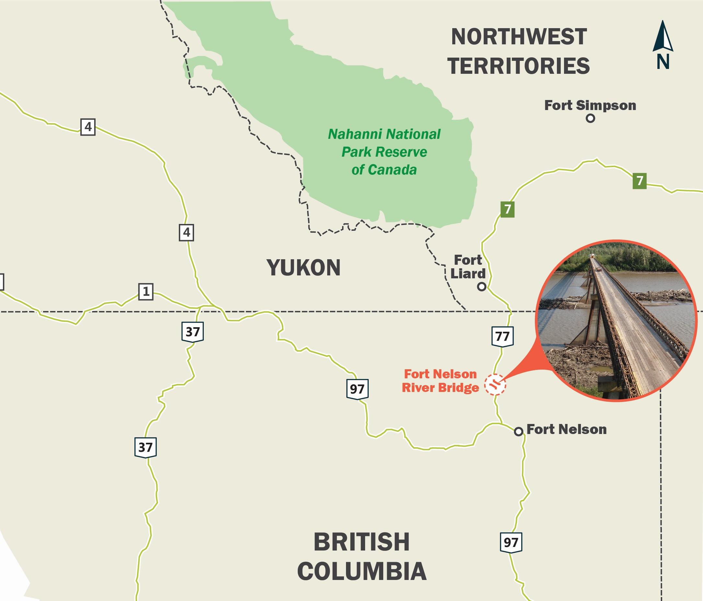
Figure 1: Fort Nelson River Bridge Location, near Fort Nelson, BC
Originally built in 1984, the single-lane crossing is causing increasing delays for traffic travelling to and from the Liard natural gas basin (one of BC’s largest reserves), as vehicles need to wait for traffic to clear in one direction before making their way across the 430-metre-long bridge. Due to the length of the bridge and the typical vehicle speed of only 15 to 20 km per hour it takes approximately three to four minutes for traffic to clear the bridge in one direction before opposing traffic can make their way across in the other direction. It is anticipated that this situation will get worse as traffic volumes go up due to increased resource development activity in the region. Figure 2 shows a small convoy of vehicles crossing the bridge.
In addition to the traffic challenges the structure presents, there are also safety concerns McElhanney’s team discovered after a condition inspection in 1992. The inspection revealed an ongoing problem with top chord reinforcing bolts breaking, likely a result of overtightening that caused tensile failure within the bolt shaft. The team also found that the existing timber deck and cross ties had deteriorated and were nearing the end of their lifespan. However, the superstructure was generally in good condition, as were the pier caps, pipe piles, concrete infill diaphragms, and abutments, and the deficiencies revealed in the 1992 inspection were being addressed through ongoing maintenance.
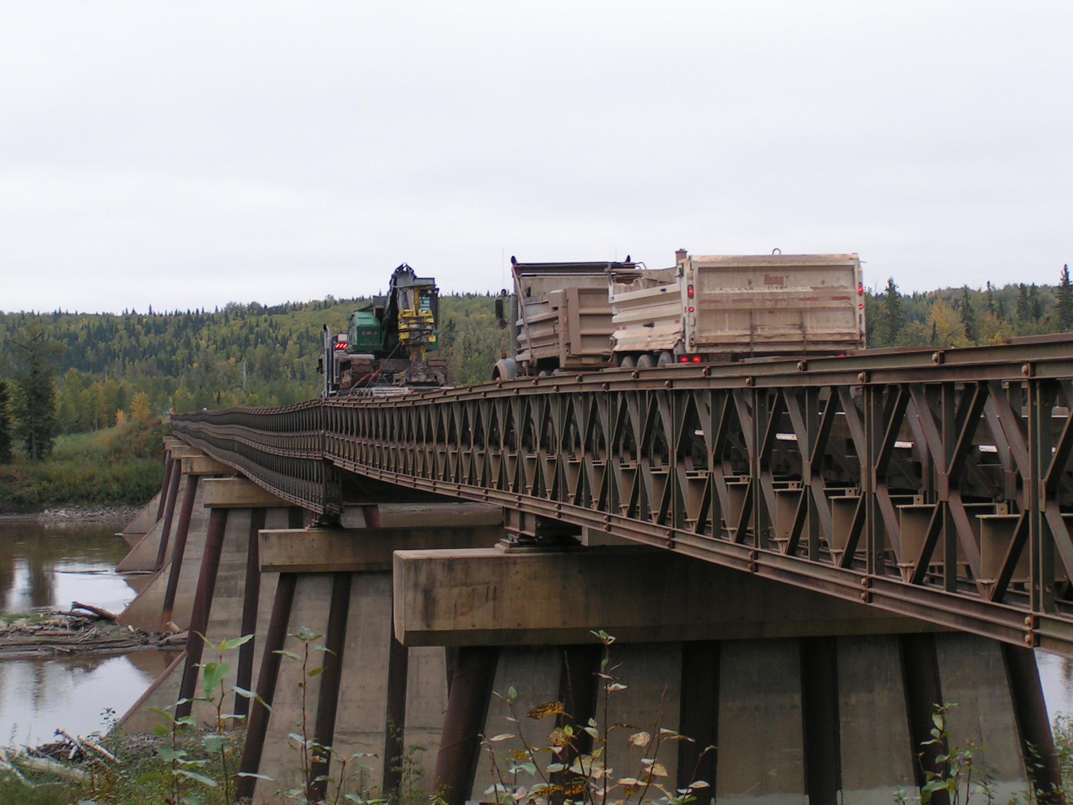
Figure 2: Vehicle Convoy Crossing Existing Bridge
This ongoing maintenance was a costly endeavour, and the owner, BC Ministry of Transportation & Infrastructure, identified the bridge as one of the structures to be upgraded as part of BC’s “On the Move” plan in 2012 (BC Ministry of Transportation and Infrastructure 2015).
- EXISTING BRIDGE
The existing structure is composed of a temporary steel ACROW bridge (one of the longest bridge structures of its kind in the world) with a timber deck and permanent steel and concrete piers, originally built from an ice bridge. The superstructure consists of eight (8) continuous spans of 34.4 m – 37.3 m – 59.9 m – 70.1 m – 70.1 m – 70.1 m – 57.9 m – 32.1 m supported on seven (7) permanent piers and two (2) permanent concrete abutments. The bridge is pile supported on 1067 mm diameter pipe piles at the river piers, 508 mm diameter pipe piles at the land piers and 356 mm diameter pipe piles at the abutments. The Fort Nelson River flows under the bridge and the existing superstructure provides a 1.9 m freeboard above the anticipated 200-year flood level. The river typically ices over in the winter and, with strengthening, the ice surface can be used for temporary vehicular travel or construction activities. Refer to Figure 3 for the existing bridge span configuration.
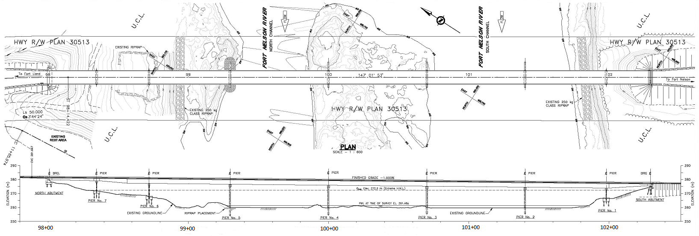
Figure 3: Existing Bridge Span Configuration
- PROJECT CHALLENGES
The project was not without challenges that needed to be addressed in the design of the replacement structure outlined below.
- The substructures and foundations needed to be evaluated and modified to ensure compatibility with a modern permanent superstructure.
- The climate and remoteness of the site made the durability and longevity of the bridge components important considerations, as maintenance demands have a higher than typical influence on lifecycle costs. Thereby solutions requiring less maintenance and more robustness are more favourable.
- Engineering the new bridge so that it could be built within the northern region’s short construction season was a major challenge to address. Solutions that allowed construction to continue through the winter or provide more flexibility vis-à-vis weather conditions were considered more favourable.
- Keeping traffic flowing during construction to minimize disruption to the industrial and public commuters was an important stakeholder requirement.
- SUBSTRUCTURE MODIFICATIONS
The use of the existing substructure, constructed in 1984, to accommodate two lanes of traffic required a reassessment based on the current code standards. Preliminary dead and live loads calculated for the new two-lane superstructure were compared to pile capacities provided in previous substructure assessment reports and reviewed by GeoNorth Engineering Ltd. and MoTI geotechnical staff. Based on the existing foundation capacities it was determined that the North and South abutments and land piers 1, 2, 5, 6 and 7 required additional piling to carry the increased superstructure loads.
The rehabilitation options for the abutments included modifications to the existing abutments and complete abutment replacement. For the north abutment, the existing pile capacity was significantly less than the calculated design load for the two-lane bridge and as such it was determined that the optimal solution was to install two new lines of piles and construct a new abutment. At the south abutment the existing piles were minimally overloaded and it was determined that only two additional piles were required, resulting in the decision to modify the existing abutment to incorporate the new piles.
At Piers 1, 2, 5, 6 and 7 the existing pile capacity was also significantly less the calculated design load for the two-lane bridge and as such it was determined that the optimal solution was to drive two new lines of piles adjacent to the existing pier and construct a new pile cap to connect the new piles with the existing piles (see Figure 4). For piers 3 and 4 the existing piles were only moderately under capacity and were strengthened by extending the existing pile cap and providing one additional pile upstream and downstream of the existing piles.
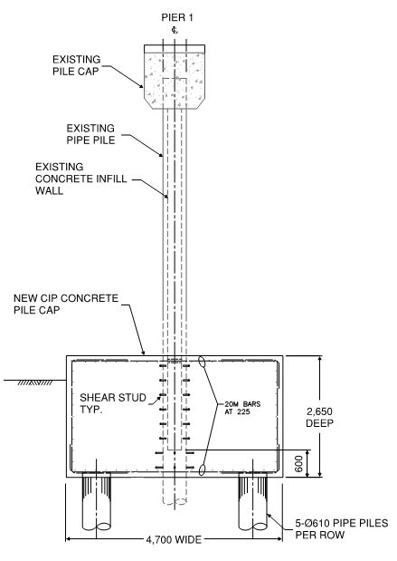
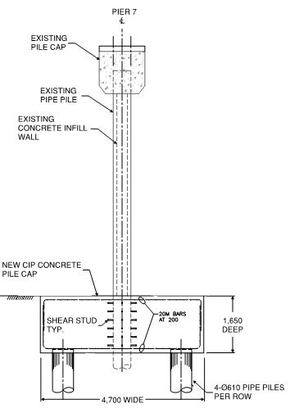
Figure 4: Modifications to piers 1 (pier 6 similar) and pier 7 for increased foundation capacity

- CONCEPTUAL SUPERSTRUCTURE DESIGN
During the conceptual design, a number of superstructure replacement options were evaluated for cost and constructability, as well as suitability for northern conditions, durability, and risk using a multi account analysis approach. As a result, steel girders were found to be more cost effective than concrete girders for this particular span arrangement and site location. Being significantly heavier than steel, concrete girders would be challenging to handle, erect and transport in full 70m long segments. Shorter segments would require post-tensioning of the drop-in segments including stick-build construction either from the frozen river or a work bridge ruling out the possibility of girder erection through incremental launching. On the other hand, steel girders are expected to be much easier to handle and transport in 40 m sections either by road or rail. Given the relatively long multi-span bridge and limited in-stream access conditions, incremental launching was determined to be the preferred erection method over conventional crane erection from a work bridge or ice bridge. Furthermore, steel plate girders with constant depth (or steadily changing depth to accommodate existing pier elevations) were found to provide the best weight and cost efficiency for the site.
The evaluation also considered options for the number of girder lines to determine an optimal arrangement. While a four-girder option was considered due to its shallower depth, this was not the preferred option as this would have required approximately 25% more steel, increasing the load on the substructure even more. The optimal arrangement in terms of structural steel efficiency, as well as adding redundancy against collapse, was a three-girder line option. The resulting girder spacing provided comfortable room for inspection and maintenance, a high priority aspect for bridges in northern remote locations.
With respect to the bridge deck, partial depth precast and full depth precast options were assessed, with the latter chosen as the preferred solution. The advantages of this method were that fabrication in a certified plant environment would ensure high quality while minimizing concrete cover (thus reducing weight) and the panels could be produced and installed in any season (CSA 2014). This modular construction method was anticipated to ultimately increase installation speed and significantly reduced on-site labour requirements.
A composite steel girder superstructure with three girder lines and a full depth precast deck was recommended to MoTI for advancement to the detailed design stage. This decision was accepted by MoTI in December 2013 and detailed design commenced in January 2014. The estimated construction cost for the selected option was $31M.
- DETAILED DESIGN FEATURES
This section discusses key design features that addressed the project challenges outlined in section 3.
  - Compatibility with Substructure
To make the new superstructure compatible with the existing substructure geometry, the three steel plate girders have a constant depth of 3.0 m over the majority of the bridge with the end spans transitioning down to 1.1 m to match the top of the existing abutment seats and top of the Pier 7 pier cap. The change in substructure elevations is due to the existing ACROW bridge switching from a double depth truss on the long interior spans to a single depth truss at the shorter end spans.
  - Designed for Reduced Maintenance
To enhance durability and reduce maintenance in the remote northern location, the bridge superstructure, including the deck, was made continuous over the entire length of the bridge with expansion joint at the abutments only (CSA 2014). Continuity of the deck shields the girder system from the weather elements and improves the durability performance of the bridge while enhancing user comfort. Minimizing the number of joints further reduces the maintenance effort and thereby the life cycle cost of the bridge. Disc bearings were deemed the most feasible bearing type for the Fort Nelson Bridge because of their compact size, simplicity and reduced maintenance requirements compared to other bearing types, and ease and cost of replacement.
Continuity over a length of 430 m was achieved through a novel articulation scheme developed to minimize longitudinal pier deflection under braking loads, minimize restraining forces arising from expansion and contraction during temperature changes and simplify bearing replacement. Piers 2, 3, 4 and 5 are fixed in the longitudinal direction, meaning the point of fixity for longitudinal expansion and contraction is offset slightly towards the South causing slightly larger displacements at the north abutment than the south abutment. The existing piers are extremely flexible in the longitudinal direction, requiring the engagement of four piers instead of only two piers to resist external longitudinal loads. Due to the flexibility of the piers, the expected longitudinal displacement at piers 2 and 5 due to the extreme temperature differential is easily accommodated with minimal stress in the pier piles.
  - Easy Access for Bearing Replacement
Transversely, the superstructure is restrained at all piers by the upstream and downstream bearings. Guide bars are placed on the outer edge of the bearings only, meaning the upstream bearings only resists downstream forces and the downstream bearings only resists upstream forces. This was done to accommodate bearing replacement. The design incorporates a bridge jacking and a bearing replacement scheme. The scheme involves jacks to be placed in line with the girder centerlines as opposed to jacking on the pier diaphragm. This allows the bearings to be slid transversely upstream or downstream when being replaced instead of longitudinally. Since there is not a lot of room on the existing piers outside of the exterior girders, the bearing design enables them to be removed towards the inside of the pier cap. The middle girder is not restrained transversely at any of the piers.
  - Design for Norther Construction Season

Given the relatively long multi-span bridge and limited in-stream access conditions for long duration construction activities due to the northern conditions, the girders were designed and detailed for an incremental launch method of construction. In this construction method, the girders and diaphragms are assembled in a launching bed at one end of the bridge and progressively pushed over the piers to the opposite bank (Figure 5). Several unique details were incorporated into the design to simplify temporary equipment and allow the superstructure to be launched without overstressing the permanent components. Design details incorporated to accommodate an incremental launch include a constant width bottom flange to simplify lateral guide designs, a gap in the bottom flange splice plate to allow the rollers to pass through, a relatively stocky bottom flange that can accommodate the high compressive stresses present during the launch, and a constant depth girder.

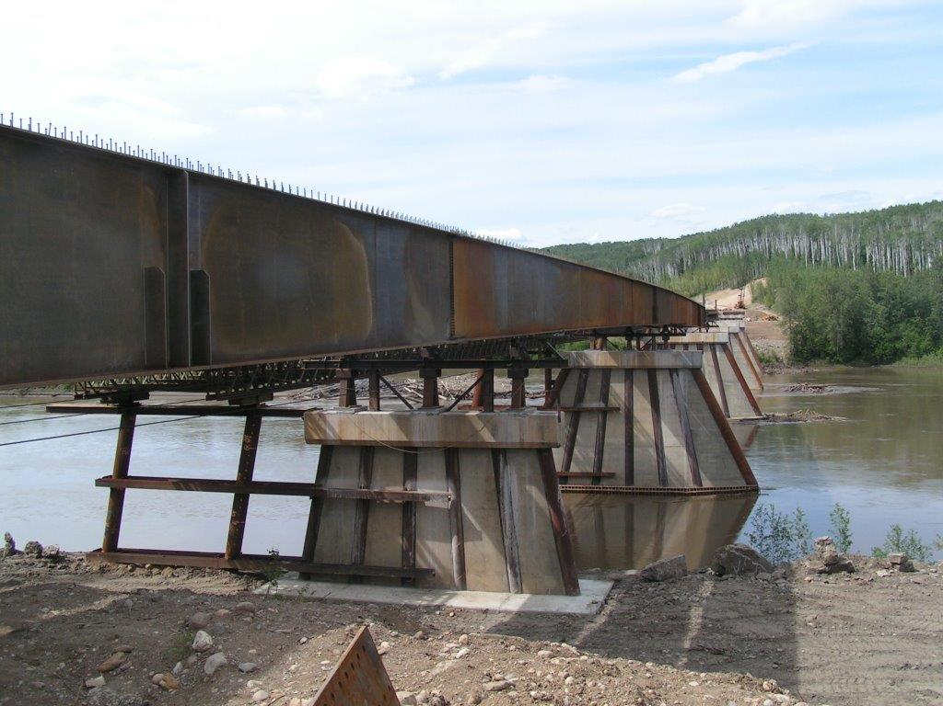
Figure 5: Incremental launch of the new girders in progress
In keeping with the design philosophy of minimizing intensive on-site labour activities such as concrete casting, the modular deck consists of full-depth precast deck panels. The entire deck was designed with mild-steel reinforcement without any pre-stressed or post-tensioned steel, similar to the system designed for the Deh Cho Bridge in the Northwest Territories (Schueller and Singh 2012).
The substructure retrofit design made use of the fact that the river would freeze over in the winter months and allow for construction access to the river piers. The new pile caps at river piers 2 and 5, designed to integrate additional rows of piles into the existing wall piers and provide a means for breaking up the ice flows, were constructed at the water level from an ice bridge during the winter months.
  - Construction Staging for Traffic Management
In consultations with the trucking association, city of Fort Nelson and local road user groups, it became evident that one lane of traffic during construction was highly desirable. Therefore, the replacement design incorporated traffic staging to minimize traffic disruptions to the commuters. The traffic staging scheme involved utilizing the existing ACROW superstructure as a temporary detour bridge adjacent to the existing highway alignment. For this, the ACROW bridge was laterally slid along the piers onto temporary extensions of the existing piers, allowing traffic to pass throughout the construction phase as shown in Figure 6.
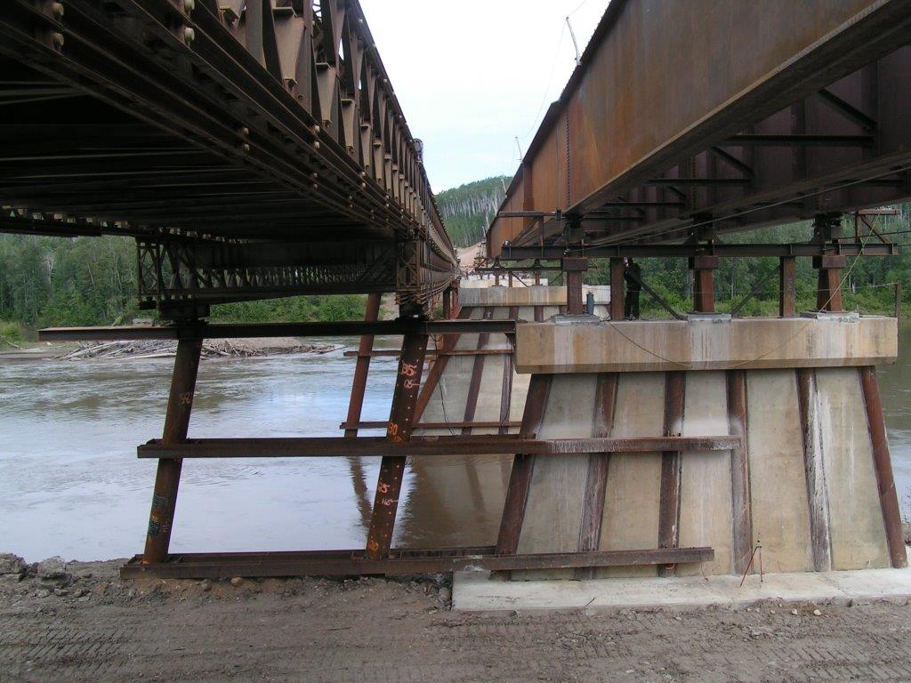
Figure 6: Existing ACROW Bridge slid onto temporary supports for use as a detour bridge while the new girders are launched in final alignment
- POST-AWARD DECK REDESIGN
The project was awarded for construction in 2015 after a competitive bid process. With the exception of the precast deck the contractor followed the consultant’s design plans and the recommended traffic staging scheme and girder erection through incremental launching.
Contrary to the design philosophy the contractor requested to build a full depth cast-in-place (CIP) deck due to past familiarity including anticipated cost savings and better quality control. On the Ministry’s request, McElhanney provided an alternative CIP deck design to the contractor post-award.
To speed up the deck casting operations considering a relatively shorter duration of favourable weather conditions, the consultant developed a unique pour sequence to allow the contractor to cast the deck in a linear sequence from one abutment to the other. This is different than the typical pour sequence where all midspan regions are poured before the pier regions to limit cracking above supports. To achieve the linear pour sequence, concrete lock blocks were used to preload the positive moment regions. The blocks were transported and lifted from the adjacent ACROW bridge and positioned on the steel girders as shown in Figure 7.
Figure 7: Concrete lock block preload of mid-span regions to allow linear deck casting operations
- CONCLUSION
The design process considered the site extreme conditions in developing a cost effective solution that incorporates an advantageous erection scheme for this bridge located in a remote northern location. The design was thoughtfully configured to speed up on-site construction while resulting in a quality bridge with improved durability and reduced maintenance. The bridge utilizes an innovative articulation scheme to allow a continuous superstructure, including the deck, over its entire length of 430 m, making this one of the longest jointless composite steel girder bridges in British Columbia. Most importantly, the existing superstructure was utilized not only for construction support during low traffic hours but also allowing the flow of industrial and public vehicles throughout construction.
The construction of the Fort Nelson River Bridge superstructure was completed in September 2017. The new two-lane bridge allows traffic to travel unimpeded along the Liard Highway No. 77 and has greatly improved traffic flow in support of the increasing industrial activity.

References
British Columbia Ministry of Transportation and Infrastructure. 2015. Fort Nelson River Bridge
project underway. News Release, https://news.gov.bc.ca/09789
British Columbia Ministry of Transportation and Infrastructure, 2016 Standard Specifications for Highway Construction.
CSA. 2014. Canadian Highway Bridge Design Code, CAN/CSA S6-14. Canadian Standard Association, Toronto, Ontario, Canada.
Schueller, M. and Singh, P. 2012. Design and Construction of the Deh Cho Bridge Challenges, Innovation, and Opportunities. Conference of the Transportation Association of Canada Fredericton, New Brunswick.

