|  |  |  |
| --- | --- | --- |
|  | **10th International Conference on Short and Medium Span Bridges**  **Quebec City, Quebec, Canada,**  **July 31 – August 3, 2018** |  |

**LIVE LOAD MOMENT AND SHEAR DISTRIBUTION FACTORS FOR PRESTRESSED CONCRETE INVERTED TEE GIRDER BRIDGES**

Abo El-Khier, Mostafa1,2, Morcous, George1 and Wood, Richard L.1

1 College of Engineering, University of Nebraska-Lincoln, NE, USA

2 [maboelkhier@unomaha.edu](mailto:maboelkhier@unomaha.edu)

**Abstract:** Prestressed concrete Inverted Tee (IT) girder bridge system has been widely used for short and medium span bridges in Nebraska due to its economy, speed of construction, and shallow structural depth. The IT system consists of closely spaced precast prestressed concrete IT girders and 152 mm (6 in.) thick (sometimes 203 mm (8 in.) thick) cast-in-place concrete composite deck. This system can achieve a span-to-depth ratio up to 35, which is significantly higher than that of prestressed concrete I-girder bridge systems. In this study, the live load moment and shear distribution factors were evaluated for IT girder bridges using three-dimensional finite element analysis and AASHTO live loads. FEA results were compared to those predicted using AASHTO Standard and LRFD bridge design specifications. This comparison indicated that AASHTO predicted distribution factors are conservative for IT girder bridges. A parametric study was performed to determine the effect of span length, skew angle, number of lanes loaded, deck slab thickness, and intermediate diaphragm type on the structural performance of the system. This study indicated that slab thickness and intermediate diaphragm type have significant effect on girder deflections and deck transverse stresses.

1. **INTRODUCTION**

The IT girder system is an efficient system for short and medium span bridges (spans up to approximately 24.40 m (80 feet)). It was originally developed by University of Nebraska-Lincoln (UNL) researchers and Nebraska Department of Roads (NDOR) engineers in 1996 (Tadros and Kamel 1996; Jaber 2013). This system consists of IT precast prestressed concrete girders with cast-in-place concrete composite deck as shown in Figure 1. The IT girder height ranges from 300 mm (11.81 in.) to 900 mm (35.43 in.) (IT 300 to 900) and the bottom flange can accommodate up to 22 – 13 mm (0.5 in.) prestressing straight strands. The production of IT beams is simple and efficient as it requires a single set of forms with variable depth. The span-to-depth ratio is up to 35, which is shallower than other I-girder bridges. Once IT girders are erected, 19 mm (¾ in.) thick plywood sheets are used between girders as stay-in-place forms for deck placement. The cast-in-place deck is often 152 mm (6 in.) thick with a single layer of reinforcement, which is typically No. 5 bars spaced at 152 mm (6 in.) and 254 mm (10 in.) for the transverse and longitudinal directions, respectively. Deck thickness of 203 mm (8 in.) with two layers of reinforcement is used on interstate bridges. At least mid-span intermediate diaphragms between the three external IT girders are used as shown in Figure 1.

Live load distribution factors are used as a simplified way to determine the live load moment and shear forces acting on each girder of the bridge when one or more lanes are loaded. These factors are dependent on the superstructure type, girder spacing, and girder and deck stiffness. Current AASHTO LRFD bridge design specifications section 4.6.2.2.2 divides bridges into several categories for distribution factor calculations (AASHTO 2014). Since the IT bridge system is a relatively newly system and not yet considered in any of these categories. the distribution factors of Category K, which consists of cast-in-place concrete slab on multi-girder systems, could be used for IT girders after ignoring the spacing condition.



Figure 1: Typical Section of IT Girder Bridge

NDOR Bridge Office Policies and Procedures (BOPP) manual recommended the use of the distribution factors of the AASHTO Standard Specification for IT girder bridges. A grid analysis was performed to evaluate these factors, and the results confirmed their adequacy (Kamel and Tadros 1996). These distribution factors are S/5.5 per wheel load and S/11 per lane load for interior girders, where S is the IT girder spacing in feet (BOPP 2016). Analysis results also indicated that intermediate diaphragm did not affect the live load distribution factors.

Finite element analysis (FEA) was also conducted on bridges with different spans, widths and skew angles to develop wheel load distribution expressions for interior and exterior girders on simply supported skewed I-beam composite bridges (Bishara et al. 1993). The three-dimensional interaction of all bridge members was considered in the analysis. Wheel load distribution equations were developed for exterior and interior girders. These equations gave distribution factors, which were 20 to 80% of the AASHTO distribution factor (S/5.5). A two-dimensional grillage model and three-dimensional finite element model were developed to evaluate the live load distribution factors for IT bridges in Kansas (Ambare and Peterman 2006). A parametric study was also conducted to determine the effect of span length, superstructure width, skew angle, number of lanes loaded, end support conditions and overhang width on the distribution factors. The live load moment distribution factors obtained from AASHTO were close to those obtained from refined models. Simple equations were developed based on this study. Three-dimensional FE models were developed to simulate reinforced concrete slab bridges that where simply support, single span, multilane, and skewed (Menassa et al. 2007). The concrete deck slabs were simulated as quadrilateral shell elements with linearly elastic behavior. Based on this study, a comparison between straight and skewed bridges were conducted. This study recommended that three-dimensional finite-element analysis should be performed when the skew angle is greater than 20˚.

1. **FINITE ELEMENT ANALYSIS (FEA)**

AASHTO LRFD bridge design specifications permit the use of finite element methods to determine the live load distribution factors. Three-dimensional finite element modeling allows the designer to better simulate bridge components and connections between the girder and slab. Several models were created using SAP2000 v18 to study the effect of design parameters on the system performance. These parameters are span length, skew angle, number of lanes loaded, deck thickness and addition of diaphragms. The deck slabs were modeled as shell elements, as shown in Figure 2, meshed into a reasonable number of elements to obtain accurate results in an efficient manner (CSI 2011). The girders were modeled as frame elements placed eccentrically below the shell elements, as shown in Figure 2, to achieve the composite section. The FE model was loaded with a load combination of a moving truck load (HL-93) and a uniformly distributed load of 9.34 KN/m (0.64 klf) according to AASHTO LRFD design specifications. The truck load was applied on paths with a maximum discretization length of 152 mm (6 in.) to obtain accurate results. This study is performed on three constructed IT girder bridges with 55.2 MPa (8 ksi) concrete strength for the prestressed IT girders and 27.6 MPa (4 ksi) concrete strength for deck slab. The investigated IT concrete girder bridges properties are shown in Table 1 and the cross sections of IT girders are shown in Figure 3.

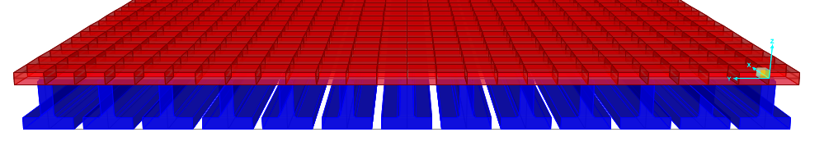

Figure 2: Finite Element Cross-Section

Table 1: Investigated IT Concrete Girder Bridges Properties

|  |  |  |  |  |
| --- | --- | --- | --- | --- |
| Properties of Bridge | Inverted Tee Bridges | | | |
| Waverly Bridge | Ashton Bridge | Otoe-west Bridge |
| Location | Lancaster County | Sherman County | Otoe County |
| Span | Three spans 14.7 m, 16.3 m, and 14.8 m (48.25 ft., 53.50 ft., and 48.25 ft) | one span 19.8 m (65.0 ft) | one span 24 m (78.9 ft) |
| Skew Angle | Straight (0˚) | 15˚ | 25˚ |
| No. of IT Girders | 25 | 13 | 15 |
| Girders Spacing, m (ft.) | 0.76 (2.48) | 0.72 (2.37) | 0.74 (2.43) |
| IT Section | IT-400 | IT-600 | IT-700 |
| Section Height, mm (in.) | 400 (15.75) | 600 (23.63) | 700 (27.56) |
| Centroid, mm (in.) | 148 (5.81) | 222 (8.75) | 264 (10.38) |
| Slab Thickness, mm (in.) | 203 (8) | 152 (6) | 152 (6) |
| Diaphragm Section | steel channel (C8x18.75) | | concrete 203 mm (8 in.) width |
| Diaphragm Location | mid-span at the exterior three girders from both sides | | two full-width at 5.6 m and 13.6 m (220 in.& 535 in.) |

*All Modeled bridges located in Nebraska State, USA



Figure 3: Cross-Sections of IT Concrete Girders

Figure 4 summarizes the parametric study conducted on the three constructed IT girder bridges. The three span lengths and the corresponding IT girder sizes of these bridges are used assuming the current skew angle as well as a zero skew angle and 45-degree skew angle. The current diaphragm of the constructed bridges is considered as a reference and two additional cases are studied: the first case is using the current steel diaphragm but for the full-width of the bridge instead of the exterior girders only; and the second case replaces the steel diaphragm with concrete diaphragm for the full-width of the bridge as shown in Figure 4. Also, 152 mm (6 in.) and 203 mm (8 in.) thick deck slabs are considered for the two loading conditions: one-lane loading, and two-lane loading.



Figure 4: Parametric Analysis Matrix

There are two types of live load distribution factors depending on the truck wheel load location, as shown in Figure 5: exterior girder distribution factors when the truck wheel is placed on the exterior girder, and interior girder distribution factors when the wheel load is placed on the interior girders. Figure 5 shows that because the truck wheel cannot be placed closer than 0.61 m (2.0 ft) from the bridge rail, the two loading conditions are almost the same. Therefore, the parametric study is conducted using the truck wheel placed at the first interior girder only as it will yield the highest distribution factors in comparison to others.

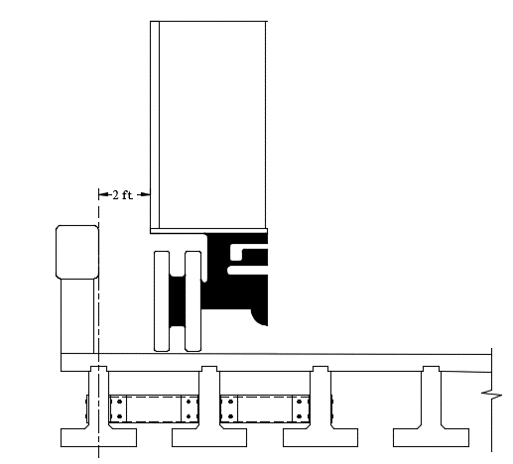 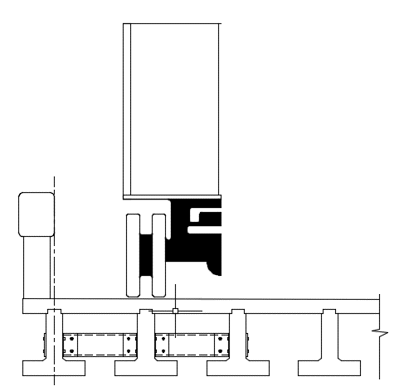

0.61 m

(2 ft.)

(a) Exterior Girder (b) First Interior Girder

Figure 5: Truck Load Location for Exterior and Interior Girders

1. **DISTRIBUTION FACTOR ANALYSIS RESULTS**

Figure 6 shows the live load moment and shear distribution factors for one bridge with different skew angles. This figure indicates that skew angle has negligible effect on the live load moment and shear distribution factors. It also indicates that the values obtained from the FE model are in a good agreement with those predicted by the BOPP manual.

Figure 7 shows the live load moment and shear distribution factors for the same bridge with different diaphragm systems. This figure also indicates that diaphragm system has negligible effect on the live load moment and shear distribution factors. In addition, it confirms that the values obtained from the FE model are close to those predicted by the BOPP manual.

Figure 8 shows the live load moment and shear distribution factors for the same bridge with different deck slab thickness. This figure indicates that there is a slight decrease in the live load moment and shear distribution factors with the increase of deck slab thickness from 152 mm (6 in.) to 203 mm (8 in.) as expected due to the increase in the deck stiffness. The figure also shows that BOPP manual provide conservative predictions for the distribution factors.

Figure 6: Effect of Skew Angle on LLMDFs and LLSDFs for Straight Bridge in Waverly, NE

Figure 7: Effect of Diaphragm on LLMDFs and LLSDFs for Straight Bridge in Waverly, NE

Figure 8: Effect of Slab Thickness on LLMDFs and LLSDFs for Straight Bridge in Waverly, NE

1. **COMPARING DISTRIBUTION FACTOR PREDICTION METHODS**

Figure 9 shows a comparison of the live load distribution factors predicted by AASHTO LRFD, BOPP, and FEA for the skewed bridges in Ashton, NE. For the one lane loaded case, the moment distribution factors obtained from AASHTO LRFD and BOPP are higher than those obtained from FEA by 5.4% and 16.7%, respectively. However, for the two lane loaded case, the moment distribution factors obtained from BOPP and FEA are the same, while those obtained from AASHTO LRFD are 37.4% higher. The shear distribution factors predicted by AASHTO LRFD and BOPP are about 14.6% to 28.5% higher than those predicted by the FEA. Also, The LLDFs obtained from the FEA of skewed bridge in Otoe, NE were compared to predicted factors by AASHTO LRFD, BOPP and it follows the same aspect as Ashton Bridge as shown in Figure 10.

Figure 11 shows a comparison of the live load distribution factors predicted by AASHTO LRFD, BOPP, and FEA for the continuous bridge in Waverly, NE. Both moment and shear live load distribution factors predicted by AASHTO LRFD and BOPP are conservative compared to those obtained from FEA in both one-lane and two-lane loading cases.

Figure 9: Live Load Distribution factors for The Ashton Skewed Bridge

Figure 10: Live Load Distribution factors for The Otoe-west Skewed Bridge

Figure 11: Live Load Distribution factors for The Waverly Straight Bridge

1. **EFFECT OF DIAPHRAGM TYPE AND SLAB THICKNESS ON IT GIRDER DEFLECTIONS**

In this study, the three cases of diaphragm type shown in Figure 4 were studied for two different design truck locations. First, two trucks were placed asymmetrically in the transverse direction at mid-span section as shown in Figure 12. Second, one truck was placed symmetrically in the transverse direction at mid-span section as shown in Figure 13. Third, two trucks were placed symmetrically in the transverse direction at mid-span section as shown in Figure 14. These figures indicates that the type of diaphragm has slight to moderate effect on the deflection of bridge girders and differential deflections between adjacent girders. Full-width concrete diaphragms transversely distribute the live loads better then other types, which results in less differential deflections than the other two diaphragm types. The relative deflection between adjacent girders is decreased by 25% when using concrete diaphragms, which reduces deck cracking. Also, it is obvious that the full-width concrete diagram reduces the maximum bridge deflection by 15.46% and 8.37% lower than the current diaphragm for one lane loaded and two lanes loaded respectively.

Figure 12: Bridge Deflection at Mid-Span for Two Trucks Placed Asymmetrically in the Transverse Direction for Different Types of Diaphragm

Figure 13: Bridge Deflection at Mid-Span for One Truck Placed Symmetrically in the Transverse Direction for Different Types of Diaphragm

Figure 14: Mid-Span Bridge Deflection for Two Trucks Placed Symmetrically in the Transverse Direction for Different Types of Diaphragm

Four different combinations of slab thickness and diaphragm type were studied using FEA of the Bridge in Ashton, NE. These four combinations are: 152 mm (6 in.) slab without diaphragm; 152 mm (6 in.) slab with full-width concrete diaphragm; 203 mm (8 in.) slab without diaphragm; and 203 mm (8 in.) slab with full-width concrete diaphragm. Figures 15 shows the deflected shape of the bridge in the transverse direction for all four cases when loaded asymmetrically with two trucks. These plots indicate that deflection values decrease significantly with the increase in slab thickness. They also shows that differential deflections decrease significantly with the addition of full-width concrete diaphragm. Therefore, the combination of 203 mm (8 in.) slab thickness and full-width concrete diaphragm results in the highest stiffness in the transverse direction.

Figure 15: Mid-Span Bridge Deflection for Two Trucks Placed Asymmetrically in the Transverse Direction for Different Slab Thicknesses w/o Diaphragm

1. **EFFECT OF DIAPHRAGM TYPE AND SLAB THICKNESS ON SLAB TRANSVERSE STRESSES**

During the field inspections of several IT bridges, longitudinal cracks over girder lines were observed. To determine the effect of diaphragm type and slab thickness in reducing deck transverse stresses that cause these cracks, a single wheel load of AASHTO HL-93 design truck and tandem (plus 75% dynamic load allowance) were applied to the developed FE models. For each model, un-cracked section analysis procedures were used and wheel loads were placed over girder lines and between girder lines as point loads. FEA results indicated that tandem wheel loads placed over the middle girder line resulted in the highest stresses for all cases of mid-span diaphragm. The maximum transverse tensile stresses occurred at second interior girder, which is typically where the longitudinal cracks are observed. Using full-width concrete diaphragm reduced deck transverse tensile stresses significantly from 2.07 MPa (0.3 ksi) (when no diaphragm was used) to 0.21 MPa (0.03 ksi). Also, using full-width steel diaphragm reduced deck transverse tensile stresses from 1.38 MPa (0.2 ksi) (when steel diaphragms were used at exterior girders only) to 0.48 MPa (0.07 ksi). Two different slab thicknesses (152 mm (6 in.) and 203 mm (8 in.)) were also investigated and indicated that increasing the deck slab thickness has a slight effect in reducing transverse tensile stresses from 2.07 MPa (0.3 ksi) to 1.52 MPa (0.22 ksi).

**CONCLUSIONS**

Based on the results of the analytical investigation conducted in this research, the following conclusions can be made:

1. Skew angle and deck slab thickness have negligible effect on live load distribution factors for IT bridges.
2. Live load distribution factors obtained from AASHTO LRFD bridge design specifications and BOPP manual are conservative compared to those obtained from FEA.
3. The maximum transverse tensile stress in the deck slab occurs at the second interior girder line and results in longitudinal cracks, which were observed in field inspections. Wheel load of AASHTO design tandom creates higher transverse stresses in the deck than HL-93 truck wheel load for IT Bridge.
4. Using full-width concrete diaphragm reduces IT bridge deflection at mid-span by 15.5% compared to using steel diaphragm at exterior girders. It also reduces differential deflection between adjacent girders and deck transverse tensile stresses significantly, which could minimize longitudinal deck cracking.

**Acknowledgements**

This research was sponsored by Nebraska Department of Transportation (NDOT) as a part of research project (No. SG-04) under the tittle “Performance Evaluation of Inverted Tee (IT) Bridge System”.

**References**

AASHTO. 2014.LRFD Bridge Design Specifications; Seventh Edition. *American Association of State Highway and Transportation Officials*, Washington, D.C., USA.

AASHTO. 1996.Standard Specifications for Highway Bridges; Sixteenth Edition. *American Association of State Highway and Transportation Officials*, Washington, D.C., USA.

Ambare, S. and Peterman, R.J. 2006. Evaluation of the Inverted Tee Shallow Bridge System for Use in Kansas. *K-TRAN: KSU-00-1 Final Report*, Kansas Department of Transportation, Kansas, USA.

Bishara, A. G., Liu, M. C. and Ali, N.D. 1993. Wheel Load Distribution on Simply Supported Skew I-Beam Composite Bridges. *Journal of Structural Engineering*, **119**(2): 399-419.

BOPP. 2016. Bridge Office Policies and Procedures. *Nebraska Department of Roads*, Bridge Division, Lincoln, Nebraska, USA.

CSI. 2011. Analysis Reference Manual for SAP2000, ETABS, SAFE and CSiBridge. *Computer & Structures Inc*, Berkeley, California, USA. 2011.

Jaber, F. 2013. Nebraska’s Inverted Tee Short-Span Bridge System. *PCI ASPIRE*.

Menassa, C., Mabsout, M., Tarhini, K. and Frederick, G. 2007. Influence of Skew Angle on Reinforced Concrete Slab Bridge. *Journal of Bridge Engineering*, **12**(2): 205-21.

Tadros, M. K. and Kamel, M. R. 1996. The Inverted Tee Shallow Bridge System for Rural Areas. *PCI Journal*, **41**(5).