|  |  |  |
| --- | --- | --- |
|  | **10th International Conference on Short and Medium Span Bridges**  **Quebec City, Quebec, Canada,**  **July 31 – August 3, 2018** |  |

**Experimental Investigation of Flexural Behaviour of Ultra High-Performance Fibre-Reinforced Concrete Girders**

Kim, Woosuk1, Jeong, Min-Seon2 and Han, Sang-Mook3,4

1 School of Architecture, Kumoh National Institute of Technology, South Korea

2 C.R.D. Ltd, South Korea

3 Department of Civil Engineering, Kumoh National Institute of Technology, South Korea

4 [corresponding_author_smhan@kumoh.ac.kr](mailto:corresponding_author_smhan@kumoh.ac.kr)

**Abstract:** The flexural behavior tests were carried out using Ultra High-Performance Concrete (UHPC) segmental box girder which has 160 MPa concrete compressive strength and 15.4 m length. The test variables were the area of prestressing wires, steel fibre volume fractions (*Vf*), and the longitudinal reinforcing bars in upper flange and web. Two prestressing tendons were installed comprising (1) 16 strands of 15.2 mm-diameter in lower flange, and (2) 12 strands and 7 strands in lower flange with steel fibre volume fractions of 1.0%, 1.5% and 2.0% being used in box girder concrete. Test results showed that Ultra High-Performance Fibre-Reinforced Concrete (UHPFRC) box girder with 32 strands in lower flange showed to be over-reinforced with brittle behavior. UHPFRC box girder having 24 strands showed a similar peak load as 32 strands girder, with large deflection in ductile behavior. UHPFRC box girder with 14 strands showed half of the peak load of 24 strand box girder and similarly reduced ductile behaviour. Applying the formula for the reinforcement index to the behaviour of the UHPFRC box girders, it was discovered that the reinforcement index does not exactly determine the characteristic of behaviour of UHPFRC box girder. Therefore the reinforcement index should be refined to consider the dimensions precisely and to modify the reference value corresponding to the 0.005 strain of the prestressing strands for the UHPFRC box girders.

1. **BACKGROUND**

Ultra-high performance fibre reinforced concrete has high compressive and tension strength, small creep and drying shrinkage strain, with excellent durability in both and in thawing, and neutralization (Chan et al. 2000, Han and An 2015, Resplendino 2012, Park and Han 2016, Jeong et al. 2017). Also, UHPFRC has geometric distinctiveness in terms of shape and self-weight compared with those of conventional concrete structure. Alternatively, the merits of UHPC are low girder depth, light self-weight and superior durability. However utilization of UHPC is less commonly used because of its high cost. If steel fibre which is used in order to improve ductile behaviour and tension reinforcement when mixed two volume percentages in UHPC, such enhancements can be had at 50% of UHPFRC cost. It is the cause that UHPC could not have the economic benefit. The purpose of this study evaluates the flexural behaviour of UHPFRC segmental box girder and verifies validity of experiment and judgment in the reinforcement index.

1. **EXPERIMNTAL PROGRAMS**

The box girder specimens were fabricated in the shape of three segmental members. Flexural experiments using box girders were performed on four specimens that were selected through adapting the mix ratio of steel fibre and PS tendon area as the main experimental parameters. Experiments were performed using a 3-point loading method. Loading is a displacement defined method used to evaluate behavior after maximum load. The experimental study analyzed the behaviour of girder dynamics, and evaluated the viability and adaptability of experimental parameters.

* 1. **Materials**

The mixing proportions of UHPC which were applied in this study are shown in Table 1. Fine aggregate is pre-used quartz sand that is sized below 0.4 mm with a high content of SiO2. The silica fume used in this study is ultra-fine particles having fineness over 0.1 ㎛; silica flour has an average diameter of range 10 to 15 ㎛ with a SiO2 content over 99.5%. The average concrete compressive strength of BF1.0, BF1.5 and BF2.0 are 161.4 MPa, 163.1 MPa and 164.7 MPa, respectively and modulus of elasticity (*Ec*) is 45,000 MPa. This study used longitudinal rebar and stirrups which rebar and stirrup properties had a yield strength of 400 MPa and 13mm-diameter (D13). Steel fibre is mixed in UHPC to augment the ductile behaviour properties in the areas of compression and tension. Steel fibre properties were a tensile strength of 2,500 MPa, 0.2 mm-diameter, 13-mm length, and an aspect ratio of 65.



* 1. **Specimens and experiment method**

UHPFRC segmental box girders were made of three segments with the girder’s total length being 15.4 m. End and centre segment length are 5.2 m and 5.0 m, respectively. Front view and ground plan of box girder are as shown in Fig. 1. EPS (Expandable Poly-Styrene) block that has a length of 100 mm is placed in the boundary surface of each segment, making an interior interval of 200 mm. The end to 1000 mm section width is 730 mm and the 1000 mm to 1500 mm section width is 600 mm that same width to centre. It is tapered section with a girder height of a constant 600 mm. In the case of box girder concrete, 2 PS tendons which have 12 or 16 strands of 15.2 mm diameter in lower flange, and 2 PS tendons which have 2 or 7 strands of 15.2 mm diameter in upper flange, were installed. Steel fibre volume fraction of 1.0, 1.5 and 2.0% were used. Post-tension of 200 kN was applied to each strand. Therefore, a load of 4800 kN is applied in lower flange containing 24 strands, and a load of 6400 kN is applied in that containing 32 strands. A load of 2800 kN is applied in the upper flange containing 14 strands, and a load of 800 kN is applied in that containing 4 strands. The experimental design is shown in Fig. 5. The flexural test was performed on UHPFRC girders using a three-point loading within a simple support boundary condition. A concentrated load was applied to a girder as a displacement control method through a 1000 kN capacity actuator. A total of 14 strain gauges were attached to the central section in order to measure sectional strain and the change of neutral axis. Also, LVDT were placed below the central section and measured the load-displacement relationship. Behavioral properties of UHPFRC girder were investigated using strain data that were measured using LVDT and strain gauges.

|  |  |  |  |  |  |  |  |  |  |  |  |  |  |
| --- | --- | --- | --- | --- | --- | --- | --- | --- | --- | --- | --- | --- | --- |
| Table 1: Mixing proportion of UHPFRC | | | | | | | | | | | | | |
| Cement | Water | | Silica fume | | Sand | | Silica flour | | W/B | Super plasticizer | | Steel fibre (vol.%) | |
| 1 | 0.22 | | 0.25 | | 1.1 | | 0.3 | | 0.18 | 40 l/m2 | | 0.70, 1.0, 1.5, 2.0 | |
| Table 2: Categories of UHPFRC box girders | | | | | | | | | | | | | |
| Specimen | | Volume fraction of steel fibre (%) | | Longitudinal steel reinforcement | | | | | | | No. of PS strands | | |
| Upper flange | | Web | | Lower flange | | | Upper | | Lower |
| BF1.0-24 | | 1.0 | | Being | | Being | | Being | | | 2x2 | | 12x2 |
| BF1.0-32 | | 1.0 | | Being | | Being | | Being | | | 7x2 | | 16x2 |
| BF1.5-14 | | 1.5 | | None | | None | | Being | | | 2x2 | | 7x2 |
| BF2.03-2 | | 2.0 | | None | | None | | Being | | | 7x2 | | 16x2 |

EMB00002dcc04fa EMB00002dcc0502

(a) Front view of box girder (b) Ground plan of box girder

Figure 1: Details of box girder

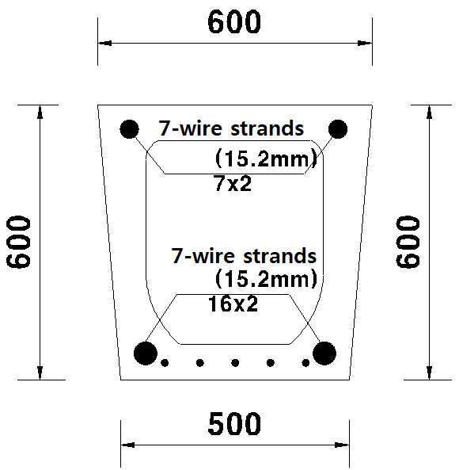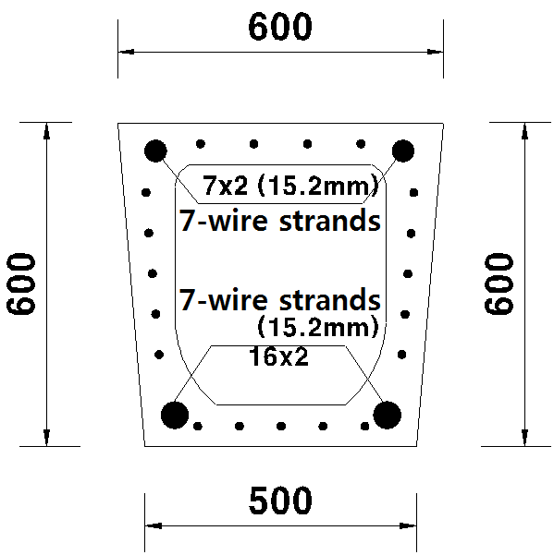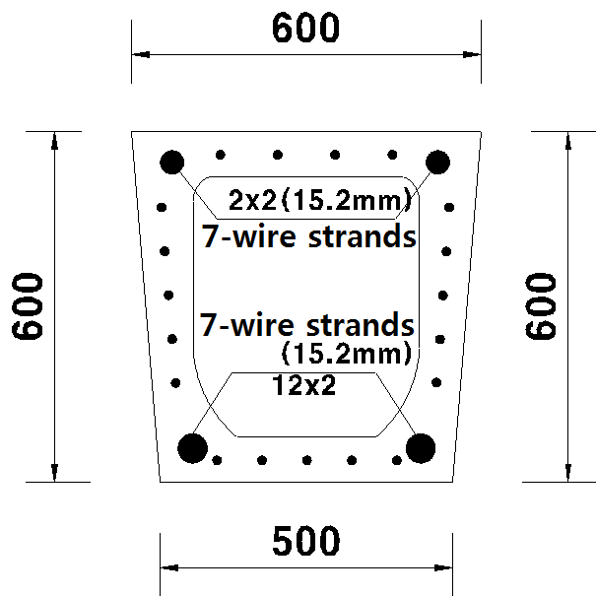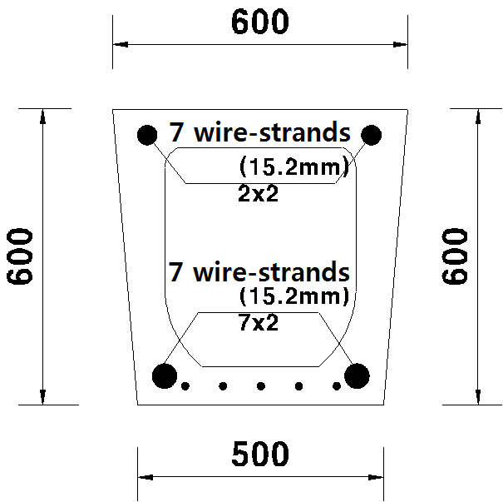

(a) BF2.0-32 (b) BF1.0-32 (c) BF1.0-24 (d) BF1.5-14

Figure 2: Mid-section of box girder (Longitudinal and stirrup bar sizes: D13, unit: mm)

EMB00002dcc0523 EMB00002dcc0526

(a) End section of B2.0, B1.5 (b) End section of B1.0

Figure 3: End section of box girder (unit: mm)

EMB00002dcc0566

Figure 4: Reinforcement of segmental box girder

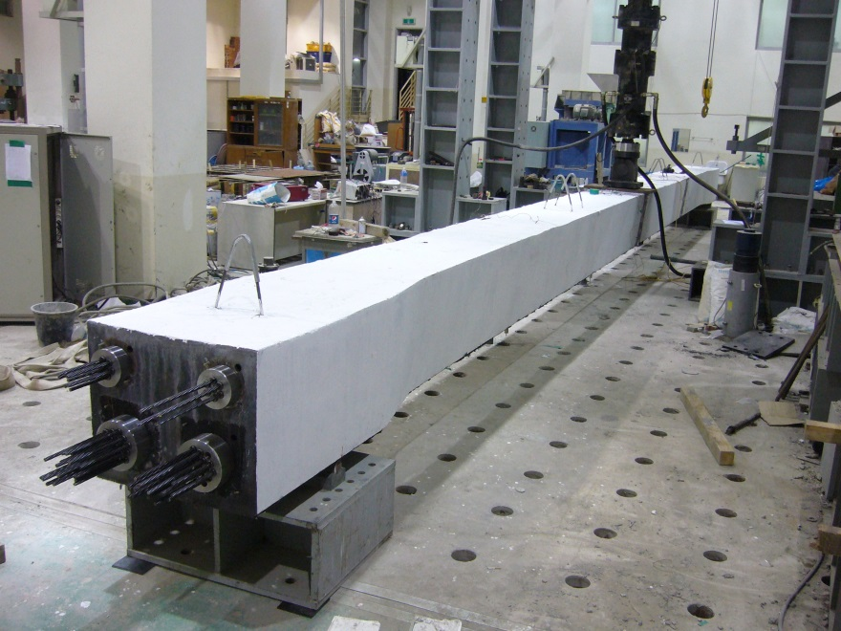

Figure 5: Flexural test under three point loading

1. **RESULTS AND DISCUSSIONS**
   1. **Load-displacement relationships**

Load-displacement curve of UHPC box girder is as shown in Fig. 6. BF1.0-32 and BF2.0-32 reflect a linear relationship until 420 kN with almost the same slope. Because BF1.0-32 and BF2.0-32 have more PS tendons than BF1.0-24 and BF1.5-14, elastic modulus of BF1.0-32 and BF2.0-32 are larger than BF1.0-24 and BF1.5-14. Initial cracking of BF2.0-32 and BF1.0-32 begins at 470 kN and 420 kN, respectively. Stiffness of BF2.0-32 which contains more steel fibre is a little larger than BF1.0-32 which uses distributed rebar at the web and upper flange. Maximum load of BF1.0-24 and BF1.0-32 was 720 kN and 747 kN, respectively, and their displacements were 256 mm and 184 mm, respectively. BF2.0-32 and BF1.0-32 have more tendons than BF1.0-24; these have similar maximums but larger displacements. Maximum load of BF1.5-14 was 470 kN and its displacement was 260 mm. Failure mode of BF1.5-14 which utilizes upper concrete was not compressive failure; and the raising deflections after yielding PS tendon is typical behavior which was indicated in the insufficient, under-reinforced PSC beam. Therefore, BF1.0-24 which is UHPC with a combination of 1.0% steel fibre volume fraction and 24 PS strands with longitudinal steel reinforcement reflects a more stable ductile behaviour and has more cost-effective mixture design than any other cases.

Figure 6: Load-displacement relationships of UHPFRC box girder specimens

**3.2 Change of strain and neutral axis at mid-span section**

Strain change of the central section is as shown in Fig. 7, and neutral axis change is as shown in Fig. 8. In Fig. 7 of BF2.0-32, compression and tension strain are linearly increasing before 400 kN; tension strain of steel fiber nonlinearly increased after 400 kN. Neutral axis moves upward due to increasing crack width, due to increasing the load after the initial crack which occurred at 460 kN in lower flange. Compression strain was 2,600 ㎛ at 600 kN and 2,960㎛at 737 kN in compression zone. Tension strain was 2,640㎛at 600 kN in tension zone. The neutral axis was placed at 287 mm from top to downside at initial load. As shown in Fig. 8, it began to rise after 460 kN and was placed at 156 mm when reaching 747 kN. In Fig. 7 of BF1.0-32, compression and tension strain linearly increased before 400 kN and tension strain of steel fibre nonlinearly increased after 400 kN, similar to BF2.0-32. Crack width increased after the initial crack which occurs at 420 kN in lower flange and neutral axis has risen. Compression strain was 2,200㎛at 600 kN and 3,340㎛at 718 kN. In tension zone, neutral axis rapidly increased due to cutting strain gauge after 600 kN. This occurs more quickly than in BF2.0-32. The neutral axis was placed on 265 mm from top to downside at initial load. As shown in Fig. 12, it began to rise after 300 kN and was placed at 162 mm upon reaching 718 kN. In Fig. 7 of BF1.0-24, compression and tension strain linearly increased before 400 kN and tension strain of steel fibre increased nonlinearly after 400 kN. Compression strain is 4,031㎛at 500 kN but decreased to 2,181 ㎛at 600 kN due to longitudinal cracking. At initial load the neutral axis was placed at 331 mm from top to downside. As shown in Fig. 8, it began to rise after a loading 400 kN, and was located at 225 mm upon reaching 720 kN. In Fig. 7 of BF1.5-14, compression and tension strain linearly increased before 200 kN; tension strain using steel fiber nonlinearly increased after 200 kN; while crack width increased after initial cracking which occurs at 260 kN in the lower flange. Corresponding compression strain was 2589㎛at 400 kN and 3122㎛at 470 kN. In the tension zone, tension strain was 8,423 ㎛at 400 kN and 9,217 ㎛ at 470 kN. The neutral axis occurred at 320 mm from top to downside at initial load. As shown in Fig. 8, it began to rise after a load of 250 kN and it occurs at 1200 mm upon reaching 470 kN.

* 1. **Relationship of failure shape and reinforcement index ratio**

Deflection of BF2.0-32 and BF1.0-32 which have 32 strands in the lower flange have less deflection than BF1.0-24 which has 24 strands. Deflection of specimens having 32 strands was 190 mm and 256 mm, respectively. However, maximum load of BF2.0-32 and BF1.0-24 were 745 kN and 714 kN, respectively. This is similar to the 715kN load of BF1.0-24; therefore, 32 strands creates over-reinforcement in UHPC box girder section. BF2.0-32 was destroyed by brittle failure at maximum load, and 745 kN in the central section. BF1.0-32 was destroyed by brittle failure separating upper flange and web at maximum load, and 714 kN in the central section. In BF2.0-32 and BF1.0-32, there was diminished strain on the tension zone due to over-area of PS tendons; the increased force appeared to bind the compression zone. However, such force induces brittle failure to PSC box girder. BF1.0-24 demonstrates the presence of ductile behavior despite the small area of PS tendons with a similar maximum load of BF1.0-32; displacement increases until reaching 256 mm. Concrete strain increased until reaching 5,431㎛ in the compression zone (and strain of PS tendons at maximum load). The produced ductile behavior indicates the strain aspect of girder and demonstrates the under-reinforcement the PSC box girder. BF1.5-14 has less area of PS tendons than other samples. Therefore, it has half the initial crack load tolerance and a maximum crack load shown by BF1.0-24. There was no failure until concrete strain reaches 3,122㎛at maximum load. This indicates that there remains additional capacity for compression strain. This girder contains less reinforcement than BF1.0-24. In ACI 318-14 (2014), reinforcement index ratio which corresponds with prestress tendon strain of 0.005 is specified as =0.32 and it is criterion for under and over-reinforcement box girder. Effectiveness of reinforcement index ratio limited to the UHPC box girder verifies the comparison criterion and use of 4-type box girders in this study. In the AFGC (2013) recommendation on Ultra-High Performance Fibre-Reinforced Concrete, stress block factor decreases from 0.65 to 0.5. Strength of PS tendons which is 7 strands and diameter of 15.2 mm is used *fpy* = 1,666 MPa and *fpi* = 1,997 MPa; PS tendons are not attached.

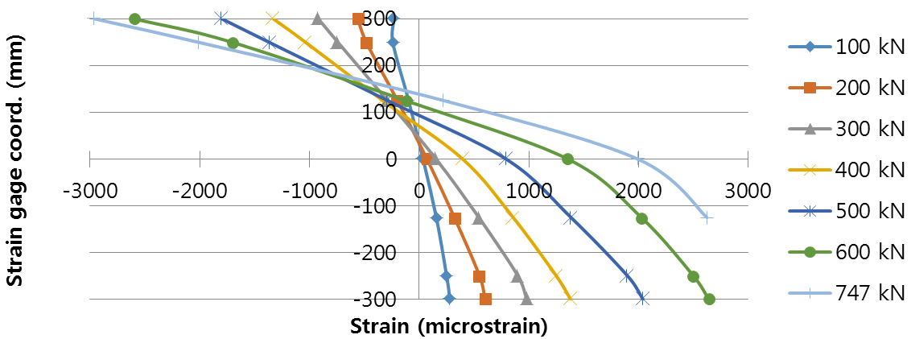

1. BF2.0-32

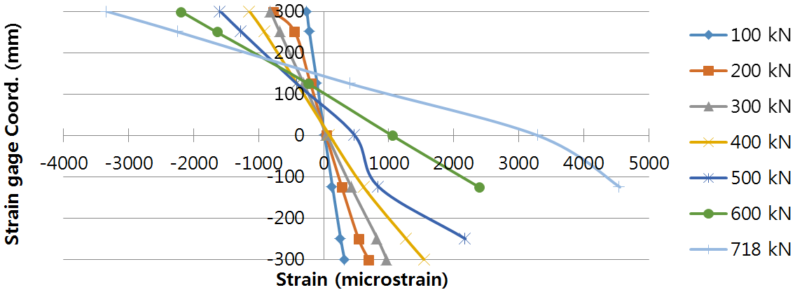

(b) BF1.0-32

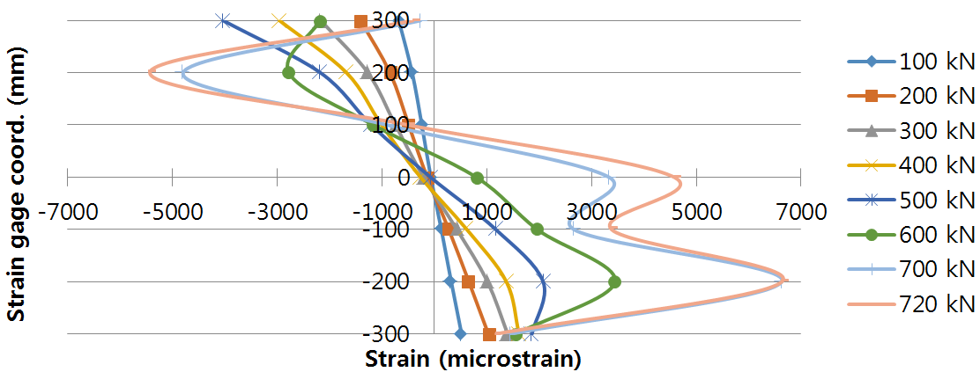

(c) BF1.0-24

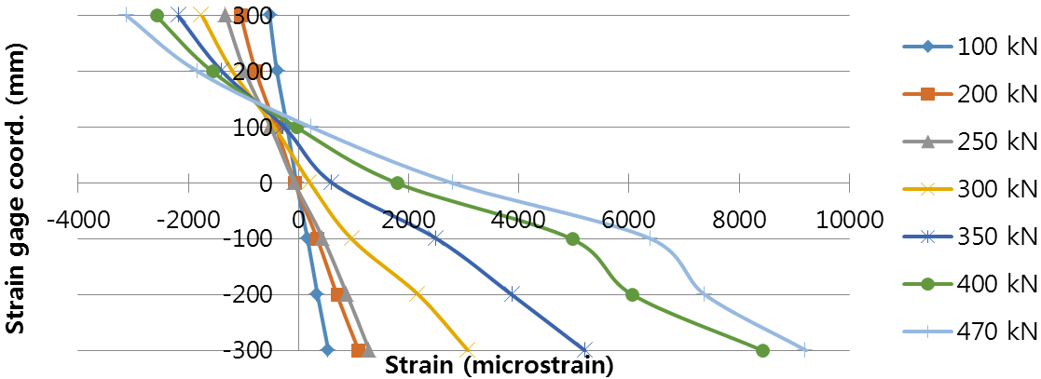

(d) BF1.5-14

Figure 7: Flexural strain distribution at mid-span section

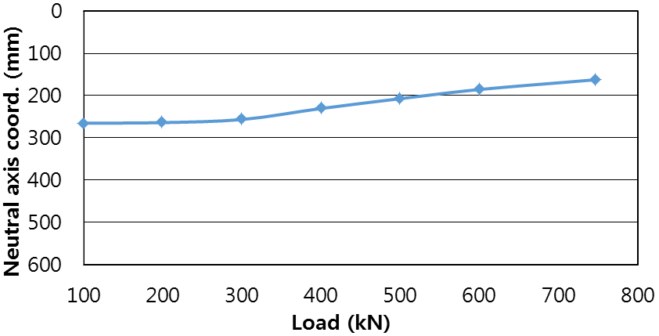

(a) BF2.0-32

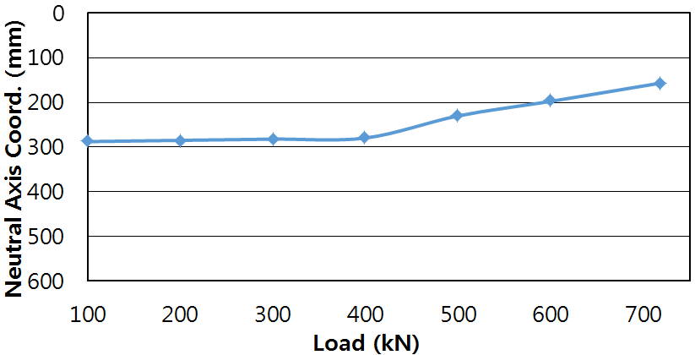

(b) BF1.0-32

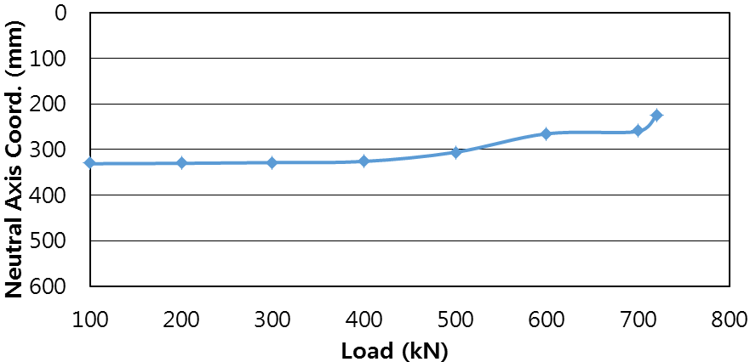

(c) BF1.0-24

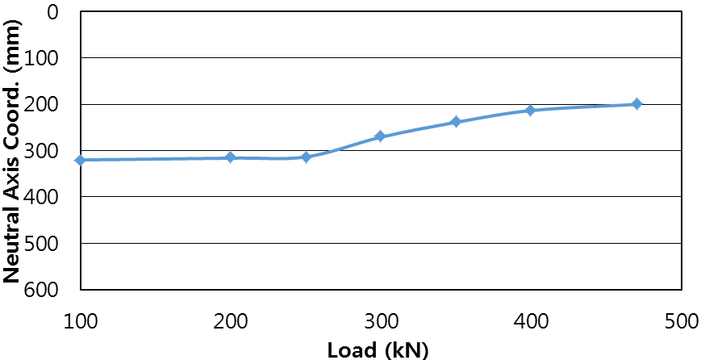

(d) BF1.5-14

Figure 8: Change of location of neutral axis at mid-span cross-section

Therefore, calculation results of reinforcement index ratio to use only tendon is shown as follows:

[1]

As shown in Table 3, the reinforcement index of both BF2.0-32 and BF1.0-32 is 0.14; this is lower than 0.32 = 0.16. This is indicative of under-reinforcement. However, actual behavior of PS tendons reflects over-reinforcement of tendons. Reinforcement of BF1.0-24 is 0.11, which is indicative of under-reinforcement. Here, actual behavior also shows under-reinforcement properties wherein both deflection and tendon strain are high until compression failure of the concrete. In order to evaluate the reinforcement index of UHPC box girder, the geometric shape of box girder must be exact, with new criteria, about 0.005 tendon strain is calculated. Therefore it is recommended that such criteria be applied to UHPFRC box girder design.

Table 3: Comparison of reinforcement index

|  |  |  |  |  |
| --- | --- | --- | --- | --- |
| Girder type | Reinforcement  index | 0.32 | Reinforcing property | |
| Design criterion | Experimental members |
| BF2.0-32 | 0.14 | 0.16 | Under-reinforcement | Over-reinforcement |
| BF1.0-32 | 0.14 | 0.16 | Under-reinforcement | Over-reinforcement |
| BF1.0-24 | 0.11 | 0.16 | Under-reinforcement | Under-reinforcement |
| BF1.5-14 | 0.7 | 0.16 | Under-reinforcement | Under-reinforcement |

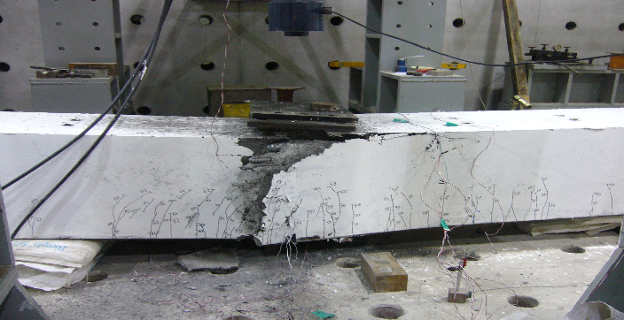 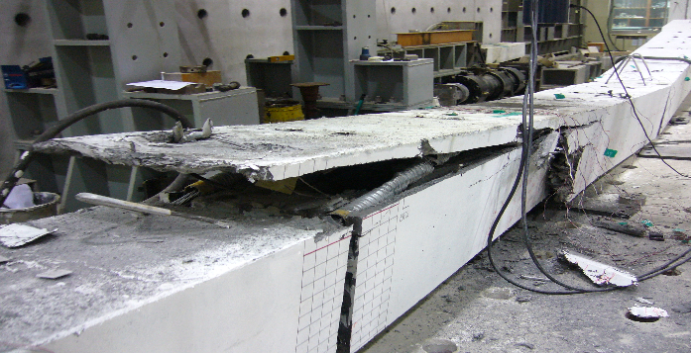

(a) BF2.0-32 (b) BF1.0-32

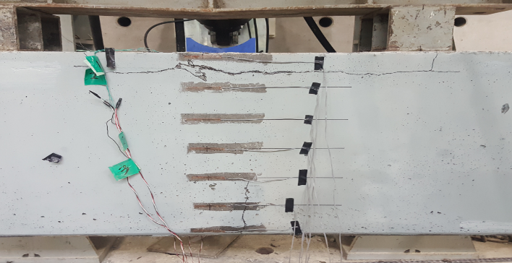 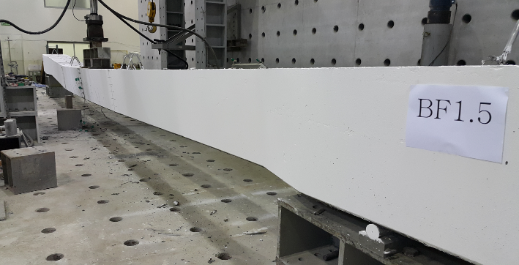

(c) BF1.0-24 (d) BF1.5-14

Figure 9: Failure patterns of specimens in the mid-span section

1. **Summary and Conclusions**

This study analyzes behavioral properties UHPFRC box-girders by measuring and evaluating displacement, strain and neutral axis under various loads. The following conclusions can be drawn from this study:

(1) BF2.0-32 showed the behavior of over-reinforcement rebar. BF1.0-24 exhibited the maximum load similar to that of BF2.0-32 and showed the behavior of under-reinforcement rebar resulting in large deflections. BF1.5-14 shows the ductile behavior and the maximum load of 1/2 of the flexural capacity of BF1.0-24.

(2) An experimental evaluation study confirms that BF1.0-24 (which is UHPC with a combination of 1.0% steel fibre volume fraction and 24 PS strands of longitudinal steel reinforcement) induces more stable ductile behavior and is a more cost-effective mixture design than other cases.

(3) The reinforcement index of the prestressed beam used in common design criteria does not accurately reflect the behavior of the UHPC box girder. Therefore, engineers need to consider in detail the geometric shape of the box girder, and a reference value corresponding to 0.005 strain of reinforcement rebar should be newly calculated.

(4) Most of all, consideration must be given to the ductile behavior of UPHC specimens using steel fibre volume fraction of 2% and 1.5% with shear reinforcement bars at lower flange, and 1% with shear reinforcement bars at upper flange, web and lower flange.

**Acknowledgement**

This work was supported by the Global Excellent Technology Innovation [grant number (10062951), research project title (Development of hybrid ultra-high strength repair & reinforcement fiber product with self-healing properties and construction methods for the civil engineering and construction)] funded by the Ministry of Trade, Industry and Energy (MOTIE) of Korea.

**References**

Association Francaise de Genie Civil (AFGC) 2013. Document scientifiques et Techniques, Ultra High Performance Fiber-Reinforced Concrete, Recommendations. 82-89.

American Concrete Institute (ACI) 2014. Building Code Requirement for Structural Code (ACI 318M-14).

Chan, S.Y., Feng, N.Q. and Tsang, M.K. 2000. Durability of High Strength Concrete Incorporating Carrier Fludifying Agent. Magazine of Concrete Research, **52**(4), 235-242.

Han, S.M. and An, J.W. 2015. The Ductile Behavior Test of Ultra High Performance Fiber Reinforced Concrete Rectangular Beam by Combination of the Fiber and Group of Reinforcing Bars, *Journal of the Korea Institute of Structural Maintenance and Inspection*. **19**(3), 139-148.

Jeong, M.S., Park, S.Y. and Han, S.M. 2017. Ductile Behavior of Ultra High Performance Fiber Reinforced Concrete Segmental Box Girder, Journal of the Korean Recycled Construction Resources Institute. **5**(3), 282-289.

Resplendino, J. 2012. State of the art of design and construction of UHPFRC structures in France, Plenary.2 3rd International Symposium on Ultra-High Performance Concrete.

Park, J.Y. and Han, S.M. 2016. The Ductile Behavior Test of the Ultra High Performance Fiber Reinforced I Beam by the Combination of the Fiber and Group of Reinforcement Bars, Journal of the Korea Institute of Structural Maintenance and Inspection. **20**(1), 18-24.