A CONTRACTOR’S PERSPECTIVE ON THE ACCELERATED BRIDGE CONSTRUCTION OF WESTMINSTER DRIVE UNDERPASS, HWY 401: PROCESS AND CHALLENGES OF GiGo BRIDGES

Gardonio, Don A. ^{1,3}, Ifabumuyi, Mike^{1,} Loh, Philip¹ and Powney, Glen²
¹FACCA Incorporated, Canada
²Total Bridge Services Inc., Canada
³ don@facca.com
Abstract: In 2014, FACCA Incorporated was contracted by the Ministry of Transportation Ontario (MTO) to replace the Westminster Drive Underpass near London, Ontario, using the Get in-Get out or GiGo concept of Accelerated Bridge Construction (ABC). This ABC contract requires the construction over the Highway 401 freeway to be completed in 45 days or less, with full closure of the cross road (Westminster Drive).
This presentation will address the construction process from the prefabrication of bridge components during winter months, including the superstructure “supermodules” comprising reinforced concrete deck and steel box girders and concrete substructures (abutments, wingwalls and pier caps), to the site preparation and the eventual erection of the supermodules. We will also address the challenges encountered during the prefabrication, unforeseen soils condition encountered during piling, maintaining extremely tight construction schedule, and the logistics involved in the heavy lifting of the supermodules.
Further, we will present the human factors, which include the Owner’s effort, and the collaboration of the Owner, Designer and Contractor to see the successful completion of Ontario’s first GiGo bridge. The success and lessons learned from this project has been implemented in another structure in Ontario in 2017.

1 INTRODUCTION

There is a backlog of bridge repairs and replacements that need to be addressed. The Ministry of Transportation (MTO) identified 40 bridges over Hwy 401 that will need to be replaced in the next 20 years. That is just in the West Region, a 285 km section of the 401. Governments are eager to spend on infrastructure as it has proven to stimulate the economy. The challenge is how to deliver these projects without creating traffic disruptions, delays and congestion. Traffic delays affect people’s lives. Accelerated Bridge Construction (ABC) techniques for replacing bridges are an exciting innovative concept being used by infrastructure Owners.

The Ministry and Stantec developed an ABC method called the Get in-Get out Bridge or GiGo Bridge (Trader et al. 2012). GiGo is a flexible solution that the MTO plans to use to complete Hwy 401 underpass replacements in less than four months, with the crossing road being closed for 45 days. Some of the key elements of Westminster GiGo Bridge included:

- Piers founded on concrete caissons
- Integral abutments on single line H-Piles
- Cast-in-place columns with precast pier caps
- Precast abutments and wingwalls
- Superstructure module (supermodules) where each supermodule is comprised of steel box girders and a cast-in-place concrete deck on the steel box girders
- Cast-in-place deck closure strips, bearings seats, barrier walls, and approach slabs

2 BRIDGE GEOMETRY & DESIGN

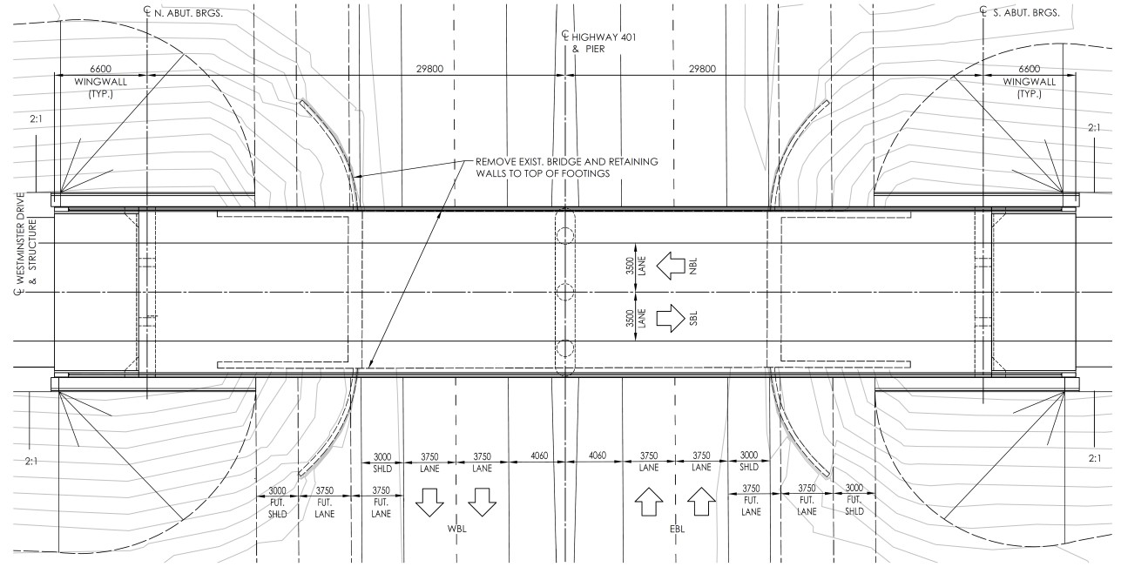
The original bridge, constructed in 1959, was a 28.8 m single-span rigid frame bridge comprised of three variable depth concrete box girders. The flyover structure carried two lanes of traffic over four lanes of Hwy 401. The abutments were situated within the clear zone and would not allow for widening.

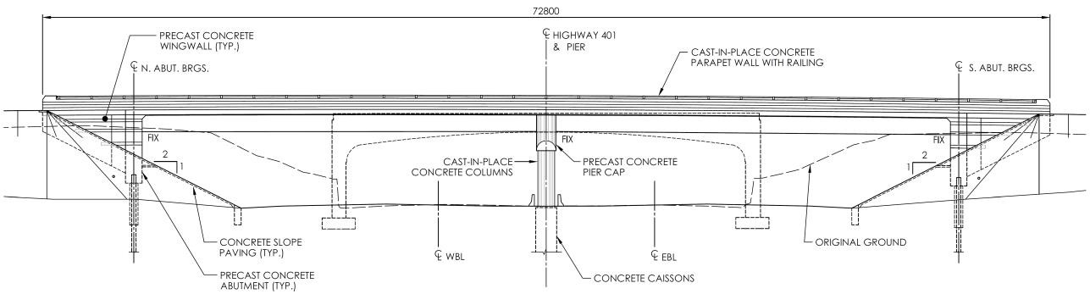
Figure 1: Westminster Drive Underpass – Plan

Figure 2: Westminster Drive Underpass - Elevation
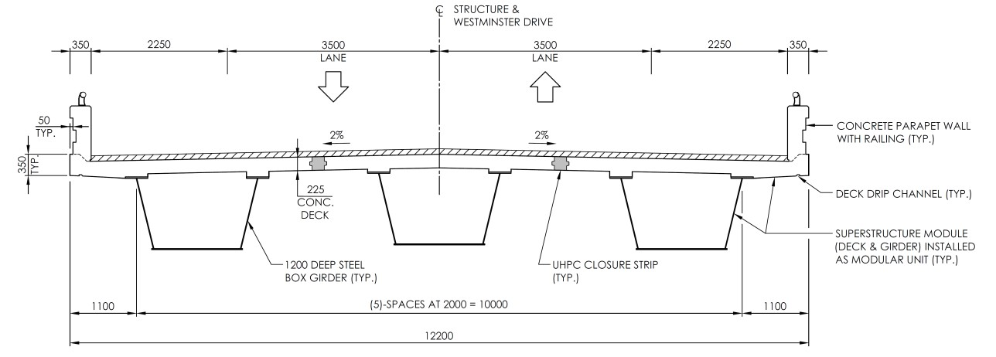

Figure 3: Westminster Drive Underpass – Cross-Section

The pier consists of a precast concrete pier cap resting on 1200 mm diameter cast-in-place concrete columns, supported on 1500 mm diameter caissons 8.9 m deep. The integral abutments, supported on H-Piles, consist of a precast concrete portion of the abutments below the bearing seats. The top portion of the abutment is cast integral with the ends of the decks.

3 PREFABRICATION

The substructure was composed of three equal width (3.65 m) precast concrete abutment stem segments and two precast concrete wingwall segments. The abutments incorporated horizontal relief strips for aesthetic purposes. The substructure elements were cast at FACCA’s CPCI approved facility in Ruscom. Each 3.50 m tall by 1.20 m thick abutment had a mass of approximately 33 tonnes. Corrugated steel pipes (CSP) formed voids in the abutment stem to allow for placement of the segment over the previously driven steel H-piles. High-early strength self-consolidating concrete (SCC) was used to fill the voids, bearing seats and closure strips between the segments.

Each 5 m long by 0.45 m thick precast concrete wingwall segment was full height (i.e. extended above the bearing seat elevation to the bottom of the barrier wall elevation) and connected to the outside abutment segments via cast-in-place high early SCC cleats. A horizontal cast-in-place ledge was constructed to the underside of the wingwall to help with installation and support of the precast wingwall segments. Each wingwall section weighed approximately 15 tonnes.

The precast pier cap was 12 m long and weighed approximately 47 tonnes. The cap sits on three cast-in-place (1200 mm diameter) concrete columns. Each of the columns is founded on a drilled cast-in-place (1500 mm diameter) concrete caisson. Ten 35M bars protrude from each of the columns into 150 mm diameter CSP sleeves in the precast pier cap. The Designer provided precise locations of the sleeves to accommodate pier cap shear reinforcing steel spacing. A template was built after the fabrication of the precast pier cap. The template was then used to place the column vertical bars to make sure they lined up with the voids in the pier cap. Solid high-strength plastic shims were placed to support the pier cap on the columns. High-early SCC was then used to fill the CSP sleeved and the gap between the pier cap and columns.

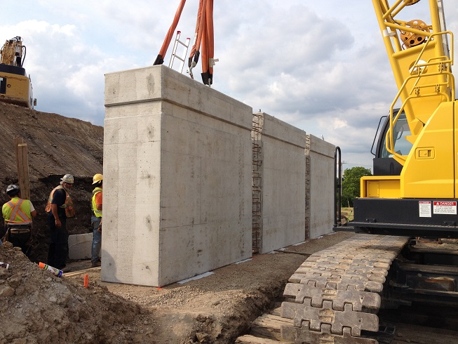

Figure 4: Prefabricated Abutment Stem Segments

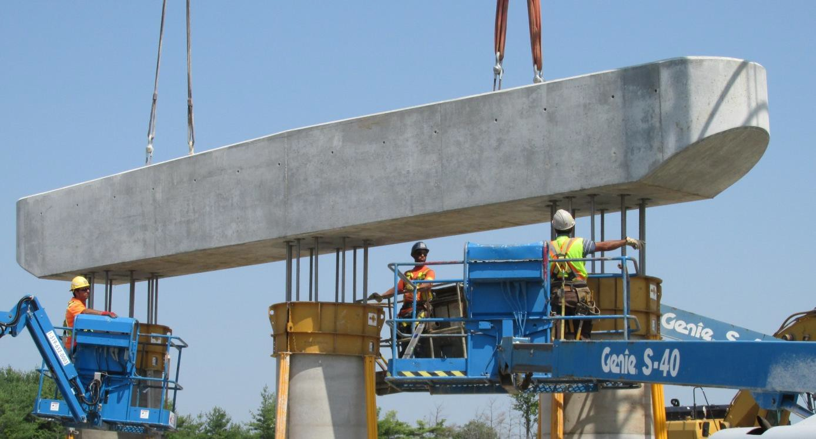

Figure 5: Prefabricated Pier Cap

4 SUPER MODULES

Each span was comprised of three supermodule, each consisting of a 1200 mm deep steel box girder supporting a 4.0m wide deck. The concrete deck portion started 900 mm from centreline of the abutment bearings and ended 1400 mm from the pier centreline. Each 30 m long supermodule weighed approximately 95 tonnes. A temporary yard was used to cast the supermodules due to transportation challenges. Temporary foundations were constructed to mimic the same support conditions and bearing locations, including dimensions, cross-fall, superelevation and grade, as the new pier and abutments in the permanent location. Once the girders were installed on the temporary supports, the concrete deck was formed, reinforced, cast and cured conventionally. The exceptions were the use of block-outs at the transverse closure locations (at pier and abutments) and at the longitudinal closure strips (between each of the three supermodules in a span)
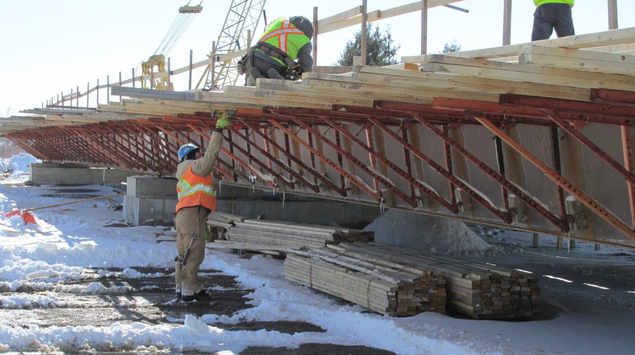

Figure 6: Supermodule Fabrication At Temporary Yard

5 HOISTING

Two large (300-tonne and 500-tonne) cranes were used to load the supermodules off the temporary support onto the specialty transport trailers. Internal bracing was placed inside the girders at the lift points to reduce risk of cracking. The supermodules were installed over two consecutive nights. EB girders were installed the first night in a 6-hour closure, the WB girders the following night in another 6-hour closure.

For the site lift, a 350-tonne crane was setup in the median with a 500-tonne crane on the outside shoulder on a 1.0m thick granular base adjacent to the abutment. OPP escorts were used to transport the supermodules to site. The haul route required permission from the City of London and an analysis of the Glanworth Bridge underpass to confirm capacity. The precast abutments and wingwall were installed using a 110-tonne crane. The components were set and braced using concrete blocks and adjustable rakers. The precast pier cap was hoisted using a mobile 150 tonne crane. The lift took less than an hour.

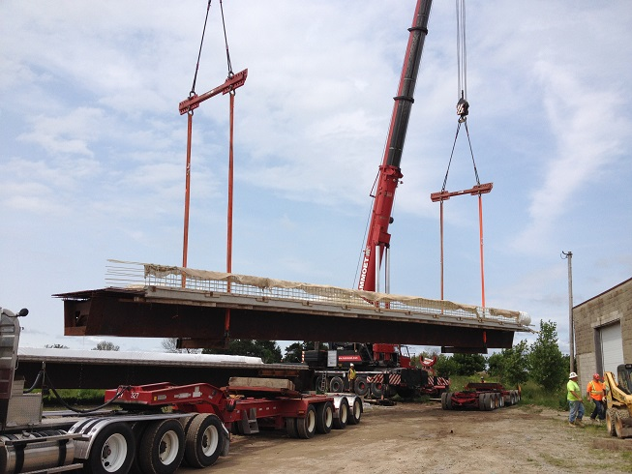

Figure 7: Loading Supermodules At Temporary Yard
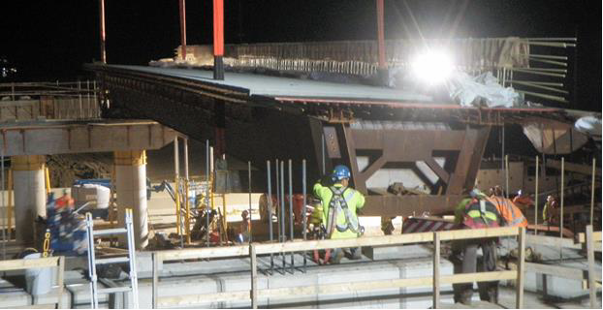

Figure 8: Installing Supermodules

6 CONSTRUCTION & SCHEDULE

FACCA was awarded the contract in September 2013. Fabrication of the precast abutments, wingwalls and pier cap began in January 2014 at FACCA’s CPCI approved yard in Ruscom. The temporary yard was located 7 km from the job site at the Colonel Talbot Road interchange. Yard preparation began in February 2014. Girders were delivered at the end of February. Forming was completed by late April. The casting of the deck was scheduled for early May to avoid cold weather protection.

Field work began on May 26, 2014. It consisted of surveying and relocation of the median sewers which was necessary to accommodate the centre pier construction. Westminster Drive was closed on July 2, 2014. The majority of the bridge was removed by the following Saturday night under a 10-hour full closure of Hwy 401. Traffic was diverted using an 11 km detour. Piling and installation of the substructure components took approximately three weeks. There was some additional time spent on pile driving as the piles were driven deeper than anticipated thus requiring splicing and NDT checks on the welds. The super modules were erected the nights of July 27 and 28, 2014. Closure strip form work and worker overhangs were installed the same night as the closure. This minimized amount of time we were working over the 401.

Completion of the superstructure construction (forming and casting longitudinal closure strips, deck over pier, deck at abutments, parapet walls, and approach slabs) took approximately 3 weeks. Waterproofing and paving was subsequently carried out. Westminster Drive was opened to traffic on August 22, 2014, 51 days after the road was closed. Median tall wall barrier construction, concrete slope paving, application of concrete sealer, and site restoration concluded in early October.

7 TEAM WORK

One of the unique aspects of this project was the collaboration between the Ministry and the Contractor. At the pre-start meeting the Ministry discussed the GiGo goals and how all parties needed to work together for the project succeed. The Ministry stepped up and worked very closely with the Contractor. After the girders were installed the camber did not deflect as expected resulting in a deep deck haunch. We reviewed with our rebar supplier and came up with a solution. This information was conveyed to the Ministry. The temporary casting yard was only a 10-minute drive from the MTO office they quickly came out to review and discuss the haunch issue. The field discussion lead to approval of the solution, i.e. add additional deck bars. The haunch issue was resolved in less than 48 hours, thereby avoiding schedule delays. It was but one example of how successful a project can be when there is strong open communication between the Owner and the Contractor.

8 CONCLUSIONS

The Westminster Drive Underpass replacement demonstrated that GiGo Bridge concepts do work in improving work zone safety by removing construction activities away from the highway. Our labourers enjoyed being able to work standing on the ground not worrying about traffic or concerns with dropping materials onto the roadway below. Utilizing prefabricated elements and supermodules to replace Hwy 401 bridges drastically reduced the impact to both roadway users and construction personnel compared to conventional bridge replacement techniques. GiGo Bridge method is an ABC technique that does work and it will be used by the Ministry to deliver the large amount of infrastructure renewal projects expected over the next few years with fewer impacts to society.

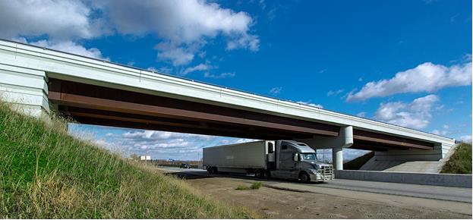

Figure 9: Westminster Drive Underpass

Acknowledgements
Hats off to all those who helped contribute to successful completion of the Westminster Drive Underpass replacement, including the MTO Staff, FACCA’s skilled hard-working team and our sub-contractors J-AAR Excavating, Coco Paving, Peeters Landscaping, Acculine Pavement Markings.

References

Young W. F., and Boparai, J. 2013. Whiteman Creek Bridge: A Synthesis of Accelerated Bridge
Construction, Ultra- High Performance Concrete, and Fibre Reinforced Polymer. Precast/Prestressed
Concrete Institute Journal, 58 (2): 37-47.
Trader M. L., Young W. F., Turnbull A., D’Andrea, M, and Wang, W. 2012. GiGo Bridge: Get in-Get out Bridge Replacements. Stantec Consulting Ltd., Hamilton, ON, Canada.

