 | 10th International Conference on Short and Medium Span Bridges  Quebec City, Quebec, Canada,  July 31 – August 3, 2018 | 

DEVELOPMENT OF A NEW DESIGN OFF-HIGHWAY LOGGING TRUCK FOR THE QUEBEC FOREST BRIDGES
Bernard, Daniel¹, Lamy, Jean-Michel¹ and Gaudet, Eric^{1,2}
¹ SNC-Lavalin Inc., Canada
² eric.gaudet@snclavalin.com
Abstract: The “Ministère des Forêts, de la Faune et des Parcs” is for the Quebec government the owner and manager of many bridges located on public lands. For several years, the increase of the carried logging loads on the Province of Quebec forest road transportation system has pushed many of those bridges to their functional limits. This increasing transportation demand has also rendered obsolete the commonly used design traffic loads, which are the CL design truck from CSA S6 and the CF3E design highway logging truck. This paper will focus on the development of a new design off-highway logging truck specifically calibrated to cover a large spectrum of overweight logging trucks. The design approach presented is based primarily on the methodology developed in the seventies and eighties by the Research and Development Division of the Ontario Ministry of Transportation and Communications; which has been used to develop the actual CSA S6 CL design highway truck. Finally, this paper will also discuss the limitations of the study and recommendations for further research regarding safety factors and lane-loading for long span bridges.

INTRODUCTION
The new forest bridges built today in Quebec are essentially designed for the needs of the local forest industry. In terms of live load capacity, they are designed for a specific load level, which depends on the local circulation relative to logging sectors. These traffic loads, adapted from actual logging trucks, do not result from a standardized configuration. This suggests a lack of uniformity across the off-highway road network and, possibly, an unsuitable level of safety and reliability. In a manner to address that problematic, the “Ministère des Forêts, de la Faune et des Parcs” (MFFP), the Regulatory Authority of the off-highway road system for the province, decided to evaluate the opportunity of adding a new design off-highway logging truck configuration to their design criteria. The MFFP commissioned SNC-Lavalin Inc. to develop a longitudinal and transversal configuration of this new design off-highway logging truck.

REVIEW OF EXISTING OFF-HIGHWAY DESIGN LOGGING TRUCK REQUIREMENTS
Design criteria may vary from one public entity to another. This is the case of the Quebec MFFP and the British Columbia (BC) Ministry of Forests, Lands and Natural Resource Operations (MFLNRO). Those two provinces are recognized to have a strong forest industry. During the literature review, the design criteria of these two authorities were compared. A fundamental difference was observed in regard to the defined design live loads: MFLNRO covers the off-highway traffic loads, while MFFP does not.

The Quebec approach
Quebec's design criteria for forest bridges are detailed in the “Norme relative aux ponts sur les terres du domaine de l’État”, which primarily refers to the Canadian Highway Bridge Design Code, CHBDC (CSA 2014). It is mentioned that the design live load configurations to be considered are the CL3, CL2 and CF3E. Their configurations are presented in Figure 1. These live load models are only representative of the legal highway logging truck configurations.

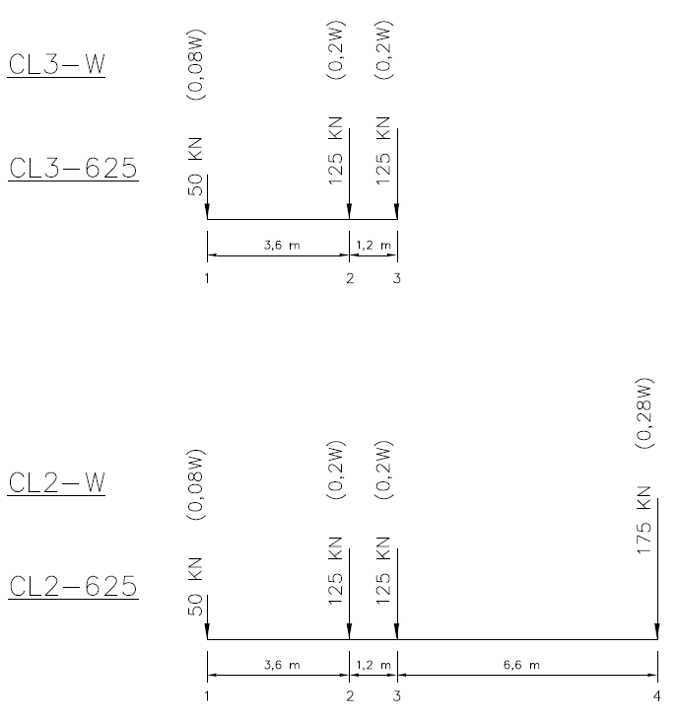 | 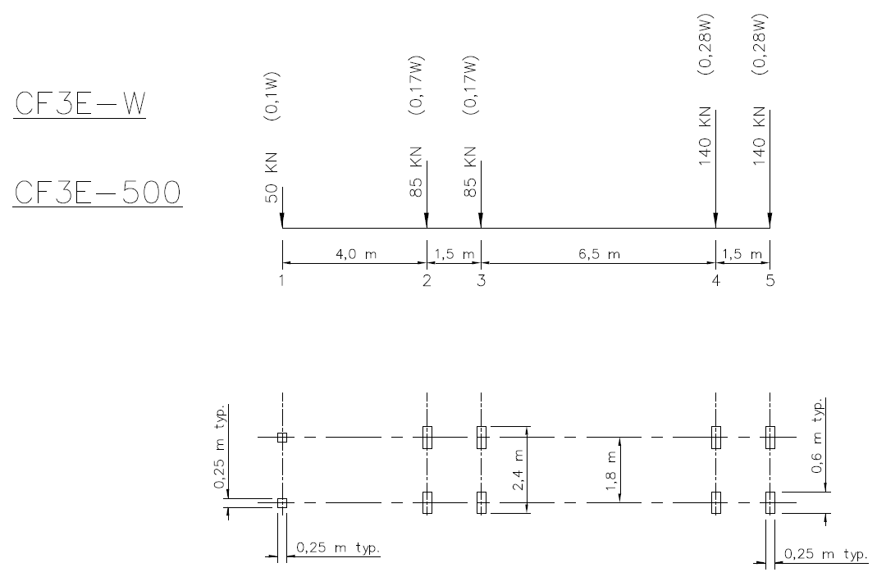
Figure 1: CL3, CL2 and CF3E design truck configurations (Norme relative aux ponts sur les terres du domaine de l’État, 2016)

As previously stated, the off-highway bridges are frequently designed for loads exceeding the legal highway limits, and are essentially designed for the needs of the forest industry. The MFFP’s design criteria also indicates that the safety factors for live loads, αL, are those defined by the CHBDC even if the off-highway truck population cannot be compared with the one on the highway network. Finally, it is noted that the design engineer shall mention on plans the calculation standard used, the design live load considered and the live load capacity factor of the new bridge, relative to the design traffic loads CL3, CL2 and CF3E.

The British Columbia Approach
The MFLNRO design guide, the “Forest Service Bridge Design and Construction Manual”, provides different requirement compared to MFFP. In BC, the notion of off-highway truck is addressed by a series of design trucks, defined by the shape of a semi-trailer truck. These design trucks range between 75 and 165 imperial tons (68 to 150 tons). Similarly to the Quebec approach, safety factors to be used are those defined by the CHBDC. However, over the last two decades, the MFLNRO commissioned various studies to ensure that their design series is reasonably representative of the current logging trucks population and can appropriately be used with the design and evaluation load factors contained in CHBDC. Finally, the manual addresses the notion of design lane loading. An additional configuration, which includes the application of two design off-highway trucks separated by a distance equivalent to the half-length of the design truck considered, is provided for the design of bridges over 40 meters long.

LOgging trucks sample

Definition of the sample
Because of the lack of design requirements for the off-highway bridges, the MFFP developed a methodology to deliver special permits for the logging truck industry. The permits are delivered on an annual basis and can be interpreted as a permit annual (PA) as defined in the CHBDC. The permit’s applicant, are asked to fill out a document in order to define the truck configuration (number of axles, spacing between axles, number of wheels per axle, transverse spacing of the wheels, mass per axle, etc.). Figure 2 provides an example of this application. The weight is obtained by using a load cell equipment while the truck is judged to be fully loaded. They also have to specify the roads they intend to use based on their logging permits. The Ministry then performs a bridge evaluation in order to validate the capacity of each structure they will cross for each logging truck application.
For the purpose of the study, the MFFP provided all the special permit applications they recently obtained from the industry. It is 171 applications that were transmitted. Among those documents, 31 have been rejected for reasons of insufficient data. Also, batches of 29 other documents were found to be duplicates. Finally, 2 more truck applications have been rejected of the analysis because they included aberrant values (extreme axle load or extremely low truck length). In summary, 109 truck configurations were processed in order to develop a new design truck configuration. This sample represents the heaviest logging trucks circulating in the off-highway road system. In order to develop a new realistic design truck for the industry (axle spacing, axle load, etc.), we can affirm that the sample is small but still representative of extreme vehicles.
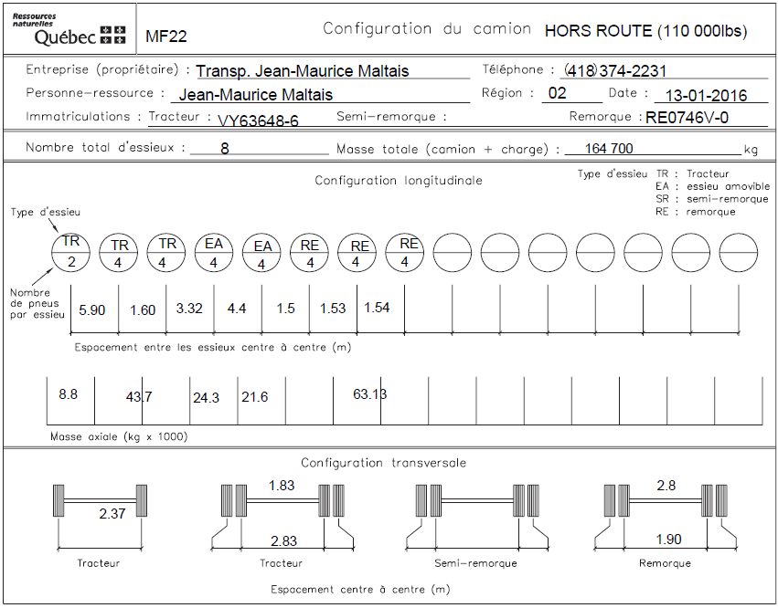
Figure 2: Truck Configuration (off-highway annual permit application)

Sample key data
In summary, here are presented some key data of the logging trucks sample:
Number of axles per truck: 6 to 11 axles.
Total truck length: 18.0 to 31.3 meters.
Average truck length: 19.9 meters.
Maximum truck mass: 89.5 tons to 264.8 tons.
Average axle mass: 19.7 tons (21.6 tons if the first axle is excluded).
Minimum longitudinal spacing between 2 axles: 1.32 meter.
Average longitudinal spacing between 2 axles in a group (tandem, 3 axle group, etc.): 1.56 meter.
Average transverse spacing between the tractor wheels (front): 2.26 meters.
Average transverse spacing between the outside tractor wheels (rear): 2.72 meters.
Average transverse spacing between the outside trailer wheels: 2.26 meters.
Amount of trucks composed of a tractor, a trailer with a 3 axles group and 0, 1 or 2 air lift axles: 88 trucks (80% of the sample).
Amount of trucks composed of a tractor and 2 trailers: 3 trucks.
Firstly, with a total mass between 89 and 265 tons, and a total average mass of 144.6 tons, the logging trucks in the sample are definitely heavier than the highway vehicles. In fact, the Ministry of Transport of Quebec limits normal traffic to a total mass of 62.5 tons. It represents only 43% of the sample’s average loading. Secondly, the same observation can be done for the axle mass. The legal limitation for the highway system in Quebec is set to 10 tons for a single axle. For tens of logging trucks in the sample, the maximum mass per axle ranges between 30.0 to 32.9 tons. Thirdly, most trucks have the same axle configuration. More precisely, 80% of the sample’s trucks are composed of a 3-axles tractor, a 3-axles trailer and no, one or two air lifts axles. The other configurations can be interpreted as a variation of this standard case, for instance a 4-axles tractor or a 4-axles trailer. There are only 3 exceptions in this sample: trucks composed of 2 trailers. As this situation is limited to one specific site in the province, it has been decided with the MFFP to disregard this particular case for the study.

DATA ANALYSIS
As the mandate was to develop a longitudinal and a transverse design truck configuration, these 2 characteristics were studied with a different and independent approach for the data analysis process.

Longitudinal configuration
The longitudinal configuration of a vehicle is a simplified model which represents each axle as a concentrated load that are spaced from each other as measured on site. This vehicle characteristic is of primary importance for a bridge design as it directly influences the load effects on the structure. The design truck must provide representative load effects of the real truck population, so its longitudinal configuration has to be accurately defined.

However, data analysis can be tedious because the final output to be analyzed is not the truck configuration but the load effects on the structures. This output is depending on parameters which can be summarized as:
- The longitudinal truck configuration (number of axles, axle spacings, mass distribution on axles).
- The structure properties (beam analogy bridges, structural continuity, span length).
- The type of load effect (bending moment or shear).

For the current mandate, only bridges that complied to the beam analogy theory with a span ranging from 3.0 to 50.0 meters were considered. Those bridges represent 99% of the 1578 structures under the MFFP jurisdiction. Even though continuous span bridges represent only 3% of their structures, this type of bridges was also studied.

Equivalent base length simplification

In the 1970’s, engineers working at the Ministry of Transport of Ontario developed an equation that simplifies a group of discrete loads (like a longitudinal truck configuration) along a beam with a total weight (W), as a uniformly distributed load which is also of a total weight W (Jung and Witecki 1971). This simplification reduces a truck loading as 2 parameters: its total weight and another parameter called the equivalent base length, B_{m}, which represents the length of the equivalent uniformly distributed weight. This second variable is dependent of the total truck weight (W), the amount of axles (N), the axle positions according to the center of gravity (xi), the mass for each axle (Pi) and the bridge span length (L, for simple spans only). Equation 1 defines Bm while Figure 3 presents it schematically.
[1]

With another simplification, the equivalent base length can even be independent of the span length (Csagoly and Dorton 1978). Equation 2 defines B_{m} independently of the span length. In this equation, b is the distance between the first and last axle loads.

[2]
Thanks to the equivalent base length simplification, each truck loading (the complete trucks and all its sub-configurations) can be plotted in a graph representing the total truck weight, W, according to its equivalent base length, Bm. For instance, let’s suppose 3 fictitious vehicles, presented in Figure 4, represent the whole truck population and need to be represented by a design truck. Each vehicle can be divided in different sub-configurations in order to study their load effects on bridges. 22 sub-configurations are shown in Figure 4. Then, if each sub-configuration is defined by its total weight (W) and its equivalent base length in a graph (black dots in the graph of Figure 4), it become obvious which sub-configurations provide the heaviest load effects on bridges. In fact, the heaviest one for a specific Bm will provide the worst load effects. If a design vehicle need to represent this truck population, the sub-configurations of this design vehicle has to be heavier than or as heavy as the one of the truck population (white dots in the graph of Figure 4).

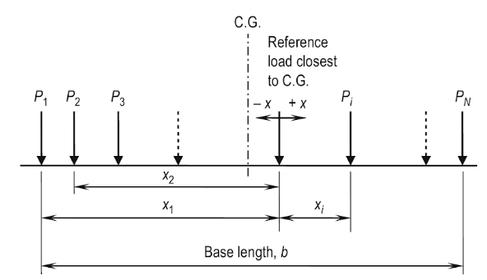
Figure 3: Parameters for the calculation of the equivalent base length (Bakht and Mufti 2015)

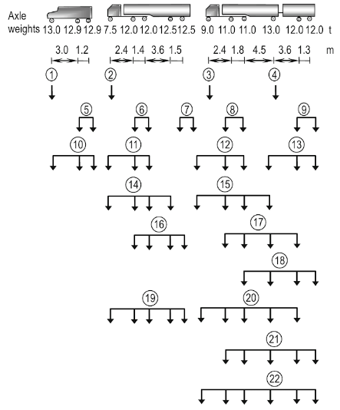 | 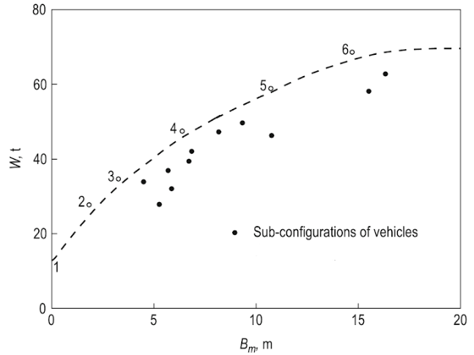
Figure 4: Example of the development of a design truck from a vehicle sample (Bakht and Mufti 2015)

Data analysis based on the concept of equivalent base length

Each truck in the remaining sample has been analyzed for each of its sub-configuration in order to catch the loading effects of these trucks’ parts on smaller bridge spans. From 109 trucks, 3715 sub-configurations were defined and the same amount of equivalent base length was calculated in a spreadsheet. Then, each result has been plotted in a graph where the total truck mass (or the sub-configuration truck mass) is compared to its equivalent base length (Figure 5).
The single axles are represented by filled red squares, all located along y axis in the graph. Their equivalent base length is obviously set to 0 meter. Their mass range from almost 0 to 32.9 tons. The tandem axles are represented by filled grey-blue squares and are located at an approximate equivalent base length of 3 meters. They all represent the second and third axle truck (rear tractor axles). The real trucks are represented by filled blue triangles. They are all located on the right side of the graph (between 19 to 24 meters of equivalent base length). The heaviest trucks have a total mass of 195 tons.
The graph in Figure 5 provides the worst truck sub-configurations. As introduced earlier, these sub-configurations are the heaviest ones for a defined equivalent base length. By considering these critical sub-configurations, it is possible to define a curve representing these extreme values. This curve is represented by the black line in Figure 5 and is called the Maximum Observed Loads (MOL) curve. The MOL will become the reference in order to develop a design logging truck representing the sample.

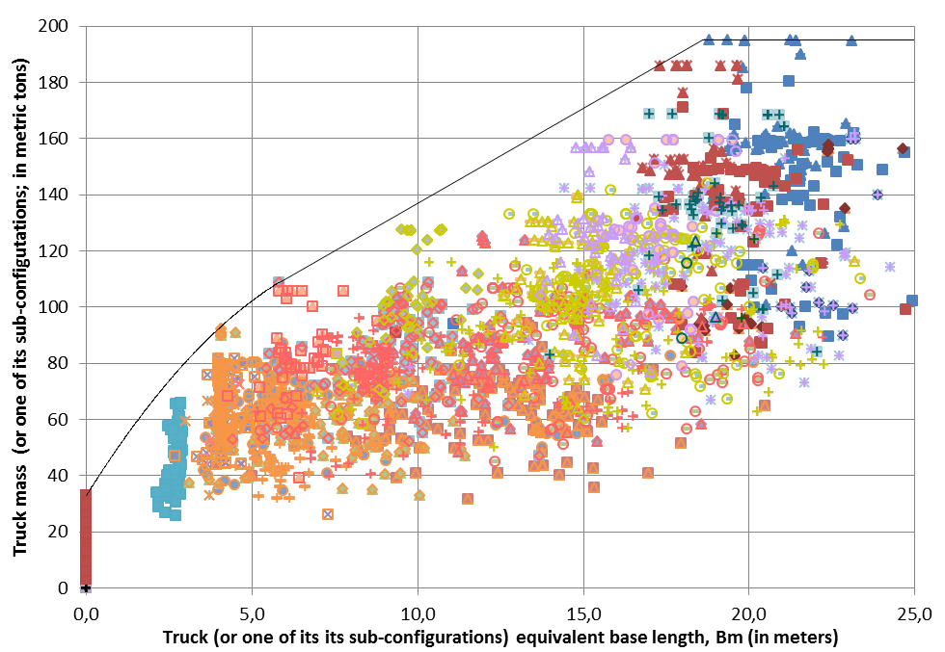
Figure 5: Truck mass (or one of its sub-configurations) according to its equivalent base length (B_{m})

Transverse configuration
The analysis of the data collected shows that the average spacing between the outer wheels of the semi-trailer is 2.26 meters. This wheelbase value is different from the highway logging truck (CF3E) value, which is 1.8m and highway truck value (CL-625) which is also 1.8 m. However, even if this value proves to be representative of the near 150 tons logging truck population, it may still underestimate, in some cases, the transversal distribution factor for the lighter off-highway truck population.

Design off-highway logging truck configuration development
During the design process, 2 objectives were set. Firstly, the new design logging truck should be representative of the real vehicle configuration. This objective will help all the truck industry’s stakeholders to understand that the proposed vehicle is a representation of their trucks using the off-highway road system. Secondly, the design truck should be modular, in terms of its mass and in order to be representative of the logging trucks of the region studied. Each operator in the province has their own truck fleet which can have different weight limitations. For some regions, a 100 tons design truck is to be more representative of the heaviest vehicle on their roads, while in another region, the design truck should be modulated to 150 tons.

Design for the longitudinal configuration
The design process for the longitudinal configuration respects the following process:
Development of a 150 tons design truck representative of the 150 tons MOL curve. The truck has to be:
- Sufficiently representative of the longitudinal configuration of the truck population (number, mass and spacing of axles).
- Designed to be representative of the truck sample load effects for single span (3 to 50 meters long) and two equal span bridges (2 spans of 3 to 50 meters long).
- Modulated to 100, 125, 175 and 200 tons and be representative of all those sub-configurations.
The first step was done by comparing the proposed 150 tons design truck to the MOL curve for 150 tons and less truck’s sample. Figure 6 shows graphically this comparison.
As it can be seen, the proposed design truck is slightly heavier compared to the MOL when B_{m} is less than 5 meters and around 20 meters. In order to make sure this proposal is representative in terms of load effects, a spreadsheet was developed. This spreadsheet calculated the maximum bending moments due to the design truck for single spans of 3 to 50 meters long and compared it to the load effects due to the MOL curve. The results are shown in Figure 7.

Figure 7 demonstrates that the design truck generates more bending moments on a bridge span compared to the MOL curve except for spans ranging 16 to 21 meters long. The design truck seems very representative of the MOL load effects as the load effects difference is ±5% for most span lengths. Furthermore, the difference is generally on the conservative side of the graph, which is desirable. For an 18 meters long bridge span, it would underestimate the load effect by 4%. This difference is small as a safety margin (safety factor) must be applied. Once the design truck is judged representative for 150 tons and less vehicles, the same process is done for mass of 100, 125, 175 and 200 tons. The results are summarized in Figure 8.
The same conclusions can be formulated for the scaled design truck. There is a tendency that the scaled design truck under 150 tons is less conservative for small spans (under 20 meters long) while it is the opposite for 150 tons and more. Regardless of the scaling level, it can be observed that the design truck gives relatively close bending moments compared to their respective MOL curves. In general, the results are generally on the conservative side of the graph. In conclusion, the proposed design truck seems representative of the truck sample for mass scaled between 100 to 200 tons. This conclusion applies for maximum bending moments in simple span bridges.
Checks were done on two continuous spans with equal length of 3 to 50 meters long for negative and positive bending moments and for shear. These checks were realized with commercial structural software. The load effects were always on the conservative side except for maximum negative bending moment for very short spans. For instance, these load effects are underestimated by 12% for a 2 spans 6 meters long continuous bridge. As this kind of configuration is quite rare on the network and the safety margin still needs to be defined, this lack of conservatism seems acceptable.

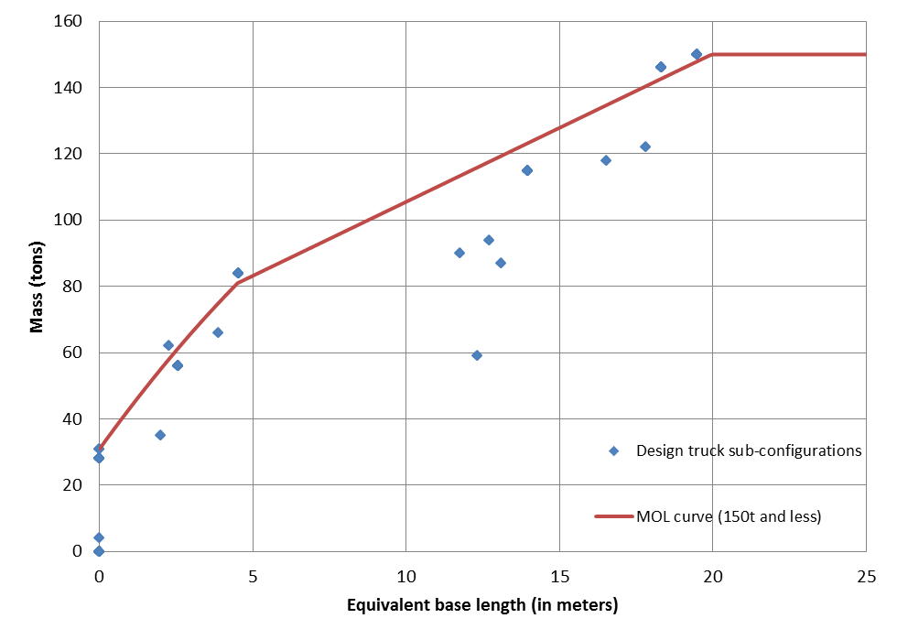
Figure 6: Design truck sub-configurations compared to the MOL curve (150 tons and less)
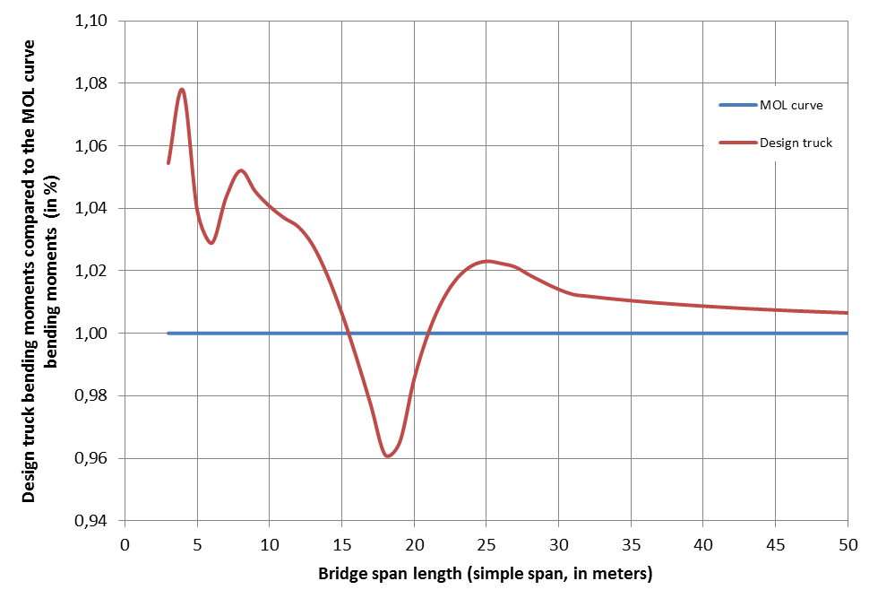
Figure 7: Ratio of design truck bending moments to MOL bending moments according to span length
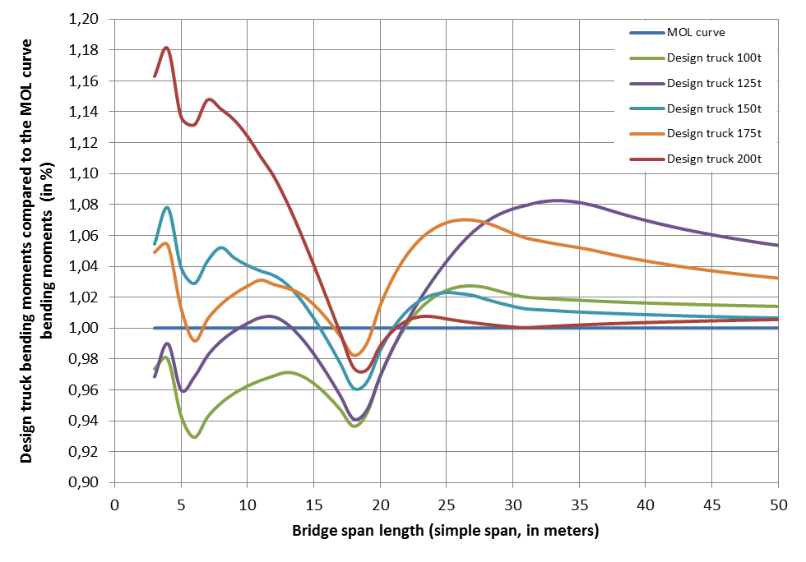
Figure 8: Ratio of design truck bending moments (100 to 200 tons) to MOL bending moments according to span length

Transverse configuration
For the reference forestry truck, the proposed wheel spacing is 2.05 meters. This value represents the average minus the standard deviation. This arrangement makes it possible to maintain a simplified configuration for the reference truck. Furthermore the underestimation of the transverse distribution factors, associated with smaller trucks (for a mass less than 125 tons), is reduced in some cases. In return, the transverse distribution factors associated with trucks of 125 tons and over will, in some cases, be overestimated. However, underestimation or overestimation of these factors only occurs when the beams spacing is greater than the wheels spacing, or when one or more wheels can physically run over the deck’s overhang. Necessarily, these observations do not apply to slab bridges.

In-plan configuration
No field study was done to address the in-plane configuration (the wheel footprint) question. This parameter concerns essentially the local effects due to surcharge. As the MFFP developed its own methodology to assess the effects of this local loading, it has been proposed to preliminary present the design truck with the CL-625 wheel footprint, even though this might be very conservative.

Proposed design truck configuration
The proposed design off-highway logging truck configuration is presented in Figure 9.
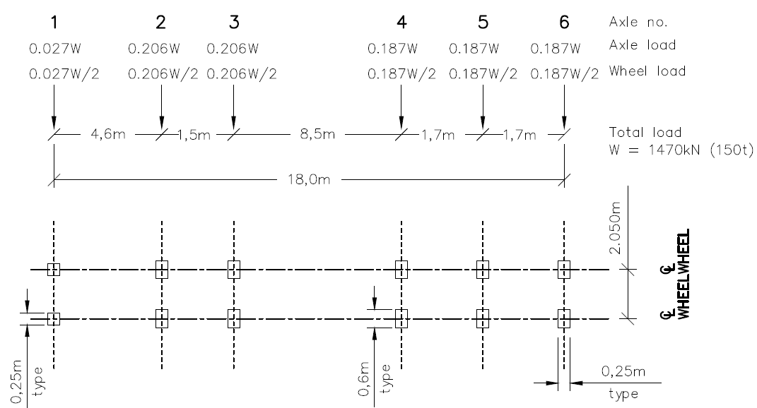
Figure 9: Proposed design off-highway logging truck configuration

DISCUSSION AND LIMITATIONS OF STUDY
Different aspects in relation to the new design off-highway logging truck remain to be developed. Firstly, the limitative nature of the sampling used to define the new design configuration does not make it possible to determine the level of safety and reliability (safety factor). The available data do not provide enough credible statistical parameters on the variation of live loads circulating on the off-highway road network. Since the variation in structural stresses caused by the off-highway trucks is unknown, it is therefore impossible to calibrate the proposed reference design truck with one or more statistically reliable safety factors. In this regard, a traffic study must be conducted, and should be representative of the off-highway trucking regional differences.
The notion of fatigue is not covered by this study. The available statistical sampling does not make it possible to calibrate the proposed new reference design truck on a hypothetical truck causing the fatigue damage, i.e. for a lighter truck whose recurrence of passage is higher than the new reference truck. In fact, no recommendation can be issued for this purpose.
Another aspect not covered by the study concern the bridges deck design. The new wheel load model recommended by the study shows that some bridge deck designs may not be adequate. However, the direct use of this load could be unjustified as it would not necessarily lead to appropriate designs, i.e. designs representative of the existing bridges deck performance. Other aspects will need to be addressed, such as the dynamic load allowance, the side to side unbalanced of axle loading, the design lane loading for longer spans and longer bridges, and the circulation of trucks carrying logging equipment. Additional study on those subjects must be performed.

cONCLUSION
The new design off-highway logging truck development work done for the MFFP has led to the presentation of a new semi-trailer-type reference design truck configuration. That configuration covers as accurately as possible a sub-group of the main sampling, i.e. trucks with a mass lighter than 150 tons. This configuration was successfully modulated for design trucks of 100, 125, 175 and 200 tons. In brief, the reference truck is meant to be a rather faithful representation of the trucks of extreme mass of the studied sample. But, as previously stated, further study will have to be carried out in order to cover the aspects of the safety levels, the dynamic load allowance, the fatigue, the bridge deck design, the side to side unbalanced axle loading, the design lane loading and, if applicable, the circulation of trucks carrying heavy logging equipment.

Acknowledgements
This work was supported by the “Ministère des Forêts, de la Faune et des Parcs”. We would like to thank our colleague Maged EL Makssoud from the MFFP who provided insight and expertise that greatly assisted this research.

References
Bakht, B. and Mufti, A. 2015. Bridges – Analysis, Design, Structural Health Monitoring, and Rehabilitation. 2nd ed., Springer International Publishing, Switzerland.
CSA. 2014. Canadian Highway Bridge Design Code, CAN/CSA S6-14. Canadian Standard Association, Toronto, Ontario, Canada.
Csagoly, P.F. and Dorton, R.A. 1978. Truck Weights and bridge design loads in Canada. Ontario Ministry of Transportation and Communications – Research and Development Division. Downsview, Ontario, Canada.
Forest Service Bridge – Design and Construction Manual. July 30 1999. Ministry of Forest, Lands and Natural Resource Operations – Engineering branch, British Columbia. 13 pages.
Jung, F.W. and Witecki, A.A. 1971. Determining the maximum permissible weights of vehicles on bridges, Research Report 175, Ministry of Transportation and Communications, Downsview, Ontario, Canada.
Norme relative aux ponts sur les terres du domaine de l’État. Mise-à-jour 5 avril 2016. Ministère de la Forêt, de la Faune et des Parcs. Québec. 13 pages.

