 | 10th International Conference on Short and Medium Span Bridges  Quebec City, Quebec, Canada,  July 31 – August 3, 2018 | 

Inspection and Monitoring of a Steel Multi-Girder Structure After an Extreme Event
Prader, John B.^{1,2}, Laning, Jennifer ¹, and Buttorff, Nathan¹
¹ Pennoni Associates Inc., United States
² jprader@pennoni.com

Abstract: Pennoni was responsible for the hands-on emergency inspection and monitoring of the superstructure and substructure of a portion of a steel multi-girder structure after an extreme event. The bridge is comprised of twin structures carrying northbound and southbound traffic with independent multi-beam superstructures and independently supported hammerhead piers under each half of the structure and carries 90,000 vehicles per day. Within 40 minutes of being alerted to the problem by the owner, engineers were onsite to assess the condition of the bridge. Transverse rotations up to 4 percent from their original position were observed in Piers 11 through 14 causing the median barriers to be vertically out of alignment by as much as 17 inches, which was visible from the roadway. It was later determined that this rotation was a result of a large earth embankment (estimated at 50,000 tons) placed immediately adjacent to the structure, causing compression of the underlying soft soils and lateral pressure on the bridge foundations. Bridge elements, including the pile cap and top of the piles, were all inspected hands-on to assess any damage caused by the global rotations/movement of the structure and measurements were collected to document these rotations/movements. In addition, Tilt sensors were installed on Piers 10 through 15 to continuously monitor pier rotations via real-time data collection, alerting, and reporting. The tilt monitoring system provided real time information regarding the position of the bridge foundations throughout the emergency and subsequent rehabilitation. A long-term tilt monitoring and alerting system was implemented following the rehabilitation and is currently operating within the owners traffic management control center. The system provides the owner the flexibility to actively and/or passively track the behavior of the structure.
- Introduction
On Monday, June 2, 2014, Pennoni was contacted regarding the need for an emergency bridge inspection. The bridge owner reported a visually apparent tilt of piers in the south approach of a multi-span highway viaduct. The affected portion of the structure was comprised of a four-span continuous steel multi-girder structure supported by concrete piers. The northbound and southbound superstructures were supported on individual piers connected by a grade beam between the pile caps. An overview of the site is shown in Figure 1.

Once on site it was found that a private contractor had placed a significant amount of fill (estimated at 50,000 tons) immediately adjacent to the bridge. The fill shown in Figure 2 caused compression of the underlying soft soils and lateral movement of the soils into the bridge foundations. This in turn caused the piers to tilt up to 4% from their original position, consequently causing the median barriers to be vertically out of alignment by up to 17 inches, which was visible from the roadway.
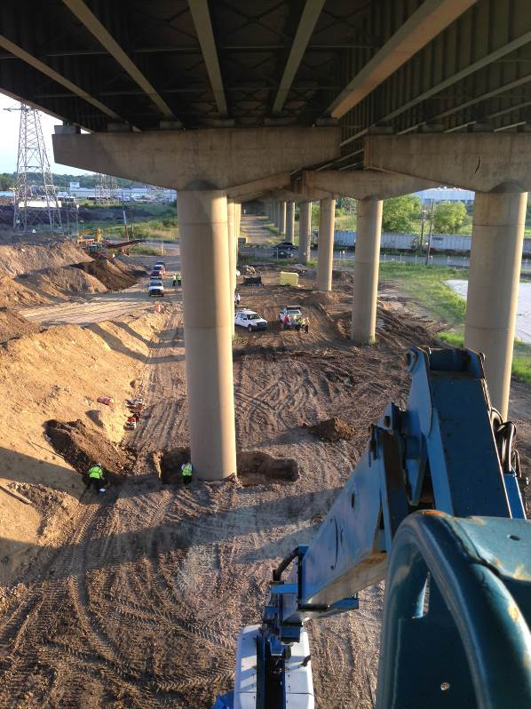

Figure 1: Overview of Bridge Site

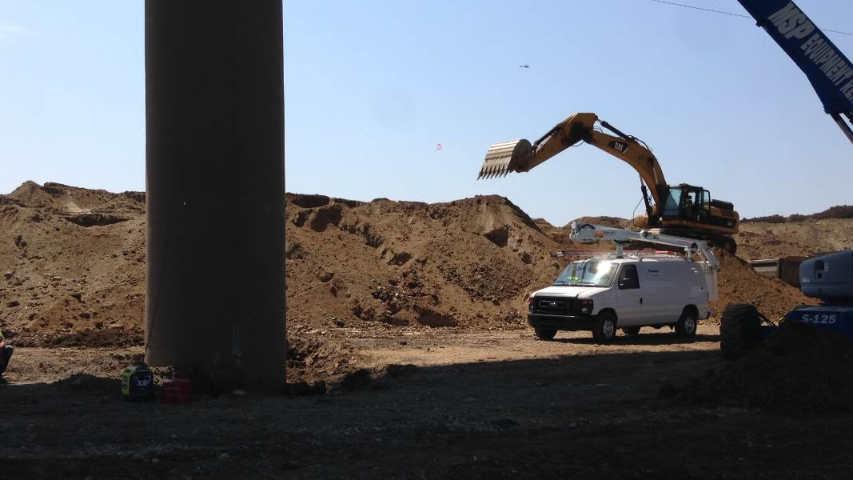

Figure 2: Fill Placed Next to Bridge Structure
- Emergency Inspection
Condition assessment of the structure began within 40 minutes of receiving notification from bridge owner and continued around the clock until all potentially affected locations could be inspected hands-on, including the deck, superstructure, bearings, piers, and foundations of each span. Due to the high-profile closure of the bridge, it was made clear to the team that it was imperative to not only complete the inspections, but also initiate monitoring the structure’s movements as quickly as possible. Pennoni provided a comprehensive assessment report within two days from the completion of the inspection work. Pennoni also attended working meetings with the design and construction teams to interpret data from the tilt meters and provide information related to the inspection findings. Monitoring equipment was in place on the more seriously affected piers within 12 hours of the start of the inspections, with installation of additional sensors occurring over the next several days and weeks.

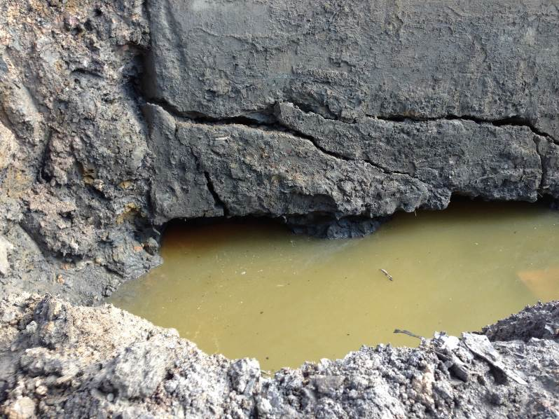

Figure 3: Cracked Pile Cap
- Emergency Monitoring
Within 12 hours from the initial phone call from the bridge owner, Pennoni had four tilt meters on the most heavily damaged piers and these tiltmeters were collecting data and staff was interpreting that data to identify any additional pier movement. Installation of the tiltmeters is shown in Figure 4. Over the next two months, Pennoni installed an additional 24 tilt meters on six pier columns near the fill pile. Data was collected hourly and produced reports twice a day for the first several weeks of the monitoring. After the owner was comfortable the bridge had stabilized and given the bridge was closed to traffic, the reporting requirements were relaxed to one per day. Throughout the process, the assessment and monitoring team remained in regular contact with DelDOT regarding the results of our condition evaluation and to alert them to abnormal movements that were observed via the monitoring. This ongoing dialogue allowed information to be shared in real time with other members of the project team involved with the repair efforts.

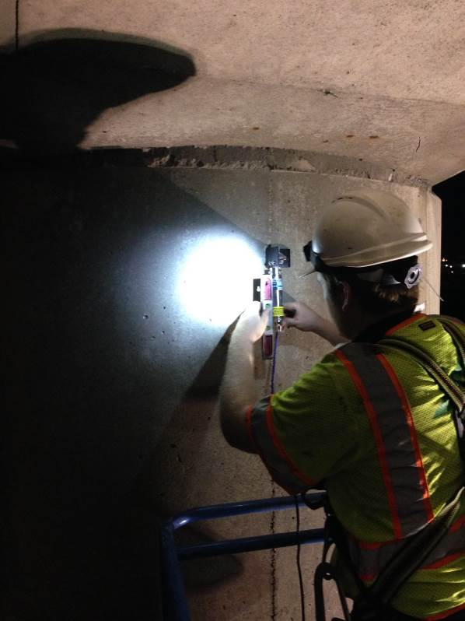

Figure 4: Tiltmeter Installation
- Repair Process and Monitoring
Since the inspection revealed lateral pile displacement and extensive pile cap cracking, it was determined that two sets of piers would need to be replaced while two others would require rehabilitation. To temporarily stabilize the piers while repairs and construction took place, post tensioning rods were installed between the pier caps of the northbound and southbound structures. The post tensioning rods are shown in Figure 5. To replace the damaged piers, the existing piers had to be demolished prior to construction of the new piers. This was accomplished by first installing drilled shaft foundations to bedrock. Once the drilled shafts were completed several grade beams were cast on top of the drilled shafts. Temporary steel towers were erected on top of the grade beams. The temporary towers supported several header beams on top of which the contractor installed temporary bearings to support the superstructure. To provide longitudinal stability to the towers, cables were tensioned between the grade beams and tower tops. The tension in the cables was monitored periodically and adjusted as needed using inline turnbuckles.

When the time came to move the bridge from the damaged supports to the temporary towers, Pennoni installed tilt meters on the header beams of the temporary support towers and strain gages on the post tensioning rods of Piers 11 through 14. During the jacking procedures, Pennoni staff was on-site around the clock to provide real time information to the design engineer and contractor. In total, 32 tilt meters and 16 strain gages were used to record movement throughout the emergency monitoring of the bridge.

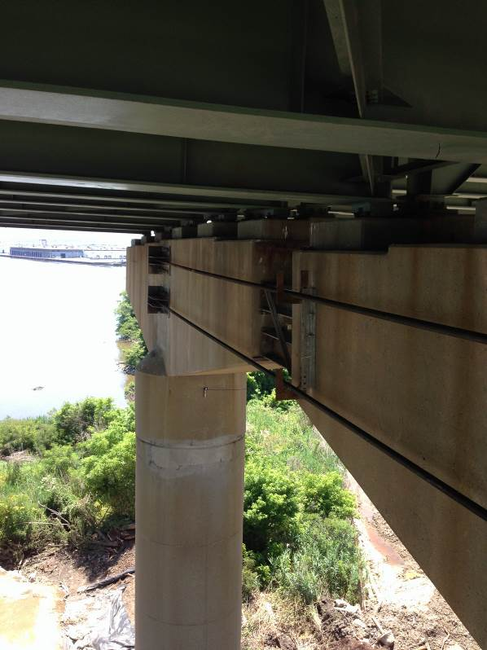

Figure 5: Temporary Pier Stabilization
- Long Term Monitoring
  - Monitoring System Design
Following the repair process, the bridge owner expressed interest in continuing with monitoring the structure in a passive manner. An instrumentation and monitoring program was designed to provide the owner with data regarding the position of Piers 10 – 15 at 15-minute intervals. A system was designed that would meet the owner’s requirements. The requirements included:

- Expandability – possible future system expansion to monitor other structural parameters
- Reliability – Battery backup for the main data collection system
- Alerting – Converting the measurements into actionable information if an event occurs
- Data visualization and Analysis – ability for the system to integrate with an existing monitoring software
- Reporting – Ability for the system to generate custom reports and scheduled reports

A long-term monitoring system was designed and installed according to the owner’s requirements. In addition to the design and installation, a year long monitoring period was undertaken to calibrate the alerting thresholds and reporting functionality.
  - System Initialization and Data Zeroing
To provide a zero point for initializing the tilt monitoring system, an offset will be subtracted from each tilt reading. Each tilt measurement has an associated temperature measurement and to extract the thermal response of the structure, a linear trendline is fit to the data. By fitting a linear trend to a plot of tilt versus temperature, a linear relationship between these two quantities is developed. From an analysis of historical data collected from January 2016-June 2016, the tilt occurring at a temperature of 60 degrees is was proposed as the offset to be subtracted from each tilt reading. This offset determined on a sensor by sensor basis and subtracted from the raw measurement before data was transmitted to the bridge owner.
  - Development of Thresholds for Alerting
One of monitoring system design requirements was to provide an alerting system to alert the owner to unusual measurements. To set reasonable thresholds to trigger alerts for the tilt monitoring system, a similar analysis used to determine the sensor offset was used to estimate thresholds. An example of this process performed on a longitudinal measurement at Pier 12 and transverse measurement at Pier 12 is shown in Figure 6 and Figure 7 respectively.

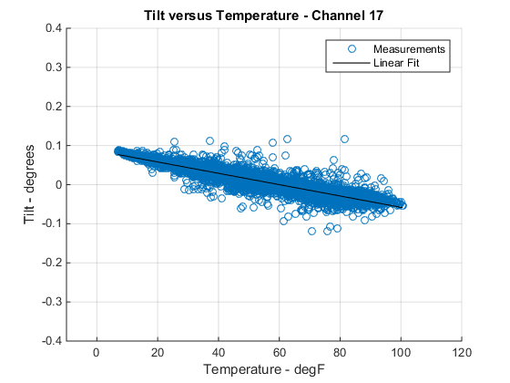

Figure 6: Pier 12 – Longitudinal Tilt versus Temperature
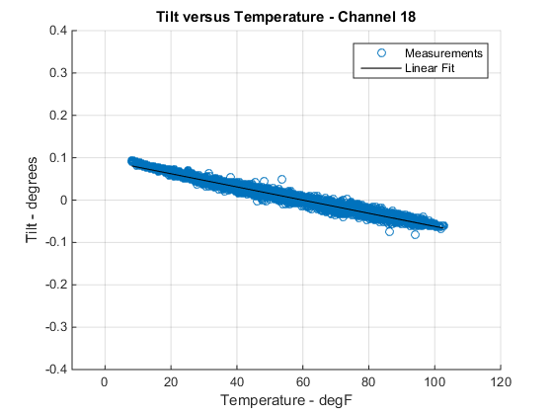

Figure 7: Pier 12 – Transverse Tilt versus Temperature
From the plots of tilt versus temperature the variability of tilt at a given temperature is smaller for the transverse tilt measurements than the longitudinal tilt measurements. This can be attributed to the input from live load that is primarily in the vertical and longitudinal directions. Since the measurements were taken every 15 minutes over 6 months and it was determined that no other extreme events occurred during this period, the linear response measured from each pier was attributed exclusively to temperature. This allowed for thresholds to be set using a linear fit of the 6 months of data.

Once a linear trendline is fit to the data, the equation of that fit can be used to extrapolate values at extreme temperatures. In this case, a temperature range of -10 to 120-degrees Fahrenheit was chosen. The tilt values at these extremes, rounded to the nearest tenth of a degree, were chosen as the limits of thermal response. Most of these values were calculated at +/-0.1 degrees and is set as the threshold for the yellow level limit. Determining the limit for the red level was a more qualitative process. Each sensor historical dataset was analyzed, and a limit was chosen that would not have generated any red alerts over the 6-month preliminary monitoring period where no abnormal events were observed. The red limit is set at +/-0.3 degrees. The limits plotted on the tilt versus temperature plots are shown in Figure 8 and Figure 9 for the examples from Pier 12.
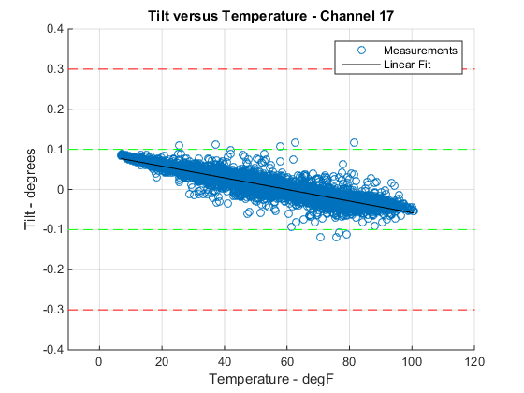

Figure 8: Pier 12 – Longitudinal Tilt versus Temperature – Limits
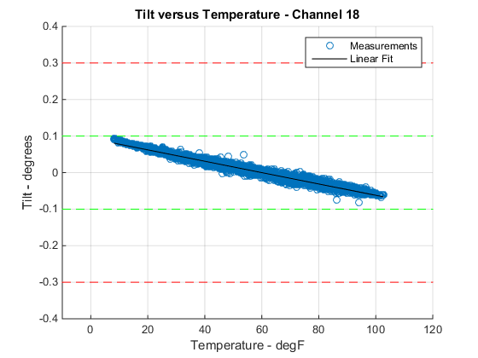

Figure 9: Pier 12 – Transverse Tilt versus Temperature – Limits

  - Alerting, Integration with Owner Standard Operating Procedures, and Reporting
The alerting functionality designed into the monitoring serves as a method to distill the collected data into usable and actionable information requiring minimal intervention from the user. The alerting system has seven alert categories including:

1. Sensor exceeds a specified threshold
2. Sensor exceeds a specified rate of change
3. Sensor malfunction
4. Data logger power
5. Wireless node power
6. Data logger to TMC - communication status
7. Wireless node to data logger - communication status

A two-level alert system was programmed into the monitoring system. The alerting system functions within the bridge owner’s procedures for high priority events. A Level One Alert will trigger an alert display at the Transportation Management Center (TMC) email and SMS communication of the alert to specified personnel. It will serve as an informational type of alert. This type of alert is sent to a small group of personnel within the ITS Unit and Bridge Management Unit. The recipients of the alert are required to make positive contact with TMC personnel acknowledging the alert. Without the positive contact, the alert will repeat at a specified interval until acknowledged by a party included in the alert communication.

Investigation of the alert is the responsibility of either the Bridge Management Unit or the ITS Unit depending on the type of alert. The ITS Unit will investigate network communication alerts and power alerts pertaining to the UPS (low battery alert) and loss of AC power. The Bridge Management Unit will investigate power alerts pertaining to loss of power to the wireless node on the bridge and loss of power to the data logger. The investigation of sensor alerts is the responsibility of the Bridge Unit as these alerts are either triggered by a sensor malfunction or by a sensor exceeding established performance thresholds. An event causing a sensor to exceed thresholds will trigger the system to increase its sampling rate until the alert is rectified, as shown in Figure 3. A Level Two Alert will be sent by email and text to a broader group of personnel. A Level Two Alert requires immediate attention and positive action by the bridge owner.

The owner’s software system allows for a user to generate custom reports from any period. The software system also provides a weekly report to a specified email list as well as a report detailing any alerts generated. The software system also allows for active monitoring and analysis where the end user can interact with the data collected and perform detailed analysis of the data as needed.
- Conclusions
The inspection and movement monitoring of the viaduct bridge allowed the owner and the design team with the information needed to make smart economic and sustainable decisions throughout the design and construction of the temporary supports. During the initial operations, the inspection teams determined that the superstructure was not in distress, having moved as a unit on the piers, which allowed the design team to develop a solution that moved the bridge superstructure directly onto temporary supports. The monitoring services played a key role in enabling the owner to operate transparently by keeping the public informed via daily press releases, assuring them that the bridge was not in danger of collapse. During the remaining inspection and construction phases, the monitoring of the piers allowed the construction operations to proceed safely and ahead of schedule. The long-term monitoring system is allowing the bridge owner to passively monitor a critical piece of infrastructure for any abnormal movements that could impact the use of the bridge by the motoring public.
Acknowledgements

The authors would like to thank Jason Arndt and Matthew Mortensen from the Delaware Department of Transportation – Bridge Management Section for their guidance and support on this project. The authors would also like to thank Michael Rakowski, Nathaniel Dubbs, Charles Young, Jeffrey Weidner, and Kirk Grimmelsman from Pennoni for their support and advice on this monitoring project.

