 | 10th International Conference on Short and Medium Span Bridges  Quebec City, Quebec, Canada,  July 31 – August 3, 2018 | 

REHABILITATION OF THE BAY OF QUINTE SKYWAY
Huh, Ben^{1, 3}, and Kenedi, Walter²
^{1, 2} Ministry of Transportation of Ontario, Canada
³ ben.huh@ontario.ca
Abstract: The Bay of Quinte (BOQ) Skyway is an 850m long, 17 span, 2-lane steel plate girder bridge that was constructed in 1967. The bridge had poor fatigue details, and was in need of deck replacement and re-coating of the steel girders. The decision was made to replace the superstructure, replace the abutments, and repair the piers. The bridge, with 4 intermediate expansion joints, would be replaced over 5.5 years. In each year, one segment of the superstructure would be replaced using 2 stages of construction, with temporary expansion joints at the segment ends to accommodate full 2-lane operation over the winter. In the following year, the adjacent bridge segment would be replaced, and the superstructure would be made continuous for super-imposed dead and live loads. This process was repeated until the entire superstructure was replaced. This elimination of the interior expansion joints would create a structure with improved seismic performance and reduced future maintenance. In addition to making the bridge semi-continuous, the bridge also required some Constraint Induced Fracture (CIF) susceptible details with intersecting weld between gusset plates and vertical stiffeners to be addressed. These details had to be improved to allow the bridge to operate as a 2 girder state in the first stage of each year. Furthermore, due to the new articulation of the bridge, the thermal movements at the bridge abutments would be greatly increased. Along with the condition of the abutments, this necessitated that they be replaced in their entirety. The new abutments were constructed behind the existing ones to speed construction. Due to tight construction schedules, the CIF repairs, and the caissons for the abutments, would be constructed in the fall of an advanced construction year. The bridge design was completed in the winter of 2018 under tight timelines, with construction to begin in the summer of 2018.
- INTRODUCTION
The Bay of Quinte (BOQ) Skyway on Highway 49 (Site # 11-245) is located immediately west of the Town of Greater Napanee, which is east of the City of Belleville (see Figure 1). The site is located in the Geographic Township of Tyendinaga (County of Hastings) on the north and the Geographic Township of Sophiasburgh (Prince Edward County) on the south.
The BOQ Skyway is one of only five access points serving Prince Edward County, which is effectively an “island” (following construction of the Murray Canal) with an area of approximately 1,000 km² and a population of roughly 25,000. Highway 49 has a regulatory speed limit of 80 km/h in the area, and an assumed Design Speed of 100 km/h.

The existing BOQ Skyway is a two-lane, 17-span skyway structure and was constructed circa 1967. It has a total span length of 847.3 m (42.6, 4x45.7, 3x50.3, 54.9, 76.2, 54.9, 3x50.3, 2x45.7, 42.7 m), a clear width between curbs of 9.144 m, and an overall width of 10.972 m (refer to Figure 2). The superstructure consists of a 203 mm thick cast-in-place reinforced concrete slab supported on 4 steel-plate I-girders. The parapet walls are 610 mm high with 406 mm high double railings on top. The bridge consists of a total five superstructure units, including; five span and three span approaches spans, two-three span shoulder spans and a three span main crossing span. All six, including 4 intermediate joints, of the structure’s expansion joints are modular expansion joints.

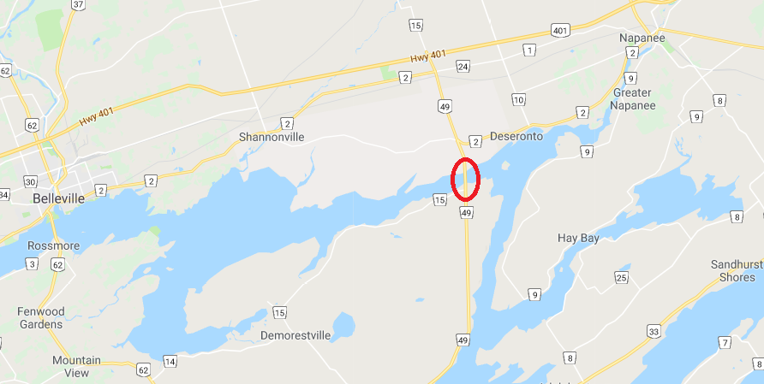
BOQ Skyway
Figure 1: Site location

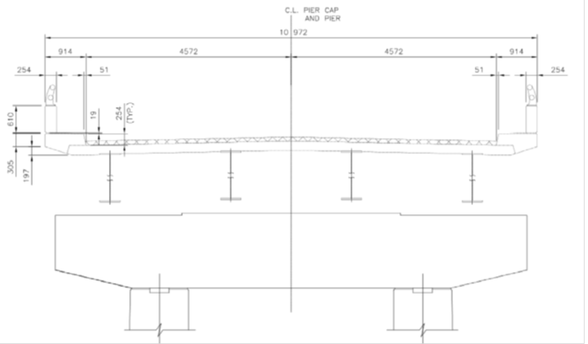 | 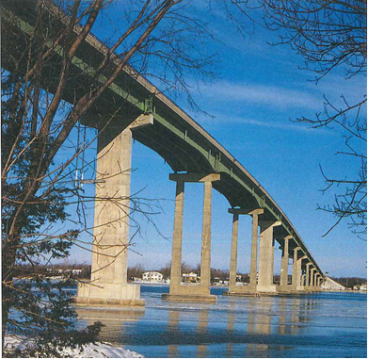
(a) Existing cross section | (b) Existing BOQ Skyway
Figure 2: Bay of Quinte Skyway Bridge

- REHABILITATION HISTORY
The construction of the Highway 49 BOQ Skyway Bridge was completed in 1967 and was subsequently rehabilitated in 1982, when the structural steel girders were recoated. In 1990 the concrete deck, curb and parapet walls were repaired, new waterproofing and asphalt were installed and finger type expansion joints were replaced with modular expansion joints.

In 1993 a pier rehabilitation project was completed to address concrete deterioration under the expansion joint which was related to joint leakage. The project included the replacement of the concrete pier columns under the expansion joints at piers 5, 8 and 11 with single pier shafts. The remaining piers were not significantly modified.

Also in 1993 during the pier rehabilitation, a large vertical crack (a 2 m long crack through the bottom flange and splitting all but the last 75 mm of the height of the web) was discovered on the east side of one of the exterior girders of span 7 between piers 6 and 7. The crack was believed to be associated with a tri-axial weld detail at a wind brace vertical stiffener location and was assumed to have been caused by Constraint Induced Fracture (CIF). A detailed inspection of the structure days after the crack was discovered revealed that the welding throughout the structure was inconsistent. The cracked girder was repaired by adding a bolted splice plate. In 2005 and 2008, several fatigue details on the structure were repaired by weld peening and weld removal.
- NEW DESIGN
In 2011, the Ministry developed detail designs for rehabilitation of 29 bridge structures throughout MTO Eastern Region, including the BOQ Skyway Bridge. An inspection of the structure carried out by a consultant revealed deficiencies such as: substantial deterioration to the bridge deck, steel girders and a lesser extent, deterioration of the piers. The existing bridge geometry does not meet the requirements of the current Geometric Design Standards for Ontario Highways such as: lane widths are less than the current design requirement for the posted speed and traffic volume. Side clearances are less than the current design requirement.

After thorough review of the condition of the structure, the Ministry determined it was prudent to replace the entire superstructure. The piers (substructure) were determined to need only minor to moderate rehabilitation. Given the extensive disruption associated with replacing the entire superstructure, a rigorous feasibility study was undertaken to examine traffic staging options to accommodate proposed work.

Additional rehabilitation work to be undertaken includes:
- Replacement of bearings (to help support movement of the bridge and provide better seismic protection).
- Pier rehabilitation.
- Replace all abutments and wingwalls.
- Construction of new approach slabs
- Installation of new modular expansion joints only at the abutments.
- Reconstruction of highway approaches to the bridge.
  - Construction sequence and staging
Alternate staging of construction approaches were considered a total of five categories for the management of traffic on Highway 49 during the rehabilitation of the BOQ Skyway, including;
- full closure (2 lanes) of the bridge for the entire duration of construction with traffic detoured to the existing adjacent roadway network,
- partial closure (1 lane) during construction with single lane, single–directional (one way) traffic,
- partial closure (1 lane) during construction with single lane, bi–directional (two way) traffic,
- maintain 2 lanes of traffic on the bridge during construction and
- full reconstruction (new bridge) on adjacent new alignment.

A total of five alternatives were carried forward to the preliminary design and environmental assessment stage. These five alternatives were evaluated based on the impacts and benefits to the environment (socio-economic, natural, and cultural), transportation operations, constructability and costs. Alternatives from categories 4 and 5 were eliminated primarily due to technical and economical feasibility and environmental effects. The only viable staging of construction approach remaining would be a partial closure of the bridge (Alternative 3 “half-and-half” staging approach) with a single-lane of bi-directional traffic maintained across the bridge and controlled by temporary traffic signals.

As a result of the assessment and evaluation, Alternative 3 was selected as the technically preferred alternative. Alternative 3 involves the replacement of the bridge superstructure in approximately 1/5 length of the bridge at the existing expansion joint locations. Single lane bi-directional traffic with temporary traffic signals is required for traffic control during the construction. Construction will primarily be undertaken with cranes from a barge for superstructure replacement in an effort to minimize day-to-day traffic disruptions, and significantly reduce the number of full closures.

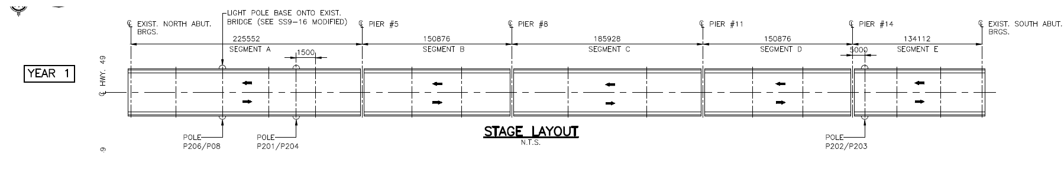
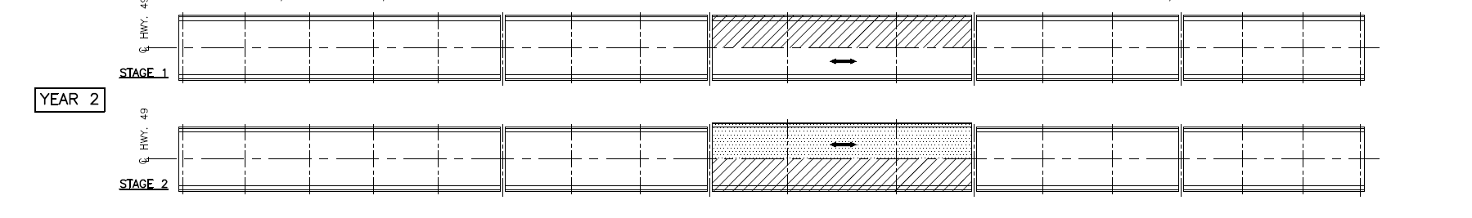
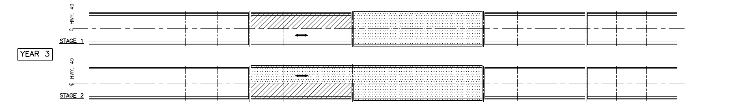
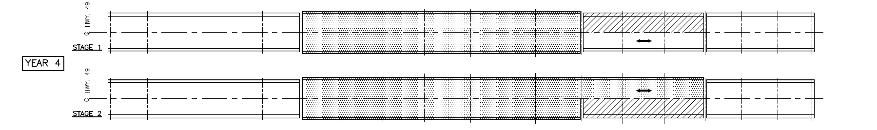
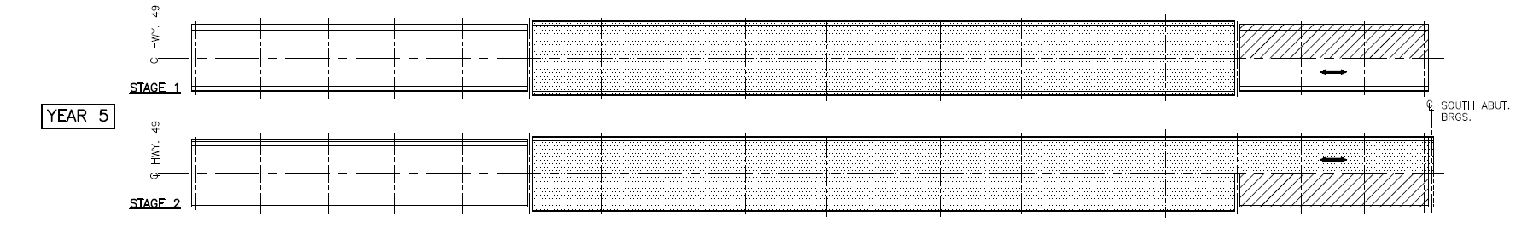
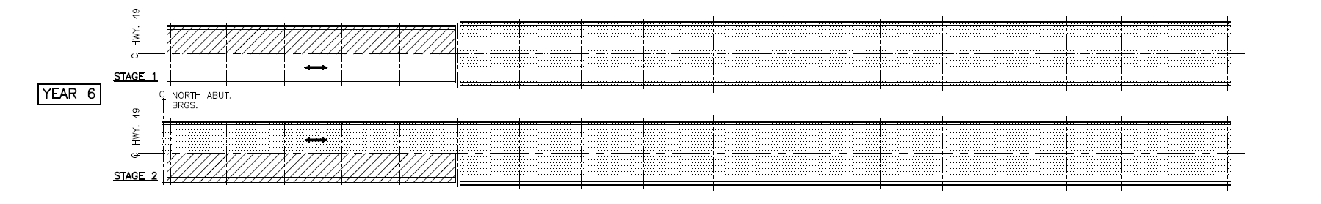
Figure 3: Construction sequence of BOQ Skyway Bridge
The bridge, with 4 intermediate expansion joints over piers 5, 8, 11, and 14, would be replaced over 5 years, with a preparatory year at the start to organize the work. In each year, one segment of the superstructure would be replaced using 2 stages of construction, with temporary expansion joints at the segment ends to accommodate full 2-lane operation over the winter. In the following year, the adjacent bridge segment would be replaced, and the superstructure would be made continuous for super-imposed dead and live loads. This process was repeated until the entire superstructure was replaced as shown Figure 3.

Ideally, for single-lane, bi-directional traffic operations on major highways, it is desirable to maintain a 4.0 m minimum lane width (including shoulders) to safely accommodate oversized loads (and wide farm equipment). Given the existing width of the structure, it is not considered possible (without a full closure for at least one stage) to provide 4.0 m traffic widths during construction. However, lane widths should still, ideally, be as wide as possible.

Figure 4: Construction staging of superstructure

To accommodate lapping of the reinforcing steel, waterproofing and asphalt lifts, the minimum distance from the back of temporary concrete barrier (TCB) in one stage to the back of the TCB in the other stage is 830 mm. This requires the use of Type M TCB bolted to the bridge deck in stage 1, which permits the TCB to be installed as close as 0.1 m from the deck edge, and a stiffened, unanchored, Type X barrier in stage 2, with a 300 mm distance from deck edge. Using this minimum lapping distance, lane widths in each stage could be 3.65 m and 3.5m, respectively. A potential wide load could overhang the safety curb by some degree in the first stage. In the second stage, the lane is 4.17 m wide (from TCB to TL-5 barrier) throughout most of the stage, with the critical lane width occurring at the pinch point transition to the safety curb where a wide load could also overhang the curb. The proposed staging section is illustrated in Figure 4.

A structural evaluation of the existing superstructure under a two-girder scenario during staged construction was carried out in conformance with Section 14 of the CHBDC S6-14, taking into account actual section loss, where significant. In addition to dead, superimposed dead and live loads, the evaluation has specifically considered wind loads as well. Load distribution will be based on the tributary width of deck supported by each of the two girders. The analysis found that from a strictly vertical load carrying perspective the one lane two-girder staging configuration had similar behavior and load carrying capacity as the two lane four girder bridge. Both bridges are predicted to support the full CHBDC live load. The deterioration that was identified during the inspection did not significantly reduce the capacity of the bridge in either the two lanes or one lane configuration.
  - Span Arrangement
The bridge rehabilitation includes the following work: Removal and replacement of existing concrete deck with cast-in-concrete deck, incorporating new expansion joints and TL-5 barrier walls; replace all structural steel; new approach slabs; waterproof and pave; bearing replacement, with bearing seat reconstruction as necessary; and concrete patch repair at the piers, and replace both abutments.

Figure 5: Span arrangement of new Bay of Quinte Skyway Bridge
The new BOQ Skyway is similar 17-span skyway structure but end spans have been increased by 3.8 m each due to the installation of new abutments behind existing abutments with staged and rapid construction. The design now has a total length of 854.8 m (46.4 m + 4x45.7 m in Segment A, 3x50.3 m in Segment B, 54.9 m + 76.2 m + 54.9 m in Segment C, 3x50.3 m in Segment D, 2x45.7 m + 46.4 m in Segment E). The existing concrete piers are capable of supporting the new superstructure to a maximum width of 11.55 m. This new cross section will accommodate two 3,75 m wide traffic lanes with 1.5 m wide side clearances. The new cross section of the bridge is illustrated in the Figure 6.
The proposed superstructure will consist of a 225 mm thick reinforced concrete deck on 4 new steel girders approximately 2 m deep. The new deck will be overlaid with 90 mm of asphalt and a waterproofing system and installed TL-5 concrete barrier walls.
Figure 6: Typical cross section
  - Bridge articulation and bearing replacement
The existing BOQ Skyway Bridge is divided into five Segments with girders separated at piers 5, 8, 11 and 14 (5 existing segments shown on the Figure 3). Each existing girder of the Segment has a rocker bearing sitting on a steel bearing pad supported on the concrete. In the longitudinal direction the rockers accommodate motion and pins prevent sliding at each bearing. Within each Segment one of the piers has a physically longitudinal restraint except the largest span in Segment C where both interior piers provide some longitudinal restraint. The lateral restraint is provided by either the rocker fitting in a slot or the end of the pin having a cap which bears against the frame of the bearing.

One of the checks required was the support length of the bearings for the seismic performance. The required support length must be calculated for each support location based upon the height of the support pier, height and skew. While the structure has no skew it does include relatively long spans and has significant height at the center of the bridge. The requirement is to have a certain length of overlap based on the formula of Clause 4.4.10.5. The support length of 1600 mm provided at the abutments exceeds required the value of 900 mm.

It is common practice to indicate symbolically on drawings the different movements or restraints at each bearing. The new bearings on the supports in the Skyway are illustrated in Figure 7. All new bearings are rotational bearings but laminated elastomeric bearings are on piers 8 and 11 which will be encased with concrete diaphragms integrally with existing piers.

It is desirable to share longitudinal forces between a number of supports, when any loads being induced by the secondary effects such as temperatures and thermal gradients share within these supports. In such cases, these supports can resist sudden applied loads (e.g. braking forces traction forces) but provide very little resistance to thermal movements (which occur very slowly). Since the central piers (piers 8, 9, 10 and 11) are tall and flexible, they are able to share certainly in longitudinal restraint. Therefore, fixed rotational bearings on piers 9 and 10 are specified and piers 8 and 11 are to be integrally connected through pier cap to the deck. After Segment C is constructed, each additional bridge segment will be constructed in the subsequent year, with the bearings on one pier being temporally fixed longitudinally until girder continuity is achieve, at which point they will be released. In service, the bearings at interior girders are guided longitudinally and the bearings at exterior bearings are free in all directions in Segments A, B, D and E.

Another important design consideration is the sequence in which the bearings are replaced. The designer must consider temporary construction conditions in each segment construction, such as the changes in fixity conditions and thermal movement range for the new and existing bearings during sequential replacement of all the bearings within each Segment, and the contract documents need to include a scheme outlining the order in which each support line would be replaced. This scheme ensured that all bearings would stay within their functional range for stresses and thermal translation during each step of replacement, as shown in Figure 7.

Another unique aspect of this semi-continuous steel girder design over piers 5, and 14 was determining the feasibility of permanent bearing installation, particularly for staged deck construction. This installation will involve half-width decking for each stage. The construction specifications require the contractor to install temporary bearings prior to each stage deck construction. After each subsequent existing segment is removed, the temporary bearings are installed for supporting girder ends at each stage. The girder ends need to be spliced and installed with permanent bearings at centerline of piers at each stage. This requirement is so that all bearings along any given bearing line would all have the same capacities for load, translation and rotation on each stage and final configuration.

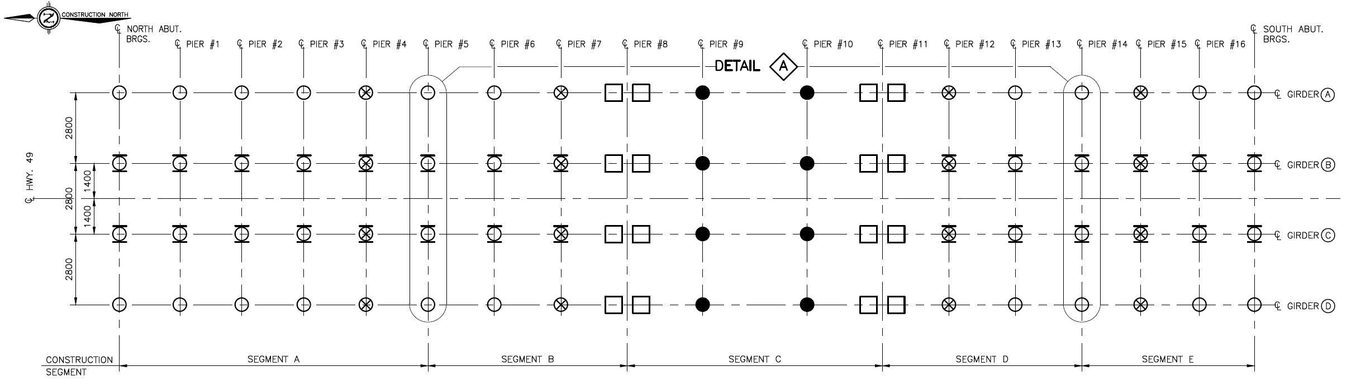
- Key plan of bearing layout
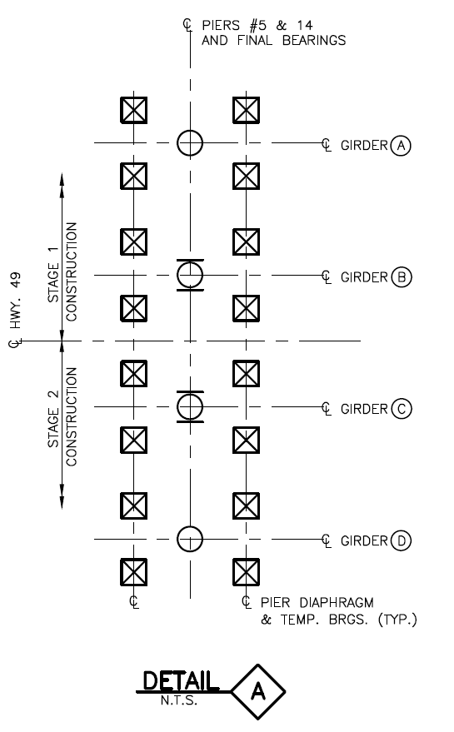 | 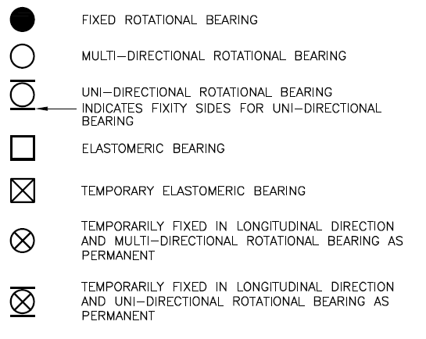
- Temp. bearings at piers 5 and 14 | - Legend of bearings
Figure 7: Bearing layout
  - Superstructure Detailing – Method of achieving Continuity
Various options were investigated to achieve superstructure continuity at the piers 5, 8, 11 and 14. Two most suitable methods of detailing the girders at the piers were considered in the design to achieve continuity for superimposed dead loads and live loads.

The longitudinal reinforcing bars in the deck slab are then designed to take the tensile forces, similar to the practice used for prestressed concrete bridges designed for continuity. Employing a design method typically used for construction of semi-continuous steel girder bridges, it is believed the first bridge project in Ontario to use such a scheme was Heart Lake Road Underpass and since then the Ministry has used this scheme a couple of projects successfully. Casting of the pier diaphragm integral with the pier cap, as shown in Figure 8, is best suited for piers 8 and 11 due to reasonably small thermal movements and adequately slender pier columns. This eliminates the need for field splices of steel plates, with their inherent future fatigue/durability issues. There is also no need for extensive reinforcing steel for a flex-link type joint. In order to ensure that the pier diaphragm will be integral with the pier cap, dowels are installed between the girder flanges into the pier cap. The holes for the dowels in the steel girders and the pier cap are installed during fabrication of the applicable component. The ends of the bottom flange of the steel girders have additional stiffeners, including a transverse stiffener plate, to help transfer the compressive forces, and some positive moments which may occur in some load cases, from the girder into the pier diaphragm.
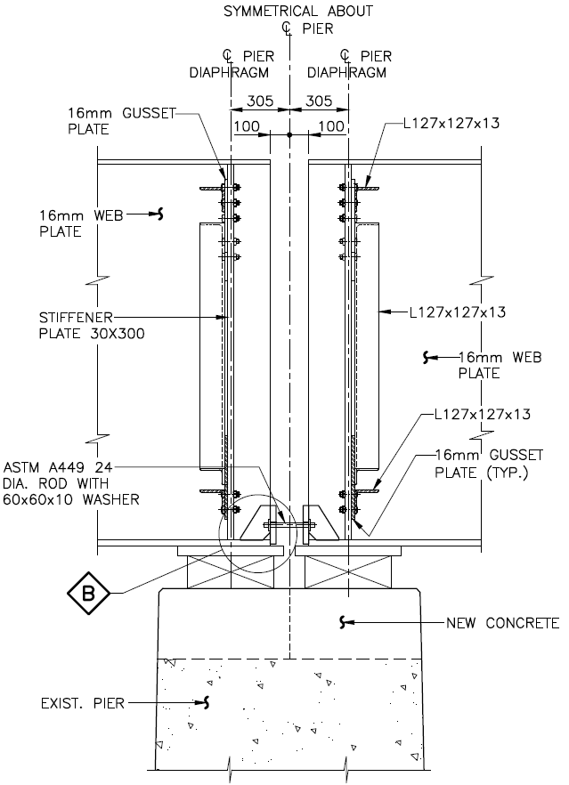 | 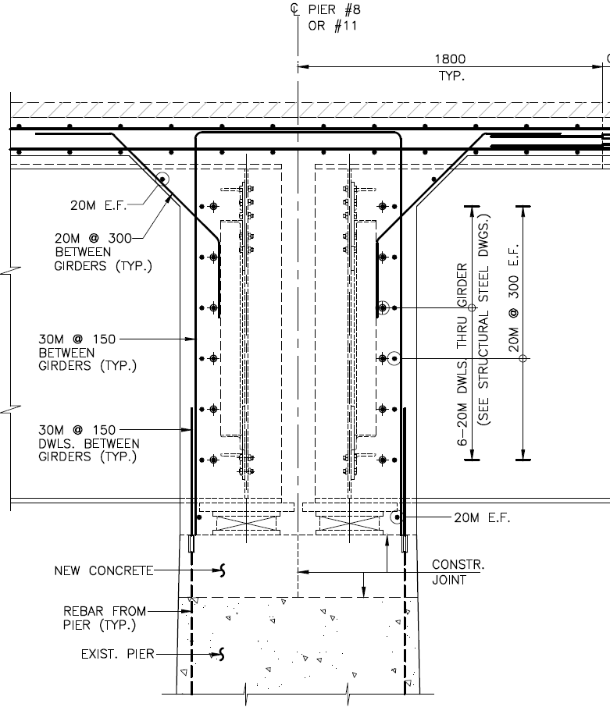
- Girder end details | - Concrete deck and diaphragm
Figure 8: Connection details at piers 8 and 11
The second method considered was for piers 5 and 8 using steel flange and web connection plates to splice over the gap, similar to a conventional steel-field splice (Figure 9). The design requirements associated with making simple steel beams continuous are similar to the design requirements associated with field-splice design—moments and shears must be carried through the detail. The semi-continuous design must ensure that forces can be adequately carried through the joint without overstressing elements, particularly the concrete elements.

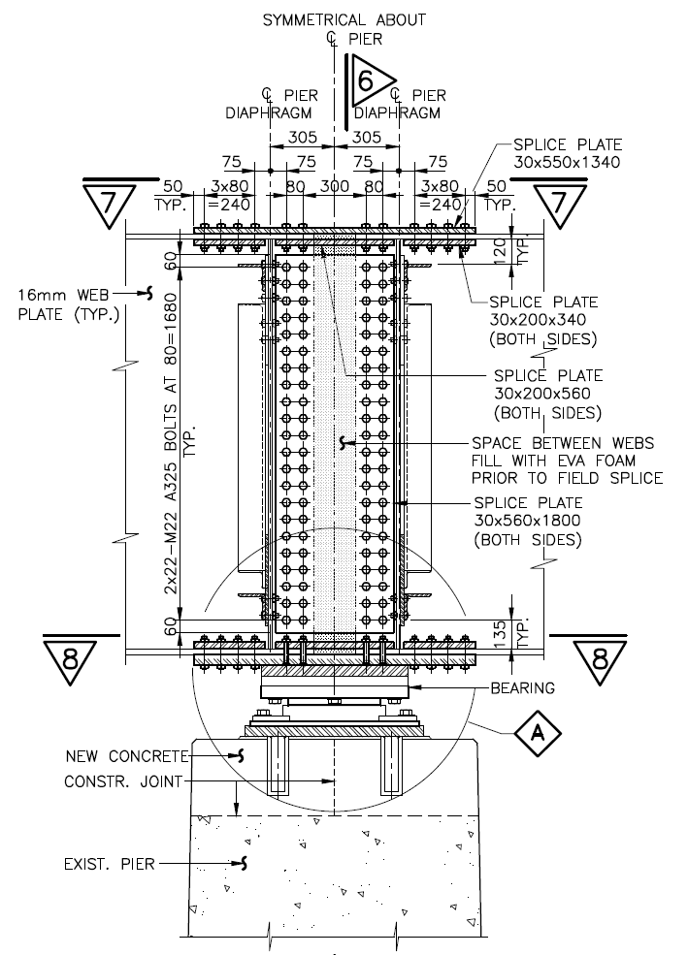 | 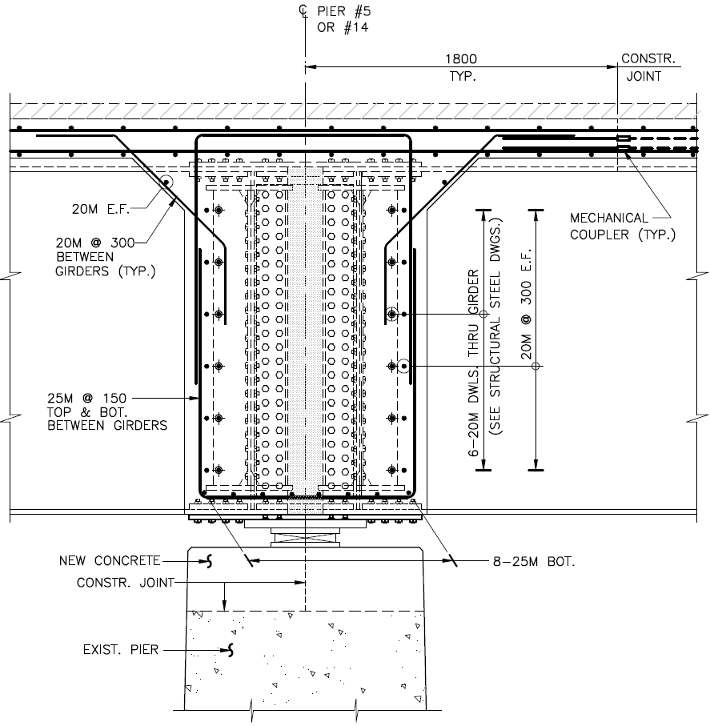
- Girder splice connection | - Concrete deck and diaphragm
Figure 9: Connection details at piers 5 and 14
  - Substructure Design
The existing abutments consist of spill through abutment walls with spread footings founding on limestone bedrock. Due to the staged construction of the superstructure replacement, existing abutments are not stable or safe to carry the traffic on each stage and all wingwalls are not sufficient to retain each corner of approach embankments. As a result, new abutments with 4 caissons at each end are required. In order to maximize contractor flexibility, caissons can either be installed in years prior to construction of the end segments, or done along with the staging of the approach span construction. The Contractor can either minimize traffic control costs, or reduce drilling rig construction time and critical path construction operations. The false abutments consist of a stub abutment supported on concrete caissons to resist the vertical loads from the superstructure. In addition, a reinforced soil system (RSS) resists horizontal loads due to earth pressure and superstructure reactions. Separated RSS wingwalls from the abutments will be installed for minimizing additional eccentric vertical reactions to the caisson foundation.
  - Expansion Joint installation
It has been confirmed that the thermal movement range of the bridge well exceeds the limits of conventional strip seal expansion joint assemblies; therefore, modular expansion joints will have to be reinstalled. Modular expansion joints have been found to be extremely problematic when field splices are required, such as when staged construction dictates that the joint has to be installed in more than one piece and connected on site.

MTO currently has a moratorium on the splicing of modular expansion joints and, as a result, traffic typically must be completely removed from the bridge during the installation of critical elements of new joints; the full closure required to install the critical elements of a new joint would be several hours in duration at a number of times. As a result, the bridging plate will be installed above the expansion joint blockouts (Figure 10). Additionally, asphalt ramps are required to carry traffic up and over the expansion joint opening for an extended period of time (weeks) to accommodate the necessary preparation work and concrete curing associated with the expansion joint installation. Since the plates sit above the blockouts, the plates allow the contractor to perform the new joint installation more gradually, using shorter but more frequent traffic closures.

To accommodate the thermal movements, the gaps between the bridging plates and the bulkhead would vary in size, with a compressible material to keep out debris. If construction extends late in the season, when the bridge is in a more contracted state, the gap would open to an unacceptable size. Options considered were to produce alternative, larger bridging plates for the colder periods, or employing slotted holes to anchor both ends of the bridging plates, and providing means to ensure that the expansion gap is distributed evenly at each end of the bridging plate.

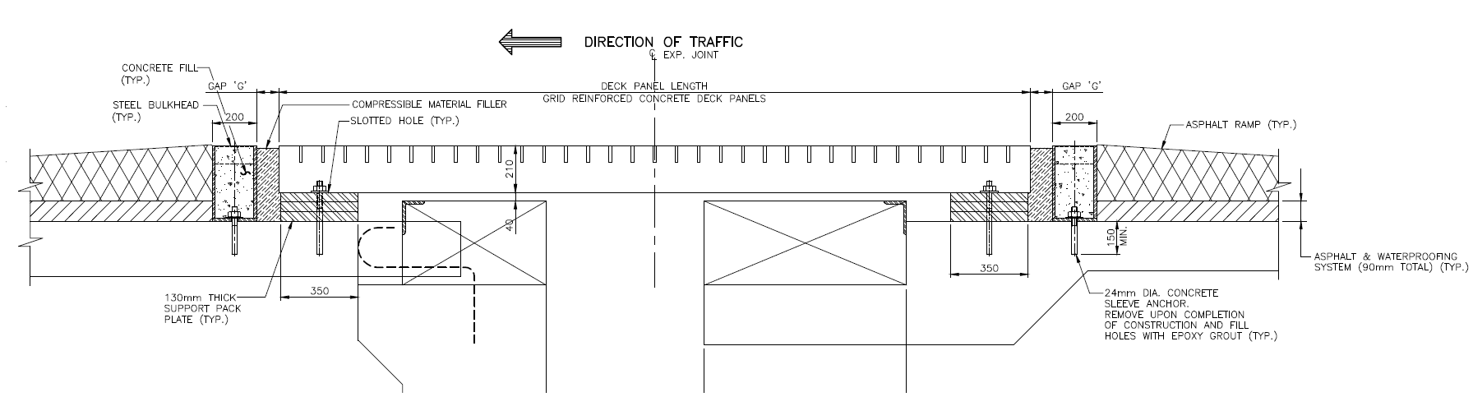
Figure 10: Temporary decking plate over modular expansion joints
Temporary steel plates will be installed on barrier walls to cover the gap. Steel plates bent to match the form of the concrete barriers are the safest option, because they provide a smooth transition matching stiffness of the wall locally, and avoid snag hazards.
- CONCLUSION
The rehabilitation of the Bay of Quinte Skyway Bridge will replace the existing 5 structure segments, including 4 intermediate expansion joints over piers, with one continuous 17 span structure. The semi-continuous steel girder design, coupled with intermediate expansion joint elimination techniques, is also able to reduce the combined number of deck joints on the Skyway from 6 to 2 in total. With nearly all previous steel deterioration occurring at deck joints, this substantial reduction in deck joints will work to significantly extend the life of the bridge. Employing a design method typically used for construction of new semi-continuous steel girder bridges, this rehabilitation design would create a structure with improved seismic performance and reduced future maintenance.

Acknowledgements
We would like to thank all those who helped contribute to the design of the Bay of Quinte Skyway Bridge, including MTO Staff in St. Catharines and Kingston, Morrison Hershfield Ltd., and Golder Associates Ltd.

References
Canadian Standard Association. 2014. CSA-S6-14 Canadian Highway Bridge Design Code. CSA International, Toronto, Ontario, Canada.

Bricks, M. and Ostrowski, J. 2017. Transportation Environmental Study Report (TESR) for Rehabilitation of the Highway 49 Bay of Quinte Skyway Bridge, Morrison Hershfield Ltd., Ottawa, Canada

