 | 10th International Conference on Short and Medium Span Bridges  Quebec City, Quebec, Canada,  July 31 – August 3, 2018 | 

BINARY CRACK SENSOR FOR STEEL GIRDER BRIDGES: INSTALLATION PROCEDURE IN FIELD
Raeisi, Farnaz^{1,3}, Mufti,Aftab¹, Mustapha, Gamal² and Thomson,Douglas¹
¹ University of Manitoba, Canada
² SMT Research, Canada
³ raeisif@myumanitoba.ca
Abstract: Civil infrastructure including steel bridges across North America are aging and many are approaching the end of their design service life. Crack formation and its propagation over time are one of the main deficiencies of aging steel girders. Detecting cracks in steel girders before they grow to an unsafe condition is critical. Existing distributed crack detection methods such as fiber optics sensors or periodic point strain sensors are excessively costly to deploy and maintain. In this work a new cost effective distributed binary crack sensor and the application of this sensor in the field are presented. The crack sensor will be installed on steel girder bridges at a fraction of the cost and is sensitive enough to detect the presence of a crack opening with a width of 0.2 mm. The crack sensor is a closed electrical circuit, comprised of a thin copper wire and an adhesive. When a crack forms in the steel girder, the strain will be transferred to the wire through the adhesive. When the strain in the wire reaches its ultimate tensile strain, the wire fractures. When the wire fractures it creates an open circuit. This can be detected by monitoring the continuity of electrical current in the sensor. The crack sensor was tested on a small scale steel girder in the lab at temperatures from -30C to +40C temperatures. The sensor was then field- tested and installed on 1.0 meter length of a steel girder of a bridge in Canada. After nine months of trial, the crack sensor is presently being installed on 30 meter girder of the same bridge. In this work, the installation procedure and required steps for installation purposes will be discussed.
- INTRODUCTION
Bridges are key elements of the transportation system. Studies show that many steel girder bridges in North America are approaching the end of their design life (ASCE, 2017). These bridges which were built before mid-1970 are at risk of crack formation in the steel girders (Dexter & W.Fisher, 2000). Fatigue cracks may occur as a result of environmental stresses, cyclic truck traffic, welding defects, material defects or defects introduced in manufacture or construction (Ghorbanpoor & Benish, 2003),(Lamtenzan, Washer, & Lozev, 2000). Detection of cracks in steel girders is important for public safety as well as to prevent the unpredictable loss of service and associated expenses. The most common method of assessing the condition of a steel girder of a bridge is to perform visual inspection along with Non Destructive Evaluation (NDE) techniques such as acoustic emission, eddy current and ultrasound testing(Chang & Liu, 2003). However, some limitations such as inspector’s skill or the discrete time interval between two sequential inspections might result in small cracks to escape detection and grow to lengths that will compromise the structure. Fracture in a girder of I-95 Highway Bridge over the Brandywine River as well as in Diefenbaker Bridge over North Saskatchewan River in Prince Albert, Canada are two examples of this issue (Chajes, Mertz, & Quiel, 2005) (Ellis & Conner, 2013).
In recent years, Structural Health Monitoring (SHM) techniques have been used for continuous monitoring of bridge girders. In this method, two general categories of sensors are available; discrete (such as strain gauges, short gauge or long gauge sensors) and distributed (such as fibre optic sensors, smart film) (Carden & Fanning, 2004; Ni, Xia, & Ye, 2012; Raeisi, Mufti, Mustapha, & Thomson, 2017; Sigurdardottir & Glisic, 2015; Zhang, Wang, Li, Zhang, & Yang, 2014; Z. Zhou, Zhang, Xia, & Li, 2015). In discrete monitoring method, sensors are installed at specified points on the length of the girder and are recording data. Therefore, in order to detect cracks the sensor should be in sufficiently enough proximity to detect the changes in monitoring data (Glisic & Inaudi, 2011). The other way to monitor girders is by installing distributed sensors. In this method, sensor will be installed along the entire length of the girder (Glisic & Inaudi, 2011).
The new binary sensor which has been presented in previous works, is a distributed sensor (Raeisi et al., 2017). The sensor is comprised of an insulated wire bonded to the steel girder using a carefully selected adhesive (Figure 1a). The binary crack sensor will be installed on the entire length of a steel girder -at tensile parts or in the vicinity of those details which will result in fatigue cracking- and has the potential to detect cracks before they open up to 0.2 mm width. As soon as a sufficiently wide crack forms on the steel girder, the strains will be transferred to the wire through the adhesive and will cause the wire to fracture (Figure 1b, c). Since both ends of wire are connected to an electrical source in series with a resistor (Figure 1d), the fracture will result in a discontinuity in the wire. A sudden change in the resistance of wire will result in an increase in the voltage of wire (Figure 1e). The first step in developing the binary sensor was to find the proper material for both wire and adhesive. Extensive testing has been carried out with copper wire and different adhesive categories such as cyanoacrylates and epoxies. The results with gauge 39 wire MW79-C (maximum tensile strain of 18%) and Loctite Epoxy E-20NS was promising. The sensor was tested in the lab in ambient temperature as well as two extreme temperature (-30ºC and +40 ºC) (Raeisi et al., 2017). After finalizing the materials, the sensor was installed on a 30 meter span steel girder of a bridge in Canada. In this work, required steps for installing the sensor on the steel girder of the bridge have been discussed. Finding the optimum placement position of the sensor is one of the initial steps in installation procedure which should be done considering special characteristics of each bridge. At part 2 of this paper, a sample calculation for determining the optimum position of the sensor on a typical simply supported steel girder has been discussed. Calculations are based on the Stress Intensity Factor (SIF) concept which is a guideline to find the critical length of the crack before it fractures. Part 3 of this paper discusses the installation procedure of the binary sensor on a steel girder of a bridge.
- OPTIMUM POSITION OF THE BINARY SENSOR ON STEEL GIRDER
The binary sensor is a distributed sensor which will be installed on the entire length of a web of a steel girder at positions with high risk of crack formation such as in the vicinity of details which will lead to fatigue crack propagation. In a girder under bending moment, the crack may start from the tension flange and extends trough the web of the girder (Figure 2b). It is important to detect cracks before they grow spontaneously and reach an unstable length which will result in sever damage of the girder and bridge. One method to determine the critical length of a crack is by measuring the stress intensity factor (SIF) at the tip of a crack and compare it with the fracture toughness of the same material. Using the critical stress intensity factor, the maximum length of the crack before it spontaneously propagates can be predicted.
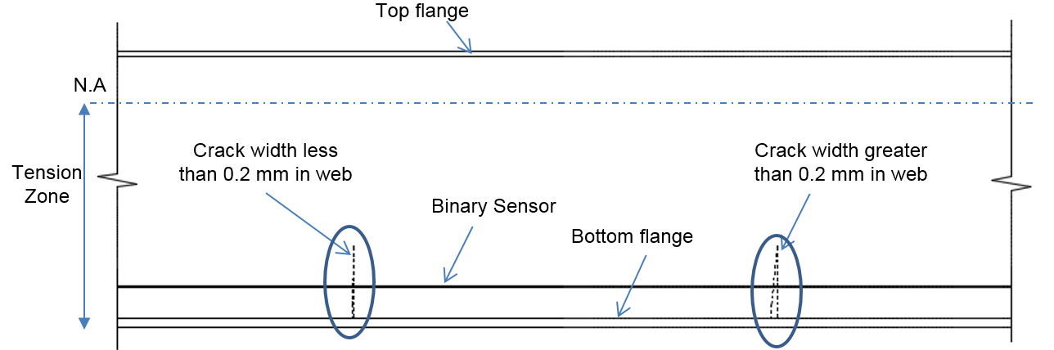
- Distributed binary crack sensor on a steel girder
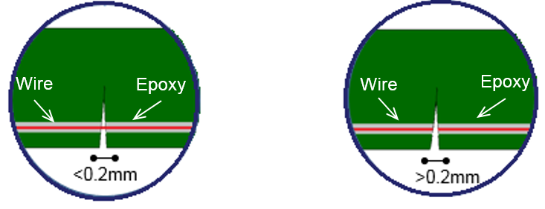
- epoxy cracks at less than 0.2mm opening
- wire breaks at 0.2 mm crack opening
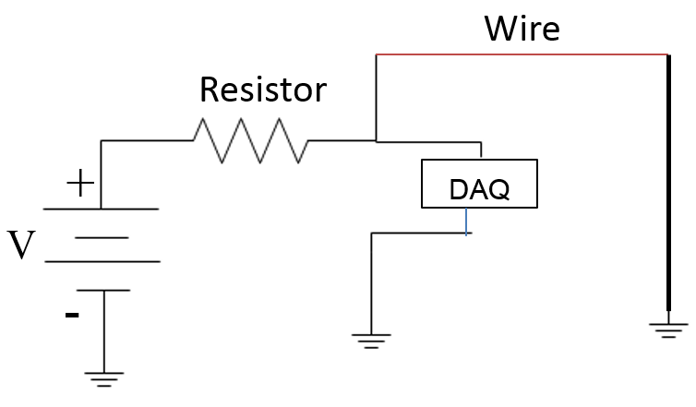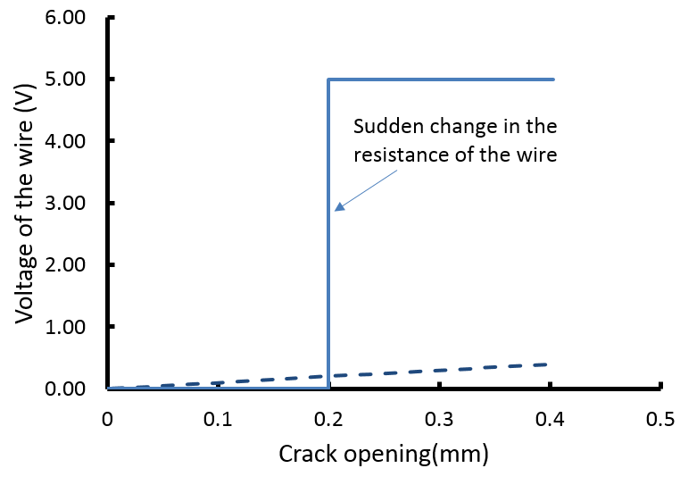
- schematic of the wire in series with resistor
- Typical output of the binary crack sensor
Figure 1. Binary crack sensor application on steel girder of bridges (Raeisi et al., 2017).
In this work a typical steel plate girder of a bridge in Canada (with the span to depth ratio of 17.86) has been selected for calculation. Girder A is a 30-meter span, simply supported girder. It is a composite girder with 200mm thick concrete slab (3.0 meter width of slab). It is assumed that a crack will initiate at mid-span at the position of possible connections such as gusset plates- at 150 mm above the bottom flange- and if not detected, it will propagate through the web of the girder. In order to estimate the maximum crack length before it reaches the critical length, the SIF at the tip of crack with different length was estimated and compared to the critical one.
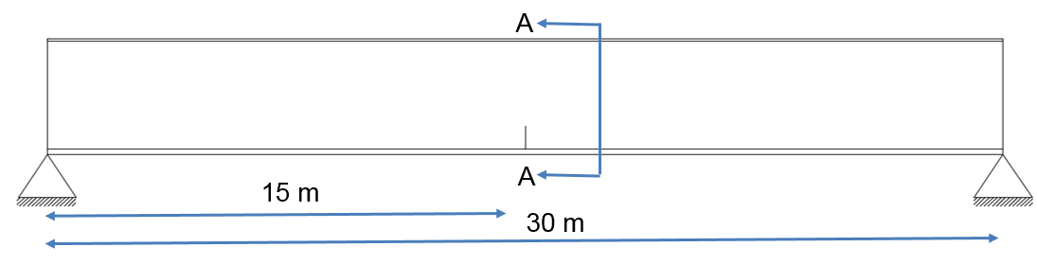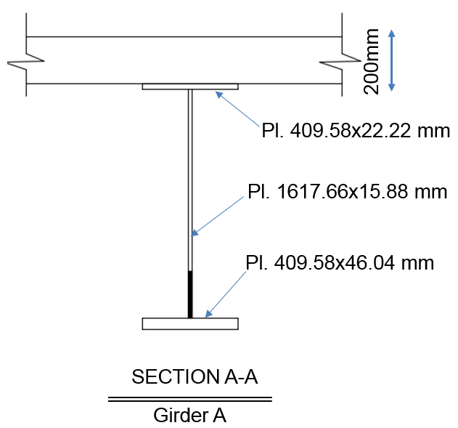
30-meter simply supported girder with a crack at mid-span
Hatched area shows the position of the crack
(a)

Figure 2. Schematic of a steel girder of a bridge
Assuming the worst temperature the bridge will experience during its service life to be between -25 ºC and -50ºC, the fracture toughness of the web of the steel girder will be estimated to be 71 MPa.(m)^{1/2} which is approximately equal to 2245MPa.(mm)^{1/2} (Y. E. Zhou & Biegalski, 2010). Therefore, for girder A, the critical length of the crack before it propagates can be calculated by using the equations 1, 2 where “a” is the half of the length of the crack, and “σ” is the average tensile stress around the crack. Using the BWIM data and by applying the dead load, the average tensile strain around an 80 cm long crack can be estimated to be 55 MPa. Therefore, the maximum crack length for girder A will be more than half of the girder’s depth (Equation 3).
[1] K_{I} = K_{IC}
[2] K_{I} = σ (π a)^{0.5}
[3] a= (2245/55)²/π → a=530 mm

The binary sensor is designed to detect cracks with opening of less than 0.2 mm. In order to estimate the crack opening along the crack for different length of the cracks, girder A has been simulated in a Finite Element software – ABAQUS –. In the FEM, a crack with varying lengths (from 20 cm to 80 cm) was defined at the mid span of the girder and the crack opening along the crack under the service load has been estimated. In order to apply the service load on the girder, available BWIM data has been used. Estimating the crack opening at different heights of the web gives an idea to predict the optimum position for placing the binary sensor.
Figure 3, demonstrates the crack length versus crack opening for girder A. for example for a 40 cm long crack (shown in figure 3 with )- which starts at 0 mm distance from bottom flange and continues to 400 mm distance from bottom flange- the maximum crack opening is approximately 0.23 mm at 200 mm distance from the bottom flange. Therefore, in order to detect a 0.2mm crack opening the optimum position of the binary sensor can be 150 mm to 250 mm distance from the bottom flange. By placing the sensor at suggested positions, cracks longer than 300 mm can be detected.
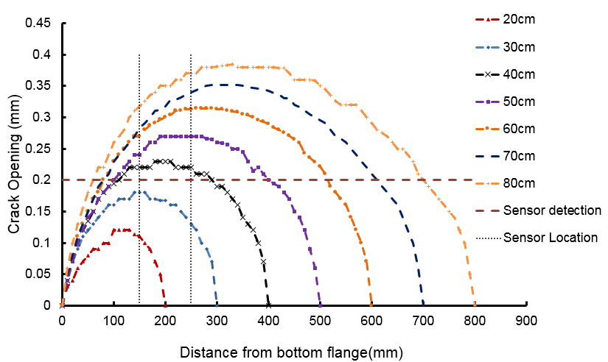
Figure 3. Crack opening versus crack length to estimate the optimum placement of the sensor.
- SENSOR INSTALLATION
The Binary sensor was installed on a steel girder of a bridge in August 2017. The main purpose of installing the binary sensor was to evaluate its application under real loading and weather condition. This includes investigation of the bonding between the steel girder and the sensor under cyclic loading, studying the effect of temperature and weather condition on the sensor, optimizing the installation procedure according to real situation on the bridge and testing to see if the sensor can detect cracks if any available. The binary sensor was installed on 30 meter span of a girder at 150 mm to 200 mm above the bottom flange. The sensor was installed in seven segments with approximately 4 and 5 meter length (Figure 4). Each segment have one contiguous sensor terminated to a unique channel on the data acquisition unit. Any crack with opening of at least 0.2 mm can be detected at each segment.
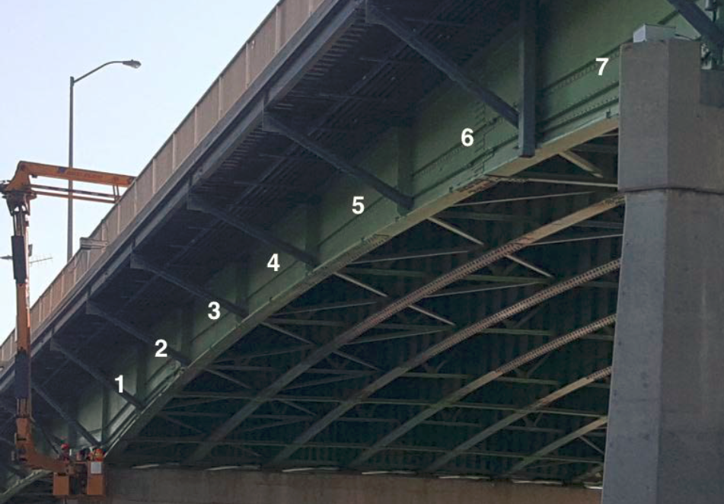
Figure 4. Installation of binary crack sensor on a 30-meter span steel girder of a bridge in 7 segments.
In order to install and place the binary sensor on the steel girder, a frame work (groove) was formed using foam tape. The depth of the groove was 2.0 mm and the width was approximately 250 mm. Then, the wire was mounted on the girder. To hold the wire at its position on the girder, an adhesive was used at few points (Figure 5a). The ends of wire were connected to a terminal block (Figure 5b). Afterwards, the epoxy was applied on the wire into the groove using an applicator and its surface got leveled using a knife (Figure 5c,d). The required time for the epoxy to cure is 24 hour. After the epoxy was cured, the frame work was removed and the surface of the binary sensor was covered with the use of foil (Figure5e). The sensor was installed in August 2017 and the Data logger was programmed to synchronize two readings per day on the analytics server based in Structural Monitoring Technology (SMT) office in Vancouver. Readings are available since then and as soon as a crack opens up to approximately 0.2 mm, the change in the continuity of the wire will be monitored.
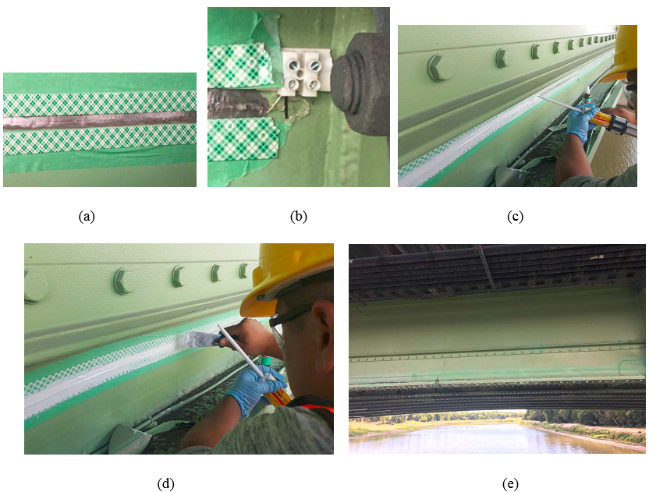
Figure 5. Installation procedure of the binary sensor on girder A.
- CONCLUSION & FUTURE WORKS
One of the main deficiencies which may occur during the service life of a steel girder bridge, is formation and propagation of a crack. Detection of cracks before they propagate spontaneously is important for public safety as well as to prevent the unpredictable loss of service of the bridge and the associated expenses. Structural Health Monitoring systems are known to be an efficient method to detect cracks at early stages. The newly introduced distributed binary crack sensor which will be installed on the entire length of a steel girder has the capability to detect cracks before the crack opening reaches to 0.2 mm. The binary sensor is comprised of MW79-C wire and E-20 NS Loctite Epoxy. When a crack with opening of 0.2 mm forms on a steel girder, the binary sensor fractures and a change in the resistance of wire will be observed. The sensor was tested in laboratory under different temperatures (ambient temperature, -30ºC, +40ºC). In August 2017, the binary sensor was installed on a steel girder of a bridge in Canada to evaluate its application under real loading and weather condition. Readings are available since the installation date and as soon as a crack opens up to approximately 0.2 mm, the change in the continuity of the wire will be monitored. One required step for installing sensors on the bridges is to find the optimum position of the sensor on the girder of the bridge. The sensor should be placed at a depth at which the crack opening is approximately 0.2 mm for the minimum length of the crack. The length of crack should be controlled to prevent any unstable growth of crack into the web of the girder. Calculation of stress intensity factor (SIF) helps to predict the maximum length of the crack before it propagates spontaneously. In this work, calculations for a typical 30 meter simply supported span has been done to find the critical length of the crack as well as the optimum placement of the binary crack sensor on the web of the girder. Future works will include calculations for a different length of the girder as well as optimization in the installation procedure.

Acknowledgement
The authors wish to express their appreciation for the supports received from the following organizations: Natural Science and Engineering Research Council of Canada, Canada Foundation for Innovation, Research Manitoba, Canadian Microelectronic Corporation, Structural Monitoring Technologies

References
ASCE. (2017). Infrastructure Report Card, A Comprehensive Assessment of America’s Infrastructure. ASCE (Vol. 11). Washington,D.C.: American Society of Civil Engineers.
Carden, E. P., & Fanning, P. (2004). Vibration Based Condition Monitoring : A Review. Structural Health Monitoring, 3(4), 355–377.
Chajes, M., Mertz, D., & Quiel, S. (2005). Steel Girder Fracture On Delaware’s I-95 Bridge Over The Brandywine River. In Proceedings of the 2005 ASCE Structures Congress. New York: ASCE.
Chang, P. C., & Liu, S. C. (2003). Recent Research in Nondestructive Evaluation of Civil Infrastructures. Materials in Civil Engineering, 15(June), 298–304.
Dexter, R. J., & W.Fisher, J. (2000). Fatigue and Fracture.
Ellis, R., & Conner, R. (2013). Investigation and Repair of the Diefenbaker Bridge Fracture. In Transportation Assosiation of Canada. Winnipeg.
Ghorbanpoor, A., & Benish, N. (2003). Wisconsin Highway Research Program: Non-Destructive Testing of Wisconsin Highway Bridges. Wisconsin DOT. Milwaukee: Wisconsin DOT.
Glisic, B., & Inaudi, D. (2011). Development of Method For In-Service Crack Detection Based on Distributed Fiber Optic Sensors. Structural Health Monitoring. http://doi.org/10.1177/1475921711414233
Hopwood, T., Oka, V., & Deen, R. (1987). Reliability Assessment of High-Risk Steel Bridges by Non-Destructive test Methods. Lexington, Kentucky.
Lamtenzan, D., Washer, G., & Lozev, M. (2000). Detection and Sizing of Cracks in Structural Steel Using the Eddy Current Method (No. FHWA-RD-00-018). Federal Highway Administration.
Ni, Y. Q., Xia, H. W., & Ye, X. W. (2012). Neutral-Axis Position Based Damage Detection of Bridge Deck Using Strain Measurement : Numerical and Experimental Verifications. In 6th European Workshop on Structural Health Monitoring. Dresden,Germany.
Raeisi, F., Mufti, A., Mustapha, G., & Thomson, D. J. (2017). Crack Detection in Steel Girders of Bridges Using a Broken Wire Electronic Binary Crack. Journal of Civil Structural Health Monitoring, 0–23. http://doi.org/10.1007/s13349-017-0211-1
Sigurdardottir, D. H., & Glisic, B. (2015). The Neutral Axis Location For Structural Health Monitoring : An Overview. Journal of Civil Structural Health Monitoring, 5(5), 703–713. http://doi.org/10.1007/s13349-015-0136-5
Zhang, B., Wang, S., Li, X., Zhang, X., & Yang, G. (2014). Crack Width Monitoring of Concrete Structures Based On Smart Film. Smart Materials and Structures, 23. http://doi.org/10.1088/0964-1726/23/4/045031
Zhou, Y. E., & Biegalski, A. E. (2010). Investigation of Large Web Fractures of Welded Steel Plate Girder Bridge. Journal of Bridge Engineering,ASCE, 15(4), 373–383. http://doi.org/10.1061/(ASCE)BE.1943-5592.0000111
Zhou, Z., Zhang, B., Xia, K., & Li, X. (2015). Smart Film For Crack Monitoring of Concrete Bridges. Structural Health Monitoring, 10, 275–289. http://doi.org/10.1177/1475921710373288
(a)

