|  |  |  |
| --- | --- | --- |
|  | **10th International Conference on Short and Medium Span Bridges**  **Quebec City, Quebec, Canada,**  **July 31 – August 3, 2018** |  |

**IDAHO SLIDE-IN-BRIDGE CONSTRUCTION**

Byrne, Brian1,2

1 Lochner, United States

2 bbyrne@hwlochner.com

**Abstract:** The Lardo Bridge is Idaho Transportation Department’s first use of slide-in-bridge-construction technology and was implemented as part of a design-build project. Given that this was a design-build project, the contractor-engineer was looking for a low cost solution that met the Department’s goals. To achieve this, the abutment stems were constructed as an integral rigid frame with the superstructure, both of which were constructed on simple falsework. The slide operation was done without proprietary equipment and without guides. This approach provided an inexpensive solution and good flexibility to meet tolerances. Ultimately, this project was designed and constructed in less than 8 months, was well under the Department's budget and was a powerful demonstration of a new technology for bridge construction within Idaho.

1. **PROJECT INTRODUCTION**

The Lardo Bridge replacement, in the resort town of McCall, Idaho is Idaho Transportation Department’s (ITD’s) first implementation of slide-in-bridge-construction (SIBC) technology for a permanent vehicular superstructure and was administered as a design-build contract. The new single-span 47.2 meter precast concrete girder bridge replaces an existing 5-span bridge carrying SH-55 over the outlet of Payette Lake.

McCall’s tourist season extends from Memorial Day through Labor Day and picks up again in late fall for snowmobilers. With SH-55 as the main route along the lake, ITD wanted to minimize delays on SH-55, and therefore let this project as a design-build with A + B bidding to encourage the design-build teams to minimize construction durations and minimize impacts to the peak tourist season. To maintain connectivity along SH-55 between lodging, restaurants and recreation areas, the existing bridge was able to remain open during the summer by using slide-in-bridge construction. The bridge slide of the 1600 t bridge occurred in the fall before tourists returned for winter outdoor activities in and around McCall.

Less typical for SIBC, full height abutments were built with the superstructure on temporary shoring, and together they were moved into place. This approach allowed the contractor to accelerate construction work by forming and placing concrete off to the side rather than beneath the confines of the existing bridge. It also reduced project costs by reducing the temporary shoring for the superstructure, particularly important for the contractor’s bid.

Once the new superstructure and its abutment were ready to be slid, SH-55 was detoured and the existing bridge was demolished. A soil-supported concrete slide slab was installed to create a continuous slide surface for the bridge to move from the temporary shoring to the permanent pile caps.

1. **PROJECT APPROACH**
   1. **Project Setting**

McCall, Idaho is a resort town of about 3,000 permanent residents. The town is at the south end of Payette Lake and is reachable from Boise in just over two hours along the two lane State Highway 55 (SH-55). The Lardo Bridge carries SH-55 over the North Fork of the Payette River at the base of the Payette Lake.

SH-55 runs north into the busy downtown area of McCall and then cuts westerly along Payette Lake. There is a commercial route which bypasses the busy downtown area and crosses the North Fork Payette River just downstream and south of the Lardo Bridge. This route provides a very reasonable detour to bypass the SH-55 crossing. However, much of the lodging, restaurants, tourist attractions and scenery are located on SH-55 and the bridge provides direct connectivity between these points of interest. Therefore, diverting through traffic during the peak tourist season was not an acceptable alternative.

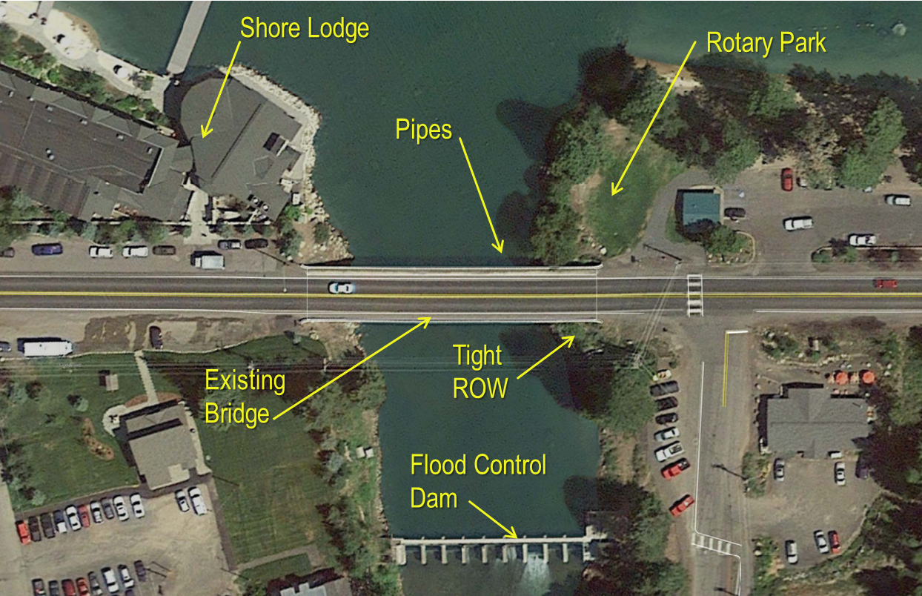

Figure 1: Bridge Location

* 1. **Project Schedule**

Original documents provided to the public suggested that a staged construction option to replace the bridge could last 8 to 9 months. In comparison, a full detour option would have a construction time of 3 to 4 months. The Request for Proposal left the decision to the proposer to either use a full closure or single lane closure. However, construction activities were constrained within the following parameters:

* Maintain two full lanes prior to September 2, 2014.
* Allow single lane closures only during off peak hours.
* Permit full closure only between either September 2nd and December 23rd, 2014 or February 9th to May 21st, 2015.

The contract used A+B bidding which allowed ITD to consider both the hard dollars of the bid and the soft “cost” for the construction duration when evaluating the overall bid. With this method, a low bid is derived by adding the contract dollar value (the “A” component) to a cost based on the days required to complete the project (the “B” component). For this project, a value of $7,700 per day of construction was assigned.

The time “B” component was the impetus for the design-build team to consider a lateral bridge slide during the procurement phase of the project. It allowed the design-build team to minimize the total construction duration by performing most of the construction off line during the summer while the two existing lanes on the bridge were kept operational. Then during the allowable Fall 2014 outage, the bridge could be slid into place while traffic was detoured.

There were three contractor teams that proposed on the project. The contract value of the Ralph L Wadsworth design-build team’s bid was $3.6 million with 194 days. A competing team submitted a bid of $6.4 million with 259 days. Nominally, there was a premium in our team’s bid for the slide in operation and temporary falsework. However, the reduction in on site time helped the team reduce the bid costs in comparison to conventional construction.

The project schedule, as it ultimately unfolded, is summarized by:

* Late March 2014 – Project Award
* Early July 2014 – Site Mobilization
* Mid-September – Set Girders
* Mid-October – Close SH-55 and start Detour
* Late October – Slide Bridge
* Late November – Reopen SH-55
  1. **Existing Conditions**

The existing bridge was a 5-span structure, totaling 61 m with 7.6 m end spans and three 15.2 m main spans. The superstructure was less than 11.6 m wide and consisted of haunched concrete t-beams carrying two lanes and one sidewalk on the north side. The curb-to-curb width was 9.1 m.

Other existing site conditions and constraints consisted of:

* The Shore Lodge, the premiere resort in McCall, is located within feet of the northwest quadrant of the bridge. Coordination was required to ensure that the Shore Lodge’s guests were accommodated while pile driving operations and construction of the bridge progressed.
* The river is controlled by a dam just downstream of the bridge and the water elevation varies only by 200 mm between the 50-year and 500-year events.
* Two existing pipes, a sanitary sewer line and a water line, run along the river bottom in close proximity to the north side of the existing bridge. Temporary and proposed foundations had to be positioned to avoid damage of the pipes as they were to be protected in place.
* Existing overhead power lines span over the river just south of the bridge. Placement of temporary structures on this side would have required a relocation of the wires, adding expense and schedule risk.

To expedite the design process, ITD contracted with a geotechnical engineer before the project was tendered to perform soil borings and issue a preliminary recommendations report. The design-build team was responsible for the final geotechnical report. The piles were driven into the dense silt and sandy silt, with blow counts in the 40s. Piles generally reached capacity at a depth of 12 m below grade.

* 1. **Belvedere Overlook**

Based on consultation with the City, ITD chose to require that the design-build team provide an overlook on the north side of the bridge. This overlook was to be a minimum of 15.2 m long and 2.4 m wide, and would extend beyond the 3 m wide sidewalk. This overlook was envisioned as a public space in which pedestrians could stop and look out over the lake and to the mountains beyond. The addition of this design element created some minor complications for the design due to the asymmetric loading.

1. **DESIGN APPROACH**
   1. **General Structure Arrangement**

The general arrangement of the proposed structure was a single-span length of 47.2 m between centerlines of bearings with no skew. The clear opening between abutments met the 46.3 m requirement for hydraulics. The structure’s out-to-out width is generally 16.5 m wide with a curb-to-curb width of 11 m. The belvedere overlook on the north side provides an additional 2.4 m of width in the center of the span.

* 1. **Superstructure**

2.3 m deep prestressed precast concrete Utah bulb tees (UBT90) are used for the superstructure of the new bridge. The girders are composite with a 200 mm thick concrete deck, with the overhanging belvedere slab supported by cast-in-place corbels extending from the fascia of the northern girder. To accommodate the eccentric loading of the belvedere slab overlook, an asymmetrical girder arrangement was provided. The typical section layout was analyzed with a grid model to determine the distribution of loads from the overlook. The girders in the two northern bays are spaced at 2.3 m on center and the next three bays are 3.1 m. The normal deck overhang is 900 mm on the north side and 1500 mm on the south side.

Transportation of girders was a significant concern with the 47.7 m total length of the girders, along with their weight and their depth. The precaster was located near Salt Lake City, Utah and the girders needed to be transported 800 km to the site, up into the mountains. To accomplish this, a somewhat less direct route was taken to the project site to minimize superelevations, tight curves and grades. For the tightest curves, oncoming traffic had to be stopped in advance to allow the truck to navigate the girder through the turn. A self-propelled truck with a low-clearance cab supported the back end of the girders and helped to negotiate the curves and turns.

To set the girders, two cranes were used with one set behind the east abutment and the other set just off the northwest corner of the bridge, wedged up near the Shore Lodge. Each girder was delivered to the north side of the existing bridge, with one-way alternating traffic until the girder was about to be picked.

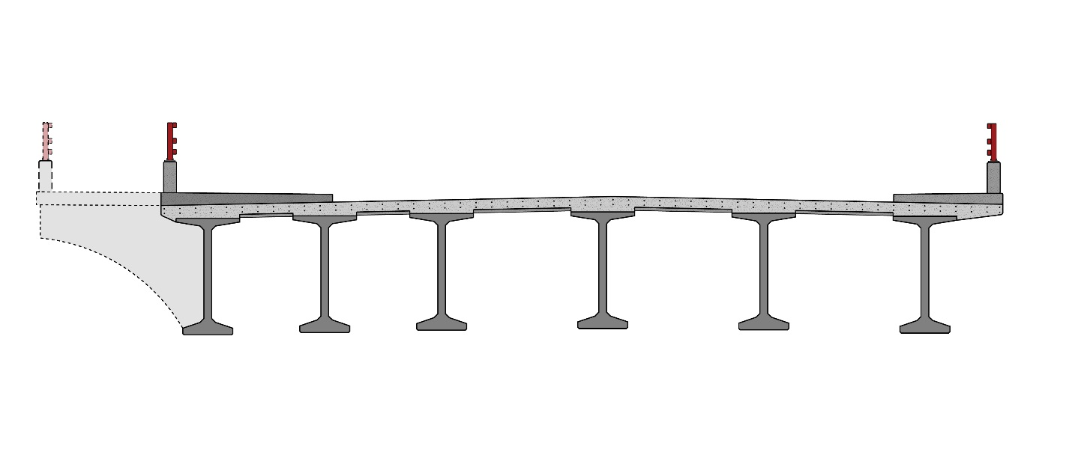

Figure 2: Typical Section

* 1. **Substructure**

The foundations are located immediately outside of the existing bridge footprint. Each abutment stem is designed to span the 14.5 m between the pile cap centers. Straight post-tensioning bars were used to supplement the mild reinforcement in the 1.8 m deep stem. The jacking force of the permanent post-tensioning was calibrated so that it supported only 90% of the dead load of the structure, ensuring that the abutments wouldn’t have an upwards camber that could have hindered the slide. The abutment diaphragm and superstructure is fully integral with the abutment stem.

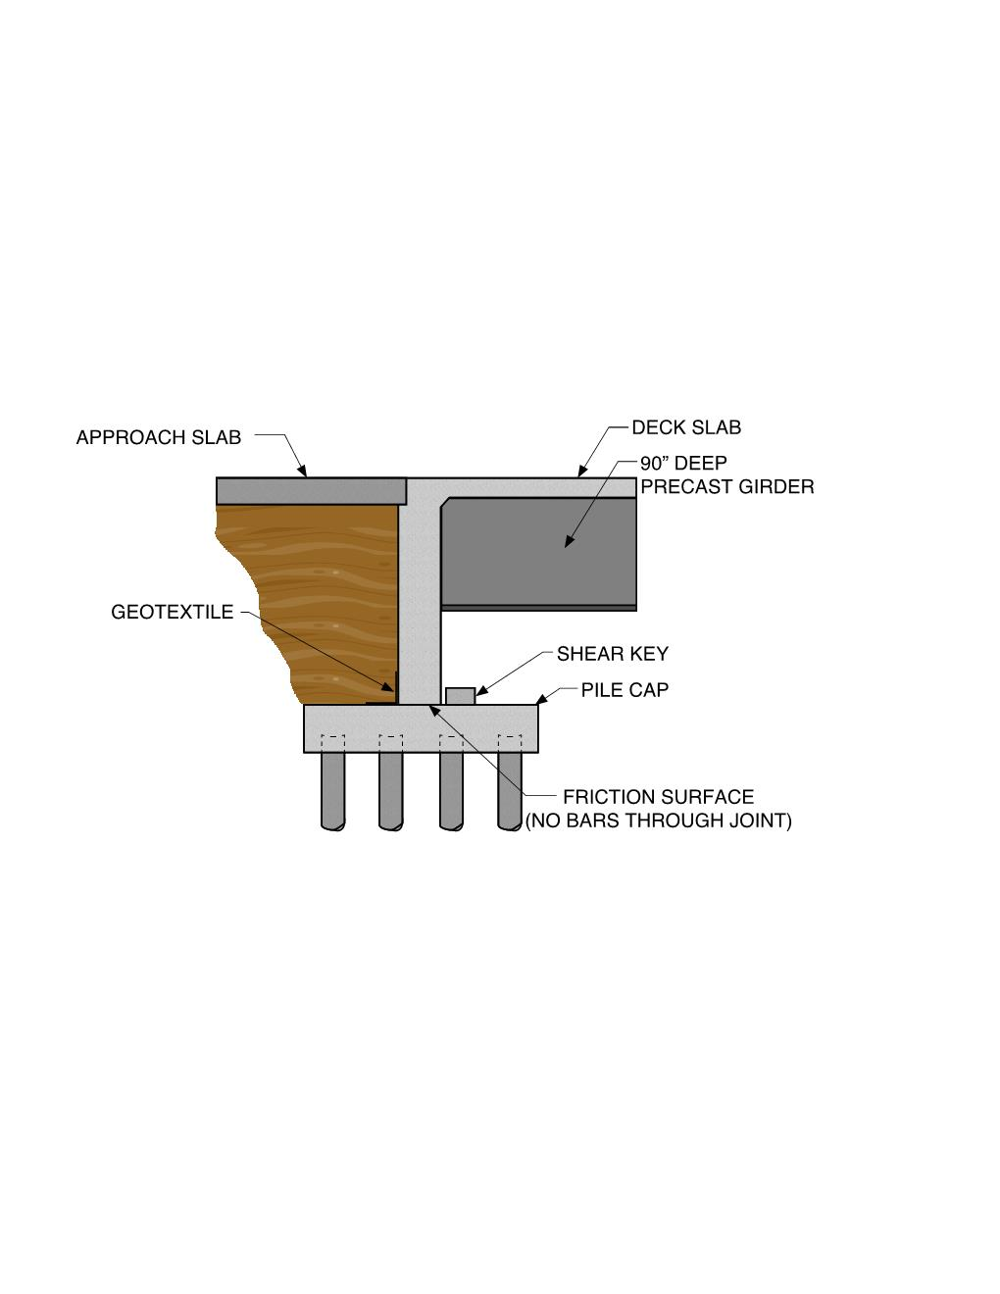

Figure 3: Abutment Detail

On the bottom of the abutment stem, four 300 mm deep blockouts were set to allow vertical jacks to be placed. The blockouts also create five concrete “shoes” that are the primary points of contact for the bridge during the slide. The leading and trailing edges of the shoes are beveled to help ride up and onto the elastomeric slide pads. Stainless steel plates are cast in with the concrete shoes and these will be discussed later in this paper.

The abutments do not have a flexural connection to the pile caps. This decision was made to allow the slide-in of the bridge to occur more smoothly and simplify the connection. As the stem wall is relatively short, flexural demand is easily accommodated by the reinforced 1 m width. The bridge is restrained from non-thermal movement through the use of external shear keys, passive soil pressure and friction between the pile caps and the abutment shoes. There are no permanent bearings below the abutments. In this manner, the bridge acts much like a three-sided culvert or stiff leg structure, albeit with a much longer span.

Wingwalls were cast-in-place after the structure was moved into its permanent location. Two layers of tar paper were set below the wingwalls before casting to create a slip plane and accommodate thermal movement.

Pile caps in the four quadrants support the abutment stems. The geometry of the caps and the pile arrangements were set so that they could be installed prior to the demolition of the existing bridge and without any partial removal of existing deck or barriers. The tight right-of-way limits in the southeast quadrant squeezed the pile arrangement to a 4 by 2 pattern of 406 mm diameter steel pipe piles. The long axis of the 2.4 m by 4.9 m pile cap was set in the east-west orientation.

1. **CONSTRUCTION APPROACH AND SLIDE DETAILS**

While slide-in-bridge construction has been used for interstate highways that require weekend closures, the speed comes at some financial cost. For the Lardo Bridge project, with a viable detour and low traffic for the off-season, there was not a need to reduce the closure time of SH-55. The design-build team’s approach minimized the traffic impacts during the peak season, and kept costs low. Ultimately, the road was taken out of service from October 15th until November 26th with traffic rerouted to cross the river just downstream. A 16-week window was allowed for the detour, but the design-build team was able to reduce the detour to only 6 weeks.

* 1. **Pre-Slide Construction**

The contractor mobilized to the site in early July, beginning preparation for the coffer dams and installing environmental controls. The temporary abutment was constructed to the north of the existing structure in early August. Although space was tight up against the Shore Lodge on the north side, it was more preferable than working to the south where the overhead wiring would need to be relocated.

The temporary abutment was one of the first construction items to occur on the site. Steel HP sections were driven in two rows, with a steel cap consisting of side-by-side W14s. The temporary abutment was then used to support the construction of the abutment stems, setting of the girders and then pouring of the abutment diaphragms and deck. The sidewalk and parapets were not poured until after the bridge was moved into place.

* 1. **Demolition**

Preparation for demolition started in early October as the water level was dropped at the end of peak season. Coffer dams, consisting of soil filled bags (Super Sacks) were shifted so that the river flowed only beneath the middle span of the existing bridge. Fill was brought in behind the coffer dams and below the spans. Temporary falsework was installed over the remaining channel. With that in place, and SH-55 detoured on October 15th, the existing bridge was demolished by dropping the superstructures onto the fill and falsework. Once the existing bridge was demolished, excavation occurred behind existing Piers 2 and 4 to stabilize the subsurface below the slide slabs and then to pour the slide slabs.

* 1. **Slide Slabs**

The slide slabs were the surfaces between the previously installed pile caps on which the bridge was to be slid. The temporary steel abutment cap rested on the pile caps and was able to be installed prior to the demolition of the existing bridge. However, as the new abutments were nearly in line with the existing Piers 2 and 4, the slide slabs had to be installed after the existing bridge was demolished.

A substantial concern during design was that as the structure was slid from the temporary abutments to the north pile cap to the slide slab that the supporting soils would settle and slow down the slide process. In order to mitigate for this, the option of driving some piles to support the slide slab was discussed. However, this option was thought to be too costly and would require an additional mobilization of the pile driving equipment. The existing pile-supported pier cap was being left in place, but the slide slab was not centered on the pile cap and there was concern that the back end would settle, twisting the slide slab and creating an uneven surface for the bridge slide. Instead, the most effective solution was to over-excavate behind the existing pier caps and to place flowable fill, which improved the soil and load distribution. The slide slabs were then built on top of the flowable fill. Ultimately, there was no observed settlement and this approach was successful.

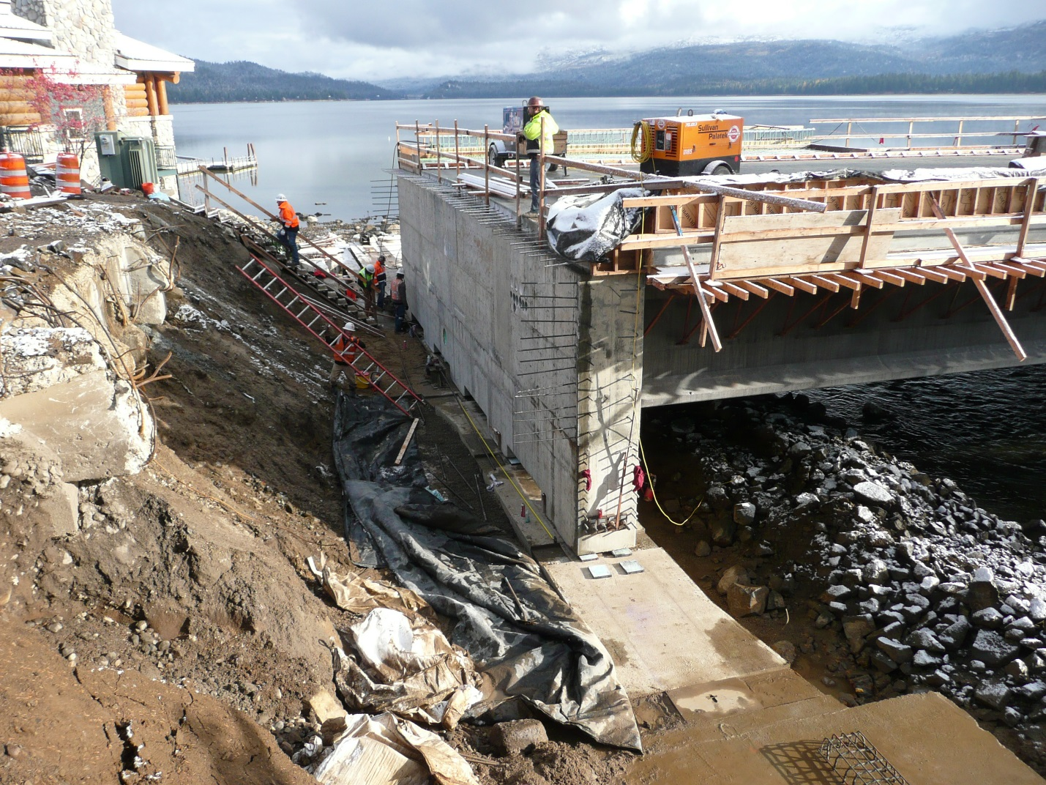

Figure 4: West Abutment Looking North with Slide Slab and Pile Cap

If there had been settlement of the slide slab that caused the binding of movement, the slide operation would have been stopped and jacks brought in to raise the bridge and shims installed. This would have been a very incremental and slow process.

To assist with the slide process a smooth transition from the pile cap to the slide slab had to be provided. The structure was going to be slid from temporary abutment to the north pile cap to the slide slab to the south pile cap. The surface had to remain nearly level, without uneven transitions between each individual element. To ensure this, concrete ledges were formed into the pile caps to support the temporary steel abutment caps and also to support the ends of the concrete slide slabs.

As previously indicated, the abutments were post-tensioned to span from pile cap to pile cap for the permanent condition. However, we chose to provide post-tensioning to resist 90% of the dead load, with the remainder of the dead and live load flexural demand resisted through mild reinforcement. This ensured that the abutment stem would not camber upwards, losing contact with the sliding surfaces. It was not our intent to have any permanent load bearing on the slide slab; however, it is reinforced to properly resist the load.

* 1. **Slide Shoes and Slide Pads**

Concrete slide shoes are commonplace with SIBC and they were used for the Lardo Bridge slide-in as well. However, for this bridge the slide shoes were detailed as full width of the abutment to provide better load distribution and to simplify detailing. A heavy move subcontractor would have required different detailing for the slide shoes to accommodate their proprietary track system. The contractor for this project had the slide pads and jacking equipment from other projects and purchased or fabricated the remaining pieces. This helped to reduce costs and eliminate the additional coordination required with a subcontractor.

The slide shoes were detailed with a 50 mm high x 150 mm long bevel at the leading and trailing edge of the slide shoe to provide a transition as the shoe approached the slide pads to ride up and over them. In actuality, the bevel was too abrupt and the slide shoe pushed some of the slide pads. This principally occurred on the temporary steel abutment cap and slowed down the overall bridge move. The contractor had to brace against the back side of the elastomeric slide pad to ensure that it stayed in position long enough to have the shoe ride up on it.

Five 1.2 m long shoes were provided at each abutment. The use of multiple shoes helped to better distribute the load along the slide path. Four to six slide pads were under each shoe at all times throughout the move. As the bridge slid forwards, the pads on the trailing edge of the shoes were moved forward to the leading edge.

With multiple shoes load distribution is less predictable with a higher likelihood that one or two shoes may lose contact with the slide pad. However, the abutments were designed to span the entire distance between the first and last/fifth shoe. If the slide slab had deflected under the second shoe, the front edge of the first shoe may not have been high enough to fit over top of the slide pad. However, this is mitigated by the bevel and because the slide pads were being spaced with no more than a 300 mm gap. In order to have created a binding issue on the front shoe, a half inch to an inch of settlement would have had to occur. The solution, had there been sufficient settlement, is described in the previous section. In the bridge move document prepared for this project, the operation was to be stopped and reassessed if there was more than a 25 mm settlement at any one location.

Between the slide shoes are pockets for jack placement. The jacks allow the entire structure to be lifted for slide pad installation. For the Lardo Bridge, 300 mm was provided to allow the placement of jacks to lift the structure and initially install the slide pads and then finally remove them, setting the structure in its permanent location on the pile caps.

Stainless steel plates (ASTM A167, Type 304 with a #7 mirror surface finish) are attached to the bottom of the concrete slide shoes with embedded anchors. Since the shoes did not travel through guides made with manufactured steel channels, there was no need to run the stainless steel plates up the sides of the slide shoes, which was a cost savings. The stainless steel is the top surface of the slip plane.

The bottom surface of the slip plane is the Teflon (PTFE) surface bonded to a reinforced elastomeric bearing, the slide pad. The slide pads were 32 mm thick x 300 mm x 250 mm and arranged side by side, with four to six under every concrete shoe. Dishwasher soap was used to reduce friction.

* 1. **Jacking System and Bridge Slide**

For design, 10% static friction was assumed, with an estimated bridge dead load reaction at each abutment of 800 t. High-strength 35 mm diameter threaded bars (threadbars) were set on either side of the abutment faces to pull the bridge into place.

One end of the threadbars were attached to a fabricated steel anchor bracket that was temporarily attached to the north pile caps. The other end of the threadbars passed through a fabricated steel push block. Center hole double acting jacks with a capacity of 68 t each were set up against the push block and pulled on the high strength bars to slide it into place in 180 mm strokes.

With a single manifold regulating each of the four jacks, a high degree of precision and ability to steer the bridge could be realized. A chalk line had been set to monitor the movement of the abutments and shifts were made to the alignment throughout the slide by engaging only the jacks at one abutment, effectively turning or steering the entire structure. The contractor was required to maintain a 13 mm tolerance in plan location.

The steel fabrications for the push block and anchor brackets were simple and could be easily manufactured. The bridge structure was moved into place on October 27th in approximately four hours. It was felt that this could have been faster if the slide pads could have been secured against sliding on the temporary abutment.

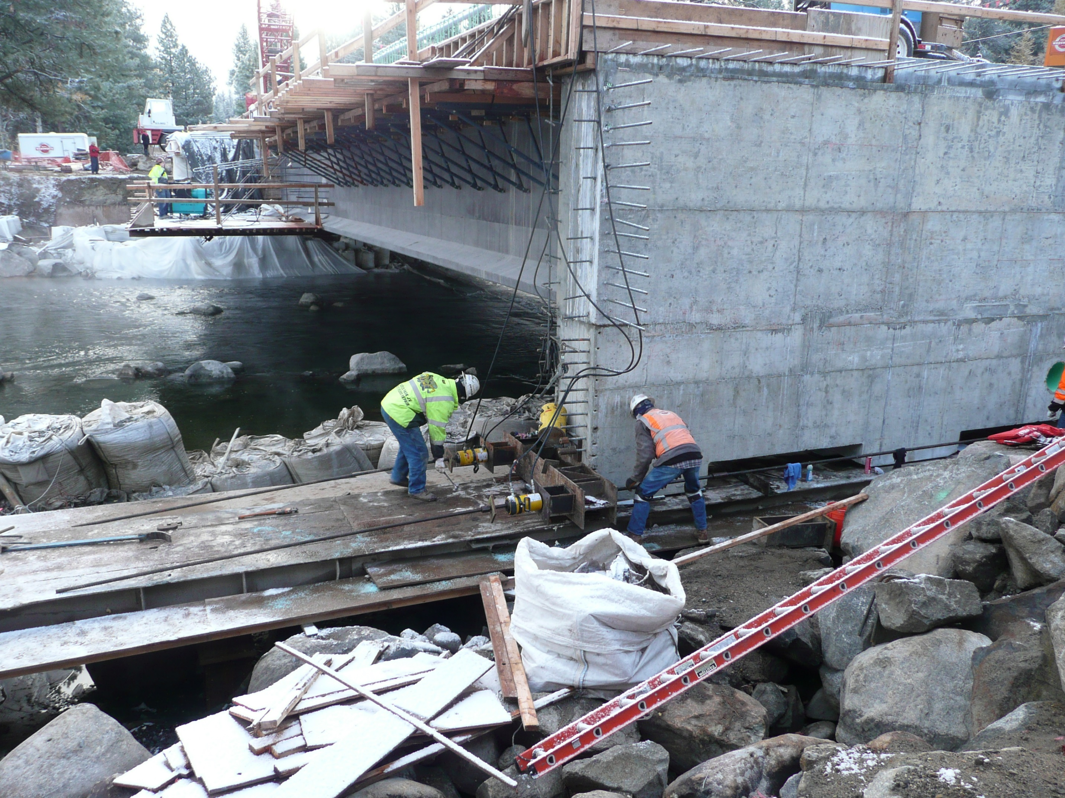

Figure 5: Push Block

As the bridge’s temporary support points always match its permanent support points, there was minimal risk with creating unintentional stresses in the structure. As this is typical for SIBC and one of its advantages, no attempt was made to place strain gages or set a means to monitor deflections of the structure. If there had been an occasion to need to back up the bridge, the anchor brackets would have been removed and reattached to the temporary abutment and the push blocks brought to the south ends of the abutments.

* 1. **Post Slide Activities**

The day after the bridge slide, the forms for the wingwalls were placed and bars were being set. Concrete for the wingwalls was curing by Halloween, four days after the slide. Early in design, it had been assumed that the wingwalls would be cast with the remainder of the structure and moved into place. As they were designed to cantilever from the back of the abutment, and the slide occurs slowly, there would have been minimal risk to damaging the wingwalls. PVC Conduits were placed in the abutment stem, through which the jacking bars could have been run.

However, with space at a premium at the site and having some schedule flexibility was reason enough to postpone construction of the wingwalls until after the bridge was moved into place. The approaches were backfilled by November 5th, with the approach slab reinforcement being set soon after. Railings were installed on the concrete parapets on November 9th and finish work was done so that the roadway could be opened by November 26th.

1. **BENEFITS AND CONCLUSIONS**

Ultimately, the use of SIBC on this project provided an effective means to construct the bridge off to the side during the summer tourist season, sliding it in during the fall when a detour was acceptable and reaching substantial completion prior to the winter season.

As it would have been very difficult to construct new abutments at this site below the existing bridge, there was a big advantage for schedule to construct the abutments with the superstructure and to moving the entire bridge in as one unit. And given that the abutments were slid in with the superstructure, it was critical that we developed the simplified connection between the abutments and the pile caps.

By using a non-proprietary jacking system with fabricated elements, reused slide pads and equipment that was available or could be rented, the costs for the project were reduced. It also allowed simplification of the concrete shoe detailing and a reduction in the quantity of stainless steel.

The slide slab presented a particular challenge for this site. However, the preparation during design and construction was of great benefit with no substantial obstacles occurring during the bridge slide.

The limitations of impacts to the citizens of McCall and their tourists provided ITD a new level of confidence in slide-in bridge construction technology.

**Acknowledgements**

An entire team was necessary to bring this project from inception through design and construction. Only with the support, feedback, ideas and know-how from the following, was this project a success:

Idaho Transportation Department Owner

City of McCall

Ralph L. Wadsworth Construction Contractor

Terracon Geotechnical Engineer

4M Engineering Construction Engineer

Hansen Structural Precast Precaster

Forsgren Associates Owner’s Representative