 | 10th International Conference on Short and Medium Span Bridges  Quebec City, Quebec, Canada,  July 31 – August 3, 2018 | 

SPRAY RIVER BRIDGE REPLACEMENT IN BANFF, AB
Rebel, C.P. (Ken)^{1,3} and Jesney, Kyle²
¹ McElhanney Consulting Services Ltd, Canada
² McElhanney Consulting Services Ltd, Canada
³ krebel@mcelhanney.com
Abstract: Replacing an existing single lane steel Pony Truss Bridge constructed in 1950 with a wider modern day girder bridge while keeping the existing roadway alignment and maintaining traffic throughout the construction period presented some interesting challenges to the project design team. The new Spray River Bridge in Banff, Alberta, CANADA is a 32.0 m long single span box girder bridge designed to carry two 3.6 m wide lanes of traffic and provide 2.0 m wide sidewalks on both sides of the bridge. Aesthetic features integrated into the bridge include the use of local Rundle Stone in retaining walls, abutment faces, barriers and landscaping, colored concrete exterior girders, low level LED lighting installed in the railing pilasters and fabricated and painted steel sidewalk railings matching the original bridge rail design. The new bridge was required to be constructed on the existing road alignment and in order to maintain traffic during construction the original bridge was moved laterally onto temporary foundations and roadway approaches. Parks Canada, the Town of Banff and the Fairmont Banff Springs Hotel were all important stakeholders providing input into the aesthetic features and functionality of the bridge which provides the only access to the Banff Springs Golf Course and Banff Wastewater Treatment Plant. To improve public access to the new upstream and downstream sidewalks on the bridge landscaping was incorporated into the design of the bridge approaches, including walking trail and golf course paths tie-ins. Existing utilities including power, cable, telephone and security lines were also required to be maintained and relocated from the underside of the original truss bridge into conduits within the new bridge and new junction boxes and vaults at each end of the bridge.
- BACKGROUND
McElhanney Consulting Services Ltd. (the Designer) was retained by Parks Canada (the Client) to provide professional services for the conceptual, detailed design and construction supervision of a two-lane replacement bridge structure for the existing Spray River Bridge. The Spray River Bridge site is located approximately two kilometres southeast of the Banff Townsite below the Banff Springs Hotel and provides access to the Banff Wastewater Treatment Plant and Banff Springs Golf Course.
The west side of the bridge site has parking for viewing the Bow Falls and a narrow access road extends south to a restaurant further up the west bank. The Banff Springs Golf Course is located above the bank on the east side of the site. A rafting company uses the east bank downstream of the existing bridge as a staging area. The original Spray River Bridge utilized a 27.4 metre long single span steel pony truss constructed around 1952. The deck has a clear roadway width of 5.2 metres and has two 1.1 metre wide sidewalks on the outside of the truss. The deck consisted of a nail laminated wood cross members and longitudinal timber planks. The original reinforced concrete abutments were supported on wood piling. The narrow bridge was identified as being deficient for full legal highway loads which limited the size and weight of vehicles using the bridge to access the golf course and Banff Wastewater Treatment Plant and this was unacceptable to Parks Canada. See Figure 1 for photo of the existing bridge.
The existing Spray River Bridge was required to remain in operation during construction of the new bridge to provide access to the golf course and treatment plant facilities. In addition, all of the utilities hanging on the underside of the bridge which included power, telephone and cable had to be maintained during construction and incorporated into the new bridge. New retaining walls and landscaping features were required in the new design to integrate the wider bridge with the existing roads and pathways.
Professional services within the Designer’s scope included bridge engineering, highway engineering, geotechnical engineering, site and construction survey, utility relocation and landscaping design. Close liaison with Parks Canada and the project stakeholders including the Town of Banff and the Fairmont Banff Springs Hotel throughout design and construction were critical to the success of the project. This paper focuses on the conceptual and detailed design aspects of the project, and how the unique requirements of each of the facets of the project were integrated into the final aesthetically pleasing solution.
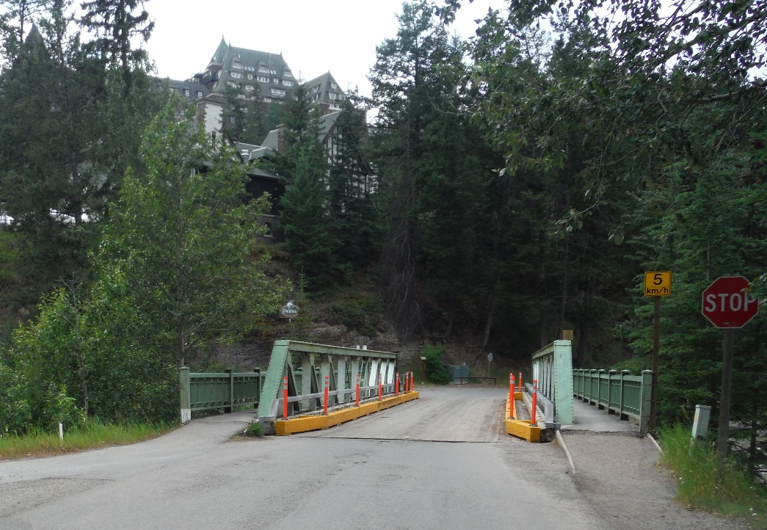
Figure 1: Original Spray River Bridge

CONCEPTUAL DESIGN
McElhanney’s original scope of work was to undertake the detailed design of the new approach roads and replacement bridge based on a June 11, 2013 Parks Canada Agency Spray River Bridge Replacement Options Report. In the report the new bridge was recommended to be located on an alignment approximately 20 metres downstream of the existing bridge and the typical deck section was to provide for two 3.6 metre wide traffic lanes and a 2.0 metre wide sidewalk with bridge railing to accommodate cyclists on each side of the bridge. Vehicle and pedestrian traffic would continue to use the steel pony truss bridge until the new bridge was completed and open to traffic. The original bridge would remain in service but would be limited to carrying pedestrians, cyclists, equestrians and golf carts.

During initial meetings with Parks Canada it was determined that the proposed downstream alignment from the Replacement Options Report would take away a number of parking spots for tourists viewing the Bow Falls and that keeping the new bridge on the original alignment would have significant advantages. McElhanney was directed to undertake a new conceptual design based on the new bridge being centered on the original alignment and perform an analysis of the roadway approaches to confirm that the design vehicle could safely negotiate the tight turn onto the new bridge.

  - KEY ISSUES, PROJECT CONSTRAINTS AND DESIGN SOLUTIONS
In addition to maintaining the existing roadway alignment McElhanney was tasked with resolving the following key issues and project constraints resulting from constructing the bridge on the existing alignment. McElhanney’s team worked closely with Parks Canada during the conceptual design phase to develop the solutions provided in italics after each of the bulleted issues.

- Maintaining traffic, as the bridge is the only access to the Banff Mountain Springs Golf Course and the Banff Wastewater Treatment Plant, only minor delays to traffic will be permissible during construction of a replacement structure. Pedestrian and cyclist traffic must be accommodated during construction. A temporary detour was designed upstream of the original alignment and the existing bridge was moved laterally and utilized as the detour bridge while the new bridge was constructed. See Figure 2 below for detour alignment.

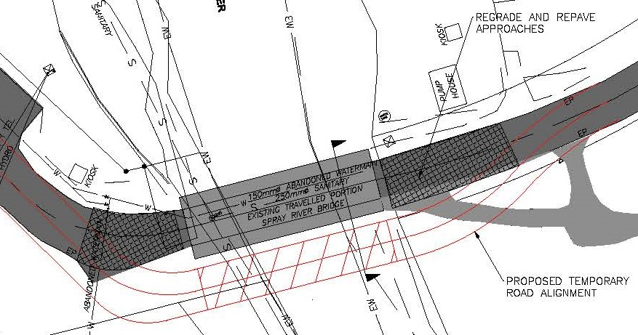
Figure 2: Temporary Detour Alignment
- Environmental, in-stream works are generally not supported by the Department of Fisheries and Oceans (DFO) or Navigable Waters Protection Program (NWPP). This means, by necessity that all permanent and temporary works should be placed outside of the normal high-water level (defined as the Q2), and that all construction activities should take part outside of the wetted perimeter of the river. Any vegetation clearing should be completed outside of the primary nesting season for migratory birds. New bridge was designed to overspan the existing abutment and all new construction was completed outside the normal high-water level.
- Hydrotechnical, based on the hydrotechnical report provided and previous work undertaken by McElhanney it was determined that the soffit of the existing bridge provides adequate freeboard above the Q100 river elevation. The new bridge was designed on a 1% grade for longitudinal drainage and the underside of the exterior girders at the West Abutment was used as the lowest soffit elevation that matched the underside elevation of the original bridge.
- Geotechnical, the existing bridge is founded on piles to bedrock and the new piles are also required to be founded on bedrock. Steel H-piles socketed a minimum of 1.0 metres into competent bedrock were used for the new integral abutment foundations.
- Pedestrian, Cyclist and Golf Cart Accommodation, pedestrians, cyclists and golf carts use the existing bridge and the new bridge must be designed to accommodate them and the railings for the replacement bridge must be designed for cyclists. The design deck cross-section provides for two 3.6 metre wide traffic lanes and two 2.0 metre wide sidewalks with pedestrian railings on outside of sidewalk and PL-1 concrete barriers separating sidewalk from roadway on the inside of sidewalk. See Figure 3 for new bridge cross-section.
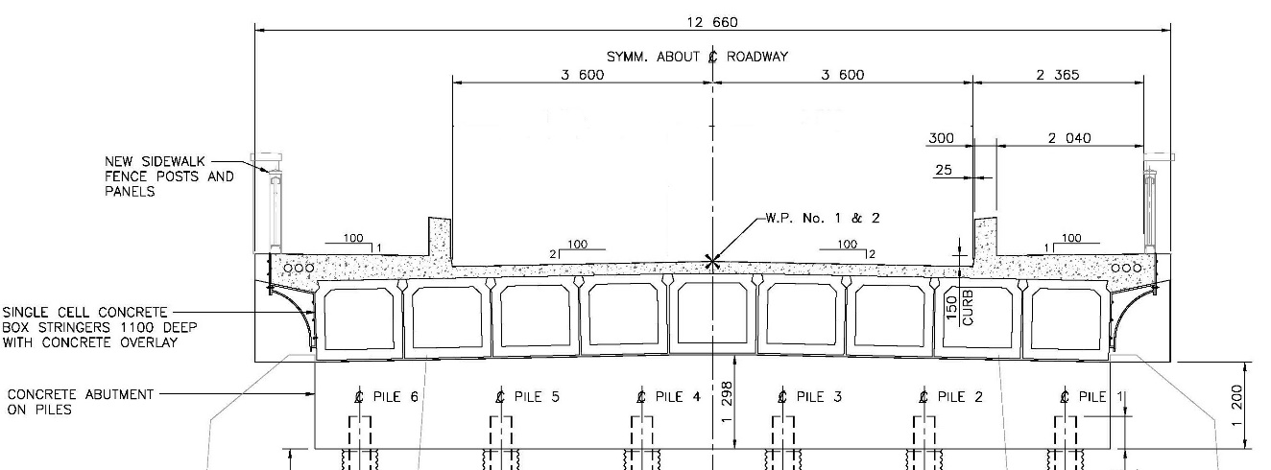

Figure 3: Bridge Cross-section at Abutment

- Aesthetics, As the bridge is in Banff National Park and several hundred meters from the Bow Falls, the Fairmont Banff Springs Hotel and Golf Course aesthetic concerns are of great importance for the replacement structure. The original thoughts on aesthetics from the previous conceptual report was to minimize the intrusion of the new structure into the surroundings while providing a clean and pleasing structure in scale and appearance. The use of weathering steel was not recommended for aesthetic reasons. Slab on girder systems are general viewed as less desirable compared to the use of box girders which provide a thinner structure, which is generally viewed to be more attractive. McElhanney engaged HFKS Architects Ltd. to assist with the development of aesthetic concepts and details for the bridge and attend meetings with stakeholders to get their input. This issue is dealt with in more detail in the detailed design.
- Utilities, the existing bridge carries multiple utilities which must be accounted for in the new bridge design. Utilities include a sewer line runs parallel to the river along the west bank, an electrical kiosk is located northwest of the existing bridge and a power line runs under the bridge as well as telephone, cable and a separate communication line to the golf course. Temporary and permanent utility relocations were coordinated with the utility companies to ensure no disruption to service throughout construction.
- Durability and Future Maintenance, the new bridge was to be designed with additional durability to provide a 100-year life and incorporate details to minimize maintenance requirements. Integral abutments were utilized to eliminate deck joints and high performance concrete reinforced with stainless steel rebar was utilized for the deck and barriers.
- Detailed design will be in accordance with the design climatic and pedestrian loading outlined in the latest CAN/CSA-S6 Canadian Highway Bridge Design Code and the Parks Canada Directive for Design, Construction, and Inspection of Vehicular and Pedestrian Bridges, January 2008. CAN/CSA-S6-6 Canadian Highway Bridge Design Code and S6S1-10 Supplement No.1 were utilized in the design with the live load based on CL-800 truck and lane load.

CONCEPTUAL DESIGN SCHEDULE
The Conceptual Design was undertaken between July 21, 2014 to September 25, 2014. Once the recommended bridge concept was approved, Parks Canada provided written direction to advance the concept to Detailed Design and Tender Document preparation.

DETAILED DESIGN
The objective of this stage was to advance the conceptual design into construction drawings and specifications for the purpose of tendering. This work commenced once we received written authorization from Parks Canada and Public Works and Government Services (PWGSC) to proceed. As per the Terms of Reference the tender submission included 100% complete Drawings with finalized details and complete specifications with all sections thoroughly coordinated with the Drawings. The submission incorporated all comments and revisions by Parks Canada and McElhanney submitted the tender documents to the PWGSC Departmental Representative for their use in the tender process.

  - DESIGN PHILOSOPHY
Our design philosophy was based around utilizing precast concrete box girders to provide a shallow aesthetically pleasing bridge solution and supporting the girders on fully integral abutments and steel H-piles to minimize bridge maintenance. All materials used on the bridge were selected and details developed to provide a durable bridge with a design life of 100 years. Highlights of the bridge and roadway approach designs that were developed during the detailed design phase to address the key issues identified during the conceptual design are provided in the following sections.

  - ALIGNMENT AND DETOUR OPTIONS
The roadway approaches to the bridge are on tight curves and as such McElhanney prepared turning templates to confirm that the design vehicles could safely cross the bridge. The approach radius on the west approach to the bridge was 25.0 metres and on the east side of the bridge was 105 metres. Three templates were developed considered the largest WB-23 truck configuration planned to be used for operation of the wastewater treatment plant in conjunction with oncoming vehicle traffic and it was found that the alignment onto the new wider bridge was acceptable. (See Figure 4)

Figure 4: West Approach Roadway Template
  - LATERAL MOVE OF EXISTING STRUCTURE
To maintain traffic during construction, the existing bridge was required to remain in use as this crossing was the only one to serve the treatment plant and golf course on the east side of the river. This option required that the temporary bridge foundations be constructed on the upstream side of existing bridge to better utilize existing roadway infrastructure and avoid existing utilities and structures on the east side of the Spray River. This detour alignment was designed to allow a standard WB-15 truck and trailer combination to cross over the relocated bridge which was found to be sufficient for the current vehicular loading on the bridge. Maintaining traffic on this upstream alignment resulted in less disruption to the Contractor as his laydown and office area was located downstream of the original alignment. Some coordination was still required during the piling operation as the piling rig needed to be positioned such that part of it protrudes onto the upstream roadway alignment during the pile driving operation.

On the west end of the bridge alignment, existing slopes and bank protection remained in place as they were found to be adequate however lock blocks were put in place to support the new extensions of the pedestrian sidewalks. On the east end of the bridge alignment, a temporary lock block wall was placed and backfilled to match the existing roadway and bridge deck running surface elevation on the upstream (south) side. The newly constructed backwall was set to match the front face of the existing abutment retaining wall to provide a similar-to-existing gap between the end of the bridge deck and backwall while providing enough allowance for the bridge during the lateral move. These walls minimized the footprint of the temporary east roadway approach fills.
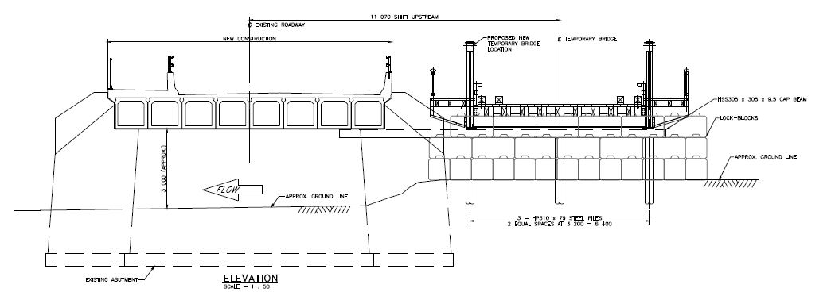
Figure 5: Lateral Move Temporary Configuration Elevation

Temporary foundations consisting of HP310 x 79 steel piles and pile cap were installed on site with the steel cap extending over to be supported on the existing concrete abutment in line with the existing bearings. It was determined that the temporary foundation and permanent bridge piles could utililize the same HP310x 79 piles. This enabled the Contractor to develop a work plan which allowed the temporary piles to be installed first and then immediately afterward, the Contractor started with the new permanent bridge piling. This eliminated the need for two piling rig mobilizations.

The existing concrete abutment seat was notched and chipped down to sound concrete to accommodate the required bearing area for the lateral move loads. Based on the poor legibility of the original bridge drawings, detailed measurements of the existing bridge members and the existing abutments were taken to calculate the weight of the existing bridge. The combined dead plus live service load reaction for each truss end was calculated to be 460 kN. The temporary bridge foundations, consisting of the piling and steel support bents were designed to resist these applied loads. Because of the width of the new and existing bridge (See Figure 5), the pile cap had a large unsupported length between the existing and temporary abutments. The concrete seat, caps and piles were analyzed for various truss positions and was ultimately treated as a moving load with two loading points located at the bearing locations. Longitudinal loading on the bridge was determined to be minimal as the new alignment, speed limits and vehicular traffic was limited and constricted substantial longitudinal loading from occurring.
The bridge was successfully jacked, placed on rollers and moved into position where it was lowered onto temporary bearings on the new temporary foundation system. Stiffened steel plates were placed over the approaches and traffic was moved onto the temporary structure with minimal road closures and disruption to traffic. With traffic on the temporary roadway, demolition of the existing foundation backwall and construction of the new bridge commenced in its permanent location. When the new bridge was completed and open to traffic, the existing bridge, temporary foundations and temporary approach roadways were de-constructed and removed from site. The existing bridge was lifted out in one piece using a large crane.

  - OVERSPANNING ORIGINAL ABUTMENTS / BRIDGE ARTICULATION
To minimize and reduce the need for retaining structures, the existing mass concrete abutment was left in place to retain fills for the new abutment structure. Following the lateral move of the existing truss bridge, the backwall on the concrete foundations was removed to accommodate the longer new bridge span. Piles, like those used in the temporary foundations, were rock socketed into bedrock just behind the existing abutment and a concrete cap was poured with the bridge set at an elevation set just higher than the existing concrete abutment. The tops of the piles were set into 2.0 metre long CSP sections to provide for longitudinal bridge thermal movements as the fully integral abutments are fixed to and move together with the girders. This construction style allowed for clean visual lines, hidden abutment foundations and minimized environmental impacts and construction costs without having to remove the existing concrete foundations. (See Figure 6)
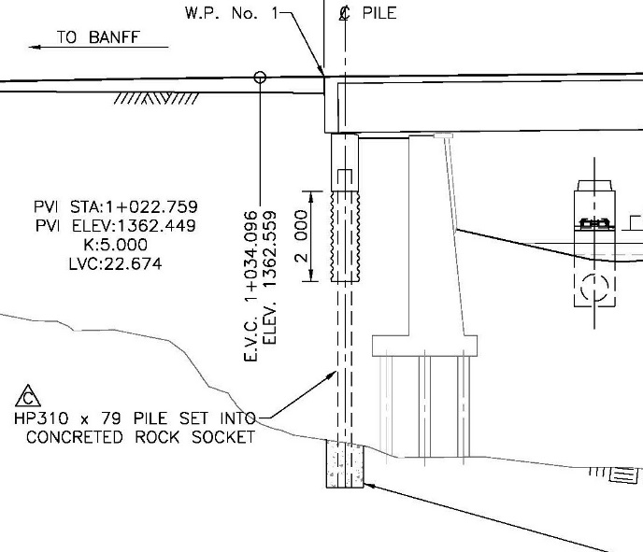
Figure 6: Section Through West Abutment

  - ARCHITECTURAL FEATURES – “BANFF TRADITION”
During conceptual design Parks Canada and the design team met with representative from the Town of Banff and we were presented with a document titled “The Banff Tradition and Bridge Infrastructure”. In the document were examples of bridge infrastructure which exemplified the application of the “Banff Tradition”. The bridge infrastructure examples included the Bow River Vehicle Bridge, Mt Norquay Road Vehicle Bridge and the Muskrat Street and Mt Norquay Road Pedestrian Bridges.
After reviewing the towns document HFKS Architects Ltd. prepared a “Spray River Bridge Architectural Components Review” document which considered the following;
- Color inspirations based on vegetation, wood, local stones, stone cladding and sculptures. Colors considered included natural browns, greys and deep Onyx.
- Colored concrete considered for exterior bridge girders.
- A number of pedestrian handrail options were developed using open steel sections, solid sections and combinations of open railings and pilasters.
The detailed design was undertaken based on using local Rundle Stone to clad the existing abutment faces, the pedestrian railing pilasters and the curved retaining wall approach railings. The exterior precast girders were cast using a dark brownish-purple pigment in the concrete to differentiate them from the concrete deck. The soffit of the overhanging deck was featured using decorative dentils comprised of curved variable depth steel sections that aligned with the pedestrian railing columns. (See Figure 7)

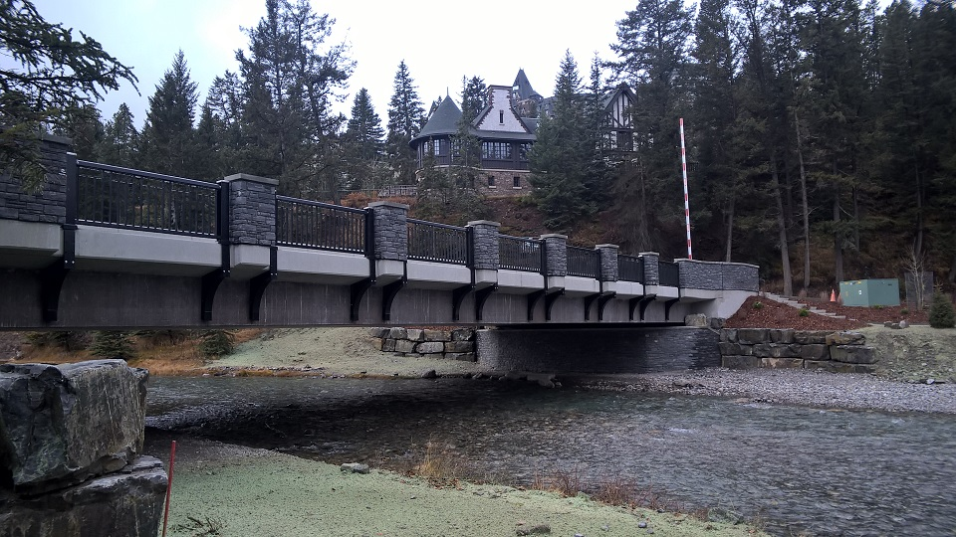
Figure 7: Downstream view of Completed Bridge with Aesthetic Features

  - ROADWAY BARRIERS, PEDESTRIAN RAILING AND POWERED GATE
HFKS Architects Ltd. and McElhanney’s design team developed a bridge rail and pedestrian railing system that provided a pleasing open look while protecting pedestrians from vehicle traffic. The 650 mm high PL-2 solid concrete barrier was kept to a minimum while still meeting the design requirements for a low speed roadway. The barrier prevents vehicles from riding up on the sidewalk and as such the pedestrian railing did not have to be designed for vehicle impact. This allowed the architect to further develop the “Banff Tradition” theme in the pedestrian railing using steel section shapes, steel posts and caps that closely matched the original pony truss sidewalk railing. Pilasters consisting of concrete core sections clad with Rundle Stone facing and cast-in-place concrete caps were integrated into the pedestrian railing to enhance the appearance of the bridge. LED lights that shine downward to provide gentle illumination to the sidewalk were also incorporated into the pilasters and the approach retaining walls railings.
During the parks off-season period a gate is used to keep recreational vehicles from driving down the golf course road as only approved parks vehicles and trucks accessing the water treatment plant are permitted at that time. The powered access gate was originally planned to be located on the east side of the bridge along the golf course road. During construction the design was altered with the powered gate being mounted to the sidewalk on the northwest corner of the bridge. This change provides better control as unauthorized vehicles were now not able to cross the bridge. (See Figure 8 on the next page)

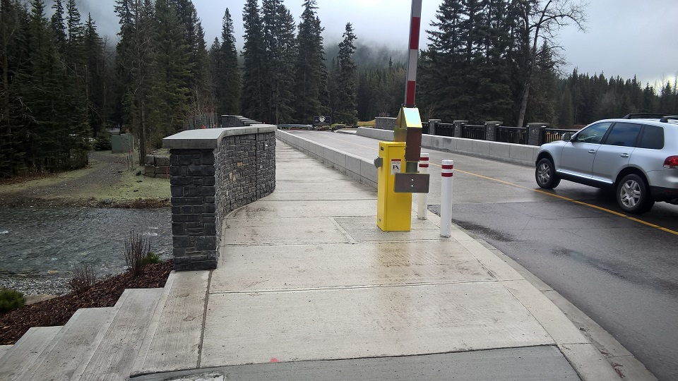
Figure 8: PL-2 Roadway Barriers, Pedestrian Railings and Powered Gate

INTEGRATED RETAINING WALLS AND LANDSCAPING PLAN
The bridge was designed to incorporate curved sidewalks on both sides that transitioned from 2.0 metres wide to 3.0 metres wide at the end of the bridge. This 3.0 metre width matched up with the curved integrated retaining walls and sidewalks on the bridge approaches. Due to the varied nature of the bridge approaches on all 4 side of the bridge, each retaining wall had unique geometry to match the varying geometric properties. The railing on top of the retaining walls featured solid concrete walls with Rundle Stone cladding and cast-in-place concrete caps.
McElhanney’s design team and landscape architects worked closely with Parks Canada and the Fairmont Banff Springs Hotel and Golf Course to develop a landscaping plan that incorporates pedestrian trails and golf cart pathways that tie into the new river crossing. The intent of the landscaping plan was to have pedestrians use the gravel pathways up to the ends of the bridge where they are then able to use the crosswalks at the end of the bridge and sidewalks on the bridge to cross the Spray River. Cyclists and golf carts are not allowed on the sidewalks and are to use the roadway approaches and bridge deck vehicle lanes to cross the bridge.
The landscaping scheme utilizes stacked Rundle Stone boulders to act as gravity retaining walls that transition the approach grades to match the ends of the existing abutments and also act as landscape features for the circular landscaped area on the east side of the bridge. The sideslopes to the bridge approaches and golf course road were planted with a native seed mix provided by Parks Canada.
Plantings located on all four corners of the bridge include white spruce, trembling aspen/balsam polar, low bush cranberry, dwarf birch, snowberry, juniper varieties and mugo pine as approved by Parks Canada. (See Figure 9 on next page)

DETAILED DESIGN AND TENDER DOCUENT SCHEDULE
The Detailed Design and Tender Document preparation for the bridge and roadway approaches was completed between September 28, 2014 and December 3, 2014 such that the project could be tendered in the weeks prior to Christmas 2014. The construction contract was awarded in February 2015 and the bridge was opened to traffic and the Certificate of Substantial Performance was issued on December 13, 2016.

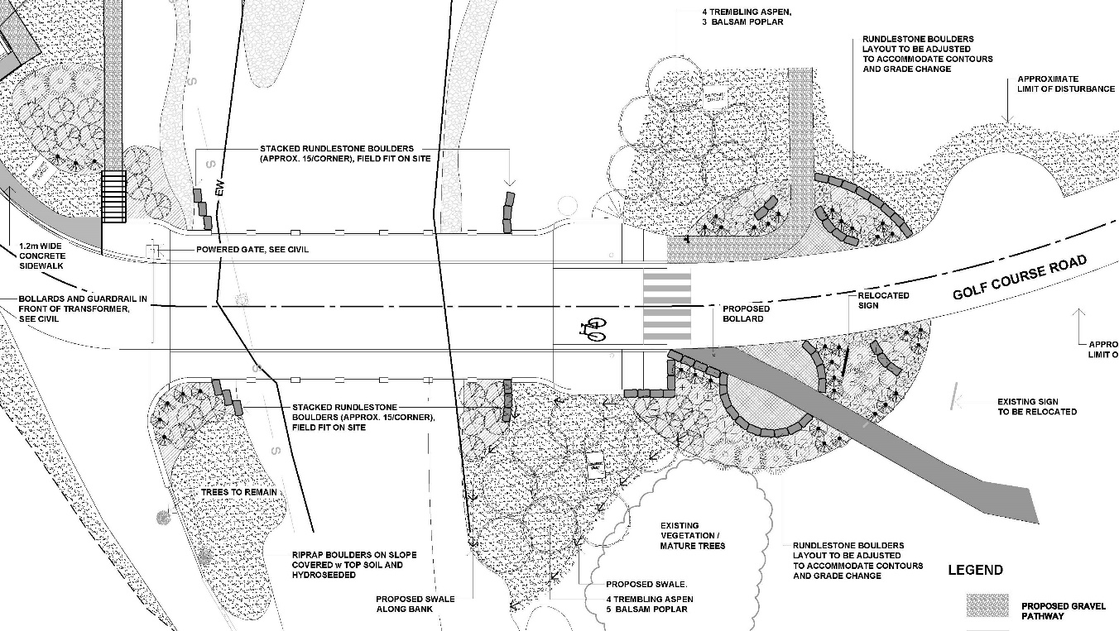
Figure 9: Landscaping Plan

CONCLUSION
The replacement of the original single lane steel pony truss Spray River Bridge with a new modern two-lane structure with sidewalks and approach pathways has greatly improved the functionality of the crossing as it can now carry current and future truck and trailer configurations to the water treatment plant and provides a bridge that meets the “Banff Tradition” for bridge infrastructure in Banff. Identifying and resolving key issues and constraints specific to the project site as well as additional owner and stakeholder requirements during conceptual design enabled the design team to develop optimal solutions to take forward through detailed design and construction, resulting in a successful bridge replacement project.

Acknowledgements
Parks Canada:  - John Rose – Asset Manager, B.Eng.  - Jaison Van Tine – Program Manager  - Anna Brown – Environmental Specialist, B.Sc.  Public Works and Government Services:  - Mark Burke – Project Manager, P.Eng. | HFKS Architects Ltd.:  - Sergio Poles, M.Arch, MAAA, MRAIC

References
CSA. 2006. Canadian Highway Bridge Design Code, CSA S6-06. Canadian Standard Association, Toronto, Ontario, Canada
CSA. 2010. Supplement No. 1 to Canadian Highway Bridge Design Code, CSA S6-06. Canadian Standard Association, Toronto, Ontario, Canada
Parks Canada Directive for Design, Construction, and Inspection of Vehicular and Pedestrian Bridges, January 2008

