 | 10th International Conference on Short and Medium Span Bridges  Quebec City, Quebec, Canada,  July 31 – August 3, 2018 | 

FLEXURAL BEHAVIOUR OF REINFORCED CONCRETE BEAMS EXTERNALLY REINFORCED WITH SHAPE MEMORY ALLOY BARS
Elbahy, Yamen I.^{1,2}, and Youssef, Maged A.¹
¹ Western University, Canada
² yelbahy@uwo.ca

Abstract: Retrofitting Reinforced Concrete (RC) structures is required to upgrade their capacities and/or address deterioration happening overtime. Several retrofitting techniques and materials are available. More innovative and cost effective retrofitting techniques are continuously being developed. In this study, a new technique for retrofitting RC beams in flexure is introduced. The technique is based on using unbonded superleastic Shape Memory Alloy (SMA) bars. A sectional analysis approach is presented, validated, and used to conduct an extensive parametric study. Results of the parametric study are used to develop equations to predict changes in the beam behaviour because of the suggested retrofitting technique.
- INTRODUCTION
The civil infrastructure systems constitute a large portion of the national wealth. Because of ageing and exposure to the environment, they rapidly deteriorate and become more vulnerable to catastrophic failure. Therefore, these structures might need retrofitting to extend their service life. Retrofitting might also be needed to correct design and/or construction errors and to allow changing the structure function.

Examples of available retrofitting techniques for Reinforced Concrete (RC) sections are: (i) concrete jacketing; (ii) attaching steel plates; (iii) applying external post-tensioning; and (iv) using Fibre Reinforced Polymers (FRPs). Flexural retrofitting of RC beams using superelastic Shape Memory Alloy (SMA) bars is another potential technique. Main advantages of superelastic SMA bars are: (i) ability to undergo large deformations and return to their undeformed shape upon unloading (i.e. superelasticity); (ii) ability to dissipate large amounts of energy and release them upon unloading (i.e. flag shape stress-strain relationship) (iii) high resistance to corrosion; and (iv) high resistance to fatigue (Alam et al. 2007, Janke et al. 2005).

In this study, the possibility of using unbonded SMA bars to retrofit RC beams is analytically investigated. A sectional method is introduced. Results of the suggested method are validated using the available experimental results. A parametric study is then carried out. Results of the parametric study are used to develop design equations that can capture the change in the flexural behaviour of beams retrofitted using external unbonded SMA bars.

- ANALYSIS METHOD

A computer program is developed using JAVA programming to predict the flexural behaviour of RC beams retrofitted using unbonded superelastic SMAs bars. The program is based on the sectional analysis methodology, where the cross-section of the retrofitted beam is divided into a discrete number of horizontal layers, Figure 1. Using the predefined stress-strain relationship of each layer, and considering the cross-section equilibrium and kinematics, the flexural behaviour of the retrofitted beam can be predicted (Youssef and Rahman 2007; Elbahy et al. 2009). Two main assumptions are proposed in the suggested analysis procedure: (i) plane sections remain plane (i.e. linear strain distribution); and (ii) perfect bond exists between concrete and internal reinforcement layers.

Figure 1: Fibre Model

Figure 2(a) illustrates a flow chart of the developed program during the loading stage. Steps of the analysis are: (i) the analysis starts by assuming an initial strain for the unbonded SMA bars; (ii) using the predefined SMA stress-strain relationship, the force in the unbonded SMA bars is then calculated; (iii) a compressive strain value, ε_{c-top}, is assumed for the top concrete layer; (iv) cross-section curvature, ϕ, is then iterated until equilibrium is achieved; (v) the corresponding cross-section moment, M, is then calculated; (vi) analysis is repeated for a range of top compressive strains ε_{c-top} until reaching a moment value that corresponds to the assumed ε_{SMA-ext}. The final moment and curvature represent one point on the desired moment-curvature relationship. This procedure is repeated for different strain values ε_{SMA-ext}.

Figure 2(b) shows a flow chart of the program during the unloading stage. Steps of the analysis are: (i) read the values corresponding to the point of unloading from the loading program (ε_{SMA-ext}, moment, curvature, layer stress, layer strain); (ii) unloading analysis starts by assuming a smaller ε_{SMA-ext} in the unbonded SMA bar; (iii) using the predefined unloading stress-strain relationship of the SMA bar, the force in the unbonded SMA bar is calculated; (iv) the compressive strain value in the top layer ε_{c-top} recorded at the maximum loading level is used as an initial top strain value for the unloading analysis; (v) using the predefined stress-strain relationship of each layer and the recorded stress and strain of each layer, the cross-section curvature ϕ is iterated until the cross-section equilibrium is achieved; and (vi) the corresponding cross-section moment and curvature are calculated and recorded. Analysis is then repeated for a range of smaller top compressive strains ε_{c-top} and ε_{SMA-ext}.

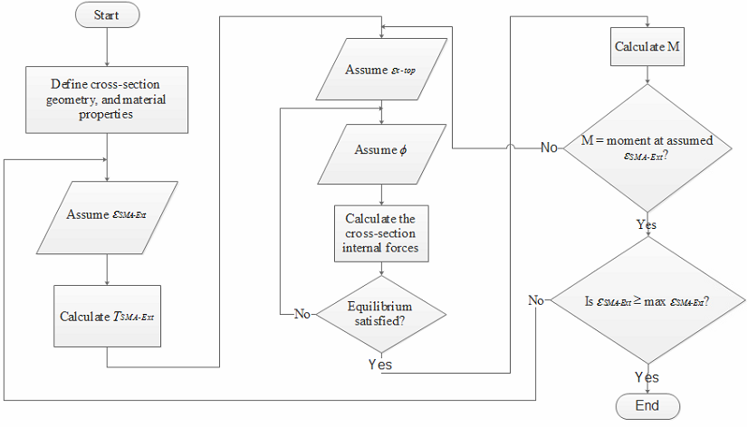
- Loading stage
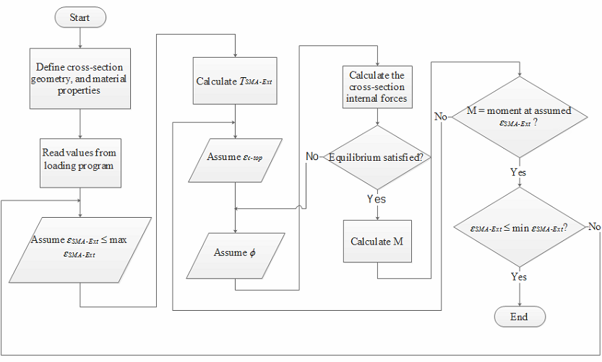
- Unloading stage
Figure 2: Flow chart of the developed program

Four material models are implemented in the developed program. These models represent the behaviour of concrete, steel, and SMA materials under tensile and compressive loadings.
- MATERIAL MODELS
  - Concrete under Compression
The model developed by Scott et al. (1982), Figure 3(a), is used to model the concrete behaviour under compression loading. This model represents a good balance between accuracy and simplicity. During the unloading stage, behaviour of concrete in compression is assumed to follow the model proposed by Karsan and Jirsa (1969). When unloading starts, the material follows linear straight path that connects the strain at the unloading start, ε_{r}, to the unloading strain at zero-stress, ε_{p}. After reaching ε_{p}, the strains continue to reduce while keeping the stress value equal to zero. This continues till reaching the point of zero strain.
  - Concrete under Tension
Behaviour of concrete under tension loading is assumed to follow the model proposed by Stevens et al. (1987) and simplified by Youssef and Ghobarah (1999), Figure 3(b). In the pre-cracking zone, the concrete behaves in a linear fashion up to the cracking stress f_{cr}. This is followed by significant reduction in the stress value.
If unloading starts before reaching f_{cr}, the concrete behaves in a linear fashion similar to the loading stage. If unloading starts after reaching f_{cr}, the material follows a linear path with a slope equal to the modulus of elasticity of concrete. After reaching the zero-stress point, the strain continues to decrease while the stress is kept equal to zero. This continues until reaching the point of zero-strain.
  - Steel Bars
The behaviour of the steel material is assumed to follow a bilinear stress-strain relationship under both tension and compression loadings, Figure 3(c). The material behaves elastically until reaching its yielding strain, ε_{y-s}. Then, the modulus of elasticity is significantly reduced.
If unloading starts within the pre-yielding zone, the material behaves in an elastic manner similar to the loading stage with no residual deformations at complete unloading. If the unloading starts within the post-yielding zone, the material follows a linear unloading path until yielding on the other side (tension or compression).
  - Superelastic SMA Bars
The stress-strain model of SMA consists of four linear branches that are connected by smooth curves (Alam et al. 2007), Figure 3(d). To simplify the modelling process of the SMA material, the smooth curves are ignored and linear branches are assumed to directly intersect. The material behaves elastically until reaching the SMA critical stress f_{cr-SMA} which represents the start of the martensite stress induced transformation. Exceeding this limit, the material stiffness significantly reduces to about 10% of its initial value. If loading continues until full transformation to martensite phase occurs, the material regains about 50% of its initial stiffness. If loading continues to the real yielding limit, another significant reduction in the material stiffness occurs.

The behaviour of SMAs during the unloading stage is illustrated in Figure 3(d). If unloading starts before reaching SMAs critical stress, the material behaves in an elastic manner similar to the loading stage (i.e. unloading path 1). If unloading starts when the stress in the material is in between the critical and yielding stresses, the material follows a flag shaped stress-strain relationship (i.e. unloading path 2). If unloading starts after the material reaches its yielding limit), the material follows a linear unloading path (i.e. unloading path 3).
- Concrete in compression | - Concrete in tension
- Steel in tension/compression | - SMA in tension/compression
Figure 3: Stress-strain models during loading and unloading stages

- EXPEIMENTAL VALIDATION

The work done by Saiidi et al. (2007) is used to validate the accuracy of the results obtained by the developed program. Saiidi et al. (2007) tested eight reinforced concrete beams under quasi-static loading. The beams have the same dimensions. The differences between the eight beams are the type and amount of reinforcement at the mid-span. Four beams are reinforced with SMA bars at mid-span, while the other four are reinforced with conventional steel bars. Details of the types and amounts of reinforcement used in the eight beams are summarized in Table 1.

Table 1: Properties of the tested beams
Specimen | Mid-span SMAs reinforcement | Yielding (Critical) Strain (mm/mm) | Yielding (critical stress) (MPa) | Modulus of Elasticity (MPa)
BNL1 | 1 ϕ 6.40 mm | 0.013 | 400 | 34078
BNL2 | 2 ϕ 6.40 mm | 0.013 | 400 | 34078
BNH1 | 1 ϕ 9.50 mm | 0.013 | 510 | 39245
BNH2 | 2 ϕ 9.50 mm | 0.013 | 510 | 39245
BSL1 | 1 # 3 bars | 0.0021 | 440 | 209524
BSL2 | 2 # 3 bars | 0.0021 | 440 | 209524
BSH1 | 1 # 4 bars | 0.0009 | 420 | 466667
BSH2 | 2 # 4 bars | 0.0009 | 420 | 466667

Figure 4 illustrates the details of the tested beams. The beams are 1530 mm long. The beams have cross-sectional dimensions of 127x152 mm at mid-span (i.e. mid-sections) and 127x305 mm at the ends (i.e. outer-sections). The beams are tested under two point symmetric loads that are placed 152 mm apart. This ensures subjecting the mid-span cross-sections to constant flexure.

Figure 4: Beams dimensions and test setup

It is also shown in the figure that the reinforcement at mid-span is attached to the beam using external angles. In addition to the external reinforcement, two internal longitudinal bars are placed at the top and bottom of the mid-sections to avoid beam damage during handling. However, to ensure avoiding any contribution of the internal bars to the tensile strength, the internal bottom bar is cut before the test.

The developed program is used in this section to predict the moment-curvature and load-bar strain behaviours of the tested beams. Figure 5 shows the experimental and analytical load-external bar strain at mid-span. As shown in the figures, good agreements between the experimental and analytical results are observed.

- BNL1 | - BNL2
- BNH2
Figure 5: Experimental versus analytical load-bar strain results for the SMAs RC beams

- DEFLECTION CALCULATIONS

The moment-area method is utilized to calculate the rotation and deflection values. Steps involved in this method includes: (i) perform moment-curvature analysis of different cross-sections defining the structural element; (ii) the bending moment distribution is used in conjunction with the moment-curvature relationship to obtain the curvature distribution along the length of the member; (iii) rotation of any part of the element can be calculated by integrating the area under the curvature distribution, while deflection can be obtained by calculating the moment of the integrated area about the target location.

- PARAMETRIC STUDY

A parametric study is carried out in this section to investigate the behaviour of RC beams retrofitted using unbonded SMA bars. Analysis is performed for the loading and unloading stages. Three parameters are investigated: (i) the ratio between the added external SMA reinforcement to the amount of internal steel reinforcement in the beam (A_{SMA}/A_{s}); (ii) applied load level (ratio between the maximum applied displacement to the displacement at which yielding of the external reinforcement occurs δ_{max}/δ_{y}); and (iii) ratio between the length of the used SMA bars to the span of the beam (L_{SMA}/L).

The parametric study is performed on simply supported beams with cross-sectional dimensions of 300 mm by 700 mm and span of 7,000 mm. They beams loaded/unloaded under either one or two point loads. For each of the studied parameters, the parameter under investigation is varied within the desired range while keeping all other parameters constant during the analysis. While varying A_{SMA}/A_{s} and load level, the length of the SMA bars is assumed equal to the full length of the beam. For the third parameter (L_{SMA}/L), nine different lengths of the SMA bars are investigated (0.05 L, 0.10 L, 0.125 L, 0.167 L, 0.25 L, 0.33 L, 0.50 L, 0.67 L, and 0.75 L; where L is the span of the studied beams).

- CHOICE OF SMA BARS

Multiple linear regression is used to model the relationship between the outputs and the inputs obtained from the parametric study. After trying numerous number of models that utilize different transformations (i.e. linear transformations, quadratic power transformation, and logarithmic transformation), the best five models for the five outputs are noted and presented in this section.

In the used backward elimination stepwise regression (Dunlop and Smith 2003), all explanatory variables (inputs) are included in the model at the beginning. Then, the non-significant variables are eliminated one at a time. At the end of the analysis, the reported remaining variables are only the statistically significant ones.

The data used in this analysis are the data obtained from the parametric study. A total of 350 data sets are used in the models. All parameters (i.e. inputs and outputs) are non-dimensional parameters. The inputs are: L_{SMA}/L, A_{SMA}/A_{s}, and load level. The outputs of the parametric study are: δ_{r}/δ_{max}, M_{rt}/M_{org}, ST_{rt}/ST_{org}, δ_{y-rt}/δ_{y-org}, and δ_{max-rt}/δ_{max-org}.

Equations [1-5] represent the summary of the final regression models for the five outputs.

[1] δ_{r}/δ_{max} = -0.14318 x A_{SMAs}/A_{s} + 0.061737 x (A_{SMAs}/A_{s})² + 0.013083 x (Load level)² + 0.751673
[2] M_{rt}/M_{org} = 82.72809 x (A_{SMAs}/A_{s}) + 5.773622 x (Load level) -23.0628
[3] ln(ST_{rt}/ST_{org}) = -0.71767 x ln(L_{SMAs}/L) + 0.88563 x ln(A_{SMAs}/A_{s}) + 3.210665
[4] ln(δ_{y-rt}/δ_{y-org}) = 8.336842 x (L_{SMAs}/L) – 11.2 x (L_{SMAs}/L)² + 0.408727 x (A_{SMAs}/A_{s}) – 0.06615 x (A_{SMAs}/A_{s})² + 2.603485
[5] ln(δ_{max-rt}/δ_{max-org}) = 14.02687 x (L_{SMAs}/L) - 17.2568 x (L_{SMAs}/L)² - 0.14746 x (A_{SMAs}/A_{s}) + 4.255832
- CONCLUSIONS
The use of external unbonded SMA bars to retrofit RC beams is investigated in this study. A simplified analysis method is developed to capture the flexure behaviour of the retrofitted beams. The analysis method is based on the sectional analysis technique for unbonded bars. Results obtained from the developed program/method are validated using available experimental results.

An extensive parametric study is then carried out to investigate the flexural behaviour of RC beams retrofitted using SMA bars. Effect of varying three different parameters is studied. These parameters are: A_{SMA}/A_{s}, load level (δ_{max}/δ_{y}), and L_{SMA}/L. For each of the studied parameters, load-displacement relationships are constructed using the moment-area method. Out of the different load-displacement relationships, δ_{r}/δ_{max}, M_{rt}/M_{org}, ST_{rt}/ST_{org}, δ_{y-rt}/δ_{y-org}, and δ_{max-rt}/_{δmax-org} are used to capture the change happening in the behaviour due to varying one of the parameters.

Results of the parametric study are then used in multiple linear regression analysis. A numerous number of models are first developed for the five outputs. Different transformations of the inputs are used. Best five models for the five outputs are then reported in this study. The five models are summarized in the form of simple equations to help the designers to decide the optimum amount and length of the used SMA bars.

- REFERENCES

Alam, M.S., Youssef, M.A., and Nehdi, M. 2007. Utilizing Shape Memory Alloys to Enhance the Performance and Safety of Civil Infrastructure: a Review.” Canadian Journal of Civil Engineering, 34(9), 1075-1086.
Dunlop, P, and Simon, S. 2003. Estimating key characteristics of the concrete delivery and placement process using linear regression analysis. Journal of Civil Engineering and Environmental Systems, 20(4), 273-290.
Elbahy Y.I., Youssef M.A., Nehdi M. 2009. Stress Block Parameters for Concrete Flexural Members Reinforced with Superelastic Shape Memory Alloys. Journal of Materials and Structures, 42(10), 1335-1351.
Janke, L., Czaderski, C., Motavalli, M., and Ruth, J. 2005. Applications of Shape Memory Alloys in Civil Engineering Structures - Overview, Limits and New Ideas. Materials and Structures, 338(279), 578-592.
Karsan, I. D., and Jirsa, J. O. 1969. Behavior of Concrete under Compressive Loading. ASCE Journal (Structural Division), 95(12), 2543-2563.
Saiidi,M.S., Sadrossadat-Zadeh, M., Ayoub,C., and Itani,A. 2007. Pilot study of behavior of concrete beams reinforced with shape memory alloys. Journal of Materials in Civil engineering, American Society of Civil Engineering, 19(6): 454-461.
Scott, B.D.; Park, R.; and Priestley, M.J.N. 1982. Stress-Strain Behavior of Concrete Confined by Overlapping Hoops at Low and High Strain Rates. ACI journal, 79(1), 13-27.
Stevens, N.J., Uzumeri, S.M., and Collins, M.P. 1987. Analytical Modeling of Reinforced Concrete Subjected to Monotonic and Reversed Loading. Publication No. 87-1, University of Toronto, 3634 p.
Youssef, M., and Ghobarah, A. 1999. Strength Deterioration due to Bond Slip and Concrete Crushing in Modeling of Reinforced Concrete Members. ACI Structural Journal, 96(6), 956-967.
Youssef, M.A., and Rahman, M. 2007. Simplified seismic modeling of reinforced concrete flexural members. Magazine of Concrete Research, 59(9), 639-649.

