 | 10th International Conference on Short and Medium Span Bridges  Quebec City, Quebec, Canada,  July 31 – August 3, 2018 | 

Sustainable Zinc Coatings for Steel Bridges
Gagné, Martin^{1,2}
¹ International Zinc Association, USA
² corresponding author: mgagne@zinc.org

Abstract: Metallic zinc coatings are well established and recognized as the most cost-effective corrosion protection available for steel structures. The zinc coating acts first as a barrier protection, isolating the base steel from corrosive elements, and secondly by cathodic protection, acting as a sacrificial anode to protect the steel should the coating be compromised. In a life cycle comparison with paint, the durability of metallic zinc coatings eliminates the repeat burdens of maintenance painting, significantly reducing the total cost of a project. Furthermore, zinc coatings have significantly lower life cycle impact in terms of embodied energy, global warming potential, acidification potential, and photo-chemical ozone creation potential. Zinc coatings can be applied either by hot dip galvanizing or by thermal spraying. Hot dip galvanizing involves the full immersion of the steel into a bath of molten zinc, ensuring complete coverage over all surfaces. However, some structures can be too large to be galvanized. Zinc thermal spray involves projecting drops of liquid zinc onto the surface of the steel using compressed air. With thermal sprayed zinc coatings, there is no size limitation to the part to be coated, and the technology is fully portable, allowing easy field applications. Whether applied by galvanizing or thermal spraying, zinc coatings are fully compatible, and steels coated by either method can be incorporated into one structure with no concerns.

- INTRODUCTION
Corrosion of steel is relentless. Direct corrosion control costs are estimated to be over 3% of GDP every year (Koch et al. 2001). Zinc provides the most effective corrosion protection for steel by acting first as a barrier coating, keeping corrosive elements away from the steel, and secondly as a sacrificial anode (Porter 1994). Zinc will corrode preferentially to protect the steel. Zinc coatings can be factory applied by hot-dip galvanizing or by thermal spraying. Zinc coatings applied by hot-dip galvanizing involve the full immersion of the steel piece into a bath of molten zinc, which ensures complete coverage of all surfaces, inside and out. Zinc thermal spray involves projecting drops of liquid zinc onto the surface of the steel using compressed air. With thermal sprayed zinc coatings, there is no size limitation to the part to be coated, and the technology is fully portable, allowing easy field applications.

Life cycle assessment (LCA) is a decision-making tool to identify environmental burdens and evaluate the environmental consequences of a material, product, process or service through production, use, and end of life (Van Genderen et al. 2016). That is, over its life cycle from cradle to gate (typical for basic raw materials and commodities such as zinc metal) or cradle to grave (typical for products such as galvanized steel). LCA has been standardized by the International Organization for Standardization (ISO) and forms the conceptual basis for a number of management approaches and standards that consider the life cycle impacts of product systems. The results are often expressed as an Environmental Product Declaration.

- HOT-DIP GALVANIZING

Hot-dip galvanizing, also known as general galvanizing, produces a zinc coating by completely immersing the steel product in a bath (kettle) of molten zinc. The process involves surface preparation followed by immersion in molten zinc and a final inspection (Bablik 1950). The process is shown schematically in Figure 1.

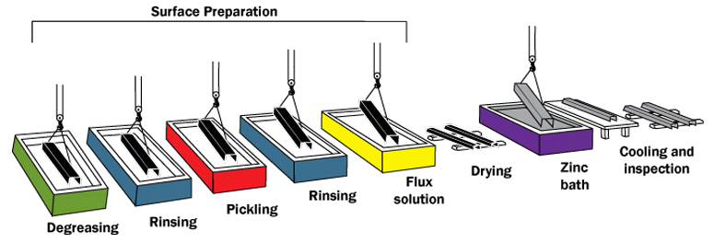
Figure 1: The hot-dip galvanizing process

Prior to immersion in the zinc bath, the steel is chemically cleaned to remove all oils, greases, soil, mill scale, and oxides. Surface preparation for galvanizing consists of three steps; degreasing, pickling, fluxing. For degreasing, a hot alkali solution, a mild acidic bath, or a biological cleaning agent can be used to remove organic contaminants such as dirt, paint markings, grease, and oil from the metal surface. Epoxies, vinyls, asphalt, or welding slag, which cannot be removed by degreasing, must be removed before galvanizing by grit-blasting, sand-blasting or other mechanical means.

After degreasing, the pickling process involves using a dilute solution of heated sulfuric acid or ambient temperature hydrochloric acid to remove mill scale and iron oxides from the steel surface. As an alternative to or in conjunction with pickling, this step can also be accomplished using abrasive cleaning or air blasting sand, metallic shot, or grit onto the steel.

Fluxing is the final surface preparation step in the galvanizing process. A zinc ammonium chloride solution is used to remove any remaining oxides from the steel surface and then deposits a protective layer on the steel to prevent any further oxides from forming on the surface prior to immersion in the molten zinc.

After surface preparation, the steel is galvanized by immersion in a bath of molten zinc. The bath consists of more than 98% pure zinc and the remaining 2% or less consists of bath additives, most commonly being aluminum, nickel, and bismuth. These additives help with zinc fluidity and consumption, coating appearance, and other efficiencies.

While in the galvanizing kettle, the molten zinc metallurgically reacts with the iron in the steel to form a distinct coating structure approximately 100 um (4 mils) thick (Figure 2). The hot-dip galvanized coating structure consists of a series of iron-zinc layers with a top surface layer of pure zinc. The intermetallic layers are tightly bonded (9,000 KPa (3,600 psi)) to and harder than the base steel, offering excellent abrasion resistance. The zinc-iron alloy layers, metallurgically bonded to the steel, become an integral part of the steel rather than just a surface coating.

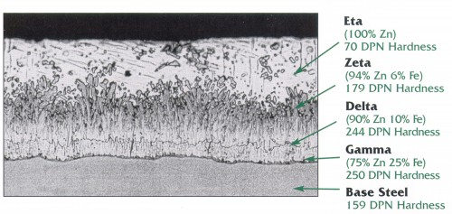
Figure 2: Galvanized Coating Structure

Another unique characteristic of the hot-dip galvanized coating is the uniform and complete coverage of all surfaces. During the metallurgical reaction in the kettle, the zinc-iron alloy layers grow perpendicular to all surfaces, ensuring that both edges and corners have a coating thickness equal to or greater than flat surfaces. Additionally, because hot-dip galvanizing is a total immersion process, all interior surfaces of hollow structures and difficult to access recesses of complex pieces are coated. This complete, uniform coverage of all surfaces ensures that critical points where corrosion commonly starts have the same protection as accessible, flat exterior surfaces.

- ZINC THERMAL SPRAYING

For the thermal spraying of zinc, two different techniques can be used, either electric arc spraying or flame spraying (Prenger 2014). For either process, the steel surface needs to be prepared for thermal spraying. Grit blasting of the steel surface, rather than shot blsting, is preferred to provide adequate mechanical adhesion of the spray coating to the steel, but shot blasting to an Sa3 coarse profile has been shown to give very satisfactory results.

In arc spraying, two zinc wires are brought together at an angle between 30° and 60°, and an imposed voltage difference between them creates an electric arc. A gas flow, of either compressed air or a special gas, then atomizes and propels the molten metal droplets toward the steel substrate (Figure 3). The rise in temperature of the steel substrate is less with the arc spraying process than the flame spraying process because of the large volume of gas that is used for the arc spraying process.

Figure 3: Arc Spraying Process Schematic (Prenger 2014)

Flame spraying uses an acetylene-oxygen flame to melt a zinc wire or powder that is continuously fed into this flame (Figure 4). A stream of gas, generally compressed air, then propels the molten metal droplets in the direction of the steel surface.
Figure 4: Flame Spraying Process Schematic (Prenger 2014)

Although pure zinc was the first corrosion-resistant thermal spray coating to be applied nearly 100 years ago, development of the zinc-15% aluminum alloy coating began in the 1970’s and is now the alloy coating of choice for the most severe environments. The benefits of this can be seen in a recent study at University of Iserlohn that compared the performance of pure zinc and zinc 15% aluminum alloy, both sealed and unsealed, in salt-spray testing (Prenger 2014). The time to red rust for the unsealed pure zinc coating was around 1,000 hours, whereas the unsealed zinc 15% aluminum coating endured 6,000 hours of salt-spray testing before red rust appeared. Also, a comparison of the melting rates for the zinc and Zn-15%Al alloy between the flame spray and arc spray techniques shows an increase in deposition efficiency and coating rate with the arc spray process (Prenger 2012).

The thermal sprayed zinc coating is produced by impacting solid or semi-solid particles on a roughened steel surface. This produces a metallic layer with micro-pores and oxide coatings on the individually solidified particles. Coating thickness is dependent on the time of spray. Porosity typically makes up 5-7% of the coating volume. The overall coating has characteristics similar to solid metallic zinc, including a Vickers hardness of around 70. This is much harder than paints, which are typically measured with a pencil-hardness technique, typically 2H or 3H on that scale.

4 SUSTAINABLE ZINC

Understanding the sustainability of zinc and zinc coated steel products starts with documenting the resource requirements and environmental releases associated with upstream metal production operations, but it also involves understanding the impacts and the benefits of using zinc during other stages in the product life cycle. For zinc coated steel, these benefits arise in use by extending the life of steel products, and in credits through end-of-life recycling, which recovers both the zinc and the steel.

Using the ISO standard 14040:2006 ‘Environmental management — Life cycle assessment — Principles and framework’ as a guide, the life cycle assessment (LCA) for the production of special high-grade zinc was compiled from data from mining and smelting operations in Asia, Australia, Europe, North America, South Africa, and South America (Van Genderen et al. 2016). Special high-grade zinc is widely used as the primary material for the galvanizing of steel, and for the production of zinc and zinc alloy wire for thermal spraying. The use of global data ensures that the resulting final LCA on primary zinc production is considered representative of the industry.

Table 1: Selected LCA Parameters of Special High Grade (SHG) Zinc
LCA Parameter | Inventory Results (per Metric Tonne) | Unit
Primary energy demand | 37,444 | MJ
Non-renewable energy resources | 27,301 | MJ
Renewable energy resources | 10,143 | MJ
Carbon dioxide | 2,541 | kg
Sulfur dioxide | 5.87 | kg
Global Warming Potential (GWP) | 2,660 | kg CO2-eq
Acidification Potential (AP) | 17.5 | kg SO2-eq
Eutrophication Potential (EP) | 2.55 | kg PO43-eq
Photochemical Ozone Creation Potential (POCP) | 0.932 | kg C2H4-eq
Ozone Layer Depletion Potential (ODP), steady state | -8.3 E-08* | kg R11-eq

*Net negative impact results have occurred due to the energy credit associated with waste incineration and should not be interpreted in a way that an increase in consumption of the products under study will lead to any ‘reversal’ of environmental burden elsewhere.

Similarly, a life cycle assessment can be made for products, such as galvanized steel, that documents the energy input and emission output for the production, use, and end-of-life phases. The results are presented as an Environmental Product Declaration (AGA 2016, EGGA 2016). For hot-dip galvanized steel, the production phase requires three life-cycle inventories as the finished galvanized product cannot be created without first mining and producing both the zinc and the steel. Therefore, the production phase for HDG includes the life-cycle inventories of zinc, steel, and the galvanizing process.

Building on the inventories for steel and zinc, the inventory for the galvanizing process provides the environmental impact of producing 1 kg of hot-dip galvanized steel. The product inventory is dominated by the steel component which forms the bulk of the galvanized steel product. The added environmental burdens of providing lifelong protection for steel components by galvanizing is extremely small (Table 2). As well, hot-dip galvanizing is unique in that all material and energy inputs and emission outputs are isolated to the production phase, as there is no maintenance required for 70 years or more in most environments during use, and recycling credits are available at the end of life for both steel and zinc.

Table 2: Selected LCA Parameters for Galvanizing Steel (AGA 2016)
Production Phase | Primary Energy  (MJ) | GWP  CO₂ equiv. (Kg) | AP  SO₂ equiv. (Kg) | POCP  C₂H₂ equiv. (Kg)
Galvanizing Steel | 25.9 | 1.8 | 0.00615 | 0.000824

Painted steel, however, requires constant maintenance over the life of the structure, which adds significantly to the environmental burden and life cycle cost. An investigation of a balcony system (Cook et al. 2004) showed that the embodied energy for the galvanized steel system was 23,700 MJ, less than half the embodied energy for the conventional painted steel system of 53,500 MJ. The energy contribution from galvanized steel to the galvanized steel system was only 16%, or 3,808 MJ, compared to the paint contribution of 63% of the embodied energy, or 33,705 MJ, for the painted system.

Along with embodied energy, the investigation also showed that zinc coatings have significantly lower life cycle impact in terms of global warming potential, acidification potential, and photo-chemical ozone creation potential, (Figure 5) compared to both a standard paint and a low VOC paint.

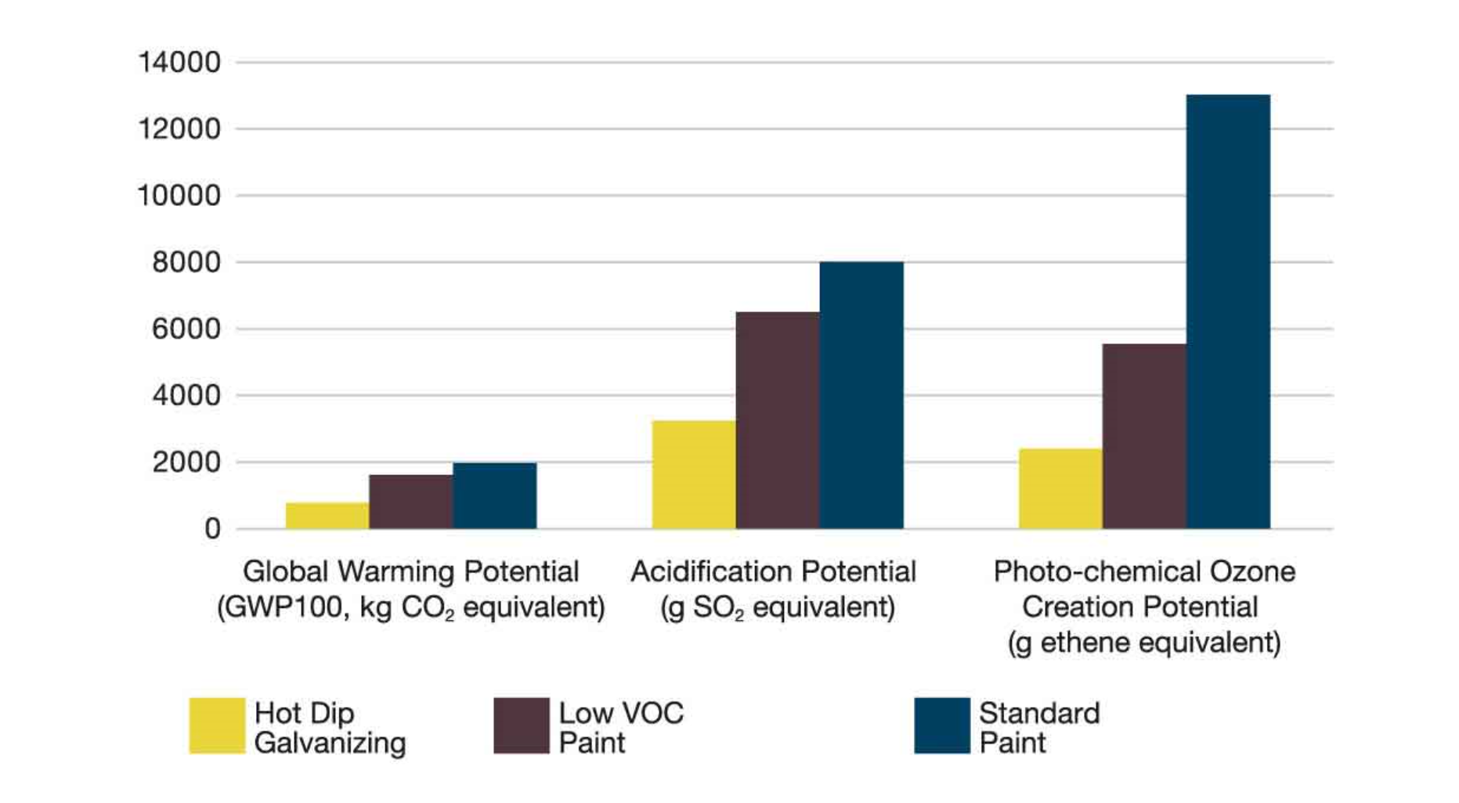
Figure 5: GW, AP, PCOP for Hot-dip galvanizing compared to paint (Cook et al, 2004)

Not only are zinc coatings an environmentally sustainable choice for corrosion protection of steel structures, they are also cost effective (Rahrig 2004). In a life cycle cost analysis between galvanized steel and painted steel for a 250 ton steel structure with a projected 30 year life, the initial cost for galvanizing of $110,000 was less than half the initial cost for painting of $260,625, for a three-coat paint system, consisting of an inorganic zinc rich primer, an epoxy primer and a polyurethane top coat (Helsel et al. 2014). In fact, no maintenance was required on the galvanized steel structure over the 30-year life, while maintenance repainting brought the total life cycle cost to $597,500 for the painted structure. The results are summarized in Table 3.

Table 3. Initial and Life Cycle Cost Analysis
Coating System | Initial Cost | Life Cycle Cost  (30 years)
Galvanized Steel | $110,000 | $110,000
IOZ / Epoxy / Polyurethane | $260,625 | $597,500

In a detailed life cycle cost analysis comparing the performance of a 116 ton hot dip galvanized steel bridge to a 105 ton painted steel bridge in an industrial, or coastal marine environment, the hot dip galvanized steel bridge life cycle cost was approximately 30% more than the original cost of the bridge (Rossi et al. 2017). The life of the galvanized bridge was 80 years and included one maintenance repair. In contrast, the painted steel bridge, with a minimum three coat paint system, required six maintenance repairs ranging from touch-up painting to complete repainting, and had a life cycle cost almost three times the initial cost of the painted bridge, while achieving only a 75 year life.

5. CONCLUSIONS

Zinc provides the most effective corrosion protection for steel by acting first as a barrier coating, keeping corrosive elements away from the steel, and secondly as a sacrificial anode. In life cycle comparisons with paint, the durability of metallic zinc coatings eliminates the repeat burdens of maintenance painting, significantly reducing the total life cycle cost of a project. Furthermore, zinc coatings have significantly lower environmental impact in terms of embodied energy, global warming potential, acidification potential, and photo-chemical ozone creation potential. Zinc coatings can be applied either by hot dip galvanizing or by thermal spraying.

References

AGA 2016. Environmental Product Declaration, Hot-Dip Galvanized Steel
https://www.galvanizeit.org/uploads/default/101.1_AGA_EPD_Hot_Dipped_Galvanized_Steel_20160922.pdf

Bablik H. 1950. Galvanizing (Hot Dip), E. & F. N. Spon Ltd, London

Cook, M., Vares, S. and Young, S. 2004. Life cycle assessment: Paint and hot-dip galvanizing compared, Hot dip galvanizing magazine, 4(4) 14-15

EGGA 2016. Environmental Product Declaration, Hot-Dip Galvanized Steel
http://www.egga.com/wp-content/uploads/2017/11/EGGA_EPD_v1.1-8-8-17.pdf

Helsel, J.L., Lanterman, R. and Wissmar, K. 2014. Expected Service Life and Cost Considerations for Maintenance and New Construction Protective Coatings Work, NACE paper C2014-4088
NACE Corrosion 2008 Confer
Van Genderen E, Wildnauer M, Santero N, Sidi N. 2016. A global life cycle assessment for primary zinc production. Int J Life Cycle Assess 21:1580–1593

Koch, G.H., Brongers, M.P.H., Thompson, N.G., Virmani, Y.P. and Payer J.H. 2001. Corrosion costs and preventive strategies in the United States, Report FHWA-RD-01-156

Porter, F.C. 1994. Corrosion resistance of zinc and zinc alloys, Marcel Dekker, New York, NY

Prenger, F. 2012. Thermal spraying of zinc and zinc-aluminum alloys for corrosion protection, International Thermal Spray Conference, May 21-24, Houston, TX

Prenger, F. 2014. Thermal spraying with zinc and zinc alloys for offshore wind energy plants, Proc. Windforce 2014, Bremen, Germany, June 17-19, Windenergie Agentur, Bremerhaven
Rahrig, P.G. 2004. Analyzing true costs of galvanizing steel, Plant Engineering 10 (54-58)

Rossi, B., Marquart, S. and Rossi, G. 2017. Comparative life cycle cost assessment of painted and hot-dip galvanized bridges, Journal of Environmental Management, Elsevier, 197 (41-49)

