|  |  |  |
| --- | --- | --- |
|  | **10th International Conference on Short and Medium Span Bridges**  **Quebec City, Quebec, Canada,**  **July 31 – August 3, 2018** |  |

Performance of the largest STEEL buried bridge UNDER EARTH LOADS-A Full-scale test

El-Sharnouby, M.M1,3; Newhook, J2; ElNaggar, H.2

1 Atlantic Industries Limited, Ayr, Ontario, Canada

2 Dalhousie University, Halifax, Nova Scotia, Canada

3 [melsharnouby@ail.ca](mailto:melsharnouby@ail.ca)

**ABSTRACT**

Flexible buried bridges have been an integral part of the Canadian infrastructure for decades. In 2017, the largest steel buried structure in the world was built for a transportation application in Europe. Utilizing the Ultra-Cor Corrugation, the structure had a span of 25.5 m and a rise of 9.0 m. A full-scale field test was conducted where the structure was instrumented with strain gauges and deflection prisms. Prior to construction, a full-scale field test of part of this structure was conducted in Dorchester, NB. The full-scale test results demonstrated that the performance of the structure during backfilling is satisfactorily albeit exceeding the deflection limits of the Canadian Highway Bridge Design Code (CHBDC,2014). The two identical tests demonstrate the inherit variability in calculated internal forces from measured strains, which can bear implications on the load and resistance factors calibration for buried bridges.

# INTRODUCTION

With the continuous increase in infrastructure needs and the existing constrained public budgets there is an increased emphasis on innovative solutions to build Canadian infrastructure. Flexible buried bridges have been an integral part of the Canadian infrastructure for decades. Flexible buried bridges, also known as buried structures, comprise of a corrugated metal structure surrounded by engineered backfill. Buried bridges are used for various applications including, transportation, mining, tunneling and forestry.

Over the last three decades, buried bridges have been increasingly used for large span applications, providing at times a more cost-effective alternative to conventional bridges (TRB Committees AFF70 and AFS 40 2013). Their maximum spans have increased from 8 m to more than 20. The increased demand on these large span structures demonstrates the need to better understand their performance under various loading conditions, and to develop appropriate design methodologies to be used in their design.

Depending on the corrugation profile, corrugated metal structures are classified as shallow, deep corrugated, or deeper corrugated. CAN/CSA S6-14 (2014) assigns additional design considerations to deep- corrugated profiles due to its higher flexural rigidity. The deepest corrugation profile was developed in 2011. The profile has a pitch of 500 mm and rise of 237 mm (Williams et al. 2011). It is classified under CAN/CSA-G401-14 (2014) as Type III deep corrugated structure plate and as ‘deeper corrugation’ under CAN/CSA-S6-14. The first structure built with this profile was in 2011 for a highway underpass in Eastern Canada with a 13.3 m span and a 5.3 m rise (Vallee et al. 2014 and Vallee 2015).

Current equations in CAN/CSA-S6-14 (2014) are based mostly on finite element analysis by Duncan (1978). There is a need to re-examine the suitability of these equations for deep and very deep corrugated profiles and long span structures. Choi et al. (2004) compared the code equations to predictions by finite element analysis for spans up to 20 m. They found that code equations are valid and a little conservative. Vallee (2015) instrumented the Type III corrugation structure with strain gauges and deflection prisms. Vallee (2015) found that the code simplified method can be very conservative for long span single radius arches and conservative for short span arches with relatively stiff plates.

In 2017, the largest flexible buried structure in the world was built for a transportation application in Europe. Utilizing the Type III Corrugation, the structure had a span of 25.5 m and a rise of 9.0 m.

The structure was instrumented with strain gauges and deflection prisms and readings were taken during backfilling. Prior to construction, A full-scale field test of part of this structure was conducted at Atlantic Industries Limited (AIL) facility in Dorchester to study its performance during construction. In this paper, internal forces and deflections of the structure during backfilling are presented. In addition, comparisons between field measurements for both tests on same structure is presented.

Load bias, defined as the ratio of predicted load to calculated load, is one of the variables utilised in calibration of load and resistance factors using reliability-based methods. The uncertainty in evaluating this term stems from the method used in determining the load, however, uncertainty of measured loads is seldom a consideration. This paper highlights the inherit uncertainty in measured internal forces and its implications on load and resistance factors calibration.

# structure details

## Structure Geometry

The 92 m structure is a custom dual radius arch with inside span of 25.5 m and rise of 8.99 m, as shown in Figure 1. The structure geometry was custom designed to fit the project clearance requirements. The structure was manufactured in Dorchester, NB. The test conducted in Dorchester is designated as Test I, and the test conducted at the project site is designated as Test II.

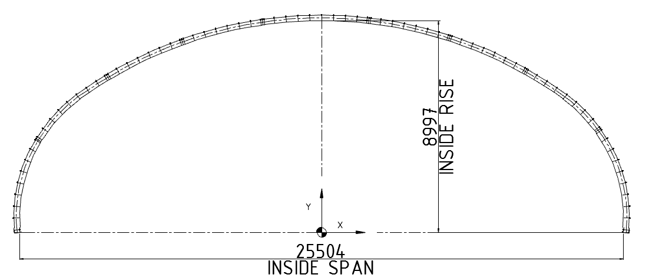

Figure 1: Structure geometry

## Structural Plate Corrugated Steel

The corrugation profile of this structure is known as ‘Ultra-Cor’ which is designated under CAN/CSA G401-14 (2014) as ‘Type III corrugation’ and under CAN/CSA S6-14 (2014) as ‘deeper corrugation.’ The corrugation profile is 500 mm x 237 mm, as can be seen in Figure 2. The straight portion is called tangent while the curved portions are called valley and crest. Thickness of the steel varies from 7 mm to 9.65 mm. The deeper corrugation offers more than three times the flexural rigidity compared to deep corrugation plates (380 mm x 140 mm) of the same thickness. The test structure cross sectional properties as per ASTM A796 (2015), and mechanical properties per the mill certification are shown in Table 1.

Table 1. Cross-section properties for the 500 x 237 mm profile (ASTM A796/A796M-15A 2015) and strength properties per mill certs

|  |  |  |  |  |  |
| --- | --- | --- | --- | --- | --- |
| Specified thickness, mm | Area, mm2/mm | Moment of inertia mm4/mm | Yield Stress (Fy), MPa | Ultimate Stress (Fu), MPa | Elongation |
| 9.65 | 14.509 | 97 031.45 | 478 | 583 | 29% |

# Field testing

## Instrumentation

The test structures were instrumented with uniaxial strain gauges placed at the valley and at or close to the crest as shown in Figure 2. For Test I, an additional gauge was placed on the tangent at Station 34R. Additionally, three strain rosettes were placed at station 34R at 150 mm from the uniaxial gauge. A total of ten sets of gauges were placed along the periphery as shown in Figure 3. Survey Prisms were affixed to the structure at 11 locations to measure vertical and horizontal deflection during construction, as shown in Figure 4. Test II structure was equipped with survey prisms are five locations along the structure, and one ring was instrumented with 17 sets of strain gauges along the periphery. The naming convention of the stations was the number of circumferential seems followed by “L” or “R” denoting left and right of the structure, respectively. Data was collected at fixed intervals during backfilling.

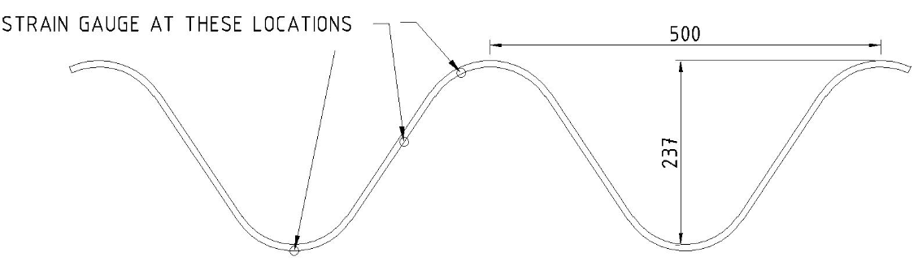

Figure 2: Corrugation profile of test structure

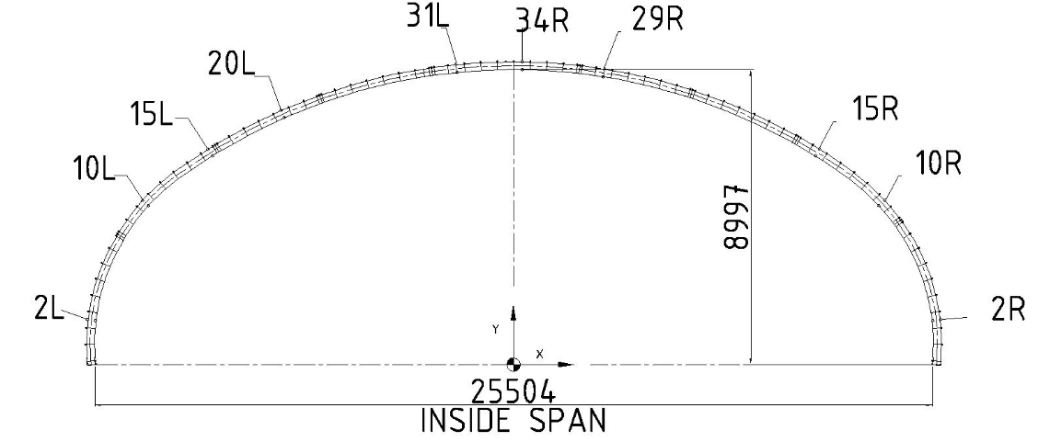

Figure 3: Strain gauges locations for Test I

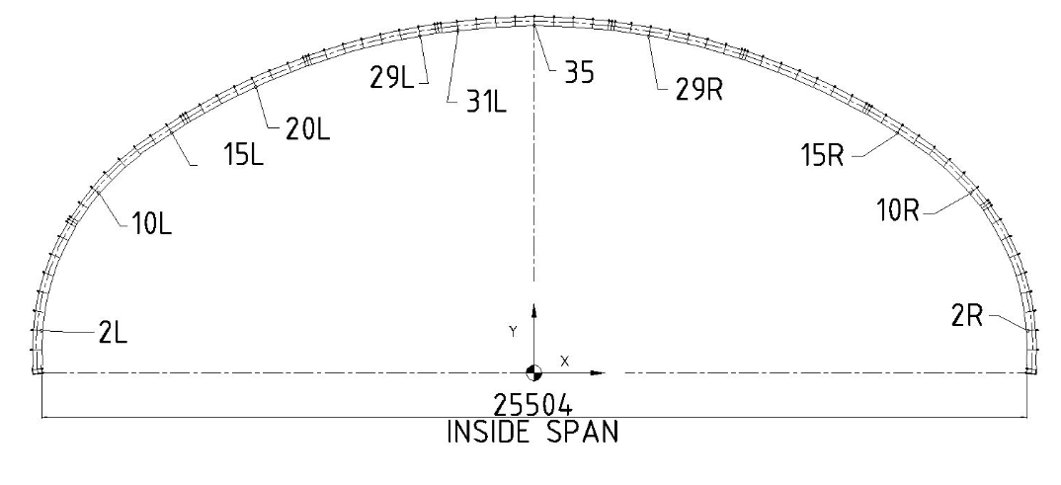

Figure 4: Survey Prisms locations for Test I

## Structural Assembly

The structure had 92 rings with each ring consisting of consists of plates bolted through overlap longitudinal seams. In the longitudinal direction, the rings are bolted together through bolted overlap joints located every 500 mm along the periphery. The structure was assembled as per industry standards. Odd rings were pre-assembled then lifted and secured into place; first ring can be seen in Figure 5a. Remaining plates were installed plate by plate by bolting the plates to the fully erected adjacent rings as can be seen in Figure 5b.

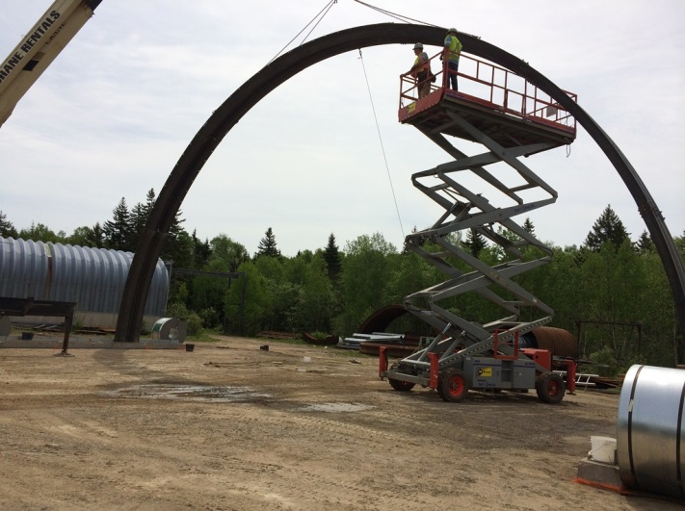

(a) Photo for first ring assembly and erection

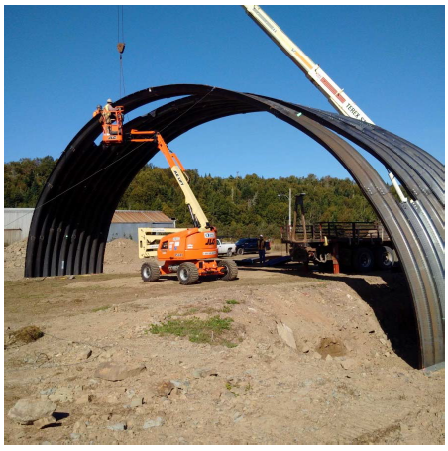

(b) Photo for test structure assembly near completion

Figure 5: Test I structure assembly

## Backfill

The backfill material for the Test I structure was pit run well graded gravel with sand (GW) per the Unified Soil Classification System (ASTM 2487-11 2015). It had a uniformity coefficient, Cu = 48.8 and coefficient of gradation, Cc = 2.05. The maximum modified proctor dry unit weight per ASTM D1557 (2015) was 2250 kg/m3 at optimum moisture content of 5.0%. Backfill was placed and compacted with a maximum lift thickness of 200 mm. The achieved compaction on-site with a vibratory plate ranged between 88% and 95% modified proctor density. The backfill material for Test II structure had Cu = 13, Cc = 2.0. Maximum dry unit weight = 2043 kg/m3, and optimum moisture content = 7.8%. The achieved compaction on-site with a vibratory plate ranged between 98% and 100% standard proctor density

# Results

## Structure Deflections

Deformation monitoring during construction is a regular practice in buried soil-metal structures. It serves an indication of structure performance. CAN/CSA S6-14 (2014) states that, upward deflection should not exceed 2% of the rise. According to the relevant code commentary (CAN/CSA S6.1-14 2014), this limit is based on empirical consideration rather than analysis. CAN/CSA S6-14 (2014) does not impose limits on lateral movements of these structures.

Figures 6 shows the measured vertical deflections during construction. As can be seen in Figure 6, measured upward movement in the crown area for Test I and Test II is 0.21 m. The maximum upward movement is 2.5% of the rise. As will be shown in the next section, the structure combined stresses were less than 160 MPa or 34% of the actual yield stress. The test results show for such very long span structures the upward deflection can exceed the code limit while still performing satisfactorily.

The above observations indicate that the structure limitations on maximum upward deflection may need to be revised, especially for Type III corrugation structures. Numerical analysis may be required to permit a higher deflection limit and should be on a project to project basis.

Figure 6: Measured vertical deflection during test

## Internal Forces

The strain gauge data collected was processed to obtain axial forces and bending moments. These internal forces are due to vertical and lateral earth pressure during placement and compaction of backfill. The observed crown bending moment for Test I and II is shown in Figure 8. As can be seen, the observed bending moment was negligible up to a backfill height of approximately 2 m. This was followed by a steady increase in bending moment. As the backfill height approached the crown elevation, the rate of bending moment increase was decreasing indicating the structure started to reverse back due to the dead load of the backfill. The highest bending moments were 165 kN.m/m and 129 kN.m/m for Test I and Test II. CAN/CSA S6-14 provides estimation of bending moment, M due to dead load and live load as,

[1] M = │M1 - MB│ + ML (or MC depending on the loading case)

Where M1 is the moment due to backfill up to the crown, Mb is the moment due to backfill from the crown to the road elevation, and ML (or C) is the moment due to live load. M1 for this structure, assuming backfill height is at the crown, is calculated as 265 kN.m/m. As can be seen, the observed bending moment, M1, is 47% to 60% compared to the value predict by CAN/CSA S6-14 Choi et al. (2004) compared code predictions to measured values from numerical analysis. The analysis included semi-circular and part-arch of shallow and deep corrugation structures, and up to 20 m span. They showed that the code equations are valid and a little conservative. As can be seen from the test results, the code equations are very conservative for evaluating the structure stresses during construction for backfill height up to the crown.

As shown in equation [1], the bending moment at end of construction due to dead load, │M1 - MB│, is the net bending moment from backfill up to the crown and backfill above the crown. Overestimating the bending moment due to peaking may result in conservative or unconservative final moment, depending on project parameters.

Figure 7: Observed bending moment at crown for Test I and II

Figure 7 shows that Test II results deviated from Test I for backfill heights higher than 7.0 m. The discrepancy between the two identical tests can be attributed to several test variables including, conversion from measured strains to bending and axial stresses. The conversion process requires knowledge of gauge locations, cross-section dimensions, and sectional properties. In Test I, the gauges were installed at the theoretical positions shown in Figure 2. Strain readings were linearly extrapolated to the crest of the corrugation. To investigate the sensitivity of bending moment to the theoretical gauge location, the assumed gauge location was varied by +/-40 mm, an arbitrary tolerance that is deemed possible in such applications, particularly in the absence of documented measurement for each gauge location. Figure 8 shows the variation of calculated bending moment with the assumed theoretical position of the upper gauge for Test I. The maximum bending moment for the gauge theoretical position is 165 kN.m/m. The range of calculated bending moment for +/-40 mm tolerance is 140 kN.m/m to 180 kN.m/m, respectively.

Figure 8: Variation of calculated bending moment with theoretical position of strain gauges for Test I at crown

Figure 9 shows the observed thrust for Test I and II at the crown and footing. Compressive forces are shown in negative values and tension forces in positive values. As can be seen, the thrust was negligible up to a backfill height of 6 m. The maximum calculated thrust from both tests was 1015 kN.m/m, yielding a maximum axial stress of 16 % of the yield stress. CAN/CSA S6-14 (2014) calculates the thrust for backfill height up to structure crown, Tc, as,

[2] Tc = 0.5 (1.0 – 0.095 Cs) Af1 W1

Where Cs is a stiffness factor, Af1 is an arching factor and W1 is weight of backfill up to crown. The code equations yields Tc = 521 kN/m which is a close match to observed value of 540 kN/m for Test I but approximately 100% higher for Test II. Similar to the bending moment, the sensitivity of the internal forces determination can be examined by applying +/-40 mm location tolerance on the upper gauge location. Figure 10 The calculated thrust is -540 kN/m for +40 mm deviation, and +369 kN/m (tension) for -40 mm deviation. As can be seen, the sensitivity of thrust calculations are considerably higher than that of bending moment, for the cases considered.

Figure 9: Variation of calculated bending moment with theoretical position of strain gauges for Test I

Figure 10: Variation of calculated thrust with theoretical position of strain gauges for Test I

# Conclusions

The largest flexible buried bridge was built in Europe in 2017. A portion of the structure was built and backfilled up to the crown in Dorchester, Canada. The structures were instrumented with strain gauges and deflection prisms. Strain gauge data is analyzed and converted to bending moment and thrust forces. Results are compared with CAN/CSA S6-14 simplified equations. The results show that the maximum bending moments due to peaking were at the crown and the haunch, with the crown displaying slightly higher values. The bending maximum bending moment was 63% of that predicted by CAN/CSA S6-14.

The thrust close to the arch tip was found to be in close match with CAN/CSA S6-14 predictions. The maximum vertical deflection during the test was 2.5% of the rise which exceed the limit of 2% defined by the code. It is recommended that the deflection limit in CAN/CSA S6-14 be updated for such structures to 2.5% of the rise, provided field measurements and/or finite element analysis are used. It is recommended that CAN/CSA S6-14 equations for bending moment prediction to be further invested for use in long span and dual radius structures. This initial project indicates that modifications are required. In the meantime, alternative methods such as finite element analysis may be viable.

This paper highlights the inherit uncertainty in measured internal forces and its implications on load and resistance factors calibration. Accurate measurement of gauge location and cross-section appears necessary to reduce the uncertainty in the calculated internal forces from measured strains. The effect of uncertainty in these measurements in load and resistance factors calibration should be considered.

**References**

ASTM A796/A796M-15A. 2015. Standard Practice of Structural Design of Corrugated Steel Pipe, Pipe-Arches and Arches for Storm and Sanitary Sewers and other Buried Application. *American society of testing and materials*. West Conshohocken, PA, USA.

ASTM D1557-12e1 2015. D1557-12e1 Standard Test Methods for Laboratory Compaction Characteristics of Soil Using Modified Effort. *American society of testing and materials*. West Conshohocken, PA, USA.

ASTM D2487-11. 2015. Standard Practice for Classification of Soil for Engineering Purposes (Unified Soil Classification System). *American society of testing and materials*. West Conshohocken, PA, USA.

CAN/CSA S6-14. 2014.Canadian Highway Bridge Design Code Canadian Standard Association. *Canadian Standard Association*. Mississauga, ON, Canada.

CAN/CSA-S6.1-14. 2014. Canadian Highway Bridge Design Code commentary Canadian Standard Association. *Canadian Standard Association*. Mississauga, ON, Canada.

CAN/CSA G401-14.2014.Corrugated steel pipe products Canadian Standard Association. *Canadian Standard Association*. Mississauga, ON, Canada.

Choi, D.-H, Kim, G.-N and Byrne, P. 2004. Evaluation of the Moment Equation in the 2000 Canadian Highway Bridge Design Code for Soil-Metal Arch Structures. *Canadian journal of civil engineering*. 31: 281-291.

Duncan, J. 1978. Soil Culvert Interaction Method for Design of Metal Culverts. Transportation research record 678. *Transportation research board*, *National research council.* Washington, DC, USA.

TRB AFF70 and AFS40. 2013. Advantages to Culvert Selection for River and Road Crossings. Transportation Research Board 92nd Annual Meeting. Washington, D.C.: Transportation Research Board.

Vallee, J.H.F 2015. Investigation of Increased Wall Stiffness on Load Effect Equations for Soil Metal Structures. Master of applied science these. Dalhousie University, NS, Canada.

Vallee, J., Newhook, J.P. and Ford, W. 2014. Construction and Monitoring of Soil-Steel Bridge with Deeper Corrugated Plates. Proceedings of 9th International Conference on Short and Medium Span Bridges Calgary, Alberta, Canada, July 15-18, 2014. Paper 466.

Williams, K., MacKinnon, S. and Newhook, J. 2012. New and Innovative Developments for Design and Installation of Deep Corrugated Flexible Steels Structures. *The 2nd European conference on buried flexible structures.* Poznan, Poland.