 | 10th International Conference on Short and Medium Span Bridges  Quebec City, Quebec, Canada,  July 31 – August 3, 2018 | 
A CASE FOR ADDING AN INSPECTION LEVEL RELATED TO SHM FOR BRIDGE EVALUATION BY CHBDC
Mufti, Aftab^{1,3}, Bakht, Baidar¹, Andy Horosko¹, and Ruth Eden²
¹ University of Manitoba, Canada
² Manitoba Infrastructure
³ muftia@cc.umanitoba.ca
Abstract: The Canadian Highway Bridge Design Code uses the concept of a target reliability index for evaluating the load carrying capacity of existing bridges. This index, which is based on risk to human life, is related to three aspects of uncertainties inherent in a bridge: those related to (a) element behaviour, (b) system behavior, and (c) inspection level. It is assumed that all bridge inspections are manual. Citing examples of tests on many instrumented bridges, the paper proposes another level of inspection, which is done with the help of electronic instruments and tests under controlled vehicle loads. The paper proposes simple additions to the clauses of the CHBDC, which can be used to determine the optimum load carrying capacities of existing bridges where structural health monitoring (SHM) information is available.

1 INTRODUCTION
The concept of a target reliability index is used in the evaluation of the load carrying capacity of existing bridges. It was introduced in the first edition of the CHBDC, CAN/CSA-S6-00 by the Technical Subcommittee of the section on Evaluation and Rehabilitation. The 9-member subcommittee was chaired by P.G. Buckland, a distinguished Canadian bridge engineer. According to the commentary to the CHBDC, S6.1-14, the philosophy behind the concept of a target reliability index is “to maintain a consistent level of risk to human life for each component of the bridge.” It is argued that the failure of bridge elements that receive regular inspection, show warning of failure, and can redistribute load to other elements are less likely to produce a loss of life than the failure of an element lacking one or all of these traits.
The target reliability index, β, for bridge evaluation was introduced by Allen (1992), and is related to uncertainties corresponding to four aspects of the evaluation of an existing bridge: (a) load distribution or force, analysis, (b) system behaviour, (c) element behaviour, and (d) inspection level.
In order of ascending confidence, the force analysis is graded as (a) the ‘simplified analysis’ specified in the CHBDC, (b) the ‘sophisticated analysis’ such as the finite element analysis, and (c) the analysis of statically determinate structures. It is implied that statically determinate structures, such as simple trusses, can be analysed very accurately.
The system behaviour of bridges, in ascending order of confidence, is graded as S1, S2 and S3. Structures with Category S1 are those, in which the failure of a single element leads to the collapse of a bridge; single load-path structures such as pony truss bridges fall into this category. Structures with Category S2 are those in which the failure of a component does not lead to the total collapse of the structure, such as multi-girder bridges. Structures with Category S3 are those in which an element failure is only local, as in concrete deck slabs of girder bridges.
The element behaviour, in ascending order of confidence, is graded as E1, E2 and E3. Category E1 elements fail without warning, such as columns failing in buckling. Category E2 elements also fail suddenly, but retain post-failure capacity. Category E3 elements fail gradually giving plenty of warning.
The inspection levels, in ascending order of confidence, are INSP1, INSP2 and INSP 3, with INSP1 relating to components that are not inspectable, such as the internal webs of voided slabs. INSP2 relates to the inspection which is done to the satisfaction of the evaluator. INSP3 relates to the inspection of critical components carried out by the evaluator himself, or herself. The values of β relating to the three aspects of bridge behaviour are listed in Table 1 for normal traffic. These values were obtained partly by using the method proposed by Allen (1992), and partly by using engineering judgement. It can be seen that β is specified in intervals of 0.25. Table 1 also lists proposed values of β for another level of inspection, which is discussed later in the paper.
Table 1: values of  for normal traffic
System behaviour | Element behaviour | Inspection level
System behaviour | Element behaviour | INSP1 | INSP2 | INSP3 | INSP4
S1 | E1 | 4.00 | 3.75 | 3.75 | 3.50
S1 | E2 | 3.75 | 3.50 | 3.25 | 3.00
S1 | E3 | 3.50 | 3.25 | 3.00 | 2.75
S2 | E1 | 3.75 | 3.50 | 3.50 | 3.25
S2 | E2 | 3.50 | 3.25 | 3.00 | 2.75
S2 | E3 | 3.25 | 3.00 | 2.75 | 2.50
S3 | E1 | 3.50 | 3.25 | 3.25 | 3.00
S3 | E2 | 3.25 | 3.00 | 2.75 | 2.50
S3 | E3 | 3.00 | 2.75 | 2.50 | 2.25
Note: The value of β for new bridges is 3.50
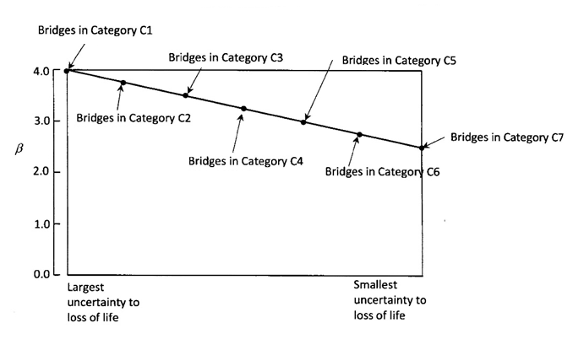

Figure: 1 Relationship between target reliability indices, bridge category and probability of loss of life
Table 2: Bridge Categories identifies C1 to C7
Category | System | Element | Inspection
C1 | S1 | E1 | 1
C2 | S1, S1, S1, S2 | E2, E1, E1, E1 | 1, 2, 3, 1
C3 | S1, S1, S2, S2,S2,S3 | E2, E3, E1, E1,E2,E1 | 2, 1, 2, 3,1,1
C4 | S1, S1, S2, S2, S3, S3,S3 | E2, E3, E2, E3, E1, E1,E2 | 3, 2, 2, 1, 2, 3,1
C5 | S1, S2, S2, S3, S3 | E3, E2, E3, E2, E3 | 3, 3, 2, 2, 1
C6 | S2, S3, S3 | E3, E2, E3 | 3, 3, 2
C7 | S3 | E3 | 3

The various levels of target reliable indices required by the CHBDC are plotted against the uncertainty to loss of life in Figure 1, in which it can be seen that the spectrum of uncertainty has at its most uncertain end structures with S1, E1 and INSP1 categories, and at its most certain end are structures with S3, E3 and INSP3 categories. For convenience, bridges with different system, element and inspection levels, but having the same value of β are grouped into Categories C1 to C7, as shown in Figure 1. The plotted line represents a consistent probability of loss of life.
It is argued in this paper that another level of inspection category, i.e. INSP4, be added to bridge evaluation that relates to inspection through structural health monitoring (SHM).

2 CHBDC PROVISIONS FOR BRIDGE EVALUATION
In the CHBDC, the live load capacity factor F for a component in an existing bridge for the ultimate limit state is calculated according to Eq. 1, in which force effects due to loads such as wind and temperature are not included.
F = {UφR - Σα_{D}D} / {α_{L}L (1+I)} [1]
In Eq. 1, U is the resistance adjustment factor being close to 1.00 for most components, φ is the resistance factor, R is the nominal resistance of the component, α_{D} is the dead load factor related to β, D is the load effect due to dead load, α_{L} is the live load factor related to β, L is the load effect due to live load, and I is the dynamic magnification factor. The CHBDC-specified dead and live load factors, as they relate to β, are reproduced graphically in Figure 2. Where, D1 is for factory produced component, D2 is for cast in place concrete and wood, and D3 is for the wearing surface It is noted that the dotted line portions of the α_{L} curves are not specified by the CHBDC.
It is important to note the difference between the safety index for new designs, and the target reliability index for evaluating the load carrying capacity of an existing bridge. If the former index is assigned a high value, the resulting bridge has a higher capacity for carrying loads than a bridge designed for a lower safety index. In contrast, if an existing bridge is found to have a high target reliability index, then the value of α_{L} is also high, as can be seen in Figure 2, with the result that F, given by Eq. 1, has a smaller value than that for a bridge with a smaller value of the target reliability index.

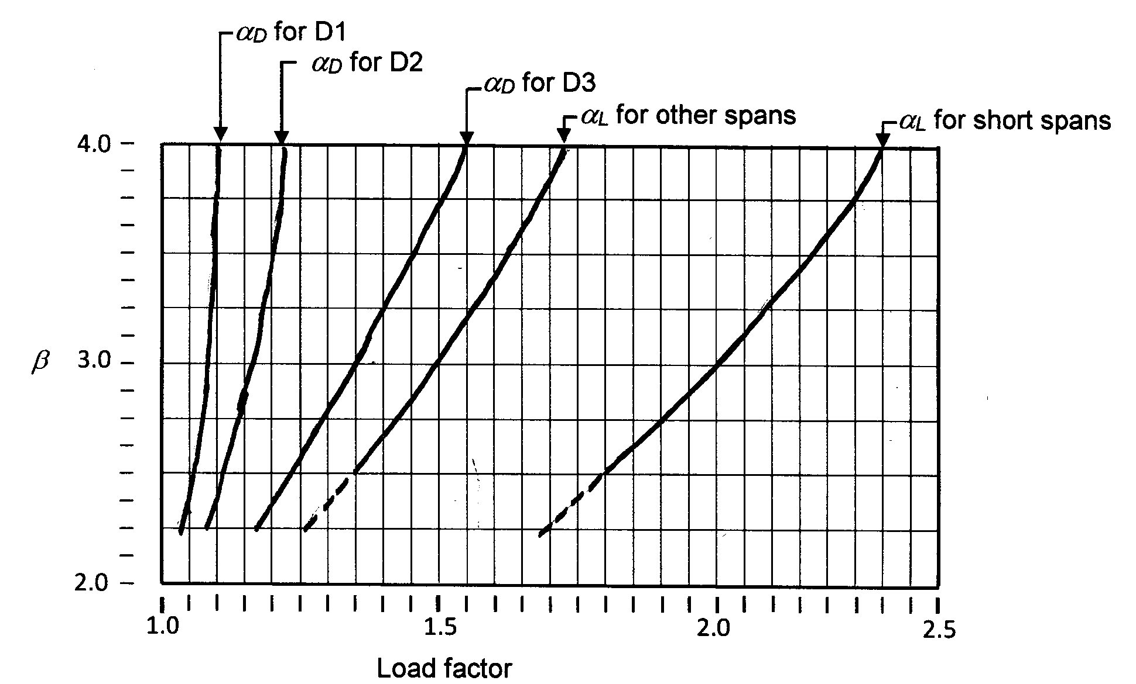
Figure 2: Dead and live load factors for evaluation of load carrying capacities of bridges
If F is equal to or greater than 1.0, the bridge can carry unrestricted traffic. However, if its value is less than 1.0, the bridge must be posted. The CHBDC provides a chart that relates F to the posting load factor, which has to be multiplied by W of the CL-W Truck to obtain the posting loads. Algohi et al. (2018) have determined that the design truck for the Canadian province of Manitoba is CL-555, for which the chart for the posting load is as shown in Figure 3. Charts such as those presented in Figure 3 are for triple load postings on bridges. If the posting is for a single weight limit, then it should correspond to the curve relating to single-unit vehicles.
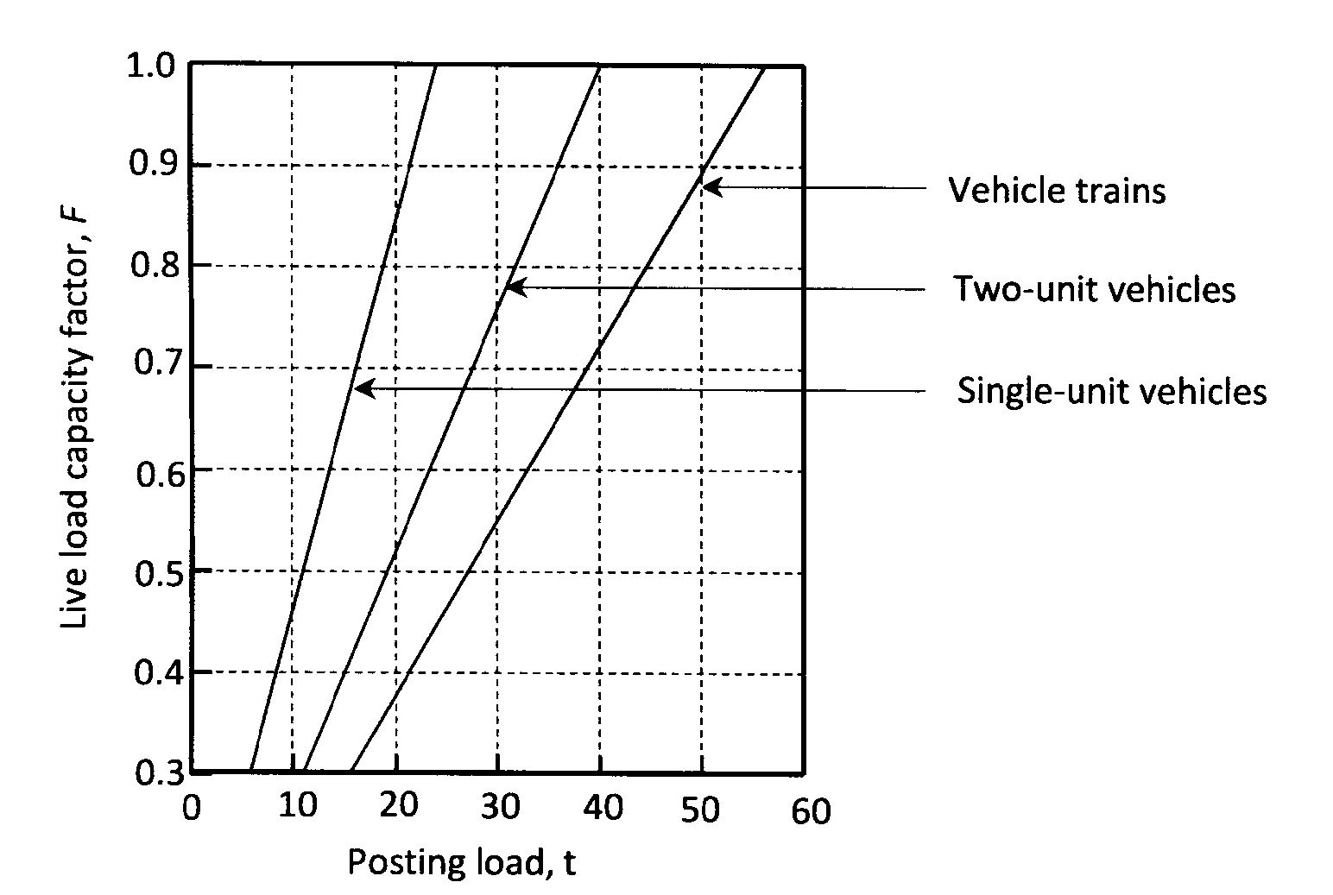
Figure 3: Posting loads for gross vehicle weights for Manitoba, Canada, plotted against F

3 CASE HISTORIES OF ONE HUNDRED AND ONE BRIDGES EVALUATED BY SHM
Bakht and Mufti (2017) have given summaries of evaluations of one hundred and one instrumented bridges conducted under controlled loads during the past four decades by them and their close colleagues. Of all the tests conducted with the help of electronic sensors, 3 were ultimate load tests, 16 were behaviour tests, and 82 were proof tests, in which the bridges were subjected to very heavy truck loads, so that their load-response behaviour up to the maximum loads remained elastic and linear. It was found that the posting of 62 of the structurally suspect 82 bridges tested for evaluation could either be removed or upgraded. The observation that about 75% of the bridges evaluated by SHM were found to have more load carrying capacity than could be identified by analytical evaluations conducted without the help of SHM is enough to make a strong case for adding another category of inspection, INSP4, to Table 1 of the CHBDC. However, for making an even stronger case, discussion is provided in the following for three categories of bridges. One category relates to ‘statically determinate’ steel through trusses, which are generally considered to be very easy to analyse, as discussed earlier. The second category relates to sawn timber stringer bridges, which are almost impossible to analyse, as discussed by Bakht (1983). The third category includes concrete rigid frame bridges, which are found to have huge reserve strengths, the source of which is yet to be rationalised.
3.1 Steel through truss bridges
It is generally assumed that ‘statically determinate’ steel trusses of through truss bridges are easy to analyse, and the failure of one of their chord members leads to the collapse of the whole truss, so that their system category is S1. Further, it is also assumed their compression chords fail in buckling so that their element behaviour falls in the E1 Category. Tests and critical observations have shown that the above assumptions are not always correct. Figure 4 (a) shows that the bottom chord of one of the statically determinate trusses of a steel through truss bridge is buckled, clearly showing that the bottom chord is not carrying any tensile force; this observation shows that (a) the usual analysis cannot always give reliable force effects in the bottom chords of the trusses, and (b) the truss under consideration cannot belong to the system category of S1.
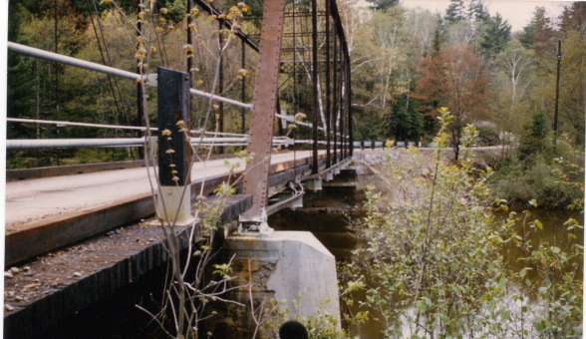
Note buckled bottom chord
- (b)
Figure 4: Chords of a steel through truss bridge: (a) buckled bottom chord, (b) inclined chord failing locally
Bakht and Csgoly (1979) have described an ultimate load test on a steel through truss bridge, in which one of the inclined chords failed locally while maintaining its post-failure capacity. The whole truss did not collapse due to the failure of one of its chords. A photograph of the failed chord is shown in Figure 4 (b). These observations confirm that the compressive chords of a steel truss do not always fall into the element category E1, and similarly a ‘statically determinate’ truss does not always belong to the system category S1.
Six steel through truss bridges with built up sections and without pin connections were evaluated through SHM by engineers of the Ministry of Transportation of Ontario (MTO). As shown in Table 2, before testing all these bridges were either posted or considered weak. In all cases except one, the posted restrictions on the bridges were either removed or upgraded, thus proving that SHM can identify reserve strengths in steel through truss bridges without pin connections. It is noted that steel through trusses with pin connections and having tension chords comprising two unconnected components may not have adequate reserve strengths because of a possible lack of fit at the pin connections (Bakht and Jaeger, 1987).

Table 3: Testing of steel through truss bridges without pin connections
Name of bridge | status before testing | status after testing
Trenton Canal Bridge | Posted for 6 t | Posting removed
Groundhog River Bridge | Not posted but considered weak | Sources of weakness identified, and bridge repaired
Princess Elizabeth Bridge | 16 t | Posted upgraded to triple posting of 20, 23 and 25 t
Glen Allan Bridge | 9 t | Posted upgraded to triple posting of 15, 22 and 28 t
Turner’s Bridge | 10 t | Posted upgraded to triple posting of 18, 30 and 32 t
Kamantistqua Bridge | Posted for a speed limit of 15 mph | Speed limit removed
A photograph of the Trenton Canal Bridge posted for 6 t and carrying a truck with a total weight of about 100 t is presented in Figure 5.
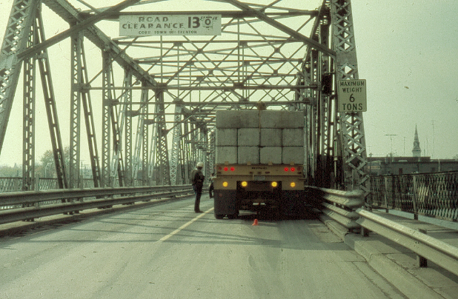
Figure 5: The Trenton Canal Bridge posted for 6 t and carrying a 100 t truck
Table 3 clearly shows that ‘inspection’ of steel through truss bridges without pin connections by SHM can provide much better information about their true state than by manual inspections, and thus reinforces the view that the additional category of INSP4 should be added to the evaluation section of the CHBDC.
3.2 Sawn timber stringer bridges
A photograph of a typical sawn timber bridge, taken from below the deck, is presented in Figure 6 (a). Because of large variations in the longitudinal moment of elasticity of wood E_{L}, it is almost impossible to determine actual values of dead and live load moments and shears in the stringers of sawn timber bridges. Bakht (1983) had analysed 60 of these bridges under a single truck by randomly selecting the values of E_{L} from a bank of data obtained for 70 Red Pine stringers; the results of his analysis presented in Figure 6 (b) show that the bending moments received by the stringers are random and cannot be predicted by deterministic analyses. It was found that the mean of the moments from the 60 analyses with randomly selected values of E_{L} was about the same as those obtained by assuming that all stringers had the same mean value of E_{L}. It was also found that the deflection patterns of the stringers are little affected by varions of E_{L}.
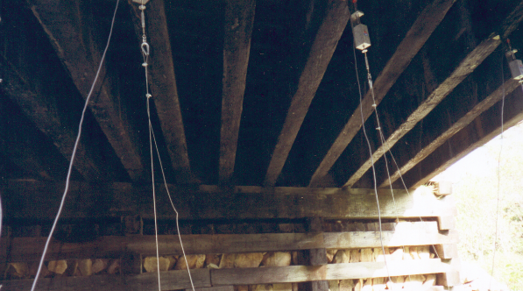
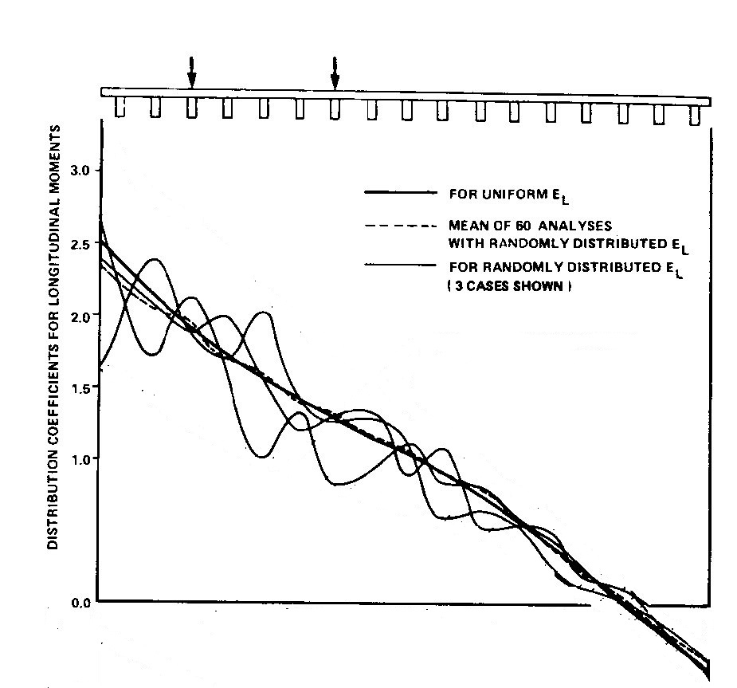

Figure 6: Sawn timber stringer bridge, (a) photograph, and (b) calculated distribution coefficients for longitudinal moments due to one truck
To account for the uncertainties in load sharing between wood components, the CHBDC has introduced a load sharing factor k_{n}, which is greater than 1.00 and which is multiplied to the specified bending or shear strength of timber beams and stringers, denoted as f_{bu} and f_{vu}, respectively. The load sharing factor depends upon the number of components n deforming nearly equally. For stringers of sawn timber stringer bridges, n is the number components within a width of 1.75 and 1.40 m for moments and shears, respectively. The values of k_{n} for all species of timber, which are based on the experimental work of Sexsmith et al. (1979) and the analytical interpretation of Bakht and Jaeger (1991), are reproduced in Table 3; these factors are applicable to both moments and shears.
Table 4: Load sharing factor for all species and grades of timber
n | 2 | 3 | 4 | 5 | 6 | 10 | 15 | 20
k_{n} | 1.10 | 1.20 | 1.25 | 1.25 | 1.30 | 1.35 | 1.40 | 1.40
Bakht and Mufti (1998) had manually evaluated six sawn timber stringer bridges in Nova Scotia, Canada. Three of these bridges were initially found to have F smaller than 1.0, so they were scheduled to be posted. Evaluation by SHM showed that the values of F for all six bridges were larger than those found by the initial manual evaluations.
Table 5: Values of F for six sawn timber bridges in Nova Scotia
Bridge name | F by initial evaluation | F by SHM evaluation (increase over initial evaluation) | F using SECAN
Sandy Gillis | 1.03 | 1.30 (26%) | 1.14
Captain Gillis | 1.31 | 1.57 (20%) | 1.48
Little River | 0.97 | 1.49 (54%) | 1.06
Margaree Harbour | 1.69 | 1.75 (4%) | 1.84
McLeod | 0.67 | 0.87 (30%) | 0.90
Grand Etang | 0.81 | 1.06 (31%) | 0.90
The main reason why these values could be upgraded was the number of stringers deforming nearly equally under the test loads. The values of F obtained by initial analytical evaluations are listed in Table 4 along with those obtained by evaluation by SHM. The table also lists the values of F obtained by rigorous analysis using the semi-continuum method, which is incorporated in program SECAN (Mufti et al. 2016). As noted in Table 4, the percentage increase in the values of F obtained through SHM over those obtained by analytical evaluations ranges between 4 and 54%. The main factor responsible for this increase is the number of stringers deflecting nearly equally under truck loads. It is obvious this information can only be obtained through SHM.
3.3 Concrete rigid frame bridges
Notwithstanding the considerable research that has already been conducted to understand the behaviour of various types of bridge structures, there is at least one type of bridge that has enormous reserve strength that cannot be identified analytically: the concrete slab rigid frame bridge, in which the abutments are made integral with the superstructure. One of these bridges, the Coniston Creek Bridge in a highly deteriorated state, was tested in 1975 by MTO. The bridge carrying a very high truck load can be seen in Figure 7 (a). Despite its apparent advanced state of deterioration, the bridge was found to have ample capacity to carry unrestricted traffic.
Unable to find the reason for the enormous reserve capacity in these bridges, the MTO decided to investigate their behaviour by instrumenting the steel reinforcing bars of the Mcintyre Bridge, and testing the bridge after construction. A photograph of the bridge is presented in Figure 7 (b). The bridge was tested and investigated by Kryzevicius (1984), a very experienced and competent bridge designer. He could not justify why the strains in the steel bars were so low. To date, the cause for low strains in the reinforcing bars, and the very high load carrying capacity of concrete slab rigid frame bridges, have not been established. A part of the reason for not investigating the behaviour of this kind of bridge could be that it is gone out of vogue, and is no longer constructed.
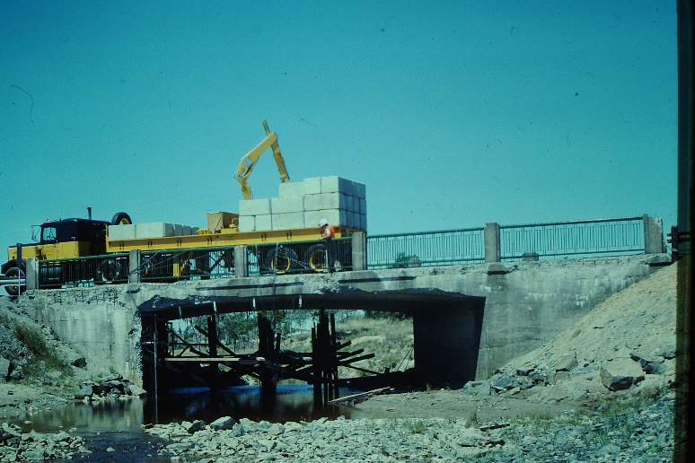
(a) (b)
Figure 7: Concrete rigid frame bridges, (a) a deteriorated bridge, and (b) a brand new bridge
Evaluation of concrete slab rigid frame bridges through SHM can indeed identify their reserve strengths, which cannot be rationalised by analytical evaluations alone.

4 PROPOSED EXTENSION TO CHBDC CRITERIA FOR EVALUATION
It is proposed that an additional level of inspection, INSP4, be added to the evaluation section of the CHBDC; the corresponding values of the target reliability index β, shown in Table 1, were obtained by using the same procedure and engineering judgment as that used for obtaining the values of β for other levels of inspection. Dead load factors α_{D} are not affected by the proposed addition, since the CHBDC already provides these factors for the additional values of β. However, the CHBDC does not provide values of live load factor α_{L} for β = 2.5. As can be seen in Figure 2, these two values of α_{L} are obtained by extrapolating the β-α_{L} curves (shown in dotted lines).

Figure 8: Revised relationship between target reliability indices, bridge category and probability of loss of life

Table 6: Bridge categories identifies C1 to C8
Category | System | Element | Inspection
C1 | S1 | E1 | 1
C2 | S1, S1, S1, S2 | E2, E1, E1, E1 | 1, 2, 3, 1
C3 | S1, S1, S1,S2, S2,S2,S3 | E2, E3, E1,E1, E1,E2,E1 | 2, 1, 4,2, 3,1,1
C4 | S1, S1, S2, S2, S2,S3, S3,S3,S3 | E2, E3, E2, E3,E1, E1, E1,E2 | 3, 2, 2, 1, 4,2, 3,1
C5 | S1, S1,S2, S2, S3, S3,S3 | E3,E2, E2, E3, E2, E3, E1 | 3, 4,3, 2, 2, 1, 4
C6 | S2, S3, S3 ,S1,S2 | E3, E2, E3,E3,E2 | 3, 3, 2,4,4
C7 | S3,S2,S3 | E3,E3,E2 | 3,4,4
C8 | S3 | E3 | 4

In light of the additional proposed level of inspection, the relationship between the target reliability index and probability of the loss of life, shown in Figure 1, is now as shown in Figure 8. It can be seen in this figure that the additional Category C8 has been added to the previous seven categories.

5 VERIFICATION OF THE TARGET RELIABILITY INDICES β FOR INSP4
Verification of the target reliability indices β for INSP4, listed in Table 1, is being conducted using heavy truck load data collected through BWIM systems on several bridges and through computer simulation programs to establish the normal distribution of loads; and the distribution of the ultimate strength of the bridges. From these two distributions, a Gumbel distribution to predict extreme values will be calculated to verify the INSP4 target reliability indices. At the completion of the study the results will be reported in a technical scholarly journal.

6 CONCLUSIONS
It has been described that the CHBDC uses the concept of target reliability index for evaluating the load carrying capacities of existing bridges. One of the factors that affects the target reliability index is the reliability of the level of inspection, which according to the CHBDC is always conducted manually. With the help of many practical examples, it is proposed that another level of inspection be added to the CHBDC clauses, in which a bridge is installed with electronic sensors, and is tested under controlled loads, i.e. through SHM. It is expected that the addition of this level of inspection will lead to an optimum utilization of the load carrying capacities of existing bridges.

References
Algohi, B., Khalid, H., Bakht, B., Mufti, A., and Regehr, J. 2018. Some observations on BWIM data collected in Manitoba. Paper submitted to 10th International Conference on Short and Medium Span Bridges, to be held in Quebec City, July 31-August 3.
Allen, D.E. 1992. Canadian highway bridge evaluation: reliability index. Canadian Journal of Civil Engineering, Vol. 19, pp. 967-991.
Bakht, B. 1982. Statistical analysis of timber bridges. ASCE Journal of Structural Engineering, Vol. 109, No. 8, pp. 1761-1779.
Bakht, B. and Csagoly, P.F. 1979. Bridge testing. Structures Research Report 79-SRR-10, Ministry of Transportation of Ontario, Downsview, Ontario.
Bakht, B. and Jaeger, L.G. 1987. Behaviour and evaluation of pin-connected steel truss bridges. Canadian Journal of Civil Engineering, Vol. 14, No. 3, pp. 327-335.
Bakht, B. and Jaeger, L.G. 1987. Load sharing factors in timber bridge design. Canadian Journal of Civil Engineering, Vol. 18, No. 2, pp. 312-319.
Bakht, B. and Mufti, A. 1998. Diagnostic testing of six sawn timber stringer bridges in Nova Scotia. Report submitted to Nova Scotia Transportation and Public Works.
Bakht, B. and Mufti, A. 2017. Evaluation of one hundred and one instrumented bridges. SIMTReC, University of Manitoba.
Canadian Highway Bridge Code CAN/CSA-S6-00. 2000. Canadian Standards Association, Mississauga, Ontario, Canada.
Canadian Highway Bridge Code CAN/CSA-S6-14. 2014. Canadian Standards Association, Mississauga, Ontario, Canada.
Commentary on CAN/CSA-S6-14, S6.1-14. 2014. Canadian Standards Association, Mississauga, Ontario, Canada.
Kryzevicius, S. 1984. Testing and evaluation of the Mcintyre River Bridge. Structures Research Report 84-SRR-07, Ministry of Transportation of Ontario, Downsview, Ontario.
Mufti, A., Bakht, B., Jaeger, L.G., Jalali, J., and Khalid, H. 2016. User manual for SECAN, SIMTReC, University of Manitoba, Canada.
Sexsmith, G.R., Boyle, P.D., Rovner, B, and Abbot, R.A. 1979. Load sharing in vertically laminated, post-tensioned bridge decking. Technical Report No. 6, Western Products Laboratory, Vancouver, B.C.

