 | 10th International Conference on Short and Medium Span Bridges  Quebec City, Quebec, Canada,  July 31 – August 3, 2018 | 

INTRINSIC CHARACTERISTICS OF COMPOSITE DOUBLE LAYER GRID BRIDGE SUPERSTRUCTURE
Maalek, Shahrokh¹, Maalek, Reza^{2,4} and Maalek, Bahareh³
¹ School of Civil Engineering, College of Engineering, University of Tehran, Iran
² Civil Engineering Department, Schulich School of Engineering, University of Calgary, Canada
³ Safira Spatial Structures Company Ltd., Iran
⁴ rmaalek@ucalgary.ca
Abstract: This paper examines the potentialities of skeletal space structures in a largely disregarded area of application. In this context, the feasibility of the use of composite double layer grids has been studied for short to medium span bridge structures. It has been demonstrated quantitatively that how a double layer grid system in composite action with a rather thin reinforced concrete two-way slab can make considerable difference and introduce several structural advantages over conventional systems, such as reduced seismic response, increased rigidity and less deck vibration, high redundancy, and so on. Well-proportioned space grid superstructures are less prone to progressive collapse and provide more reliability, reducing risk of sudden failure and increasing structural resilience. The load transfer efficiency of composite double layer grids in the transverse direction under passing truck loading has also been demonstrated through a series of dynamic analyses. Further improvements have been gained by optimizing the distance between the transverse grid lines. A discussion has also been given on the fatigue behavior, corrosion, durability and behavior in cold environments. Ease of inspection and maintenance and easy access for the installation of health monitoring devices are important advantages for taking timely preventive measures. Using a realistic economic model for life cycle costs, an analysis has revealed the profitability of the proposed system after a few years of production over conventional bridges. A value engineering workshop has proved remarkable advantages over the segmental box bridge in a case study. Reduced material consumption means much less damage to the environment. Bolted grid-works can be so designed to be dismountable for reuse or recycling. Focusing on safety, functionality, performance, durability, maintainability, aesthetical aspects, cost effectiveness, speed, ease and quality of construction, the proposed system may be employed to build essential sustainable infra-structures with a look to the future.
- INTRODUCTION
Skeletal space structures in the form of double layer flat grids, braced barrel vaults and braced domes have been used extensively to cover large spaces. Dating back to the reconstruction period after the Second World War, their main advantages were considered to be lesser material consumption, ease and speed of fabrication and erection, and economical mass production. Later, as demands were changing, new construction methods and materials emerged and new computational technologies and techniques were developed, attention was focused on innovative structural forms to create buildings with unique characters. In this work, potentialities of skeletal space structures have been examined in relation to a largely disregarded area of application, namely short to medium span bridge superstructures, where little or no attempts have been exercised by the engineering community to appreciate their advantages (Maalek et.al., 2014).
- DOUBLE LAYER GRIDS IN COMPOSITE ACTION WITH REINFORCED CONCRETE DECKING
  - Preliminary Studies
Beam and Slab Bridge Superstructures have been utilized widely in short span bridges with the use of prefabricated reinforced and/or pre-stressed concrete beams or steel plate girders in composite action with in-situ reinforced concrete topping. Now we demonstrate how a double layer grid system in composite action with a rather thin layer of reinforced concrete deck can make a remarkable difference. Figure 1a shows a sample single span Composite Double Layer Grid Superstructure (CDLGS). In this Section, a number of single span bridges of the Composite Plate Girder Superstructure (CPGS) type, designed as typical bridges (Rahimian et al., 1999) for construction across the country in Iran, have been used as our benchmark bridges for the purpose of comparison. Initially, two single span benchmark bridges consisting of two traffic lanes with identical deck width of 11.1 m, but different span lengths of 22.5 m and 30 m have been considered. The 22.5 m and 30 m benchmark bridges were respectively composed of 1560 mm and 2060 mm deep plate girder stringer beams, located at center to center distance of 1800 mm with 200 mm reinforced concrete slab topping. Adopting a normal design practice under AASHTO (1996), and also satisfying the requirements specified in the Iranian codes of practice (MPOrg 400, MPOrg 511, MPOrg 2000 and INBR, 2008), a square on square regular rectangular double layer grid consisting of 1760 mm typical regular pyramidal units was designed for the 22.5 m span bridge. For the 30 m span bridge, the module dimension was taken as 2380 mm. In this example, the module dimension refers to the longitudinal and transversal subdivisions as well as the center to center distance of the top and bottom layers. With the consideration of the two-way behavior and two-way arching action of the continuous slab deck resting on rather small modules, it was required to take a slab thickness just sufficient to satisfy the requirements set for punching shear. The steel material was considered to be of class ST-37 to INBR (2008), equivalent to ST-37 to DIN 1025-1994 and close to Grade 40A steel in BS 4360-1986 and ASTM A36 steel. Figure 1b shows a deformed shape of a CDLGS bridge model. In the analysis of the CDLGS, the joints were assumed to be infinitely rigid and member connections to joints were considered as ideally hinged. The results of this simple comparison may be surprising to many bridge engineers (Maalek et al., 2014; Ghadirli and Maalek, 2014). Consider the case of two stage analysis of the system consisting of: stage (i), when the double layer grid should bear its own weight plus the weight of fresh concrete and probable additional construction loads, followed by stage (ii), in which the composite system after the hardening of concrete should resist any additional dead weight of paving, piping, guard rails, etc. together with live loads on the bridge. Using the CDLGS system, the weight of steel reduced to about 43% of the benchmark bridge in the case of the 22.5 m span bridge and to 39% of the original in the case of the 30m span bridge. Also live load displacements was reduced by 20% for the 22.5 m and by 28% for the 30 m models reducing the chance of deck vibration usually observed in composite beam and slab bridges. It is quite an easy task to introduce an initial camber to the double layer grid in order to limit displacements even further. Optimizing the distance between the transverse grid lines will also lead to a more reduced weight (Maalek and Sadooghi Shabestari, 2007). Now that the proposed system allows the use of 120 to 150 mm thick reinforced concrete two-way deck slabs with two-way arching action in place of the one way 200 mm thick slabs used in the benchmark bridges, the reduction in concrete consumption of decking lies between 40% and 25%. Moreover, if the situation allows the construction of the CDLGS on an elevated ground at one side of the bridge site to be pushed to position with the use of a front runner truss, or where conditions permit the assembly and placement of concrete on the ground followed by lifting the CDLGS up in position by lifting equipment located on the piers and abutments, or when it is possible to support the space grid in final position temporarily during concreting by scaffolding until the concrete hardens, the weight of the space grid will be reduced further. In this case, the steel material consumption can be further reduced to about 33% and 27% of the original benchmark bridges for 22.5 m and 30 m long span bridges respectively. The total heights of the CDLGSes in the above examples were somewhat (10 to 25%) larger than the corresponding CPGSes. This was not only for the sake of increasing bending rigidity, but also to provide good spatial angles between space structural members for fabrication and erection reasons. An increased depth of the superstructure results in a reduction in the free height of the underpass traffic. A slight modification to the road way design may resolve the problem, where necessary. In another study, Heydari-Digehsara and Maalek (2014a) considered a 30 m long single span, two lane highway bridge. A comparison between the CPGS system and the alternative design, CDLGS, was carried out assuming the use of the same slab thickness of 200 mm. The overall height of the CPGS (including the plate girder and slab) and CDLGS was considered as 2200 mm and 3000 mm in the design respectively. In the case of the CPGS, the lateral distance between the stringer beams was considered to be 1800 mm. In the case of CDLGS (Figure 1c), the dimensions for a typical module were taken as 2200 mm (in the transverse direction) x 4400 mm (in the longitudinal direction) x 3000 mm (in height). The longitudinal subdivision dimension was hence twice as much as that of the transversal subdivision. This would result in a reduction of the steel consumption, but more complicated joints. A comparison of the material consumption indicated 60% reduction of steel in the CDLGS compared with the CPGS.
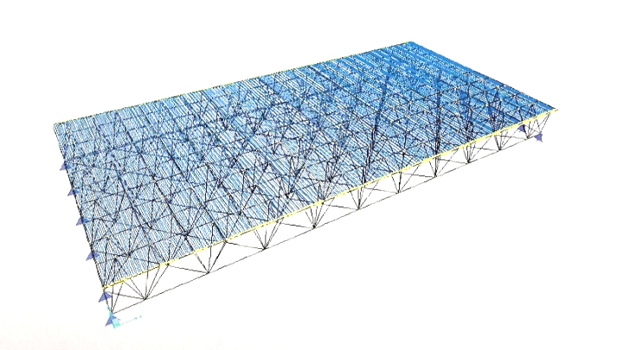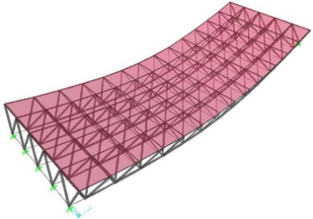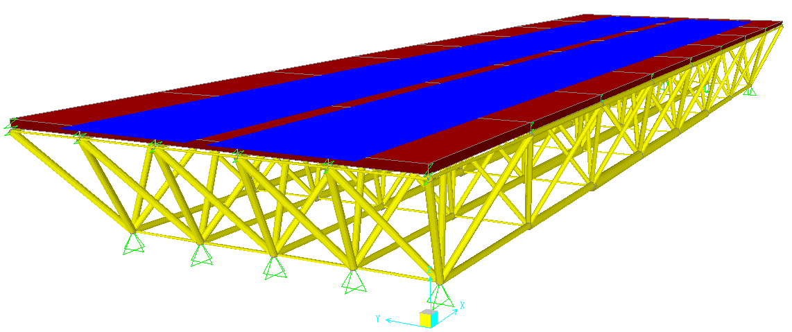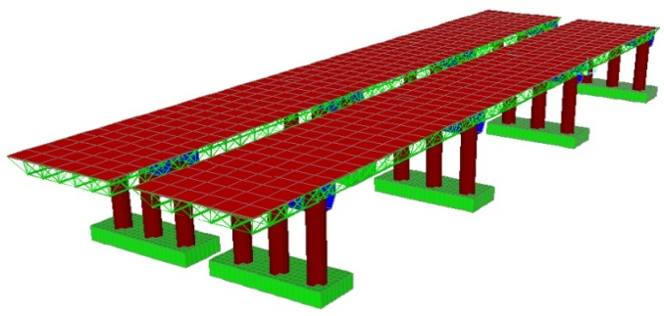
(a)
(b)
(c)
(d)
Figure 1: Samples of CDLGS: a) single span square on square; b) deformed shape of a single span; c) single span with rectangular modules; d) multi span supported by reinforced concrete bents
  - Continuous Superstructures on Reinforced Concrete Bents – Seismic Behavior
Assume that a CDLGS, as discussed above, is now employed as a deck system for a rather regular continuous multi-span bridge, supported by reinforced concrete bents, as shown in Figure 1d (Maalek et al., 2014). Here, the depth of the double layer grid system is taken as constant. Further assume that the superstructure is supported on elastomeric bearings allowing longitudinal movements, except at an abutment and/or selected piers, but constraining the lateral displacement of the deck to the supporting bents at the locations of supports. Now consider the component of ground motion in the transverse direction. For such regular bridges, it is customary in preliminary design to carry out a preliminary equivalent static analysis, according to AASHTO (1989) where for non-busy highway bridges, the earthquake forces are considered to be proportional to the dead weight of the bridge. The dead weight of such a CDLGS has been found to be about thirty to forty percent of the customary CPGS system consisting of composite plate girders for 20 to 40 m long spans. This would be even more pronounced in comparison with voided slab reinforced concrete superstructures. Accordingly, the equivalent static earthquake forces would be reduced substantially (Maalek et al., 2014). If we keep stiffness of the bents as it was in the customary bridge, due to lesser mass, the period of vibration will also be reduced. But, in actual practice, the designer proportions the stiffness of the bent accordingly. Hence, an increase in the related response coefficient due to a reduction in period is not expected to be as influential as the effect of considerable reduction of the dead load. With the consideration of the soil condition and the influence of soil-structure interaction, we still expect a considerably lesser equivalent static earthquake force in our preliminary design. During the current investigations, the authors have already found that the benefit will be enhanced in skewed bridges (Maalek et al., 2014). Further improvements will be gained by adopting variable depths along the double layer grid (Eskandar and Maalek, 2016). In the case of short bridges having a few short to medium length spans with closed abutments, depending on the total length to width ratio, usually the CDLGS system is stiff enough to act as an effective diaphragm in the plane of the deck without so much lateral displacement to cause unwanted longitudinal support actions. In such cases, it may not be needed to design the bents for lateral seismic actions. If the deck is designed to move freely with respect to its supporting bents, but kept restrained at both abutments against lateral movements, it will not be difficult to design the abutments and their supports to take the full lateral seismic forces with due consideration of the light weight of the superstructure. Concerns may arise in relation to their performance under the action of wind against uplift, overturning, etc.; hence, the authors are currently investigating the behavior of such bridges under extreme wind conditions.
  - Further Investigations
Further studies were carried out on single span, two span and three span bridges with identical widths of 12 m, but with different span lengths of 20, 26, 32 and 40 m. The two and three span continuous bridges had equal spans supported by reinforced concrete bents through appropriate elastomeric bearings. The concrete topping slab was considered as 200 mm, although as discussed, a lesser slab thickness could be used due to the two way action of the slab in the case of the CDLGS, resulting in a reduced dead load and a reduction of concrete consumption. Here, steel class ST-52 to INBR (2008) was assumed. Normal weight concrete with characteristic compressive strength of 300 N/mm² was assumed. Here lateral distance between the stringer beams was taken as 2 m in the case of CPGS bridges. In the case of CDLGS bridges, the transversal subdivisions were taken as 2 m and the longitudinal subdivisions equal to 2, 2.6, 3.2 and 4 m for 20, 26, 32 and 40m span bridges respectively. In the case of the CPGS, the heights of plate girders were taken as 1/20 of the span lengths. Three different ratios of the heights of superstructures to span lengths of 1/12.5, 1/15 and 1/17.5 were investigated for each span length (a total of 12 cases) for the CDLGS bridges. The longitudinal distance between the transverse vertical diaphragms for the CPGS was between 5 to 6 m. The design of the CDLGS bridges indicated that with the configurations adopted, only a reduction of less than 10% could be achieved in the weight of steel by an increase of about 40% of the CDLGS height (depth). This can be explained by the increase in the lengths of the web members for which a limitation had to be imposed for their slenderness ratios. The rigidity of a deeper CDLGS was obviously higher and the maximum live load displacements were in all cases well below the permissible live load displacements specified by the AASHTO LRFD (2012) specification. The results of this study can be summarized in terms of the reduction of steel material consumption by employing the CDLGS instead of the conventional CPGS, as follows (Heydari-Digehsara and Maalek, 2014b):
- In the case of single span bridges, the reduction in steel material consumption was calculated as 33% for the 20 m span bridge up to 43% for the 40 m span bridge with an almost linear variation in between, i.e. for the 26 m and 32 m spans.
- For two span bridges, this reduction was higher, ranging from 45% for 2x20 m span bridges to 52% for 2x40 m span bridges.
- For three span bridges, this reduction was even higher ranging from 47% for 3x20 m span bridges to 56% for 2x40 m span bridges.
It was observed that the weight of steel material per unit area of superstructure increases almost linearly in the range of span lengths under investigation for both systems; however, the rate of increase is rather small in the case of the CDLGS, but much higher in the case of the CPGS, so that the use of the latter system becomes inefficient for larger spans. In current steel bridge design practice, for longer spans, truss bridges replace the plate girder bridges. Further studies are under progress by the authors to carry out similar comparisons between the proposed CDLGS and truss bridges for span lengths ranging from 50 m to 100 m. Bearing in mind that here slab thickness for both systems was considered to be the same and equal to 200 mm, greater saving in steel and concrete material consumption can be made by utilizing the two way action of the slab and reducing the slab thickness in the case of the CDLGS. It can be seen that in the range of span lengths and number of spans investigated, as the span length increases, greater saving in steel consumption is achieved. Also, further savings in steel materials can be achieved in the continuous three span bridge compared with the two-span bridge. It is hence expected that the more the number of spans of a continuous CDLGS system, the greater will be the material savings compared with the corresponding CPGS bridges. The results are clearly dependent upon the manner in which design has been conducted and to the optimization restraints such as limitations in the member slenderness ratios, design requirements and available tubular sections. In relation to the space truss configuration, Maalek and Sadooghi Shabestari (2007) have proved that the rectangular on rectangular configuration is the appropriate configuration for straight bridges and presented formulae for finding the optimum dimension of the grid modules.
  - Load Transfer in the Traverse Direction
The present section is concerned with the load transfer efficiency of composite double layer grids under passing truck loading to AASHTO (2012) resulting from a series of static and dynamic vibration analyses. The widely used composite plate girder superstructure consisting of steel stringer beams and reinforced concrete slabs has been employed as a bench-mark for the purpose of comparison. Referring to Figure 2a and considering the positioning of the passing vehicle along the strip shown, a mid-span point lying under the longitudinal axis of the passing truck (referred to as point 1) and another point at the mid-span of the bridge near the unloaded edge of the superstructure (point 2) have been chosen to assess the load transfer capabilities of both systems in the transverse direction. The linear elastic dynamic analysis has been performed for an extreme vehicle velocity of 40 m/second (Heydari-Digehsara and Maalek, 2015; Heydari-Digehsara, 2015). For the composite steel-concrete constructions under investigation, a damping ratio of 0.04 has been used in the analysis. As far as the load transfer efficiency in the transverse direction is concerned, it can be seen clearly from Figures 2b and 2c that the CDLGS is far more superior to the common types of the CPGS with intermediate vertical diaphragms.
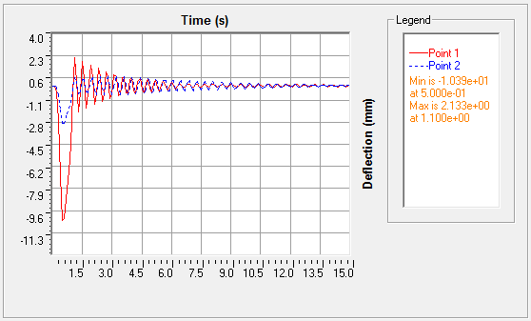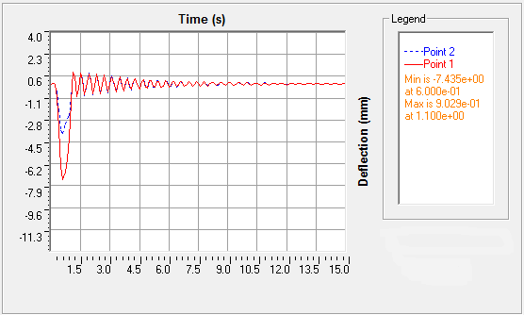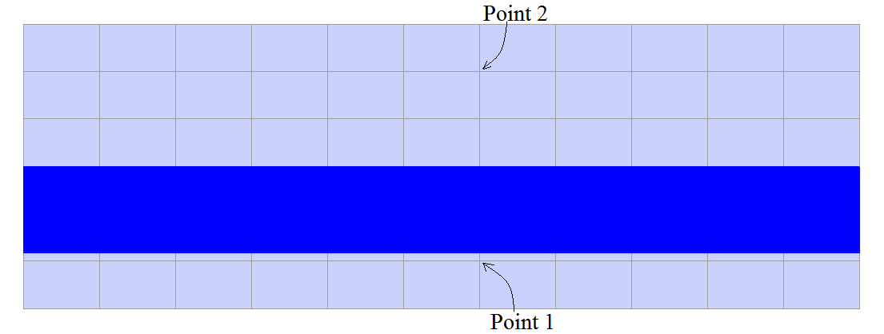
Point 2
Point 1
(a)
(b)
(c)
Figure 2: (a) The plan view of the 32m long single span bridge deck on which the vehicle passageway and points 1 and 2 are shown; (b) time history of the displacement response calculated at points 1 and 2 for the CPGS; (c) time history of the displacement response calculated at points 1 and 2 for the CDLGS
  - Effect of the Vertical Component of Earthquake Ground Motion
The influence of the vertical component of earthquake has been studied by Maalek and Mohyeddin Kermani (2002) for flat grids and by Maalek et al. (2014) for braced domes. Here, this effect has been investigated on both the CDLGS and CPGS systems by the push over as well as the nonlinear dynamic analyses. Single span and two span bridges with 20, 30 and 40 m span lengths have been modeled and analyzed. The superstructure width has been taken as 10 m in all cases. The span length to depth ratios have been taken as 16 for the CDLGS and 20 for the CPGS. Regular 2x2 m modules have been employed for the CDLGS. The side by side distance of the stringer beams in the CPGS has been taken as 2 m. Considering one way behavior and arching action in the CPGS bridges, the slab thickness is calculated as 180mm and taken as 200mm in the analysis model. Accounting for the two way behavior and two way arching action in the case of the CDLGS slab modules, the slab thickness for the latter system can be reduced to 120 mm controlled by punching shear. However, for practical and durability reasons it has been taken here as 150 mm. The distance between the transverse vertical diaphragms has been taken as 5 m in all cases for the CPGS. The steel class St-37 has been assumed.
    - Member Modelling
Each space grid member has been defined as a combination of a three node line element with the capability of geometric nonlinearity at the middle and two linearly elastic beam elements for each of which one end was defined as hinged (see Fig. 3a). The choice of such member modelling was made as a result of a study on the suitability of a number of models. A practical range of values of the slenderness ratios, l, were taken into account (i.e. 50, 80, 120 and 200). Joint flexibility can be incorporated when needed (Ahmadizadeh and Maalek, 2014). A member and its end connections can also be modeled as a substructure representing an assembly of a number of internal elements and end springs. A formex approach to substructuring has been presented by Maalek (1989 and 1993) which is suited to the analysis of modular structures such as the CDLGS under consideration (Maalek, 2002). The influence of the member initial imperfection was studied through the application of compressive loads on isolated models at different values of the initial eccentricity e₀ (Figures 3b and 3c). A bilinear material model was considered. A damping ratio of 0.04 was used for the composite steel-concrete constructions under investigation.
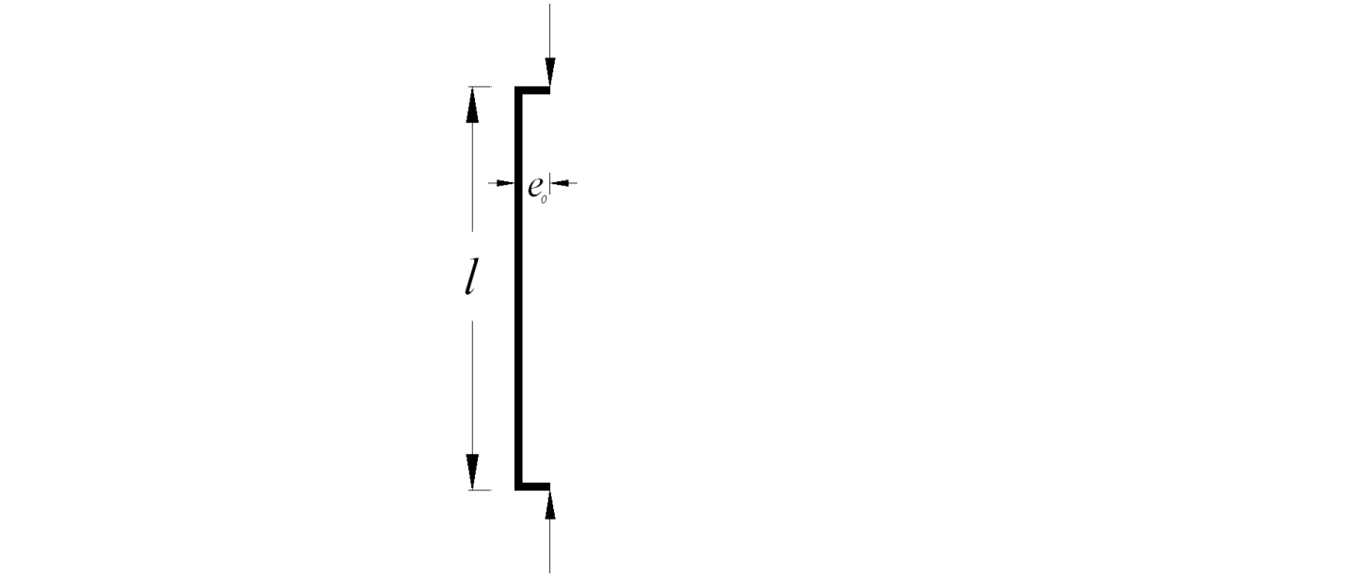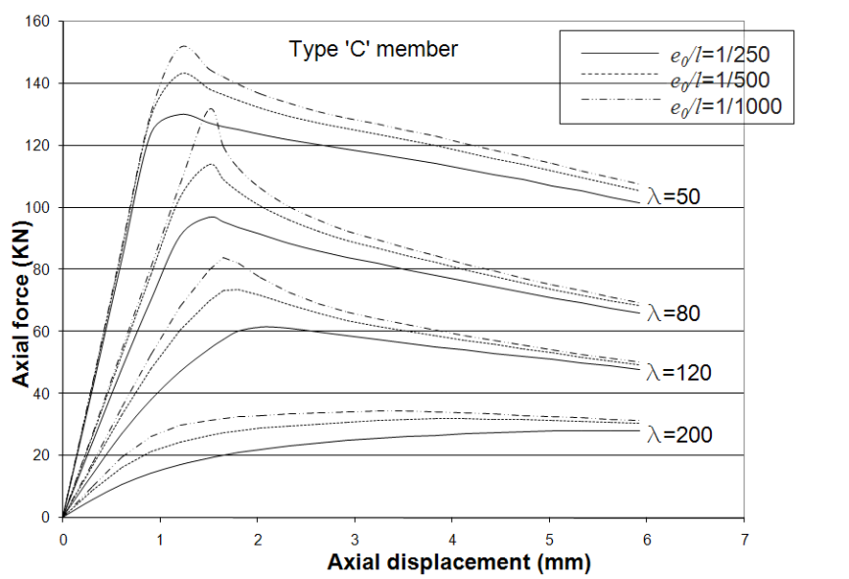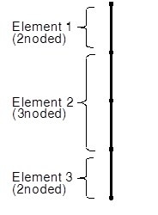
(a)
(b)
(c)
Figure 3: a) Space grid member modelling; b) eccentricity of loading applied to account for imperfection; c) axial force-displacement curves for different slenderness ratios and eccentricities
    - Numerical Analysis Approaches and Results: Nonlinear Static and Dynamic Analyses

In order to investigate the effects of the vertical component of ground motion on the CDLGS, a pushover analysis was initially carried out under displacement control preserving the mode shape pertaining to the fundamental (dominant) mode of vibration in the vertical direction for each sample bridge deck (Lotfi, 2016). Considering the nature of load reversal in actual earthquake excitations, two cases were considered: i) push from the top towards bottom, in which the incremental loading is in the same direction as the gravity loading that represents the deal loads (Figure 4a) and ii) push from the bottom towards the top in which the incremental loading opposes the gravity loading. Focusing on strength, stiffness and ductility, single span bridges behaved quite well. However, the two span bridges needed strengthening in members of the bottom layer in the vicinity of the middle piers in the case of pushing from the top towards the bottom. With imposing some more limitations on their slenderness ratios, good behavior was resulted. No problem was noticed at and near the middle support for the case when pushing would be applied from the bottom towards the top due to the presence of compressive concrete at the middle support after counteracting the gravity loading. The superstructure was capable of undergoing sufficient plastic deformation with the consideration of the composite action of the top layer of the space grid and the reinforcing steel present in the concrete slab even after concrete cracking, while the bottom layer could perform acceptably well by limiting the member slenderness ratios to achieve a controllable ductility. Figure 4b represents the results of the pushover analyses for two span superstructures with 20, 30 and 40 m span lengths in terms of the capacity (in excess of the dead loads) versus maximum vertical displacement near the midspan.

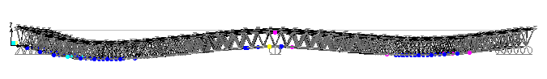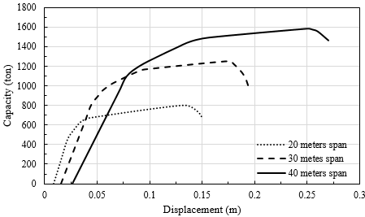
(a)
(b)
Figure 4: Pushover analysis of two span CDLGS: (a) push from top to bottom; (b) pushover curves
A series of the nonlinear time history analyses was carried out under the application of the vertical component of earthquake excitation for all the model bridges introduced above in this section (Lotfi, 2016). Identical excitation was assumed at all the supports. Sample results for 40 m long single span CPGS and CDLGS bridges are shown respectively in Figures 5a and 5b corresponding to the analysis under the Kobe earthquake with the peak acceleration in the vertical direction of 0.43g, where g is the gravitational acceleration. It can be seen from the figure that the maximum calculated displacement amplitude in the case of the two span CDLGS with 40 m long spans is about 55% of the corresponding value for the CPGS. Similarly, the maximum stress range of members of the CDLGS was found to be considerably smaller than the stress range at critical locations of the sample CPGS.
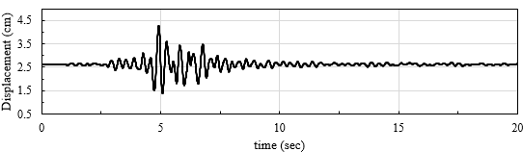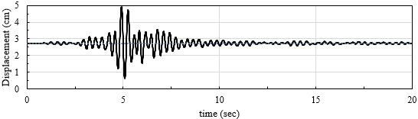
(a)
(b)
Figure 5: The nonlinear time history analysis results under the action of the vertical component of the Kobe ground motion in terms of the mid-span displacement: (a) CPGS; and (b) CDLGS
- TECHNICAL AND ECONOMICAL FEASIBILITY CONSIDERATIONS
A feasibility study was carried out in relation to the utilization of the CDLGS (Ghadirli and Maalek, 2014; Maalek, et al. 2014) by attempting to present a realistic business and production plan taking into account the long term highway and railway development plan of the region. The initial expenditure for the construction of a factory to produce the required space structural elements was estimated accounting for the duration and the coverage area of service. The production and maintenance costs were also estimated using an economical model to account for cost adjustment indices during the production period. The study included: i) an estimation of the production capacity and the useful life of the production plant, ii) a preliminary study of the production line, iii) an estimation of the required equipment and facilities, iv) an estimation of the required space (area), v) the planning of a realistic layout for the production plant with the possibility of future expansion, vi) prediction of a suitable organizational system, vii) an estimation of human resources, viii) an estimation of the input materials, ix) an estimation of the initial expenditure including the cost of real estate, x) an estimation of the life cycle costs considering the production, maintenance, wear of equipment and depreciation, overhead costs, deconstruction, etc., xi) an estimation of the man-hour productivity, xii) an estimation of the product value based on the current bill of quantity for spatial structures suggested for use in Iran (MPOrg 2009), and so on. Using an economical model in connection with the foreseeable inflation and the change in the value of money and the related aspects, the Net Present Value was found and the cash flow was calculated for the useful life of the production on a yearly basis. It was found that the payback period for the investment was only seven years, after which an acceptable profitability would be expected. It was also found that based on the assumptions made, the calculated Internal Rate of Return exceeded the usual Required Rate of Return in this country demonstrating the desirability of the proposed method of bridge construction. Regarding the reduction in material consumption and industrialized mass production, considerable savings could be made during the production period. The amount of saving could be used to expand infrastructure development programs. In connection with a twin Segmental Precast Post Tensioned Box Girder Superstructure (SPPTBGS) of a 5 km long bridge recently constructed in Tehran, a value engineering study was conducted with substantial positive results in favor of the CDLGS over the SPPTBGS (Maalek and Abbasabadi, 2016) from technical, economical and environmental viewpoints.
- REMARKS ON CONSTRUCTION METHODS AND MANAGEMENT
In the mass production of typical bridges, urgently needed in developing countries to expand their infrastructure, there will be a need for an initial expenditure for the construction of a manufacturing plant to serve a decided area for a decided number of years. Management decision making process should consider not only the initial cost, but also the costs of normal activities and maintenance of the plant as well as the life cycle costs of the fabricated and erected projects. The utilisation of the proposed system must be decided in a much wider area of strategic planning for the development and extension of regional infrastructures. Each factory can be planned to serve a region and can be programmed to produce continuously in 3 shifts. Under proper management, the initial expenditure per meter of the constructed deck falls sharply in a short period of time. Eskandar and Maalek (2016) have presented detailed step by step procedures for the design, fabrication, assembly and erection of CDLGS bridges. Different situations and topographic conditions have been considered for each of which the method of construction has been presented. The CDLGS can be erected with ordinarily available construction equipment due to its light weight. Where conditions permit the assembly and placement of concrete on the ground, the whole composite superstructure of a full span can be lifted up in position by lifting equipment located on the piers and abutments. Also, on waterways, multi-span bridges of this type can be built in composite form at shore and pushed to position using a space grid front runner truss. Reusable steel formworks have been designed for the top slab. Full design details have been provided. The possibility of applying the principles of industrial management, total quality management, operational research and facility management in a production line will be a significant advantage. Permanent work and job security for production workers as well as the inspection and maintenance teams are another aspect of such an approach. Continually well-trained technicians and engineers are the driving forces behind continuous improvements in the design and construction practice.
- SUSTAINABILITY AND RESILIENCE
The construction of bridges of the proposed type is in line with recent human awareness to enhance sustainability. In place of customary beam and slab bridges, the mass production of the CDLGS for many typical straight or skewed bridges all over the world reduces material consumption immensely. It is hence obvious that the environment will be less damaged by saving such a great amount of material consumption. At the same time, so much saving can be made by reducing the costs of energy (and the associated pollution) consumed for the production of the excess steel and concrete materials. Durability and maintainability are also other key advantages of the system. Local repairs, and overall rehabilitation and retrofit of such a system would be easy due to accessibility of the structural elements. Bolted grid-works can be so designed to be dismountable for further usage or neat recycling (Maalek, et al., 2014). The system is associated with reduced seismic demands and achievable high reliability in resisting progressive collapse. The authors would like to emphasize the importance of employing this system to save lives and resume operation and serviceability of bridges under severe earthquakes. In an investigation (Maalek et al., 2014), the seismic behavior of multi-span bridges composed of such superstructures resting via elastomeric bearings on piers and abutments were compared with the seismic response of very common types of bridges consisting of prestressed post tensioned segmental concrete boxed bridges. Assuming the same substructures, it was shown that the response of piers, abutments and foundations could be remarkably reduced and reliability against seismic damages could be considerably improved. In the case of the CDLGS, much smaller piers and foundations were needed
- CONCLUSIONS
A bridge deck system referred here to as Composite Double Layer Grid Superstructure (CDLGS) was introduced for use in short to medium span bridges. It was demonstrated clearly that the proposed system introduces many advantages over the common type of Composite Plate Girder Superstructure (CPGS) for such applications. Much less material consumption (both in steel and concrete materials) not only leads to cost saving, but also results in much less damage to the earth and environment, and significant reduction in the costs of energy (and the associated pollution) consumed for the production of excessive steel and concrete materials. It was also shown that the proposed system is superior in load transfer efficiency in the transverse direction. The light dead weight of the CDLGS encourages the possibility of longer spans. Considering its lightweight and high redundancy and hence more reliable behavior against progressive collapse, much safer overall bridge seismic behavior can be achieved. The nonlinear time history analysis results revealed reduced superstructure seismic response under the vertical component of earthquake excitation. For the purpose of mass production of this class of typical bridges, a realistic business and production plan was studied. It was found that the payback period for the investment was only a few years, after which an acceptable profitability would be expected. In connection with a recently constructed twin Segmental Precast Post Tensioned Box Girder Superstructure a value engineering study revealed promising positive results in favor of the CDLGS. A discussion was also given on the fabrication and construction methods for a variety of situations with the consideration of ease and speed of construction, ease of inspection and monitoring, maintainability and dismountability for reuse and/or recycling. The system is well suited to progressive management techniques. Considering only the material consumption, the amount and cost of materials that we are spending to build one of such customary bridges can be spent to build about three bridges of the proposed CDLGS system leading to enhanced economic and social development with the use of limited available resources. To conclude, the joy of experimentation of building creative free form spatial structures or innovative bridge forms exhibiting unique characters will continue to expand as a part of the historical challenge of human being to overcome nature’s obstacles and to symbolize the man’s capabilities at a particular place and at a particular time. These are certainly valuable advancements to be encouraged. However, no contradiction exists between these efforts and that introduced here. Wishing to see more from the engineering community in making the most of limited available resources, the authors are hoping that they have given their message here and have been able to demonstrate that modular skeletal space structures have yet many usage and advantages to offer in order to meet the needs of contemporary societies combining technical, economical and environmental aspects to build sustainable and resilient bridges in essential infrastructure development programs. However, the use of the proposed system must be decided in a much wider area of strategic planning for the development and extension of regional infrastructures.

References
Ahmadizadeh, M. and Maalek, S. 2014. An Investigation of the Effects of Socket Joint Flexibility
in Space Structures. Journal of Constructional Steel Research, 102 (2014) 72–81.
American Association of State Highway and Transportation Officials. 1989 and 1996. Standard
Specifications for Highway Bridges, AASHTO, Washington, D.C., USA.
American Association of State Highway and Transportation Officials. 2004 and 2012.
AASHTO Bridge Design Specifications, AASHTO, Washington, D.C., USA.
Iranian Bureau for Preparation and Promotion of National Building Regulations. 2008. Part 10:
Standard Specifications for the Design and Construction of Steel Buildings, INBR, Tehran, Iran.
Du Chateau, S. 1994. On the Unibat and SDC Space Structural Systems. Invited Lecture, Faculty
of Engineering, University of Tehran, Tehran, Iran.
Eskandar, H. and Maalek, S. 2016. A Technical and Economical Study on Composite Space Grid
Superstructures. 9th National Congress on Civil Engineering. Ferdowsi University, Iran.
Ghadirli, B. and Maalek, S. 2014. A Feasibility Study on the Application of Composite Space Grid
to Straight Bridges – a Technical and Economical Investigation. 4th National Conference on
Spatial Structures. University of Tehran, Iran.
Heydari-Digehsara, P. and Maalek, S. 2014a. An application of Composite Double Layer Grids to
Bridge Superstructures. 4th National Conference on Spatial Structures. University of Tehran, Iran.
Heydari-Digehsara, P. and Maalek, S. 2014b. Short to medium Span Bridges Composed of
Space Grids. 4th International Conference on Bridges. Amir-Kabir University of Tech., Iran.
Heydari-Digehsara, P. 2015. Application of Composite Double Layer Grid Superstructures to Short and Medium Span Bridges. MSc Dissertation, Supervised by S. Maalek, University of Tehran, Tehran, Iran.
Heydari-Digehsara, P. and Maalek, S. 2015. An Investigation of the Dynamic Vibration Behavior
of Composite Space Grid Superstructures, 6th International Conference on Structures and Earthquakes. Kerman Bahonar University, Iran.
Lotfi, M. 2016. An Analytical Study on the Behavior of Double Layer Composite Grids Including
Their Seismic Response for Application to Short to Medium Span Bridges. MSc Dissertation, Supervised by S. Maalek, University of Tehran, Iran.
Maalek, S. 1989. A Formex Formulation for Substructure Analysis of Open Web Grids.
International Journal of Space Structures, 4(1): 43-64.
Maalek, S. 1993. A Formex Approach to Substructuring. Fourth International Conference on
Space Structures, Thomas Telford, Guildford, Surrey, UK, 2: 1073-1084.
Maalek, S. 1999. Structural Assessment and Quality Control Procedures for the Homa Aircraft
Hangar No. 3. International Journal of Space Structures, 14(3): 167-184.
Maalek, S. 2002. The Analysis of Modular Structures. Fifth International Conference on
Space Structures, Thomas Telford, Guildford, Surrey, UK, 2: 1593-1604.
Maalek,S. and Mohyeddin Kermani, A. L. 2002. Three Component Versus Single Component
Excitation in the Study of the Behavior of a Triple Layer Grid. Fifth International
Conference on Space Structures, Thomas Telford, Guildford, Surrey, UK, 2: 1043-1051.
Maalek, S., Hajisoltani, A., Mohyeddin Kermani, A. L. and Maalek, R. Three Versus Single Component Seismic Excitation of Braced Domes. 4th Nat. Conf. on Spatial Structures. University of Tehran, Iran.
Maalek, S., Maalek, R. and Maalek, B. 2014. Largely Neglected Areas of Application of Skeletal
Space Structures. 4th National Conf. on Spatial Structures. University of Tehran, Iran.
Maalek, S., Sadooghi Shabestari, M. and Rahmati, A. 2007. Optimization of Bridge
Superstructures Composed of Double Layer Grids. 2nd National Conf. on Space Structures, University of Tehran, Iran.
Maalek, S. and Abbasabadi, F. 2016. Value Engineering in Bridge Projects. Submitted for publication.
Management and Planning Organization of Iran. 2009. Code of Practice for Skeletal Steel Space
Structures. Publication No. 400, By: S. Maalek and Colleagues, MPOrg, Tehran, Iran.
Management and Planning Organization of Iran. 2010. Guide Manual for the Seismic Vulnerability Assessment and Retrofit of Bridges. Publication No. 511, By: S. Maalek, MPOrg, Tehran, Iran.
Management and Planning Organization of Iran. 2000. Code of Practice for Loading on Highway
and Railway Bridges. Publication No. 139, MPOrg, Tehran, Iran.
Rahimian, M., Maalek, S., Eskandari Ghadi, M. and Bakhtiari, H. 2000. The Design and Detailing
of Typical Highway Bridges. Research Report, University of Tehran, Tehran, Iran.

