 | 10th International Conference on Short and Medium Span Bridges  Quebec City, Quebec, Canada,  July 31 – August 3, 2018 | 

COLLAPSE ANALYSIS AND RECONSTRUCTION PROCESS OF PRECAST BRIDGE IN SLOVAKIA
Moravčík, Martin¹, Bujňáková, Petra ^{2,3}
¹ University of Žilina, Slovakia
² University of Žilina, Slovakia
³ petra.bujnakova@fstav.uniza.sk
Abstract: In the 1950s, the first generation of precast prestressed girders has been developed and introduced in Czechoslovakia. Many road bridges with short and medium span range (9 - 35.0 m) were built by using first standard post-tensioned beams. Nowadays, many of these precast bridges are exhibiting signs of deterioration due to the construction errors, overloaded vehicles, environmental distress, inadequate maintenance and other. The prestressed bridge No. 59- 090 on the international route I/59 connecting Slovakia to Poland has been closed for the traffic at the end of 2015 following a routine inspection, where structural defects of brittle character were found on four girders of the bridge structure. This paper presents the cause of deterioration, the reconstruction process and some experimental data available from the in-situ load testing of the original bridge girder.
- Introduction
Post-tensioned precast bridge girders have been used in Czechoslovakia since 1950. Generally, the first precast girders were post-tensioned and additionally prestressed in the transverse direction to create orthotropic carrying systems without using monolithic member. The gap between diaphragms was filled by concrete mortar. These girders were cast in one piece for bridges with small length or for longer spans in three separated parts. Several bridges in the northern part of Slovakia were built using this technology. Nowadays, many of these bridges are in insufficient condition and require extensive rehabilitation after 60 years of their service. The insufficient grouting of ducts and corrosion of the anchorage zone of post-tensioning wires are among reasons for of the emergency condition of these bridges.

The heavy traffic had considerably increased in the last years due to the strategic location of the bridge. Following the decision to close the bridge a light temporary bridge was promptly assembled for public transport and personal vehicles. The light temporary steel bridge was placed on concrete panels fixed on original abutments and central pier. This structure was installed without any additional loading of the original damaged superstructure, see Figure 1. Heavy trucks have been redirected in other alternate routes through a mountain pass during the additional diagnostic survey of the substructure. Consequently in two months the heavy temporary railway bridge, type ŽM 60, was built near the damaged bridge for heavy transport too, Figure 9. All traffic had been controlled with one-way traffic light system during the rehabilitation process.
- Description of the bridge
The prestressed bridge no. 59- 090 is located near the village Podbiel, in north part of Slovakia, crossing the river Studený Potok and is one of the first generation of the prestressed road bridges built in 1956. The bridge consists of the two simple 26.65 m long spans. The total length of bridge is 63.90 m. The bridge width is 11.80 m. The superstructure consists of the 10 post-tensioned girders with spacing of 1.14 m. In addition, the girders are transversely connected with crossbeams in spacing of 5.24 m. The girders were transversely post-tensioned through the top flange with spacing of 0.80 m and trough the diaphragms. The construction depth of the girder is 1.35 m, top flange is 1.10 m and the bottom flange is 0.47 m wide. The girders were post-tensioned with the 22 tendons consist from 12 patent wire strands with diameter  P 4.5 mm. The layout scheme of the original bridge is shown in Figures 2, 3.
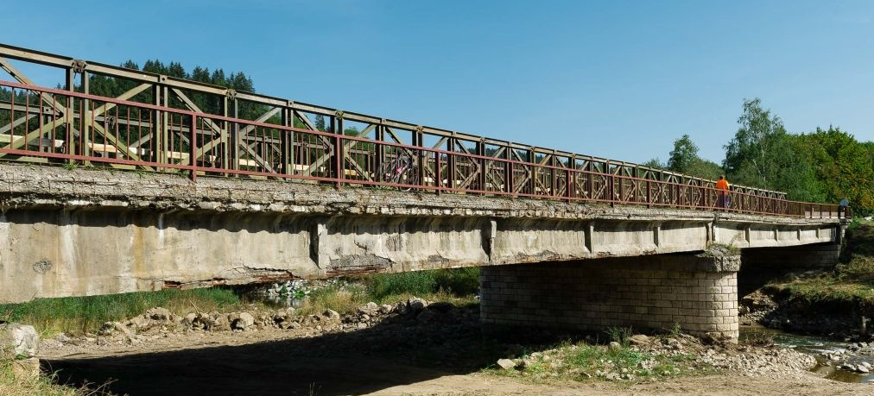
Figure 1: Light temporary bridge for standard traffic | Figure 2: Cross section of the original bridge

Figure 3: Longitudinal section of the original bridge

The superstructure was placed on steel bearings on abutments and steel fixed bearings on the central pier. The gravity abutments were made of plain concrete protected by the stone facing. The abutment length is 11.40 m, the height 4.80 m and the width of 1.65 m. The cross-section of pier has the rectangular shape. The length of pier is 13.40 m, the width is 1.80 m and the height of 3.65 m.
The shape of the pier is modified to triangular shape on the upstream side and to circular shape on the downstream side. This shape corresponds to flow direction. The pier was protected by stone facing too. The bridge foundation was installed on massive footing.
- The causes of bridge failures
A brittle failure has been observed at the right edge of the bridge in the second span. There was found out that 4 girders were totally broken. Critical crack in the middle section with several centimeters crack width has been discovered and was developing through almost entire cross-sectional height, see Figure 4. An excessive deformation of the right part of the bridge deck was visible and that effect was accompanied by the excessive oscillation of the structure as the heavy trucks passed through the bridge. The isolated wide crack in the middle cross-section has been identified as a textbook example of brittle bending failure of concrete member. No other traditional distributed bending cracks have been recorded. Overloading and gradually developing cracks in the centre of span on remaining 6 girders have been visually detected as well. These beams have been overloaded by the traffic and self-weight of the broken girders.
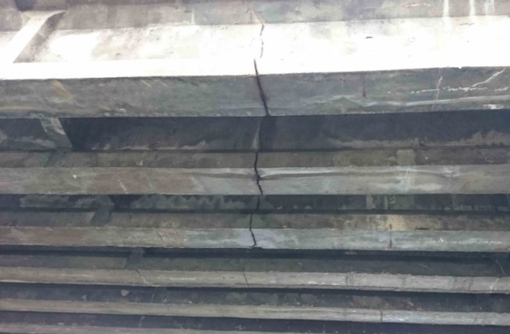 | 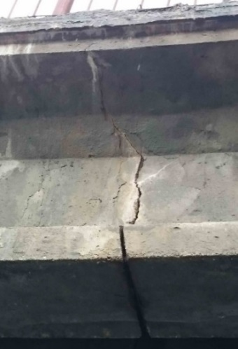
Figure 4a: Brittle failure on the 4 edge girders | Figure 4b: Detail of the primary crack

During the demolition work the main cause of the collapse has been detected step by step. Many of the prestressing wires with parabolic shape have been corroded in the middle of the span, as a consequence of water concentrating in post-tensioned ducts, see Figure 5a. Around 50% of anchors have not been protected against corrosion and were permanently under water. Next ones had very poor concrete cover (Figure 5 b). Around 90 % of the ducts were no grouted. There were the total number of 44 anchors, 16 anchors were anchored on the top flange of the girder under the levelling concrete layer of the pavement. That fact has greatly accelerated water flow to the middle cross-section and corrosive action in the ducts.

Beside loss of prestressing, the absence of the standard reinforcement was another factor leading to the brittle character of collapse. The amount of conventional reinforcement was around 85 % compare to the current European Standards requirements (STN EN 1992-1-1). The characteristic concrete strength was observed to be relatively good (49 to 52 MPa) and concrete was visually in good condition. That fact that the reasons for brittle failure are hidden inside of the beam and not visible prior to failure could be called a “time bomb”.

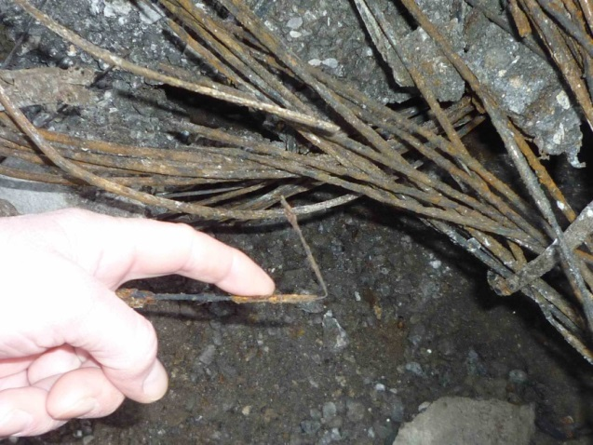 | 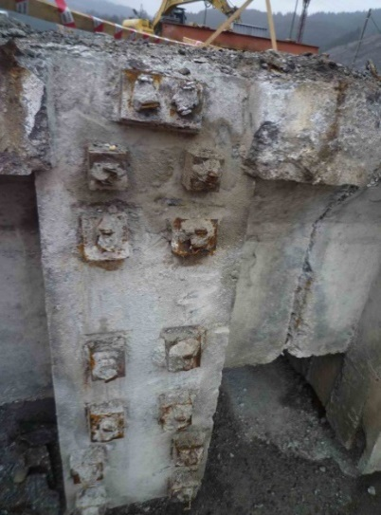
Figure 5a: Corroded wire pulled out from the duct with no grouting |  | Figure 5b: Anchorage zone

The transverse prestressing consisted of 11 wires φ P 4.5 mm and has been relatively functional and even partially grouted. That fact essentially ensured that no fatal event has occurred to that time on the bridge. This is evidenced because after transverse wires cutting all damaged girders felt down. They were not able to carry their self-weight.

During the demolition works on superstructure a static load test has been performed in situ on one girder in relatively good condition from the other which has been still acting on abutments. Three sensors (s1 - s3) fixed in the middle section were installed to measure deflection during the test. As a load member a hydraulic jack with 1000 kN capacity was used. An ultimate load 650 kN has been reached. But actual ultimate limit state occurred under load 605 kN. It represents a reduction of about 20% compared to the assumed load capacity (around the 750 kN), see Figure 6. The first crack was discovered on a load level about 400 kN. Calculated value has been on the level around 480 kN, so it represents reduction around 17 %. Figure 6 shows that the course of the theoretical and actual deflection begins to be different significantly after the first crack being formed. The reason of such load capacity and smaller ductility reduction has been about 30 % lower level of prestressing. It was derived by reverse iterative calculation based on the girder stiffness according Figure 6. Assumed prestressing reduction at the other girders in worse condition more than 50 % can be considered.

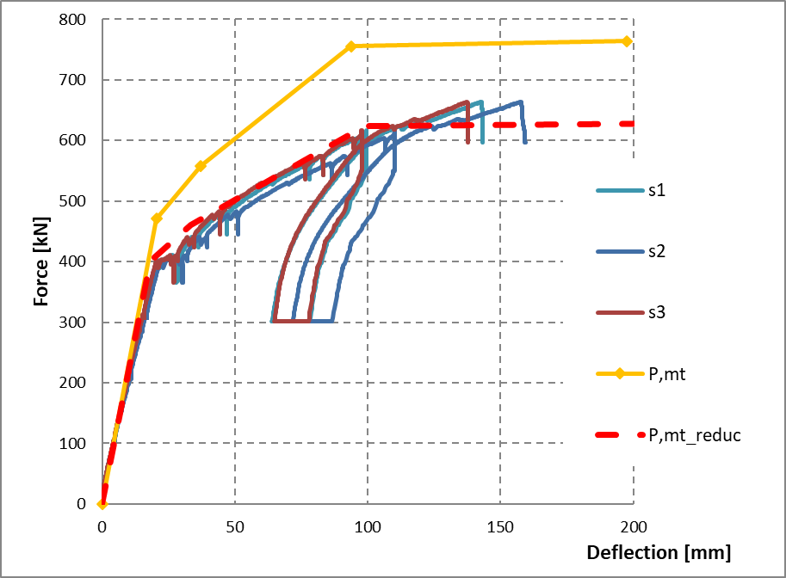
Figure 6: Load vs. deflection diagram

Besides the primary defects of superstructure other common failures in the supporting structure and bridge accessories were identified. They were mainly related the time of the bridge exploitation. The degradation of the concrete as well as the relatively large corrosion of the reinforcing concrete had been marked on head of both of abutments and the center pier. Expansion joints were damaged and it resulted in extensive corrosion of steel bridge bearings.
- Bridge rehabilitation process
The diagnostic survey and structural analysis of the both abutments and the central pier had proved their relatively good technical condition and the ability for later application. The substructure could be retained after the recommended rehabilitation. The superstructure was demolished due to the significant failure of the girders. The abutment caps as well as backwalls and pier cap had to be demolished and replaced with new ones, considering their bad conditions. The concrete class C 35/45 was used into these members. Footing of the pier was strengthened by reinforcing steel. The new footing extension was cast of the concrete class C 30/37. Micropiles were installed through the existing foundation to increase the capacity of existing massive footing and to enhance the stability of the pier, see Figure 7. The vertical and inclined micropiles were designed with 159 mm nominal diameter. Finally, prestressing bars of 32 mm diameter were horizontally installed through the new footing extension and the waist of the original pier. The new riprap stone was constructed against scour around the pier area.
Figure 7: Longitudinal section of the new bridge

Due to the extreme traffic situation in the region, the new superstructure had to be built in a very short time. Therefore, the same type of precast superstructure as the original one was designed, using the original substructure. The new bridge superstructure follows the same vertical layout and horizontal curve radius of the original road I/59. The bridge consists of two simple spans 26.38 m+ 26.38 m long with composite continuous bridge deck. The width of the new bridge structure is 11.98 m. The transverse slope of the bridge is one-sided 2.5 %. The investor's requirement was to extend the width of the roadway from the original dimension of 9.0 m to the standard one of 9.50 m. A one-side footpath is placed on the left side. The cross-section consists of the 9 standard precast pretensioned girders “DPS VP I/ 10”, 27 m long and 1.25 m high, Figure 9. The girder spacing is 1.29 m and designed concrete class of girders C 55/67. The thickness of concrete deck is min. 200 mm and concrete class C 35/45.
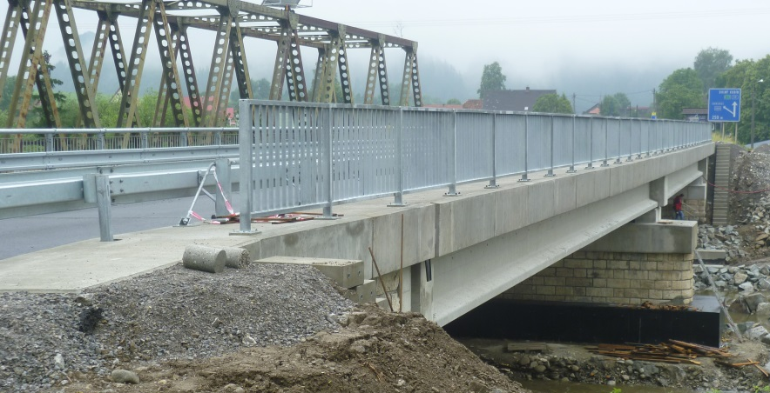
Figure 8: View on rehabilitated structure during finishing works | Figure 9: Cross section of the new superstructure

- Conclusions
As shown in above-mentioned emergency case, prestressed structures reaching only half of their service life might exhibit serious structural deficiencies, especially is their maintenance has been neglected. In particular the first-generation prestressed bridges, precast or monolithic, is beginning to exhibit increasingly frequent problems. The problems can be partly attributed to the limited level of knowledge and from technical possibilities at the time when these structures were designed and built. The case presented in the paper confirmed that on of main factors of superstructure failure is the corrosion of the prestressing wires and the anchors those were installed without grouting. In combination with the absence of conventional reinforcement the girders are actually acting as a plain concrete member with unbonded prestressing. In addition prestressing is losing its capacity due to corrosion. The accelerating element of corrosion process was often anchoring about 1/3 of the cables in the top flange of the girder and low or almost non protection of the anchors in the girders. Low level of maintenance quality in combination with heavy traffic on bridge has been affiliated to that effect too. The main disadvantage in diagnostic process is the question how to determine the actual level of prestressing. In practice only indirect diagnostic methods based on deformation or strain values observations are applicable.

Early and accurate diagnostic intervention using detailed diagnostics and structural analysis it is the most suitable approach how to prevent a similar emergency situation on the bridges. Especially on the prestressed bridges where some systematic deficiencies of the original technology are suspected. There is need even more thorough and more frequent inspection in the form of regular monitoring and possibly detailed diagnostics. The subsequent solution of the emergency situations with a sudden act of the traffic closing is often very complicated. It is problem from the social point of view and requires substantial financial costs for rapid rehabilitation.
Acknowledgements
This research work was supported by the Slovak Grant Agency under contract No. 1/0336/15 and 1/0343/18.

References
STN EN 1992-1-1. 2015. Eurocode 2: Design of Concrete Structures – Part 1-1: General Rules and Rules for Buildings. UNMS, Bratislava, SK
STN EN 1991-2. 2006. Eurocode 1: Actions on Structures. Part 2: Traffic Loads on Bridges. UNMS, Bratislava, SK
STN EN 1992-2. 2012. Eurocode 2: Design of Concrete Structures. Concrete Bridges. Design and Detailing Rules. UNMS, Bratislava, SK
STN EN 1990. 2009. Eurocode: Basis of Structural Design. UNMS, Bratislava, SK
Eder, R.W., Miller, R.A., Baseheart, T.M, Swanson J.A. 2005. Testing of Two 50-Years- Old Precast Post Tensioned Concrete Bridge Girders, PCI, May-June: 90 – 95.
Moravčík, M. 2015. Diagnostic Report - Prestressed Concrete Bridge no. 59-090, Podbiel, SK.
Moravčík, M. 2017. Design of Prestressed Structures According to the Eurocodes, Edis, Žilina, SK.
Taylor H.P.J, 1998. The Precast Concrete Bridge Beam: The First 50 years. The Structural Engineer, Volume 76/No 21, 407 – 414

