 | 10th International Conference on Short and Medium Span Bridges  Quebec City, Quebec, Canada,  July 31 – August 3, 2018 | 

Evaluation of simplified method of analysis for deck-free shear-connected precast box beam bridges
Azimi, Hossein^{1,4}, Teklé, Samuel² and Sennah, Khaled³
¹ Senior Bridge Engineer, WSP Canada Inc., Calgary, Canada
² Director Bridges Western Canada, WSP Canada Inc., Edmonton, Canada
³ Professor and Chair, Department of Civil Engineering, Ryerson University, Toronto, Canada
⁴ hossein.azimi@wsp.com
Abstract: The use of precast box girder (or box beam) bridges is advantageous for short span bridges partly because no deck formwork is required for the Cast-in-Place (CIP) deck installation. This is because installation of CIP deck is still a time-consuming activity during construction. For accelerated bridge construction (ABC), installation of box girders with no CIP deck has been undertaken. With proper detailing on top of girders and deck waterproofing wearing surface, long-term durability can be obtained reducing the maintenance cost. However, this practice is not yet implemented in all Canadian jurisdictions. Such deck-free systems, usually require a closure strip (or a shear key) in the longitudinal direction to connect the girders together (so-called shear-connected beams). With respect to bridge structural analysis, the 2014 edition of Canadian Highway Bridge Design Code (CHBDC) specifies a simplified method to determine the live load demand in shear-connected beam bridges in the form of load distribution factors. However, the information provided is rather limited and more research is required. Despite the general availability of computers and computer software programs for the bridge analysis which are mainly based on Finite Element Analysis (FEA), bridge designers in North America strongly prefer simplified methods of analysis to reduce the time spent in design which will be reflected on a considerable reduction in the design cost. In this study, several common types of box beam bridges are modeled and analyzed by FEA under CHBDC design truck moving load analysis. Live load distribution factors are then calculated and results are compared with those obtained from simplified method of analysis. Development of new formulas for live load distribution factors is investigated along with the effectiveness of closure strip types in the load distribution.
- Introduction
Aging highway and municipal bridge infrastructure in Canada is subject to increasing traffic volumes and must be continuously renewed while accommodating traffic flow. The traveling public demands the rehabilitation and replacement be done more quickly to reduce traffic congestion and improve safety. Conventional bridge reconstruction is typically on the critical path because of the sequential and labor-intensive processes of construction. New bridge systems are needed that allow components to be fabricated offsite and moved to the bridge site for quick assembly. Depending on the specific site conditions, the use of prefabricated bridge systems can minimize traffic disruption, improve work zone safety, minimize impact to the environment, improve constructability, and increase quality. This method is generally called Accelerated Bridge Construction (ABC) and is applicable and desirable for both existing bridges upgrade and new bridge construction.
One of the structural systems used in ABC is precast prestressed concrete box-girders. Bridges built with this system are a popular and economical solution for short-span bridges. Box girders are usually used for longer span bridges compared to shallower precast girders with circular voids. This type of bridge construction is categorized within the broader category of multi-beam bridges also called shear-connected girder bridges in the CHBDC. Lateral live load distribution between these girders was the subject of much research. A good literature review on this subject could be found in Jajjawi (2016).
Adjacent precast box girders can be constructed deck-free, i.e., without any cast-in-place deck slab on top of box girders. In this system, the top flanges of the precast box girders form the final bridge deck surface. The precast box girders with thick top flanges are cast in a controlled environment at the fabrication facility and then shipped to the bridge site. The box girders are then placed side-by-side over the abutment and piers with small gaps. A closure strip (also called shear key) is then poured on site between the precast box girders for lateral live load distribution. The depth of the shear key is typically equal to the depth of the box girder top flange.
With respect to bridge structural analysis, the CHBDC specifies a simplified method to determine the live load demand in bridge girders and slab bridges in the form of load distribution factors. Recent commercial software programs, based on the finite element (FE) method, provide powerful tools to analyze bridges sustaining moving load. Despite the general availability of computers and computer software programs for bridge analysis, bridge designers in North America strongly prefer simplified method of analysis to reduce the time spent in design which will be reflected on a considerable reduction in the design cost. In addition, most engineers are reluctant to use FE technique, especially in the preliminary design phases. The latest edition of CHBDC (issued 2014) provides a specific section for lateral live load distribution of shear-connected girder bridges. Prior versions of CHBDC did not have a dedicated section for such bridges and the design was done using specifications provided for multi-spine bridges. However, limited information on the source and methodology used to develop such section is provided in the CSA (2014b). This research aims to provide a comparison of FE results with those obtained by new formulas given in CSA (2014a) for deck-free shear-connected box girder bridges.
- Bridge modeling
The software used for this study was CSiBridge (2017) software which is a powerful and customized software for bridge modeling and analysis.
  - Girder and bridge geometries
Typical geometry of box girders was considered for this study shown in Fig. 1, where the only variable is the girder depth. Depending on the number of girders used in a bridge and the length of girders, many geometric configurations could be obtained. Each bridge girder depth is economical and practical to be used for a range of span lengths. Minimum, maximum, and median of such span ranges was used for each bridge girder in this study as tabulated in Table 1. For each span length, five different bridge widths were used accommodating 2 to 6 lanes as shown in Table 1. One lane bridge was not considered since it is not commonly used. Therefore, 15 different bridge models (three lengths x five design lanes) were created for each bridge girder depth. With five different girder depths, the total number of bridge models created for this study was 75 bridges.
Only single span simply-supported bridges are considered in this study. If multiple span bridges are used, each span is usually built simply-supported. However, these types of bridges could also be detailed to have continuous spans with monolithic piers taking more time for the construction. For continuous span bridges, the method specified in CSA (2014a) based on effective span length can be applied when using simplified method to calculate live load effects.
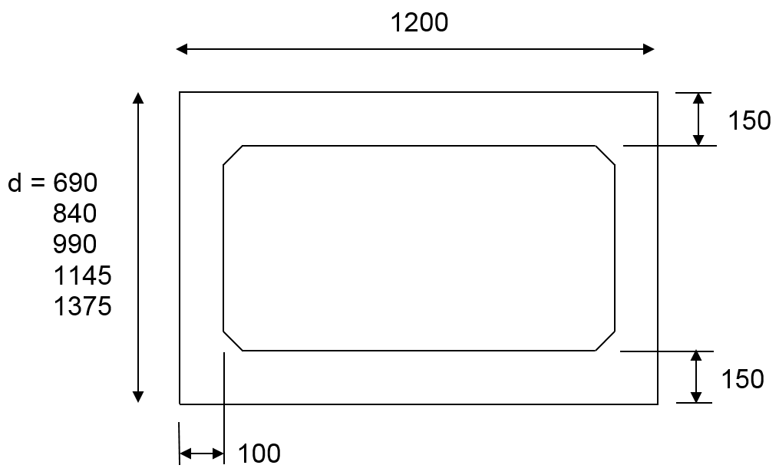
Figure 1: Typical geometry of box girders considered with various depths (dimensions are in mm)

Table 1: Bridge model parameters
Girder depth | Bridge length | Number of design lanes
(mm) | (m) | Number of design lanes
690 | 14, 18, 22 | 2, 3, 4, 5, 6
840 | 18, 22, 26 | 2, 3, 4, 5, 6
990 | 22, 26, 30 | 2, 3, 4, 5, 6
1145 | 26, 30, 34 | 2, 3, 4, 5, 6
1375 | 30, 34, 38 | 2, 3, 4, 5, 6
  - Edge barrier width
Edge barriers were not included in the bridge modeling in accordance with CSA (2014a) but the edge barrier width on the exterior girder is discussed here since it affects the location of the exterior wheel line. Location of the exterior wheel line with respect to the free edge has an effect on the load distribution of mainly the exterior girders. Bakht, et al., (1983) used 3.5 ft. (1.07 m) in their analysis which is a main reference for transverse shear distribution for the Canadian code. In each traffic lane, the minimum spacing of the wheel line to the edge of the lane shall be 600 mm as specified in CSA (2014a). This means that Bakht, et al., (1983) used 0.47 m for barrier or curb width on exterior girders. If TL-4 or TL-5 barriers are installed on the exterior girders, different Canadian jurisdictions have various standard barrier geometries. For a TL-5 barrier, the barrier base width is larger than 435 mm which is for Jersey barriers. Base width for TL-4 barriers can be larger than 400 mm for Jersey barriers and larger than 250 mm for vertical parapets.
Other types of TL-4 barriers are steel railing or thriebeam on top of a concrete curb. This system could be installed with an overhang outside the exterior girder edge as shown in Figure 2. However, the curb width over the exterior girder is not likely to be smaller than 250 mm. TL-2 or TL-1 barriers are not very likely to be installed on box girders and if it is the case, they are a version of concrete curb and steel railing or w-beam and similar discussion will apply for those as well. Foregoing discussion concludes that the minimum width of roadside safety system (barriers or curbs) commonly used in Canada could be considered 250 mm. Hence the effective bridge deck width for the analysis presented in this paper is considered to be 500 mm smaller than the total bridge width which is considered to be the distance between outside edges of exterior girders. Bridge cross-sectional geometry is shown in Table 2.
If the precast box girder has CIP deck, the edge barrier could be installed entirely on the overhang, however, this is not normal practice if a deck-free system is used and the barrier is installed entirely or partially on the exterior girder.
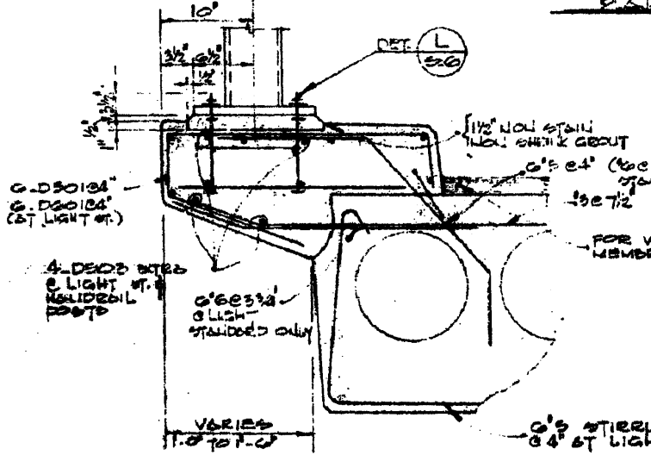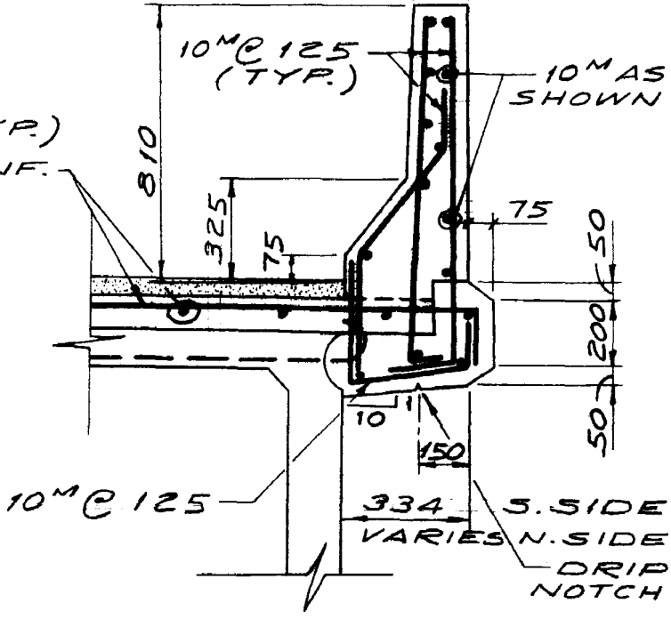

Figure 2: Concrete curb installed on a deck-free prestressed girder, TL-4 barrier installed entirely on the overhang of a box girder with cast-in-place deck.

Table 2: Bridge cross-sectional geometry and lanes
Number of design lanes | Number of girders used | Effective bridge width (m) | Deck driving width (m) | Multi-lane modification factor
2 | 7 | 8.4 | 7.9 | 0.9
3 | 10 | 12 | 11.5 | 0.8
4 | 13 | 15.6 | 15.1 | 0.7
5 | 16 | 19.2 | 18.7 | 0.6
6 | 19 | 22.8 | 22.3 | 0.55

- Finite Element (FE) modeling
In FE modeling, each girder is modeled with shell elements. Only simply-supported bridge span is considered, that is the typical approach in research on lateral load distribution between girders. End diaphragm with 500 mm thickness is included at each abutment. Support restraint provided at each abutment are all three translational degree of freedom (DOF) on one abutment and transverse and vertical DOF on another abutment allowing longitudinal movement. No intermediate diaphragm was considered as this is the regular practice in Canada. CSA-S6 specifies that if certain conditions are met, no intermediate diaphragm is required. In some United States’ jurisdictions, it is common to install two intermediate diaphragms and apply transverse post-tensioning along the intermediate diaphragms (Hanna, 2008). However, this is not the common practice in Canada. Other parameters such as longitudinal bearing restraint (Bakht and Jaeger, 1988) and edge stiffening effect of edge barriers (Azimi and Sennah, 2015) have effect on the lateral load distribution, but were not included in this study since they are not considered when using simplified method of analysis prescribed by CSA (2014a).
  - Modelling closure strip (shear key)
Closure strip (also called shear key) is a longitudinal strip connecting two adjacent box girders. High performance concrete or non-shrink grout is poured to fill the designated areas on each top corner of the box girders. Considering reinforcement inside the closure strip, there are three types for closure strips typically used for shear-connected beams (see Figure 3):
- No reinforcement, while the transverse load transfer between girders is done through interlocking shear with almost zero transverse moment transfer.
- One layer of transverse reinforcement with usually 180 degree hook. This shear key can transfer shear through concrete interlocking and also reinforcement shear off resistance. It also can transfer some amount of transverse moment which is usually conservatively neglected. Reinforcement size is usually 10M and widely spaced.
- Two layers of transverse reinforcement in the shape of a U-bar. Longitudinal reinforcement is sometimes placed inside the two U-bars. This system can better transfer shear and can provide the largest transverse moment transfer compared to other types of shear keys.
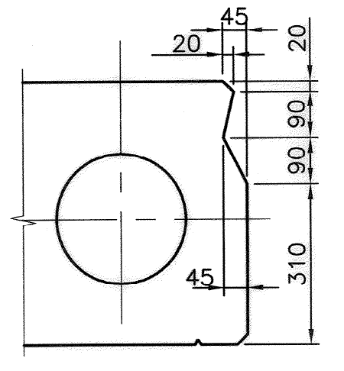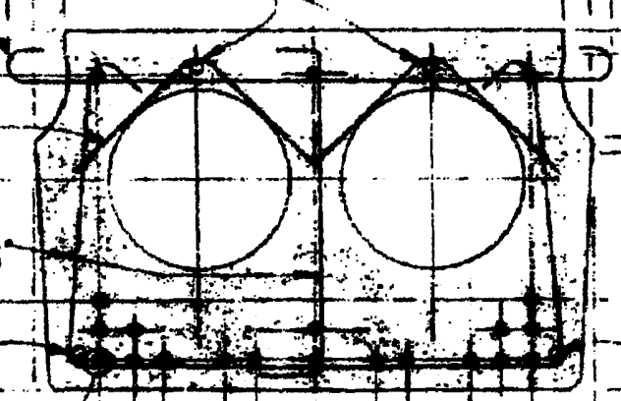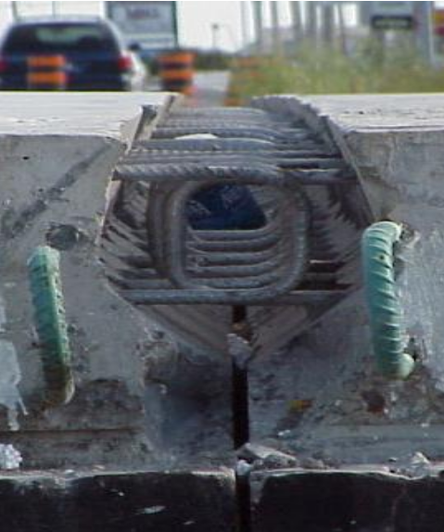
Type 1
Type 2
Type 3 (Jajjawi, 2016)

Figure 3: Different types of closure strip.
CSA (2014a) categorizes the shear connected beam bridges with the continuity of transverse flexural rigidity. If there is continuity in the top slab, the simplified method of analysis for slab-on-girder bridges can be used. Continuity is usually considered if a cast-in-place slab is placed on top of precast box girders. For deck-free box girder bridges, no continuity of transverse flexural rigidity is usually considered. Among the three types of closure strips described above, Type 3 is capable of providing some degree of continuity in transverse flexural rigidity. The other two types of closure strips are unable to provide a considerable continuity. The general approach in design of deck-free shear-connected bridges is to assume no continuity of transverse flexural rigidity, a conservative approach.
The subject of this research is to evaluate the newly introduced simplified method of analysis in CSA (2014a) for shear-connected beam bridges with no continuity of transverse flexural rigidity. Therefore, no transverse flexural rigidity shall be introduced in the FE modeling between box girders. Therefore, modeling the closure strip is essential in terms of type of output obtained from the FE program. A bridge with five box girders was modeled and a constant vertical load was applied on the inside web of exterior girder in order to study different modeling approaches for closure strip. Two main approaches are to model closure strip with shell element or with beam element.
If the shear key was modeled by shell element (Approach 1) with the same thickness of the top flange, this will provide full continuity of transverse flexural rigidity on the top flange and is not suitable for analysis of deck-free shear-connected box girder bridges.
If shear key was modeled by beam element with middle hinge (Approach 2), increasing both weak and strong flexural and also torsional stiffness of the beam elements do not have any effect on girder load sharing capability since hinge was used for all these three effects. However, significantly reducing flexural and torsional stiffness will make the beam element unstable similar to a hinge-hinge beam with no shear transfer between girders. Figure 4 shows a schematic view of modeling Approach 1 and Approach 2.
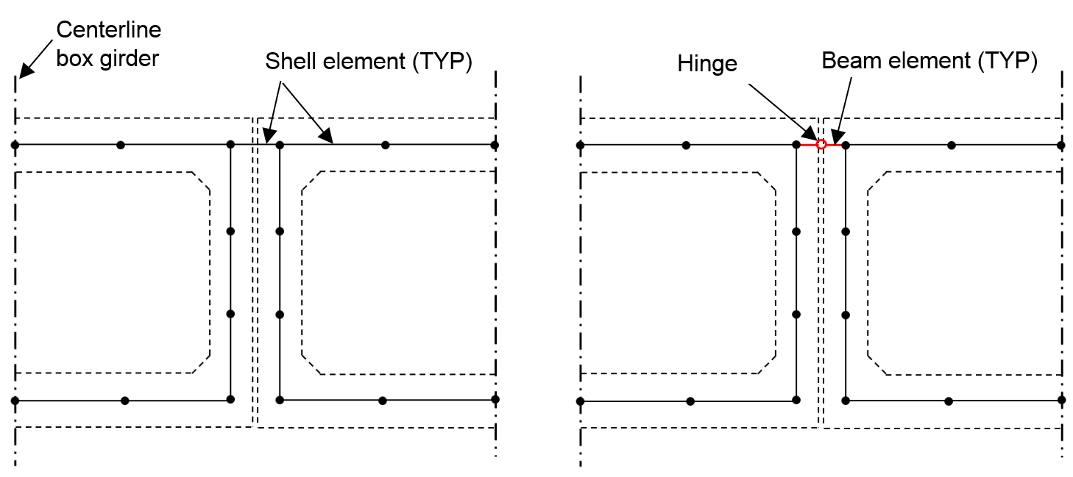
Approach 1
Approach 2
Figure 4: Modeling closure strip using shell element (Approach 1) or using beam element with middle hinge (Approach 2).
Figure 5 shows the plan view of the stress distribution of these two approaches. The general load distribution pattern is similar as expected but girders farther from applied load are more engaged in the case of Approach 1. This specifies that more load was transversely transferred between girders in Approach 1. This is because there is full continuity of transverse flexural rigidity in Approach 1 and no continuity in Approach 2. However, as mentioned above, Approach 1 is not suitable for the subject of this study. Therefore, Approach 2 with reasonably high beam stiffness was used in this study. Beam element stiffness was selected high enough such that further increasing it did not have any effect on the analysis output.
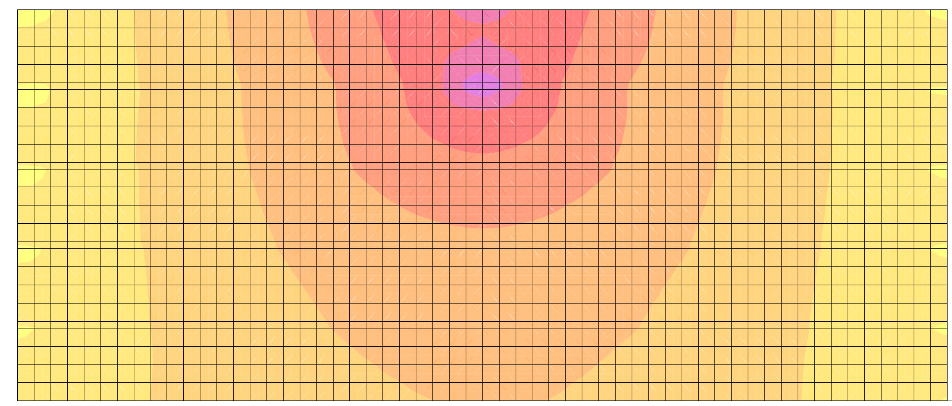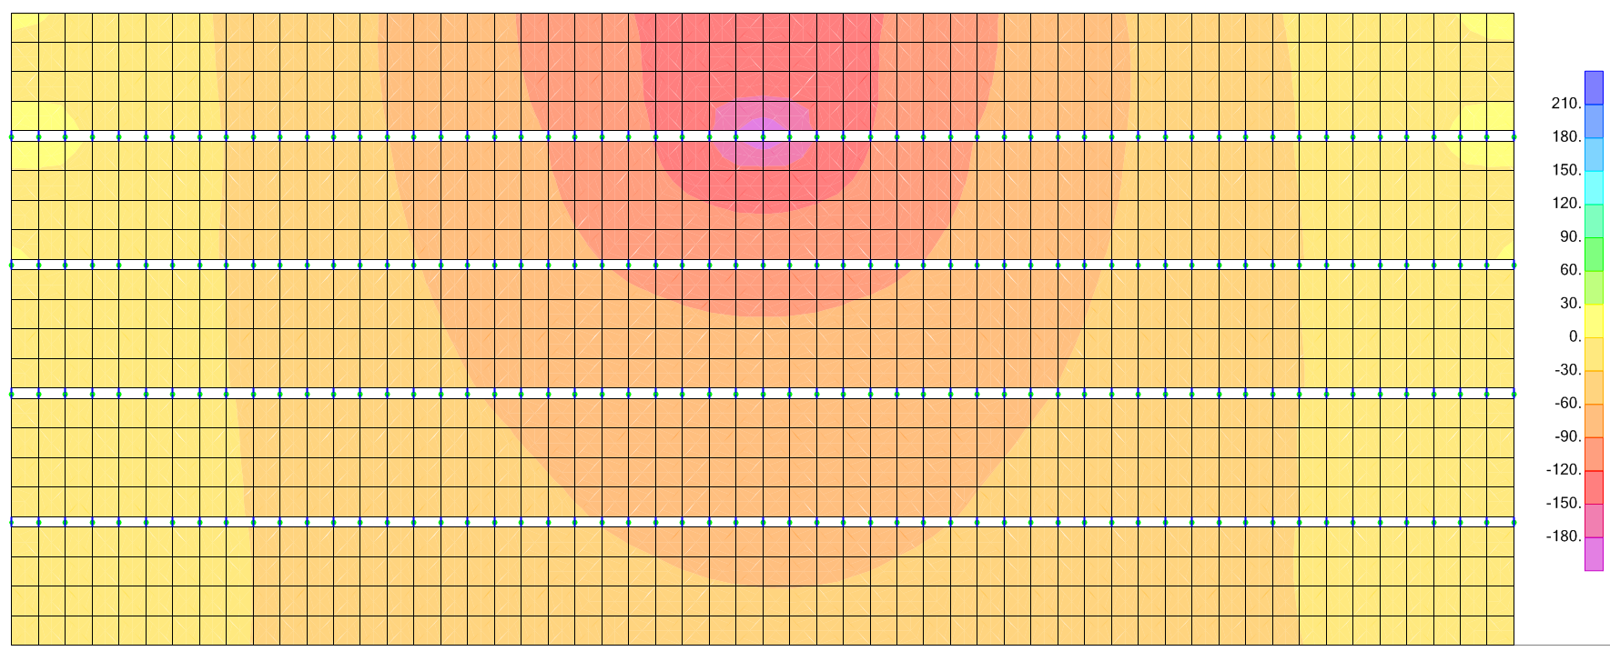
Approach 1
Approach 2
Figure 5: Plan view of stress distribution on top of the example bridge with closure strip modeled using shell element (Approach 1) or using beam element with middle hinge (Approach 2).
- Analysis
Moving load analysis was completed for each bridge using CSiBridge (2017) software. Number of lanes in moving load analysis was considered to be minimum one lane to maximum number of design lanes. Multi-lane modification factors were also included in the software. Then, all the different moving load cases including CL-625 lane loads and truck loads were analyzed. Only live load moving load cases corresponding to ultimate limit state (ULS) and serviceability limit state (SLS) were studied. Different moving load cases are required for fatigue limit state (FLS), bridge deflection, and transverse shear, which are outside the scope of this research.
The simplified method of analysis prescribed by CSA (2014a) to calculate live load effects, is essentially defined by truck load fraction (F_{T}) and skew factor (F_{S}). In this study, no skew is introduced in bridge models, so F_{s} is equal to 1.0 for all bridge models. Skew effect is an important parameter and has been shown that it could significantly affect the load distribution (Théoret, et al. 2012). Formulas are presented in CSA (2014a) to calculate F_{T} depending on the bridge type and geometry. Then, the live load longitudinal moment (M_{L}) or shear (V_{L}) in each box girder is obtained by multiplying a truck load fraction (F_{T}) to the longitudinal moment (M_{T}) or shear (V_{T}) generated by one lane loading on one box girder. Formulas presented in CSA (2014a) for shear-connected girder bridges without continuity of transverse flexural rigidity was considered and F_{T} values were calculated for all 75 bridges in this study.
The software has a capability to calculate the output results through section cuts. Quadrilateral surfaces were defined at a distance of dv (shear depth) to obtain longitudinal shear (V_{L}) and at the location of maximum moment close to mid-span to obtain longitudinal moment (M_{L}) in each box girder. Then the maximum values of moment and shear among girders were selected. A two dimensional moving load analysis of one lane was carried out on one box girder to obtain the maximum shear (V_{T}) and moment (M_{T}) at the same locations as those for aforementioned section cuts. Then truck load fractions (F_{T}) for moment and shear are obtained by M_{L}/M_{T} for moment and V_{L}/V_{T} for shear. The total of 75 three-dimensional bridge models were analyzed and F_{T} results are tabulated in Fig. 6 for moment and in Fig. 7 for shear. Following main observations can be concluded from Figs. 6 and 7:
- Moment F_{T} reduces with the increase in the number of design lanes. Less reduction in F_{T} is observed for higher number of design lanes. This trend is similar for both analysis results and those obtained from CSA except for the case of two design lanes.
- Analysis results for moment F_{T} decrease with the increase in span length, although the reduction in F_{T} is more significant for bridges with 5 and 6 design lanes. However, results obtained from CSA show reduction in F_{T} with increase in span length only for bridges with 2 or 3 design lanes and almost no changes for 4 and more design lanes.
- Analysis results for shear F_{T} show almost similar values for bridges with 3 or more design lanes while it is slightly larger for bridges with 2 design lanes. Therefore the effect of design lanes on shear F_{T} can be ignored for the number of design lanes of 3 or more. However, CSA method shows that shear F_{T} decreases with the increase in number of design lanes.
- Analysis results demonstrate that the effect of bridge span length on shear F_{T} is small compared to moment F_{T} and it could be ignored. This is a similar to CSA results where span length has no effect on shear F_{T}.
- The most significant observation from Figs. 6 and 7 is when comparing FE results with those from CSA (2014a) simplified method; the general expectancy is to have smaller FE results as compared to those from CSA (2014a). This is due to inherent conservatism expected from code formulation. However, all the FE results for moment and shear (except shear for 690 mm deep girder with 2 lanes loaded) are larger than those obtained from CSA (2014a) simplified method.

(A) 690 mm deep girder
(B) 840 mm deep girder
(C) 990 mm deep girder
(D) 1145 mm deep girder
(E) 1375 mm deep girder
Figure 6: Comparison of F_{T} for moment obtained from analysis with those obtained from CSA (2014a)

(A) 690 mm deep girder
(B) 840 mm deep girder
(C) 990 mm deep girder
(D) 1145 mm deep girder
(E) 1375 mm deep girder
Figure 7: Comparison of F_{T} for shear obtained from analysis with those obtained from CSA (2014a)
- Conclusion
The total of 75 deck-free shear-connected precast box girder bridges were modeled in three-dimension using Finite Element (FE) having various depths, span lengths, and bridge widths. Moving load analysis was performed and maximum moment and shear results in each girder was obtained. Those results were used to calculate the truck load fraction (F_{T}) which was compared with F_{T} results calculated from simplified method of analysis for shear-connected girder bridges recommended by CSA (2014a). All three parameters (girder depth, span length, and design lanes) had considerable effect on moment F_{T}, while the effect of span length and number of design lanes were negligible for shear F_{T}. Majority of results obtained from analysis for both moment and shear F_{T} were greater than those obtained by CSA (2014a) implying that the CHBDC formulation was not conservative for the bridges studied in this research. This is of concern and requires further research.

Acknowledgements
Authors greatly acknowledge the financial support provided by The Natural Sciences and Engineering Research Council of Canada (NSERC) in the form of an Industrial Research and Development Fellowship.

References
Azimi, H., Sennah, K. (2015). Parametric effects on the evaluation of an impact-damaged prestressed concrete bridge girder repaired by externally bonded CFRP sheets. ASCE Journal of Performance of Constructed Facilities, 29(6), 250-252.
Bakht, B., Jaeger, L.G. (1988). “Bearing restraint in slab-on-girder bridges.” ASCE Journal of Structural Engineering, 114(12), 2724–2740.
Bakht, B., Jaeger, L.G., and Cheung, M.S. (1983). “Transverse shear in multibeam bridges.” ASCE Journal of Structural Engineering, 109(4), 936–949.
Canadian Standards Association (CSA). 2014a. Canadian Highway Bridge Design Code (CHBDC), CAN-CSA S6-14, Toronto, Ontario, Canada.
Canadian Standards Association (CSA). 2014b. Commentary on CAN/CSA-S6-06 Canadian highway bridge design code, Toronto, ON, Canada.
CSiBridge. (2017). Integrated structural analysis and design software, Computers and Structures, Berkeley, CA.
Hanna, K.E. (2008). Behavior of adjacent precast prestressed concrete box girder bridges. PhD thesis, University of Nebraska, Lincoln, Nebraska, USA.
Jajjawi, M. (2016). Simplified method of analysis for adjacent “deck free” concrete box beams used in accelerated bridge construction. MSc thesis, Ryerson University, Toronto, Ontario, Canada.
Théoret, P., Massicotte, B., and Conciatori, D. (2012). Analysis and Design of Straight and Skewed Slab Bridge. Journal of Bridge Engineering, ASCE, 17(2): 289–301.

