|  |  |  |
| --- | --- | --- |
|  | **10th International Conference on Short and Medium Span Bridges**  **Quebec City, Quebec, Canada,**  **July 31 – August 3, 2018** |  |

**CASE STUDY OF TWO FINITE ELEMENT ANALYSES IN BRIDGE EVALUATION**

Leprince, François1,2, Martel, Jean-François1, Paradis, François1 and Perron, Jean-Philippe1

1 CIMA+, Canada,   
2 [francois.leprince@cima.ca](mailto:francois.leprince@cima.ca)

**ABSTRACT:** Most bridge design and evaluation projects do not require the modeling and analysis to be pushed further than the grillage technique, the orthotropic plate theory or the 2-D beam analogy. Nonetheless, most commonly employed software offer some advanced structural analysis tools of which the modeling and analysis of complex problems might benefit. This article focuses on two case studies where Finite Element Analysis (FEA) using shell elements were performed in the evaluation of short and medium span bridges. The first case illustrates how a bending analysis on a corroded and deformed steel girder was performed using a given commercial software. The second case, modeled using a different software with proven non-linear capabilities, addresses the capacity analysis of a compression member in a Warren truss that has undergone significant deformation following a vehicle impact. For both cases studied, the FEA modeling and analysis allowed for a thorough understanding of the problem and the development of proper solutions for the Clients. Because FEA requires judgement and caution, the reliability of the shell element models was validated following peer review principles. The comparison of the results produced using the different software confirmed that complex problems can benefit from pushing further the analyses, using commercial packages commonly employed, for better understanding the problems and optimizing the solutions.

1. INTRODUCTION

To ensure the sustainability of their infrastructures, Owners (Ministry of Transportation, City, etc.) conduct regular inspections and maintenance. When deemed necessary, an evaluation of the structural capacity is performed in order to assess whether retrofit work or posting loads is required. In Quebec, the department of Transportation provides manuals to guide engineers through inspection and evaluation requirements. Those guidelines accompany the engineer in the analysis of the damages’ effects through simplified analytical methods. However, as demonstrated here, some special cases might benefit from more complex analyses. This case study covers two finite element analyses carried out in different bridge evaluation projects, emphasizing two problems for which conventional approaches would not result in satisfying solutions.

1. APPROACH

For both projects, the problems required a solution that would be logical, reliable, and achievable within the projects’ timeline. The means had to be readily available in the Industry and verifiable by the Clients. Consequently, the supplemental analyses were performed using common structural analysis softwares. Since exact analytical solutions are often time consuming, without yielding added benefits, reasonable assumptions allowed for problems simplification as discussed hereafter in the specific sections.

1. Corroded and deformed steel girder
   1. Background

In 2015, the inspection of a bridge showed that the top flange of an assembled steel girder suffered high deformations, as shown on Figure 1. The vertical deformation reached a maximum of 22 mm between the stiffeners. In addition, a significant thickness loss due to corrosion was measured on the angles forming the flanges. The girders being in a simple span configuration, the compression stress in the top flange led to the assumption that the wave-patterned deformation might be the result of a buckling failure. Alternatively, crevice corrosion between the angles might have been another reason explaining the deformation. For this project, a bridge evaluation was already planned, but due to the particular shape of the deformation, conventional analysis did not allow for appropriate calculation of the girder resistance using a constant or linearly varying section. With the Client’s agreement, additional surveys and analyses were carried out to verify if the bending capacity of the girder was exceeded by the Canadian Highway Bridge Design Code (CHBDC), CAN/CSA S6­‑06 (CSA 2006), traffic loads.

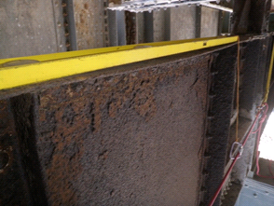

Figure 1: Deformed top flange of an assembled girder

* 1. Finite element modeling

For the girder model to allow for adequately calculating the bending capacity of the element, it must replicate its actual flexural behavior. The linear-elastic portion of the latter being bounded by buckling, finding the buckling modes of the elements allows for calculating the critical elastic moment Mu (CHBDC cl. 10.10.2.3). Because of its integrated tool allowing for buckling modes analysis, the SAFI 3D 8.0.3 software, SAFI Quality Softwares inc. (SAFI 2016), was selected for the modeling and analysis of the girder using shell elements. This integrated structural engineering software is used for Quebec DOT projects and provides a comprehensive interface to implement shell models. The riveted girder cross section is illustrated on Figure 2. To simplify the model shown on Figure 2, the thickness of the shell elements combined the total thickness of the steel plates and angles. Stiffeners were modeled, the boundary conditions were carefully implemented, and the rivets were specifically omitted. It should be noted that the 12 802 mm-long girder span is simply supported. The deck loads are transferred by stringers bearing on the top flange at both ends and at each third of the girder’s span. Therefore, besides the girder’s self weight, only the loads transferred by the two middle stringers causes bending stresses in the girder. Consequently, two vertical unit loads were added at the location of the stringers for the purpose of the buckling analysis. Also, all stringers act as a lateral support for the compressed flange. To model the deformed flanges according to the damage state shown by the surveys, a linear slope was used to shape the elements with a vertical deformation reaching 22 mm. This allowed for replicating the wave pattern shown on Figure 2, thus matching the actual girder (Figure 1).

A)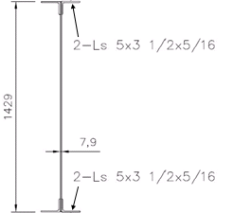 B) 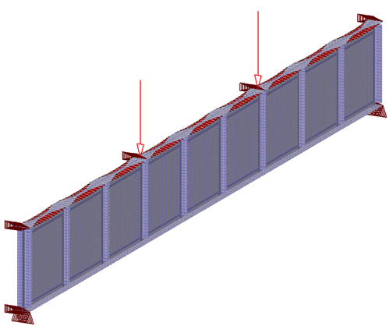 C) 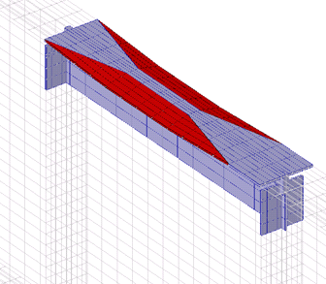

Figure 2: A) Girder’s cross section, B) Complete girder model, C) Close-up of the deformed flange detail

* 1. Analysis and results

The buckling modes analysis for the deformed girder have shown that buckling occurred when the bending moment reached a maximum of 1,932 kN.m. In comparison, analysis performed on a reference model (with an undeformed girder) resulted in a bending moment capacity of 2,262 kN.m before buckling occurred. For the undeformed girder, the buckling moment (Mu) can also be computed from the equations given in clause 10.10.2.3 of the CHBDC. A value of Mu = 2,255 kN.m was obtained from the equations, showing that the undeformed model accurately predicted the buckling force (0.3 % gap). The 15 % reduction of the Mu value found from the analysis of the deformed girder model can thereafter be implemented in the bending capacity equation of the girder. In the bridge evaluation, it was found that the total factored loads do not exceed the bending capacity of the girder and that it did not show any other sign of failure, such as significant vertical deformations. The engineers therefore concluded that the deformation of the top flange was due to crevice corrosion between the two angles. The water and humidity trapped between the elements caused rust that expanded and caused the flanges to deform.

1. Deformed Warren truss diagonal
   1. Background

Following a preliminary bridge evaluation of a steel Warren truss bridge, the inspection of the structure, in 2016, allowed for any observed structural disorders to be taken into account. Along with corrosion, multiple vehicles impacts were recorded on the diagonals and vertical posts of the trusses. Most of the impacts only caused local deformations of the triangulated members. However, one main compression diagonal had sustained a significant deformation (Figure 3), combined with a section loss. Additional geometric surveys confirmed the diagonal misalignment (by approximately 100 mm) and the deformation of both ends of the member. The gusset plates were however intact. Elastic (simplified) analyses quickly led to the conclusion that the capacity of the member would be exceeded under unfactored dead loads. Indeed, the bending moment caused by the eccentrically applied (100 mm) compression overstressed the member. Despite the acknowledgement that the diagonal needed reinforcements, additional analyses were carried out in order to assess the remaining (current) capacity of the member.

A) 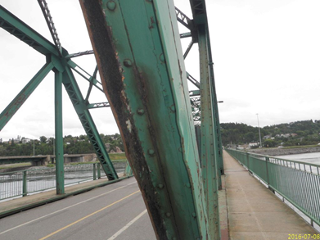 B) 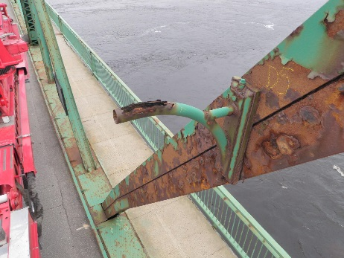

Figure 3: A) Local buckling of the diagonal, B) Global misalignment of the diagonal (± 100 mm)

* 1. Finite element modeling

The surveys on the diagonal clearly showed three zones where an elasto-plastic state was reached as permanent deformation were observed. The first one is located at the impact zone where the compressed flanges are partially buckled. The other zones, at the top and bottom of the diagonal, were slightly deformed before the gusset. To simplify the problem, dead loads are applied to the model as an initial condition. Then, an impact would be simulated with an horizontal force to permanently deform the diagonal until an eccentricity of 100 mm is reached. Afterwards the remaining structural capacity of the diagonal is computed by incrementally adding axial load, up to member failure. The software CSI Bridge v.18.1.1, CsiBridge Software, Computers and Structures (CSI 2016), was chosen because of its ability to carry out non-linear analysis and incremental loading. This structural analysis software is also used for Quebec DOT projects and is known for its wide applications in bridge design and evaluation. Figure 4 shows the detail of the riveted, triangulated diagonal. To simplify the shell model shown on Figure 4, the thickness of the shell elements combined the total thickness of the steel plates and angles. To allow the formation of the three plastic hinges, the rivets connecting the diagonal to the gussets were modeled as pinned supports. Spaced over a length of 700 mm along each end of the diagonal, the rivets create a semi-rigid connection thus sustaining bending moments.

A) 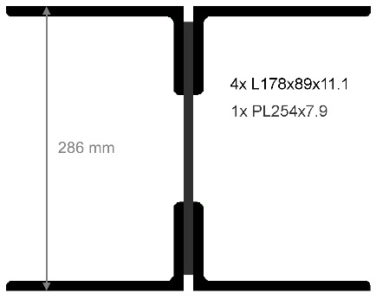 B) 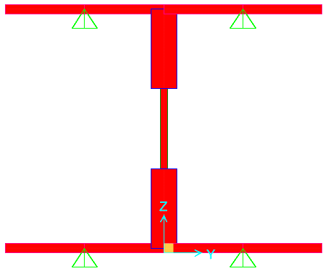

Figure 4: A) Diagonal’s cross section, B) Model’s cross section

* 1. Analysis and results

After the application of the dead load on the diagonal (axial 360 kN), iterative analyses were performed in order to find the horizontal (shear) force that caused the 100 mm deformation, which was found to be 171 kN. This value corresponds to a significant impact load when compared to the maximum barrier design load of 210 kN (CHBDC cl 3.8.8.1 Level TL-5). The non-linear analysis also showed that the diagonal still had a reserve of structural capacity, even after the formation of the three elastoplastic zones (Figure 5). After applying and increasing axial load on the deformed diagonal, it was found that the total buckling resistance, or factored compression resistance, corresponds to 1,330 kN. If compared to the compression resistance of an undeformed diagonal (1,775 kN), obtained with the CHBDC (cl.10.14), the structural issue observed on the diagonal results as a loss of resistance of 25 %.

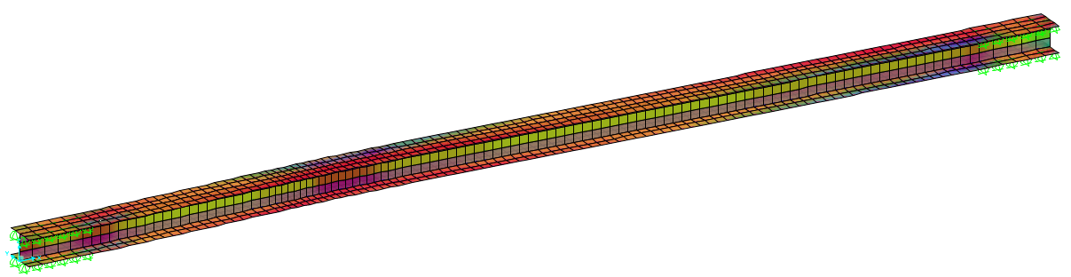

Figure 5: Non-Linear model analysis with three elastoplatic zones (pink)

1. Conclusion

During the course of two bridge inspection and evaluation mandates, situations arose that could not be solved nor explained with the use of the simplified analysis and methods generally deemed mandatory by the authorities. Those case studies demonstrated that common software can be used to carry out detailed analyses using finite elements to reach satisfactory and reliable solutions for specific bridge evaluation situations. In the first case, the bending capacity of a steel girder was assessed, taking into account the wave-patterned top flange deformation due to crevice corrosion. The second case illustrated the compression capacity calculation of a significantly deformed Warren truss diagonal. The analysis results explained why a failure had not happened, even though elastoplastic hinges formed. Both solutions were quickly achieved and did not require in-depth knowledge of finite element analysis since the common software selected offered simple analysis tools.

Acknowledgements

The authors would like to thank the Clients for their confidence in CIMA+ throughout the course of these projects.

References

CSA. 2006. Canadian Highway Bridge Design Code, CAN/CSA S6-06. Canadian Standard Association, Toronto, Canada.

CSiBridge. 2016. CsiBridge Software. Computers and Structures, California, USA.

SAFI. 2016. SAFI Quality Software inc. Québec, Canada.