 | 10th International Conference on Short and Medium Span Bridges  Quebec City, Quebec, Canada,  July 31 – August 3, 2018 | 

A precast barrier alternative connected to moment slab for accelerated construction
Azimi, Hossein^{1,5}, Grégoire, Marc², Liu, Zihong³ and Bahous, André⁴
¹ Senior Bridge Engineer, WSP Canada Inc., Calgary, Canada
² Senior Engineer, WSP Canada Inc., Montréal, Canada
³ Senior Project Engineer, WSP Canada Inc., Calgary, Canada
⁴ Senior Bridge Engineer, SNC-Lavalin Inc., Montréal, Canada
⁵ hossein.azimi@wsp.com
Abstract: The new bridge for the St. Lawrence (NBSL) corridor project (the new Champlain Bridge project) located in Montréal is one of the largest public-private partnership (P3) projects in Canada with a total cost of $4.2 billion. In addition to the main bridge over the St. Lawrence River, the project includes other structures such as several overpass bridges and Mechanically Stabilized Earth (MSE) retaining walls. On top of MSE retaining walls, structural concrete parapet barriers needed to be constructed. The common practice is to connect such barriers to moment slabs sitting on top of MSE retaining walls. The self-weight of the moment slab together with the asphalt and gravel placed on top of the moment slab act as a counter-weight resisting the barrier collision loads. A standard test level 5 (TL-5) Jersey shape barrier needed to be constructed. The conventional construction method is to cast the moment slab then form and pour the barriers in-situ. Forming barriers on top of MSE retaining walls requires some falsework, formwork and reinforcing installation, pouring concrete, and curing. On a long length of MSE walls, this work could be time-consuming, labour-intensive and costly. For accelerated construction, a precast barrier alternative was developed. A simplified, easily constructible, and cost-effective bottom anchorage was developed to connect the precast barrier to the moment slab. The precast barrier is designed such that it has exposed U-bars to be tied into exposed U-bars from a cast-in-place (CIP) moment slab. Then a CIP stitch is poured to connect the precast unit to the CIP moment slab. The total length of such precast barriers is about 2.2 km in this project.
- Introduction
The NBSL project is located in a congested urban area with numerous limitations for roadway geometry and multiple grade separations, hence it requires the use of retaining walls. The Mechanically Stabilized Earth (MSE) retaining wall system is widely used for urban areas due to many advantages such as cost-effectiveness and architectural appearance. Therefore, MSE retaining walls are extensively used in the NBSL project. In order to provide roadside safety, concrete edge barriers are installed, connected to moment slabs on top of the MSE retaining walls. Construction of cast-in-place (CIP) barriers on top of the MSE walls require considerable amount of temporary support, on-site reinforcing and formwork installation, concrete pour and cure. This is a time-consuming process which is a very important consideration for P3 projects. In order to accelerate the construction, a precast barrier alternative was developed for wide use throughout the project. Another advantage in using precast as opposed to cast-in-place is the fact that precast elements have longer durability since they are built in the more controlled environment of a precast plant.
- Details and construction
The configuration of the moment slab and precast barrier is shown in Fig. 1. Precast barrier wall geometry and reinforcement is in accordance with Performance Level 3 (PL-3) per CSA (2006) or Test Level 5 (TL-5) per CSA (2014) concrete barrier of the Ministère des Transports, de la Mobilité durable et de l’Électrification des transports du Québec (MTQ) Type 301. There are other types of precast barriers in literature connecting to the deck slab (Patel 2014), which are not necessarily suitable for connection to a moment slab. Reinforcement at the bottom of the precast barrier is detailed to suit the design and a drop down is installed at the bottom of precast barrier, covering the top of MSE wall facing panel as depicted in Fig. 1. In order better to withstand vehicular collision loads, a so-called male-female shear key is detailed to provide some degree of continuity between precast units, enabling load sharing between barrier segments. The precast barrier is connected to the cast-in-place moment slab by means of a CIP stitch. The construction sequence outlining main construction activities is as follows:
- After finishing MSE wall construction, a compressible filler is placed on top of MSE wall panels and the CIP moment slab is cast. The moment slab has projecting modified U-bars at the CIP stitch location.
- Precast barriers are then installed. Precast barriers have projecting exposed modified U-bars at the bottom that are mechanically tied into the projecting modified U-bars from moment slab to secure the precast barrier in place.
- Then grout is injected underneath the precast barriers, until the grout holes in the precast barriers are full. Special consideration should be given to ensure preventing grout leakage from the bottom or in front of precast barriers.
- The final step is to form and pour the CIP stitch. Reinforcement in CIP stitch is from the moment slab and the precast barrier plus longitudinal bars.
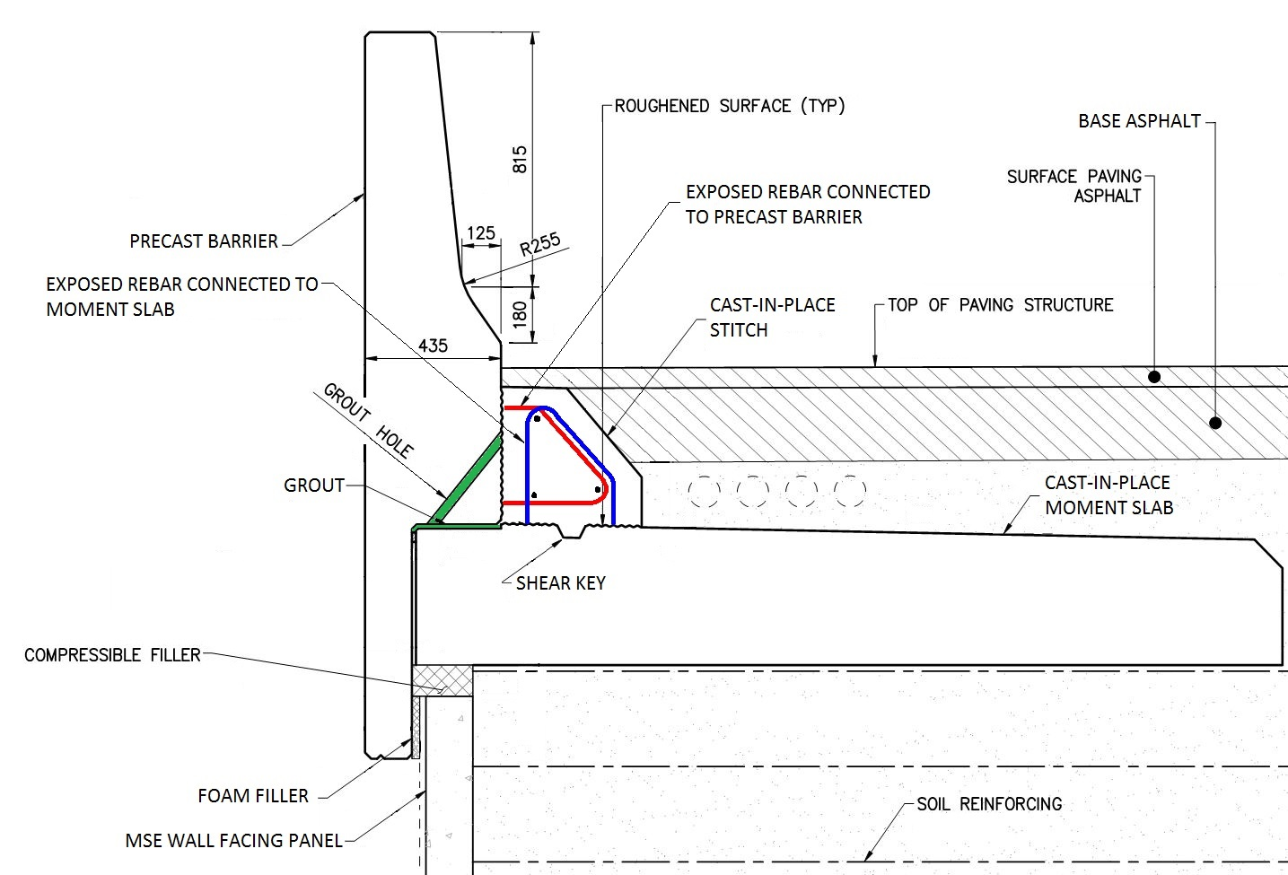
Figure 1: Configuration of the precast barrier anchorage to moment slab
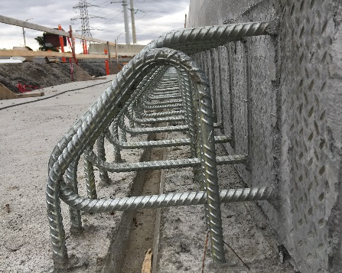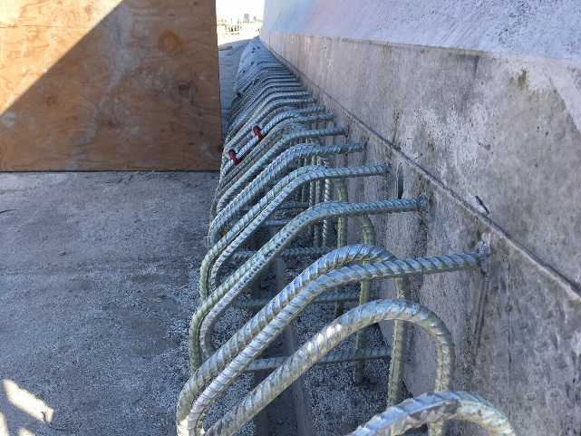
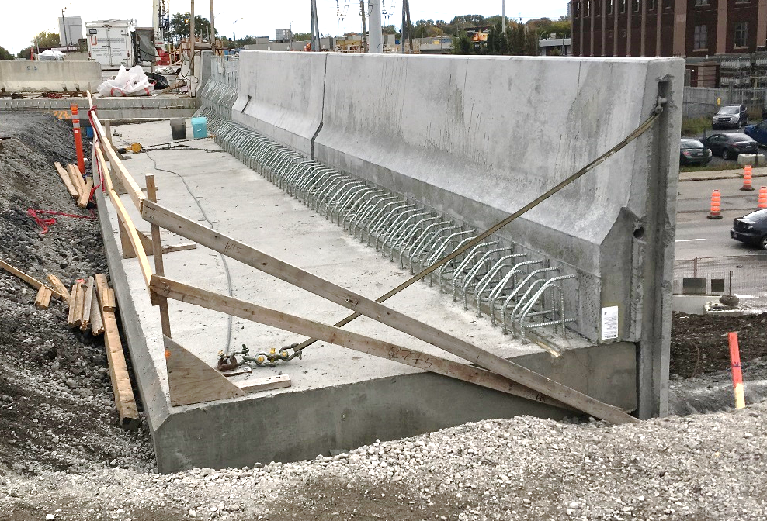
Figure 2: Sample construction photos. Note galvanised reinforcement.
- Analysis
The standard MTQ barrier Type 301 geometry and galvanised steel reinforcement was used for the precast barrier wall above the CIP stitch elevation. Reinforcement in the lower portion of precast barrier, in the CIP stitch, and in the moment slab was designed considering various applied loads and load combinations. Wind loads were considered as noise abatement barriers of up to 4 m in height are attached to the precast barriers at certain locations. However, the principal lateral load governing the reinforcement design was the vehicular collision load.
During the design of the reinforcing steel, the influence of precast barrier bottom grout on the barrier analysis was investigated. It was known that the construction of the grout at the bottom of precast barrier was a challenge during construction. The two challenges were first to prevent leakage at the inside face of precast barrier drop down and bottom front face of the precast barrier, and secondly to ensure grout was properly placed at the bottom of precast barrier with minimal voids. An investigation was conducted to quantify the influence of grout in order to assess whether the benefits of using grout are worth the challenges of placing.
In order to quantify the structural effect of grout on the analysis and design, two extreme cases are assumed here:
Case 1: No grout at the base of the precast barrier. It is assumed that the only connection to the precast barrier is at the vertical interface with the CIP stitch and no contact or connection exists between the bottom of the precast barrier and the top of the moment slab.
Case 2: Grout fills the void at the base of the precast barrier, providing full contact with the moment slab. Therefore, the precast barrier is connected to both the moment slab and the CIP stitch.
In reality, the precast barrier rests on either bare concrete or levelling shims, transferring its dead load to the moment slab prior to pouring the CIP stitch. Hence, even without grout there would be some degree of contact between the precast barrier and the moment slab, though not a full contact (i.e. a partial contact). Hence, the real case lies somewhere in between two extreme cases 1 and 2.
  - Analysis of Case 1
There are three critical sections shown in Fig. 3a for the precast barrier anchorage design with respect to Case 1 with no grout at the bottom of precast barrier. Sections 1 and 3 have similar loading effects including moment and tensile force while the shear force is equal to zero (i.e. V'₂=0). The effect of vertical restraint provided by MSE Wall backfilling under the moment slab is conservatively neglected. Design for Section 1 is similar to bridge overhang design and is not discussed here; as the main focus of this article is on the CIP stitch, which provides anchorage for the precast barrier.
The Free-Body Diagram (FBD) for Sections 2 and 3 is shown in Figs. 3b and 3c, respectively. Collision load P_{t} applied over the length of L_{t} at the height of H_{t} associated with the TL-5 barrier is used for this study. P_{t} and L_{t} are 210 kN (unfactored) and 2400 mm, respectively, applied at the height of 900 mm above the asphalt surface as specified in CSA (2014). The effect of vertical and longitudinal collision load components are not included here for simplicity and also considering the fact that their effect is small compared to the lateral collision load component. In accordance with CSA (2006), load dispersion can be assumed within barrier wall from point of collision to the anchorage design sections (see Fig. 4). For a PL-3 barrier (equivalent to TL-5) the recommended dispersal angle (θ) is as follows: 42˚ and 48˚ for moment in inner and end portions, and 3˚ and 0˚ for shear force in inner and end portions, respectively. Research (i.e. Azimi et al. 2014a) has shown that several parameters are important for the load distribution within barrier walls and using one number as dispersal angle is not conservative in design. For this article, barrier anchorage is analyzed as being an end portion due to the relatively small 6.2 m length of precast barriers. Dispersal angles used for the analysis are 45˚ for moment and 0˚ for shear.
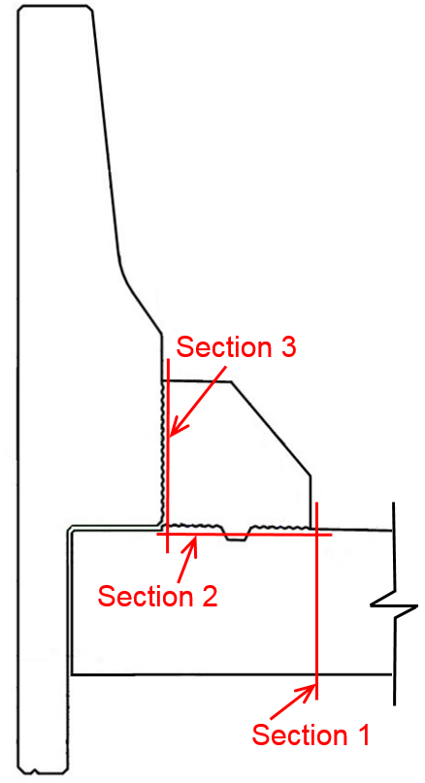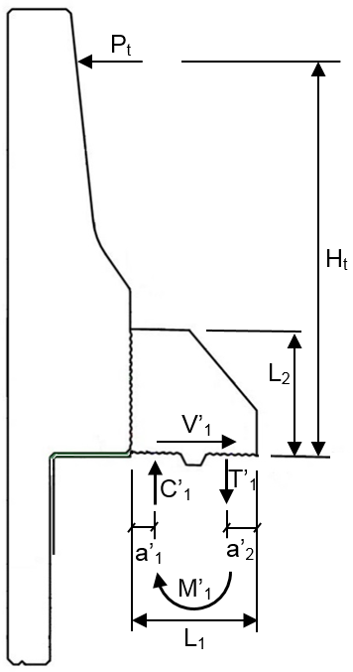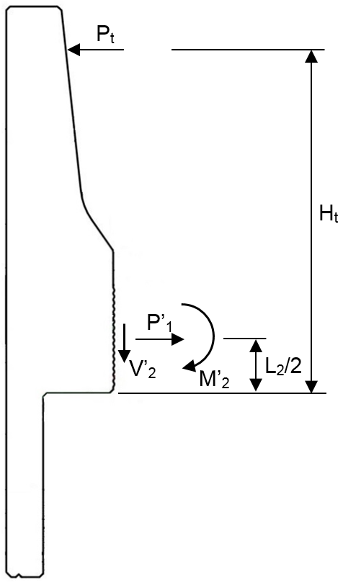
No grout
(a)
(b)
(c)
Figure 3: Analysis of Case 1
Considering no dispersal angle for tensile force, the tensile force per unit length in Section 3, P'₁, is equal to P_{t}/L_{t} which is also equal to V'₁. Considering the dispersal angle θ, moment per unit length in Section 2 (M'₁) and moment per unit length in Section 3 (M'₂) are obtained by equilibrium as shown in Eq. 1 and 2, respectively:
[1] ${\text{M'}}_{1}=\left(\frac{1}{L_{t}+H_{t}\text{tanθ}}\right)H_{t} P_{t}$
[2] ${\text{M'}}_{2}=\left(\frac{1}{L_{t}+\left(H_{t}−\frac{L_{2}}{2}\right)\text{tanθ}}\right)\left(H_{t}−\frac{L_{2}}{2}\right) P_{t}$
The moment at Section 2, M'₁, produces two equal but opposite coupled forces C'₁ and T'₁; C'₁ is the compression component (mainly resisted by the CIP stitch concrete) and T'₁ is the tension component (resisted by CIP stitch reinforcement). These components can be obtained by Eq. 3:
[3] ${\text{T'}}_{1}={\text{C'}}_{1}=\left(\frac{1}{L_{1}−{\text{a'}}_{1}−{\text{a'}}_{2}}\right) {\text{M'}}_{1}$
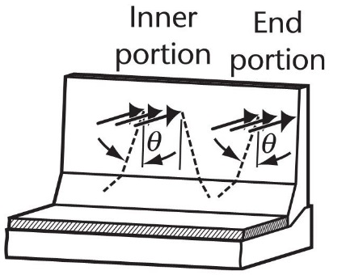
Figure 4: Lateral load dispersal for barrier anchorage design (CSA, 2006)
  - Analysis of Case 2
It should be mentioned that all the resultant forces at the CIP stitch Sections 2 and 3 are per linear length (e.g. shear and tension are kN/m and moment is kN-m/m). There are three critical sections shown in Fig. 5a for the precast barrier anchorage design with respect to Case 2 having grout at the bottom of precast barrier. Analysis of Section 3 is similar to that of Case 1. The Free-Body Diagram (FBD) for Sections 2 and 3 is shown in Figs. 5b and 5c, respectively. Considering a similar dispersal angle to Case 1, the moment at Section 2, M₁, is equal to M'₁ and can be obtained from Eq. 1. Assuming full grout contact at the bottom of precast barrier, the total depth of the section resisting M₁ is L₁+L₃, instead of being just L₁ resisting M'₁ in Case 1. Hence the compression and tension coupled forces C₁ and T₁, respectively, are obtained by:
[4] $T_{1}=C_{1}=\left(\frac{1}{L_{1}+L_{3}−a_{1}−a_{2}}\right) M_{1}$
It is also assumed that the interface shear force at Section 2 is resisted at the bottom of the CIP stitch which has a shear key and an intentionally roughened surface, with a negligible amount resisted by the grout interface at the bottom of precast barrier, i.e. V₁=P_{t}/L_{t} and V₃=0. In addition, P₁=P_{t}/L_{t} and V₂=C₁ using Section 3. By taking moment equilibrium about C₁, M₂ is obtained as:
[5] $M_{2}=M_{1}−V_{2}\left(L_{3}−a_{1}\right)−P_{1}\left(\frac{L_{2}}{2}\right)$
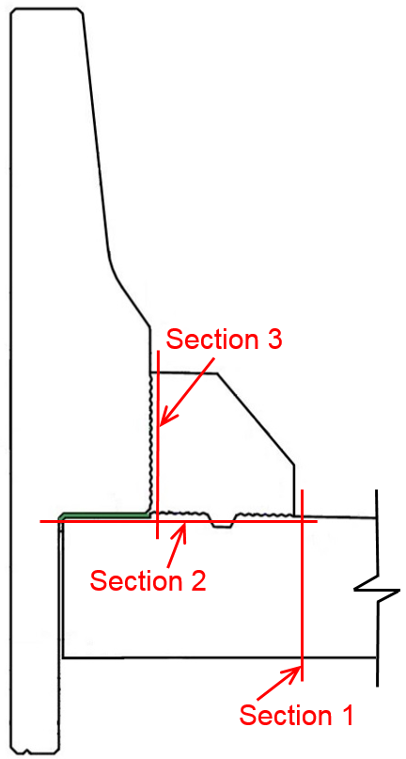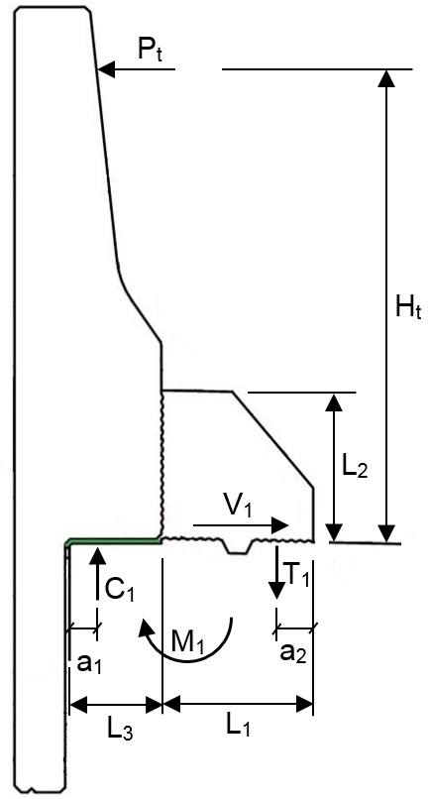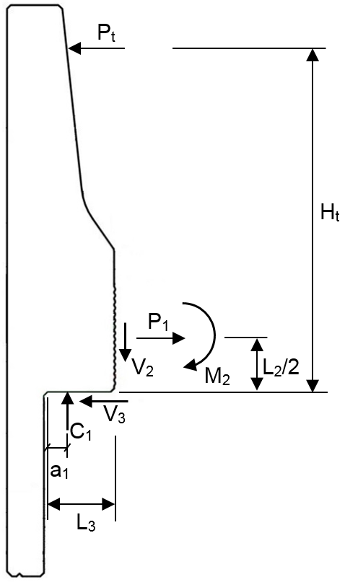
With grout
(a)
(b)
(c)
Figure 5: Analysis of Case 2
All the parameters in Eqs. 1 to 5 are readily known from geometry except a₁, a₂, a'₁ and a'₂. However, these parameters are not completely unknown. Parameter a'₂ is the distance of the main tension reinforcement centroid to the concrete surface, including the concrete clear cover which is known. Parameter a₂ would be the centroid of both front and back CIP stitch reinforcement if both of them are in tension and yielded. However, in reality, there could be less tensile stress in the back row of reinforcement compared to the front row. Therefore, a₂ would range between L₁/2 and a'₂. Parameters a₁ and a'₁ are more complicated to obtain. Considering a rectangular compression stress block one could argue that these parameters are equal to a/2 where ‘a’ is the depth of the compression block. However, the compression block assumption is valid only if the ultimate moment capacity of the section is being calculated and if the ultimate concrete compressive strain occurs at the outermost compression fibre. Therefore, the real values for parameters a₁ and a'₁ are equal or larger than a/2. Table 1 depicts resultant forces calculated for various parameters and a comparison between Case 1 and Case 2.
Table 1: Summary of Case 1 and Case 2 analysis comparison
Parameters |  |  |  |  | Resultants* |  |  |  |  |  |  | Comparison
a'₁ | a'₂ | a₁ | a₂ |  | T₁=C₁=V₂ | M₂ | T'₁ |  |  |  | T'₁/T₁ |  | M'₂/M₂**
(mm) | (mm) | (mm) | (mm) |  | (kN/m) | (kN-m/m) | (kN/m)
20 | 85 | 20 | 100 |  | 218 | 44 | 382 |  |  |  | 1.75 |  | 2.71
30 | 85 | 20 | 100 |  | 218 | 44 | 394 |  |  |  | 1.81 |  | 2.71
40 | 85 | 40 | 100 |  | 225 | 46 | 406 |  |  |  | 1.80 |  | 2.56
50 | 85 | 40 | 150 |  | 246 | 41 | 418 |  |  |  | 1.70 |  | 2.86
60 | 85 | 60 | 100 |  | 233 | 49 | 432 |  |  |  | 1.85 |  | 2.41
20 | 85 | 60 | 150 |  | 256 | 44 | 382 |  |  |  | 1.49 |  | 2.68
30 | 85 | 80 | 100 |  | 242 | 52 | 394 |  |  |  | 1.63 |  | 2.27
40 | 85 | 80 | 150 |  | 266 | 47 | 406 |  |  |  | 1.52 |  | 2.50
50 | 85 | 100 | 100 |  | 251 | 55 | 418 |  |  |  | 1.67 |  | 2.14
60 | 85 | 100 | 150 |  | 278 | 51 | 432 |  |  |  | 1.56 |  | 2.34
*All resultant forces are evaluated at ULS1.
**M₁=M'₁=132 kN-m/m; M'₂=118 kN-m/m.
  - Discussion
The values for T'₁/T₁ given in Table 1 show that the tensile reinforcement force in vertical reinforcing in the CIP stitch (Section 2 in Figs. 3 and 5) of Case 2 is considerably less than that of Case 1. Similarly, the moment at the interface of precast barrier and CIP stitch (Section 3 in Figs. 3 and 5) of Case 2 is considerably less than that of Case 1 (values for M'₂/M₂). The foregoing comparison implies that the application of grout at the bottom of precast barrier considerably reduces tensile forces in both the vertical and horizontal reinforcement in CIP stitch, resulting in better performance during a collision event.
Despite similar applied moment at Section 2 of both Case 1 and Case 2, the corresponding moment-resisting capacity is significantly different. In Case 1, the depth of the concrete section resisting the applied moment of M'₁ is equal to L₁ with a factored resisting moment of 208 kN-m/m. In Case 2, the depth of concrete section resisting the applied moment of M₁ is equal to L₁+L₃ with a factored resisting moment of 484 kN-m/m. Therefore, the capacity over demand ratio of Case 2 is 2.33 times that of Case 1.
Another noticeable difference between Case 1 and Case 2 is the presence of V₂ in Case 2 which is the interface shear at Section 3 shown in Fig. 5. The values for V₂ (which are equal to T₁) are given in Table 1, showing a considerable amount of shear force. However, the interface shear at this location for Case 1 is equal to zero. This implies that applying grout at the bottom of precast barrier (i.e. Case 2) generates considerable shear force at the interface of the CIP stitch and the precast barrier. However, this will not cause any issue since the available factored interface shear resistance is 950 kN/m, significantly larger than the values for V₂ presented in Table 1 (demand over capacity ratio is about 25%).
- Finite Element Analysis
For a better theoretical understanding of stress distribution within the precast barrier anchorage area with and without grout, a two-dimensional finite element model (FEM) was created using CSiBridge (2017) software. All components were modelled by shell elements with maximum size of 50x50 mm. Restraint was provided at a distance of 1.5 m from the face of precast barrier. Restraint included both horizontal and vertical transitional degrees of freedoms. Case 1 (no grout) and Case 2 with grout at the bottom of precast barrier were considered.
The contact between the moment slab and the MSE wall backfilling was also considered. Gap elements (compression only) with large compressive stiffness were used representing large backfill stiffness; while another case with no gap element was also considered representing zero compression stiffness for backfill. The real case is somewhere in between these two extreme cases. Due to much larger concrete rigidity and stiffness compared to the MSE wall backfill, the real case is closer to the case with no gap element. A lateral unit load was then applied on the precast barrier wall at the location associated with TL-5 collision loading. The vertical and longitudinal collision load components were not used, knowing that they have negligible effect on the stress distribution. The maximum and minimum linear forces of elements (principal two-dimensional stresses) are depicted in Fig. 6 for all cases.
Figure 6 shows that the presence of the gap element under the moment slab significantly reduces the magnitude of stress and alters the stress distribution within the CIP moment slab. However, presence of the gap element under the moment slab has negligible influence on the stress distribution within the precast barrier or CIP stitch. As mentioned above, the real case is closer to the case with no gap element. It is recommended to design the CIP moment slab for this case for simplicity and conservatism, which is also similar to the deck cantilever overhang design well-known to engineers.
As shown in Fig. 6, the presence of grout at the bottom of the precast barrier has considerable effect on the magnitude and distribution of stresses on the lower portion of the precast barrier and also within the CIP stitch. A large compressive stress concentration exists in Case 1 at the bottom of the interface between the precast barrier and the CIP stitch (maximum value of 54 kN/m), which is eliminated in Case 2 and is shifted to the end of grout pad with a smaller magnitude of 31 kN/m. The ratio of 54/31 = 1.74 is comparable with the values for T’₁/T₁ (which is equal to C’₁/C₁ since C’₁=T’₁ and C₁=T₁) given in Table 1.

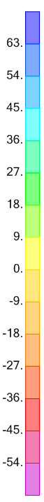
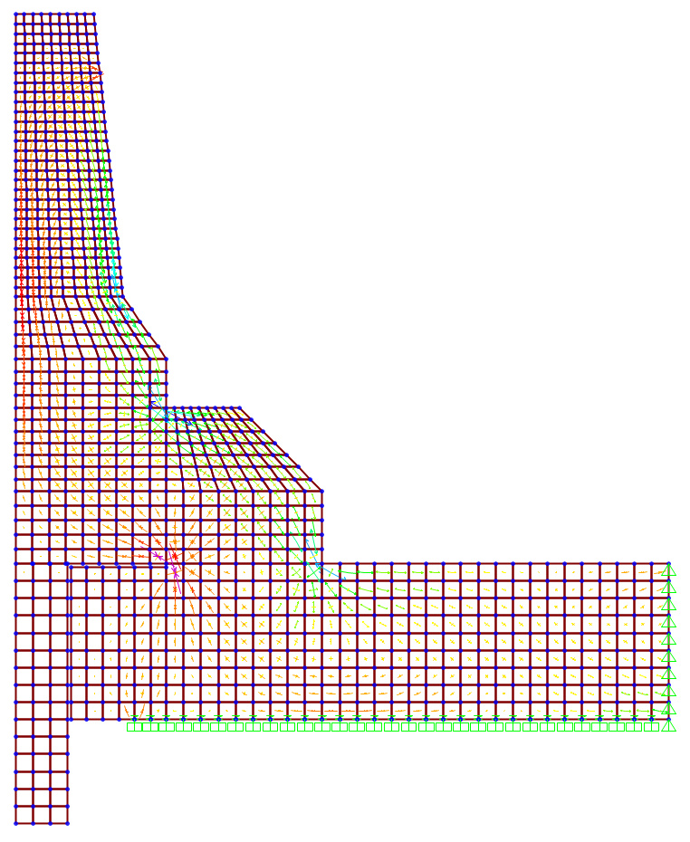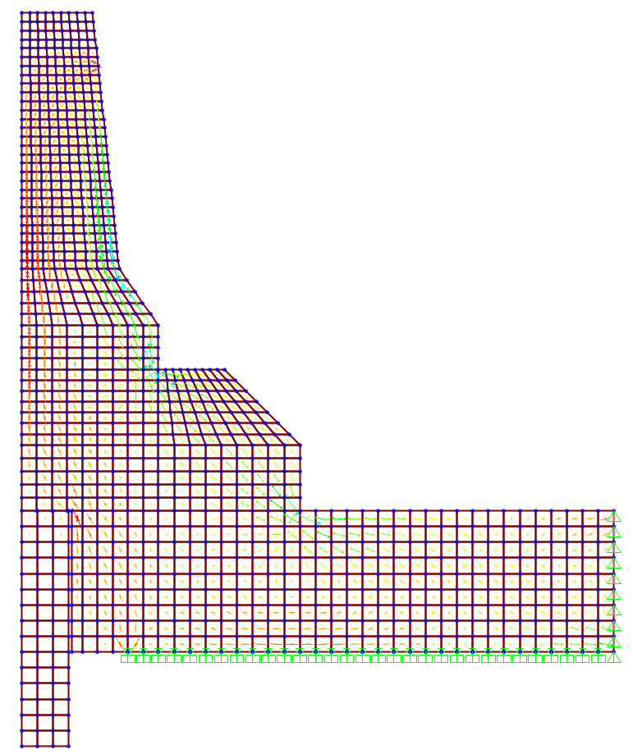
(b) Case 2 (with grout) with full base support on top of MSE wall.
(a) Case 1 (no grout) with full base support on top of MSE wall.
kN/m
1 kN
1 kN
Gap element
End support
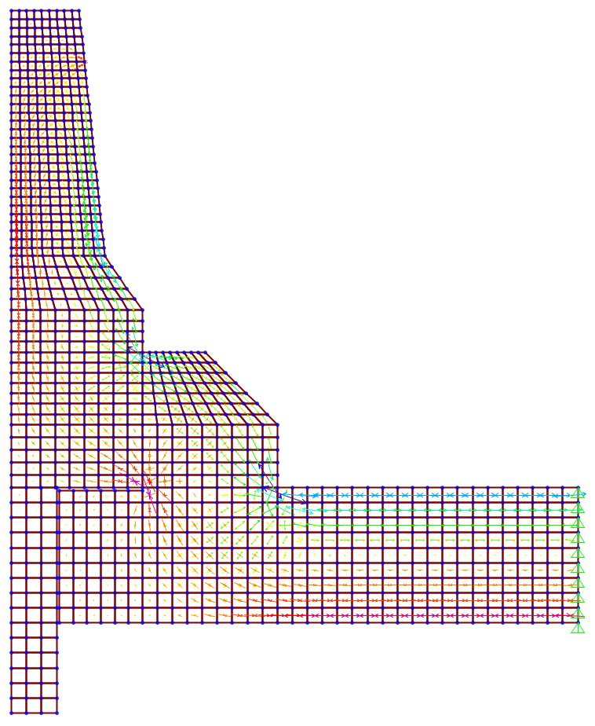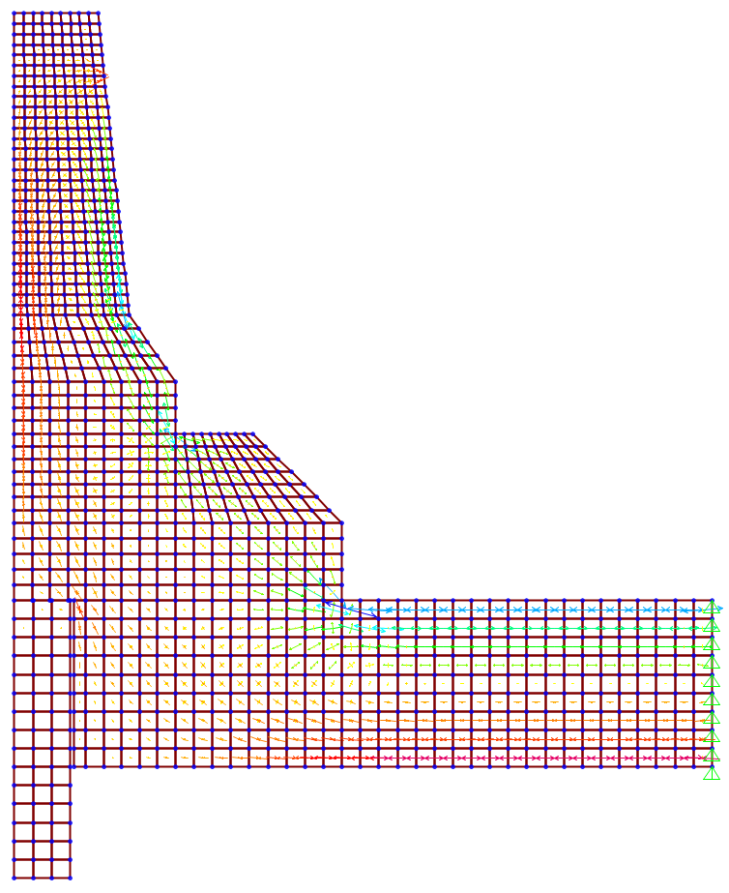
(c) Case 1 (no grout) with negligible base support on top of MSE wall.
(d) Case 2 (with grout) with negligible base support on top of MSE wall.
1 kN
1 kN
Figure 6: FEM showing maximum and minimum linear resultant force distribution in elements
It should be highlighted that the stress distribution shown in Fig. 6 is obtained from a two-dimensional analysis which does not consider force dispersal in the longitudinal direction within the barrier height (as shown in Fig. 4). The purpose of this type of modelling is to investigate how the stress distribution is affected by the grout application at the bottom of precast barrier. This is also why a unit load was applied instead of a full 357 kN factored collision load for TL-5 barriers. The values given in Fig. 6 can be used if multiplied by the full load and divided by the effective dispersal length used for design.

- Conclusion
A TL-5 precast barrier alternative that can be used in accelerated construction was discussed. The precast barrier anchorage was detailed and designed so as to provide versatility during construction and good performance during a vehicular collision event. A CIP stitch is used as the main anchorage element. This configuration can be used to connect precast barrier onto a moment slab sitting on top of MSE walls or on the ground.
A sectional analysis of the proposed precast barrier anchorage was discussed. Critical design sections were identified and the effect of grout at the base of the precast barrier (Case 1 vs Case 2) was quantified. The main beneficial effect was found to be reducing the CIP stitch reinforcing tensile force by more than 35% and also reducing the moment at the precast barrier to CIP stitch interface by more than 50%. The use of grout generated an interface shear between the precast barrier and the CIP stitch which was found to be only 25% of the available interface shear resistance, causing no lack of resistance.
A two-dimensional finite element analysis (FEA) was also performed showing that using grout at the bottom of the precast barrier significantly alleviated stress concentration and improving stress distribution within the lower portion of the precast barrier and the CIP stitch. FEA output also showed conformance with the sectional analysis results. A flowable structural grout has been successfully placed by the contractor at the base of precast barriers during construction which, as shown in this article, will provide better barrier anchorage performance and more reliability over the design life of the structure.

Acknowledgements
The authors would like to acknowledge the support provided by the Signature on the Saint Lawrence Consortium. In addition, the technical support provided by Michael Hatch, Qingsong Liu, and Stuart Culpan of WSP is greatly appreciated.

References
Canadian Standards Association (CSA). 2014. CAN/CSA-S6-14 Canadian highway bridge design code, Toronto, ON, Canada.
Canadian Standards Association (CSA). 2006. Commentary on CAN/CSA-S6-06 Canadian highway bridge design code, Toronto, ON, Canada.
CSiBridge. 2017. Integrated structural analysis and design software, Computers and Structures, Berkeley, CA.
Patel, G. Sennah, K. Azimi, H. Lam, C. Kianoush, R. 2014. Development of a precast concrete barrier wall system for bridge decks. PCI Journal, PCI, 59(1): 83-102.
Azimi, H. Sennah, K. Tropynina, E. Goremykin, S. Lucic, S. and Lam, M. 2014a. Anchorage capacity of concrete bridge barriers reinforced with GFRP bars with headed ends. Journal of Bridge Engineering, ASCE, 19(9): 1-15.
Azimi, H. Sennah, K. Sayed-Ahmed, M. Nikravan, N. Louie, J. Hassan, A. Al-Bayati, N. and El-Sayed, M. 2014b. Bridge deck-guardrail anchorage detailing for sustainable construction. Journal of Bridge Engineering, ASCE, 19(10): 21-32.

