 | 10th International Conference on Short and Medium Span Bridges  Quebec City, Quebec, Canada,  July 31 – August 3, 2018 | 

A Review on Defects Detection in RC Bridge Decks with a Model Developed for Automated Corrosion Detection Using GPR
Abdul Rahman, Mohammed¹, Alsharqawi, Mohammed^{2,4} and Zayed, Tarek³
¹ Concordia Université, Canada.
² Concordia Université, Canada.
³ Hong Kong Polytechnic University, Hong Kong.
⁴ mohammed.alsharqawi@concordia.ca
Abstract: Condition assessment of reinforced concrete bridges is necessary for sustainable infrastructure. The widely used visual inspection method for condition assessment is not completely reliable due to its inability to detect subsurface defects. A variety of Non-Destruction Techniques (NDT) such as Ground Penetrating Radar (GPR), Infrared thermography, Impact echo have been used by transportation agencies based on diverse types of defects such as corrosion, cracking, delamination, leaching among others. Digital image processing and computer vision techniques are generally utilized for processing output data for localization and identification of defects. Cracking is identified by measuring characteristic parameters of cracks from images obtained from scanning bridge elements. The data profiles obtained from GPR scanning are processed to identify corrosion and presence of moisture content. This paper will provide a comprehensive review on various such automation approaches developed for detection of defects using NDT. Corrosion is a major defect in reinforced concrete bridges. GPR has been extensively utilized due to its ability to identify major subsurface defects in a short span of time, particularly for corrosion. The GPR data is commonly analyzed through numerical analysis approach which involves picking amplitude values at rebar location manually or automatically to develop corrosion maps. While this approach has been employed almost as a sole technique to interpret GPR data, it cannot always differentiate between non-corrosion-based and corrosion-based signal attenuation causes such as surface anomalies, supporting structures, and reinforcing bar depth. An alternative visual image analysis approach developed in literature involves manual scanning of GPR profiles by an expert analyst. However, this approach is subjective and prone to human error but can be automated by applying image processing for automation. A novel approach based on edge detection of image analysis of GPR data has been proposed and validated with a case study. The authors aim to develop such an automation method because it can help bridge inspectors analyze and process data rapidly for reliable corrosion assessment of bridge elements.
- INTRODUCTION AND BACKGROUND
Bridges are a crucial part of transportation infrastructure, which need to be regularly inspected and maintained for safety and serviceability purposes. The identification of surface and subsurface defects in bridge decks has evolved significantly over the years with the utilization of non-destructive techniques (NDT). The most commonly used NDT with its advantages and disadvantages for defects detection in bridge decks has been classified by Yehia et al. (2007) in Table 1. The recent focus of improvement in defects detection has been to automate the use of the NDT for efficient implementation at network levels and this paper provides a brief review of such attempts.
Table 1 Summary of NDT for various bridge deck defects
Method | Uses | Advantages | Disadvantages
Visual inspection | • Cracks  • Geometry  • Surface roughness | • Accessibility  • Oldest known technique  • Well established | • Subjective  • Time consuming  • Qualitative results
Liquid penetrant dye | • Surface flaws  • Detection of irregularities | • Portable  • Easy interpretation | • Surface preparation  • Exhausting for inspector  • Time consuming
Chain drag | • Flaw detection inside decks  •Delaminations | • Simple  • Portable  • Good for delaminations | • Time consuming  • Tedious  • Subjective  • Not good with overlays
Half-cell potential | • Detect corrosion state in concrete reinforcement  • Corrosion rate | • Simple  • Portable  • Good for corrosion | • Deck needs preparation  • Time consuming  • Not good for delaminations  • Lane closure  • Not very accurate
Acoustic emission | • Cracks  • Delaminations  • Corrosion | • Real-time response  • No lane closures | • Qualitative results only  • Not good with overlays  • Interpretation  • Costly  • Not reliable
Ultrasonic pulse velocity | • Homogeneity of concrete cracks, voids  • Strength determination | • Portable  • Easy test procedure at relatively low cost  • Relatively easy to interpret | • Not very reliable for concrete  • Attenuation negatively affects results  • Does not give information about the shape of defect
Ground penetrating radar | • Concrete mapping, mining, geotechnical, road, and bridge  • Forensics  • Detection of voids, honeycombing  • Delaminations  • Moisture | • Versatility  • Portability  • Effectiveness  • Low cost  • Good with overlays  • Minimum traffic control  • Prediction of repair quantities in road | • Interpretation  • Complexity of results  • Interpretation of results sometimes requires destructive testing
Impact echo | • Detection of voids, cracks, delaminations, unconsolidated concrete, and debonding  • Determining thickness | • Requires one surface of the tested material to be exposed, independent of the geometry of the structure  • Less susceptible to steel reinforcement  • High accuracy | • Size of detected flaws is highly dependent on the impact duration  • Less reliable in the presence of asphalt overlays  • Interpretation of the results is difficult
Thermography | • Detection of thermal differences, delaminations, cracks, voids | • Portable  • Simple, easy interpretation  • Minimum traffic interference | • No information about depth of defects  • Dependent on environmental conditions
Traditional monitoring methods use visual inspection to assess the condition of bridges, where an inspector physically determine the deterioration level of the structure at the bridge site. Automation of this process can lead to more frequent inspection cycles (Abdel-Qader et al. 2003). One aspect of this automation is implementing edge detection techniques in identifying cracks. Abdel-Qader et al. (2003) analyzed and compared four imaging edge-detection algorithms. Another bridge inspection technique for large crack detection was used by Chen et al. (2011). Chen demonstrated the capability of remote sensing for bridge monitoring in which he presented small-format aerial photography as an effective tool for detecting visible defects on bridge superstructures. Furthermore, Chen et al. (2011) proposed the use of ground-based LiDAR as another commercial remote sensing (CRS) technology for bridge structural health monitoring (SHM). Later, Vaghefi et al. (2012) evaluated 12 potential remote sensing technologies for assessing the bridge deck and superstructure condition. Each technology was rated for accuracy, commercial availability, cost of measurement, pre-collection preparation, complexity of analysis and interpretation, ease of data collection, standoff distance, and traffic disruption. Digital image processing was also used for crack quantification. Adhikari et al. (2014) developed neural networks models to predict crack depths given crack widths in such a way that it mimics the on-site visual inspections. Subsequently, Adhikari et al. (2016) also proposed a novel approach for the periodic detection of defects in concrete bridges based on fractal analysis of digital images. Similarly, Li et al. (2014) and Liu et al. (2014) proposed an automated crack detection and crack assessment methods, respectively using digital image processing. Yu et al. (2013a; 2013b) also studied bridge crack detection through image-based analysis techniques. Moreover, the use of laser scanners is studied and investigated by Guldur et al. (2015) as a tool for improving the current visual inspection strategies. Such developments capture, locate, quantify, and document surface damage automatically.
On the other hand, advanced Non-Destructive Technologies (NDT) have been utilized to provide information about deteriorations of bridge subsurface defects. For instance, Abdel-Qader et al. (2008), Washer et al. (2010), and Ellenberg et al. (2016) used Infrared thermography (IR) to detect voids and delamination in concrete bridge decks through measuring the radiant energy emitted from the surface. Martin et al. (2001) used Ultrasonic Pulse Velocity (UPV) which uses ultrasonic (acoustic) stress waves in assessing defects in concrete elements, debonding of reinforcement bars, shallow cracking, and delamination. Gucunski et al. (2010) used Half-Cell Potential (HCP) which measures the potential corrosion of steel reinforcement and prestressed concrete structures. Sansalone (1993), Gucunski et al. (2011), Olson et al. (2011), and Chase (2015) used Impact Echo (IE) which detects and characterizes delamination within concrete bridge decks. Tarussov et al. (2013) and Dinh et al. (2015) used Ground Penetrating Radar (GPR). GPR utilizes electromagnetic (EM) waves that can detect the corrosion damage in the surrounding concrete and also some concrete delamination. Other researchers combined more than one NDT in order to improve the effectiveness of these technologies and enhance the detection of concrete bridge defects, including Kohl and Streicher (2006), Helmerich et al. (2008), Kee et al. (2011), Vaghefi et al. (2013), Gucunski et al. (2015), Kim et al. (2016), Moselhi et al. (2017), and Abu Dabous et al. (2017).

Various NDT have been utilized for reinforced concrete bridge inspection. The scope of this paper, as stated earlier, is to emphasize on corrosion detection. Thus, available technologies that have the capability to detect and evaluate this type of subsurface defect in bridge decks were studied and analyzed. It was concluded from a study conducted by Alsharqawi et al. (2017) that among several tested NDT, Ground Penetrating Radar (GPR) ranks first for condition assessment of concrete bridge decks. The study was based on technical benefits or selection criteria, including (1) capable of detecting corrosion-induced defects such as (1a) corrosion and (1b) delamination; (2) does not require traffic close for bridge inspection; (3) inspection result can be reproducible; (4) usable for various bridge elements; (5) works well with asphalt overlays that is commonplace in Canada; (6) objective with minimal subjective interpretation from operators; and (7) can be used as a stand-alone technique that does not require other tests. This recommendation is consistent with the result of Gucunski et al. (2013), wherein too, GPR was evaluated as the most appropriate technology based on several performance criteria as well as field and laboratory testings, Thus, in this research, GPR is selected as a NDT to detect and evaluate corrosion in RC bridge decks.
  - Ground Penetrating Radar
Ground Penetrating Radar (GPR) is the recommended tool for overall assessment of bridge elements due to its ability to determine subsurface detects especially the corrosiveness state in a short span of time (Gucunski et al. 2013). The process of inspecting bridge decks using GPR equipment involves scanning the deck using an antenna capable of transmitting electromagnetic signals (in the frequency range of 1 to 5 GHz) either manually or using a mobile acquisition system. The reflected energy signals are recorded at regular intervals known as GPR profiles or B-Scans as shown in Fig. 1 for a bridge deck with asphalt overlay (Dinh et al. 2014). The reflections at rebar form a characteristic hyperbolic shape and the peak of the hyperbola typically correspond to the rebar present in the concrete (Krause et al. 2007). The attenuation of signal is primarily due to increase in conductivity at corroding rebar level and thus, the GPR profiles can be used to evaluate the corrosiveness state of bridge deck (Tarussov et al. 2013).

Figure 1 GPR Profile or B-Scan obtained from scanning bridge deck (Dinh et al. 2014)
    - GPR Data Analysis
The GPR profiles obtained from scanning is analyzed for interpretation of data and there have been many methods proposed in literature such as Clemena (1983), Chung et al. (1984), Chung et al. (1993), Barnes and Trottier (2004), Dinh et al. (2014) among others. However, the most commonly utilized method delineated as a standardized procedure in ASTM D6087 is based on measuring amplitude values at different media interfaces, i.e., asphalt-concrete, top rebar, bottom rebar and slab bottom (ASTM 2008). For example, one of the methods involves measuring amplitude values at top rebar layer and this value is indicative of the condition of concrete, i.e., higher values of amplitude indicate less attenuation of signal or sound concrete and vice versa. Utilizing this principle, deterioration maps are generated for a bridge deck where corroded areas are indicated. The amplitude analysis neglects much of the information contained within a profile as it considers GPR only as a measuring device. Therefore, the corrosiveness states indicated by this method are inconsistent and unreliable as it does not consider several factors affecting amplitude such as reinforcement bar spacing, surface anomalies, polarization effects among others (Tarussov et al. 2013). The method based on visual analysis of GPR data discussed in Tarussov et al. (2013) and Kien et al. (2013) overcomes limitations of amplitude analysis by considering GPR data as an imaging tool. The procedure involves an experienced analyst marking attenuated areas (red or yellow) depending upon the severity of the condition across all profiles while considering various surface and structural anomalies as shown in Fig. 2. The corrosion maps generated from this analysis are accurate when compared with the actual state at bridge site as validated by Tarussov et al. (2013). This method, however, has the major limitation of being subjective as the zones of corrosion are marked manually by an expert and can be time consuming. The current research proposes an automated method based on edge detection of visual analysis of GPR data. Prior to explaining the proposed method, previous efforts of visual analysis are discussed below.
Figure 2 Marking attenuated areas using visual analysis (Tarussov et al. 2013)
    - Previous efforts related to visual analysis
There have been numerous efforts in the literature to interpret GPR profile data visually, but none have been as comprehensive as (Tarussov et al. 2013). Chung et al. (1993) detected the characteristic of individual waveforms at asphalt-concrete level in bridge decks for sound and deteriorated concrete. (Barnes and Trottier 2004) evaluated the effectiveness of GPR in measuring deteriorating areas in bridge decks by qualitative visual comparison of individual waveforms. Krause et al. (2007) used a segmentation algorithm in concrete slab to detect rebar. Automatic rebar detection by Sobel edge detection and curve fitting was utilized by Liu el at. (2010) while canny filter and highest energy localization were used by Mertens et al. (2016) to detect peaks in real time GPR images. Automated depth correction methods were proposed by Barnes et al. (2008) to improve the ASTM standardized method based on amplitude analysis. Neural networks were utilized by Gamba and Lossani (2000), Al-Nuaimy et al. (2000), Shaw et al. (2005), Birkenfeld (2010) and Singh and Nene (2013) for automatic rebar detection while Pasolli et al. (2009) used support vector mechanism (SVM). A fuzzy clustering approach was used by Delbo et al. (2000), sparse reconstruction based on minimization algorithm was used by Soldovieri et al. (2011) while Hough transform was used by Capineri el al. (1998) for automatic rebar detection. Two wholesome approaches to develop deterioration maps based on automatic rebar detection and amplitude analysis are by (1) Wang et al. (2011) using partial differential equation and (2) Kaur et al. (2015) using SVM and random sample consensus (RANSAC). All these previous methods of visual analysis either focus only on detection of hyperbolic peaks with no clarity of deterioration detection or implement generation of deterioration maps based on amplitude analysis. The visual analysis method by Tarussov el al. (2013) is the single approach which generates deterioration maps accurately and overcomes limitations of amplitude analysis. Therefore, this method is being automated by the current researchers.
- Research Methodology
The methodology adopted for GPR profiles corrosion assessment is shown in Fig. 3. The premier step involves obtaining real-case profiles from scanning bridge deck using a GPR equipment from a manufacturer such as Geophysical Survey Systems, Inc. (GSSI) or Ingegneria Dei Sistemi (IDS).
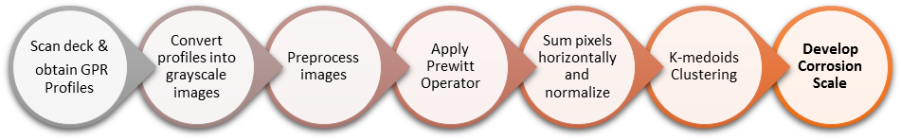
Figure 3 Methodology for developing corrosion scale based on automated visual analysis
Subsequently, the GPR profiles from the proprietary software are converted into greyscale image files for further processing in an image processing tool. MATLAB® has been utilized in this research and the next step is to preprocess images by adjusting image intensity or histogram equivalization for improving contrast and find edges. A texture filter is subsequently applied which transforms the image whose resulting values contain local standard deviation at each pixel in its neighborhood. Edge detections refer to finding areas in an image where the intensity changes rapidly and it highlights image contrast. A first-order edge detector, Prewitt operator, removes significant noise and in detecting contrast, it emphasis the boundaries of hyperbolas in a GPR profile comparatively better than any other edge detector. The gray-level gradient (g) at a pixel in an image, which can be approximated by the digital equivalent of the first-order derivative can be written for a pair of coordinates (x, y) with function value f (x, y) as shown in Eq. 1 (Gonzalez and Woods 2006):
[1] g_{x} (x,y) ≈ f(x + 1,y) – f(x – 1,y)
g_{y} (x,y) ≈ f(x + 1,y) – f(x – 1,y)

If we consider a 3x3 neighborhood of pixels as shown in Fig. 4(a), the Prewitt operator finds edges by implementing diagonal difference on each pixel (x, y) using a mask as shown in Fig. 4(b) and written as in Eq. 2 (Gonzalez and Woods 2006):
[2] g_{x} = = (z₇ + z₈ + z₉) – (z₁ + z₂ + z₃)
g_{y} = = (z₃ + z₆ + z₉) – (z₁ + z₄ + z₇)

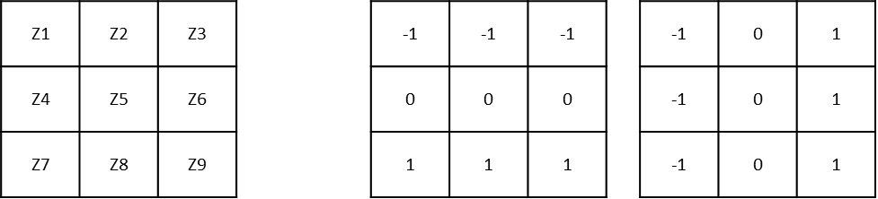
(a) (b)
Figure 4 (a) 3x3 neighborhood of a pixel (b) Prewitt operator masks along x and y value of a pixel
The implementation of edge detector converts the image into a black and white image containing pixel values of either zero or one. The characteristic difference between sound and corroded concrete in the resulting image is that the hyperbolic edges in sound concrete are relatively far greater than bad concrete. By utilizing this principle, the edge pixels are summed up horizontally, normalized with values ranging for a grey-scale image (0 to 255) and finally, zoned into a number of desired corrosion levels using k-medoids clustering of normalized values. For example, typically the areas are zoned into three regions which are color coded as green for sound concrete, yellow and red for concrete with moderate and severe corrosion respectively. k-medoids is a partitional algorithm which minimizes the sum of distances from each object to its cluster medoid, over all clusters and it is insensitive to outliers in the data unlike k-means as it takes medoid in a cluster as a reference point (Islam and Ahmed 2013). Its application is illustrated with an example in the next section wherein real case GPR profiles are classified with corrosion scale using the methodology explained.
- Model Implementation
The model is applied on two real-case bridge deck GPR profiles to showcase its implementation. The first profile as shown in Fig. 5(a) has areas of severe and moderate corrosion marked manually on the image. The edge detection of this profile using Prewitt operator results in an image as shown in Fig. 5(b). As it can be visually seen from the image, the areas of corrosion have fewer edge lines compared to sound concrete. The values of edges are summed up on horizontal axis and normalized in the range from 0 to 255. The lower summation values are indicative of higher corroded concrete and vice versa. It is zoned into three corrosion levels by finding k-medoid clusters of the values. The boundaries of clusters are taken as boundaries of corrosion levels, i.e., red-yellow and yellow-green. The corrosion boundary for red-yellow was obtained at 77 and therefore, if the summed up normalized values below 77, the area is zoned as red. Similarly, the boundary for yellow-green was obtained at 171 (i.e., the yellow range is between 77-171 while the green range is between 171-255) and the corrosion scale is drawn above the profile as shown in Fig. 5(a). The scale developed needs to be smoothened by substituting smaller zones of different colors with the predominant color in the region. For example, the green zone on the left-side of the scale in the original scale after classifying using k-medoids would have various smaller regions of yellow and red zones within the scale and is smoothened to showcase the predominant color (green) for correct representation. The resulting scale marked areas of moderate and severe corrosion accurately.

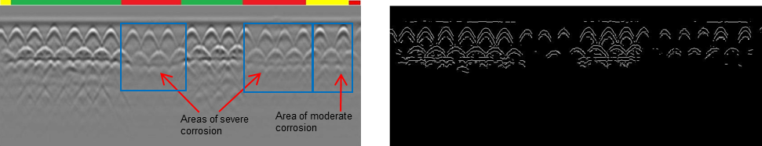
(a) (b)
Figure 5 (a) GPR profile with the corrosion scale on top (b) Prewitt edge detection of the GPR profile
To validate the applicability of the model, a complete real-case bridge deck profiles has been analyzed with the proposed approach and the corrosion map generated is compared with the manually analyzed visual analysis method by Tarussov et al. (2013). The bridge deck being analyzed is situated in Iowa State, USA and was scanned using GSSI SIR® 3000 equipment with a 1.5 GHz antenna. The hand-cart driven GPR antenna was dragged at a uniform speed across the bridge longitudinally with each trace being two feet apart and a total of twenty-four swabs were taken to cover the whole width. The 24 profiles obtained were first analysed by an experienced analyst by manually marking the three zones (green, yellow and red) based on the amount of corrosion visualized by the deformity of hyperbolas contained within the profiles. A corrosion map was generated by combining the corrosiveness scale for each profile and is shown in Fig. 6. Subsequently, each profile was analyzed using the developed model by apply Prewitt edge detection and classify all the profiles into three zones using k-medoids. The corrosion boundary for red-yellow was obtained at 30 and for yellow-green was obtained at 120 (i.e., the red range is between 0-30 pixels, yellow range is between 31-120 while the green range is between 121-255). The corrosion map was correspondingly generated and is shown in Fig. 7. The maps look visually similar and the corrosion zones are marked significantly similar to each other. To perform a quantitative analysis, the percentage areas of green, yellow and red zones are compared as shown in Table 2. The zones differ slightly in areas; for example, green zone percentage differs by 8.2%, but the visual analysis would mark the areas more accurately as it would be void of human error in visually marking zones appropriately.

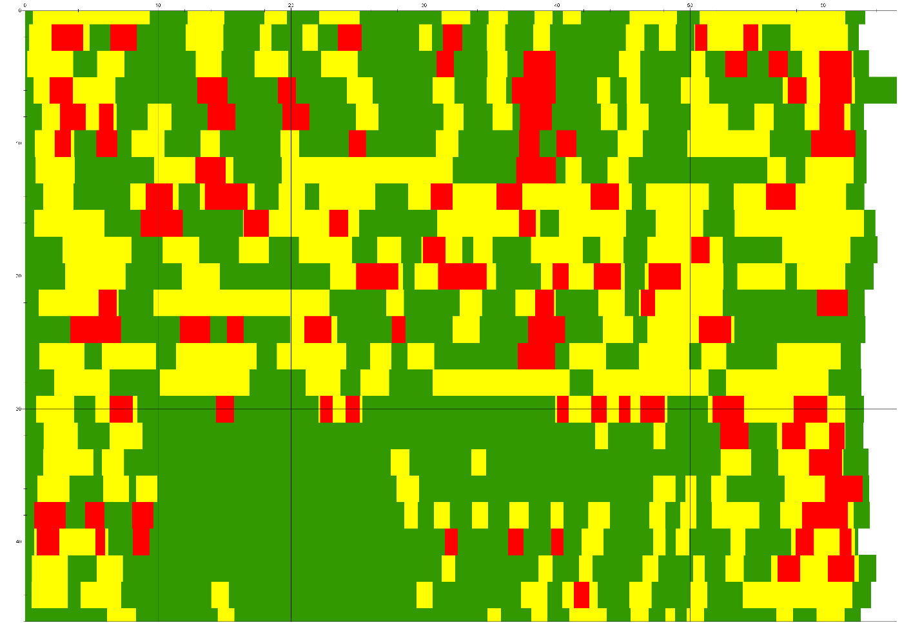
Figure 6 Corrosion map generated using manual visual analysis of studied bridge deck
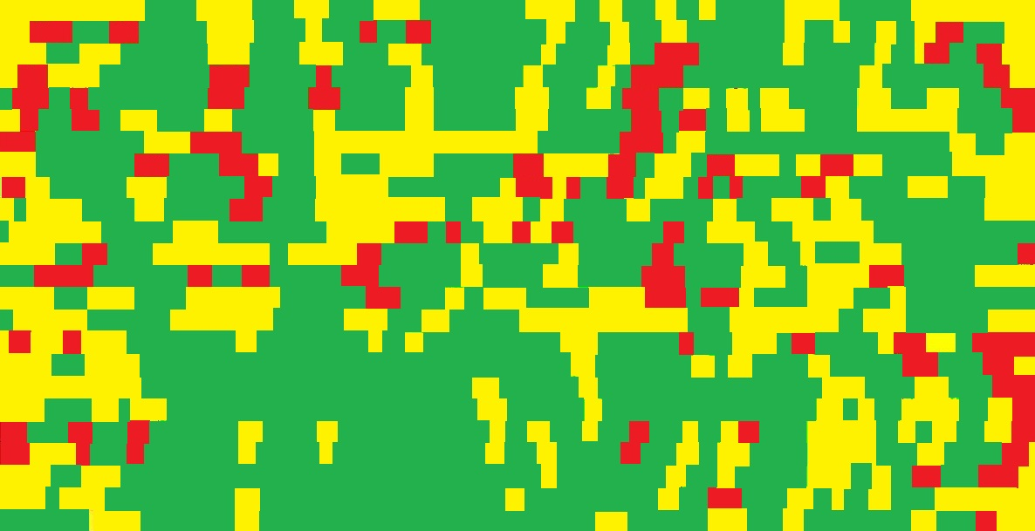
Figure 7 Corrosion map generated using developed Prewitt edge detection model of studied bridge deck

Table 2 Quantitative comparison of generated maps based on areas of corrosion
Corrosion Map Method | Green Area (%) | Yellow Area (%) | Red Area (%)
Expert based manual visual analysis | 54.05% | 34.47% | 11.48%
Developed model  Zone Scale: Red (0-30); Yellow (31-120); Green (121-255) | 58.46% | 31.68% | 9.86%

- Conclusion and Future Works
This paper provides a comprehensive review of using non-destructive techniques for surface and sub-surface defects detection in bridge decks. Since GPR is the most recommended technology for the main type of defect, i.e., corrosion, the application of GPR and the data analysis approaches has been discussed. Several automated approaches for analyzing GPR profiles have been listed from the past and the need of automating visual analysis has been identified. A model based on edge detection using Prewitt edge detection for detecting corrosion has been developed and validated with a real case study. The model will be further developed to identify different anomalies and extended to generate corrosion maps for varied bridge decks. The generated corrosion maps based on the developed model could help bridge inspectors in identifying corrosion zones and assist in maintenance and rehabilitation of bridge decks.

References
Abdel-Qader, Ikhlas, Osama Abudayyeh, and Michael E. Kelly. 2003. Analysis of Edge-Detection Techniques for Crack Identification in Bridges. Journal of Computing in Civil Engineering 17, no. 4:255-263.
Abdel-Qader, Ikhlas, Solange Yohali, Osama Abudayyeh, and Sherif Yehia. 2008. Segmentation of Thermal Images for Non-Destructive Evaluation of Bridge Decks. NDT & E International 41, no. 5:395-405.
Abu Dabous, Saleh, Salam Yaghi, Sabah Alkass, and Osama Moselhi. 2017. Concrete Bridge Deck Condition Assessment Using IR Thermography and Ground Penetrating Radar Technologies. Automation in Construction 81, 340-354.
Adhikari, R., O. Moselhi, and A. Bagchi. 2014. Image-based Retrieval of Concrete Crack Properties for Bridge Inspection. Automation in Construction 39, 180–194.
Adhikari, R., O. Moselhi, A. Bagchi, and A. Rahmatian. 2016. Tracking of Defects in Reinforced Concrete Bridges Using Digital Images. Journal of Computing in Civil Engineering 30, no. 5:04016004.
Al-Nuaimy, W, Y Huang, M Nakhkash, M.T.C Fang, V.T Nguyen, and A Eriksen. 2000. Automatic Detection of Buried Utilities and Solid Objects with GPR Using Neural Networks and Pattern Recognition. Journal of Applied Geophysics 43 (2–4): 157–65.
Alsharqawi, Mohammed, Tarek Zayed, and Saleh Abu Dabous. 2017. Common Practices in Assessing Conditions of Concrete Bridges. MATEC Web of Conferences 120, 02016.
ASTM. 2008. “Standard Test Method for Evaluating Asphalt-Covered Concrete Bridge Decks Using Ground Penetrating Radar.” D6087-08, West Conshohocken, PA.
Barnes, Christopher L., and Jean-François Trottier. 2004. Effectiveness of Ground Penetrating Radar in Predicting Deck Repair Quantities. Journal of Infrastructure Systems 10 (2): 69–76.
Barnes, Christopher L., J. F. Trottier, and Dean Forgeron. 2008. Improved Concrete Bridge Deck Evaluation Using GPR by Accounting for Signal Depth-Amplitude Effects. NDT and E International 41 (6): 427–33.
Birkenfeld, S. 2010. Automatic Detection of Reflexion Hyperbolas in GPR Data with Neural Networks. World Automation Congress (WAC), 2010.
Capineri, Lorenzo, P Grande, and J A G Temple. 1998. Advanced Image‐processing Technique for Real‐time Interpretation of Ground‐penetrating Radar Images. International Journal of Imaging Systems and Technology 9 (1). Wiley Online Library: 51–59.
Chase, S., Adu-Gyamfi, Y., and Tunuguntla, P. 2015. Bridge Deck Sub-Surface Defect Detection using Time-lapse Thermography. Washington, D.C., United States: Transportation Research Board of the National Academies.
Chen, Shen-En, et al. 2011. Remote Sensing for Bridge Monitoring. In Condition, Reliability, and Resilience Assessment of Tunnels and Bridges.
Chen, Shen-En, Corey Rice, Chuck Boyle, and Edd Hauser. 2011. Small-Format Aerial Photography for Highway-Bridge Monitoring. Journal of Performance of Constructed Facilities 25, no. 2:105-112.
Chung T, C. Carter, D. Manning, and F. Holt. 1984. Signature Analysis of Radar Waveforms Taken on Asphalt-Covered Bridge Decks. Technical report ME-84-01, Ontario Ministry of Transportation and Communications.
Chung, T., C. Carter, R. Reel, T. Tharmabala, and D. Wood. 1993. Impulse Radar Signatures of Selected Bridge Deck Structures. In Proceedings of Canadian Conference on Electrical and Computer Engineering, 59–62. IEEE.
Clemena, Gerardo G. 1983. Nondestructive Inspection of Overlaid Bridge Decks with Ground-Penetrating Radar. Transportation Research Record, no. 899.
Delbo, S, Paolo Gamba, and D Roccato. 2000. A Fuzzy Shell Clustering Approach to Recognize Hyperbolic Signatures in Subsurface Radar Images. IEEE Transactions on Geoscience and Remote Sensing 38 (3). IEEE: 1447–51.
Dinh, K., Tarek Zayed, and Alexander Tarussov. 2013. GPR Image Analysis for Corrosion Mapping in Concrete Slabs. In Canadian Society of Civil Engineering 2013 Conference Proceedings, 30:1.
Dinh, K., Tarek Zayed, F Romero, and Alexander Tarussov. 2014. Method for Analyzing Time-Series GPR Data of Concrete Bridge Decks. Journal of Bridge Engineering 20 (6). American Society of Civil Engineers: 4014086.
Dinh, K., et al. 2015. Clustering-Based Threshold Model for Condition Assessment of Concrete Bridge Decks with Ground-Penetrating Radar. Transportation Research Record: Journal of the Transportation Research Board 2522, 81-89.
Ellenberg, A., A. Kontsos, F. Moon, and I. Bartoli. 2016. Bridge Deck Delamination Identification from Unmanned Aerial Vehicle Infrared Imagery. Automation in Construction 72, 155-165.
Gamba, P, and S Lossani. 2000. Neural Detection of Pipe Signatures in Ground Penetrating Radar Images. IEEE Transactions on Geoscience and Remote Sensing.
Gonzalez, Rafael C, and Richard E Woods. 2006. Digital Image Processing (3rd Edition). Upper Saddle River, NJ, USA: Prentice-Hall, Inc.
Gucunski, Nenad, et al. 2010. Multiple Complementary Nondestructive Evaluation Technologies for Condition Assessment of Concrete Bridge Decks. Transportation Research Record: Journal of the Transportation Research Board 2201, no. Bridge Engineering:34-44.
Gucunski, Nenad, et al. 2011. Rapid Bridge Deck Condition Assessment Using Three-Dimensional Visualization of Impact Echo Data. Journal of Infrastructure Systems 18, no. 1:12-24.
Gucunski, Nenad, Imani, A., and Romero, F. 2013. Nondestructive Testing to Identify Concrete Bridge Deck Deterioration. Vol. S2-R06A-RR-1. Washington, D.C., United States: Transportation Research Board.
Gucunski, Nenad, et al. 2015. Implementation of a Fully Autonomous Platform for Assessment of Concrete Bridge Decks RABIT.Structures Congress.
Guldur, Burcu, Yan, Yujie, and Hajjar, Jerome F. 2015. Condition Assessment of Bridges Using Terrestrial Laser Scanners.
Islam, Saiful, and Majidul Ahmed. 2013. Implementation of Image Segmentation for Natural Images Using Clustering Methods. Int J Emerg Technol Adv Eng 3 (3): 175–80.
Helmerich, Rosemarie, et al. 2008. Bridge Inspection and Condition Assessment in Europe. Transportation Research Record: Journal of the Transportation Research Board, no. 2044:31-38.
Kaur, P, K J Dana, F A Romero, and N Gucunski. 2015. Automated GPR Rebar Analysis for Robotic Bridge Deck Evaluation. IEEE Transactions on Cybernetics.
Kee, Seong-Hoon, et al. 2011. Nondestructive Bridge Deck Testing with Air-coupled Impact-Echo and Infrared Thermography. Journal of Bridge Engineering 17, no. 6:928-939.
Kim, Jinyoung, Nenad Gucunski, Trung H. Duong, and Kien Dinh. 2016. Three-Dimensional Visualization and Presentation of Bridge Deck Condition Based on Multiple NDE Data. Journal of Infrastructure Systems 23, no. 3:B4016012.
Kohl, Christoph, and Doreen Streicher. 2006. Results of Reconstructed and Fused NDT-data Measured in the Laboratory and On-Site at Bridges. Cement and Concrete Composites 28, no. 4:402-413.
Krause, Vincent, Ikhlas Abdel-Qader, Osama Abudayyeh, and Sherif Yehia. 2007. An Image Segmentation Algorithm for the Detection of Rebar in Bridge Decks from GPR Scans. 2007 IEEE International Conference on Electro/Information Technology, EIT 2007, 114–19.
Li, Gang, Shuanhai He, Yongfeng Ju, and Kai Du. 2014. Long-Distance Precision Inspection Method for Bridge Cracks with Image Processing. Automation in Construction 41, 83-95.
Liu, Yayu, Meiqing Wang, and Qiurong Cai. 2010. The Target Detection for GPR Images Based on Curve Fitting. In Image and Signal Processing (CISP), 2010 3rd International Congress on, 6:2876–79. IEEE.
Liu, Yu-Fei, Soojin Cho, BF Spencer Jr, and Jian-Sheng Fan. 2014. Concrete Crack Assessment Using Digital Image Processing and 3D Scene Reconstruction. Journal of Computing in Civil Engineering 30, no. 1:04014124.
Martin, J., et al. 2001. Ultrasonic Tomography of Grouted Duct Post-Tensioned Reinforced Concrete Bridge Beams. NDT & E International 34, no. 2:107-113.
Mertens, Laurence, Raffaele Persico, Loredana Matera, and Sébastien Lambot. 2016. Automated Detection of Reflection Hyperbolas in Complex GPR Images with No a Priori Knowledge on the Medium. IEEE Transactions on Geoscience and Remote Sensing 54 (1). IEEE: 580–96.
Moselhi, Osama, Marwa Ahmed, and Anjan Bhowmick. 2017. Multisensor Data Fusion for Bridge Condition Assessment. Journal of Performance of Constructed Facilities 31, no. 4:04017008.
Olson, Larry D., Tinkey, Yajai, and Miller, Patrick. 2011. Concrete Bridge Condition Assessment with Impact Echo Scanning. In Emerging Technologies for Material, Design, Rehabilitation, and Inspection of Roadway Pavements, 59-66.
Pasolli, E, F Melgani, and M Donelli. 2009. Automatic Analysis of GPR Images: A Pattern-Recognition Approach. Geoscience and Remote Sensing, IEEE Transactions on.
Sansalone, M. 1993. Detecting Delaminations in Concrete Bridge Decks with and Without Asphalt Overlays Using an Automated Impact-Echo Field System. Liverpool University: The British Institute of Non-Destructive Testing.
Shaw, M.R., S.G. Millard, T.C.K. Molyneaux, M.J. Taylor, and J.H. Bungey. 2005. Location of Steel Reinforcement in Concrete Using Ground Penetrating Radar and Neural Networks. NDT & E International 38 (3): 203–12.
Singh, N P, and M J Nene. 2013. “Buried Object Detection and Analysis of GPR Images: Using Neural Network and Curve Fitting.” Emerging Research Areas and 2013 International Conference on Microelectronics, Communications and Renewable Energy (AICERA/ICMiCR).
Soldovieri, Francesco, Raffaele Solimene, Lorenzo Lo Monte, Massimo Bavusi, and Antonio Loperte. 2011. Sparse Reconstruction from GPR Data with Applications to Rebar Detection. IEEE Transactions on Instrumentation and Measurement 60 (3). IEEE: 1070–79.
Tarussov, A., M. Vandry, and A. De La Haza. 2013. Condition Assessment of Concrete Structures using a New Analysis Method: Ground-Penetrating Radar Computer-Assisted Visual Interpretation. Construction and Building Materials 38, 1246–1254.
Vaghefi, Khatereh, et al. 2012. Evaluation of Commercially Available Remote Sensors for Highway Bridge Condition Assessment. Journal of Bridge Engineering 17, no. 6:886-895.
Vaghefi, Khatereh, Theresa M. Ahlborn, Devin K. Harris, and Colin N. Brooks. 2013. Combined Imaging Technologies for Concrete Bridge Deck Condition Assessment. Journal of Performance of Constructed Facilities 29, no. 4:04014102.
Washer, Glenn, Naveen Bolleni, and Richard Fenwick. 2010. Thermographic Imaging of Subsurface Deterioration in Concrete Bridges. Transportation Research Record: Journal of the Transportation Research Board, no. 2201:27-33.
Wang, Zhe Wendy, Mengchu Zhou, Gregory G Slabaugh, Jiefu Zhai, and Tong Fang. 2011. Automatic Detection of Bridge Deck Condition from Ground Penetrating Radar Images. IEEE Transactions on Automation Science and Engineering 8 (3). IEEE: 633–40.
Yehia, Sherif, Osama Abudayyeh, Saleh Nabulsi, and Ikhlas Abdelqader. 2007. Detection of Common Defects in Concrete Bridge Decks using Nondestructive Evaluation Techniques. Journal of Bridge Engineering 12 (2): 215-225.
Yu, Yong-bo, Wan-heng Li, Jin-quan Zhang, and Jian-guo Nie. 2013a. Bridge Crack Extraction Method Based on Image-connected Domain. Journal of Highway and Transportation Research and Development (English Edition) 7, no. 1:34-37.
Yu, Yong-bo, Wan-heng Li, Jin-quan Zhang, and Jian-guo Nie. 2013b. Three-dimensional Detection Method for Bridge Surface Defects Based on Line-shaped Lasers. Journal of Highway and Transportation Research and Development (English Edition) 7, no. 2:69-72.

