|  |  |  |
| --- | --- | --- |
|  | **10th International Conference on Short and Medium Span Bridges**  **Quebec City, Quebec, Canada,**  **July 31 – August 3, 2018** |  |

**ADAPTING THE KING STREET BRIDGE FOR THE FUTURE**

Shields, Rowan1, Wadlow, Sara2, and Paulsen, Michael1

1 Associated Engineering, Edmonton, AB, Canada

2 Associated Engineering, Fort McMurray, AB, Canada

**Abstract:** The King Street Bridge is located in the lower townsite of Fort McMurray, Alberta and consists of a single span steel pony truss with a clear span of 30.5 m. The deck system comprises steel floor beams and stringers supporting a wood driving surface composed of Ekki wood running planks. The bridge superstructure is supported by a timber substructure consisting of a double row of timber piles with caps and corbels. Constructed over the Hangingstone River in 1958, the bridge is historic for the area. The timber substructure has now reached the end of it’s service life and the bridge needs to be adapted for continued use.

The bridge is located immediately adjacent to the main fire station servicing the downtown of Fort McMurray. On the opposite corner of the bridge is Heritage Village, a local museum showcasing the history of the region including structures dating back to the original settlement in the area. The King Street Bridge has served as a local landmark, accommodating local traffic and emergency vehicles.

The rehabilitation or replacement of the existing bridge was reviewed and a solution was proposed which maintained the existing superstructure while strengthening and reconstructing the substructure. This alternative was found to be cost effective, provides the necessary future proofing considerations to provide capacity for future superstructure modifications for full highway loads, and was highly rated aesthetically by maintaining the existing pony truss and historic nature of the bridge. The rehabilitation strategy will accommodate the additional loading requirements of the emergency vehicles while continuing to be a historical landmark for the region.

# Introduction

The King Street Bridge is located within the downtown core of the urban service area of Fort McMurray, in Northern Alberta, and provides traffic accommodation across the Hangingstone River. The existing bridge has a single 30.5 m span, clear width of 7.3 m and is comprised of two rivetted steel pony trusses with steel floor beams and stringer, supporting a wood driving surface composed of Ekki wood running planks on a timber subdeck. The bridge has a timber substructure consisting of a double row of piles with caps and corbels. The bridge is depicted below in Figure 1.

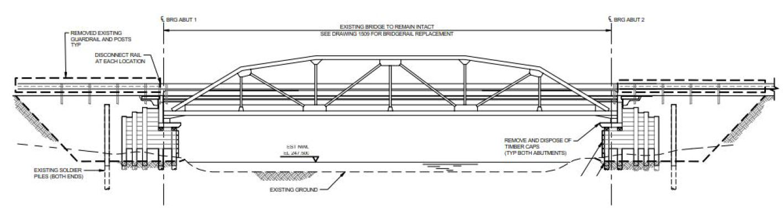

Figure 1: The King Street Bridge

The bridge has been a fixture in the community during the development and growth of the Fort McMurray region, through the development of nearby oil sands sites and the demands that has placed on this northern community. The steel truss was originally designed by the Dominion Bridge company in Winnipeg to accommodate two HS20 trucks.

Through the years the functional and capacity demands of this structure have evolved with the community. In 1966, a cantilevered timber sidewalk was added to the downstream side of the bridge to accommodate pedestrians. Bridge repairs including installation of field treated piles and corbels, installation of north abutment sheeting, riprap installation, grader blade protections, and replacement of the strip deck were all completed in 1970. By 1985, the deck was in need of replacement again and an Ekki Wood deck replacement option was implemented. In 1987, Alberta Transportation posted the bridge to a vehicle limit of 58 tonnes which was reduced in 1990 to vehicle postings of CS1-24 tonnes, CS2-27 tonnes, and CS3-36 tonnes.

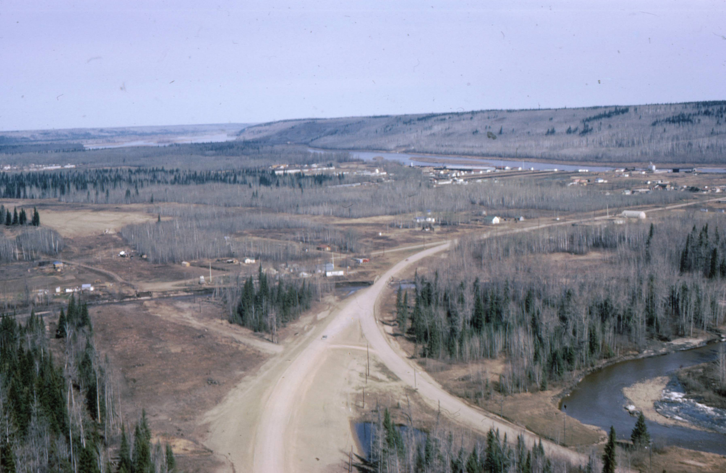In 2011, another rehabilitation was required. During this rehabilitation it was decided to remove the cantilevered walkway as it was negatively impacting the Live Load capacity of the bridge. An adjacent pedestrian bridge was constructed, and the bridge capacity was increased to accommodate the Municipality’s new fire trucks. This bridge rehabilitation included replacement of the previously installed Ekki Wood wearing surface and replacement with new Ekki Wood timbers. The truss coating system was also replaced with a new five layer coating system. This rehabilitation would give the truss an extend life of around 25 years. Figure 2: Township of Fort McMurray Circa 1965

This bridge has also been subjected to several significant events in the community’s recent history. In 2013, a major flood event occurred in the region including the Hangingstone River. The major event was near the 1:100 year flood event and submerged the entire substructure. Additionally, in 2016 the Fort McMurray Wildfire swept through the town, burning within meters of the structure. Although the timber substructure was sparred from fire damage, large and uncontrolled vehicles passed over the bridge at high speeds throughout the event.

Following the wildfire, an inspection was completed on all bridges in the community. Although the King Street bridge was not directly damaged by the fire, it is believed that the heavy uncontrolled vehicles crossing the bridge led to observed substructure damage, specifically timber pile caps crushing and rotating. It is also possible that the saturated substructure following the 2013 flood may have contributed to accelerated degradation of the timber.

The poor condition of the substructure is what led to the scheduling for the current rehabilitation program.

# King Street Bridge Location & Demands

Today, the bridge is located in an urban environment, in the downtown core of Fort McMurray, immediately adjacent to the Historical Village, condominium buildings, and the main Fire Hall. Additionally, it is blocks away from the Composite High School and Keyano College, both institutions servicing large portions of the population. The location and area demands lead to a number of project specific constraints when considering the future plans for the structure. Figure 3 below provides a visual representation of these constraints and influencers.

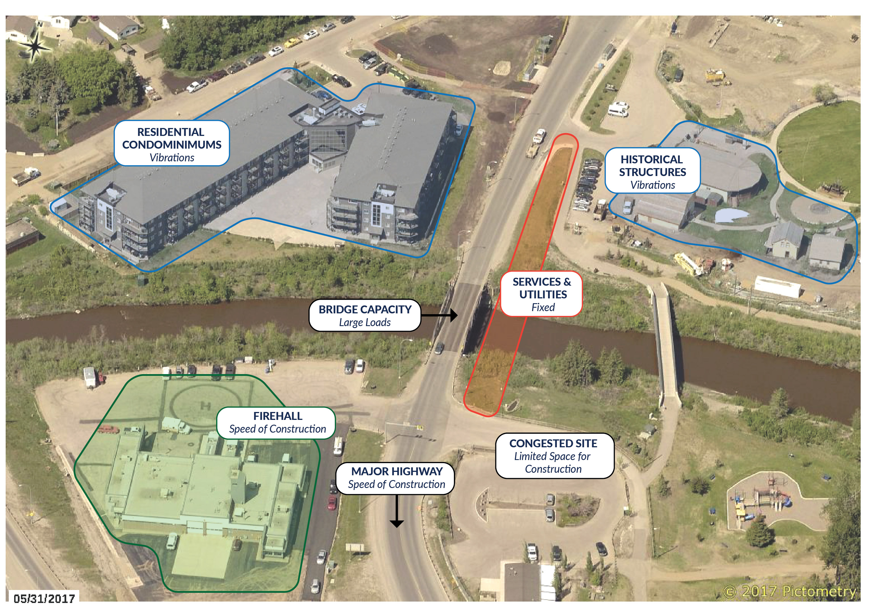

Figure 3: King Street Bridge Location & Constraints

The project constraints identified led to the following considerations when evaluating options to complete bridge rehabilitation and/or replacement work:

* *Firehall & Highway access*: The speed of construction is a critical driver to ensure that the emergency services capabilities of the firehall is only inconvenienced for the minimum amount of time. King Street is directly accessed from a major highway and is a primary arterial road.
* *Residential condominiums & Historical Structures:* Residences are located immediately adjacent to the bridge. Construction activities must be minimized to limit the impact on these individuals. The historical structures located within the Heritage Village are vibration sensitive structures, to alleviate concerns of damage to these structures, vibration concerns and monitoring should be considered during construction activity planning.
* *Services*: Critical services linking the community that cannot be relocated or diverted
* *Bridge Capacity:* Sustain emergency vehicle loads from the firehall in addition to bus loads from nearby schools in the area.
* *Congested Site:* The site is live and active with limited laydown and construction area.

# Structural Adaptations

The structure has been adapted over time to extend its functionality and serviceability to fit the changing needs of the Fort McMurray community. From reviewing the available bridge record files, prior to replacing the timber deck with Ekki Wood, the timber deck was replaced on average every 3 years. The bridge deck material was changed to provide a more robust solution, and reduce the inconvenience and restrictions on traffic affected with regular deck replacement.

Ekki Wood originates from Western Africa and provides a more durable long-term solution compared to conventional timber deck members owing to it’s significant strength characteristics. Table 1 below shows the comparison between them.

Table 1: Comparison of Ekki Wood & Spruce Pine Fir No.1

|  |  |  |  |  |  |  |
| --- | --- | --- | --- | --- | --- | --- |
| Characteristic | Bending  fbu  (MPa) | Longitudinal Shear  fvu  (MPa) | Compression Parallel to Grain  fpu  (MPa) | Compression Perp. To Grain  fqu  (MPa) | Tension Parallel to Grain  ftu  (MPa) | Elastic Modulus  (MPa) |
| Ekki Wood1 | 25 | 2 | 20 | 8 | 23 | 17000 |
| Spruce-Pine-Fir No.12 | 8.4 | 1.2 | 6.7 | 3.0 | 3.9 | 8500 |

The removal of the cantilever sidewalk on the bridge was made possible by the construction of an adjacent pedestrian bridge to the east of the King Street bridge. This adaption not only extended the lifespan of the through truss by reducing load demands, it also provided a convenient separation for user groups solely accessing the historical village and playground on either side of the river.

# Current Structure Condition and Rehabilitation Design Criteria

The current structure condition and key decision criteria for evaluating the potential rehabilitation strategies are discussed in turn below;

***Structural condition:*** The latest routine bridge inspection indicated that the substructure was in a poor condition and the subsequent detailed Timber coring inspection reported findings of rot in numerous timber substructure elements. The expected remaining service life of the substructure was estimated to be no more than 10 years.

Based on the most recent bridge inspection, the superstructure was rated as adequate and the coating system on truss was estimated to have a 20 to 25 year remaining service life with minor touch ups in 10 years time.

***Hydrotechnical Issues:*** The highwater levels in the bridge are governed by downstream ice-jam levels causing the water level to rise whereby the highest recorded level was within 0.30 metres of the truss bottom chord. For a repair strategy, this would not be a significant factor as the current structure adequately spans the river, however, for a replacement strategy, this would be a significant factor as the revised arrangement would require a hydrotechnical review.

***Geotechnical Issues****:* From bridge inspection files there was no recorded historical geotechnical issues and a recent site investigation found no signs of movement due to settlement, however, the overall condition of substructure was in poor condition and any strategy would require pilling work.

***Roadway Geometrics:*** The existing structure accommodates two 3.65 metre lanes with no shoulder. Speed limit is posted at 50 km/hr. In a repair or rehabilitation strategy roadway geometrics is not a governing factor. Conversely, in a replacement strategy this becomes a significant factor as the replacement structure would need to address current servicing standards.

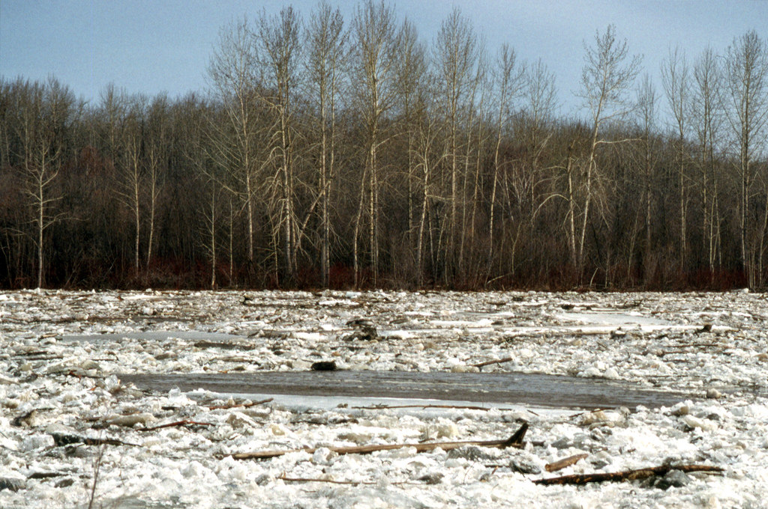

Figure 5: Ice-Jam on the Clearwater River Leading   
to Backwater Flood Event at the Bridge

# Future of the King Street Bridge

The process of future-proofing an engineering asset while retaining its historic significance requires identifying and developing a complete understanding contributing factors. The critical elements to provide a sound evaluation basis are:

* *Documented bridge history:* Visual, ultrasonic and timber coring inspections, Hydrotechnical data and as-built drawings provide the best basis of assessing and predicting remaining service life.
* *Client & Stakeholder engagement:* These influencers are more personally involved with the asset and they can provide an insight into the historical significance of the asset.
* *Applicable design parameters & future adaptations*: Sustainable solutions require data that not only addresses the current demands but also future demands. The Hydrotechnical profile of the area since it’s construction has changed and needed to be remodelled with data that not only addresses the current conditions but also future conditions. The replaced substructure was designed for a 75 year and has designed to accommodate a new superstructure in the future.
* *Accurate costings*: Having experienced contractors in the required areas of construction and familiar with the economic setting of the project will ensure all options can be critiqued evenly with a confident financial comparison base.
* *Future Planning & Local development*:Having a sense of how the surrounding area around the asset will develop over time is consideration. If area near the asset is expected to be further developed with industry or housing, then the inferred demands would be expected to increase. Conversely, if the area in the vicinity of the asset is expected to be re-zoned to a less demanding environment then the inferred demands would be similar to or less than the current demands.

The selected option for the rehabilitation comprises replacement of the timber substructure with a modern concrete abutment on an H-Pile foundation. The profile and abutment elevation are shown in Figure 6 and Figure 7. Some of the details are outlined below:

* Provide a 75-year service life to the community. The truss is in good condition, however the opportunity will be used to complete some minor maintenance (touch-up to the coating system). It is expected that over the service life, the coating system will need to be redone at approximately 20 to 25-year intervals, similar to the estimated replacement frequency for the timber deck.
* The future demands and possible changes in use are not known, and as such the decision was made to design the new substructure based on future replacement of the truss with a steel-plate girder bridge supporting CL-800 design vehicles, such that the substructure can be repurposed in the future with minimal modifications.
* Modifying bridge geometrics to accommodate changing hydrotechnical demands. From the major flood in 2013, the Client was sensitive to hydrotechnical capacity. This rehabilitation provided the opportunity to review, and modify the bridge accordingly. The vertical profile was raised by 300 mm to provide additional freeboard for 1:100 year design events.

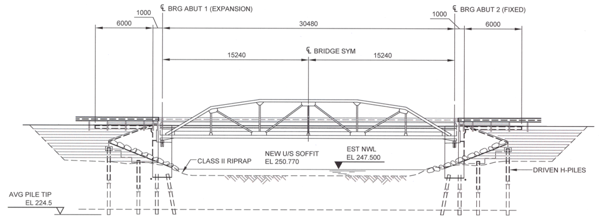 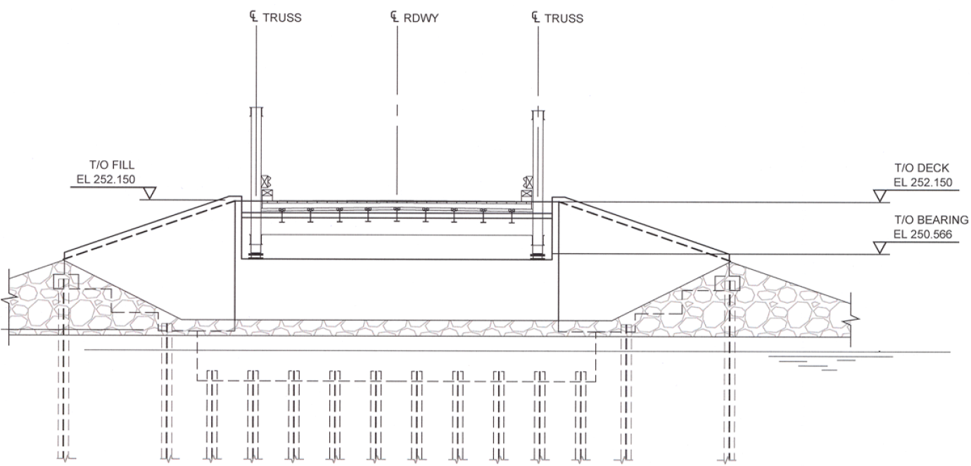

Figure 6: Bridge Profile Figure 7: Abutment Elevation

# Construction Summary

Construction commenced on the 2nd of February 2018 with substantial completion achieved by the 23rd of June. The key features and activities of the construction are summarised below:

* Two Kobelco CK110G cranes were used to transversely move the truss onto temporary supports for the substructure replacement and superstructure reinstallation (shown in Figures 8 and 9).
* The demolition of the existing timber substructure took 3 weeks.
* Installation of 48 Piles took 2 weeks (Figure 10).
* Abutment concrete casting operations used cold weather concrete procedures and took 3 weeks (Figures 11 – 15).

The specified contract completion date was June 30, 2018 and the successful early delivery of the project can be attributed to the successful collaboration between contractor, client and consultant.

|  |  |  |
| --- | --- | --- |
|  | |  |
| Figure 8: Superstructure move onto temporary supports | | Figure 9: Superstructure move onto new abutments |
| IMG_0554 | IMG_0954 | |
| Figure 10: Pile installation | Figure 11: Abutment construction in cold weather | |
|  |  | |
| IMG_1221 | IMG_1278 | |
| Figure 12: Backwall construction in cold weather | Figure 13: Partially constructed south abutment | |
|  |  | |
| IMG_1346 | IMG_1656 | |
| Figure 14: Placement of the truss on the new abutments | Figure 15: Constructed north abutment | |
| IMG_2080 | | |
| Figure 16: Finished bridge open to the public | | |

# Conclusion

The King Street Bridge may not seem to be a historic resource when compared to other jurisdictions; however, in Fort McMurray this bridge provides a tangible connection to the past when the area was a true frontier within Alberta. The bridge has been able to continue to providing service to the community through several changes in use. Beginning as a local road bridge providing the only access across the Hangingstone River, and connection between Fort McMurray and the rest of the Province. Through several rehabilitations, the bridge has had pedestrian access, and provided emergency service response in two major emergency events.

The process of preserving and future-proofing historical bridge structures requires a comprehensive approach considering various aspects ranging from reviewing its service life to date, engaging the client and stakeholders, establishing applicable design parameters and future adaptations, future planning and local development and accurate cost estimates.

Through the project development, it was determined that the bridge was still able to provide the necessary level of service, with a major rehabilitation of the substructure. This allowed a landmark within the community to continue to adapt to changing use, and continue to provide access to the citizens of Fort McMurray for the foreseeable future.

# Acknowledgements

The authors would like to acknowledge the collaborative working relationship that has been developed with the Regional Municipality of Wood Buffalo over the years and support in the completion of this project.

# References

Tropical Marine Timbers [Internet]. Ekki Strength and Toughness; c 2012, [cited 2018 January 23]; Available from; http://tropicalmarinetimbers.com/strength.php

CSA Group. Canadian Highway Bridge Design Code S6. 2014 Ed. Table 9.12 p 397.