|  |  |  |
| --- | --- | --- |
|  | **10th International Conference on Short and Medium Span Bridges**  **Quebec City, Quebec, Canada,**  **July 31 – August 3, 2018** |  |

**CURVED-IN-PLAN BRIDGES: CONTINUOUSLY CURVED VS. KINKED-STRAIGHT GIRDERS**

Samson, Lee1,4, Hristov, Filip2 and Wong, Chelene3

1 Hatch Corporation, Canada

2 Hatch Corporation, Canada

3 Hatch Corporation, Canada

4 [samson.lee@hatch.com](mailto:samson.lee@hatch.com)

**ABSTRACT:** Curved-in-plan bridges have become widespread and are commonly used where road alignment geometries rule out straight options. These types of structures present unique challenges that require additional design considerations. Engineers typically choose from two girder layout options: continuously curved girders, or kinked-straight (chorded) girders to form a curved-in-plan alignment. This paper compares kinked-straight girders with their curved girders counterparts by presenting differences in key considerations, including specific design precautions, girder torsion, flange lateral bending, special fabrication concerns, and constructability concerns. This paper also discusses recent experiences in designing kinked-straight steel girder bridges and presents observations on how kinked-straight girders may be advantageous over continuously curved girders in the application of moderately-curved bridges.

1. **INTRODUCTION**

Curved-in-plan structures are most commonly seen in highway ramp and flyover structures. While local municipal roads with lower speed limits may have radii of plan curvature as small as 90 m, curved highway bridges typically have radii greater than 300 m to accommodate the higher traveling speeds. Even at these relatively moderate curvatures, angular changes in girders still have a significant effect on design and construction. The key consideration for the kinked-straight girder layout is the offset of the curve from the straight girder segment, the chord. A large chord length to radius ratio would result in large offsets and thus large deck overhangs. When the offset exceeds 0.5 m, construction and deck reinforcing become inefficient. However, for most highway alignments and practical span configurations of steel I-girder bridges, offsets rarely exceed 0.3 m which, with careful girder layout, can be accommodated.

The significance of plan curvature on girder design is often measured by the curvature ratio, L2/BR, where L is the span, B is the deck width, and R is the radius of plan curvature. Clauses 5.6.2 and 10.13.3.2 of the Canadian Highway Bridge Design Code (CHBDC) prescribe that for bridges with moderate plan curvature, the bridge can be treated as straight for the purposes of evaluating longitudinal load effects when the curvature ratio is equal or less than 0.5 (CSA, 2014). Upon reviewing the latest guidelines and various design manuals, current design practices seem to indicate that curved girders are the preferred option in curved-in-plan bridges regardless of the plan curvature magnitude. For example, NCHRP Report 424 (1999) states that “bridges constructed in [the kinked-straight girder] fashion are not aesthetically pleasing and the advantages of structural continuity are lost”. While the above statement may be valid in the application of some curved-in-plan bridges, especially for those with small radii, it discounts the advantages of kinked-straight girders in moderately-curved bridges. By comparing the many design and construction aspects, the goal of this paper is to present evidence that the kinked-straight girder configuration is the more preferred girder layout option than curved girders for moderate horizontal curves.

1. **COMPARISON BETWEEN CURVED GIRDERS AND KINKED-STRAIGHT GIRDERS**

This section highlights the main differences between a kinked-straight girder and a curved girder. This section discusses and provides experiences on analysis effort, flange lateral forces, girder fabrication, girder transport, girder erection, deck construction, and aesthetics. As part of the comparison of the two girder layout options, the authors have also engaged a steel fabricator of a curved-in-plan steel bridge in Winnipeg to provide steel girder material and fabrication cost estimates for the two girder layout options.

* 1. **Design Criteria**

The distinction in design between a curved-in-plan bridge and a straight bridge is that warping forces due to the curved-in-plan geometry are required to be explicitly addressed in CHBDC. Curved-in-plan girders must resist torsion in addition to vertical loads. Torsion can be resisted in two ways: 1) St. Venant torsion, and 2) warping torsion. Warping is the main torsion-resisting mode for an open section like I-girders. In curved I-girders, the flange forces from major axis bending are non-collinear, which results in radial pressures, causing the flange to bend laterally and the section to warp. Note that kinked-straight girders do not exempt the requirements of designing for these lateral forces as kinked (chorded) girders exhibit the same actions as curved girders, except that the effect of the non-collinearity is concentrated at the kinks. Kinked girders should be treated as horizontally curved girders in this regard (AASHTO, 2012).

* 1. **Analysis Effort**

The analysis of curved-in-plan girders are generally in line with the methods for straight girders, except warping forces need to be assessed and addressed in curved girders. Approximate methods, such as the M/R method and the V-Load method, are adequate in assessing these warping forces for the preliminary sizing of curved bridges (The Steel Construction Institute (SCI), 2012). The assessment of warping forces in kinked-straight girders is simpler, as the resultant lateral forces in the flanges at the kink locations can be obtained by simple trigonometry without using the approximate methods mentioned above.

Although CHBDC does not require refined analysis for regular bridges with curvature ratio lower than 0.5, engineers nonetheless employ refined analysis using three-dimensional (3D) finite-element (FE) models. With proper modeling techniques, an FE model can accurately capture the warping and lateral bending effects in curved-in-plan girders. The FE modeling method is meant to encompass computerized structural analysis models where the superstructure is modeled fully in three dimensions, including 1) using shell elements to model girder webs, 2) either shell or line elements for girder flanges, and 3) 3D cross-frame line elements to facilitate accurate depiction of bracing forces. Substructure and piles, if modeled, are usually represented with frame elements complete with soil springs applied along the pile at a spacing usually not greater than two times the pile diameter.

The term ‘mesh’ is used to describe the sub-division of shell members into elements, with a finer mesh giving more accurate results. The meshing of deck shell elements is important in a 3D FE model – shell elements should be “well-conditioned”, meaning that the ratio of maximum to minimum length of the sides should not exceed 2 to 1. The bridge engineer must assess how fine the mesh should be; a coarse mesh may not give an accurate enough representation of the forces. With the current generation of commercially available structural software, 3D FE modeling of curved-in-plan bridges, either kinked-straight or continuously curved, is easily achievable. Engineers, however, need to be diligent in selecting appropriate element types for the FE model and checking all outputs of computer models. Understanding and verifying the outputs using first principles is critical to ensuring good results. Figure 1 shows the 3D FE model of an example curved-in-plan steel bridge; further details on this example bridge are discussed in Section 2.4.

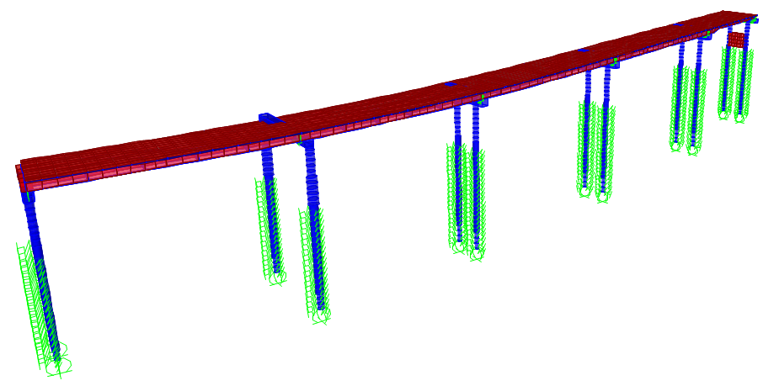

Figure 1: Example of a Typical Finite-Element Model for Steel Composite Girder Bridge

* 1. **Flange Lateral Forces and Bracing Requirements**

In a straight, multi-girder bridge, CHBDC recommends typical cross-frames to be located at a spacing not greater than 8.0 m – this ensures that the buckling reduction factor is kept close to unity. Unlike straight girders, which do not deflect laterally unless approaching buckling failure, curved-in-plan girders deflect laterally and twist with the application of vertical loads. Cross-frames and diaphragms need to be designed and strategically placed to resist torsion and lateral forces, which vary along the girder span. Away from the cross-frames, non-uniform torsion is resisted by lateral bending in the flanges. As a result, the spacing of the bracing affects the lateral bending of the flanges and the forces in the bracing. SCI discusses the distribution of lateral forces in a curved girder due to the second-order effects from the flange axial forces (Figure 2). Each cross-frame in a curved girder bridge forms the essential load path and are designated as primary tension members per CHBDC. CHBDC requires all primary tension members to meet Charpy V-notch fracture-toughness requirements. Cross-frame members required to meet these requirements are typically more expensive; this increased cost is not advantageous to curved-in-plan bridge construction especially when cross-frames are considered as higher-cost items.

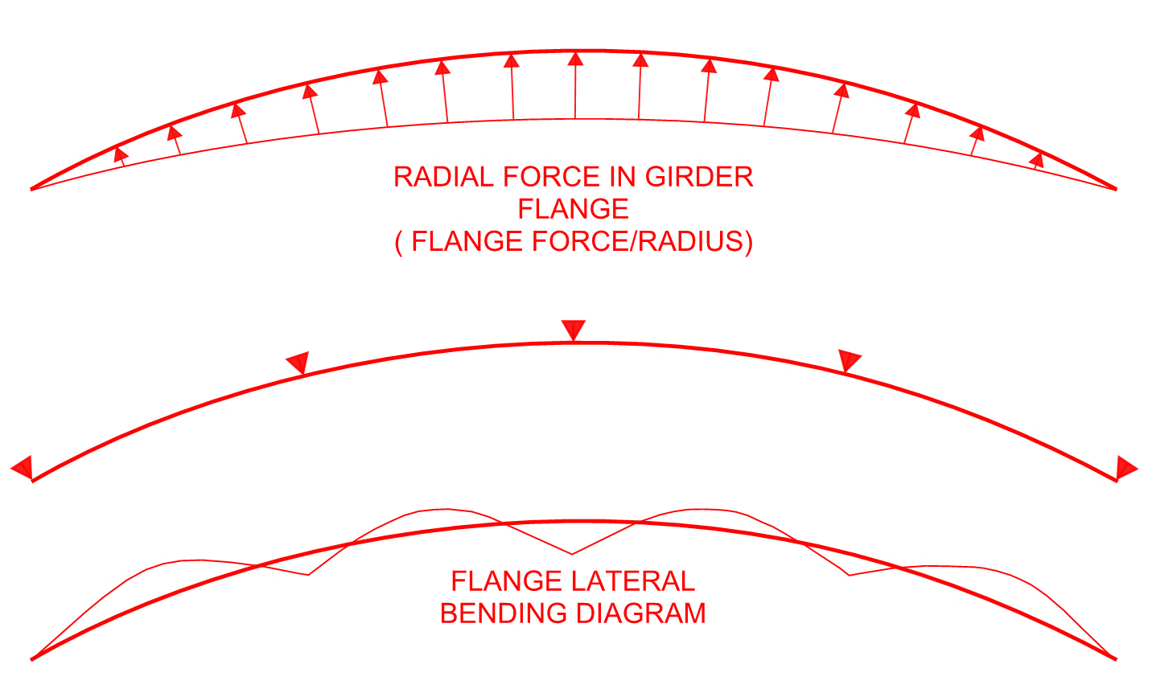

Figure 2: Lateral (Radial) Forces in Curved Girder Flanges due to Vertical Moments

When kinked-straight girders are used, unlike curved girders, the lateral forces due to flange axial forces are concentrated at the kinks rather than distributed along the girder length. The change in flange direction results in radial forces that act outwards at the compression flange and inwards at the tension flange. Figure 3 shows the lateral forces at the kink due to flange axial forces. These lateral forces must be resisted by cross-frames. For economy, kinks are located at moment inflection points, which normally coincide with girder splice locations. By positioning the kinks at moment inflection points, the lateral flange forces resisted by the cross-frames are minimized. Like the cross-frames in curved girders, the cross-frames at the kinks are primary tension members and are required to meet the same fracture-toughness requirements. However, cross-frames other than those at the kinks are not primary tension members and are typically only designed to stabilize the compression flange. Optimizing the number of fracture critical elements along the bridge, especially for numerous cross-frames, makes kinked-straight girders a more attractive option.

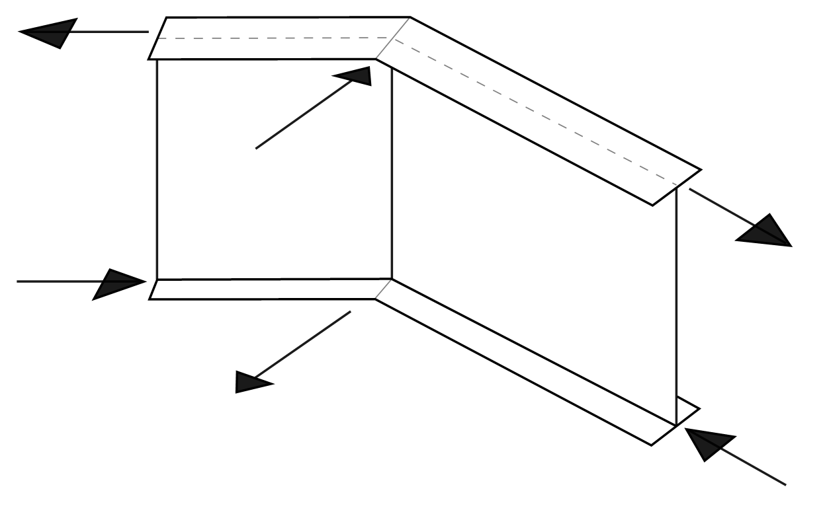

Figure 3: Resultant Flange Lateral Forces at Kinks (Girder in Negative Moment, Cross-Frame Bottom Chord in Tension)

* 1. **Girder Fabrication**

Fabrication of curved-in-plan girders have many aspects that require additional attention. Curves in flange plates can be achieved in two ways: cut curving or heat curving. Cut curving is performed by numerically-controlled heat cutting machines to achieve the desired curvature, making this option ideal for girders with smaller plan curvature. Heat curving is accomplished by heating one side of the top and bottom flange of a fabricated I-girder to introduce residual curvature after cooling and is usually selected for greater radii. Benefits and drawbacks of each option are outlined below:

* Cut Curving: One primary advantage of cut curving is that complex, non-uniform transitioning curvatures can be achieved by cutting from standard steel plates. However, cut curving often leads to plate wastage, even with careful planning and cut optimization. To achieve the required curvature, it may be required to cut flange plates one at a time, rather than cutting several plates simultaneously using multiple head machines otherwise possible for cutting straight flanges. Plate wastage and multiple cut runs for curved girders lead to higher costs and longer fabrication schedules compared to straight girder fabrication.
* Heat Curving: The added complexity to heat curving is that cambering of girders is required before heat curving. The girder webs are cut to the required camber, taking into account the allowance for shrinkage due to cutting, welding, and heat curving. The horizontal and vertical curvatures are then checked once heat curving is completed. Significant additional measures and efforts are required to ensure the quality and heat correction of curved girders, which would otherwise not be required for straight girders. The effect of the additional fabrication complexities associated with heat curving would generally increase cost.

From the fabricator’s quality assurance standpoint and from the discussion points above on methods of making curved girders, the fabrication of curved girders is much more difficult compared to straight girders. Radial geometries are made easier with computer-aided design (CAD) tools, but in practice are still difficult to achieve when fabricating the pieces. Issues with fit-up are also a problem, as a correction to flanges with an excessive sweep, or a deviation in curvature, can add up and cause complex issues. With a simple straight girder design, presentation and verification are easier to control. Straight girders have simple fitting plans and tolerances from a single point of reference. Achievement of an accurate final product is far simpler. According to the fabricator of the Letellier Bridge, depending on the complexity and the amount of plan curvature, it is estimated that the manhours spent on curved girders could be as much as double.

As part of the comparison of the two girder layout options, the authors have engaged the steel fabricator of a curved-in-plan steel bridge in Winnipeg on inputs regarding steel girder material and fabrication cost estimates for the two girder layout options. The reference bridge is called Letellier Grade Separation, hereafter referred to as the Letellier Bridge. The Letellier Bridge is a 198 m long curved-in-plan composite steel I-girder bridge consisting of five continuous spans crossing over three existing rail tracks. Spans are 41.0 m: 39.9 m: 44.5 m: 44.1 m: 28.0 m. Piers are orthogonal to the alignment and the deck follows the transitway’s curved horizontal alignment. The minimum radius of plan curvature is 330 m occurs in the southern two spans, yielding a maximum curvature ratio of 0.46 (Table 1). The bridge then transitions back to a tangent alignment north of Pier P2 (Figure 4). Figure 5 shows the cross-section of the Letellier Bridge; further information on the Letellier Bridge is presented in the paper by Wong et al. (2018).

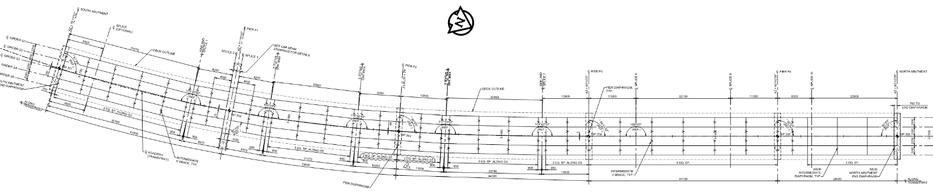Figure 4: Letellier Bridge Overall Plan

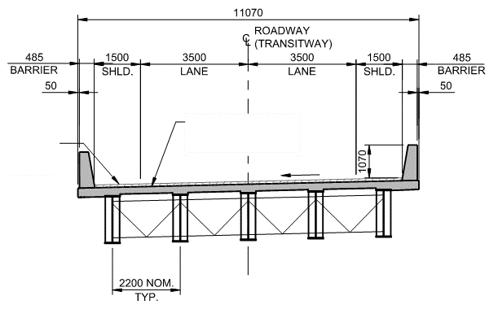

90 OVERLAY

225 DECK

Figure 5: Letellier Bridge Typical Superstructure Cross-Section

Table 1: Maximum Curvature Ratio of Letellier Bridge

|  |  |  |  |  |
| --- | --- | --- | --- | --- |
| Span No. | Span Length, L (m) | Bridge Width, B (m) | Plan Curvature Radius, R (m) | Curvature Ratio, L2/BR |
| 1 | 41.00 | 11.07 | 330.00 | 0.46 |

Early in the design stage, curved girders and kinked-straight girders were both considered for this bridge. After much discussion with the contractor and the fabricator, the kinked-straight girder arrangement was chosen over curved girders. Two estimates are provided, one for the kinked-straight girder option (Table 2), which is the chosen option and the other for the assumed curved girder option (Table 3). The cost estimates are broken down into major steel components and highlight the cost premiums in a form of increased unit costs. The cost estimate considers:

* Steel tonnage
* Costs for either heat curving or cut-curving of flanges
* Welding of webs to curved flanges
* Additional quality control and quality assurance measures required for curved plates
* Costs for kinked splice plates
* Additional costs for primary tension members requiring to meet V-notch fracture-toughness requirements

Table 2: Estimated Material and Fabrication Costs: Kinked-Straight Option

|  |  |  |  |
| --- | --- | --- | --- |
| Girder Component | Steel Tonnage | Cost | Unit Cost* |
|  | (Tonne) | ($CAD) | ($CAD/Tonne) |
| Flanges & Webs | 450 | 2,350,000 | 5,200 |
| Stiffeners | 26 | 260,000 | 9,700 |
| Typical Splices & Plates | 14 | 130,000 | 9,300 |
| Kinked Splices & Plates | 7 | 80,000 | 11,200 |
| Splices at Straddle Bent | 11 | 100,000 | 9,300 |
| Typical Cross-Frames & Gussets | 10 | 100,000 | 9,700 |
| Primary Tension Cross-Frames & Gussets | 3 | 40,000 | 10,700 |
| TOTAL | 162 | 3,100,000 | - |
| *\*Unit costs are approximate for purposes of comparison only* | | | |

Table 3: Estimated Material and Fabrication Costs: Curved Girder Option

|  |  |  |  |
| --- | --- | --- | --- |
| Girder Component | Steel Tonnage | Cost | Unit Cost* |
|  | (Tonne) | ($CAD) | ($CAD/Tonne) |
| Flanges & Webs | 450 | 2,780,000 | 6,200 |
| Stiffeners | 26 | 260,000 | 9,700 |
| Typical Splices & Plates | 21 | 200,000 | 9,300 |
| Splices at Straddle Bent | 11 | 100,000 | 9,300 |
| Primary Tension Cross-Frames & Gussets | 11 | 130,000 | 10,700 |
| TOTAL | 160 | 3,500,000 | - |
| *\*Unit costs are approximate for purposes of comparison only* | | | |

* 1. **Girder Transport**

Curved girders can face potential problems that would otherwise not occur in the transportation of straight girders. When a curved girder is transported individually by truck, the location of the rear bogie is critical in ensuring the girder does not flip over due to misalignment of the center of gravity in the girder transverse (radial) direction. For the reason above, pairing girders in multiple girder bridges for transport is especially advantageous and sometimes necessary. Pairs of girders typically have an overall width exceeding 4 m and can be more than 5 m with the additional width due to the curved-in-plan geometry, which may exceed transport limits depending on local highway jurisdiction. The overall width for transportation is not simply the width of the rectangular 'box' into which the girders could theoretically fit. The cantilever behind the rear bogies, due to the curve geometry, extends sideways increasing the total transport width on the road (SCI, 2012).

* 1. **Girder Erection**

Erection and fit-up of horizontally curved steel girders are also generally more complex than those of straight girder chords in kinked-straight bridges of similar spans. The erection of horizontally curved I-girder bridges involves significant stability issues and requires detailed analysis to ensure stability (Bentinez et al., 2010). A successful implementation of curved girders often requires significantly more attention to the critical phases of construction. This process usually requires an additional engineering team with the expertise in construction staging design, compared with an otherwise much less involved construction design for the erection of kinked-straight girders. Curved girders are often erected relying on the experience of the contractor; an inexperienced contractor may not consider fit-up issues in the erection plan, which can sometimes lead to issues during construction (NCHRP,1999).

Another complication for the erection of a curved girder is ensuring that it can be lifted from above its center of gravity. With a straight girder, the center of gravity and the lifting points all lie on the girder line. Figure 6 shows the additional pick points often required when lifting a curved girder. The length of a girder segment to be lifted is most often controlled by the transportation length, which is usually limited to 50 m in Canada. Pick points of horizontally curved girders are determined through structural analysis; a typical girder lift analysis involves evaluating each girder to determine the center of gravity and completing a stress analysis to ensure stresses due to twisting are kept within allowable limits.

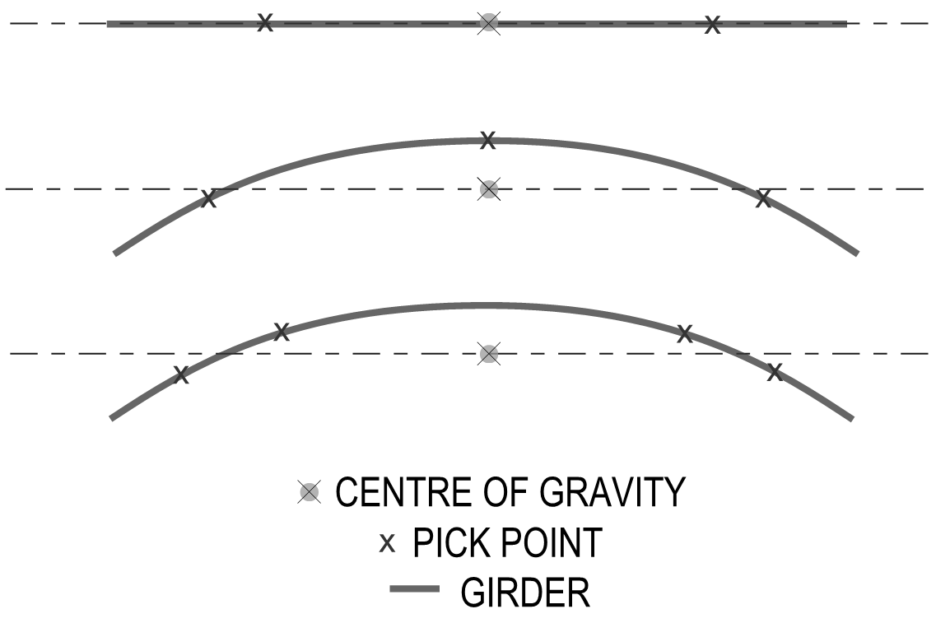

Figure 6: Typical Pick Point Setup for Curved Girders

To add to the complexity, the ends of a curved girder are prone to twisting when it is lifted, which can complicate the fit-up to the previously landed girder. The lifting and connecting procedures of curved girders require close attention, for safety and efficiency. It is difficult to attribute a direct dollar value to account for the increased cost due to lifting curved girders, especially during the early conceptual design stage, which is typically when the girder layout is selected. Nonetheless, girder erection is a critical aspect in the design of curved-in-plan bridges and should be a key consideration when choosing between a kinked-straight or curved girder layout.

* 1. **Deck Construction**

Curved deck forming is an aspect where construction of kinked-straight girders may be less preferred than that of curved girders. In a kinked-straight girder bridge, there is an offset of the curved deck edge from the straight girder segment, or the chord. This offset is especially pronounced when the curvature ratio, L2/BR is high (greater than 0.5). For moderately curved bridges, when L2/BR ≤ 0.5, the offset is subtle and is often not significant enough to an extent to cause a change in the bridge overhang bracket design during slab casting. With the small offset, deck overall ULS design is also inconsequential as the design is often governed by the horizontal parapet collision loads. Table 4 and Figure 7 present the offset values of a kinked-straight girder chord to the curved deck edge for various girder spans and plan curvatures. For comparison, the curvature ratio is kept at the limit of 0.5 and a 12 m overall deck width is assumed to be typical of highway ramp/fly-over structures. There may be a perception of difficulty regarding forming a curved deck on straight girders and whether contractors are able to achieve the design intent; however, lack of contractor experience has not been observed to be a problem in uneven overhang construction, as similar construction is commonly employed for chorded concrete girders across North America.

Table 4: Typical Offsets of Chord to Curve for 12 m Wide Deck at L2/BR = 0.5

|  |  |  |  |
| --- | --- | --- | --- |
| Span, S  (m) | Plan Curvature Radius, R  (m) | Chord Length, L  (m) | Offset, O  (m) |
| 34.5 | 200 | 17.25 | 0.20 |
| 42.5 | 300 | 21.25 | 0.20 |
| 55 | 500 | 27.5 | 0.20 |
| 69 | 800 | 34.5 | 0.20 |

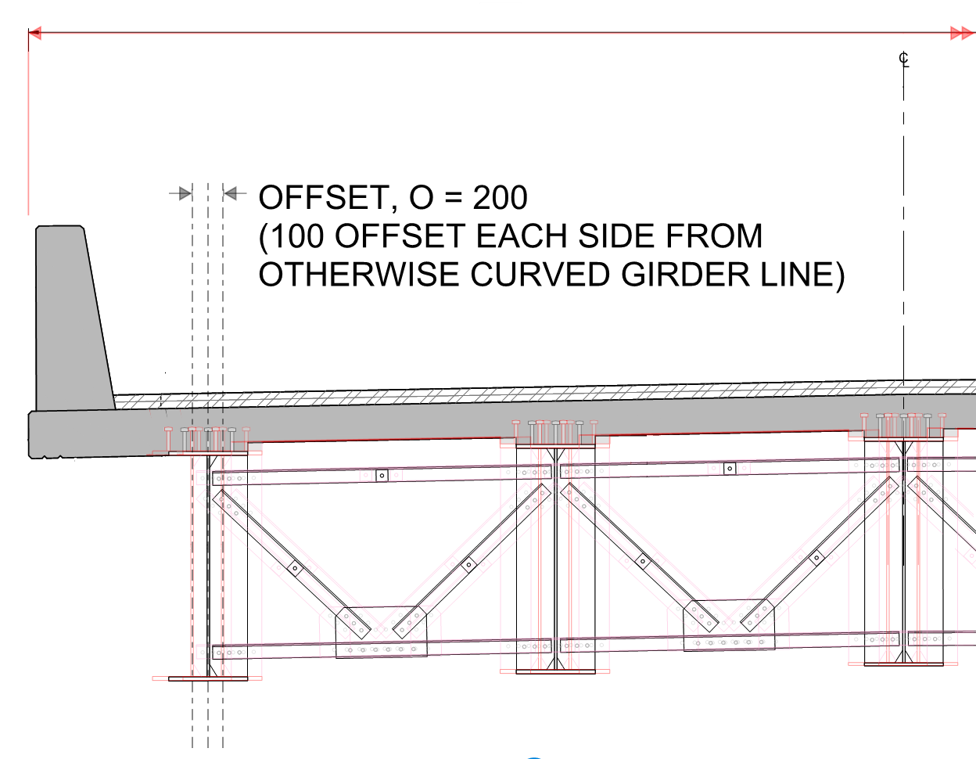

Figure 7: Girder Section Showing Offsets of Chord to Curve

* 1. **Aesthetics**

Generally, bridges with curved-in-plan deck supported on curved girders have been regarded as more aesthetically pleasing, as they allow for constant-width overhangs. A number of transportation authorities have published guidelines on bridge aesthetics that encourage the use of curved girders, and this option is regarded as a preferred option by the owner. The discrete kinks located along the bridge spans can be apparent when viewed at certain angles and can be perceived as unsightly visual discontinuities. Moreover, steel girder bridges are usually chosen for its functional qualities and structural efficiency in a highway setting as opposed to their aesthetic characteristics. For bridges with larger radii of curvature, the visual difference between a kinked-straight girder bridge and a curved girder bridge is not as noticeable. Aesthetic considerations applied to other portions of the superstructure, such as careful selection of barrier finishes, railings, or light base placements can have a much more profound aesthetic impact to a bridge’s overall appearance. These items are often more apparent to the observer than the relative differences between the kinked-straight girder and deck curvature.

1. **CONCLUSION**

Despite preferences to the curved girder layout in current design guidelines for curved-in-plan bridges, kinked-straight girders exhibit many advantages over their curved counterparts. In most highway applications, kinked-straight girders for moderate horizontal curves may often be cheaper overall. In addition to cost, other aspects with respect to analysis, design, fabrication, transport, and the erection of curved-in-plan bridges have been compared between the two common girder layouts. Kinked-straight girders seem to present advantages in most aspects and appear to be the preferred girder layout option for moderately curved-in-plan bridges.

**Acknowledgments**

The authors acknowledge effort leading to the overall success of this paper:

* Capitol Steel Corp. – Steel Fabricator of the Letellier Bridge
* PCL Constructors Canada Inc. – General Contractor currently building the Letellier Bridge

**References**

American Association of State Highway and Transportation Officials (AASHTO), 2012. AASHTO LRFD Bridge Design Specifications, 6th Edition, Washington, D.C.

Canadian Standards Association (CSA). 2014. Canadian Highway Bridge Design Code, CAN/CSA-S6-14. Canadian Standards Association, Mississauga, Ontario, Canada.

Benitez, L. and Haas, M. 2010. Placing Curves Overhead. Modern Steel Construction, American Institute of Steel Construction (AISC). Retrieved from <https://www.aisc.org/globalassets/modern-steel/archives/2010/02/2010v02_placing_curves.pdf>

National Cooperative Highway Research Program (NCHRP), 1999. Improved Design Specifications for Horizontally Curved Steel Girder Highway Bridges, NCHRP 424, Washington, D.C.

The Steel Construction Institute (SCI). 2012. Design of Composite Highway Bridges Curved in Plan, Berkshire, UK

Wong, C., Hristov, F. and Lee, S. 2018. Design Challenges and Innovations for the Letellier Grade Separation – A Curved Steel Bridge with Integral Straddle Bent in Winnipeg, Manitoba. 10th International Conference on Short and Medium Span Bridges, Canadian Society for Civil Engineering, Quebec City, Quebec, Canada, 10 p. paper in online proceedings.