 | 10th International Conference on Short and Medium Span Bridges  Quebec City, Quebec, Canada,  July 31 – August 3, 2018 | 

Design of an architectural bascule bridge in St-Jean-sur-Richelieu
Cusson, Benoit^{1,2} and Mailhot, Tony^{1,3}
¹ WSP, Canada
² benoit.cusson@wsp.com
³ tony.mailhot@wsp.com
Abstract: In 2009, WSP designed a bascule bridge for PWGSC over the Chambly Canal in Carignan. Bridge #9 was the first structure of its kind in North America. In 2011, the WSP/Cima+/Stantec consortium was commissioned by the MTMDET to design a new movable bridge over the same canal, as well as a new fixed bridge crossing the Richelieu River to link Iberville to St-Jean-sur-Richelieu. Placed in front of three movable structure scenarios (bascule, rotating and lifting), the MTMDET chose the bascule bridge following a rigorous multi-criterion analysis. With its required span and width, the new Gouin Bridge will be 2.0 times longer, 1.7 times wider and 2.1 times higher than Bridge #9. As part of a project to revitalize and modernize the city center, the architectural concept of the movable bridge will provide a landmark to this highly touristic site. While the geometric complexity was a real engineering feat during the design phase, the construction of this bridge will require unusual precision and survey methods. The challenges of the project include severe architectural criteria, fabrication and alignment of over 800 mm in diameter pins, the assembly on-site of remarkably large bridge parts and the precise balancing of the bridge using an over 320 tons counterweight suspended 20 meters above ground level. These operations, which will take place in the midst of urban areas, will create their share of challenges to maintain traffic and mitigate environmental issues. In addition, no interruption of navigation on the canal is allowed during construction.
- Introduction
Throughout history, movable bridges have always fascinated the public. Modern examples of rotating, lifting or bascule structures are the fantastic results of the work of dedicated structural engineers and architects. While the imagination of the designers pushes the limits of feasibility further, modern design codes continue to be more demanding. It’s in this perspective that WSP, along with its partners, rose to the challenge with the design of the new Gouin Bridge over the Richelieu River in St-Jean-sur-Richelieu, Quebec, Canada.
  - Context
The existing Gouin Bridge was built in 1915. It consists in a 440 m long fixed structure crossing the Richelieu River and a steel truss bascule superstructure with an overhead concrete counterweight. The mobile structure spans 26 m over the Chambly Canal. Its 12 m total width provides for a vehicular traffic lane as well as a bicycle and pedestrian path in each direction. Located on the Canadian side of the border, the Gouin Bridge is the furthest upstream of the 17 canal structures allowing boats from Champlain Lake (USA) to travel all the way to the St-Lawrence River (Canada). The site of the project is located in the midst of high density urban traffic areas as well as local businesses and parks. The Chambly Canal is proudly recognized as a National Historic Site by the Canadian Government for its contribution to the historical economic development of the area.
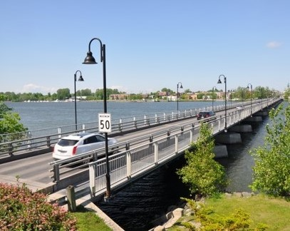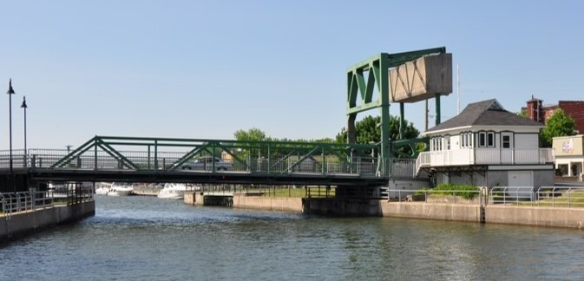
Figure 1: Existing structures (fixed on the left and movable on the right)
The bridge is managed by the Ministère des Transport, de la Mobilité durable et de l’Électrification des transports (MTMDET), owned by the City of St-Jean-sur-Richelieu and operated by Parks Canada. Evaluation reports over the last years indicate that the existing century-old structure is to be replaced in the short term. In the planning process of this replacement, the city of St-Jean-sur-Richelieu has also provided additional funds for the revitalisation of the city’s downtown area and the creation of a landmark with the new structure.
  - Project organisation
Replacement of the Gouin Bridge is a multidisciplinary project involving the following disciplines: bridges, roadways, municipal infrastructures, industrial-mechanical, automation and control, electricity, environment, hydraulics, architecture, building, archeology and communications. The partners of the consortium shared the workload efficiently to meet the client’s deadlines. WSP was leading the project and responsible for the bascule bridge. Cima+ and Stantec were responsible for the long fixed bridge. In addition, Le Groupe des Sept was chosen to provide the architectural concept of the entire project.
  - Preliminary study
In the early stages of the project, the client was accompanied by WSP to decide on the type of movable bridge to use: bascule, rotating or lifting. The rotating bridge option was rejected because of the important land space and real estate acquisitions required within the city’s downtown area. Between the bascule and the lifting structure concepts, the client chose the former for its architectural potential, its great speed of operation and the accessibility of its mechanical equipment for the maintenance operations.
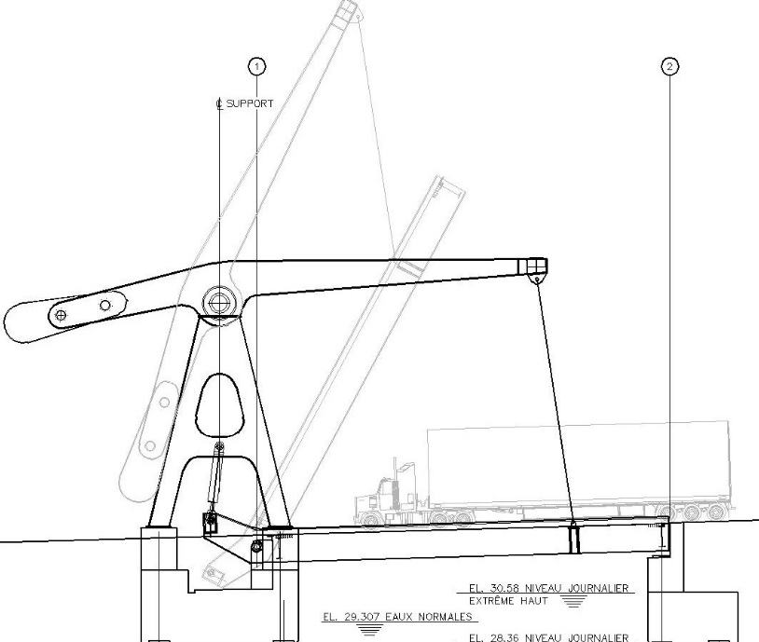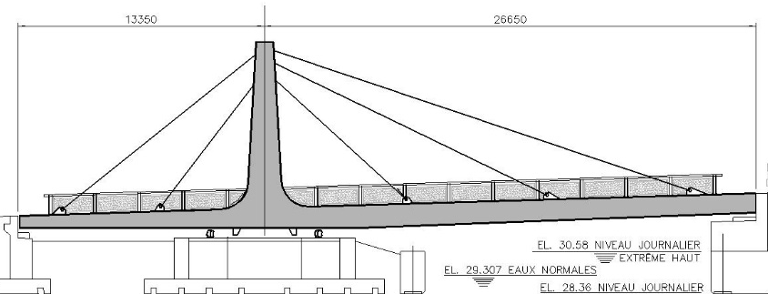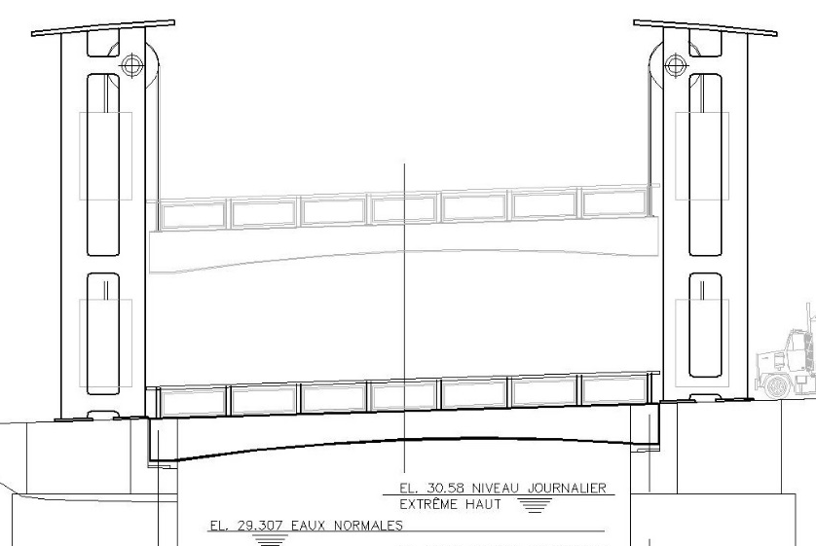
Figure 2: Movable bridge options: bascule, rotating and lifting
  - Past experience
In 2009, WSP designed a bascule bridge for Public Works and Government Services Canada (PWGSC) over the Chambly Canal in Carignan. Bridge # 9 was the first bridge of its kind in North America with its 12 m span and 11 m of width. The construction required 250 tons of steel. The lessons learned from this project include the following:
- Unconventional structure design process
- Constant checks during design required to avoid potential interferences
- Important dimensional control on-site and at the factory
- Bridge’s dynamic behavior under heavy traffic at the free end of the deck
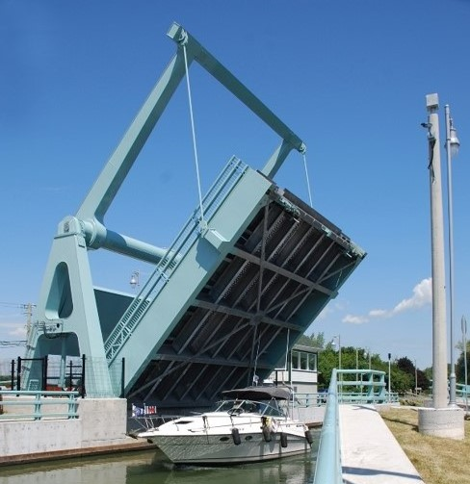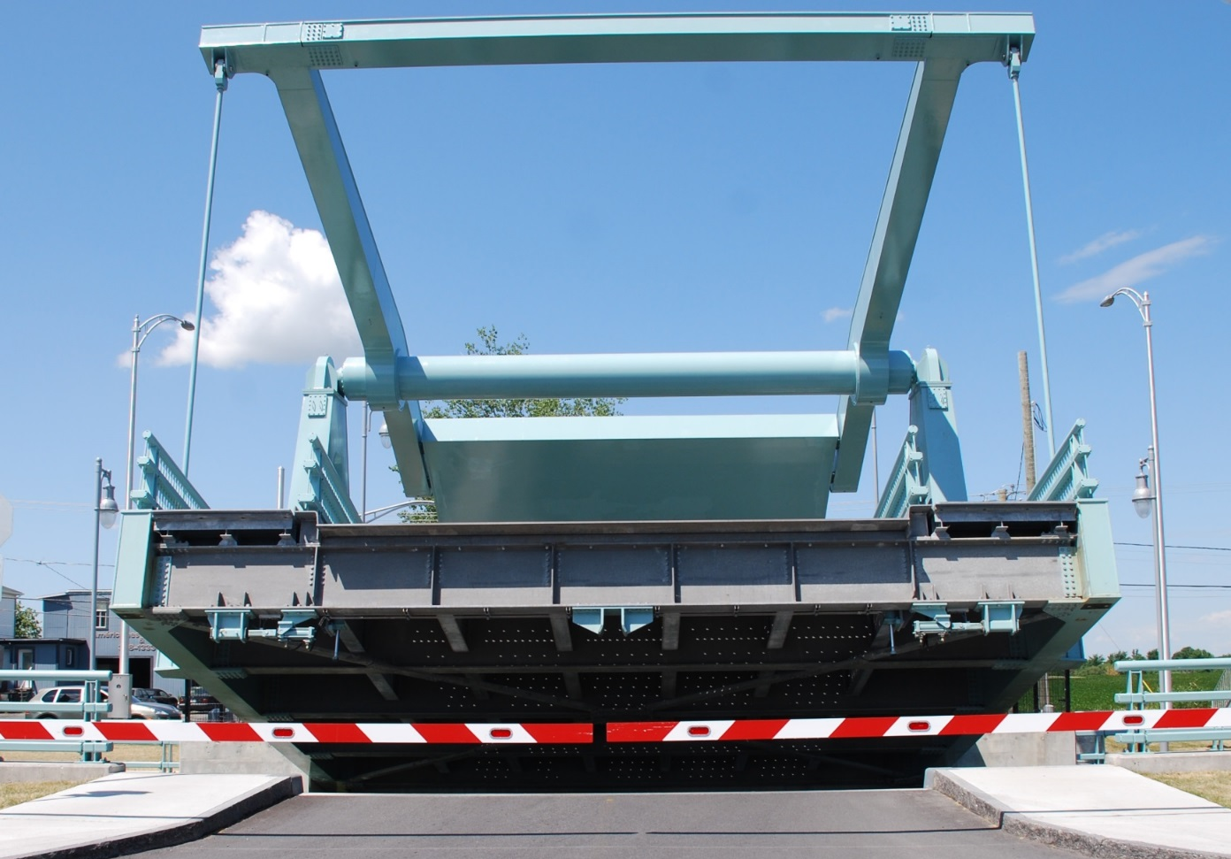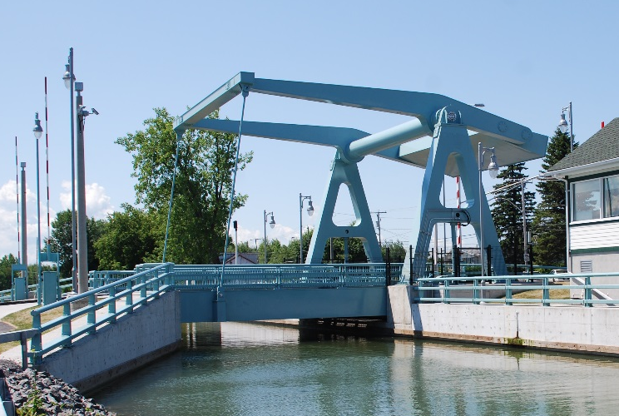
Figure 3: Bridge #9 in Carignan opened in 2012
  - New bascule bridge
In simple words, the Gouin Bridge will be Bridge #9’s big brother. With its 24 m span and 19 m width, it will be 2.0 times longer, 1.7 times larger, 2.1 times higher and 4.8 times heavier than its precursor. About 1200 tons of steel will be required for its fabrication. The proposed architectural concept was developed in collaboration with the city of St-Jean-sur-Richelieu’s representatives. For the two linked cities, the reconstruction of the Gouin Bridge represents an opportunity to revitalize the neighborhoods of Old St-Jean-sur-Richelieu and Old Iberville:
- Improvement of roadway geometry on both shores
- Revamping of the image of the two historic sectors
- Redevelopment of the banks of the Richelieu River into waterfront parks
- Development of the bicycle network
- Lighting concept enhancing rendition of both bridges
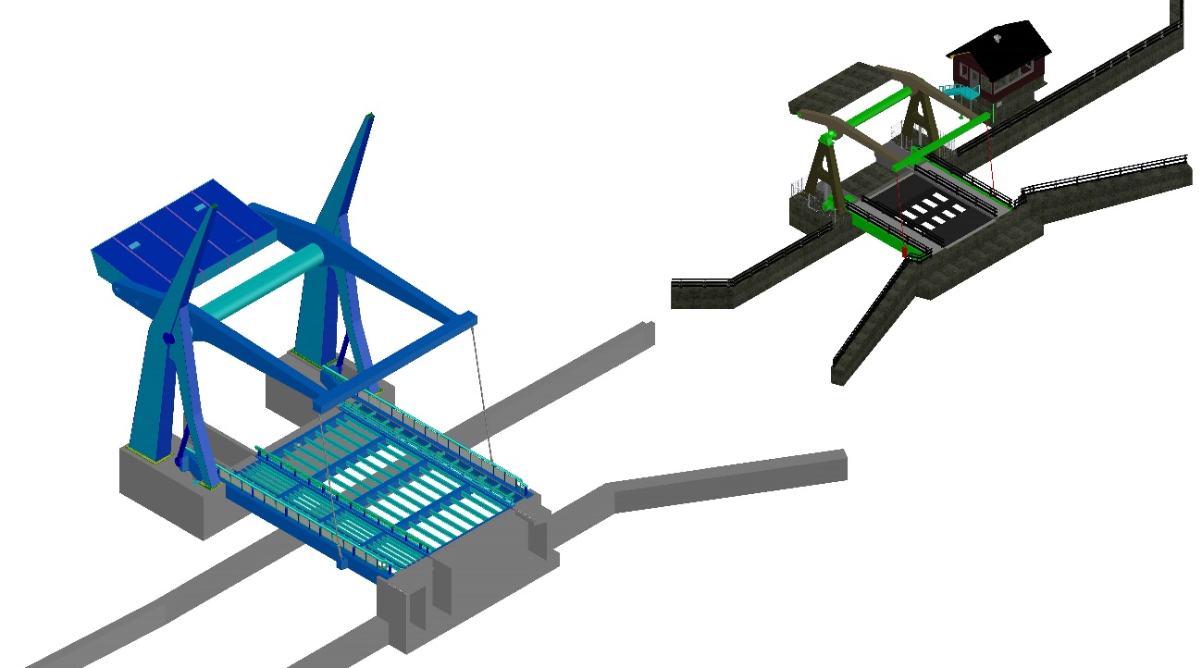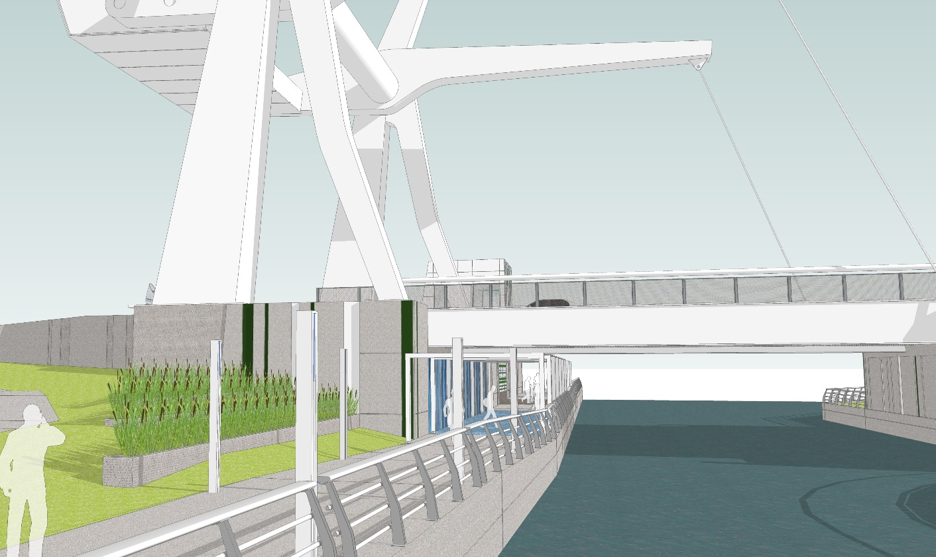
Figure 4: Scaled comparison of the Gouin Bridge and Bridge #9 sided with the architectural concept
The open deck steel grid is supported by transverse floor beams which are connected to the two main box girders. These main girders are connected to the lower pivots and the stay cables which transmit the required forces to lift the deck. The upper part of the structure consists in two 4 meters deep main arms supporting the stay cables and the steel counterweight. These arms are stiffened together by a horizontal tube and an ending transverse girder. Two architectural piles support the upper structure. When completing its 70 degrees rotation, the arms align themselves with the sleek top arrows of the piles creating a minimalistic effect.
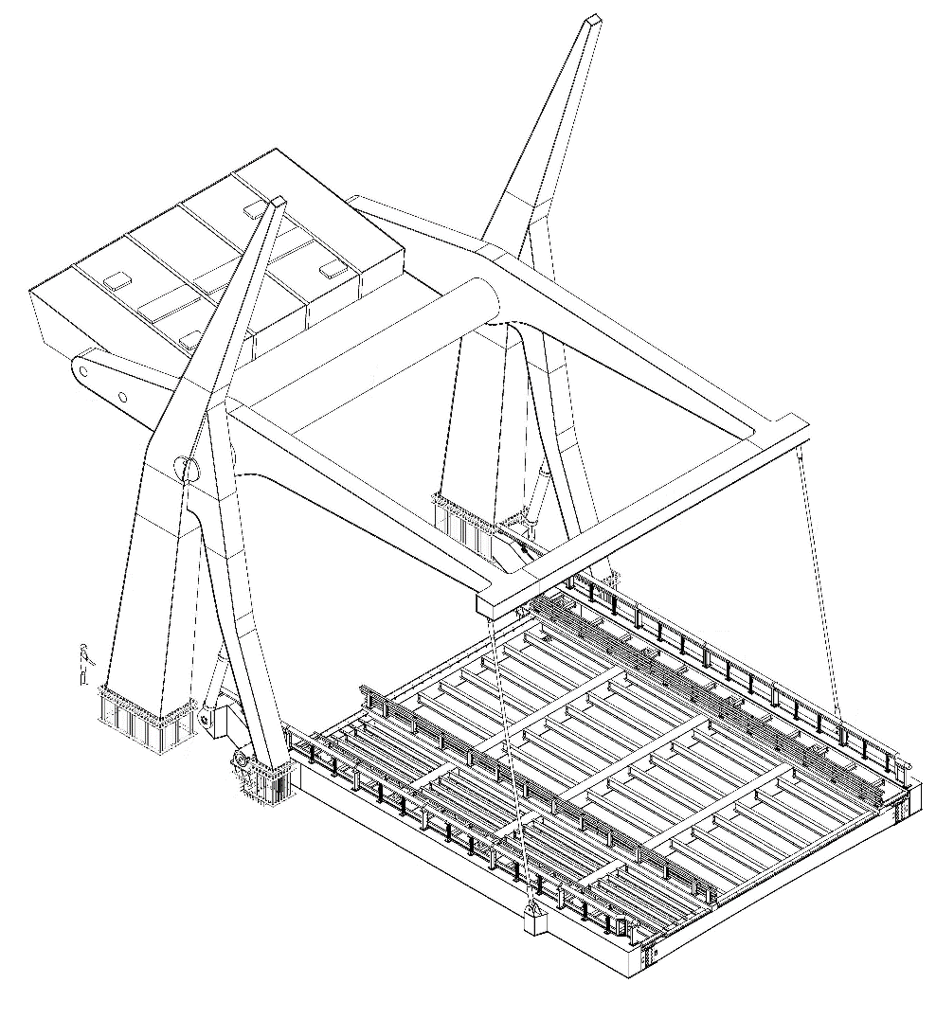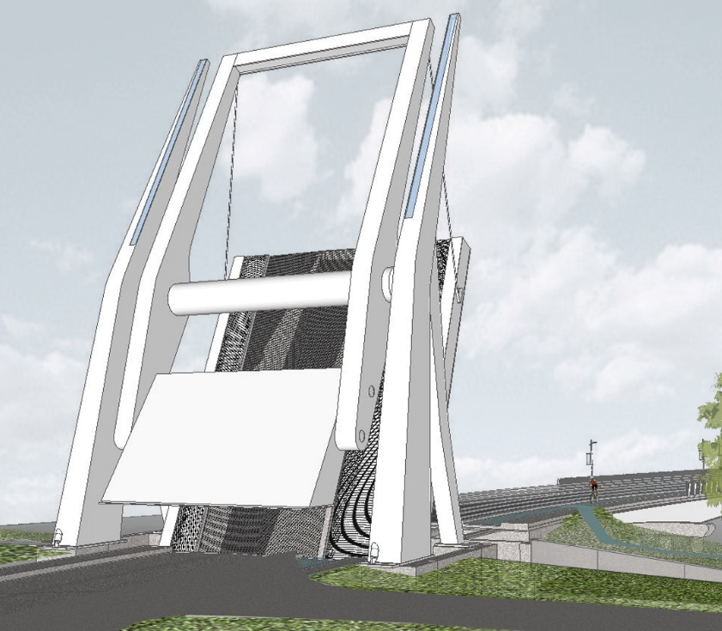
Figure 5: 3D representations of the new bascule bridge
The elements required to transfer the loads from the upper structure to the piles are some 800 mm in diameter steel casted pins. The hydraulic cylinders activate the rotation of the bridge by applying force at the back of the main girders. When fully extended, their length reach up to 9.8 m. Safety devices are installed under the free end side of the deck. These devices lock the bridge down in the case where maintenance operation or malfunction of the main lifting cylinders would be combined with extreme load cases scenarios. They also mitigate vibration issues created by heavy vehicle passage.
- Bascule bridge design
The bridge was designed according to specifications provided by the Canadian Highway Bridge Design Code (CHBDC) (CSA 2006). Even though chapter 13 provides precious indications, some aspects are left for the consideration of the designer.
  - Balanced state
Bascule bridges are classical examples of statically determined structures. Analysis of the dead load reveals that equalizing the moments sum to zero about the top and then the lower hinges allows to isolate the tension force in the stay cables. These two equations are used to solve the cable tension and the weight of the counterweight. When they might seem simple, these calculations become quite complex as the actual considerations are accounted for.
In order for the bridge to remain balanced at every step of the rotation, the previous equilibrium must be preserved. If the center of gravity of the lower and the upper structures are aligned with the hinges, this condition is respected. In most case though, the calculations will reveal that the centroids are offset vertically and transversely. Hence, special considerations are to be taken when analysing the centroid of the upper structure to control equilibrium along the rotation of the structure. Furthermore, dynamic and static friction in the hinges tend to complicate the calculation of the equilibrium state. Ultimately, internal researches reveal that unbalancing slightly the structure to give it propensity to close itself will help to mitigate the dynamic issues at the free end of the deck under traffic crossing. However, these advanced aspects of the design go beyond the scope of this paper.
For architectural purposes, to allow for displacement compatibility and to limit the number of variables in the static analysis, it is recommended that the four main hinges form a parallelogram. With the pile hinge and the lower girder hinge being fixed in the space, perfect parallelism of the opposed working lines is obtained. As a result, the lower girders and the top arms will remain parallel and the stay cables’ angle will remain the same during the rotation of the structure.
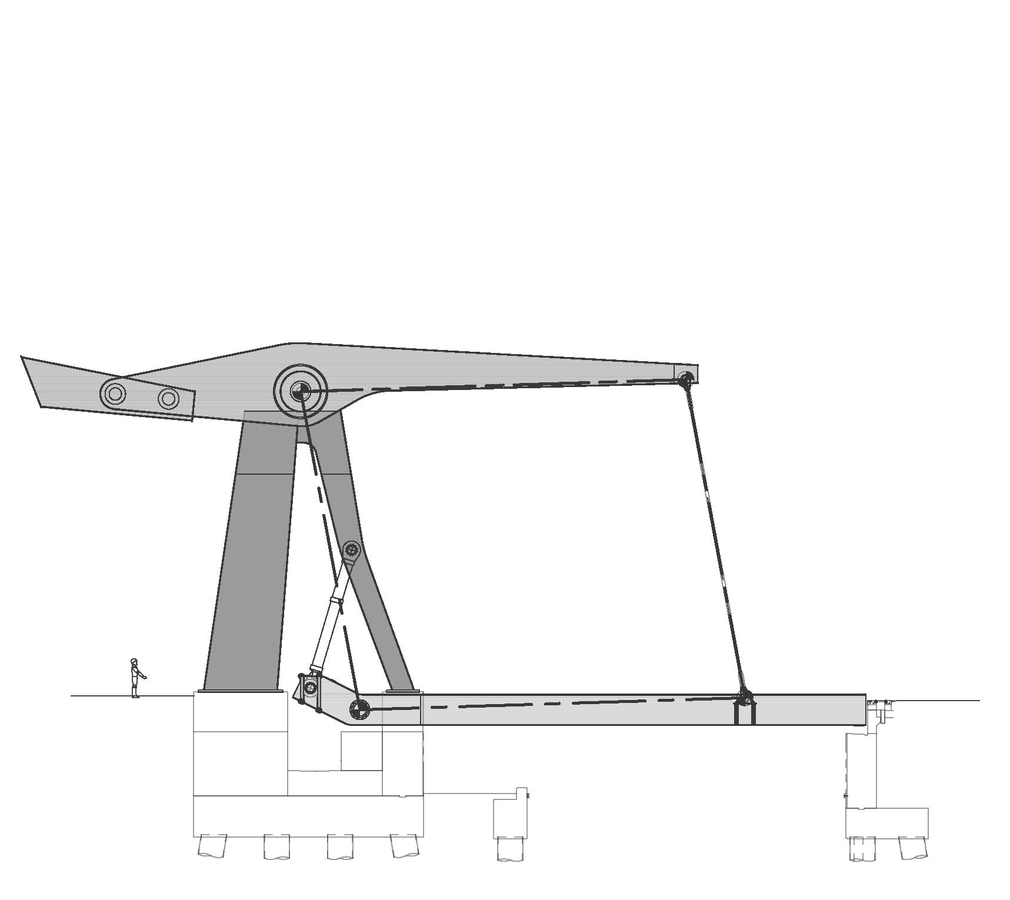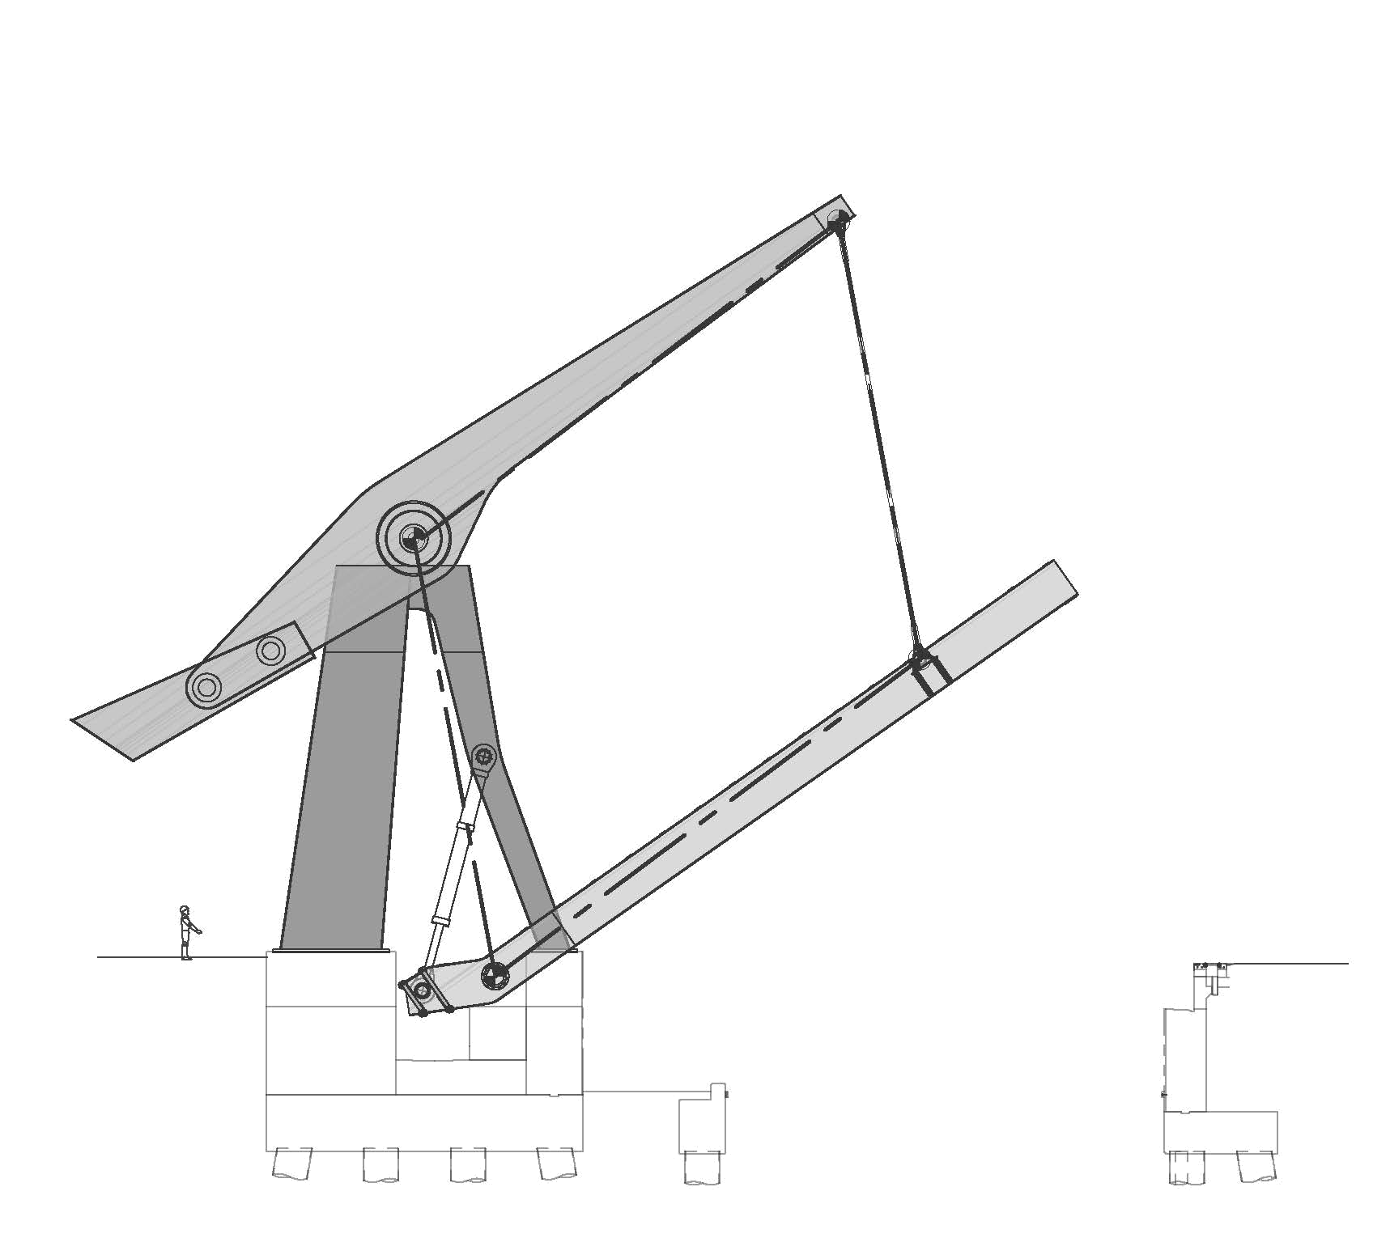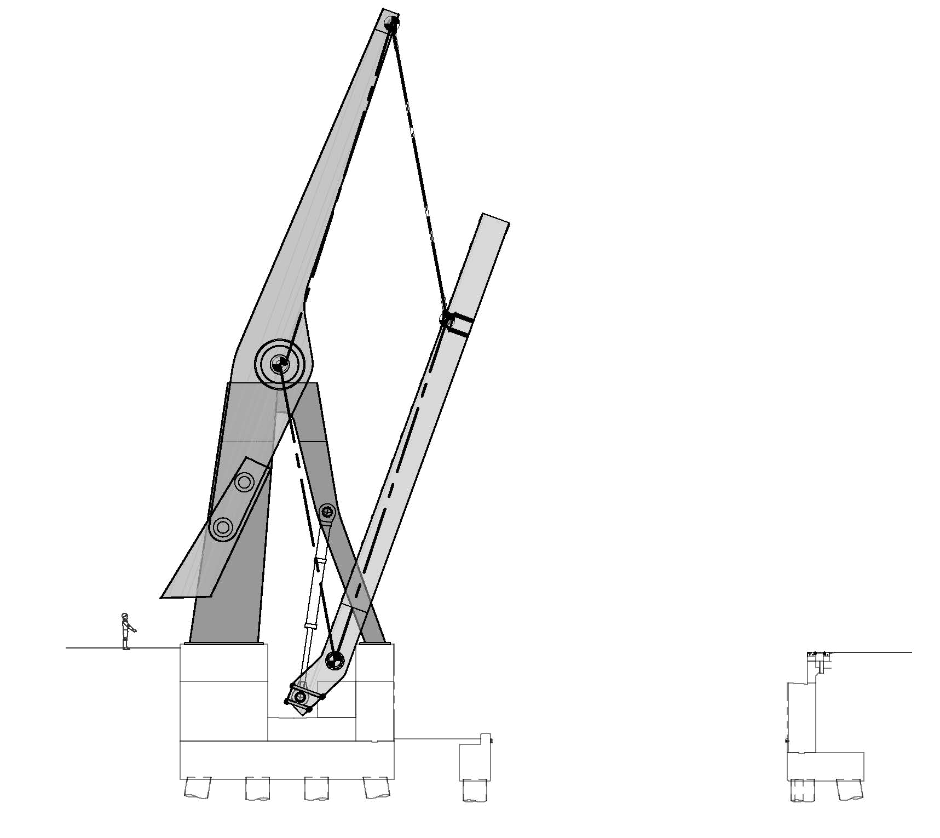
Figure 6: Geometric considerations of the bascule bridge (0, 35 and 70 degrees)
  - Code requirements
The CHBDC specifies a 75 years life span for every new structure. In its closed position, the code specifies traditional load cases and combinations including traffic, thermal effects, seismic events and wind. Furthermore, chapter 13 indicates that the bridge should be analysed in every state of rotation for special bascule bridge loads such as modified wind and seismic loads, dynamic maneuver impacts as well as static and dynamic friction. Special dead loads were added in the model to make sure that the actual centroids of the main parts calculated precisely apart would be respected within the model.
Serviceability limit state verifications include traffic induced deflexions and general deformation of the structure in its balanced state. Fatigue limit state is checked for regular traffic but also for the stress variation caused by each rotation cycle of the bridge over its design life span. Finally, ultimate limit state checks are also made for every position and respective loads. In this case, it is not that intuitive to predict which position is going to create the highest demand/capacity ratio for every part of the bridge. Rigorous numerical analysis is required to do so.
For pile design, it was deemed impractical to account for plastic hinges in case of a major seismic event due to the complexity of repairing such structure. Also, high rigidity of the piles was required to guarantee a well aligned rotation of the parts. Moreover, analysis revealed that seismic loads (ULS #5) induced D/C ratios only 10 % higher than wind loads (ULS #4) when considering an elastic analysis. Hence, planned plastic hinges wouldn’t have supported ULS #4 loads. Therefore, the bridge was designed elastically with respect to seismic loads.
  - Structural optimisation
The structure was completely modeled from drilled shafts to movable parts including the piles and the hinges using the structural software Advanced Design America by Graitec. The software allowed to efficiently rotate the parts, apply the loads specific to each level of rotation and compare the results from every analysis in order to verify the design according to the CHBDC.
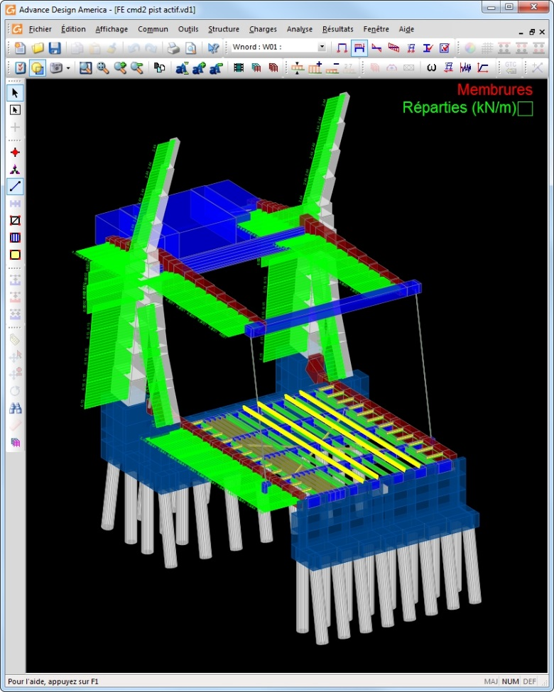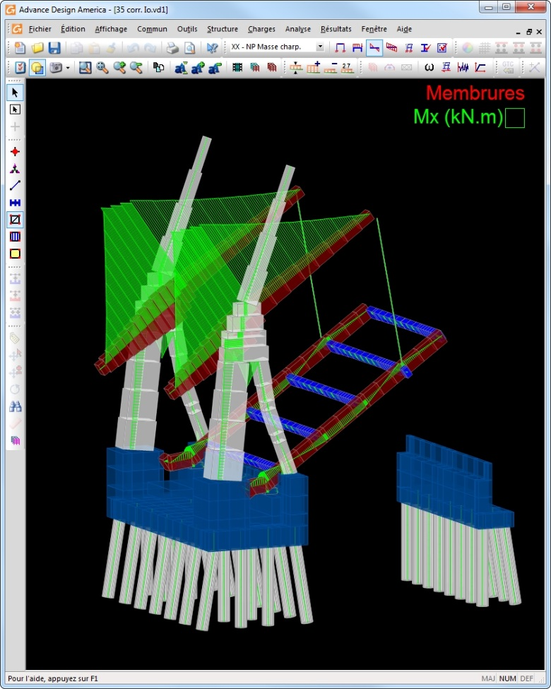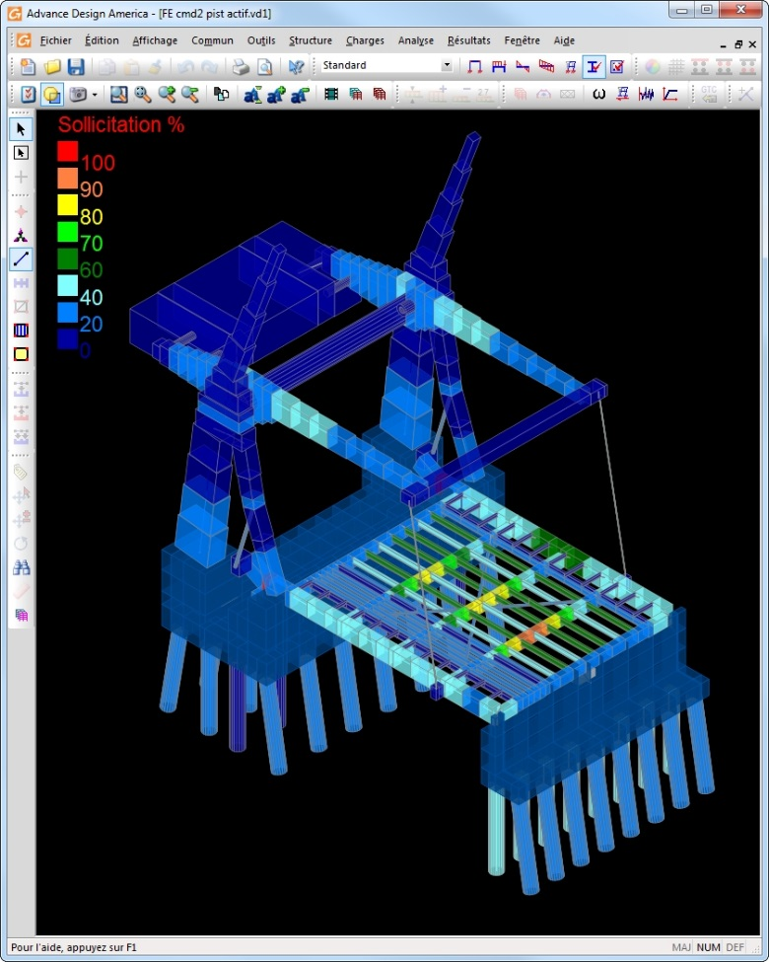
Figure 7: Numerical optimisation using ADA structural software
Optimisation is mandatory for this type of structure to limit the amount of steel required. A heavy deck leads to deep girders. The counterweight increases along with the weight of the lower structure. Then, the upper arms follow the trend in order to withstand the higher negative moment. Finally, the piles’ size increase due to higher vertical dead loads and lateral loads caused by the pendulum effect during seismic events. Hence, every kilogram of steel that is not optimized in the deck will be paid many times its own weight as the result of the dead load forces path described here.
The designers tuned the targeted demand/capacity ratios of each part with respect to its structural redundancy and level of reliability.
Table 1: Targeted demand/capacity ratios
Bridge elements | Targeted D/C ratios  (%)
Foundations | 90
Open grid deck, stringers, floor beams | 90
Main girders | 80
Upper arms | 60
Piles | 60
Stay cables and hinges | 50
- Project challenges
While preparing the plans and specifications, not only did the designers had to provide for a safe and economical structure, they also had to anticipate all the challenges that the contractor and the manufacturer would have to overcome.
  - Design
Geometry control is one of the main challenges when designing a bascule bridge. The design team had to anticipate every possible conflict during the rotation of the structure.
- The deck ends must leave a reasonable opening gap with the abutments. These openings are affected by temperature variations which are considerable in this area.
- Traffic barriers and railings had to be custom designed to accommodate for the rotation of the deck while offering the same level of safety.
- Alignment of the arms, the top arrows of the piles and the ending transverse beam is required by the architect when fully opening the bridge to its 70 degrees position.
- Upper arms must fit between the piles.
- Within the main foundation, room had to be provided to allow for the movement of the hydraulic cylinders and the back of the main girders below ground level.
The CHBDC requests the counterweight to be adjustable from 95 to 110 % of its theoretical weight. Since the structural shell is only about 65 % of the theoretical weight, filing plates are installed at the factory to arise the weight to the lower 95 % limit. Then, removable adjustment plates installed on-site allow for the variation of the weight up to the upper 110 % limit. The technique used to position these two types of plates and their influence of the calculation of the center of gravity of the upper structure go beyond the scope of this paper.
Even if some tolerance is provided by the adjustment plates, the CHBDC requests that the balancing state of the bridge be recalculated after all the shop drawings are verified and accepted by the designer. Hence, this source of variation of the weights and centers of gravity is avoided and the 95 to 105 % flexibility is reserved for less predictable variables. The 105 to 110 % margin is specified to allow for some new equipment to be installed on the deck like heavier barriers or opened grid deck. Unusual level of precision was required to properly calculate the centroids of the lower and upper structures. Every bit of steel was considered into these calculations including architectural railings, stiffeners, bolts, nuts and even fillet welds. Again, this precaution aims to eliminate controllable variables.
  - Planning
The new bridges are built north to the existing link to maintain traffic flow. On the Chambly Canal, boats have always had priority over vehicular traffic crossing the bridges. The clients wanted to maintain that constraint during the replacement of the Gouin Bridge. Therefore, a detailed work sequence was prepared by the design team. This arrangement includes first the displacement of the old control building during the navigational period to a temporary location to clear the area for the new foundations. As soon as the canal is closed to boat traffic in the late fall, intensive construction work begins in the canal to complete the foundations of the movable bridge and the canal’s new combined walls.
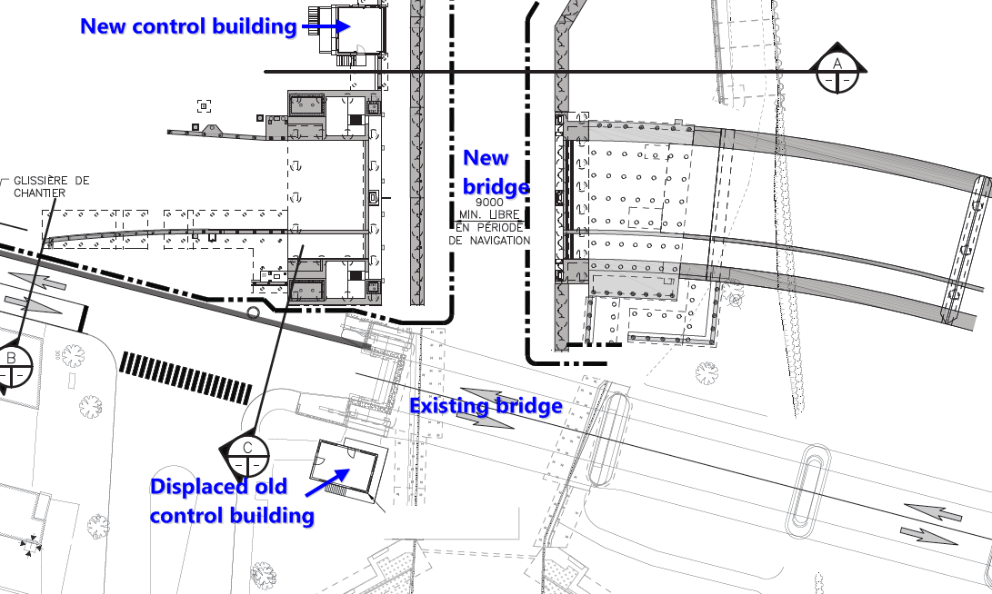
Figure 8: Planned work sequence for the movable bridge
As the navigation is reopened in the following spring, fabrication of the parts continues and these are progressively shipped on-site where they are preassembled and ready for their erection. During the second closure of the navigation, the new bridge is erected, balanced and opened to traffic. The old bridge is planned to be dismantled before navigational canal is opened again. Furthermore, works at the approaches have their share of constraints given the dense urban situation of downtown St-Jean-sur-Richelieu. Throughout the streets reorganisation, infrastructure works and soils improvements, a dedicated area was reserved for the preassembly of the main parts of the bascule bridge.
  - Fabrication
Even though Bridge #9’s experience helped imagining the construction sequence, the Gouin Bridge’s proportions are so large that special fabrication considerations had to be taken right from the design stage. The counterweight is divided into five similar sections that are light enough to be transported and then welded on-site. For similar reasons the 37 m high piles were divided into five sections. For the architectural criteria, no apparent bolting connections were allowed for the piles. Internal connections were designed and require outstanding precision to ensure that the end bearing plates are parallel to one another.
Many of the massive pins are custom casted for the purpose of this project and require months of fabrication. Insertion of some large pins require cooling of the pin and heating of the insertion zone for a tight thermal fit. The manufacturer used 3D modelling of the entire bridge to detect any conflict within the structural parts or with the mechanical components.
  - On-site construction and erection
In this project, mechanical precision is applied to civil engineering. Perfect alignment of the hinges is mandatory to allow smooth and stress-free rotation of the structure. On-site machining is planned for the supporting plates of the lower hinges. These supporting plates are themselves positioned using a rigid steel frame to ensure precise positioning during concrete casting. The foundations are casted in multiple phases to ensure that conflicts with the structure are avoided and proper final joint openings are obtained.
All the upper structure is preassembled on-site. The counterweight sections are welded together on-site before the final painting of this 320 tons steel element. Inserting the tube into the arms requires planning and precision methods given the size and weight of the parts to be assembled on-site. Once the back pins connect the arms to the counterweight, the upper structure can be lifted on the piles’ bearings and supported by temporary falsework.
Then, the lifting hydraulic cylinders and the stay cables are installed to the specifications of the designers. Balancing of the structure using the adjustment plates described before is performed at that point. After this is completed and the final deformation of the structure due to its dead load is effective, final adjustments can be performed. Stay cables must be adjusted to their required lengths considering elongation due to their final tension force. Locking devices under the free end of the deck are installed and adjusted considering the balanced state of the bascule bridge. Finally, middle bearings are installed making sure that their elevations match the final position of the two end floor beams. Following this erection sequence, the bridge can be opened to traffic.
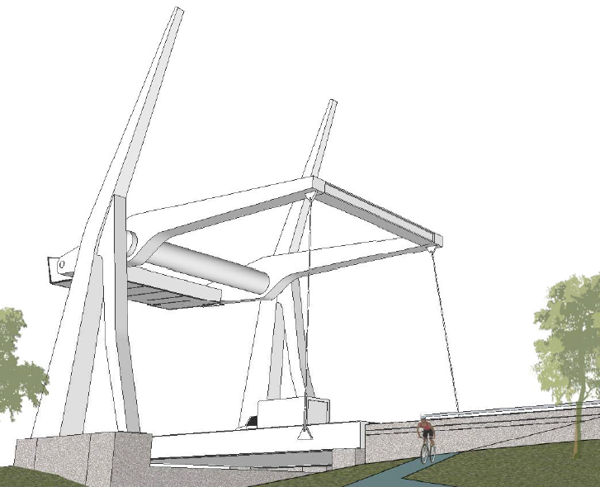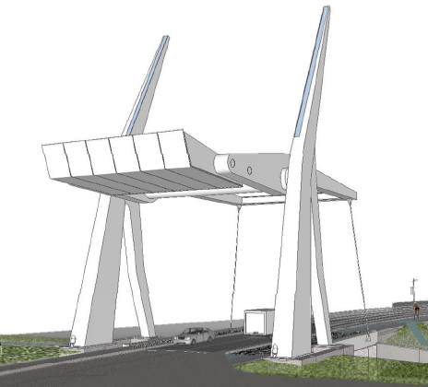
Figure 9: The Gouin Bridge to be opened to traffic in 2019
  - Operation
When it comes to operating the bridge, safety is the first concern of the design team. The control building was designed to allow for maximum visibility of the operator. Automation and control system ensures that a safe sequence is performed for each rotation maneuver.
- Warning horns and flashing traffic lights
- Lowering of barriers for vehicles, cyclists and pedestrians on each end with camera surveillance
- Unlocking of the safety devices under the bridge
- Activation of the hydraulic cylinders to requested position
- Safe passage of boats
The hydraulic cylinders can rotate the bridge from 0 to 70 degrees in less than 60 seconds and provide three phases to reduce maneuver impact loads: acceleration, constant speed and a deceleration. Should there be any extreme load case while the deck is lifted, like heavy winds and seismic event, the structure is designed to withstand these according to CHBDC specifications.
- Conclusion
As presented in this paper, designing an architectural bascule bridge like the Gouin Bridge required no ordinary set of skills and creativity. At every step of the design, WSP had to foresee feasible detailing of the structure leading to strong contractual documents. Dedicated engineers and technicians rose to the challenge to design one of the largest bascule bridge in North America. It is noteworthy that few similar examples exist in the world.
After the bidding process, the project was granted to the Pomerleau Construction Firm in the winter of 2017. Groupe Canmec was selected as the movable bridge manufacturer. Shop drawings for the bascule structure were produced and verified during the fall of 2017. Construction of the foundations and the canal’s combined walls started at the end 2017. The new bridge is scheduled to be opened to traffic in 2019.

Acknowledgements
The authors would like to express their gratitude to the Ministère des Transport, de la Mobilité durable et de l’Électrification des transports, Parks Canada as well as the city of St-Jean-sur-Richelieu for the opportunity to lead this project from the preliminary studies to final completion. Main partners Cima+, Stantec and Le Groupe des Sept are thanked for their collaboration in completing the various other aspects of the global project.

References
CSA. 2006. Canadian Highway Bridge Design Code S6-06, Canadian Standards Association, Mississauga, Ontario, Canada.

